**Online Auction Web Project**

**Use cases**

Group: OneMember (1753102)

**Revision**

|  |  |  |  |
| --- | --- | --- | --- |
| **Version** | **Content** | **Date** | **Author** |
| 1.0 | Initial project | 19/11/2019 | Bui Quang Thang |
| 1.1 | Draft use-case diagram | 19/11/2019 |  |
|  |  |  |  |
|  |  |  |  |
|  |  |  |  |

1. **Use-case diagram**

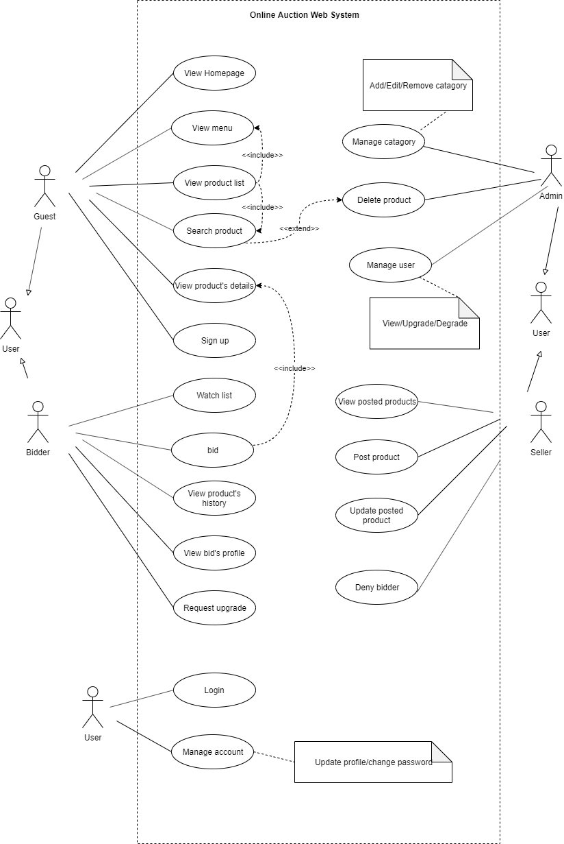

1. **Use-case specification**

See ‘Requirements’