# The 2026 NeuroGolf Championship
Design the smallest neural networks to solve ARC-AGI image transformations

## Overview
Design the smallest possible neural networks to solve ARC-AGI image transformations (all drawn from the ARC-AGI benchmark suite) and discover how many parameters those tasks actually require.

## Description
Solving a task is only the first step. Doing it efficiently is harder.
Today’s AI systems perform well on familiar tasks but often struggle with new ones. This gap is highlighted by François Chollet's ARC-AGI benchmark suite (and subsequent ARC Prize competitions), in which each task is presented as a series of grids illustrating some specific transformation.
In this competition, you’ll work with tasks from the ARC-AGI public training set (v1) and build neural networks that reproduce each transformation. Your models must be correct—and as small as possible. Your models must be correct—and as small as possible. You’ll submit ONNX-formatted networks and aim to jointly minimize their size and parameter count. The objective is to have a network that solves each task with as few operations as possible.
Strong solutions could help define how many layers of computation these tasks actually require, and could serve as reference implementations and support research into more adaptable AI systems.
For example, consider the following (hypothetical) task #000:
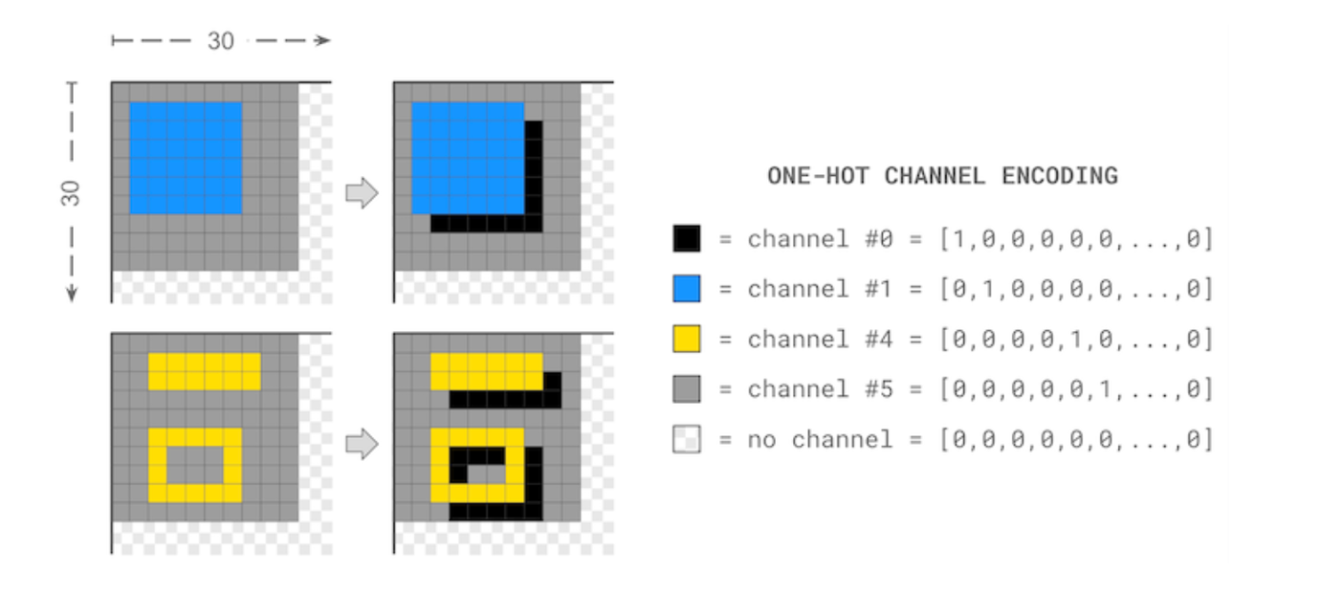
Your .zip submission might include a file task000.onnx that embodies the following single-layer 3×3 convolutional network:
```
def weight(channel_out, channel_in, kernel_coord):
if kernel_coord == ( 0, 0) and channel_in == channel_out: return 1.0
if kernel_coord == ( 0, 0) and channel_in != 5 and channel_out == 0: return -1.0
if kernel_coord == (-1, -1) and channel_in != 5 and channel_out == 0: return 1.0
if kernel_coord == (-1, -1) and channel_in != 5 and channel_out == 5: return -1.0
return 0.0

network = neurogolf_utils.single_layer_conv2d_network(weight, kernel_size=3)
```
When applied to a 30×30 image grid with a channel depth of ten, the above network would require 900 parameters in total.

## Constraints
All tensors and parameters in each ONNX network file must have statically-defined shapes so that the performance of the network can be properly evaluated. In addition, the following ONNX operations are disallowed: Loop + Scan + NonZero + Unique + Script + Function. Finally, the size of each ONNX file is limited to at most 1.44MB. These constraints will be checked automatically by our official network validator.

## Evaluation
For any of the 400 tasks in the ARC-AGI public training v1 benchmark suite, your team will earn a score of max(1, 25 - ln(cost)) for a functionally correct network whose cost is the sum of the following:
- The total number of parameters in the network
- The total memory footprint of the network (in bytes)
Functional correctness will be determined by validating the network against the original ARC-AGI benchmarks, the ARC-GEN-100K dataset, and a small private benchmark suite (so as to prevent teams from overfitting their solutions). To be eligible for points, your network must produce correct results across all of these tests.

## Submission File
You must submit a file named submission.zip containing at most one ONNX file per task:
```
task001.onnx
task002.onnx
...
task400.onnx
```

Note: if our evaluation metric requires adjustments—or, if we have to ban additional ONNX operators that compromise the aims of our contest—we will announce such changes and rescore submissions as needed.
## Timeline
- April 15, 2026 - Start Date.
- July 8, 2026 - Entry Deadline. You must accept the competition rules before this date in order to compete.
- July 8, 2026 - Team Merger Deadline. This is the last day participants may join or merge teams.
- July 15, 2026 - Final Submission Deadline.
All deadlines are at 11:59 PM UTC on the corresponding day unless otherwise noted. The competition organizers reserve the right to update the contest timeline if they deem it necessary.

## IJCAI-ECAI 2026
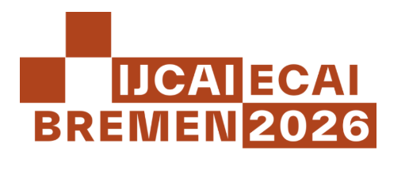
This contest is part of the IJCAI-ECAI 2026 Competitions Track. Top submissions for the competition will be invited to give talks at a special session during the conference in Bremen, Germany. Attendance at the special session is not required to participate in the competition. Attendees presenting in person are responsible for all costs associated with travel, expenses, and fees to attend IJCAI-ECAI 2026.
Members of the winning teams will also be invited to collaborate with the competition organizers on a contest retrospective submitted to the IJCAI 2027 Demo Track.

## Other Resources
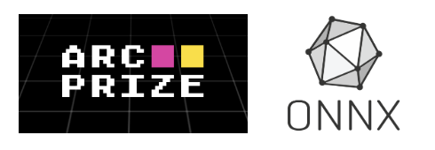
- arcprize.org — Learn more about the ARC Prize Foundation and its mission to accelerate the development of Artificial General Intelligence (AGI)
- onnx.ai — Learn more about ONNX, an open format built to represent machine learning models

## Citation
Michael D. Moffitt, Walter Reade, Ashley Oldacre, and Addison Howard. The 2026 NeuroGolf Championship. https://kaggle.com/competitions/neurogolf-2026, 2026. Kaggle.

