Midterm Group Project - Part 2: Sharding the Sales Database

Data Avengers

Part 1: Setup & Exploration

Task 1.1: Start the Part 2 Environment

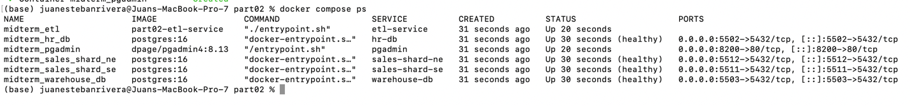

Task 1.2: Count Rows in Each Shard

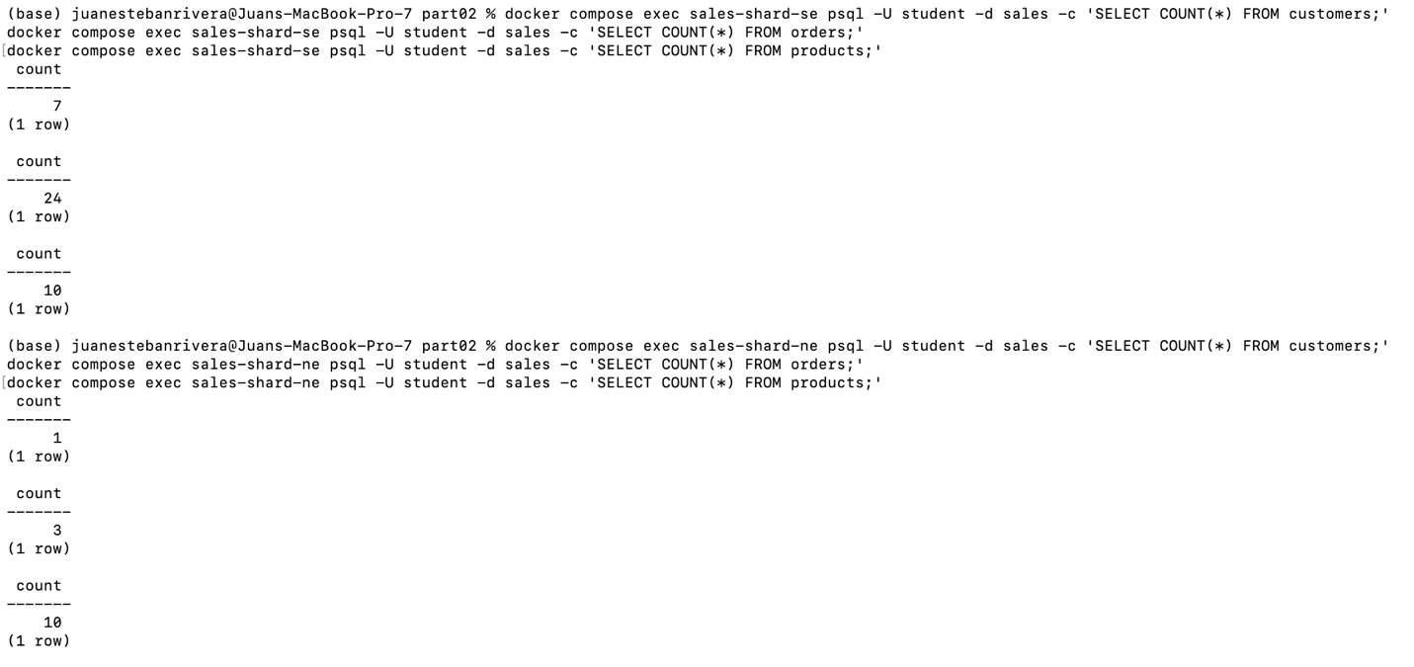

Task 1.3: Analyze Uneven Distribution

The shard distribution is completely uneven because the southeast shard has much more data than the northeast shard. The results show that the southeast shard has 7 customers and 24 orders, and the northeast shard only has 1 customer and 3 orders, The creates imbalance because one shard receives much more data and traffic than the other. This is a problem for performance because most queries and writes will hit the southeast shard more often. It can become much slower while the northeast shard stays underused. It is also a storage problem because one shard grows much faster than the other, so the system is not balanced well. Failure risk is also higher too, because if the busy shard goes down and fails, most of the business data and activity are affected at the same time since most of it is running through one single shard. A good solution would be to equally divide customers and orders across the two shards so that the whole data is split evenly across shards and there is a more balanced utilization of resources.

Part 2: Update ETL Pipeline

Task 2.1: Diagnose the ETL Failure

1.

sales_conn = get_connection("SALES")
customers, products, orders = extract_sales(sales_conn)
sales_conn.close()

2.

Starting cron for scheduled runs (every 5 minutes)...
midterm_etl | ETL FAILED: 'SALES_DB_HOST'

3.

The ETL fails because the script still uses get_connection(“sales”) in run_etl(), so it looks for environement variables that are not there because in this part 2 of the midterm project the environment no longer has one single sales database. Instead, it has two shard connections. This means the script is trying to read a variable that does not exist in the new shard setup. The lines that need to change are the sales connection part at the beginning of run_etl() and the extract logic. The script must connect to both shards, extract customers, products, and orders separately then merge the results before loading.

Task 2.2: Modify the ETL Script

Script code

def extract_sales(conn, shard_name):
"""Extract customers, products, and orders from one sales shard."""
cur = conn.cursor()

cur.execute("SELECT customer_id, first_name, last_name, email, city, state FROM customers;")
customers = cur.fetchall()
print(f" Extracted {len(customers)} customers from {shard_name}")

cur.execute("SELECT product_id, product_name, category, unit_price FROM products;")
products = cur.fetchall()
print(f" Extracted {len(products)} products from {shard_name}")

cur.execute("""
SELECT order_id, customer_id, product_id, quantity, total_price, order_date
FROM orders;
""")
orders = cur.fetchall()
print(f" Extracted {len(orders)} orders from {shard_name}")

cur.close()
return customers, products, orders

# --- EXTRACT ---
print("\n[EXTRACT] Reading from operational databases...")
sales_conn_se = get_connection("SALES_SHARD_SE")
customers_se, products_se, orders_se = extract_sales(sales_conn_se, "sales-shard-se")
sales_conn_se.close()

sales_conn_ne = get_connection("SALES_SHARD_NE")
customers_ne, products_ne, orders_ne = extract_sales(sales_conn_ne, "sales-shard-ne")
sales_conn_ne.close()

customers = customers_se + customers_ne
products = products_se
orders = orders_se + orders_ne
hr_conn = get_connection("HR")
employees = extract_hr(hr_conn)
hr_conn.close()

Output

[EXTRACT] Reading from operational databases...
midterm_etl | Extracted 7 customers from sales-shard-se
midterm_etl | Extracted 10 products from sales-shard-se
midterm_etl | Extracted 24 orders from sales-shard-se
midterm_etl | Extracted 1 customers from sales-shard-ne
midterm_etl | Extracted 10 products from sales-shard-ne
midterm_etl | Extracted 3 orders from sales-shard-ne
midterm_etl | Extracted 12 employees from hr-db
midterm_etl |
midterm_etl | [TRANSFORM] Preparing dimension data...
midterm_etl | Generated 365 dim_date rows for 2026
midterm_etl | Employee dimension: denormalized with department info (done in extract query)
midterm_etl |
midterm_etl | [LOAD] Writing to data warehouse...
midterm_etl | Loaded dim_date (365 rows, conflicts skipped)
midterm_etl | Loaded dim_customer (8 rows, upserted)
midterm_etl | Loaded dim_product (10 rows, upserted)
midterm_etl | Loaded dim_employee (12 rows, upserted)
midterm_etl | Loaded fact_sales (27 inserted, 0 already existed)

Task 2.3: Verify Warehouse Data

Step 1

(base) juanestebanrivera@Juans-MacBook-Pro-7 part02 % docker compose exec warehouse-db psql -U student -d warehouse -c "SELECT 'dim_customer' AS table_name, COUNT(*) FROM dim_customer UNION ALL SELECT 'dim_product', COUNT(*) FROM dim_product UNION ALL SELECT 'fact_sales', COUNT(*) FROM fact_sales;"
table_name | count
--------------+-------
dim_customer | 8
dim_product | 10
fact_sales | 27
(3 rows)

Step 2

(base) juanestebanrivera@Juans-MacBook-Pro-7 part02 % docker compose exec sales-shard-se psql -U student -d sales -c "INSERT INTO orders (customer_id, product_id, quantity, total_price, order_date) VALUES (2, 1, 1, 1299.99, '2026-02-25');"
INSERT 0 1

Step 3

(base) juanestebanrivera@Juans-MacBook-Pro-7 part02 % docker compose exec etl-service python /app/etl_script.py
============================================================
ETL Pipeline Starting
============================================================

[EXTRACT] Reading from operational databases...
Extracted 7 customers from sales-shard-se
Extracted 10 products from sales-shard-se
Extracted 25 orders from sales-shard-se
Extracted 1 customers from sales-shard-ne
Extracted 10 products from sales-shard-ne
Extracted 3 orders from sales-shard-ne
Extracted 12 employees from hr-db

[TRANSFORM] Preparing dimension data...
Generated 365 dim_date rows for 2026
Employee dimension: denormalized with department info (done in extract query)

[LOAD] Writing to data warehouse...
Loaded dim_date (365 rows, conflicts skipped)
Loaded dim_customer (8 rows, upserted)
Loaded dim_product (10 rows, upserted)
Loaded dim_employee (12 rows, upserted)
Loaded fact_sales (1 inserted, 27 already existed)

============================================================
ETL Pipeline Complete
============================================================
(base) juanestebanrivera@Juans-MacBook-Pro-7 part02 %

Step 4

(base) juanestebanrivera@Juans-MacBook-Pro-7 part02 % docker compose exec warehouse-db psql -U student -d warehouse -c "SELECT f.sale_key, d.full_date, c.first_name, c.last_name, p.product_name, f.quantity, f.total_price FROM fact_sales f JOIN dim_date d ON f.date_key = d.date_key JOIN dim_customer c ON f.customer_key = c.customer_key JOIN dim_product p ON f.product_key = p.product_key ORDER BY f.sale_key DESC LIMIT 3;"
sale_key | full_date | first_name | last_name | product_name | quantity | total_price
----------+------------+------------+-----------+---------------+----------+-------------
214 | 2026-02-25 | Bob | Smith | Laptop Pro 15 | 1 | 1299.99
27 | 2026-02-14 | Eva | Davis | Laptop Pro 15 | 1 | 1299.99
26 | 2026-01-28 | Eva | Davis | Standing Desk | 1 | 599.99
(3 rows)

Part 3: Cross-Shard Challenges

Southeast

(base) juanestebanrivera@Juans-MacBook-Pro-7 part02 % docker compose exec sales-shard-se psql -U student -d sales -c "SELECT c.state, SUM(o.total_price) AS total_revenue FROM orders o JOIN customers c ON o.customer_id = c.customer_id GROUP BY c.state ORDER BY total_revenue DESC;"
state | total_revenue
-------+---------------
FL | 7291.80
GA | 1863.91
TN | 549.96
(3 rows)

Northeast

(base) juanestebanrivera@Juans-MacBook-Pro-7 part02 % docker compose exec sales-shard-ne psql -U student -d sales -c "SELECT c.state, SUM(o.total_price) AS total_revenue FROM orders o JOIN customers c ON o.customer_id = c.customer_id GROUP BY c.state ORDER BY total_revenue DESC;"
state | total_revenue
-------+---------------
NC | 1979.96
(1 row)

Since the data is shredded, each shard only contains part of the business data, this means neither query gives the full company revenue by state itself.

Task 3.2: Sharding Trade-off Analysis

There are some important benefits of the sharding approach used in this assignment. One major advantage of using this technique is geographic data locality. Since data is split by region, users in the southeast and northeast can access data that is stored closer to them, and that can help the company improve performance. The next benefit that we found is independent scaling. If one shard grows faster, that shard can be upgraded without changing the whole system. Also, sharding helps with failure isolation. If one shard fails, the other shard can continue working. Finally, each shard has smaller tables, so local queries can run faster because they need to scan less data. On the other hand, this sharding approach has some negative impacts. The biggest problems that I found was that cross-shard queries are harder because there is not all the data in one single shard. One example that demonstrates this is that is the company needs to find revenue across all regions they need to manually combine the data from both shards. Also, one issue that we found is that if table products need to be updated, they need to be synchronized in both shards and that adds extra work for the company. Finally, we found that this design can create uneven data distribution, because one shard can get much more data and traffic than other and that can affect the company workflow and complicate solutions.

Part 4: EXPLAIN ANALYZE

Task 4.1: Query Plan on the SE Shard

(base) juanestebanrivera@Juans-MacBook-Pro-7 part02 % docker compose exec sales-shard-se psql -U student -d sales -c "EXPLAIN ANALYZE SELECT p.category, COUNT(*) AS order_count, SUM(o.total_price) AS total_revenue FROM orders o JOIN products p ON o.product_id = p.product_id GROUP BY p.category ORDER BY total_revenue DESC;"
QUERY PLAN
----------------------------------------------------------------------------------------------------------------------------------
Sort (cost=53.21..53.48 rows=110 width=258) (actual time=0.125..0.126 rows=3 loops=1)
Sort Key: (sum(o.total_price)) DESC
Sort Method: quicksort Memory: 25kB
-> HashAggregate (cost=48.10..49.48 rows=110 width=258) (actual time=0.083..0.084 rows=3 loops=1)
Group Key: p.category
Batches: 1 Memory Usage: 24kB
-> Hash Join (cost=12.47..38.58 rows=1270 width=234) (actual time=0.045..0.050 rows=25 loops=1)
Hash Cond: (o.product_id = p.product_id)
-> Seq Scan on orders o (cost=0.00..22.70 rows=1270 width=20) (actual time=0.010..0.012 rows=25 loops=1)
-> Hash (cost=11.10..11.10 rows=110 width=222) (actual time=0.015..0.016 rows=10 loops=1)
Buckets: 1024 Batches: 1 Memory Usage: 9kB
-> Seq Scan on products p (cost=0.00..11.10 rows=110 width=222) (actual time=0.011..0.012 rows=10 loops=1)
Planning Time: 0.861 ms
Execution Time: 0.232 ms
(14 rows)

Task 4.2: Query Plan on the Warehouse

(base) juanestebanrivera@Juans-MacBook-Pro-7 part02 % docker compose exec warehouse-db psql -U student -d warehouse -c "EXPLAIN ANALYZE SELECT p.category, COUNT(*) AS order_count, SUM(f.total_price) AS total_revenue FROM fact_sales f JOIN dim_product p ON f.product_key = p.product_key GROUP BY p.category ORDER BY total_revenue DESC;"
QUERY PLAN
----------------------------------------------------------------------------------------------------------------------------------
Sort (cost=30.86..30.87 rows=3 width=50) (actual time=0.139..0.139 rows=3 loops=1)
Sort Key: (sum(f.total_price)) DESC
Sort Method: quicksort Memory: 25kB
-> HashAggregate (cost=30.80..30.84 rows=3 width=50) (actual time=0.083..0.084 rows=3 loops=1)
Group Key: p.category
Batches: 1 Memory Usage: 24kB
-> Hash Join (cost=1.23..23.53 rows=970 width=26) (actual time=0.045..0.051 rows=28 loops=1)
Hash Cond: (f.product_key = p.product_key)
-> Seq Scan on fact_sales f (cost=0.00..19.70 rows=970 width=20) (actual time=0.011..0.012 rows=28 loops=1)
-> Hash (cost=1.10..1.10 rows=10 width=14) (actual time=0.020..0.021 rows=10 loops=1)
Buckets: 1024 Batches: 1 Memory Usage: 9kB
-> Seq Scan on dim_product p (cost=0.00..1.10 rows=10 width=14) (actual time=0.013..0.014 rows=10 loops=1)
Planning Time: 1.138 ms
Execution Time: 0.276 ms
(14 rows)

The warehouse query plan is not affected by the operations sharding because the warehouse already has the combined data from both shards in one central schema. The ETL pipeline extracts data from the southeast shard and the northeast shard, merges the results and loads everything into the warehouse tables. Because of this, he warehouses query does not need to know where the data originally came from, or which shard stored it. It only reads one complete dataset. This is a major benefit of the ETL and data warehouse approach because it hides the difficulty or complexity of the operational system from company workers or analysts. Sharding only affects the source systems, while the warehouse gives a unified and simple view for reporting and analysis.

