**Supermarket Sales Data: Store’s Performance**

**Introduction:**

The growth of supermarkets in most populated cities are increasing and market competitions are  
also high. The dataset is one of the historical sales of a supermarket company which has been  
recorded in 3 different branches for 3 months.

The objective is to gain a comprehensive understanding of the store's performance, identify  
areas for improvement, and make informed decisions to drive growth and profitability

**Attribute Information  
Invoice id**: Computer generated sales slip invoice identification number  
**Branch:** Branch of supercenter (3 branches are available identified by A, B and C).  
**City:** Location of supercenters  
**Customer type**: Type of customers, recorded by Members for customers using member card and  
Normal for without member card.  
**Gender**: Gender type of customer  
**Product line**: General item categorization groups - Electronic accessories, Fashion accessories,  
Food and beverages, Health and beauty, Home and lifestyle, Sports and travel  
**Unit price**: Price of each product in $  
**Quantity**: Number of products purchased by customer  
**Tax:** 5% tax fee for customer buying  
**Total:** Total price including tax  
**Date**: Date of purchase (Record available from January 2019 to March 2019)  
**Time:** Purchase time (10am to 9pm)  
**Payment:** Payment used by customer for purchase (3 methods are available – Cash, Credit card  
and Ewallet)  
**COGS**: Cost of goods sold  
**Gross margin percentage**: Gross margin percentage  
**Gross income**: Gross income (Total - COGS)  
**Rating**: Customer stratification rating on their overall shopping experience (On a scale of 1 to 10)

**Analysis Questions:**1. How does the revenue vary across different branches?   
2. Can you identify the top-selling product lines and the least popular ones?  
3. What is the distribution of customer types (Members vs. Normal)?  
4. What are the preferred payment methods for customers?  
5. Is there a correlation between payment method and the total purchase amount?  
6. How do the different branches compare in terms of customer ratings?  
7. Which of the branches has more of the highest customer rating?  
8. Which Gender purchases the most?

**Project Tool Used:** SQL

**SQL Queries and Results**

1. The revenue vary across different branches in closely the same manner.

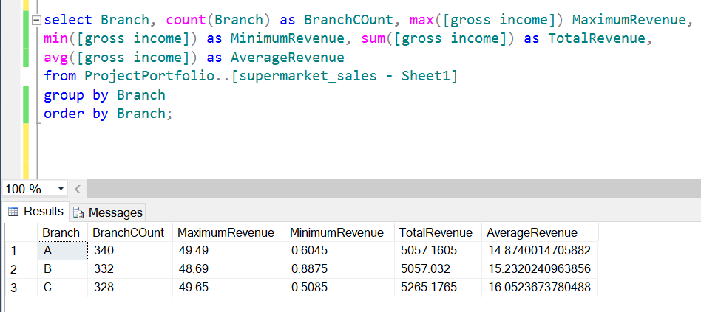  
2. The top-selling product line is “Electronic Accessories” followed by “Food and Beverage”, and “Sport and Travel” while Health and Beauty records the least-selling product line.

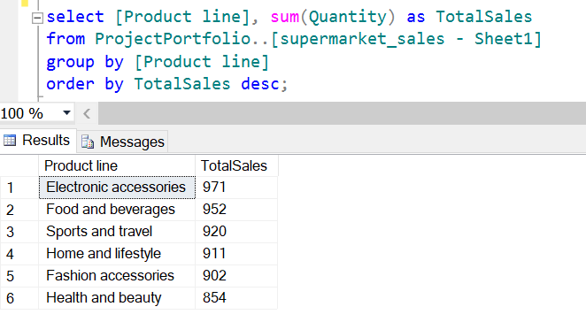

3. Members are fairly more than Normal customers.

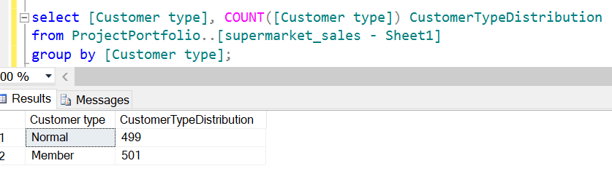

4. The customers prefer mostly E-wallet followed by Cash methods.

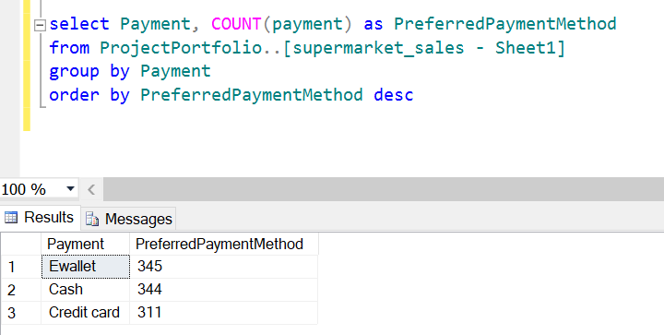  
5. The payment method and the total purchase amount are related with credit card to be the least.

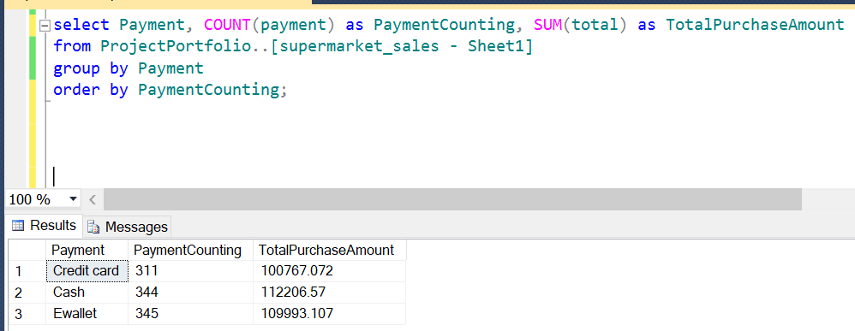

6. The branches are all rated by the customer with 4 as the least and 10 as the highest. But branch C attracts the best rating in average.

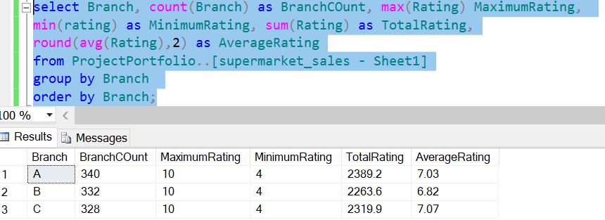

7. Branch B has more of the highest customer rating which shows that it is of utmost satisfaction to the customers compared to other.

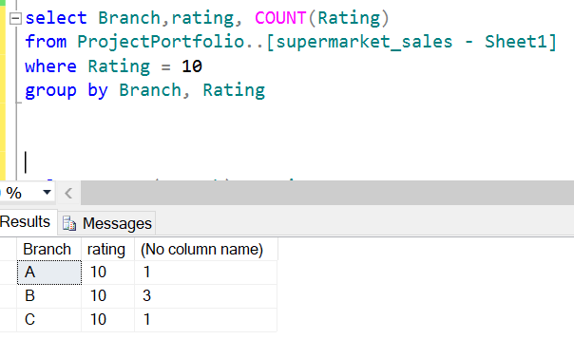  
8. Females are recorded to purchase the most

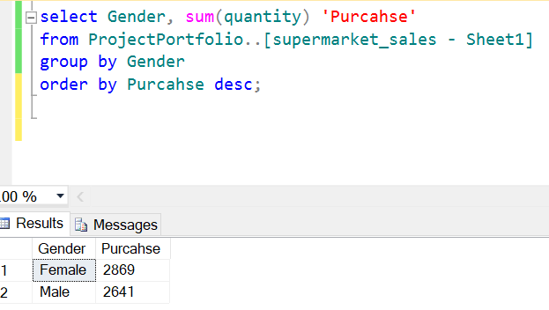

**Conclusion**

From the analysis, the store is encouraged to always make available and focus more on “Electronic accessories” while improving their advertisement “Health and Beauty”.

**The Overall SQL Queries**

select *

from ProjectPortfolio..[supermarket_sales - Sheet1];

select Branch, count(Branch) as BranchCOunt, max([gross income]) MaximumRevenue,

min([gross income]) as MinimumRevenue, sum([gross income]) as TotalRevenue,

avg([gross income]) as AverageRevenue

from ProjectPortfolio..[supermarket_sales - Sheet1]

group by Branch

order by Branch;

select [Product line], sum(Quantity) as TotalSales

from ProjectPortfolio..[supermarket_sales - Sheet1]

group by [Product line]

order by TotalSales desc;

select [Customer type], COUNT([Customer type]) CustomerTypeDistribution

from ProjectPortfolio..[supermarket_sales - Sheet1]

group by [Customer type]

order by CustomerTypeDistribution desc;

select Payment, COUNT(payment) as PreferredPaymentMethod

from ProjectPortfolio..[supermarket_sales - Sheet1]

group by Payment

order by PreferredPaymentMethod desc;

select Payment, COUNT(payment) as PaymentCounting, SUM(total) as TotalPurchaseAmount

from ProjectPortfolio..[supermarket_sales - Sheet1]

group by Payment

order by PaymentCounting;

select Branch, rating, COUNT(Rating) as RatingCount, round(sum(Rating),0) as TotalRating

from ProjectPortfolio..[supermarket_sales - Sheet1]

group by Branch, rating

order by Branch;

select Branch, count(Branch) as BranchCOunt, max(Rating) MaximumRating,

min(rating) as MinimumRating, sum(Rating) as TotalRating,

round(avg(Rating), 2) as AverageRating

from ProjectPortfolio..[supermarket_sales - Sheet1]

group by Branch

order by Branch;

select Branch,rating, COUNT(Rating) as RatingCount

from ProjectPortfolio..[supermarket_sales - Sheet1]

where Rating = 10

group by Branch, Rating

order by RatingCount desc;

select Gender, sum(quantity) 'Purcahse'

from ProjectPortfolio..[supermarket_sales - Sheet1]

group by Gender

order by Purcahse desc;