**Supply Chain Data: Areas for Improvement**

**Introduction:**

A supply chain is a network of individuals and companies who are involved in creating a product and delivering it to the consumer. Links on the chain begins with the producers of the raw materials and end when the van delivers the finished product to the end user.

The objective of this data analysis is to delve into the intricacies of the supply chain processes,  
leveraging data-driven insights to identify potential areas for improvement.

**Business Task**1. Which product types have the highest revenue generation?  
2. What are the lead times for different suppliers?  
3. How do shipping costs vary across different locations?  
4. What are the manufacturing lead times and defect rates for various production volumes?  
5. Can we identify any patterns in customer demographics that influence their buying behavior?  
6. Are there any transportation modes or routes that consistently incur higher costs?

**Project Tool Used:** Tableau

**Visualizations and Results**

1. Skincare has the highest revenue generation while cosmetics generates the lowest revenue.

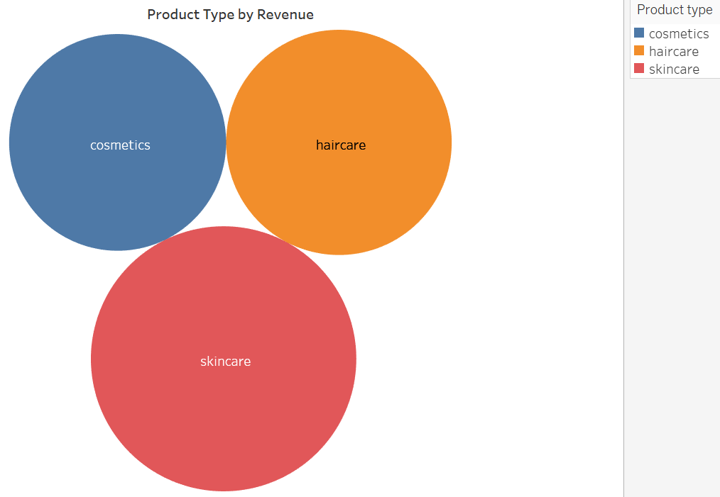

2. The lead time for the different suppliers are shown below.

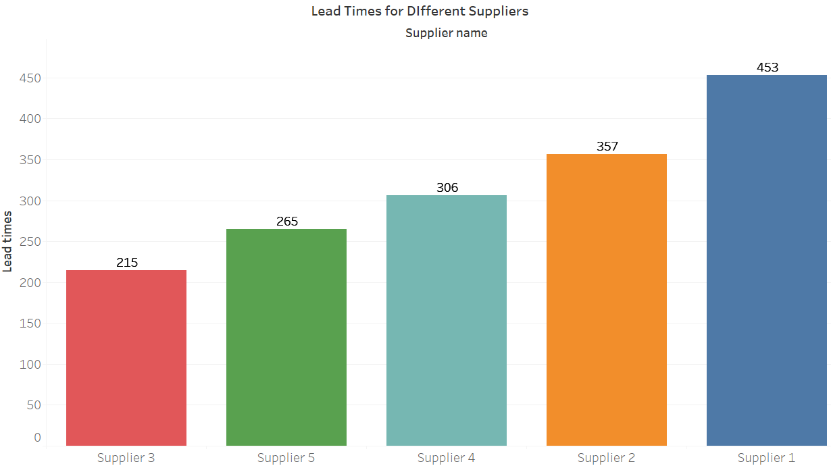

3. Shipping costs is most expensive in Kolkata followed by Mumbai while Delhi is very cheap in shipping.

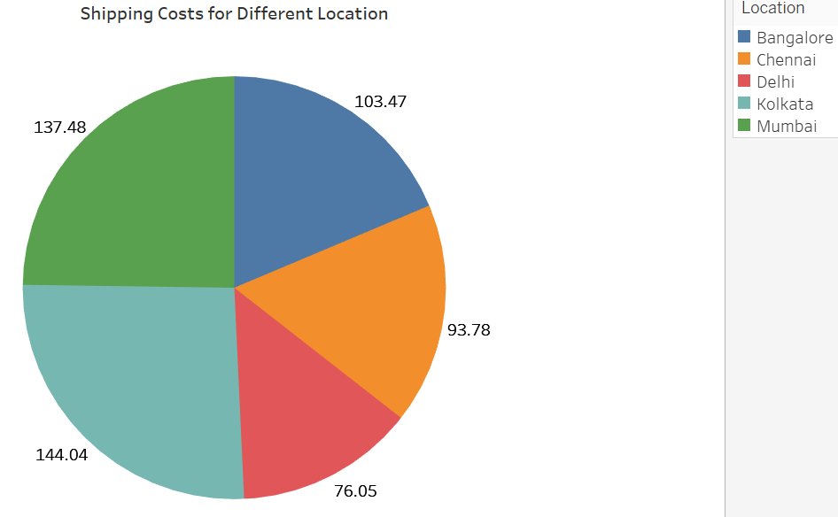

4. Production volumes along their manufacturing lead times and defect rates are shown below.

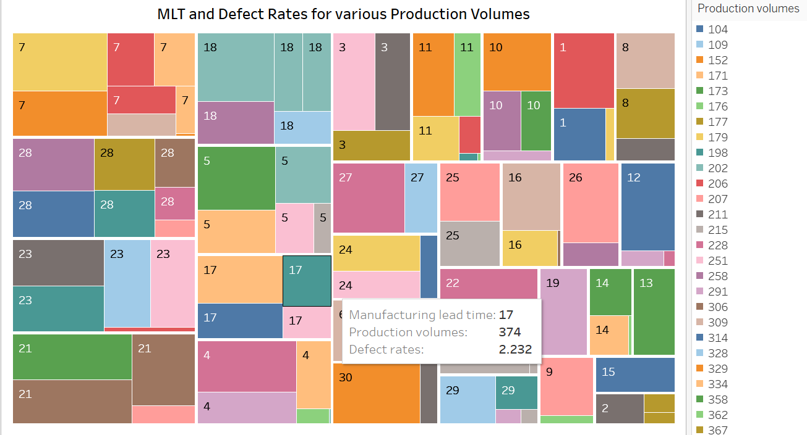

5. As shown below, all the genders tend to buy more when using Route B and buy least with Route C.

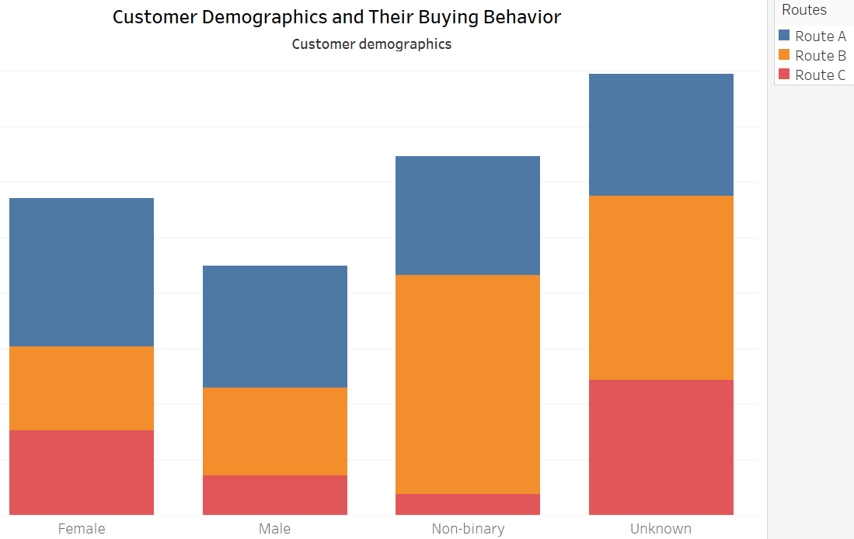

6. Road as a transportation mode tends to consistently incur higher cost.

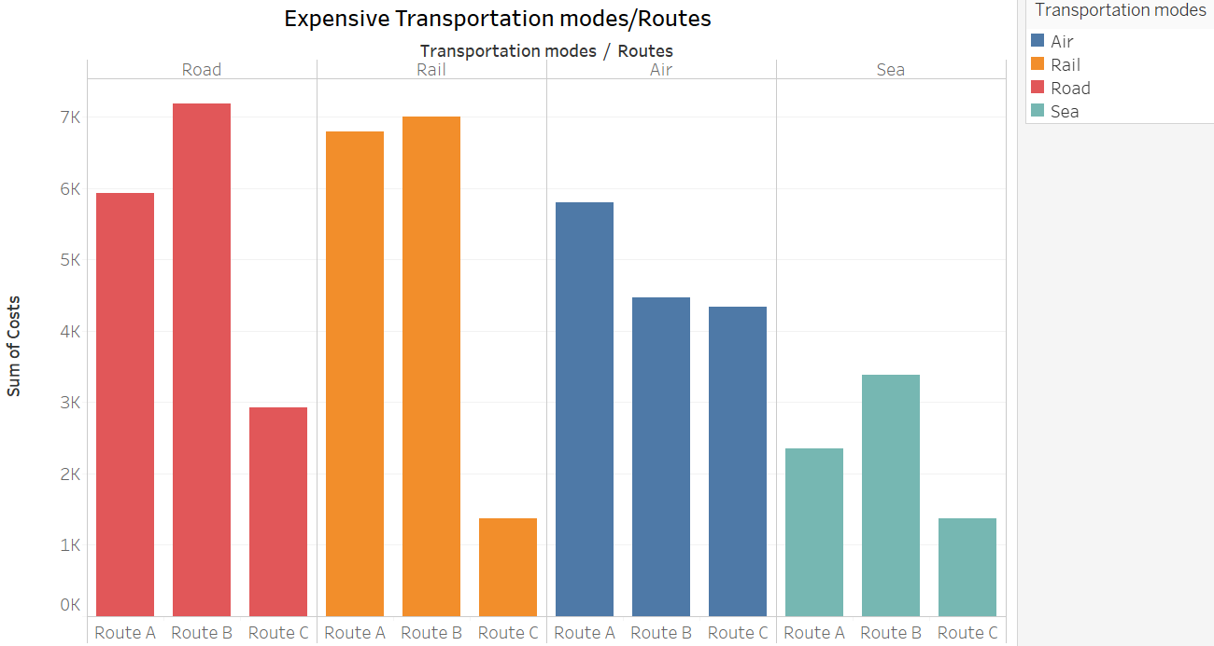

**Conclusion**

From the analysis, skincare is found to be the best product with highest revenue generation while road as a route incurs frequent higher cost. Also, supplier 1 has the highest lead time followed by supplier 2 while supplier 3 performs poorest. The supply chain is therefore encouraged to concentrate more on skincare and route B; and improve its road transportation to reduce cost while promoting cosmetics product through advertisement. There is also need for improvement on supplier 3 and route C along with sea transportation mode generally.

**Dashboard**

