C

C

COMP4 Computing Coursework

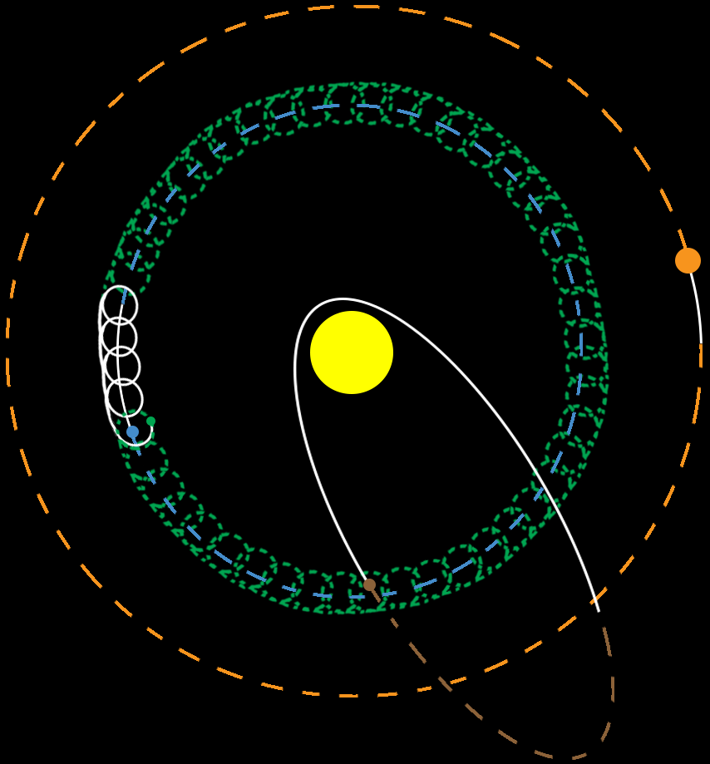

“GravitPY”

Declan Thomas