Supplemental Information
A Transferable Computational Framework for Modeling and Tuning Biomimetic Catalysis
Thomas Quaid¹, Cooper Citek², John F. Hartwig^{2,3}, Douglas S. Clark^{1,4*}
¹Department of Chemical and Biomolecular Engineering, University of California, Berkeley, California, 94720, United States
²Chemical Sciences Division, Lawrence Berkeley National Laboratory, Berkeley, California, 94720, United States
³College of Chemistry, University of California, Berkeley, California, 94720, United States
⁴Molecular Biophysics and Integrated Bioimaging Division, Lawrence Berkeley National Laboratory, Berkeley, California, 94720, United States

*To whom correspondence should be addressed (dsc@berkeley.edu)

TABLE OF CONTENTS
EXPERIMENTAL PROCEDURES 2
QUANTUM MECHANICS COMPUTATIONAL PROCEDURE 4
pH CORRECTION OF RATE CONSTANTS 6
KINETIC ASSAYS 8
MATHEMATICAL TREATMENT OF THE Zn-METHYLIMIDAZOLE SPECIATION KINETIC MODEL 16
Stage 1: Thermodynamic Speciation and Inner-Sphere Rate 17
Stage 2: Initial-Rate Product Inhibition and Tetrakis Damping 19
$Φ$ Correction Factors 20
Reproducibility Procedure 20
DATA AVAILABILITY 21
SUPPLEMENTARY REFERENCES 22

EXPERIMENTAL PROCEDURES
The catalytic rate constants for the hydration of CO₂ by Zn-ligand complexes were measured by stopped-flow absorption spectroscopy following a general procedure previously described ^{16,31}. All stopped-flow mixing and optical monitoring experiments were performed with a BioLogic μSFM mixer utilizing 500 μL Hamilton gas-tight syringes and an MOS-200/M spectrometer fitted with a 0.8 mm pathlength cuvette. All chemicals were purchased from commercial sources and used without further purification. Buffered solutions were prepared with 0.1 M AMPSO, 0.2 M NaClO₄, and 2.5 x 10 ⁻⁵ M thymol blue indicator. The pH of the buffered solution was adjusted to pH = 9.0 as measured by an Extech PH220 pH meter by addition of concentrated aliquots of aqueous sodium hydroxide. This indicator concentration is 5x that of the concentration utilized by Koziel et al. to achieve sufficient signal with a 0.8-mm optical pathlength. Further details are available in the Supplemental Information.

Prior to experiments, portions of the buffered indicator solution were degassed by several cycles of evacuation followed by bubbling with N₂ gas. A separate portion of deionized water was continuously sparged with CO₂ gas through a fine metal frit for at least 30 minutes to give an assumed CO₂ concentration of 33.8 mM in water at standard conditions. Zinc-ligand complexes of differing stoichiometries were prepared daily as-needed by adding the appropriate ratios of solutions of 1 M zinc perchlorate hexahydrate (Zn(ClO₄ ) 2 ∙6H₂O in degassed, deonized water and 0.1 M ligand dissolved in the degassed buffered indicator solution to an additional aliquot of buffered solution to yield a total volume of 1 mL and final zinc concentration of 1 mM. This procedure was adopted to avoid precipitation of zinc perchlorate or zinc-ligand complexes from the buffered solution at higher concentrations (≈ 1M). Portions of the 1 mM zinc solution were further diluted with additional buffered solution to give solutions with final zinc concentrations of 0.5 mM and 0.25 mM.

The buffer Q factor for the degassed buffered indicator solution in the μSFM (0.8 mm cuvette) was determined by rapid 1:1 mixing with aqueous HCl solutions at several concentrations (0 M, 0.005 M, 0.015 M, 0.025 M, 0.035 M, and 0.040 M) with monitoring the change in absorption relative to a water blank at 596 nm. The changes in absorption were plotted against the HCl titrant concentration, giving a linear response across the concentrations (R² = 0.99), and Q was taken to be the inverse of the slope of the line (Q = -0.410).

The solutions of zinc-ligand complexes were again sparged with N₂ gas for several minutes before being taken up into the gas-tight syringes and loaded into the μSFM, along with the saturated aqueous CO₂ solution. The stopped flow mixer was programmed to mix 25 μL each of the zinc and CO₂ solutions at a 0.50 mL/s rate in a 1:1 ratio. Monitoring of the change in absorption at 596 nm was programmed to begin 10 ms before the hard stop of the stopped-flow mixer engaged. The hard stop was left closed between experimental “shots.” Before each run of multiple shots, the cuvette was flushed with a portion of CO₂ solution and a baseline “blank” detector voltage was found. Shots were replicated 5 times per zinc concentration at each ligand stoichiometry. Individual kinetic traces with clear discontinuities in the data or distinct deviation from the smooth decay function of the other replicate traces were discarded. Kinetic monitoring was continued for at least 100 s, with one data point per 0.001 s for the first 6001 points followed by one data point per 0.02 s.

QUANTUM MECHANICS COMPUTATIONAL Procedure
All computations follow the same prescribed procedure and methods unless otherwise stated. A visual representation of the procedure is offered in Figure S1. The outline follows that a target molecule was built in Avogadro2 [1] based on fundamental chemical intuition for baseline geometry. A semi-empirical optimization was performed on the structure using XTB [2] in the Avogadro program. The optimized structure underwent a CREST [3] conformational search utilizing the GFN2-xTB –gfnff keywords. The lowest energy conformer was subjected to a geometrical optimization in ORCA 5 [4], [5] with the B3LYP functional and def2-SVP basis set with solvation parameters of CPCM for water and D4 corrections. The resulting geometry was again optimized with B3LYP and the more rigorous def2-TZVPP basis set while still applying the CPCM(water) and D4 keywords. A vibrational frequency analysis was included with this optimization to ensure a single imaginary frequency existed. Next a single point energy calculation utilizing DLPNO-CCSD(T) wavefunction and Def2-TZVPP basis set still applying the CPCM(water) keyword was performed.

Figure S1: Quantum mechanics computational procedure for generating database of molecules. The procedure involves XTB optimization, Crest conformational search, multiple theory levels of geometry optimization, frequency calculations, WFT single point energy analysis, and standard property calculations for bicarbonate binding energy to Zn(II) ligand in this order.
The outlined procedure was performed for a Zn(II)-Ligand, Zn(II)-Ligand bound bicarbonate, and a single bicarbonate molecule for each studied ligand. The results of the DFT thermodynamic corrections and WFT energies were used to compute the binding energy of bicarbonate to Zn(II) through equation S1. Where $E_{binding}$ is the binding energy of bicarbonate to the Zn(II) ligand catalyst and each energy has undergone frequency calculations to account for thermodynamic corrections.

S1. $E_{binding}=E_{Zn\left(II\right)ligand}+E_{HCO3^{-}}-E_{Zn\left(II\right)ligand-HCO3^{-}}$
Table S1: Comparison of ten DFT procedures (Trials 1–10) for predicting catalyst–substrate binding energies. Each procedure varies in functional, basis set, dispersion correction, and solvation model. Performance metrics include the coefficient of determination (R²) and root mean square error (RMSE) from linear regression of computed binding energies $(ΔE_{bind})$ against experimental ln(k) values and R² for k values. Computational efficiency is represented by the wall-clock time for single-point energy calculations. Trial 5 (B3LYP/def2-TZVPP with D4 dispersion and CPCM solvation) was selected for subsequent studies due to its optimal balance of accuracy, robustness, and computational cost despite similar scorings from cheaper methods with the goal of expanding the modeled systems to more complex intra and intermolecular forces through directed design of ligands and multi-speciation systems.

Functional | Basis Set | Dispersion  correction | Solvation CPCM(Water) | Time (s) | R² | R² ln(k) | RMSE ln(k)
B3LYP | def2-svp | - | Yes | 43 | 0.88 | 0.71 | 0.77
B3LYP | def2-svp | D3BJ | Yes | 44 | 0.80 | 0.60 | 0.89
B3LYP | def2-tzvp | D3BJ | Yes | 55 | 0.88 | 0.67 | 0.81
B3LYP | def2-tzvpp | D3BJ | Yes | 66 | 0.88 | 0.67 | 0.81
B3LYP | def2-tzvpp | D4 | Yes | 66 | 0.86 | 0.70 | 0.77
PBE0 | def2-tzvpp | D4 | Yes | 66 | 0.37 | 0.05 | 0.81
M06-2x | def2-tzvp | - | - | 98 | 0.18 | 0.60 | 0.89
wB97X | def2-tzvpp | D4 | Yes | 98 | 0.86 | 0.64 | 0.85
wB97X | def2-tzvpp | D4 | - | 103 | 0.14 | 0.52 | 0.98
M06-2x | def2-tzvpp | - | Yes | 156 | 0.82 | 0.67 | 1.37

pH CORRECTION OF rate constants
Quantum mechanical computations are unable to account for pH of a system in a straightforward manner as they are limited to gas phase, implicit solvation, or small-scale explicit solvation techniques. Because of this limitation the microkinetic models are translated to intrinsic kinetic constants rather than observed experimental constants. The output of computations assumes the entirety of catalysts in solution is activated. The speciation of catalysts in solution is described as a function of the catalyst’s pKa and pH of the solution through equation S2 as effectively applied for zinc-ligand systems by Koziol et al [6]:

S2. $k_{intrinsic}=k_{observed}(1+{10}^{pKa-pH})$
where $k_{intrinsic}$ is the intrinsic rate constant, $k_{observed}$ is the experimentally observed rate constant at a given pH and 25°C. This method has been applied to all predicted $k_{intrinsic}$ values when direct comparison to experiments is necessary.

Determining the pKa of each modeled ligand requires an efficient predictive method outside of the time requirements and precipitation issues of experimental analysis. A series of papers have been dedicated to the effort of producing such a method from ab initio procedures specifically with DFT [7]. Harding et al [7], [8] found an effective method for such predictions involving the association of calculated bond length and pKa with reported root-mean-square errors of about 0.4−0.8 pKa units. This method has been successfully applied to zinc-ligand systems involved in the hydration of $CO_{2}$ by several authors since. For example, Ma et al [9] found that among a variety of tested bond lengths the zinc-$OH^{-}$ bond length best predicted pKa values with an $R^{2}$ of 0.97, which also produced higher accuracy than thermocycle DFT predictions [6]. This method was extended in this study to include 8 literature pKa datapoints that span tri, tetra, macrocyclic, and scorpionate type ligands, whose predicted bond lengths were correlated to experimental literature pKa values available in table S1. The $R^{2}$ value of this expanded set between experimental and predicted pKa is reduced to 0.83 but results in a more generalized model.

Table S2: Calculated bond lengths for eight ligands to be fit with experimental pKa for linear predictive equation. Nomenclature per ligand adopted from source article. $R^{2}$ value for experimental vs. literature is 0.83.
Ligand | Bond Length (Zn-O) (Å) | experimental pKa | predicted pKa | Source
[14]aneN4 | 1.94 | 9.8 | 9.6 | [10]
M2 | 1.93 | 8.6 | 9.2 | [6]
[12]aneN4 | 1.88 | 7.9 | 7.0 | [10], [11]
[12]aneN3 | 1.88 | 7.3 | 7.0 | [11], [12]
M5 | 1.86 | 5.6 | 6.1 | [6]
CR | 1.91 | 8.7 | 8.4 | [13]
Zn7 | 1.90 | 7.5 | 8.0 | [14]
Zn8a | 1.87 | 6.7 | 6.7 | [11]

KINETIC ASSays
Equation S3 is used to determine the initial rate of reaction in the catalyst-buffer-${CO}_{2}$ -aqueous system which is assumed to be first order at initial conditions.

S3. $v_{initial}=-\frac{dCO_{2}}{dt}=Q\frac{dA}{dt}$

Where $t$ is time, $v_{initial}$ is the initial rate of disappearance of CO₂ at $t\sim 0$, A is absorbance, the buffer factor (Q) relates change in absorbance to protonation of buffer indicator.
Figure S2 is a representation of the double exponential decay fit applied to a catalytic experimental measurement, which is performed in quadruplet. Following common literature procedures, 10% of the reaction curve is fitted and the derivative at t~0 is taken as the initial rate of reaction. The first 5 data points are regarded as turbulence artifacts and removed from the dataset.

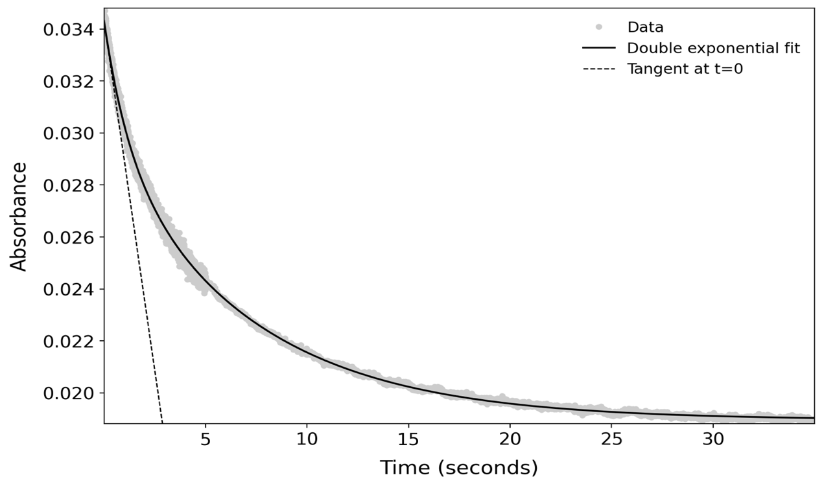
Figure S2, Data output of a single zinc-cyclen stopped flow spectroscopy run with a fitted double exponential line and the initial slope representing the initial rate of reaction.
Due to the sensitivity of the determination of the rate constant to the processing of the spectrographic data, a consistent baseline reaction value of 0.15 +/- 0.4 (measured in this work) was the metric used for affirming the successful evaluation of the data. Figure S3 displays the trendline used to determine the catalytic reaction constant of zinc-cyclen.

Figure S3: 3 datapoints representing the initial rate of reaction adjusted for substrate concentration vs catalyst concentration at measured concentrations of 1, 0.5, and 0.25 mM. The slope of the trendline is equivalent to the intrinsic rate constant of the hydration of CO₂.

Figure S4: Correlation between DFT-optimized Zn–OH bond lengths (Å) and experimental pKₐ values for a benchmark set of macrocyclic Zn complexes. The linear model
(pKa = 43.34·d_{Zn–O} (Å) – 74.42) reproduces literature values with R² = 0.83 and forms the basis for speciation correction in intrinsic rate constant calculations.

Table S3: NBO second-order stabilization energies (ΣE⁽²⁾), changes in Zn Mulliken charge upon bicarbonate coordination (Δq_{Zn}), and percent buried volume differences (Δ%V_{bur}) were computed at the B3LYP-D4/def2-TZVPP level with CPCM(water) solvation. Rate constants (k_{int}) were measured or normalized to matched assay conditions and converted to ln k for regression. For ligands with no detectable activity, a nominal value of k = 10⁻⁶ M⁻¹ s⁻¹ was used to enable continuous modeling. All values correspond to structures optimized in the Zn–OH⁻ state. Descriptor ranges: ΣE⁽²⁾ = 164–198 kcal mol⁻¹, Δq_{Zn} = 1.66–1.77, Δ%V_{bur} = –2.8% to +6.4%.
Ligand | k_{int} (M⁻¹s⁻¹) | ΣE⁽²⁾ (kcal/mol) | q_{Zn} | Δ%V_{bur}
Zn6a | 0 | 187 | 1.69 | 5.14
TPMA | 717 | 188 | 1.68 | 3.37
TPMA2 | 735 | 185 | 1.66 | 2.93
c | 290 | 198 | 1.67 | -2.84
Zn6c | 832 | 164 | 1.77 | 2.94
Zn6b | 0 | 190 | 1.67 | 5.29
M3 | 495 | 189 | 1.67 | 2.09
M1 | 614 | 190 | 1.66 | 3.07
Zn8a | 0 | 172 | 1.76 | 6.43
Zn7 | 392 | 182 | 1.75 | 4.3
e | 240 | 186 | 1.69 | -1.87

Table S4: Mapping of predicted rate constants to CHEMBL compound IDs for the 29 unidentate ligands shown in Figure 4. ΔG_{bind} values were calculated using the protocol previously and converted to intrinsic rate constants using the regression fit from the eleven-ligand training set. Compounds are labeled by bar chart ID (1–29) corresponding to their position in Figure 4 of the main document.
CHEMBL ID# | Bar Chart ID | k_{int} (M⁻¹s⁻¹)
1397797 | 1 | 1030
1230309 | 2 | 743
352185 | 3 | 662
293391 | 4 | 647
64560 | 5 | 625
140037 | 6 | 603
61455 | 7 | 599
363992 | 8 | 595
1789772 | 9 | 594
286232 | 10 | 580
135599 | 11 | 580
134454 | 12 | 557
3260774 | 13 | 549
189750 | 14 | 545
540 | 15 | 537
2324236 | 16 | 471
433637 | 17 | 457
3559405 | 18 | 439
292983 | 19 | 414
292042 | 20 | 373
1896807 | 21 | 339
1232569 | 22 | 338
3144350 | 23 | 316
1256006 | 24 | 313
3230461 | 25 | 212
366968 | 26 | 188
1688968 | 27 | 50
307778 | 28 | 0
360417 | 29 | 0

Table S5. Statistical metrics for determining performance of DFT vs DFT+WFT methods on the 11 data point set from Table S5 as it pertains to usability for screening future candidates. The WFT method achieved significant gains not only in variable accounting but even more so in systematic error. These results suggest a much more robust model for future screenings and database generation for machine learning applications.
Metric | DFT | DFT+WFT | Improvement
R² | 0.80 | 0.90 | +0.10 (+12.5%)
RMSE (M⁻¹s⁻¹) | 133 | 94 | -39 (-29%)
MAE (M⁻¹s⁻¹) | 101 | 67 | -34 (-34%)

Table S6. Structures of 11-ligand set from Figure 2 of manuscript and Table S5 in Supplemental Information.
Name | Structure | Name | Structure | Name | Structure
Zn6a | 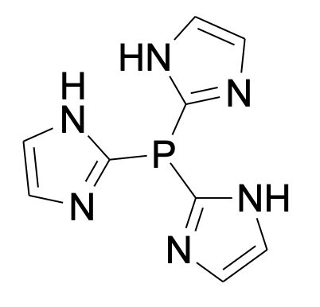 | c | 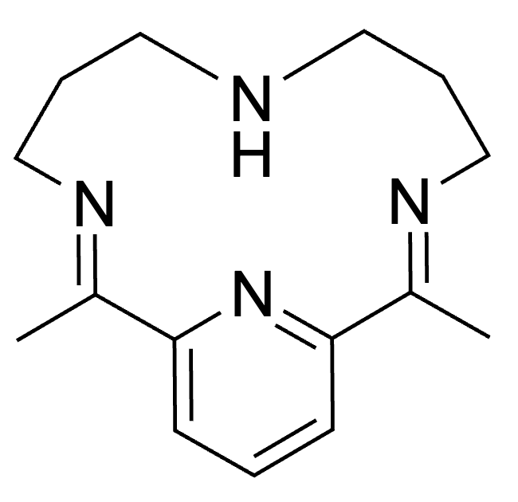 | Zn7 | 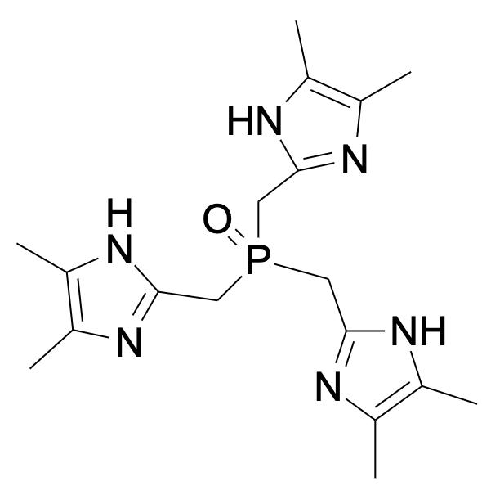
Zn6b | 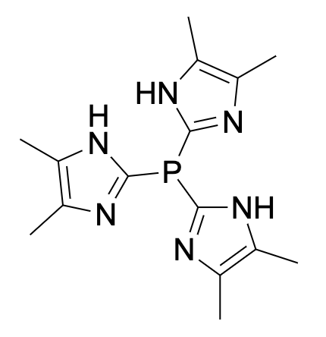 | e | 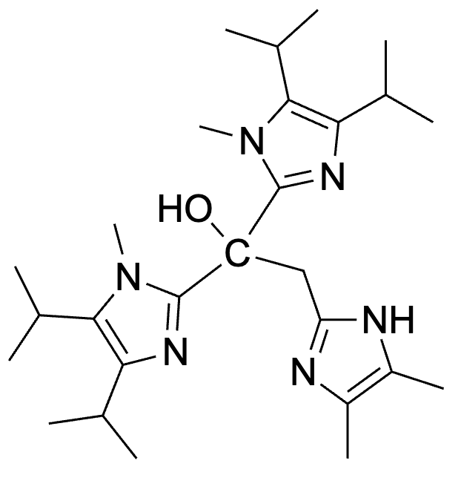 | TPMA | 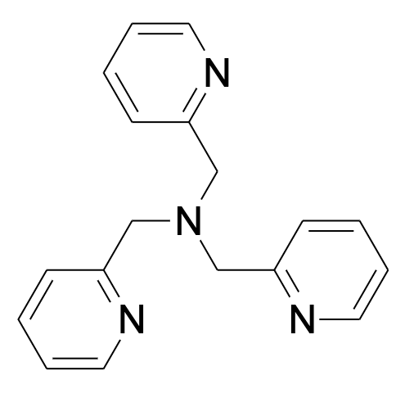
Zn6c | 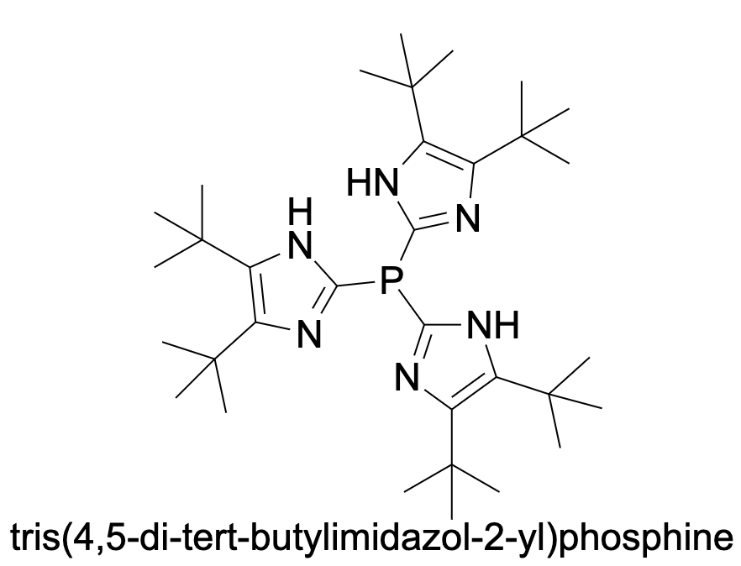 | M1 | 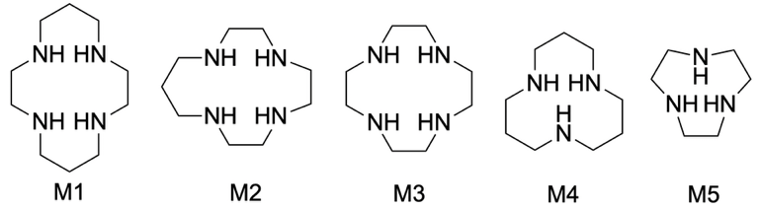 | TPMA2 | 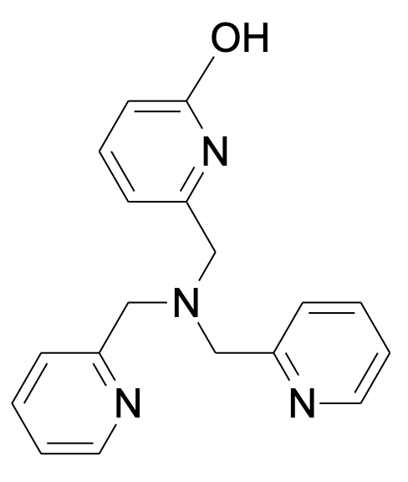
Zn8a | 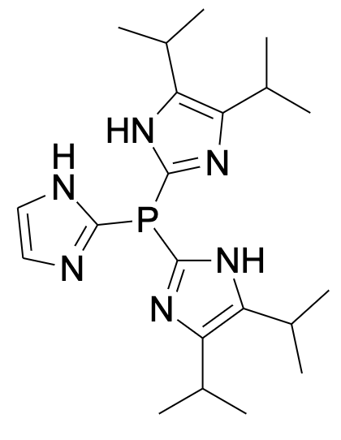 | M3 | 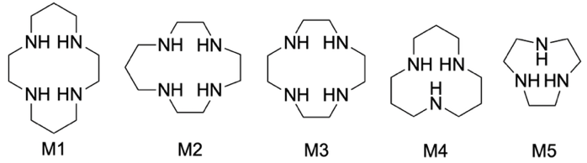
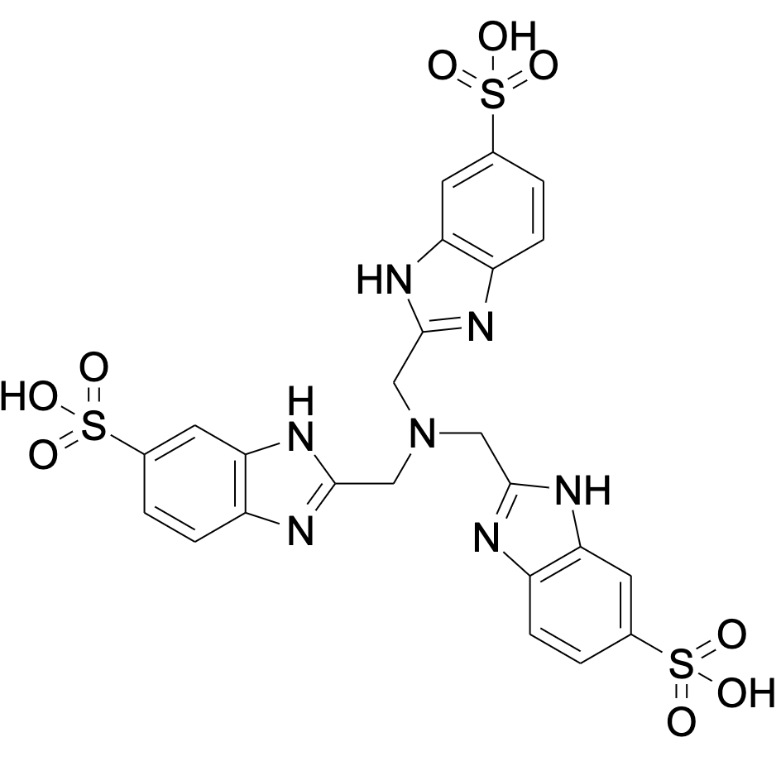
Figure S4. L1S ligand structure.

MATHEMATICAL TREATMENT OF THE Zn-METHYLIMIDAZOLE SPECIATION KINETIC MODEL
CONSTANTS AND NOTATION
The mechanistic model operates at fixed $pH$ and temperature using the equilibrium data compiled by Appleton and Sarkar [18]. Stepwise stability constants $K_{n}$ (base 10 logs reported in the configuration) are converted to cumulative binding constants
S4 $β_{1,0,n}=\prod_{i=1}^{n}{K_{i}} (n=1,…,6).$
The hydrogen-ion activity is $[H^{+}]={10}^{-pH}$. Free ligand is denoted $[L]$ and total metal $[M]_{tot}$. Protonated ligand obeys Henderson–Hasselbalch with $pK_{a}^{LH^{+}}$ and the metal-bound water has acidity $pK_{a}^{M-OH_{2}}$. The hydrolysed tetrakis cumulative constants are $β_{1,-1,4}$ and $β_{1,-2,4}$. The hydroxylation factor for coordinated water is 2.
S5 $θ_{OH}=\frac{{10}^{pH-pK_{a}^{M-OH_{2}}}}{1+{10}^{pH-pK_{a}^{M-OH_{2}}}}.$

Stage 1: Thermodynamic Speciation and Inner-Sphere Rate
For a given composition (total concentrations $[M]_{tot}$ and $[L]_{tot}$) the free ligand $[L]$ is obtained by solving the mass-balance equation:
S6 [L]tot=[L]+[LH+]+i​νi[ZnLi]+4[ZnL4OH]+4[ZnL4(OH)2],
where $ν_{i}=i$ for ${ZnL}_{i}$ and $[LH^{+}]={10}^{pK_{a}^{LH^{+}}-pH}[L]$. A bisection solver brackets the root on $[0,[L]_{tot}]$ and iterates until the residual is below ${10}^{-15}$ M.
The binding polynomial is:
S7 $Q([L],[H^{+}])=1+\sum_{n=1}^{6}{β_{1,0,n}}[L]^{n}+β_{1,-1,4}[L]^{4}[H^{+}]^{-1}+β_{1,-2,4}[L]^{4}[H^{+}]^{-2}.$

Fractional populations of the nine Zn-containing microstates are:
S8
S9
S10
S11
$$\begin{aligned}f_{0}&=Q^{-1}, \\ f_{n}&=β_{1,0,n}[L]^{n}Q^{-1} (n=1,…,6), \\ f_{7}&=β_{1,-1,4}[L]^{4}[H^{+}]^{-1}Q^{-1}, \\ f_{8}&=β_{1,-2,4}[L]^{4}[H^{+}]^{-2}Q^{-1}.\end{aligned}$$
Hydrolysed fractions participating in catalysis are:
S12
S13
S14

$$\begin{aligned}f_{2,OH}&=f_{2}θ_{OH}, \\ f_{3,OH}&=f_{3}θ_{OH}, \\ f_{4,raw}&=f_{7}.\end{aligned}$$
Competition between aquation and tetra-imidazole occupancy is described by
S15
$$α_{aq}(L_{free})=\frac{L_{ref}}{L_{ref}+L_{free}}×\frac{1}{0.5}$$
with $L_{ref}$ specified in the configuration. If the model is operated in penalty-only mode the factor is clipped at unity. The aquated tetrakis fraction becomes:
S16
$$f_{4,eff}=f_{4,raw} α_{aq}(L_{free}).$$
Inner-sphere predicted rate constants are $k_{MA_{2}OH}$, $k_{MA_{3}OH}$ and $k_{MA_{4}OH}$. The Stage 1 (speciation-only) rate constant is the sum of channel contributions:
S17
$$k_{Stage1}=k_{MA_{2}OH}f_{2,OH}+k_{MA_{3}OH}f_{3,OH}+k_{MA_{4}OH}f_{4,raw}.$$
When aquation is enabled the intrinsic (pre-inhibition) rate mixes the aquated tetrakis fraction:
S18

$$k_{inner}=k_{MA_{2}OH}f_{2,OH}+k_{MA_{3}OH}f_{3,OH}+k_{MA_{4}OH}f_{4,eff}.$$
The active fraction that couples to inhibition is
S19

$f_{active}=f_{2,OH}+f_{3,OH}+f_{4,eff}$.

Stage 2: Initial-Rate Product Inhibition and Tetrakis Damping
During the observation window $t_{obs}$ the bicarbonate concentration is partitioned into background buffer and catalytically produced contributions. The time-dependent weighting is:
S20

$$f_{init}=1-e^{-0.12 t_{obs}}.$$
Background bicarbonate $[{HCO}_{3}^{-}]_{eq}$ is computed from the buffer equilibrium; catalytic production is
S21

$$[{HCO}_{3}^{-}]_{prod}=k_{inner}[M]_{tot}[{CO}_{2}]t_{obs}.$$
The effective inhibitor seen by the active fraction is:
S22

$$[{HCO}_{3}^{-}]_{eff}=f_{active}\left(f_{init}[{HCO}_{3}^{-}]_{eq}+[{HCO}_{3}^{-}]_{prod}\right).$$
With an inhibition constant $K_{I}$ the denominator entering each channel is:
S23

$$D=1+K_{I}[{HCO}_{3}^{-}]_{eff}.$$
Per-channel suppressed contributions become:

$$\begin{aligned}{\tilde{k}}_{2}&=\frac{k_{MA_{2}OH}f_{2,OH}}{D}, \\ {\tilde{k}}_{3}&=\frac{k_{MA_{3}OH}f_{3,OH}}{D}, \\ {\tilde{k}}_{4}&=\frac{k_{MA_{4}OH}f_{4,eff}}{D}.\end{aligned}$$
High-ligand suppression of the tetrakis channel is captured by a logistic damping factor:
S26

S23

S24

S25

$$C(L_{free})=\frac{1}{1+{\left(\frac{L_{free}}{L_{c}}\right)}^{m}}$$
where $(L_{c},m)$ are obtained either from the configuration or by golden-section fitting to the tail data. The Stage 2 rate constant is:
S27

$$k_{Stage2}={\tilde{k}}_{2}+{\tilde{k}}_{3}+C(L_{free}) {\tilde{k}}_{4}.$$

$Φ$ Correction Factors
The mechanistic suppression applied to intrinsic rates is recorded in $Φ$ tables. Two correction factors are reported:
S27

S28

$$\begin{aligned}Φ_{Stage1}&=\frac{k_{Stage1}}{k_{inner}} \\ Φ&=\frac{k_{Stage3}}{k_{inner}}\end{aligned}$$
The first measures the effect of replacing the aquated tetrakis population with the raw hydrolysed fraction; the second is the net damping and inhibition applied to the intrinsic inner-sphere kinetics. Multiplying any intrinsic prediction by the appropriate $Φ$ reproduces the stage-specific rate constants tabulated in the script outputs.

Reproducibility Procedure
- Supply the experimental conditions (target $pH$, metal and ligand totals, buffer parameters) in the configuration of Speciation_comprehensive.py.
- For each composition, solve the mass-balance equation for $[L]$, evaluate $Q$, and compute the fractions $f_{i}$.
- Form $f_{2,OH}$, $f_{3,OH}$, and $f_{4,eff}$ using $θ_{OH}$ and $α_{aq}$, then evaluate Eqs. S17 and S18.
- Compute the bicarbonate terms and denominator $D$; evaluate Eq. S27 with the fitted $C(L_{free})$ to obtain the Stage 2 rate.
- Record $Φ$ and $Φ_{Stage1}$ for each ratio using the formulas above.
These steps regenerate the CSV files prediction_summary_by_ratio.csv, phi_correction.csv, and the stage tables distributed with the repository. All expressions are analytic and require only standard numerical root finding for $[L]$.

DATA AVAILABILITY
All mentioned scripts and scripts not mentioned that are used to carry out equations are available at https://github.com/quaidtUC

SUPPLEMENTARY REFERENCES

[1] M. D. Hanwell, D. E. Curtis, D. C. Lonie, T. Vandermeersch, E. Zurek, and G. R. Hutchison, “Avogadro: an advanced semantic chemical editor, visualization, and analysis platform,” J. Cheminformatics, vol. 4, no. 1, p. 17, Aug. 2012, doi: 10.1186/1758-2946-4-17.
[2] “GFN2-xTB—An Accurate and Broadly Parametrized Self-Consistent Tight-Binding Quantum Chemical Method with Multipole Electrostatics and Density-Dependent Dispersion Contributions | Journal of Chemical Theory and Computation.” Accessed: May 09, 2025. [Online]. Available: https://pubs.acs.org/doi/10.1021/acs.jctc.8b01176
[3] P. Pracht et al., “CREST—A program for the exploration of low-energy molecular chemical space,” J. Chem. Phys., vol. 160, no. 11, p. 114110, Mar. 2024, doi: 10.1063/5.0197592.
[4] F. Neese, “Software update: the ORCA program system, version 5.0,” WIRES Comput. Molec. Sci., vol. 12, no. 1. p. e1606, 2022. doi: 10.1002/wcms.1606.
[5] F. Neese, F. Wennmohs, U. Becker, and C. Riplinger, “The ORCA quantum chemistry program package,” J. Chem. Phys., vol. 152. p. Art. No. L224108, 2020. doi: 10.1063/5.0004608.
[6] L. Koziol et al., “Toward a Small Molecule, Biomimetic Carbonic Anhydrase Model: Theoretical and Experimental Investigations of a Panel of Zinc(II) Aza-Macrocyclic Catalysts,” Inorg. Chem., vol. 51, no. 12, pp. 6803–6812, June 2012, doi: 10.1021/ic300526b.
[7] A. P. Harding and P. L. A. Popelier, “pKa prediction from an ab initio bond length: Part 3—benzoic acids and anilines,” Phys. Chem. Chem. Phys., vol. 13, no. 23, pp. 11283–11293, May 2011, doi: 10.1039/C1CP20380K.
[8] A. P. Harding and P. L. A. Popelier, “pKa Prediction from an ab initio bond length: part 2—phenols,” Phys. Chem. Chem. Phys., vol. 13, no. 23, pp. 11264–11282, May 2011, doi: 10.1039/C1CP20379G.
[9] R. Ma, G. F. Schuette, and L. J. Broadbelt, “Microkinetic modeling of CO2 hydrolysis over Zn-(1,4,7,10-tetraazacyclododecane) catalyst based on first principles: Revelation of rate-determining step,” J. Catal., vol. 317, pp. 176–184, Aug. 2014, doi: 10.1016/j.jcat.2014.06.001.
[10] E. Kimura, T. Shiota, T. Koike, M. Shiro, and M. Kodama, “A zinc(II) complex of 1,5,9-triazacyclododecane ([12]aneN3) as a model for carbonic anhydrase,” J. Am. Chem. Soc., vol. 112, no. 15, pp. 5805–5811, July 1990, doi: 10.1021/ja00171a020.
[11] X. Zhang and R. van Eldik, “A functional model for carbonic anhydrase: thermodynamic and kinetic study of a tetraazacyclododecane complex of zinc(II),” Inorg. Chem., vol. 34, no. 22, pp. 5606–5614, Oct. 1995, doi: 10.1021/ic00126a034.
[12] X. Zhang, R. van Eldik, T. Koike, and E. Kimura, “Kinetics and mechanism of the hydration of carbon dioxide and dehydration of bicarbonate catalyzed by a zinc (II) complex of 1,5,9-triazacyclododecane as a model for carbonic anhydrase,” Inorg. Chem., vol. 32, no. 25, pp. 5749–5755, Dec. 1993, doi: 10.1021/ic00077a017.
[13] P. Woolley, “Models for metal ion function in carbonic anhydrase,” Nature, vol. 258, no. 5537, pp. 677–682, Dec. 1975, doi: 10.1038/258677a0.
[14] R. S. Brown, D. Salmon, N. J. Curtis, and S. Kusuma, “Carbonic anhydrase models. 4. [Tris[(4,5-dimethyl-2-imidazolyl)methyl]phosphine oxide]cobalt(2+), a small-molecule mimic of the spectroscopic properties of cobalt(II) carbonic anhydrase,” J. Am. Chem. Soc., vol. 104, no. 11, pp. 3188–3194, June 1982, doi: 10.1021/ja00375a043.
[15] R. Ma, G. F. Schuette, and L. J. Broadbelt, “Catalyst Screening through Quantum Chemical Calculations and Microkinetic Modeling: Hydrolysis of Carbon Dioxide,” Theor. Found. Chem. Eng., vol. 51, no. 6, pp. 949–960, Nov. 2017, doi: 10.1134/S0040579517060124.
[16] J. H. Satcher et al., “Modeling, synthesis and characterization of zinc containing carbonic anhydrase active site mimics,” Energy Procedia, vol. 4, pp. 2090–2095, Jan. 2011, doi: 10.1016/j.egypro.2011.02.092.
[17] D. Park and M. S. Lee, “Kinetic Study of CO2 Hydration by Small-Molecule Catalysts with A Second Coordination Sphere that Mimic the Effect of the Thr-199 Residue of Carbonic Anhydrase,” Biomimetics, vol. 4, no. 4, Art. no. 4, Dec. 2019, doi: 10.3390/biomimetics4040066.
[18] D. W. Appleton and B. Sarkar, “The activity-related ionization in carbonic anhydrase,” Proc. Natl. Acad. Sci. U. S. A., vol. 71, no. 5, pp. 1686–1690, May 1974, doi: 10.1073/pnas.71.5.1686.

