PEOPLEOPS ASSISTANT
Demo presentation script
Two agentic tasks, fully traceable
2  end-to-end agentic tasks | 8  MCP operations per final task | 6  exact retrieved citations
Target run time: 9 minutes 10 seconds
Prepared from the live deployed system, GitHub Actions evidence, and Phase 10 evaluation results. All employee data is synthetic. The script explains auditable operational reasoning—tool calls and evidence—not hidden chain-of-thought.

PRESENTER SETUP
Requirement coverage and run of show
Requirement | Where shown | Evidence | Presenter check
Two agentic tasks end to end | Slides 3–8 | Remote-work eligibility and PTO balance + draft | Yes
Tool names, arguments, outputs | Slides 4–5, 7–8 | Visible MCP trace, sanitized arguments, result summaries | Yes
Retrieved citations | Slides 3, 5, 6 | INT-5, INT-13, RWK-5, SEC-8, PTO-6, PTO-7 | Yes
Final answer or action | Slides 3, 6, 8 | Conditional guidance; reviewable draft, not sent or saved | Yes
Design walkthrough | Slide 2 | Browser → FastAPI → orchestrator → MCP → evidence stores | Yes
Deployment and CI/CD | Slide 9 | Healthy runtime; CI #39; hosted smoke #36; release ac6bed0 | Yes
Evaluation results | Slide 10 | 25/25 gold cases; required metrics and safety gates at 100% | Yes
Run of show
0:00–1:25 | 1:25–4:25 | 4:25–7:15 | 7:15–8:05 | 8:05–8:50 | 8:50–9:10
Opening + design | Task 1 | Task 2 | Deployment + CI/CD | Evaluation | Close

SLIDE 1 · 0:00–0:40
Two agentic tasks, fully traceable
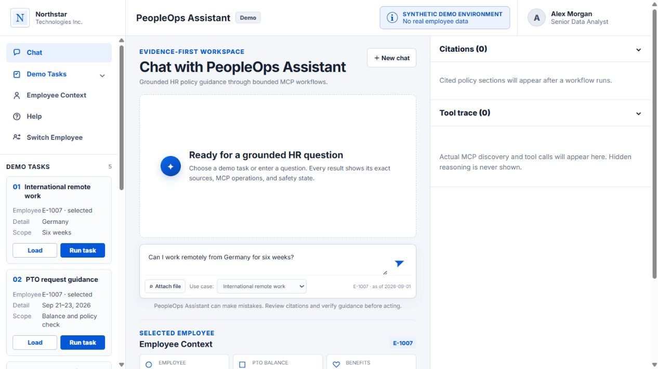  On-screen evidence · 01_workspace_ready.png | SCREEN ACTION  Open the deployed app on the prepared workspace. Keep the task rail, answer area, citations panel, and tool trace visible.  SAY  Today I’ll show two agentic PeopleOps tasks end to end. For each one, I’ll expose the MCP tool names, sanitized arguments, outputs, retrieved policy citations, and the final answer or action. This is a synthetic demo: no production employee records are involved.  MCP PROOF TO POINT AT  - The interface reserves visible regions for citations and the MCP trace.  - The demo starts from a clean, ready state.  TRANSITION  First, a 45-second design walkthrough explains why those traces are trustworthy.

SLIDE 2 · 0:40–1:25
The agent plans; MCP performs every evidence operation
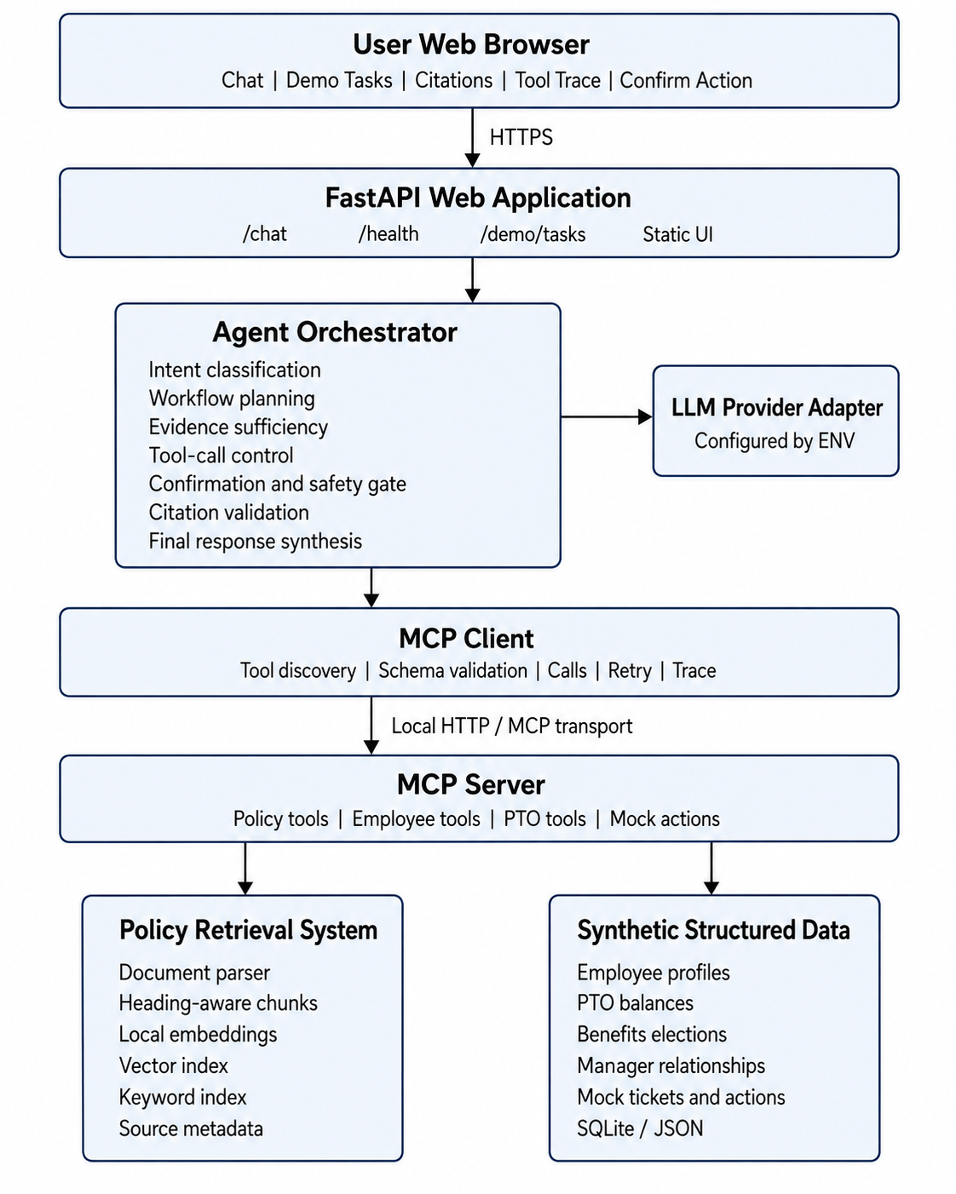  On-screen evidence · architecture.png | SCREEN ACTION  Point left-to-right across the architecture diagram from the browser to the evidence stores.  SAY  The browser calls FastAPI, which routes intent into a bounded workflow. The orchestrator uses the MCP client to discover and call typed tools. MCP is the evidence boundary for synthetic employee data, policy retrieval, exact-section lookup, compliance checks, and draft creation. Only after structured results and exact citations validate does the system synthesize the user-facing response.  MCP PROOF TO POINT AT  - Discovery and tool schemas come through MCP.  - The displayed trace exposes operational reasoning without revealing hidden chain-of-thought.  - A deterministic verified fallback remains available when provider output is unavailable or fails grounding checks.  TRANSITION  Now I’ll run the first task: international remote work.

SLIDE 3 · 1:25–2:40
Task 1 returns conditional eligibility, not an invented approval
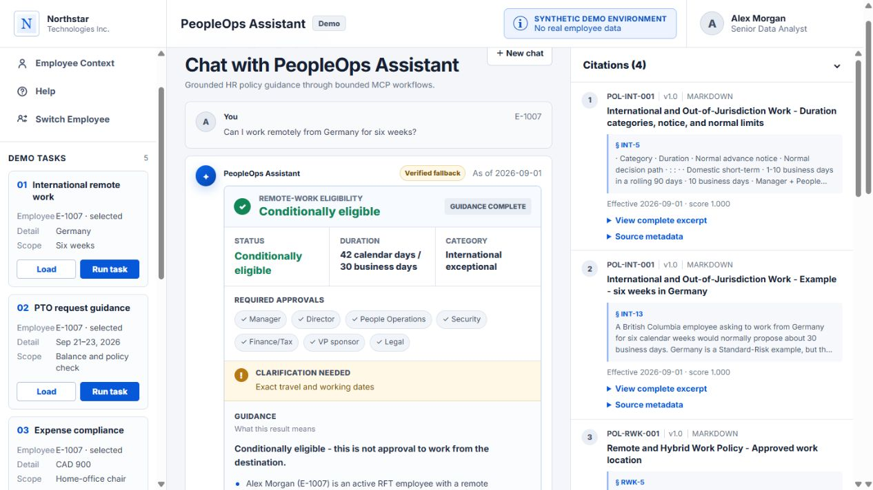  On-screen evidence · 02_remote_work_result.png | SCREEN ACTION  Load employee E-1007, run ‘Can I work remotely from Germany for six weeks?’, then point to the status, required approvals, clarification, and citations.  SAY  The result is conditionally eligible—not approved. Six weeks resolves to 42 calendar days or 30 business days, classified as international exceptional. The answer names the required reviewers: manager, director, People Operations, Security, Finance or Tax, VP sponsor, and Legal. It also asks for exact travel dates and states the 30-business-day notice requirement.  MCP PROOF TO POINT AT  - Final status: completed; outcome: conditional.  - Workflow: remote_work.  - Retrieved citations: POL-INT-001/INT-5, INT-13, POL-RWK-001/RWK-5, POL-SEC-001/SEC-8.  TRANSITION  Next I’ll expand the trace and explain exactly how MCP produced that answer.

SLIDE 4 · 2:40–3:40
Eight MCP operations form a visible evidence chain
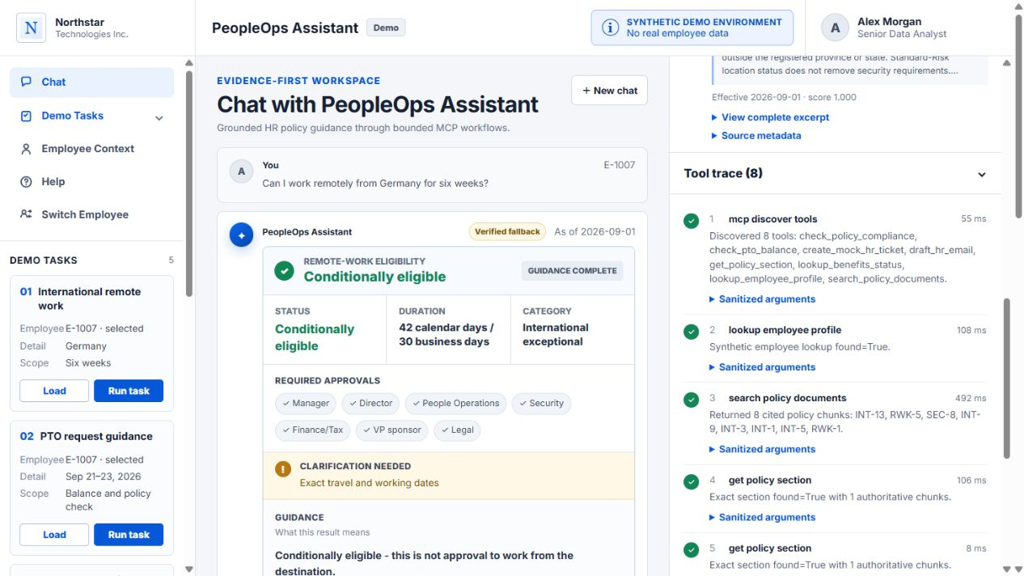  On-screen evidence · 04_remote_work_tool_trace.png | SCREEN ACTION  Scroll through all eight trace entries and point to success state, duration, result summary, and the sanitized-arguments disclosure.  SAY  The workflow begins with mcp_discover_tools and finds eight callable tools. lookup_employee_profile confirms the selected synthetic employee. search_policy_documents returns eight ranked policy chunks. Four get_policy_section calls replace fuzzy matches with exact authoritative sections. Finally, check_policy_compliance returns conditionally_eligible and international_exceptional.  MCP PROOF TO POINT AT  - 1: mcp_discover_tools → 8 tools.  - 2: lookup_employee_profile → employee found.  - 3: search_policy_documents → 8 ranked chunks.  - 4–7: get_policy_section → one authoritative chunk each.  - 8: check_policy_compliance → conditional result.  TRANSITION  The next slide ties those calls to their arguments and exact citations.

SLIDE 5 · 3:40–4:25
Arguments bind the decision to one employee, destination, and duration
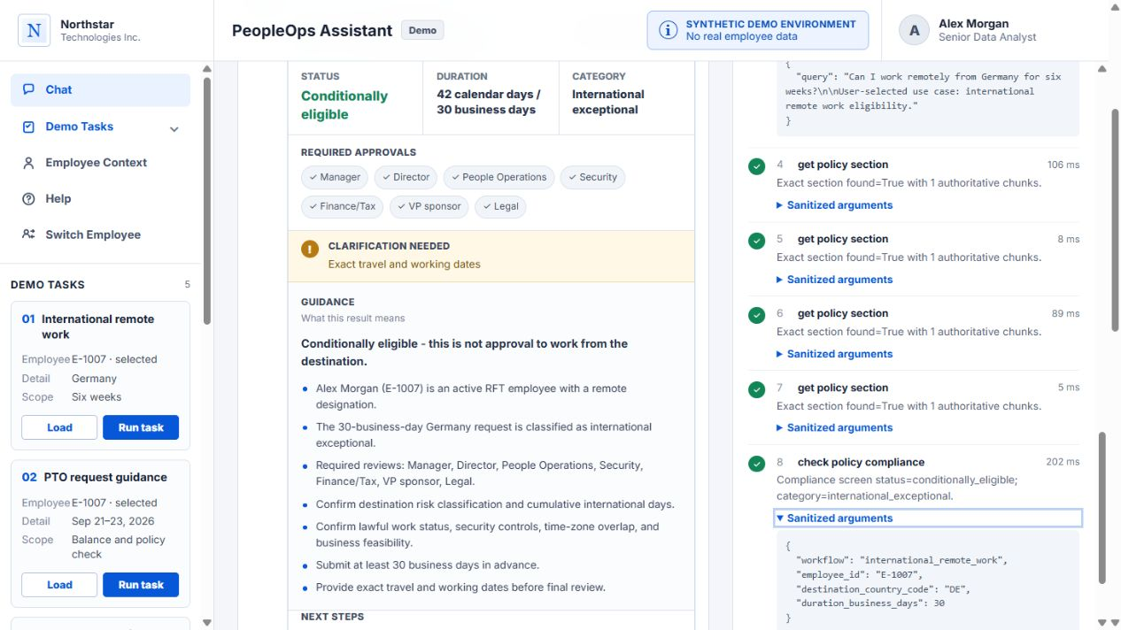  On-screen evidence · 06_remote_work_compliance.png | SCREEN ACTION  Expand the employee lookup, policy search, and compliance argument panels. Point to DE and 30 business days.  SAY  The lookup is bound to employee_id E-1007. Retrieval uses the user’s Germany and six-week question. The compliance call is typed as workflow international_remote_work with destination_country_code DE and duration_business_days 30. Those arguments make the result reproducible. The exact-section calls then bind each claim to INT-5, INT-13, RWK-5, and SEC-8.  MCP PROOF TO POINT AT  - lookup_employee_profile({ employee_id: E-1007 }).  - search_policy_documents({ query: original question }).  - check_policy_compliance({ workflow: international_remote_work, employee_id: E-1007, destination_country_code: DE, duration_business_days: 30 }).  TRANSITION  Task 1 is complete: visible inputs, outputs, citations, and a bounded final answer. Now PTO.

SLIDE 6 · 4:25–5:30
Task 2 combines a live balance calculation with policy guidance
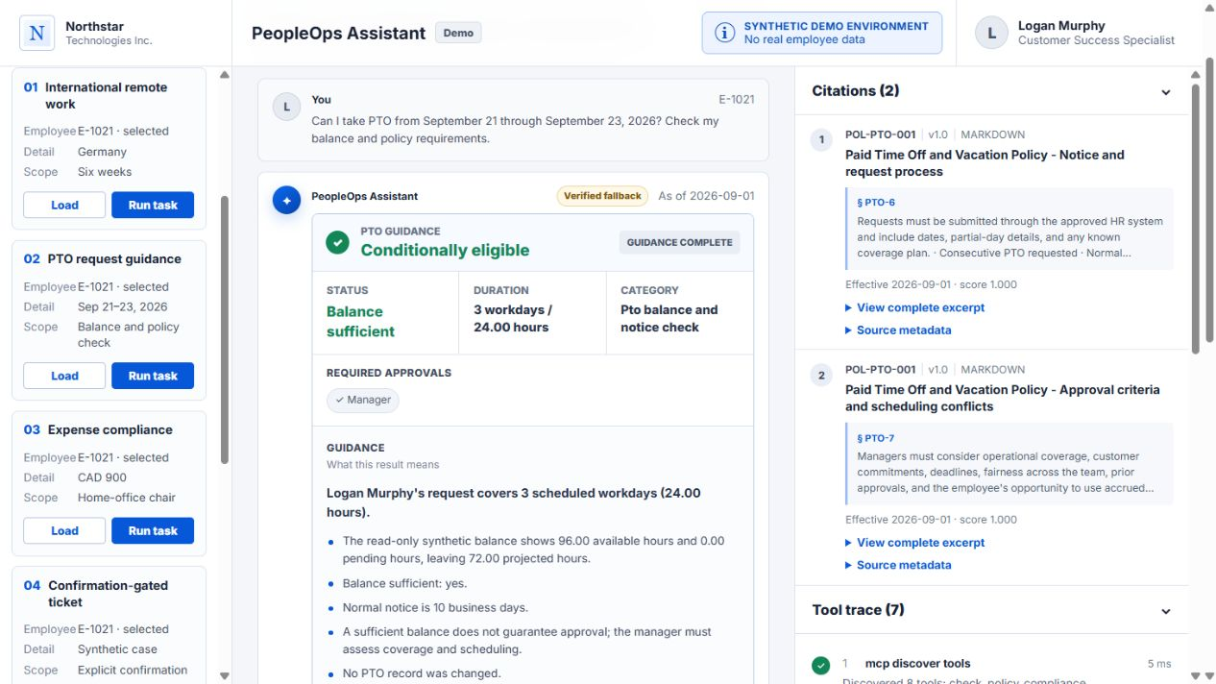  On-screen evidence · 07_pto_guidance_result.png | SCREEN ACTION  Load E-1021 and run the September 21–23 PTO request. Point to the balance figures, notice rule, citations, and the draft panel.  SAY  The system calculates three scheduled workdays, or 24 hours. The synthetic balance is 96 hours available, zero pending, and 72 projected after the request. It reports balance sufficient while clearly stating that sufficient balance does not guarantee manager approval and that the normal notice period is ten business days. No PTO record is changed.  MCP PROOF TO POINT AT  - Final status: completed; outcome: draft_only.  - Workflow: pto.  - Retrieved citations: POL-PTO-001/PTO-6 and POL-PTO-001/PTO-7.  TRANSITION  I’ll now trace how structured balance data and exact policy sections are joined.

SLIDE 7 · 5:30–6:30
The PTO workflow joins structured data and exact policy sections
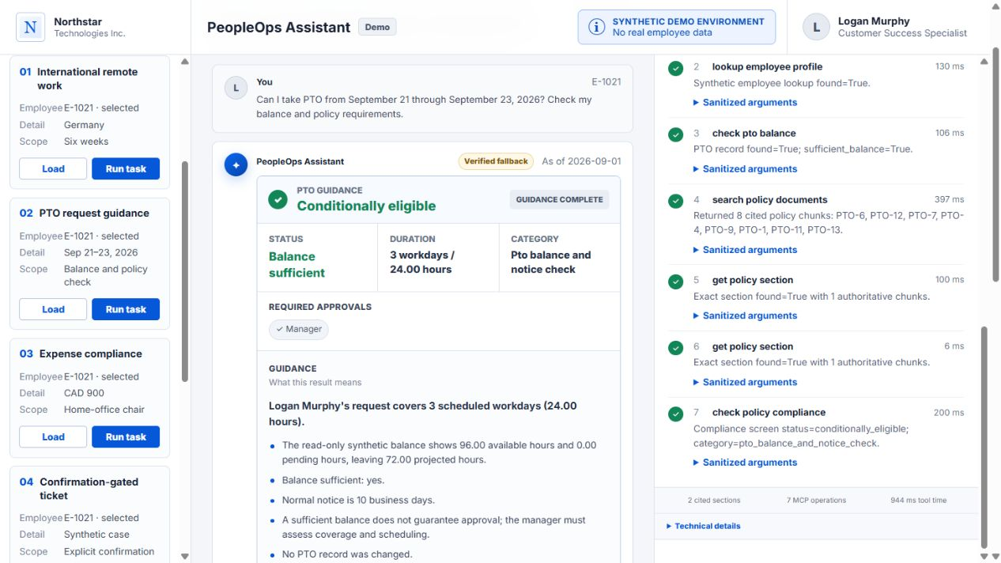  On-screen evidence · 08_pto_guidance_tool_trace.png | SCREEN ACTION  Scroll entries one through seven, expanding balance, search, exact-section, and compliance results.  SAY  After discovery and employee lookup, check_pto_balance receives E-1021 and the start and end dates, then returns record found and sufficient balance. search_policy_documents returns eight ranked chunks. Two get_policy_section calls retrieve PTO-6 and PTO-7 exactly. check_policy_compliance returns conditionally_eligible for the PTO balance-and-notice check.  MCP PROOF TO POINT AT  - check_pto_balance({ employee_id: E-1021, request_start: 2026-09-21, request_end: 2026-09-23 }).  - search_policy_documents → 8 chunks.  - get_policy_section ×2 → PTO-6 and PTO-7.  - check_policy_compliance → conditionally_eligible.  TRANSITION  The eighth call demonstrates the action boundary.

SLIDE 8 · 6:30–7:15
The final action is a structured draft that is neither sent nor saved
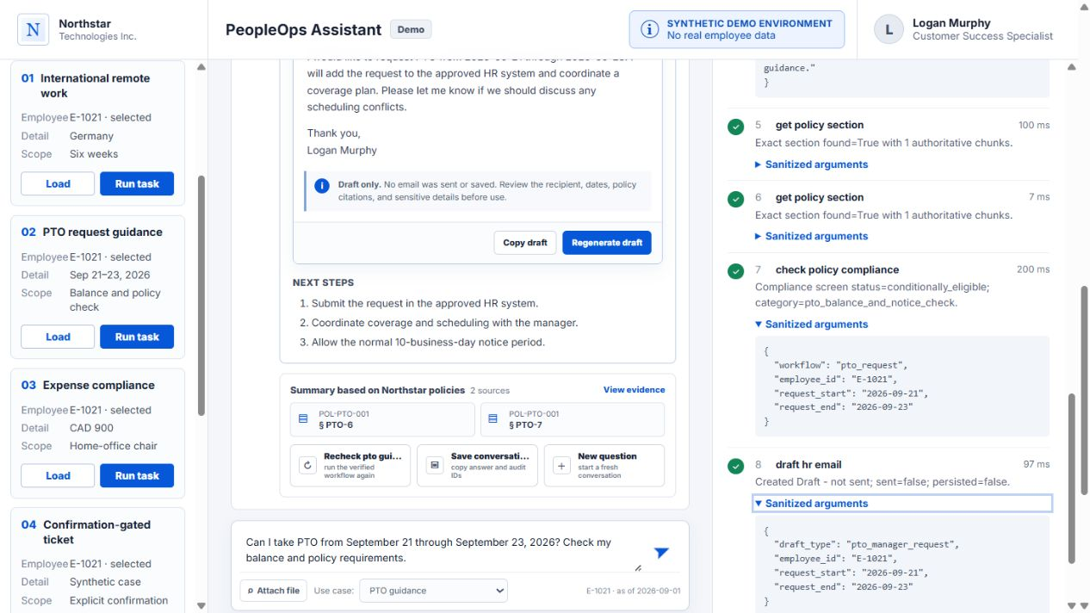  On-screen evidence · 12_pto_email_draft_tool_call.png | SCREEN ACTION  Expand draft_hr_email, then point to the draft recipient, subject, and the ‘Draft — not sent’ label.  SAY  The eighth call is draft_hr_email. Its arguments specify draft_type pto_manager_request, employee E-1021, and the same start and end dates. The output creates a reviewable draft addressed to Kendall Price with the subject ‘PTO request: 2026-09-21 to 2026-09-23.’ The safety fields are explicit: sent equals false and persisted equals false.  MCP PROOF TO POINT AT  - Tool: draft_hr_email.  - Arguments: draft_type, employee_id, request_start, request_end.  - Output: Draft - not sent; sent=false; persisted=false.  - Final action: a reversible draft; no email or PTO mutation.  TRANSITION  With both tasks complete, I’ll show how the exact build reaches production.

SLIDE 9 · 7:15–8:05
CI and hosted smoke bind the deployed app to an exact release
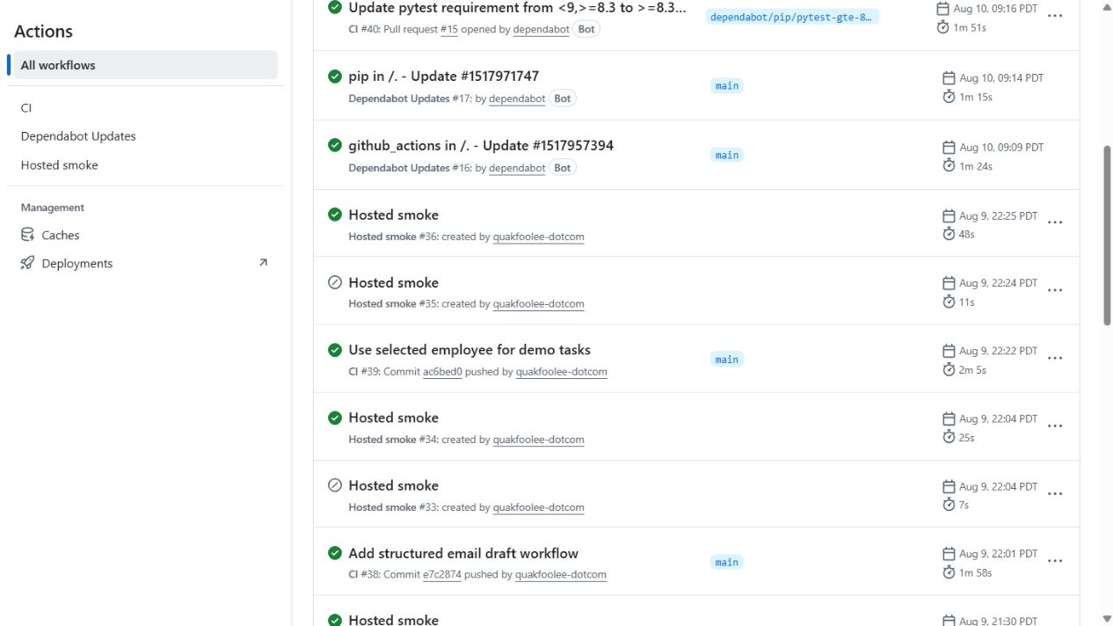  On-screen evidence · 15_ci_hosted_smoke_release.png | SCREEN ACTION  Show the successful GitHub Actions runs, then briefly switch to the system-health screenshot if presenting live.  SAY  The pipeline gates the application with build and test checks, then deploys and runs a hosted smoke test. CI run 39 passed, and Hosted smoke run 36 passed against release ac6bed0. The production health panel reports MCP, RAG, synthetic data, and the LLM provider as healthy. The hosted smoke verifies health, release identity, the root UI, and a read-only MCP workflow.  MCP PROOF TO POINT AT  - CI #39: success.  - Hosted smoke #36: success.  - Release identity: ac6bed0.  - Runtime components: healthy.  TRANSITION  The last proof point is evaluation: does the system consistently select tools, cite evidence, and stay safe?

SLIDE 10 · 8:05–8:50
Evaluation measures the exact properties shown in the demo
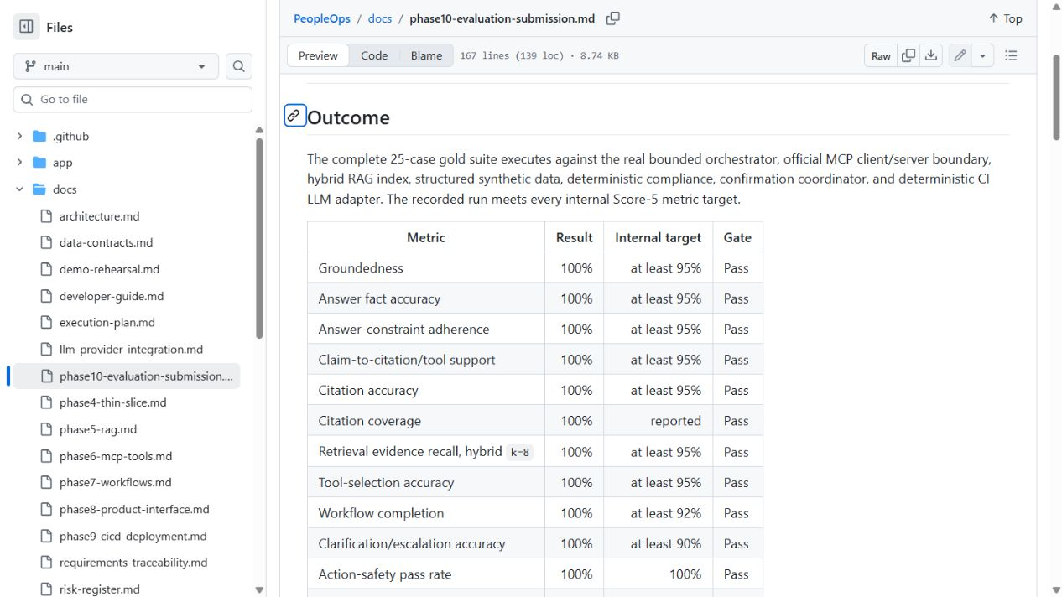  On-screen evidence · 16_evaluation_results.png | SCREEN ACTION  Point to the gold-suite completion row, then the groundedness, citation, tool-selection, workflow, and safety metrics.  SAY  The Phase 10 gold suite completed all 25 cases. The reported gates are 100 percent for groundedness, answer accuracy, claim support, citation accuracy, retrieval recall, tool selection, workflow completion, clarification accuracy, and action safety. Both primary workflows also completed ten consecutive warm runs. These are bounded synthetic evaluation results, not a production service-level promise.  MCP PROOF TO POINT AT  - 25/25 gold cases completed.  - 100% groundedness and citation accuracy.  - 100% tool selection and workflow completion.  - 100% action-safety pass rate.  TRANSITION  I’ll close with the compact proof statement.

SLIDE 11 · 8:50–9:10
Production-shaped and deliberately bounded
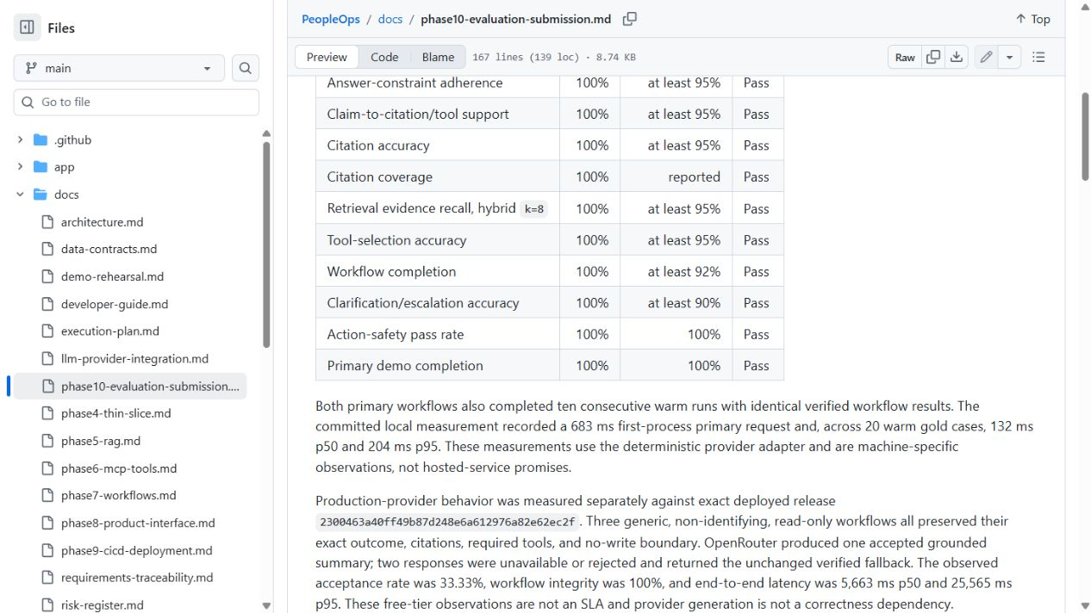  On-screen evidence · 17_evaluation_completion.png | SCREEN ACTION  Return to the closing slide. Pause on the four metrics and finish without reopening the app.  SAY  We completed two agentic tasks end to end. Each used eight visible MCP operations. Together they returned six exact policy citations. And the system performed zero irreversible actions: no email was sent and no PTO record was changed. The design is production-shaped because evidence, deployment identity, CI, hosted smoke, and evaluation are all inspectable—and deliberately bounded because unverified generation cannot become the final answer.  MCP PROOF TO POINT AT  - Two tasks.  - Eight MCP operations in each final trace.  - Six exact citations.  - Zero emails sent or PTO records changed.  TRANSITION  Invite questions. If asked for deeper detail, use the exact-call appendices that follow.

APPENDIX A
Task 1 exact MCP call reference
Prompt: Can I work remotely from Germany for six weeks? · Employee: E-1007 · Final outcome: conditional
Step | Tool | Key arguments | Observed output | Use in final answer
1 | mcp_discover_tools | {} | 8 tools discovered | Confirms the available MCP surface
2 | lookup_employee_profile | employee_id=E-1007 | found=true; active RFT employee | Binds guidance to the selected synthetic employee
3 | search_policy_documents | query=original Germany/six-week prompt | 8 ranked chunks | Candidate policies for exact retrieval
4 | get_policy_section | POL-INT-001, INT-5 | exact=true; 1 authoritative chunk | International duration/category rule
5 | get_policy_section | POL-INT-001, INT-13 | exact=true; 1 authoritative chunk | Advance notice and exceptional review
6 | get_policy_section | POL-RWK-001, RWK-5 | exact=true; 1 authoritative chunk | Remote-work eligibility boundary
7 | get_policy_section | POL-SEC-001, SEC-8 | exact=true; 1 authoritative chunk | Security review requirement
8 | check_policy_compliance | workflow=international_remote_work; employee_id=E-1007; destination_country_code=DE; duration_business_days=30 | conditionally_eligible; international_exceptional | Final conditional answer, approvals, and clarification
Retrieved citations used in the answer: POL-INT-001/INT-5; POL-INT-001/INT-13; POL-RWK-001/RWK-5; POL-SEC-001/SEC-8.

APPENDIX B
Task 2 exact MCP call reference
Prompt: PTO September 21–23, 2026, with a manager-request draft · Employee: E-1021 · Final outcome: draft_only
Step | Tool | Key arguments | Observed output | Use in final answer/action
1 | mcp_discover_tools | {} | 8 tools discovered | Confirms the available MCP surface
2 | lookup_employee_profile | employee_id=E-1021 | found=true | Binds guidance to the selected synthetic employee
3 | check_pto_balance | employee_id=E-1021; request_start=2026-09-21; request_end=2026-09-23 | record found; sufficient_balance=true; 96h available; 72h projected | Three workdays/24h and balance result
4 | search_policy_documents | query=original PTO prompt | 8 ranked chunks | Candidate policies for exact retrieval
5 | get_policy_section | POL-PTO-001, PTO-6 | exact=true; 1 authoritative chunk | Notice and request process
6 | get_policy_section | POL-PTO-001, PTO-7 | exact=true; 1 authoritative chunk | Approval criteria
7 | check_policy_compliance | workflow=pto_request; employee_id=E-1021; start/end dates | conditionally_eligible; pto_balance_and_notice_check | Final guidance and no-mutation boundary
8 | draft_hr_email | draft_type=pto_manager_request; employee_id=E-1021; start/end dates | Draft - not sent; sent=false; persisted=false | Reviewable email to Kendall Price; no send or save
Retrieved citations used in the answer: POL-PTO-001/PTO-6 and POL-PTO-001/PTO-7. Final action: draft only; sent=false; persisted=false.

APPENDIX C
Presenter recovery and verification checklist
Before the demo | If the live path slows or fails
- Open the app and confirm System Health is healthy.  - Confirm employee E-1007 for Task 1 and E-1021 for Task 2.  - Keep the tool-trace and citations panels expanded.  - Verify release ac6bed0 if using the captured evidence set.  - Use only synthetic data and do not navigate to production HR systems. | - Use the embedded screenshots; each is a direct capture of the deployed app or CI/evaluation evidence.  - State clearly that the provider may use a verified deterministic fallback; this is a safety design, not a hidden failure.  - Do not improvise an approval. Preserve the shown conditional and draft-only outcomes.  - Use Appendices A and B to narrate exact calls even if the live trace cannot be expanded.  - Close with the four proof numbers: 2 tasks, 8 calls each, 6 citations, 0 irreversible actions.
Final requirement check
- Task 1: final answer, eight MCP calls, sanitized arguments, outputs, and four citations shown.
- Task 2: final guidance/action, eight MCP calls, sanitized arguments, outputs, and two citations shown.
- Design, deployment, CI/CD, and evaluation each receive a dedicated walkthrough slide.
- Screenshots are embedded in both the PowerPoint and this presenter guide.

