# Stock symbol: FB

## Recommendation: BUY

FB will increase in price during the next trading period.

## Price History

The price of FB has increased in recent years.

The chart below is made with the quantmod R package, a widely used package for collecting and visualizing financial data in R. You can learn more about quantmod at the website [www.quantmod.com](rstudio.github.io/DT/).

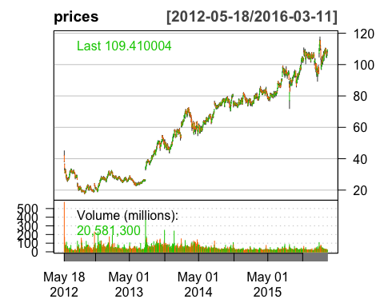

## Method

This forecast was predicted with the *recency algorithm*, a simple---probably useless---method for determining stock prices. The recency algorithm predicts that the next price movement, *Mj*, will be in the same direction as the most recent price movement, *Mi*, where *Mi = Closei - Openi*.

## Raw Data

The table below displays the daily price data for FB.

FB.Open FB.High FB.Low FB.Close  
2012-05-18 42.05 45.00 38.00 38.23  
2012-05-21 36.53 36.66 33.00 34.03  
2012-05-22 32.61 33.59 30.94 31.00  
2012-05-23 31.37 32.50 31.36 32.00  
2012-05-24 32.95 33.21 31.77 33.03