## **Deployments options**

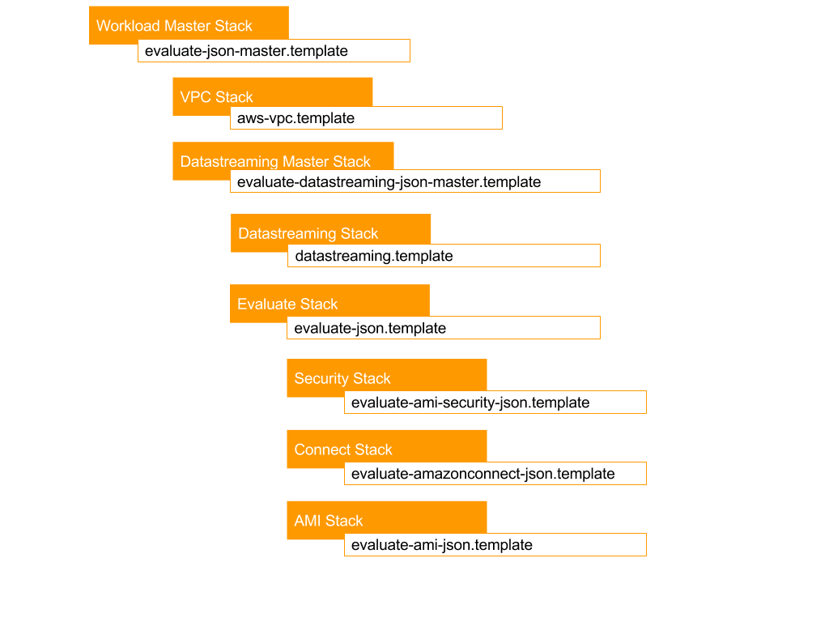

Your customer's organisation must be using Active Directory, either in AWS (e.g. SimpleAD) or on premise with Direct Connect

* Option 1 : Deploy for a new VPC

This option will create a new VPC, deploy the [Data Streaming](https://aws.amazon.com/quickstart/connect/data-streaming/) stack and Evaluate for Amazon Connect

Template: evaluate-json-master.template

* Option 2 : Deploy for an existing VPC with Data Streaming

This option will deploy the [Data Streaming](https://aws.amazon.com/quickstart/connect/data-streaming/) stack and Evaluate for Amazon Connect into an existing VPC

Template: evaluate-datastreaming-json-master.template

* Option 3 : Deploy for an existing VPC without Data Streaming

This deployment will deploy Evaluate for Amazon Connect into an existing VPC

Template: evaluate-json.template