XPath is a language to query data from XML documents. It is built in to XSLT and can be used standalone in several .NET APIs. (http://www.w3.org/TR/xpath)
In some cases customers need to parse XPath expressions themselves to analyze, modify or validate them.
XPathParser is the class that can help you doing this.

To make parser extensible XPathParser uses “Builder” pattern. It takes string with XPath expression and instance of IXPathBuilder interface (builder) as input and generates set of calls to the builder.

This way implementation of the XPathParser doesn’t dictate how parsed expression would be represented.

With the XPathParser we provide XPathParserTest that contains two sample implements of the IXPathBuilder: XPathTreeBuilder which builds XLinq tree as a result of parsing and XPathStringBuilder that generates string implementation of the compiled XPath.

The work of XPathParser can be demonstrated in the following diagram:
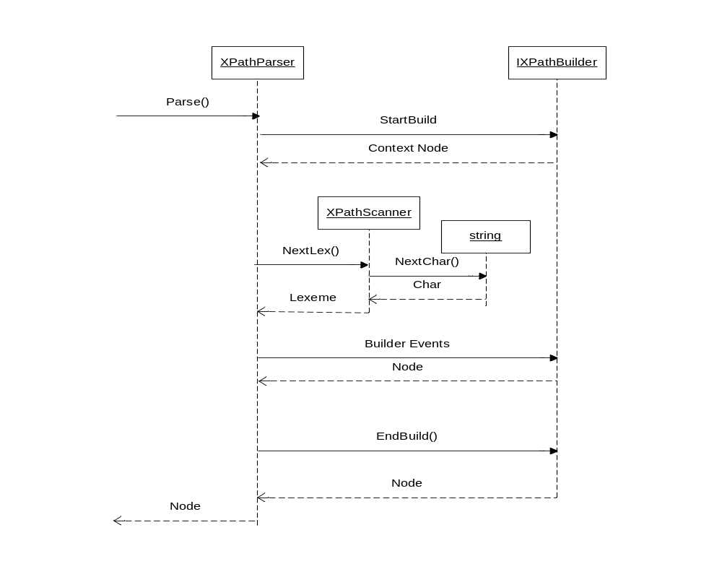

Examples:
1. Expression “1 + 2” :

ctx = StartBuild();
return EndBuild(Operator(XPathOperator.Plus, Number(1), Number(2)))

2. Expression “a/@*” :

ctx = StartBuild();
stp1 = Axis(ctx, XPathAxis.Child, QilXmlNodeKind.Element, “”, “a”);
stp2 = Axis(stp1, XPathAxis.Attribute, QilXmlNodeKind.Attribute, “”, “”);
return EndBuild(JoinStep(stp1, stp2));

3. Expression “parent:a[@b]” :

ctx = StartBuild();
stp1 = Axis(ctx, XPathAxis.Parent, QilXmlNodeKind.Element, “”, “a”);
stp2 = Axis(stp1, XPathAxis.Attribute, QilXmlNodeKind.Attribute, “”, “b”);
return EndBuild(Predicate(stp1, stp2));

