Home Improvement Application Packet
The Ranch Community Association — Architectural Review
Property: 12344 Passerine Court, Rancho Cordova, CA — Lot 46, The Ranch Village 2
Project: Sierra Fiberglass “Bermuda” swimming pool (14' × 30'), concrete pool deck, and backyard landscaping
Prepared: July 2026 Owner: ______________________

Packet Contents
- 1. Submission Checklist
- 2. Application Form Draft (copy onto the official HOA form)
- 3. Site Plan (scale drawing)
- 4. Landscape Plan — plant locations & species
- 5. Concrete Specifications, Setbacks & Drainage Statement
- 6. Pervious Surface Worksheet
- 7. Photographs of Existing Conditions
- Attachments (separate files): product brochure PDF, approved plot plan PDF
Submit to: Landmark Limited, Attn: Home Improvement Dept., 1731 E. Roseville Pkwy., Suite 100, Roseville, CA 95661 · homeimprovements@landmarklimited.net · (916) 746-0011

1. Submission Checklist
Checked items are included in this packet. Unchecked items must be completed by the homeowner before submitting.

Included in this packet
- ☑ Landscape plan — location & species of all plantings and materials
- ☑ Site plan / detailed drawing — existing structure, fence lines, property lines, improvements
- ☑ Color, finish and dimensions of proposed concrete
- ☑ Concrete setbacks from property lines + drainage statement
- ☑ Pervious-surface worksheet (lot math prepared; needs your flatwork measurements)
- ☑ Color photographs of the area from several angles
- ☑ Product brochure (Sierra Fiberglass Bermuda PDF)
- ☑ Application form draft answers

Homeowner to complete
- ☐ Print and sign the official application form (name, phone, dates, owner signature)
- ☐ Neighbor acknowledgment signatures (Lots 45 & 47 and rear neighbors)
- ☐ Measure existing flatwork (driveway, front walk, rear walkway) and complete the worksheet blanks
- ☐ Concrete color/finish sample chip from contractor
- ☐ City of Rancho Cordova building permit (pools require one)
- ☐ Photos of any work already completed (N/A if none started)
- ☐ Mail or email the complete package to Landmark Limited; allow up to 45 days
Reminders: work may NOT begin before written approval. Incomplete applications are returned. Construction hours after approval: 8:00 a.m.–6:00 p.m.

2. Application Form Draft
Copy these answers onto the official Home Improvement Application form.
Field | Enter
NAME | (your name)
DATE | (submission date)
ADDRESS | 12344 Passerine Court, Rancho Cordova, CA
LOT NO | 46
PHONE (H)/(W) | (your numbers)
E-MAIL | jay@quampy.com
PROPOSED COMPLETION DATE | (typ. 8–12 weeks from permit)

Boxes to check
- Swimming Pool/Spa/Solar Panels
- Landscaping backyard (plant location & species attached)
- Driveway/Walkways (covers new concrete deck flatwork)
- Materials: Concrete — write in “Fiberglass pool shell (Sierra Fiberglass — Bermuda)”
- Same color/type as house: No — “Concrete matches existing builder walkway (natural gray, broom finish)”

Additional Comments (suggested text)
Install a Sierra Fiberglass “Bermuda” swimming pool (14' wide × 30' long × 3'6"–6' deep, freeform) in the rear yard, centered between side fences. Pool is surrounded by a new 3'-wide broom-finish concrete deck (36' × 20' gross footprint) that ties into the existing rear walkway. Concrete is set back 3' from the rear property line per HOA requirement; the setback strip is planted as a privacy screen (Podocarpus gracilior at 4' o.c.) with accent plantings (kangaroo paw, salvia, lantana, lomandra) flanking the deck. Existing drainage pattern is unchanged; deck slopes away from pool and house to pervious landscape. See attached site plan, landscape plan, concrete specifications, pervious-surface worksheet, photographs, product brochure, and builder plot plan. A City of Rancho Cordova building permit will be obtained prior to construction; a copy can be provided upon issuance.

3. Site Plan
Scale drawing — pool placement, setbacks, fence lines, and planting areas. Property lines and recorded setbacks per the attached approved plot plan.
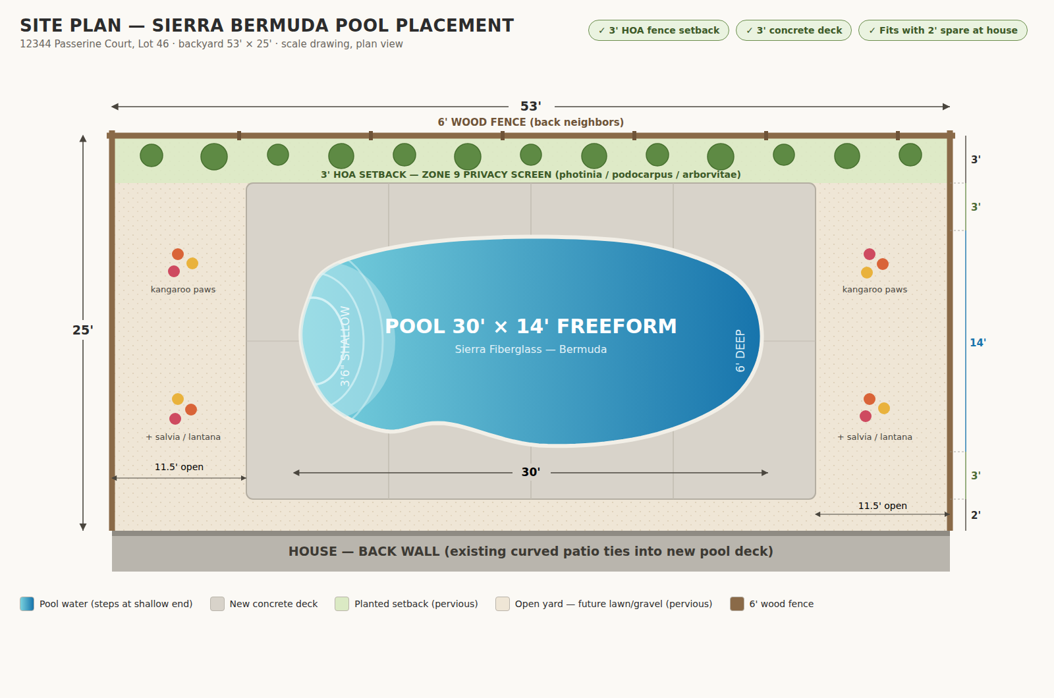

4. Landscape Plan — Plant Locations & Species
Backyard only (53' × 25'). Locations shown on the Site Plan. All selections are USDA Zone 9b / Sunset 14 appropriate (Sacramento area).

Area A — Privacy screen (3' setback strip, rear fence)
Qty | Plant | Botanical name | Install size | Spacing | Maintained size
12 | Fern Pine (columnar screen) | Podocarpus gracilior | 15-gal | 4' o.c. | 8–10' H × 3–4' W
Alternates at same spacing: Photinia × fraseri, or Green Giant Arborvitae. Podocarpus recommended near pools (evergreen, low litter).

Area B — Accent color pockets flanking the deck
Qty | Plant | Botanical name | Install size | Spacing | Bloom
8 | Kangaroo Paw | Anigozanthos 'Bush Ranger' / flavidus hybrids | 1-gal | 30" o.c. | Red/orange, spring–fall
6 | Autumn Sage | Salvia greggii (red & pink) | 1-gal | 30" o.c. | Spring–fall
6 | Lantana 'New Gold' | Lantana × hybrida | 1-gal | 3' o.c. | Gold, spring–frost
6 | Dwarf Mat Rush | Lomandra longifolia 'Breeze' | 1-gal | 30" o.c. | Evergreen grass

Area C — Remaining open yard
Decomposed granite or river rock over landscape fabric (pervious), or drought-tolerant no-mow fescue.

Materials & Irrigation
- Bed mulch: 3" shredded bark or ¾" crushed rock (pervious)
- Bed edging: steel or concrete mow strip
- Irrigation: automatic drip to all plantings, per Rancho Cordova Municipal Code 23.716.060
- No front-yard changes; no plantings within the recorded P.U.E.

5. Concrete Specifications, Setbacks & Drainage

Specifications
Item | Specification
Overall deck footprint | 36' × 20' (720 sf gross)
Pool shell cut-out | approx. 380 sf (Bermuda 14' × 30' freeform)
Net new concrete flatwork | approx. 340 sf
Thickness | 4" over compacted aggregate base (per pool contractor)
Color | Natural gray — matches existing builder walkway
Finish | Medium broom (slip-resistant), matches existing flatwork
Coping | Pre-cast concrete, buff/cream tone
Joints | Tooled control joints, nominal 9' grid
A physical color/finish sample chip from the concrete contractor accompanies this application.

Setbacks from property lines
Direction | Distance to concrete edge
Rear (north fence) | 3' 0" — HOA setback, kept as planted strip
Side (east) | 8' 6"
Side (west) | 8' 6"
House side | Ties into existing walkway; 2' clear at house wall
Pool water edge is a minimum of 6' 0" from the rear property line (3' setback + 3' deck).

Drainage statement
- Existing drainage pattern is NOT altered; downspouts remain on builder underground drains
- Deck finished at grade, sloped min. 2% away from pool and house onto pervious landscape
- 3' rear setback strip remains a pervious planted bed; no runoff directed at neighboring lots
- Any deck drains discharge to the existing yard drainage system
- To be verified against the pool contractor's final engineering/grading plan

6. Pervious Surface Worksheet
CC&R rules: max 75% of total lot non-pervious; max 40% of front yard non-pervious.

Known values (from approved plot plan)
Item | Value
Lot area | 5,565 sf
House footprint | 2,301 sf
Builder-stated lot coverage | 41.3%
New pool + deck (this application, counted fully non-pervious) | 720 sf

Measure and fill in
Item | Measured sf
Driveway
Front walk / porch flatwork not in house footprint
Existing rear walkway / patio
Other existing flatwork (side pads, trash pad)
TOTAL existing flatwork (D)

Calculation
Total non-pervious = 2,301 + D + 720 = 3,021 + D
Percentage = (3,021 + D) ÷ 5,565 75% limit = 4,174 sf → D must be ≤ 1,153 sf
Heads-up: a 3-car driveway (~550–650 sf) plus existing walkways can approach this limit. Measure before submitting. If over 75%: reduce deck aprons, use permeable pavers for part of the deck, or ask Landmark whether pool water surface may be excluded.

Front yard
No front-yard changes are proposed — the front-yard non-pervious ratio is unchanged by this application.

7. Photographs of Existing Conditions
Rear yard as it exists today (bare dirt, 6' wood fence, builder walkway), three angles.
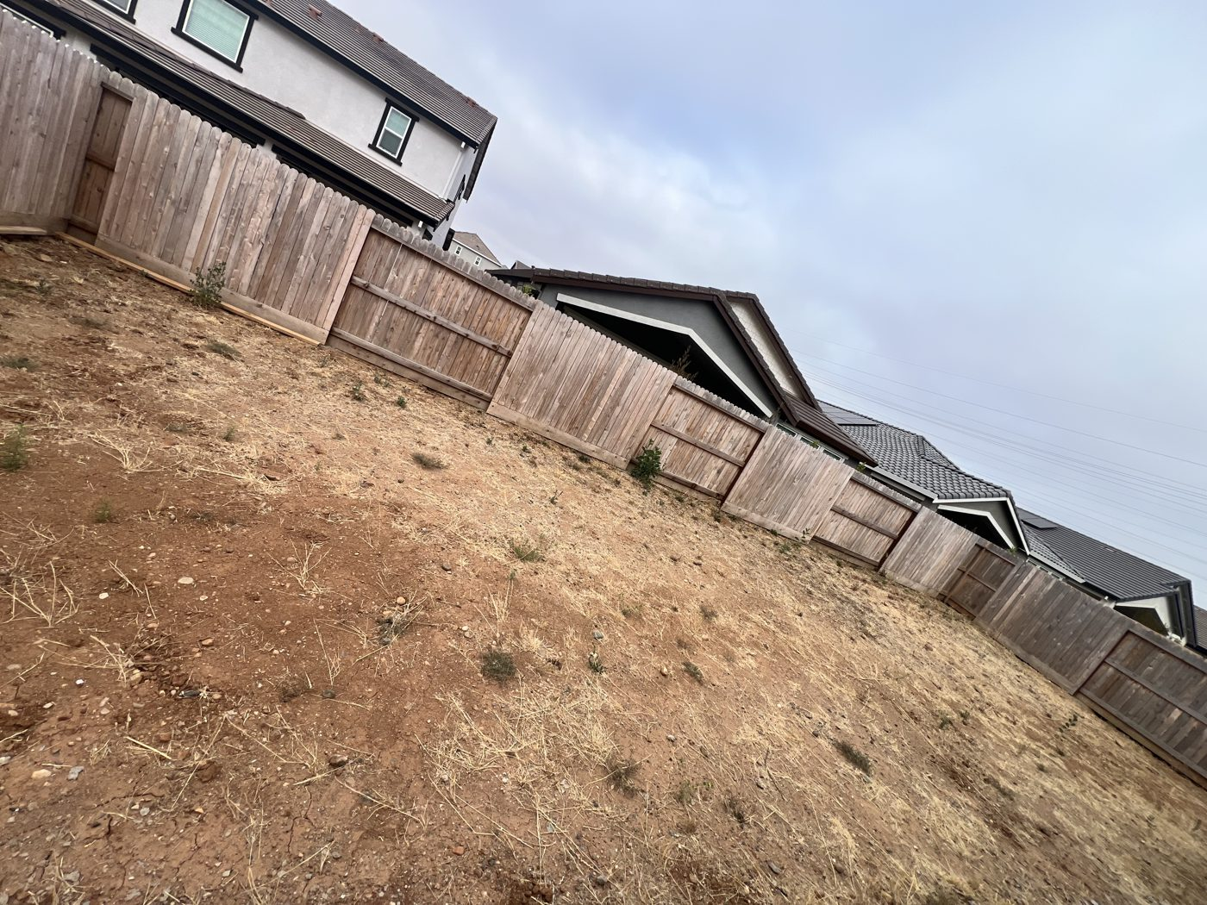
View 1 — from side yard looking across the rear fence line
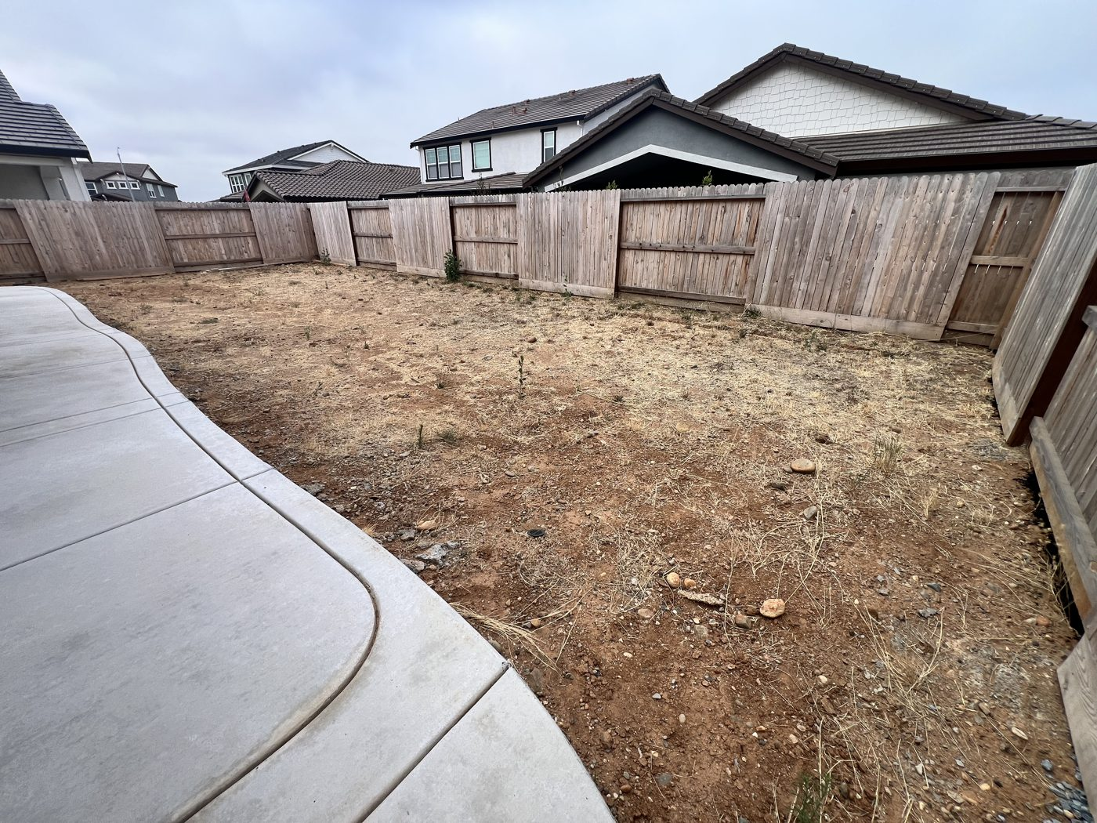
View 2 — from the patio looking north across the yard
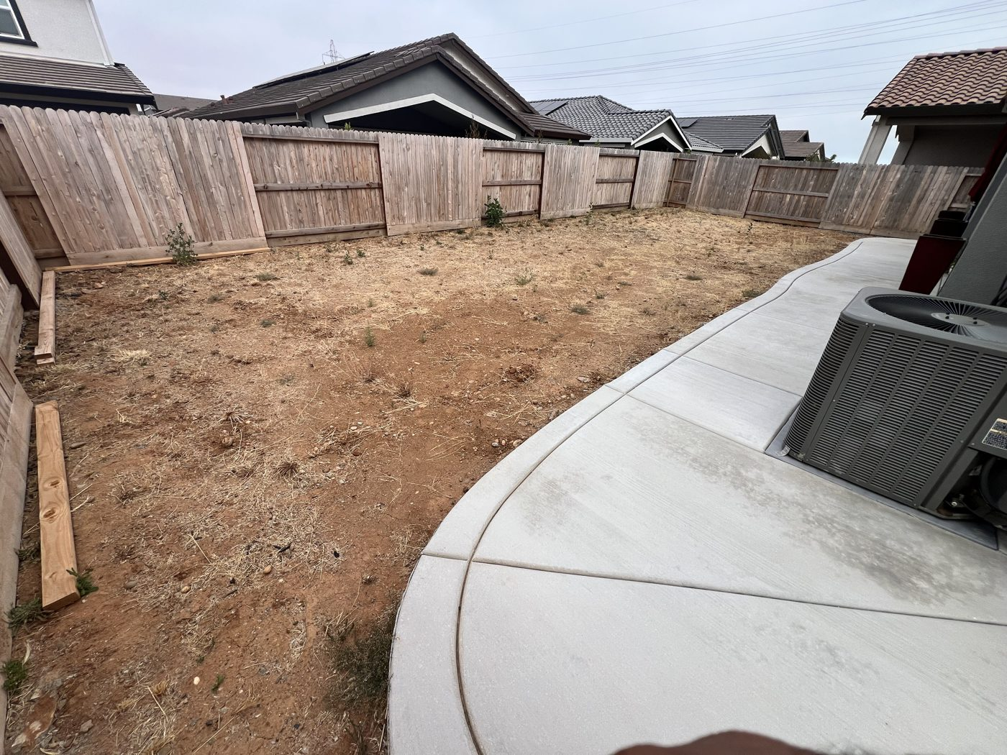
View 3 — along the yard from the east end (walkway and A/C at right)

