Hannah - AI Learning Assistant for Software Engineering Education

1. Introduction  
  
The "Hannah" system is an intelligent virtual assistant designed to support students in Software Engineering (SE) education. It addresses key challenges faced by learners, such as limited instructor access, immediate need for assistance, overwhelming learning resources, and difficulties understanding complex technical concepts. Hannah offers real-time support, personalized guidance, and reduces faculty workload through automation.  
  
2. Functional Requirements  
  
2.1 Student Interface  
- Real-time chat with Hannah for technical Q&A  
- Access to curated SE learning resources  
- Troubleshooting project issues  
- Personalized learning progress tracking  
- Code snippet sharing and interpretation  
- Clarification of assignments (without solving them)  
- Queries about academic and administrative information  
  
2.2 Faculty Module  
- Review and approve AI-generated responses  
- Add tailored responses to FAQs  
- Monitor conversation quality  
- Curate and manage knowledge base entries  
- Analyze student concerns and trends  
- Identify common learning gaps  
- Escalate conversations needing human intervention  
  
2.3 Admin Module  
- User account and permission management  
- System configuration and integration  
- Monitor system usage and performance  
- Knowledge base versioning  
- Generate detailed analytics reports  
- Manage AI parameters and training datasets  
  
2.4 Knowledge Management System  
- Structured repository for SE materials  
- Tag-based content organization  
- Version control of documents  
- Intelligent, context-aware search engine  
- Multimedia content support  
- Integration with academic databases  
- API connections for external resources  
  
3. Non-Functional Requirements  
- Platform compatibility: Web & Mobile  
- AI vs Human response indicators  
- Scalability to handle large student bases  
- Data privacy and user authentication  
- High availability and performance  
- Secure APIs and encrypted communication  
- Localization and multilingual support  
  
4. System Architecture  
  
4.1 Server-side Technologies  
- AI Engine: NVidia ChatRTX (Open Source)  
- Backend: Python with FastAPI  
- Database: PostgreSQL (structured), MongoDB (conversation logs)  
- Search Engine: Elasticsearch  
- Content Management: Django CMS  
- Caching: Redis  
  
4.2 Client-side Technologies  
- Frontend: React.js with TypeScript  
- UI Framework: Material-UI  
- Real-time Communication: WebSockets  
- State Management: Redux  
- Mobile: React Native  
  
5. Use Case Diagram  
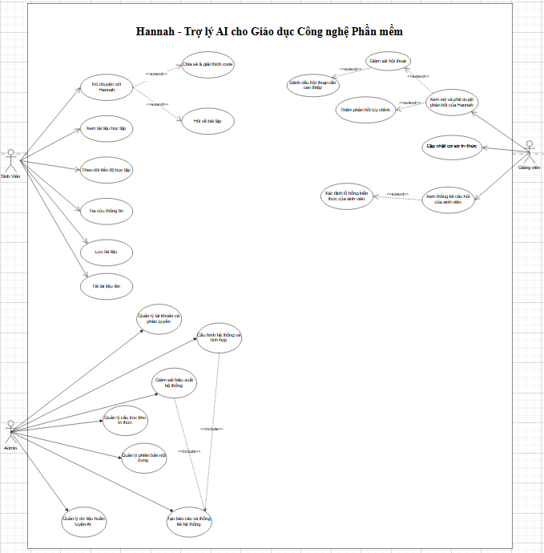

6. Class Diagram  
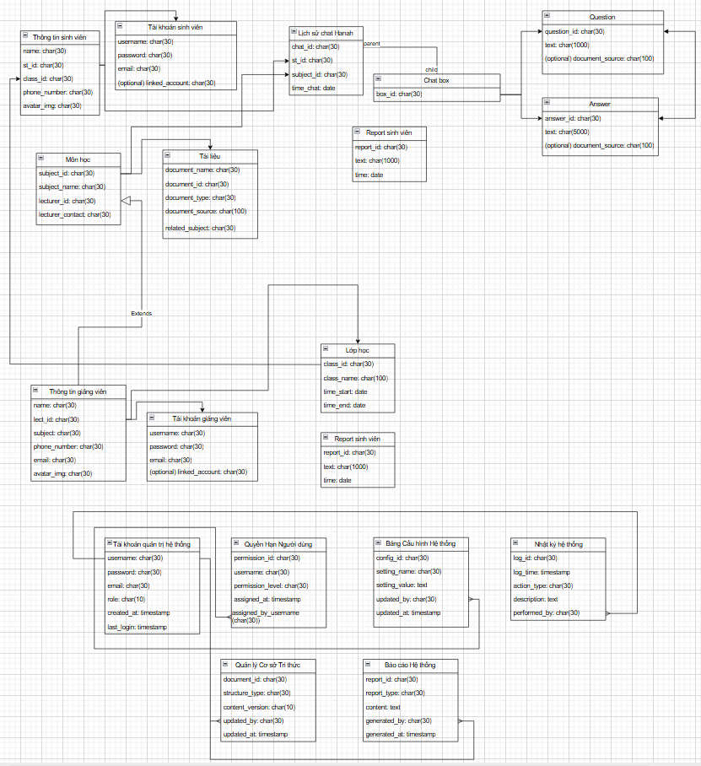  
  
7. Main Deliverables  
  
Documents:  
- User Requirements  
- Software Requirement Specification (SRS)  
- Architecture Design  
- Detailed Design  
- Implementation Plan  
- Testing Documentation  
- Installation Guide  
- User Manual  
- Source Code & Deployment Package  
  
Products:  
- Hannah AI Assistant  
- Conversational Web & Mobile Interfaces  
- Integrated SE Knowledge Base  
- Faculty Review Portal  
- Context-Aware AI Response System  
- CMS for Educational Content  
- Analytics Dashboard  
- Admin Monitoring & Configuration Tools  
  
8. Proposed Task Packages  
  
*1. System Analysis and Design  
2. AI Assistant Development  
3. Knowledge Management System Implementation  
4. Faculty & Student Web/Mobile Interface Development  
5. Documentation Preparation (System, Testing, User, Installation)*

# Figure 1 - Use Case Diagram

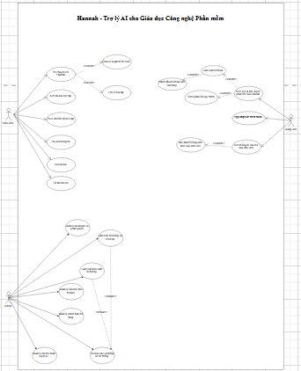

# Figure 2 - Class Diagram

