Họ và tên : Lê Ngọc Anh Quân – 20176852

Bài 2

Code :

.text

li $s0,0x12345678 #load test value for these function

andi $t0,$s0,0xff000000 #Extract the MSB of $s0

andi $t1,$s0,0xff #Extract the LSB of $s0

andi $s0,$s0,0xffffff00 #Clear LSB of $s0

or $s0,$s0,0xff #set LSB of $s0 (bits 7 to 0 are set to 1)

xor $s0,$s0,$s0 #Clear $s0

Kết quả

* Extract the MSB of $s0

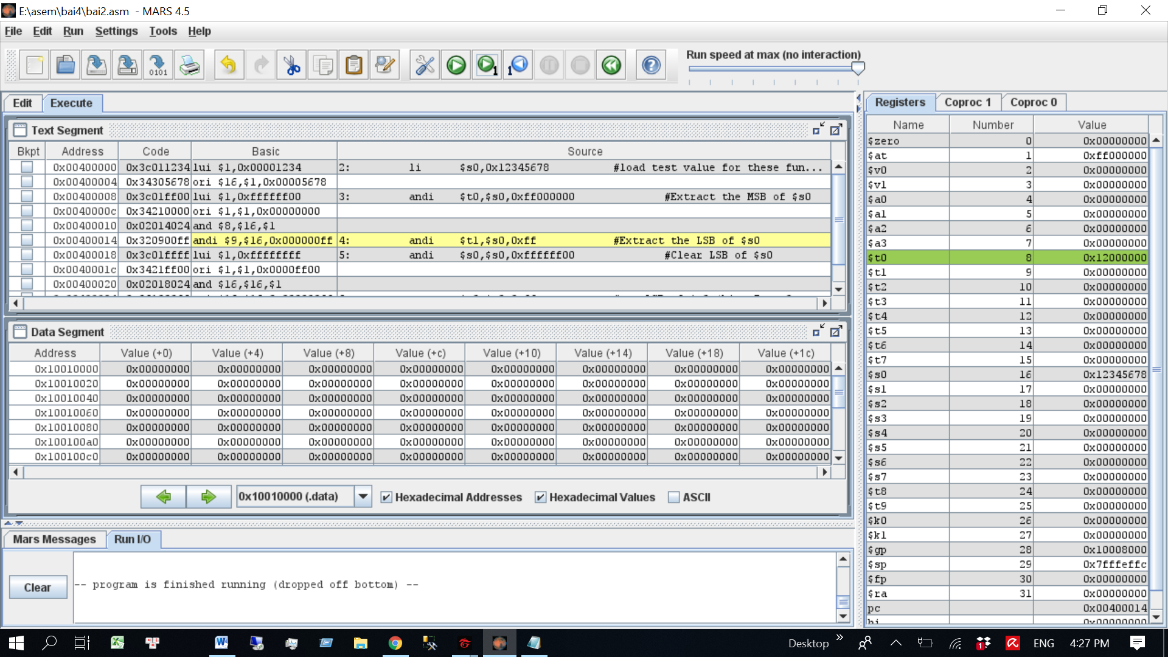

* Clear LSB of $s0

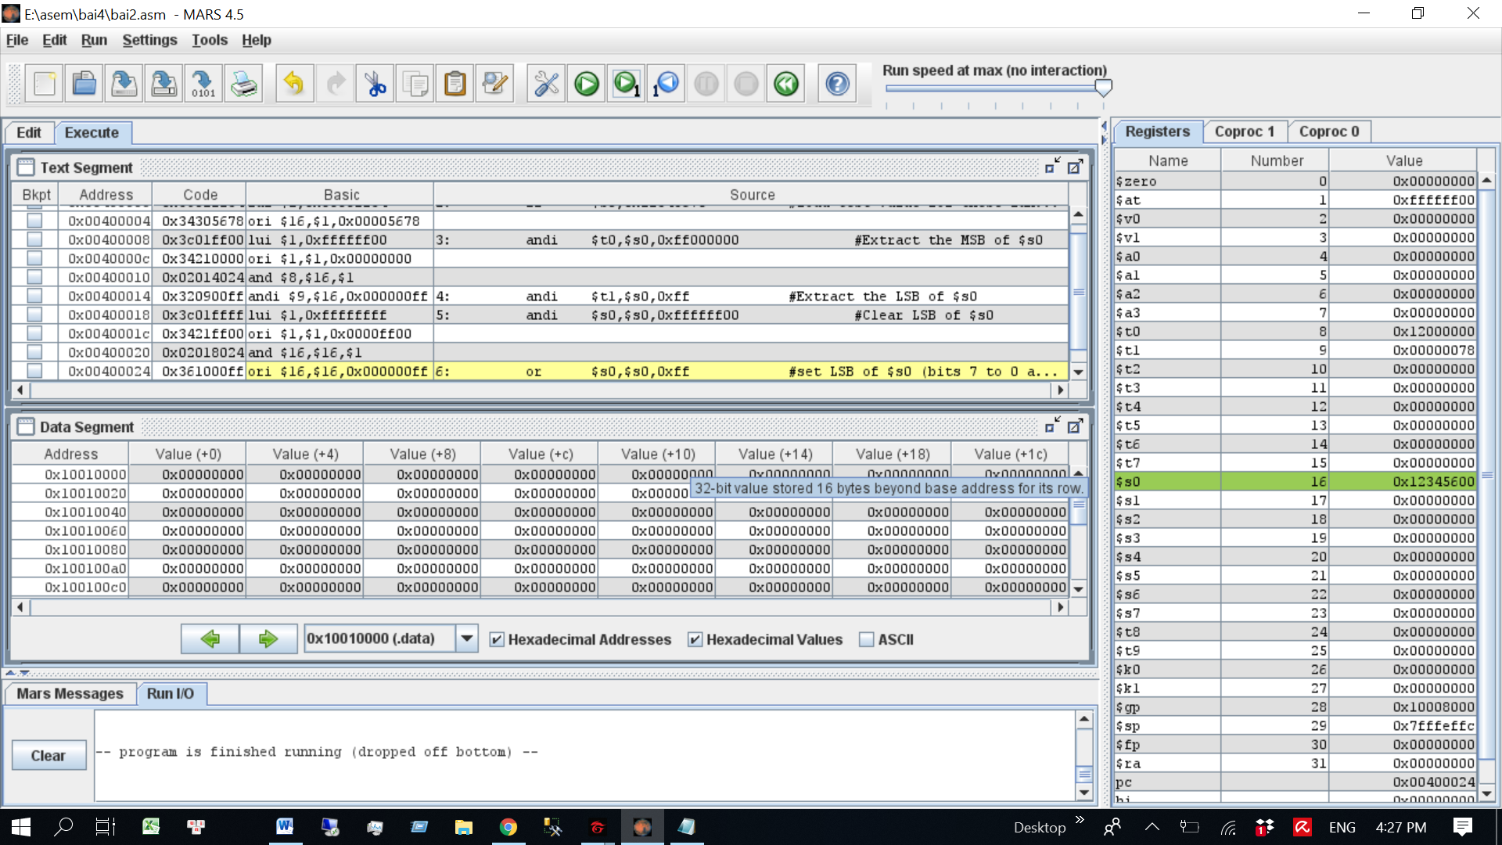

* Set bit 7 to 0 =1

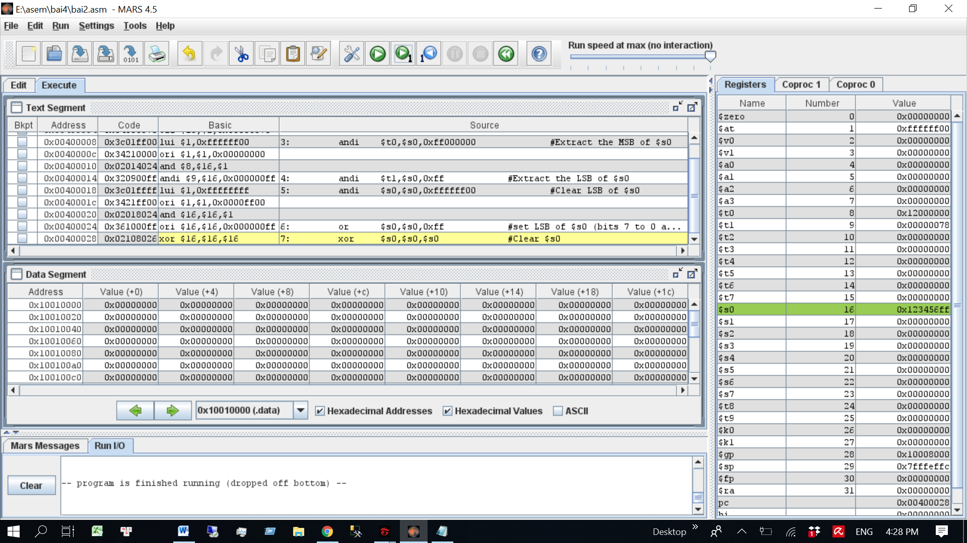

* Clear $s0

