Họ và tên : Lê Ngọc Anh Quân – 20176852

Bài 4

Source code :

#Laboratory Exercise 5, Home Assignment 3

.data

string: .space 50

Message1: .asciiz "Nhap xau:”

Message2: .asciiz "Do dai la "

.text

main:

get_string: # TODO

li $v0, 54 #service 8 is to show InputDialogString

la $a0, Message1

la $a1, string #the string input

la $a2,50 # maximum number of characters to read

syscall

get_length: la $a0, string # a0 = Address(string[0])

xor $v0, $zero, $zero # v0 = length = 0

xor $t0, $zero, $zero # t0 = i = 0

check_char: add $t1, $a0, $t0 # t1 = a0 + t0

#= Address(string[0]+i)

lb $t2, 0($t1) # t2 = string[i]

beq $t2,$zero,end_of_str # Is null char?

addi $v0, $v0, 1 # v0=v0+1->length=length+1

addi $t0, $t0, 1 # t0=t0+1->i = i + 1

j check_char

end_of_str:

end_of_get_length:

print_length: # TODO

li $v0, 56 #service 56 is to show MessageDialogInt

la $a0, Message2

la $a1, 0($t0) #the integer to be printed is the length of input string

syscall

Kết quả :

Input String Dialog:

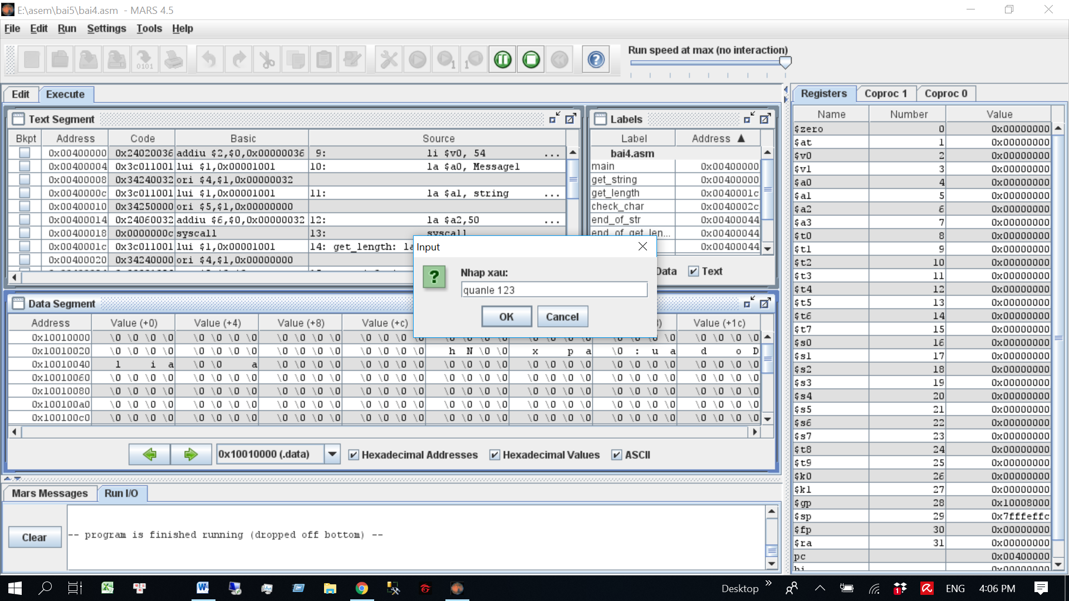

Number of character show dialog:

