1a.

Thêm dữ liệu :

INSERT INTO NhanVien (MaNV, HoTen, NgaySinh, GioiTinh, DiaChi, SoDienThoai, Luong)

VALUES ('NV004', 'Nguyen Van A', '1990-01-01', 'Nam', 'Ha Noi', '0987654321', 10000000);

backup database QLBanHang to disk = 'E:\Backup\QLBH.bak'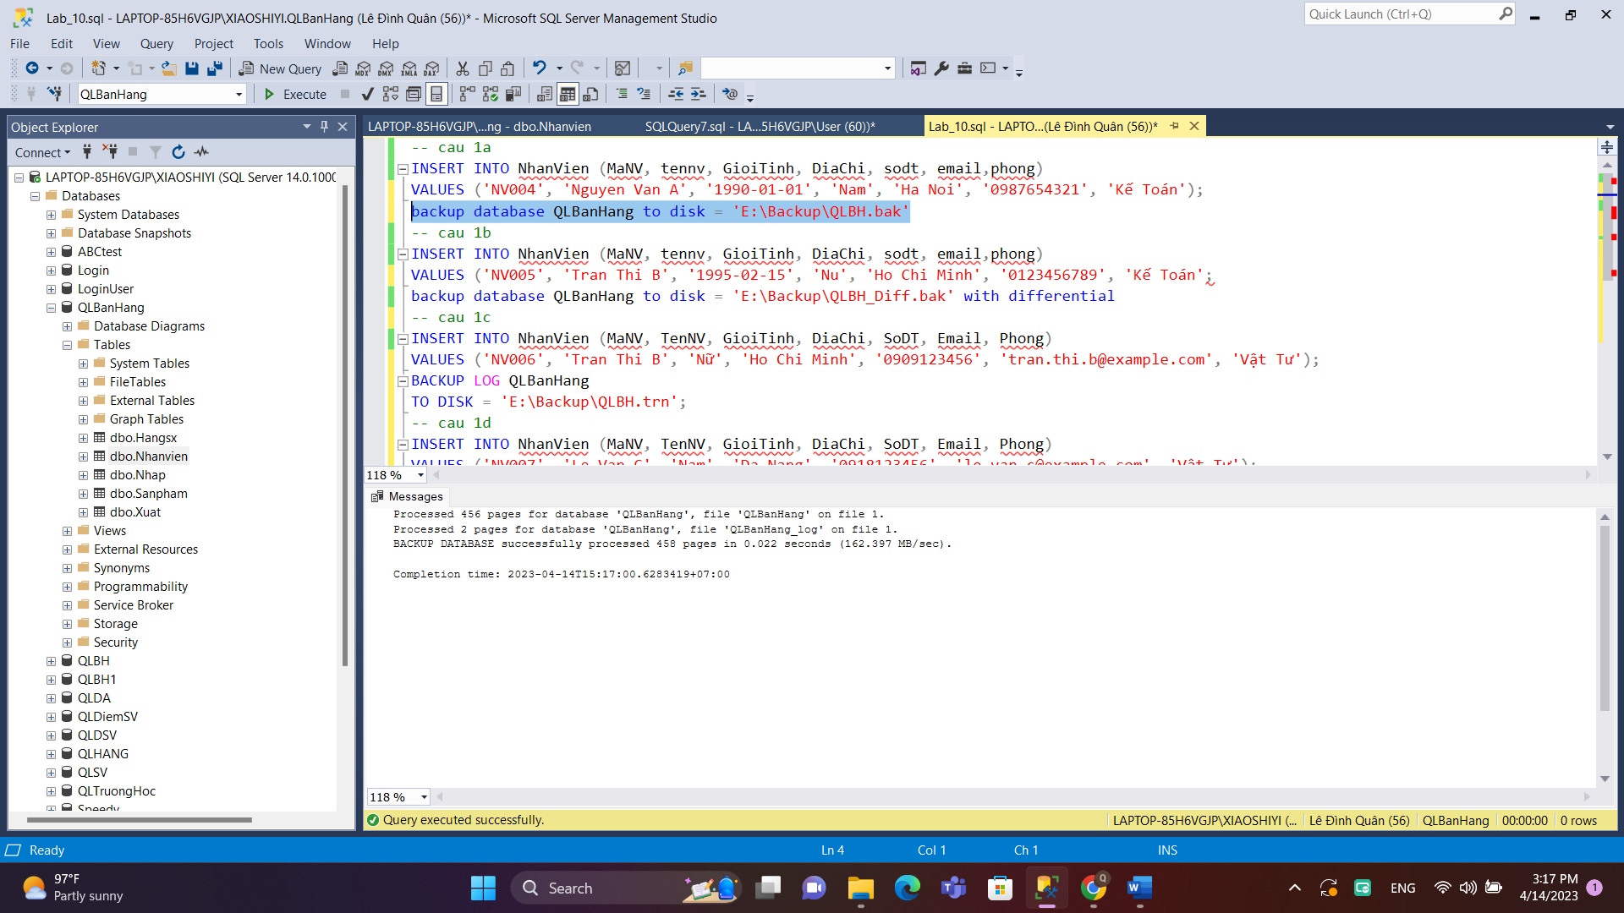

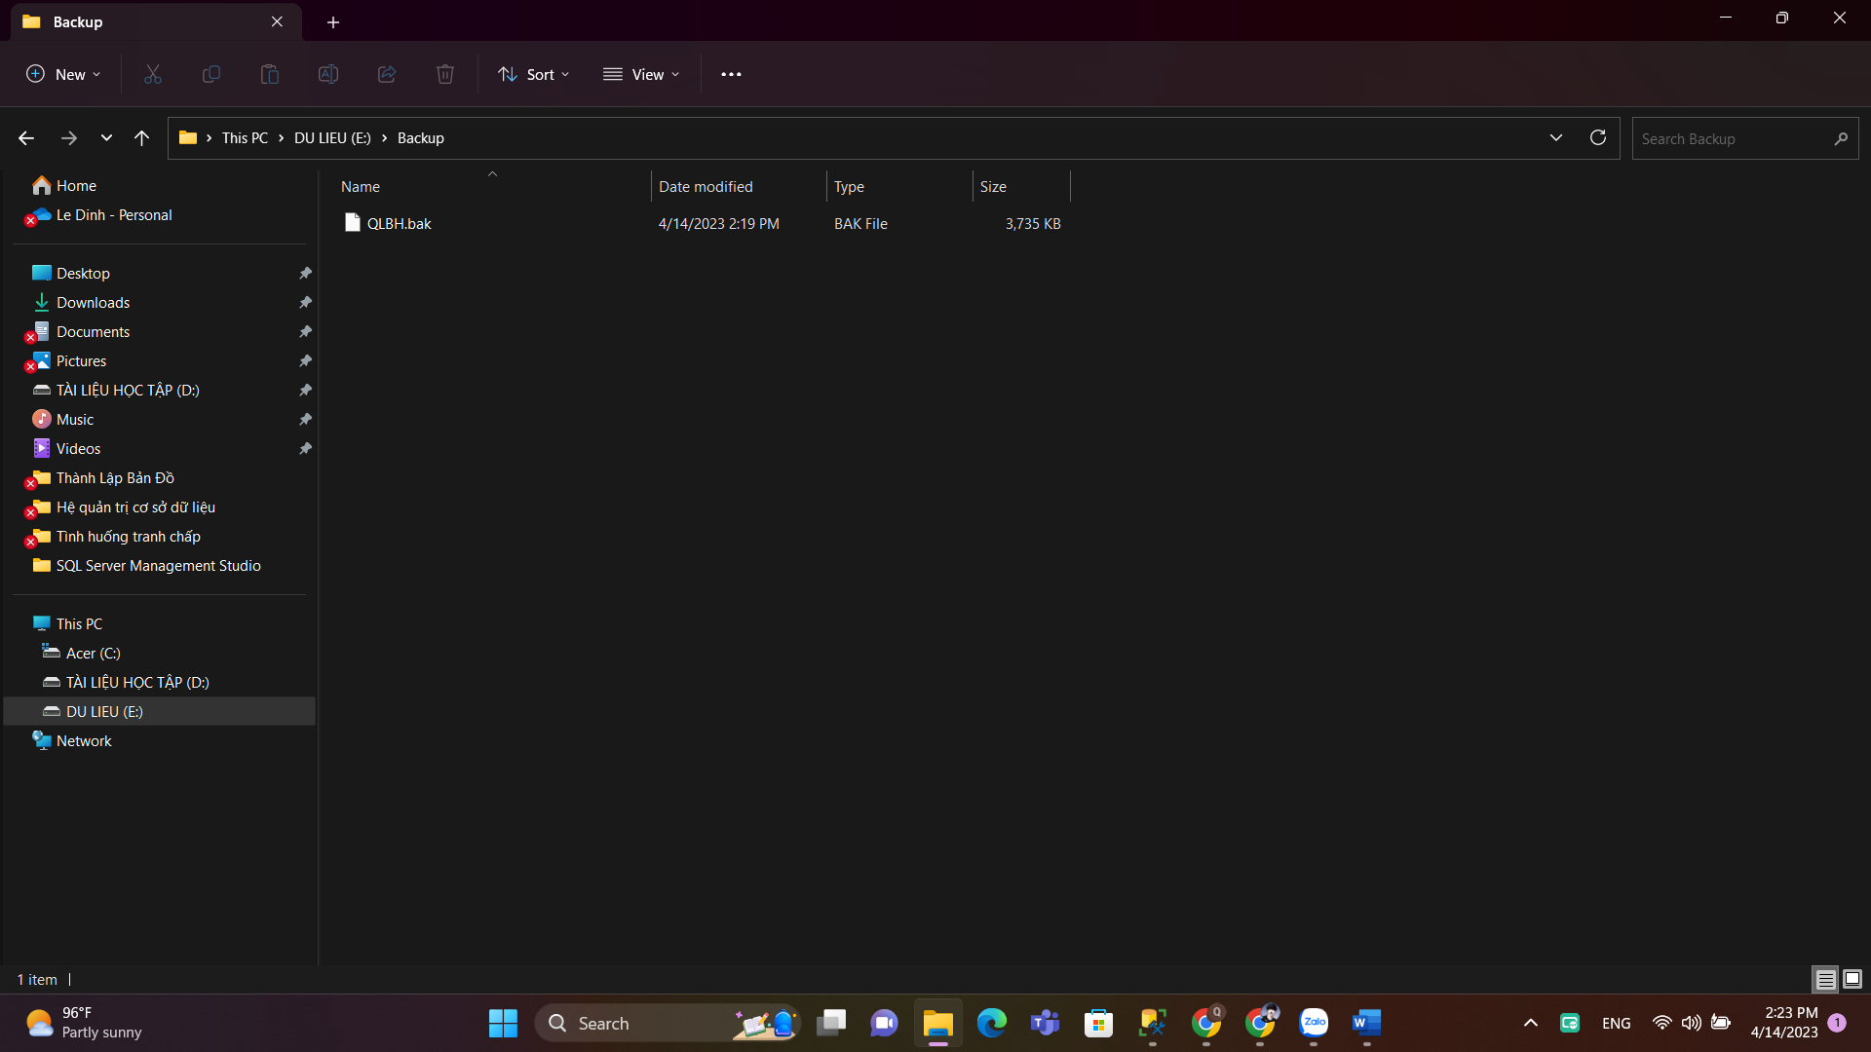

1b.

Thêm

INSERT INTO NhanVien (MaNV, tennv, GioiTinh, DiaChi, sodt, email,phong)

VALUES ('NV005', 'Tran Thi B', '1995-02-15', 'Nu', 'Ho Chi Minh', '0123456789', 20000000);

Backup

backup database QLBanHang to disk = 'E:\Backup\QLBH_Diff.bak' with differential

1c

Thêm

INSERT INTO NhanVien (MaNV, TenNV, GioiTinh, DiaChi, SoDT, Email, Phong)

VALUES ('NV006', 'Tran Thi B', 'Nữ', 'Ho Chi Minh', '0909123456', 'tran.thi.b@example.com', 20000000);

Backup

BACKUP LOG QLBanHang

TO DISK = 'E:\Backup\QLBH.trn';

1d.

INSERT INTO NhanVien (MaNV, TenNV, GioiTinh, DiaChi, SoDT, Email, Phong)

VALUES ('NV007', 'Le Van C', 'Nam', 'Da Nang', '0918123456', 'le.van.c@example.com', 'Vật Tư');

BACKUP LOG QLBanHang

TO DISK = 'E:\Backup\QLBH.trn'

WITH INIT;

BACKUP LOG QLBanHang

TO DISK = 'E:\Backup\QLBH.trn'

WITH NOINIT;

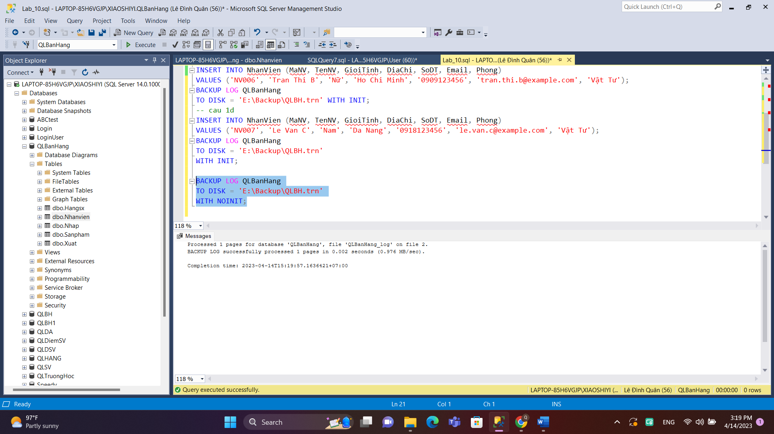

Câu2

a.

DROP DATABASE QLBanHang;

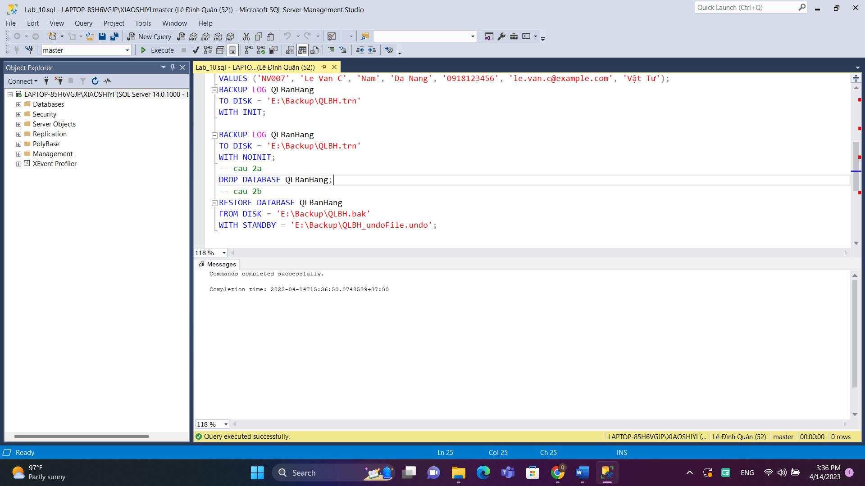

b.

RESTORE DATABASE QLBanHang

FROM DISK = 'E:\Backup\QLBH.bak'

WITH STANDBY = 'E:\Backup\QLBH_undoFile.undo';

