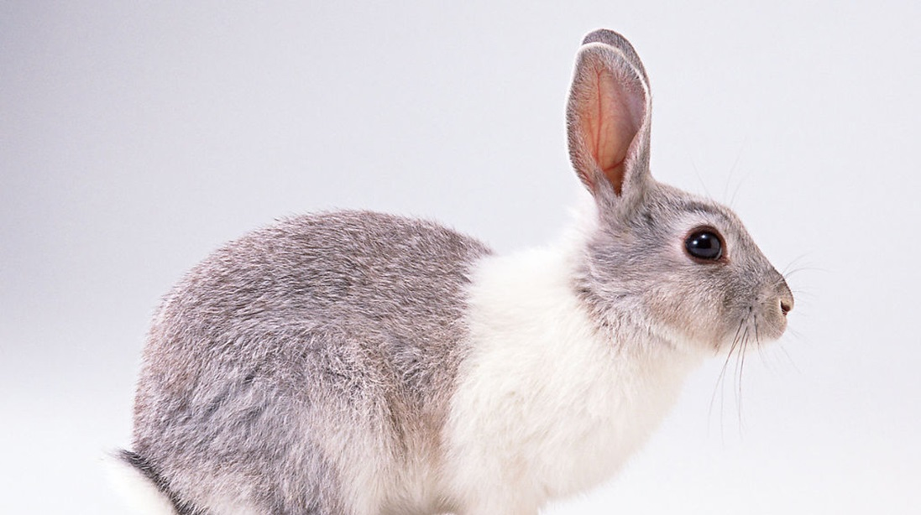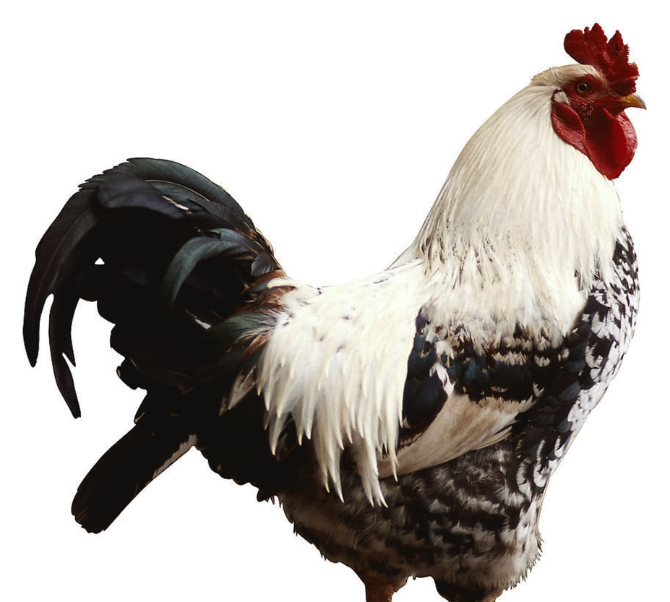

图片来源：<http://www.nipic.com/show/1/9/cd4f17e640878c18.html>

图片来源：<http://www.nipic.com/show/1/64/f1dc8549c86d2d02.html>