Face Recognition and Driver Drowsiness Alert
Trần Trọng Chinh (Team leader); Trần Quốc Việt; Nguyễn Danh Tám
Advisor: Phan Duy Hùng

Introduction

Problem and Motivation
In recent years, the increase in personal vehicles and busy travel schedules have made long driving more common. However, a major challenge that many drivers face is drowsiness while driving, especially at night or after long hours of continuous travel. This not only reduces the ability to concentrate but also increases the risk of serious traffic accidents. Driver drowsiness warning systems are emerging as a potential solution to reduce risks by detecting signs of fatigue and promptly reminding drivers. However, many current systems still have difficulty accurately recognizing the level of driver drowsiness in different real-world conditions, resulting in ineffective or annoying warnings.

Related works
Several studies have explored various approaches to driver drowsiness detection. Traditional deep learning-based methods, such as [1], applied CNN models to classify driver alertness based on facial features, but these models struggled with variations in illumination and head poses. Vision Transformers (ViT) were later introduced in [2] to improve robustness in complex environments, yet real-time processing remained a challenge.
Other studies [3] and [4] focused on using physiological indices such as the Eye Closure Ratio (ECR) and Mouth Opening Ratio (MAR) for better drowsiness detection accuracy. However, these approaches required additional sensors, increasing implementation complexity and cost. A more practical approach was introduced in [5], where image super-resolution techniques enhanced visibility in low-light conditions, improving detection performance.
Additional studies have explored non-intrusive, real-time detection methods using facial landmarks. In [6], a system was proposed that utilized an adaptable Eye Aspect Ratio (EAR) to monitor eye openness and detect drowsiness. The study also introduced a smart alarm system triggered by hand gestures, enhancing the driver's response to drowsiness alerts. Another work [7] developed a real-time detection system using Raspberry Pi and a Pi camera, achieving 90% accuracy even under dim lighting and microsleep conditions by continuously analyzing EAR values.
In contrast, our system avoids deep learning-based feature extraction and instead utilizes facial landmarks detected by Mediapipe's FaceMesh model. Key metrics such as Eye Aspect Ratio (EAR) and Mouth Aspect Ratio (MAR) are computed directly from landmark positions to classify driver drowsiness. This approach reduces dependence on high-end hardware while maintaining reliable real-time performance.

Contribution
We propose a driver drowsiness detection method using facial landmark-based feature extraction. Our approach consists of the following main steps:
- Detect facial landmarks using Mediapipe FaceMesh.
- Compute EAR and MAR to quantify eye openness and mouth movement.
- Label the data as 1 (drowsy) or 0 (not drowsy).
- Put the data set into the Logistic regression model for training.
Unlike deep learning-based methods, our approach is computationally efficient, making it feasible for deployment on low-power devices while ensuring high accuracy.

Data

Data Collection
Our dataset is collected in Kaggle. Facial landmarks are detected using Mediapipe FaceMesh, from which EAR (Eye Aspect Ratio) and MAR (Mouth Aspect Ratio) values are computed as shown in Figure 1. These measurements serve as the primary features for drowsiness classification.
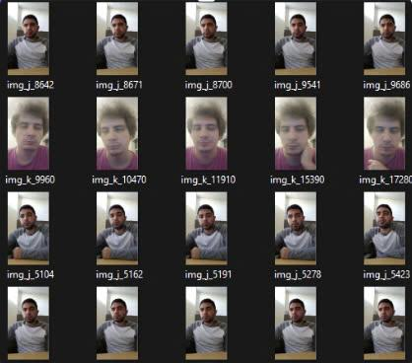
Figure 1. Image of raw data

Methodology

Problem Definition
This study aims to develop a real-time driver drowsiness detection system by leveraging facial feature analysis. Using a dataset collected from Kaggle, the system extracts Eye Aspect Ratio (EAR) and Mouth Aspect Ratio (MAR) using MediaPipe. These features are then labeled and used to train a Logistic Regression model, which classifies driver alertness based on learned patterns. By integrating data-driven insights with lightweight computational models, the system aims to provide an efficient and accurate solution for real-time drowsiness detection.

System Overview
Our system consists of the following stages:
- Data Preprocessing: Resize images, convert to grayscale, balance brightness, reduce noise and detect edges to highlight eyes and mouth.
- Facial Landmark Detection: Mediapipe FaceMesh detects facial landmarks.
- Feature Extraction: EAR and MAR are computed based on facial landmark positions.
- Model Training: Put data into the model for training.

Facial Landmark-Based Feature Extraction
Instead of using CNNs, we employ geometric calculations to extract drowsiness-related features:

Eye Aspect Ratio (EAR): Measures eye openness:
$EAR = \frac{\left|\left|p_{2}- p_{6}\right|\right| + \left|\left|p_{3}- p_{5}\right|\right|}{2 × \left|\left|p_{1}- p_{4}\right|\right|}$
where $p_{1},p_{2},p_{3},p_{4},p_{5},p_{6}$ are key landmarks around the eye. If $EAR$ falls below a threshold (0.41), the eye is considered closed.

Mouth Aspect Ratio (MAR): Measures mouth opening extent:
$MAR=\frac{\left|\left|P_{8}- p_{10}\right|\right| + \left|\left|p_{9}- p_{11}\right|\right|}{2 × \left|\left|p_{7}- p_{12}\right|\right|}$
where $p_{7},p_{8},p_{9},p_{10},p_{11},p_{12}$ are key landmarks around the mouth. If $MAR$ exceeds a threshold (0.9)
, the driver is considered yawning.

Drowsiness Classification
The extracted EAR and MAR values are used with the following predefined conditions to classify driver drowsiness:
- Drowsy condition: If the driver yawns more than 3 times per minute and EAR is consistently below 0.41, the driver is considered drowsy.
- Awake condition: If EAR remains above 0.41 or yawning frequency is low, the driver is considered awake.

Evaluation Metrics
To evaluate the performance of the driver drowsiness detection system, we use standard classification metric as shown in Figure 2:
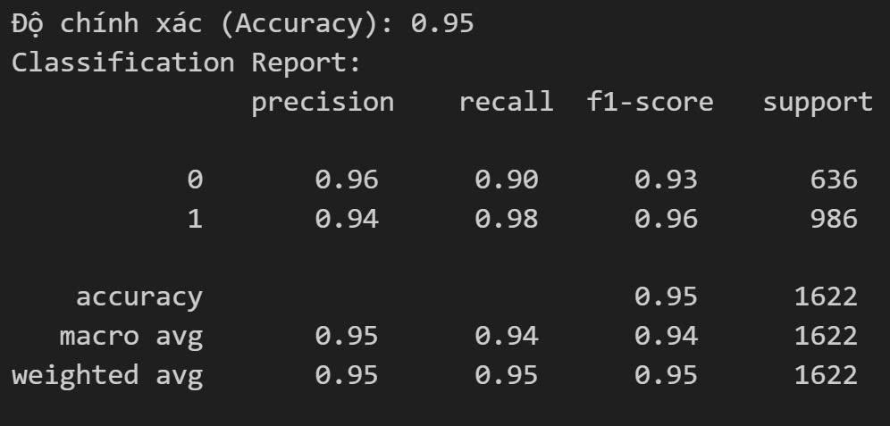
Figure 2. Model evaluation results

Experiment

Implementation Details
The system is implemented using OpenCV and Mediapipe for facial landmark detection. The threshold-based classification is computed in real-time to determine drowsiness. The system operates in a continuous loop to capture frames from a webcam and process them dynamically.

Result Analysis
Performance evaluation demonstrates that the proposed method achieves competitive accuracy compared to CNN-based approaches while significantly reducing computational requirements. The system successfully detects drowsiness in various lighting conditions and head orientations.
- Conclusion and Future Work
This study presents an efficient and lightweight driver drowsiness detection approach based on facial landmark analysis. By leveraging EAR and MAR measurements instead of deep learning-based feature extraction, our system offers real-time performance with reduced hardware requirements. Future work will focus on incorporating temporal patterns from video sequences to improve classification accuracy further.

References
- "Driver Drowsiness Detection Using Mediapipe In Python," LearnOpenCV. Available: https://learnopencv.com/driver-drowsiness-detection-using-mediapipe-in-python/.
- M. E. Elidrissi, et al., "Drivers’ drowsiness detection based on an optimized random forest classification and single-channel electroencephalogram," Int. J. Electr. Comput. Eng., vol. 13, no. 2, pp. 1234-1245, Mar. 2023.
- "Driver Fatigue and Distracted Driving Detection Using Random Forest," MDPI Appl. Sci., vol. 12, no. 17, p. 8674, 2022.
- "Drowsiness-Detection-Mediapipe," GitHub Repository. Available: https://github.com/Tandon-A/Drowsiness-Detection-Mediapipe.
- "Driver-Drowsiness-detection-using-Mediapipe," GitHub Repository. Available: https://github.com/SaiVishwa021/Driver-Drowsiness-detection-using-Mediapipe.
- J. Chandiwala, S. Agarwal, "Driver’s real-time Drowsiness Detection using Adaptable Eye Aspect Ratio and Smart Alarm System," 7th International Conference on Advanced Computing & Communication Systems (ICACCS), 2021.
- S. Sathasivam, A. Sidek, A. K. Mahamad, M. M. Som, S. Saon, H. A. Ameen, "Drowsiness Detection System using Eye Aspect Ratio Technique," IEEE Student Conference on Research and Development (SCOReD), 2020.

