TECHNICAL REPORT
How Simian Catches Duplicate Code
A structural analysis of the matching engine at the heart of the Simian Similarity Analyzer: how a tool with no idea what a “function” is still finds exact structural duplication across Java, Go, TypeScript, Python and a dozen other languages.
Subject Simian Similarity Analyzer v4.2.2 Grounded in main/com/quandarypeak/simian/*.java Verified against real simian.jar runs, not description alone

1 The problem
Simian finds blocks of source code that recur, verbatim or near-verbatim, anywhere across a set of files, in any of roughly twenty supported languages, fast enough to scan the Linux kernel source tree in minutes. It does this without ever building a parse tree. There is no AST, no control-flow graph, no notion of “function” or “class” at all in the matching engine. That is the central design decision this report explains: Simian treats a source file as nothing more than a sequence of lines, and finds duplication by comparing sequences of lines against each other using hashing, not syntax trees.
This is a deliberate trade. AST-diffing tools (structural clone detectors) can recognize duplication that survives renaming, reordering, or reformatting that a line-based tool cannot. But they need a real parser per language, and a real parser is expensive to build and to keep correct. Simian’s bet, proven over two decades of the tool’s history, is that a much cheaper line-canonicalization step, followed by a language-agnostic matching engine, catches the overwhelming majority of duplication that actually matters in a codebase, at a fraction of the engineering cost of a full compiler front end per language.
The rest of this report walks through exactly how that works: how a line of source becomes a fingerprint, how fingerprints become windows, and how windows become the duplicate-block reports you see on the command line.
2 Architecture at a glance
Simian’s implementation splits cleanly into two layers, and the split is the whole story. A front end, one per language, turns arbitrary source text into a canonical stream of classified tokens. A single matching engine, shared by every language, turns that stream into duplicate-block reports. Everything language-specific (Go’s raw strings, Python’s triple-quoted strings, TypeScript’s type annotations) is resolved before the boundary in Figure 1. Nothing past that boundary knows or cares what language it came from.
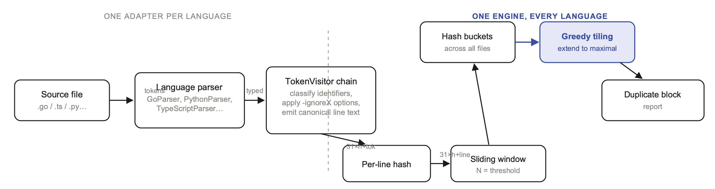
Figure 1. Everything left of the dashed line is written once per language and knows nothing about hashing. Everything right of it is written once, total, and knows nothing about syntax: it only ever sees canonical text and 64-bit numbers.
Sections 3 and 4 walk each side of that boundary in turn.
3 Layer 1: canonicalizing source into a line stream
Each language’s Parser (e.g. GoParser, PythonParser, TypeScriptParser) wraps a java.io.StreamTokenizer-style scanner configured for that language’s comment syntax, string delimiters, and word characters. For anything a plain character-oriented tokenizer would get wrong (Go’s backtick raw strings, TypeScript’s template ${literals}, Python’s triple-quoted strings), a normalising Reader sits in front of the tokenizer and rewrites those constructs onto a single line first, so a literal that spans ten physical lines still produces exactly one token instead of desynchronizing every line number after it.
The tokenizer emits a stream of typed events (visitIdentifier, visitNumber, visitString, visitPunctuation, visitComment), one line at a time, into a chain of TokenVisitor decorators (the Decorator pattern: each stage wraps the next and can rewrite or drop what passes through). The first stage that matters is classification.
3.1 Classifying identifiers without a symbol table
RecogniseIdentifiersTokenVisitor looks at a bare identifier and, using only lexical shape and a per-language keyword/type-name set, buckets it into one of four kinds (TYPE, CONSTANT, METHOD, or VARIABLE) with no symbol table and no lookahead beyond the very next token:
- In the language’s known type/keyword set → TYPE or KEYWORD directly.
- All-uppercase with at least one letter (MAX_RETRIES) → CONSTANT.
- Leading uppercase otherwise (BufferedReader) → TYPE.
- Anything else, held back until the next token is seen: an immediately-following ( makes it a METHOD, anything else makes it a VARIABLE.
WHY THIS MATTERS RIGHT NOW
This is exactly the heuristic that this branch’s two classification fixes touch. A one-character name like T is “all-uppercase” by the naive rule (no lowercase letters), so it used to fall into CONSTANT, which is wrong for a generic type parameter. The fix special-cases length-1 names to fall through to the leading-uppercase rule instead, landing on TYPE. Symmetrically, _ has no lowercase letters either, but it also has no uppercase letters; the fixed rule requires at least one actual uppercase character before calling something a constant, so _ now lands on VARIABLE. See RecogniseIdentifiersTokenVisitor.java:113.

3.2 The decorator chain: options as line transforms
Every -ignoreX command-line option is implemented as one more link in that same decorator chain: IgnoreWordsTokenVisitor, IgnoreStringsTokenVisitor, IgnoreTypeAnnotationsTokenVisitor, and a dozen others. Each one either passes a token through unchanged, rewrites it, or suppresses it entirely before it reaches the final stage, DefaultTokenVisitor, which concatenates whatever tokens survive into one canonical, single-space-normalised string per physical line.
Source line | Options active | Canonical line fed to the hasher
const tax: number = price * 0.08; | none | const tax : number = price * 0.08 ;
const tax: number = price * 0.08; | ignoreTypeAnnotations | const tax = price * 0.08 ;
const vat: string = cost * 0.08; | ignoreTypeAnnotations | const vat = cost * 0.08 ;
func GetUserGreeting(name string) | ignoreVariableNames | func GetUserGreeting ( _ string )

Table 1. The same source line, canonicalized under different option sets (illustrative).
Note the second and third rows: two lines that differ in both variable name and declared type collapse to two lines that differ only in one identifier (tax vs. vat) after type annotations are suppressed. Add ignoreVariableNames and they become byte-for-byte identical. This is the entire mechanism behind every -ignoreX flag: they never touch the matching engine. They only change what canonical text the engine is asked to compare.
A line that canonicalizes to nothing (for example, a line containing only a curly brace once ignoreCurlyBraces is active) never reaches the matching engine at all. DefaultTokenVisitor.visitEnd() checks !_line.isEmpty() before notifying the next layer, so an emptied-out line is skipped entirely: no line number is consumed, and it cannot break a run of otherwise-matching neighbours. This is why a Go import ( ... ) block or a closing brace can sit physically between two matching regions without severing the match: as far as the engine is concerned, that line never existed.
4 Layer 2: the matching engine
Everything from here on operates on one input only: a stream of (line number, canonical text) pairs, one per significant line, with no memory of which language, parser, or option produced it.
4.1 Turning a line into a number
As DefaultTokenVisitor builds the canonical text for a line, it simultaneously folds every token into a running 64-bit hash, via LineBuffer:
hash = 0
for each token t appended to the line:
hash = 31 * hash + hashOf(t)

The multiplier 31 is not incidental: it is the same constant java.lang.String.hashCode() uses, for the same reason: it is prime, small enough to be a single shift-and-subtract, and produces a well-distributing polynomial hash over token sequences. Two lines produce the same hash if and only if (modulo the vanishingly small chance of a 64-bit collision) their canonical token sequences are identical.
4.2 Fixed-width windows over the line stream
Simian never compares single lines: a one-line match is almost always coincidence (a lone closing brace, a common return null;). Instead, -threshold (default 6) sets a window width, and StreamLoader maintains a small ring buffer of in-flight windows as significant lines arrive:
- Every new significant line extends every currently open window by one more line, folding that line’s hash into the window’s running hash the same way: windowHash = 31 * windowHash + lineHash.
- A fresh window is opened at every single line position.
- Once the oldest open window has accumulated exactly threshold lines, it is sealed into an immutable Block: a (start line, end line, 64-bit hash) triple, linked to the previous sealed block from the same file.
The upshot: a file with k significant lines produces k − threshold + 1 overlapping windows, each shifted by exactly one line from its neighbour, each independently hashed.
4.3 One global table, every file
Every sealed window, from every file being scanned, is inserted into one process-wide table keyed by its 64-bit hash (BlockMap, backed by a primitive long → object map from GNU Trove specifically to avoid boxing millions of Long objects). Windows land in the same bucket if and only if their hashes match: by construction, that means their canonical content matches, regardless of which file, or where in that file, they came from. A bucket with only one window in it is not a duplicate: it is thrown away in removeNonDuplicates(). A bucket with two or more is exactly one raw “hit”: threshold consecutive lines that occur more than once.
5 From a minimal hit to a maximal block
A raw hit at the window size is rarely what gets reported. If two functions share 40 duplicated lines and threshold=6, reporting every one of the 35 overlapping 6-line hits inside that region would be useless noise. Simian instead grows each hit one line at a time, in lock-step across every occurrence, for as long as growth is possible, a process the source calls tiling (BlockMap.tile()).
Concretely: two windows that are adjacent within the same file (window at line i and the very next window, at line i+1) are fused into one SuperBlock spanning both, whose hash is 31 * hash(first) + hash(second). That fused hash is inserted into a new, one-line-wider table, and the same rule applies again: it only survives if some other occurrence produced the identical fused hash, which can only happen if that other occurrence’s underlying lines are also identical, one line further. This repeats, one line at a time, until a level is reached where nothing merges any further.
The worked example below is a real, verified run, not a hypothetical. Two files each define a method with an identical seven-line body:
// A.java and B.java: identical bodies, different class names
class A { class B {
void run() { void run() {
int total = 0; int total = 0;
for (int i = 0; i < 10; i++) { for (int i = 0; i < 10; i++) {
total += i; total += i;
} }
System.out.println(total); System.out.println(total);
return; return;
} }
} }

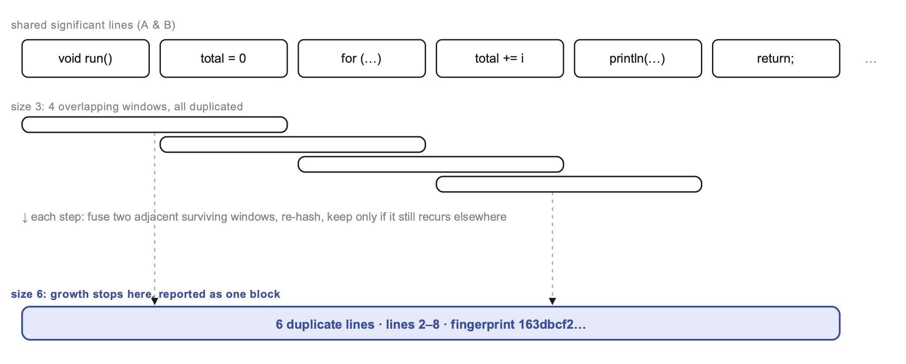
Figure 2. Real output from java -jar simian-4.2.2.jar -threshold=3 A.java B.java (curly braces ignored by default, so the closing } lines contribute zero significant lines and simply don’t interrupt the run). Growth stops at 6 lines because line 1 (class A { vs. class B {) never matched, and there is no ninth significant line to extend into. See §6 for why only this one, maximal block is printed instead of four separate 3-line reports.
6 Why the output stays quiet
A natural question about §5: tiling produces a whole ladder of intermediate levels: size 3, then 4, then 5, then 6. Does Simian print all of them? In the run behind Figure 2, it printed exactly one. The mechanism is a small piece of bookkeeping in BaseBlock, and it is worth naming because it is easy to get wrong by reasoning about the algorithm from the outside (an earlier draft of this report did, before checking the source): it is not the -ignoreOverlappingBlocks option that does this; that option is a narrower feature for a different case (§6.1).
What actually happens: the moment two adjacent size-N windows are fused into a size-(N+1) block, both parents are marked as subsumed (setParentWhenStart / setParentWhenEnd), literally “a larger match already accounts for you.” When the engine later asks a bucket of size-N blocks whether it is worth reporting (BlockCollection.isAuditable()), a block that has been subsumed says no. Because the tiling step for level N always runs before level N is asked whether to report itself, every window that successfully grew into something bigger is silently skipped at its own size; only the windows where growth actually stopped (no further identical extension exists anywhere else in the scanned files) get reported, and they get reported at exactly the size where they stopped. This is what makes the final report read as one clean 6-line block instead of a ladder of four overlapping fragments.
6.1 A different knob: -ignoreOverlappingBlocks
This option addresses a separate situation: multiple reported occurrences inside the same duplicate set whose line ranges overlap each other, for instance a pattern that repeats twice back-to-back inside one file, so the same block is detected against itself at a shifted offset. IgnoreOverlappingBlocksAuditListener filters those overlapping self-matches out of a set’s reported occurrences; it has no effect on the level-by-level subsumption behaviour described above, which is unconditional.
7 Configuration options are just alternate canonicalizations
Sections 3 and 4–6 together explain every one of Simian’s ~20 command-line options with a single sentence: everything before the boundary in Figure 1 changes what the canonical line looks like; everything after it treats that canonical line exactly the same regardless of how it got that way. -ignoreStrings, -ignoreNumbers, -ignoreVariableNames, -ignoreTypeAnnotations, Go’s raw-string normalisation, Python’s string-prefix stripping: all of them are decorators in the same TokenVisitor chain from §3.2. None of them touch Hasher, LineBuffer, BlockMap, or the tiling logic. This is also precisely why adding a new language to Simian (as this branch did, twice) never means touching the matching engine: writing a GoParser and a handful of Go-specific TokenVisitor decorators is sufficient, because the engine downstream was never language-specific to begin with.
8 Complexity, and why it scales
Let L be the total number of significant lines across every file scanned. Each line is hashed once (O(1) amortised per token). Each line opens and extends O(threshold) in-flight windows, so sealing all windows is O(L · threshold). Every sealed window is inserted into a hash table once, in O(1) amortised time. Tiling only ever processes buckets that already contain ≥ 2 blocks, so its cost is proportional to the amount of actual duplication found, not to L squared: files with no duplication cost only the initial O(L) hashing and insertion pass, never a pairwise comparison against every other file. This is the same shape of result that let much older Simian releases advertise scanning the entire Linux 2.4 kernel source (3.6 million lines) in under four minutes using well under a gigabyte of memory: the algorithm was never going to be the bottleneck; I/O and JVM startup are.
9 What this approach can’t see
The trade described in §1 has real, specific costs, and they follow directly from the mechanism:
- Reordered statements. Two functions with the same five statements in a different order hash to entirely different windows. Nothing in the engine reasons about semantic equivalence, only literal sequence.
- Indentation-insensitive languages. Simian treats every physical line as an independent unit (per PythonParser’s own documentation); it does not track Python’s INDENT/DEDENT structure. In practice this rarely matters because a real duplicate run is almost always ≥ threshold lines regardless, but it means a reported block can in principle straddle two adjacent functions rather than staying inside one, the same caveat that has always applied to brace-delimited languages, where a closing } is just another line.
- Statements split across lines differently. A logical statement broken across two physical lines in file A but one line in file B produces different line-hash sequences even though the parsed meaning is identical, unless the relevant balanceParentheses / balanceSquareBrackets option is enabled to re-join it first.
- The ternary/tuple ambiguity noted in IgnoreTypeAnnotationsTokenVisitor’s own documentation: a token-stream approach cannot always distinguish cond ? val : [a, b] (a ternary whose else-branch is an array literal) from a genuine tuple type annotation, because both look identical as a bare token sequence without a real expression parser.
None of these are bugs so much as the visible edge of the core trade-off: a token-stream-and-hash engine is enormously cheaper to extend to a new language than a full parser, at the cost of a small, well-understood set of blind spots.
10 Related techniques
Simian’s approach sits in a well-known family of line/token-shingling clone detectors, alongside tools like MOSS (winnowing: hash every k-gram, then keep only a sparse, position-independent subset of fingerprints to detect similarity even under reordering) and JPlag (explicit greedy-string-tiling over token sequences, searching for the longest common substring repeatedly). Simian’s variant is comparatively simple and exact rather than approximate: it hashes every window rather than a sampled subset (no winnowing), and it extends matches by direct hash-chain adjacency rather than by an explicit longest-common-substring search, which is what keeps it fast and memory-light, at the cost of being naturally exact-match-and-append rather than approximate-match-and-align.
11 Conclusion
Simian’s matching engine is, in essence, four ideas stacked on top of each other: hash a canonical line; slide a fixed-width window of threshold lines across every file; group windows globally by exact hash; and greedily fuse adjacent surviving windows until growth stops, reporting only what stopped. Every one of the tool’s ~20 fuzzy-matching options, and every one of its ~20 language front ends, operates entirely on the canonicalization side of that boundary and never on the matching engine itself. That separation is what let this branch add two new languages and fix four classification bugs without a single change to Hasher, BlockMap, or the tiling logic that has been running, largely unchanged, since long before either language existed as a Simian target.
A Appendix: reproducing this analysis
The worked example in Figure 2 is exact output from the actual jar built from this repository, not a fabricated transcript:
$ ./gradlew jar
$ java -jar build/libs/simian-4.2.2.jar -threshold=3 A.java B.java
Found 6 duplicate lines with fingerprint 163dbcf26398da27f2f7accddade0aa5 in the following files:
Between lines 2 and 8 in A.java
Between lines 2 and 8 in B.java
Found 12 duplicate lines in 2 blocks in 2 files
Processed a total of 14 significant (20 raw) lines in 2 files

where A.java and B.java are the two ten-line files shown in §5, identical except for their class names.

References: source locations
Concept | Location
Line hash / rolling hash | LineBuffer.java, Hasher.java
Sliding window construction | StreamLoader.java (BlockBuilder, BoundedFifoBuffer)
Global hash-bucket table | BlockMap.java, BlockCollection.java
Greedy tiling / fusion | BlockMap.tile(), SuperBlock.java
Subsumption / quiet reporting | BaseBlock.isSubsumed(), BlockCollection.isAuditable()
Overlap filtering (a different feature) | IgnoreOverlappingBlocksAuditListener.java
Identifier classification | RecogniseIdentifiersTokenVisitor.java
Option → token-visitor wiring | GoParserFactory.java, PythonParserFactory.java, TypeScriptParserFactory.java

Simian Similarity Analyzer · Apache License 2.0 · simian@quandarypeak.com

