TECHNICAL REPORT
Inside the TokenVisitor Chain
A close reading of Simian's decorator pipeline: the mechanism that turns a raw token stream into the canonical text the matching engine hashes, and a complete catalog of every visitor implemented today.
Subject Simian Similarity Analyzer v4.2.2 Grounded in main/com/quandarypeak/simian/*TokenVisitor*.java Companion to How Simian Catches Duplicate Code

1 What a visitor sees
A TokenVisitor is not handed a line of text. It is handed a sequence of typed events, one call per token, and it decides what to do with each one before the next arrives. The full interface, in TokenVisitor.java, is nine methods:
Method | Called when
visitFile() | once, before the first line of a file
visit(lineNumber) | at the start of each significant line, before its tokens
visitNumber(value) | a numeric literal, e.g. 42 or 0.08
visitIdentifier(name, type) | a bare word: a variable, type, keyword, or method name
visitString(text, type) | a string or character literal (type is the delimiter: " or ')
visitComment(text) | a comment, in whatever form the language uses
visitPunctuation(c) | a single punctuation character: ( ) { } [ ] ; , . : and so on
visitOther(s) | anything the tokenizer could not classify into the above
visitEnd() | at the end of each significant line, after its tokens

The type passed to visitIdentifier is one of six integer constants also declared on the interface: UNKNOWN, METHOD, VARIABLE, CONSTANT, TYPE, KEYWORD. A raw tokenizer only ever produces UNKNOWN; everything else is assigned later in the chain, by the one visitor whose entire job is classification (section 5).
Every concrete visitor in this codebase implements TokenVisitor indirectly, by extending DecoratorTokenVisitor, a thin base class that forwards all nine methods unchanged to a wrapped TokenVisitor called _decorated. A concrete subclass overrides only the one or two methods it actually cares about; everything else passes through for free. This is the Decorator pattern, applied uniformly, and it is what makes a chain out of what would otherwise be one large method full of option checks.
2 Construction versus execution: the twist
Every parser factory builds its chain with the same shape of code:
TokenVisitor visitor = new DefaultTokenVisitor(listener);
if (optionA) visitor = new VisitorA(visitor);
if (optionB) visitor = new VisitorB(visitor);
visitor = new RecogniseIdentifiersTokenVisitor(visitor, types, keywords);
return new SomeLanguageParser(visitor);

Read top to bottom, this looks like a pipeline where DefaultTokenVisitor runs first. It is the opposite. Each line wraps the visitor built by the line before it: VisitorA's _decorated field is DefaultTokenVisitor, VisitorB's is VisitorA, and RecogniseIdentifiersTokenVisitor's is VisitorB. The parser is handed only the last object built, RecogniseIdentifiersTokenVisitor, and calls its methods directly. So the visitor built last in the code is the one that sees every raw token first at runtime, and DefaultTokenVisitor, built first, is the one that sees each token last, after everything else has had a chance to rewrite or drop it.
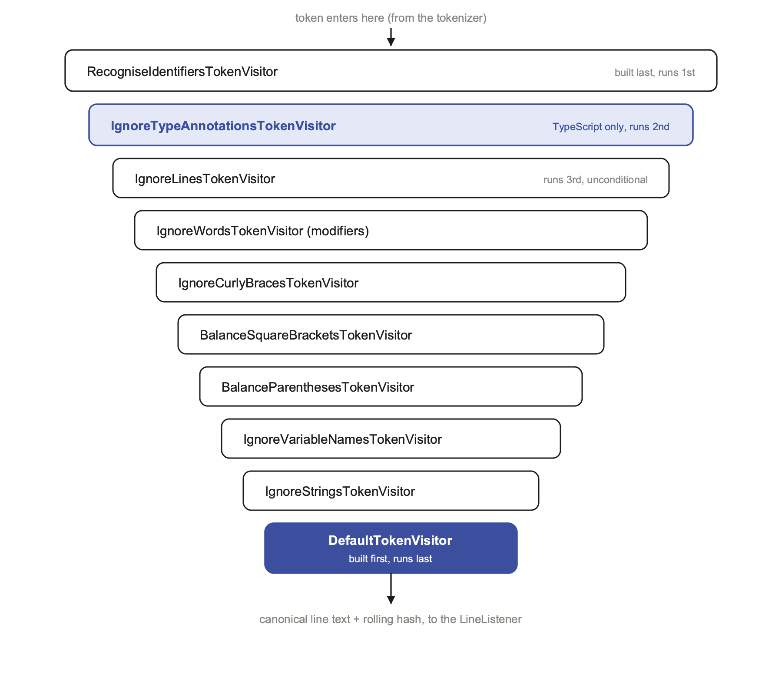
Figure 1. One representative chain (a fully optioned TypeScript file), narrowing from outermost to innermost. Each layer's visitXxx call either rewrites, drops, or passes through to the layer below. Read bottom to top and you have the construction order in TypeScriptParserFactory.createParser(); read top to bottom and you have what actually happens to a token.
3 Where a new visitor belongs
Because construction order fixes runtime order, adding a visitor to a factory is really a decision about what information it needs to already exist when it runs. Two visitors added by the language work in this repository make the opposite choice, correctly, for opposite reasons.
3.1 Needs classification: IgnoreTypeAnnotationsTokenVisitor
IgnoreTypeAnnotationsTokenVisitor decides whether a : starts a type annotation by checking whether the identifier right after it was classified as TYPE. That classification does not exist until RecogniseIdentifiersTokenVisitor has run. So in TypeScriptParserFactory, it is constructed before RecogniseIdentifiersTokenVisitor, which places it just inside that layer, meaning it runs just after it: it always receives already-typed tokens.
3.2 Needs raw text: StripPythonStringPrefixTokenVisitor
StripPythonStringPrefixTokenVisitor decides whether an identifier like rb is a string prefix by checking its raw spelling, and whether it is immediately followed by a string token. It does not need to know how RecogniseIdentifiersTokenVisitor would have classified rb, and if it ran after classification, a stray one or two letter prefix could already have been folded into a VARIABLE or CONSTANT decision it has no use for. So in PythonParserFactory, it is constructed after RecogniseIdentifiersTokenVisitor, making it the true outermost layer: it sees every identifier before anything else does, prefix or not.
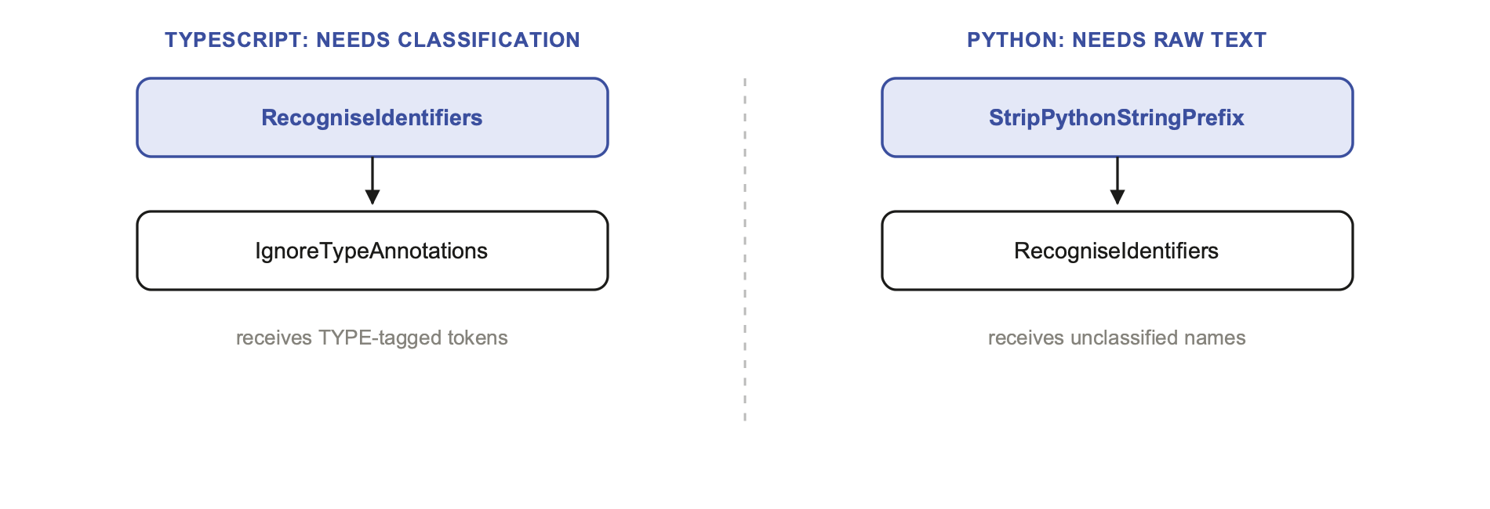
Figure 2. Same base class, opposite placement. A visitor that reads a token's classification sits above RecogniseIdentifiersTokenVisitor in construction order (inside it at runtime); a visitor that only reads lexical shape can sit below it in construction order (outside it, and first, at runtime).
4 Replace, do not delete
Most of the ignore visitors do not remove a token from the stream. If they did, the tokens on either side would become adjacent in the canonical line where they never were in the source, which can create or destroy a match by accident. Instead, they call visitPunctuation with a fixed placeholder character, so the token's position in the line survives even though its content does not.
Visitor | Replaces | With
IgnoreNumbersTokenVisitor | a numeric literal | #
IgnoreStringsTokenVisitor | a double-quoted string's contents | "
IgnoreCharactersTokenVisitor | a character literal's contents | '
IgnoreVariableNamesTokenVisitor | an identifier classified VARIABLE | _
IgnoreIdentifiersTokenVisitor | any identifier not classified KEYWORD | _
IgnoreLiteralsTokenVisitor | a number or a string, both | _

A DISTINCTION THAT ONLY SHOWS UP COMBINED
IgnoreLiteralsTokenVisitor is what runs when -ignoreLiterals is set, and it is used instead of IgnoreNumbersTokenVisitor and IgnoreStringsTokenVisitor, never alongside them (see AsbtractParserFactory.java:24). It maps both a number and a string to the same placeholder, _. Turn on -ignoreNumbers and -ignoreStrings separately instead, and a numeric literal's position still reads as # while a string's reads as ", two different placeholders. That means two lines differing only in whether a literal was a string or a number can still be told apart under the separate options, but collapse together under -ignoreLiterals. It is a small, verified difference in what ignore literals buys you compared to combining the two narrower flags.

5 Classifying identifiers: the one-token lookahead
RecogniseIdentifiersTokenVisitor is the one visitor every language factory constructs (almost) last, and its classification work was covered structurally in the companion report. What is worth adding here is exactly how it tells a method call from a plain variable, since it is the one decision on this list that cannot be made from the identifier's spelling alone: it needs to see one token ahead.
When visitIdentifier receives a name that is not a known type, not a keyword, not all-uppercase, and does not start with an uppercase letter, it does not forward the call yet. It stores the name in a single pending-name field and waits. Whatever event arrives next decides its fate:
- If the very next call is visitPunctuation('('), the pending name is forwarded as METHOD: it was a call, or a declaration, immediately followed by an argument list.
- If the next call is anything else, the pending name is flushed as VARIABLE first, and that other event is then processed normally.
The flush is implemented once, in a private xxx() method, and called from every event handler that is not visitPunctuation: visitNumber, visitString, and visitEnd all call it before doing their own work. That last case matters: a name that is the very last token on a line (for example, a bare variable reference with nothing after it) is flushed as VARIABLE by visitEnd(), since there is no following ( and never will be one on that line.
6 Watching it happen: one line, three ways
Everything so far has been read from the source. This section is different: it is captured output from actually running the classes described above, not a description of what they should do. The method was to write a small harness in the same package (so it can reach the package-private classes directly), reconstruct the exact TypeScript chain from sections 2 and 3 by hand, insert a logging decorator at two seams, run it, and delete the harness afterward. The commands are in the appendix.
6.1 From source text to raw tokens
The line is const tax: number = price * 0.08;, from billing.ts in the companion report. Handed to TypeScriptParser with no decorators at all attached, an implementation of TokenVisitor that only logs sees exactly this, in order:
visit(1)
visitIdentifier("const", UNKNOWN)
visitIdentifier("tax", UNKNOWN)
visitPunctuation(':')
visitIdentifier("number", UNKNOWN)
visitPunctuation('=')
visitIdentifier("price", UNKNOWN)
visitPunctuation('*')
visitNumber(0.08)
visitEnd()

Two things worth noticing, both verified directly against TypeScriptParser.parse(): every identifier arrives as UNKNOWN, since classification has not happened yet at this stage; and the trailing ; never appears as a token at all. TypeScriptParser calls tokenizer.whitespaceChars(';', ';') before tokenising, so a semicolon is discarded as whitespace before any TokenVisitor, decorator or otherwise, ever sees it. The :, by contrast, is ordinary punctuation and does reach the chain, which is exactly what gives IgnoreTypeAnnotationsTokenVisitor something to intercept in section 6.3.
6.2 The same two lines, three option sets, three fingerprints
Table 1 in section 3 claimed that const tax: number = ... and const vat: string = ... become fingerprint-identical once both ignoreTypeAnnotations and ignoreVariableNames are active. Here is that claim run for real, printing the exact canonical text DefaultTokenVisitor builds and the exact 64-bit value LineBuffer.getLineHash() returns for it:
Options | Line | Canonical text | Hash
defaults only | tax line | tax:number=price*0.08 | −853441943700094
defaults only | vat line | vat:string=cost*0.08 | −720350292591412
+ ignoreTypeAnnotations | tax line | tax=price*0.08 | 208605722995
+ ignoreTypeAnnotations | vat line | vat=cost*0.08 | 110553218933
+ ignoreVariableNames | tax line | _=_*0.08 | 91120061
+ ignoreVariableNames | vat line | _=_*0.08 | 91120061

The first two option sets still produce two different 64-bit numbers, because tax/vat and, in the first row, number/string are still literally different characters feeding the same 31 times hash plus tokenHash accumulation. Only in the third row, once IgnoreVariableNamesTokenVisitor has replaced both variable names with the same placeholder, do the canonical strings become byte-for-byte identical, _=_*0.08, and the hash follows deterministically: same input string to Hasher.hash, same output. This is what two lines fingerprint the same means in the most literal sense available: not a similarity score, an equality of a signed 64-bit integer.
6.3 Three seams in one pass
The trace below instruments the real chain at two points: immediately as tokens leave RecogniseIdentifiersTokenVisitor (seam A, already classified, not yet touched by type-annotation suppression or variable-name replacement), and immediately as tokens leave IgnoreVariableNamesTokenVisitor (seam B, downstream of every other stage in this configuration). Both fire while processing the single line const tax: number = price * 0.08; under ignoreTypeAnnotations and ignoreVariableNames:
[seam A] visitIdentifier("const", KEYWORD)
[seam A] visitIdentifier("tax", VARIABLE)
[seam B] visitPunctuation('_')
[seam A] visitPunctuation(':')
[seam A] visitIdentifier("number", TYPE)
[seam A] visitPunctuation('=')
[seam B] visitPunctuation('=')
[seam A] visitIdentifier("price", VARIABLE)
[seam B] visitPunctuation('_')
[seam A] visitPunctuation('*')
[seam B] visitPunctuation('*')
[seam A] visitNumber(0.08)
[seam B] visitNumber(0.08)

DefaultTokenVisitor builds: _=_*0.08
final hash: 91120061

Read the two columns against each other and the whole chain becomes legible in one pass. const reaches seam A classified KEYWORD, and then simply never appears at seam B at all: it is a member of the TypeScript MODIFIERS set, so IgnoreWordsTokenVisitor (running between the two seams) drops it outright. The : and number reach seam A as ordinary tokens, one of them now classified TYPE, and likewise never reach seam B: IgnoreTypeAnnotationsTokenVisitor, which also runs between the two seams, buffered the colon and swallowed the whole annotation once it saw a TYPE-classified identifier follow it (section 6.1 explains why the colon survives long enough to be caught here at all: it is real punctuation, not whitespace). tax and price both reach seam A classified VARIABLE, and at seam B they have already become visitPunctuation('_'), the replace-do-not-delete idiom from section 4 caught in the act. Only the arithmetic that survives every filter, = * 0.08, reaches both seams unchanged, and it is what DefaultTokenVisitor is left holding at the end of the line.
WHAT THIS DOES AND DOES NOT PROVE
This is one line, one language, one option combination. It is not a substitute for the general rules in sections 2 through 5, which hold across every visitor and every factory; it is a single concrete instance of them, chosen because it is the same example already used illustratively in section 3's Table 1, now backed by numbers instead of assertions.

7 The full catalog
Every TokenVisitor implementation in the codebase today, grouped by role. Toggle names the command-line option that constructs it, where one exists; always on means the language factory constructs it unconditionally.
Visitor | Role | Toggle
Infrastructure
DecoratorTokenVisitor | pass-through base class every concrete visitor extends | n/a
DefaultTokenVisitor | terminal stage: assembles the canonical line and its rolling hash, notifies the LineListener | always on
RecogniseIdentifiersTokenVisitor | classifies bare identifiers into TYPE, CONSTANT, METHOD, or VARIABLE | always on
Fuzzy matching: literals
IgnoreNumbersTokenVisitor | replaces numeric literals with # | -ignoreNumbers
IgnoreStringsTokenVisitor | replaces string contents with " | -ignoreStrings
IgnoreStringCaseTokenVisitor | lower-cases string contents | -ignoreStringCase
IgnoreCharactersTokenVisitor | replaces character literals with ' | -ignoreCharacters
IgnoreCharacterCaseTokenVisitor | lower-cases character literals | -ignoreCharacterCase
IgnoreLiteralsTokenVisitor | replaces both numbers and strings with _ (used instead of the three rows above) | -ignoreLiterals
Fuzzy matching: identifiers
IgnoreIdentifierCaseTokenVisitor | lower-cases every identifier | -ignoreIdentifierCase
IgnoreVariableNamesTokenVisitor | replaces VARIABLE-classified names with _ | -ignoreVariableNames
IgnoreSubtypeNamesTokenVisitor | trims a TYPE name to its last capitalised segment (BufferedReader to Reader) | -ignoreSubtypeNames
IgnoreIdentifiersTokenVisitor | replaces every non-KEYWORD identifier with _ (used instead of the three rows above) | -ignoreIdentifiers
IgnoreTypeAnnotationsTokenVisitor | suppresses a : and the type expression that follows it, including generics and tuples | -ignoreTypeAnnotations (TS)
Fuzzy matching: structure
IgnoreCurlyBracesTokenVisitor | drops { and } entirely | -ignoreCurlyBraces
IgnoreWordsTokenVisitor | drops any identifier in a supplied word set (one class, reused with a different set per language: modifiers, in every factory) | -ignoreModifiers
IgnoreLinesTokenVisitor | suppresses an entire line if any trigger word appears on it (imports, packages, and reused by C# for #region/#endregion) | always on, per language
IgnoreBlocksTokenVisitor | suppresses everything between a configured start and end marker, comment-delimited, with nesting support | -ignoreBlocks=START:END
Line balancing
BalanceBracketsTokenVisitor | shared base: suppresses the line-boundary events while a configured bracket pair is unbalanced, so a split expression reads as one logical line | n/a
BalanceParenthesesTokenVisitor | BalanceBracketsTokenVisitor for ( ) | -balanceParentheses
BalanceSquareBracketsTokenVisitor | BalanceBracketsTokenVisitor for [ ] | -balanceSquareBrackets
BalanceCurlyBracesTokenVisitor | BalanceBracketsTokenVisitor for { } (documented; see section 8) | -balanceCurlyBraces
Language-specific
StripPythonStringPrefixTokenVisitor | drops a Python string-prefix identifier (f, b, r, rb...) when immediately followed by a string | Python, always on
RecogniseRubyBlockCommentKeywordsTokenVisitor | reclassifies =begin / =end as KEYWORD, and splits any other =-joined identifier apart | Ruby, always on
RecogniseIbmLanguageStringsTokenVisitor | recognises System/360 Assembler self-defining terms and literals that a generic tokenizer sees as opaque other tokens | IBM Assembler, always on

8 One primitive, two purposes
IgnoreLinesTokenVisitor is the plainest visitor in the catalog: it watches for a trigger word, and if one appears anywhere on a line, the whole line is dropped when visitEnd() would otherwise fire. Every C-family factory constructs it unconditionally, with a small, fixed per-language word set: import and package for Java and Go, just import for TypeScript, require and require_gem for Ruby.
CSharpParserFactory reuses that exact mechanism for a second, unrelated purpose. Its default trigger set adds the literal strings #region and #endregion, so a region marker line is unconditionally dropped the same way an import line is. When -ignoreRegions or -ignoreBlocks is explicitly set, C# switches those two words back out of the trigger set and instead wraps the LineListener itself in an IgnoreBlocksLineListener, a different, adjacent mechanism (it is a LineListener decorator, not a TokenVisitor) that suppresses every line strictly between a start and end marker rather than only the marker lines themselves. The plain word-trigger version and the range-aware version answer two different questions, does this line mention #region versus am I currently inside one, and C# needs the cheap one by default and the precise one on request.
9 A visitor that is never built
VERIFIED, NOT ASSUMED
BalanceCurlyBracesTokenVisitor exists as a class, and Option.BALANCE_CURLY_BRACES exists as a settable option (reachable from the Ant task API in SimianCheck.java), and the README documents balanceCurlyBraces as a Ruby-only feature. But a repository-wide search for its constructor, new BalanceCurlyBracesTokenVisitor(, returns zero matches under main/. No parser factory, including RubyParserFactory, ever builds one. Setting -balanceCurlyBraces+ today parses without error and silently does nothing, because the option value is never read by anything that constructs a visitor chain.

This is worth stating plainly rather than glossing over, because it is exactly the kind of gap that is invisible from the README and only visible from the wiring code: a class can be complete, tested in isolation, and still be unreachable from any command line invocation. BalanceParenthesesTokenVisitor and BalanceSquareBracketsTokenVisitor, its siblings under the same BalanceBracketsTokenVisitor base, are both wired in (sections 6 and 9); only the curly-brace variant is not.
10 Per-language wiring, side by side
Every factory shares two building blocks, AsbtractParserFactory.createBaseLanguageTokenVisitor(listener, options) for the option-driven core, and AbstractCFamilyParserFactory's overload of the same name for the C-family layer on top of it (square brackets, curly braces, modifiers, line triggers). What differs per language is the word sets passed in, and what gets added outside that shared shell.
Language | Added outside the shared shell | Constructed
Java | n/a | RecogniseIdentifiers
Go | n/a | RecogniseIdentifiers
TypeScript | tuple/generic-aware type suppression | IgnoreTypeAnnotations, then RecogniseIdentifiers
Python | string-prefix stripping, wrapped around everything | RecogniseIdentifiers, then StripPythonStringPrefix
Ruby | block-comment keyword recognition, plus a LineListener wrapper for =begin/=end | RecogniseIdentifiers, then RecogniseRubyBlockCommentKeywords
C# | region markers folded into the line-trigger set, or a LineListener wrapper on request | RecogniseIdentifiers

The Constructed column reads left to right in construction order, which by section 2's rule means right to left in execution order. Python is the outlier worth re-reading against Figure 2: it is the one language where a visitor is added strictly outside RecogniseIdentifiersTokenVisitor, because prefix-stripping is a lexical concern, not a classification-dependent one.
11 Conclusion
The chain is small in its parts and large in its combinations. Every concrete class does one narrow thing: drop a token, replace it with a fixed placeholder, lower-case it, buffer it for one step, or gate a whole line or block on a running state machine. None of them know about hashing, windows, or tiling; that is the matching engine's job, described in the companion report. What this report adds is the piece that only shows up once you read the factories side by side: placement in the chain is not cosmetic. It is a direct, checkable claim about what information a visitor needs already computed, and getting it backward either breaks the feature outright or, as with -balanceCurlyBraces, leaves an option that parses cleanly and does nothing at all.
A Appendix: verification log
Every claim in this report that depends on wiring, not just on one file's contents, was checked directly rather than inferred:
$ grep -rn "new BalanceCurlyBracesTokenVisitor" main/
(no output: confirms section 9)

$ grep -n "createParser" main/com/quandarypeak/simian/*ParserFactory.java
(read to confirm the construction order in the table, section 10)

Section 6's traces were produced by a small harness, TraceHarness.java, written directly into main/com/quandarypeak/simian/ so it could reach the package-private classes, then compiled against the already-built classes and removed once the output above was captured:
$ ./gradlew jar
$ javac -cp build/classes/java/main -d /tmp/simian-trace-out \
main/com/quandarypeak/simian/TraceHarness.java
$ java -cp "build/classes/java/main:/tmp/simian-trace-out" \
com.quandarypeak.simian.TraceHarness
(the exact output printed in section 6.1 through 6.3)

$ rm main/com/quandarypeak/simian/TraceHarness.java

References: source locations
Concept | Location
The interface and its classification constants | TokenVisitor.java
The decorator base class | DecoratorTokenVisitor.java
Shared chain assembly | AsbtractParserFactory.java, AbstractCFamilyParserFactory.java
Per-language wiring examples | JavaParserFactory.java, GoParserFactory.java, TypeScriptParserFactory.java, PythonParserFactory.java, RubyParserFactory.java, CSharpParserFactory.java
Identifier classification and the lookahead buffer | RecogniseIdentifiersTokenVisitor.java
Type-annotation suppression | IgnoreTypeAnnotationsTokenVisitor.java
Python prefix stripping | StripPythonStringPrefixTokenVisitor.java
Bracket balancing base and the unwired sibling | BalanceBracketsTokenVisitor.java, BalanceCurlyBracesTokenVisitor.java
Block-marker state machine | BlockMarkerState.java, used by both IgnoreBlocksTokenVisitor and IgnoreBlocksLineListener

Simian Similarity Analyzer · Apache License 2.0 · simian@quandarypeak.com

