Diagram

Data transfer from esp8266 to laptop
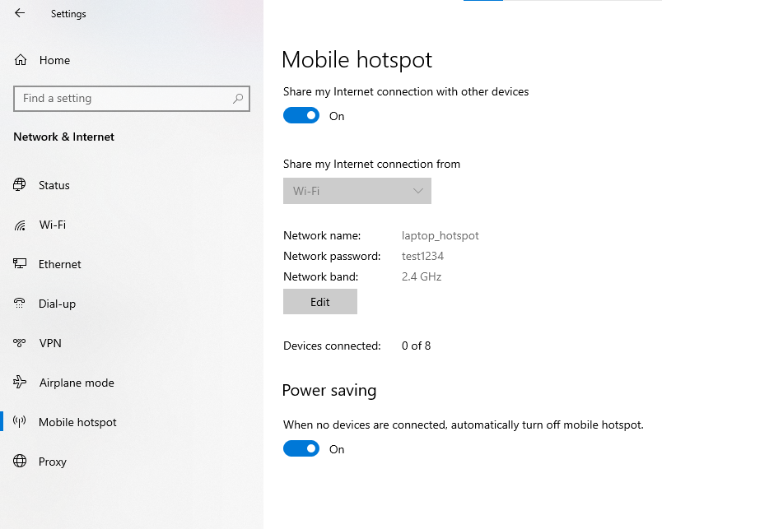
- Set up wifi hotspot on laptop, and setup a python server program to bind it to this hotspot.
- Esp will need to connect to the wifi hotspot to join the network first and then it can connect to the server.
Note: when esp trys to join network, VPN on laptop can block Dynamic host configuration protocol on laptop to give esp a IP address. We can make esp assign to itself IP address and register them to WIFI network.

Use mDNS avahi on rasberry-pi for laptop to ssh to raspberry-pi

Hardware
Driver TB6612FNG + motor JGB37-520: 22 rounds in 5 seconds

