### 4.2.1. Functional Requirements

#### 4.2.1.1. Menu Management

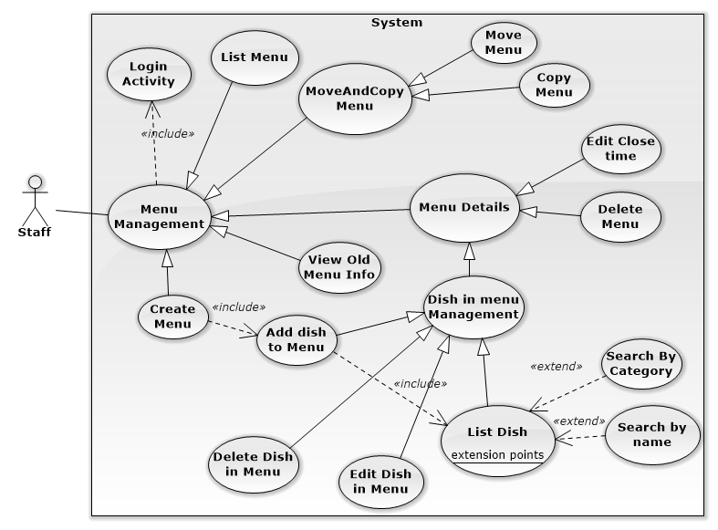

#### 4.2.1.1.1 List Menu:

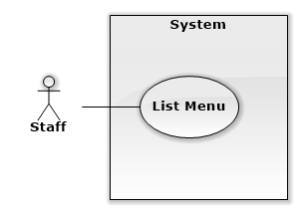

| **USE CASE SPECIFICATION** | | | |
| --- | --- | --- | --- |
| **Use-case No.** | UC001 | **Use-case Version** | 2.0 |
| **Use-case Name** | List Menu | | |
| **Author** | Trương Quang Bảo | | |
| **Date** | 17/03/2014 | **Priority** | High |
| **Actor:**  Staff  **Summary:**  List all menu in calendar  **Goal:**  The purpose of Show Dish Category use case is allowed staff view all menu by time  **Triggers:**  Trigger when Staffclick “Menu” in menu bar.  **Preconditions:**  User must log in with role “Staff”.  **Post Conditions:**  **Success:**   * Show Calendar page * Show all Menu in Calendar with right time.   **Failure:**   * Page not load, system show Error page. * Menu not show in calendar screen or show with wrong time.   **Main Success Scenario:**   |  |  | | --- | --- | | Actor Actions | System Response | | 1. Staff click “Menu” in left sidebar.  [Exception 1] | 2. Redirect to “Calendar” page. Show all menu by time in calendar |   **Alternative Scenario:**   |  |  | | --- | --- | | Actor Actions | System Response | | * N/A | * N/A |   **Exceptions:**   |  |  | | --- | --- | | Actor Actions | System Response | | [Exception 1]  1. System fails to load data. | 2. Show Error page. |   **Relationships:**   * Create Menu Use case. * Menu Details Use case. * Suggest Menu Use case.   **Business Rules:**   * One day not contain more than one menu. | | | |

#### 4.2.1.1.2 Create Menu:

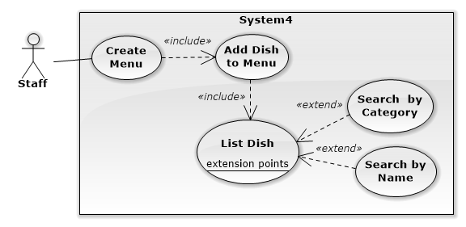

| **USE CASE SPECIFICATION** | | | |
| --- | --- | --- | --- |
| **Use-case No.** | UC002 | **Use-case Version** | 2.0 |
| **Use-case Name** | Create Menu | | |
| **Author** | Trương Quang Bảo | | |
| **Date** | 17/03/2014 | **Priority** | High |
| **Actor:**  Staff  **Summary:**  Staff create new menu and add dish to this menu.  **Goal:**  The purpose of Create Dish Category use case is allowed staff insert a new menu and add dish to menu for convenience way.  **Triggers:**  Trigger when Staff click date field in calendar, add dish and click “lưu” button.  **Preconditions:**  User must log in with role “Staff”.  **Post Conditions:**  **Success:**   * New Menu insert into database and display on calendar page with right date.   **Failure:**   * System show error message on screen.   **Main Success Scenario:**   |  |  | | --- | --- | | Actor Actions | System Response | | 1. Staff click date field at present time or future in calendar.  3. Staff drag dish from field “Món Ăn” and drop it in field “Menu”.  [Alternative 1] [Alternative 2] [Alternative 3] [Alternative 4]  5. Click “lưu” button  [Alternative 5][Alternative 6][Exception 3] | 2. Show Create menu popup model include:   * Left field name “Món Ăn” show all dish with name and imgae. * [DishCategory: dropdown list, string ]. * [SearchbyName:textbox, string]. * Right field name “Menu” for drop dish into. * “Xuất hiện đến: [ClosedTimeSession: datetime picker,datetime].   4. Dish disappear in “Món Ăn” and appear in “Menu”  6. Redirect calendar page. New menu appear in calendar with right date apply. |   **Alternative Scenario:**   |  |  | | --- | --- | | Actor Actions | System Response | | [Alternative 1]  1. Staff click button “đóng”  [Alternative 2]  1. Staff chose category in category filter dropdown list.  [Alternative3]  1. Staff types in “Tìm kiếm theo tên” textbox.  [Alternative 4]  1. Staff input close time session in “Xuất hiện đến” textbox and click button “lưu”.  [Alternative 5]  1. Staff click button “sửa” beside price of dish in menu field.  3. Staff input price(x) and click button “Ok”.  [Exceptions 1]  [Alternative 6]  1. Staff click button “sửa” beside quota of dish in menu field.  3. Staff input quota(x) and click button “Ok”.  [Exceptions 2] | 2.Close popup, do nothing.  2.Show dish with suitable category filter conditions.  2. Show dish with suitable name filter conditions.  2.Create new menu with close time session inputed.  2.Show prompt edit price [Textbox, positive integer].  4.System show success message “Giá của món ăn đã được đổi thành x”.  2.Show prompt edit quota [Textbox, positive integer].  4.System show success message “Số lượng của món ăn đã được đổi thành x” |   **Exceptions:**   |  |  | | --- | --- | | Actor Actions | System Response | | [Exceptions 1]  1.Input price isn’t a number or less than 1.  [Exceptions 2]  1.Input quota isn’t a number or less than 1.  [Exceptions 3]  1.No dish in field “Menu” | 2.System show error message:” Dữ liệu không đúng, giá của món ăn phải là số nguyên dương!”.  2.System show error message:” Dữ liệu không đúng, số lượng của món ăn phải lớn hơn 1!”.  2.System show message:”Cần có ít nhất một món ăn trong menu” |   **Relationships:**  **-** List Dish Use case.  **-** Create Menu Use case.  **-** Menu Management Use case.  **Business Rules:**  - Can’t create Menu at past time.  - Menu has least one dish. | | | |

#### 4.2.1.1.3. Menu Details:

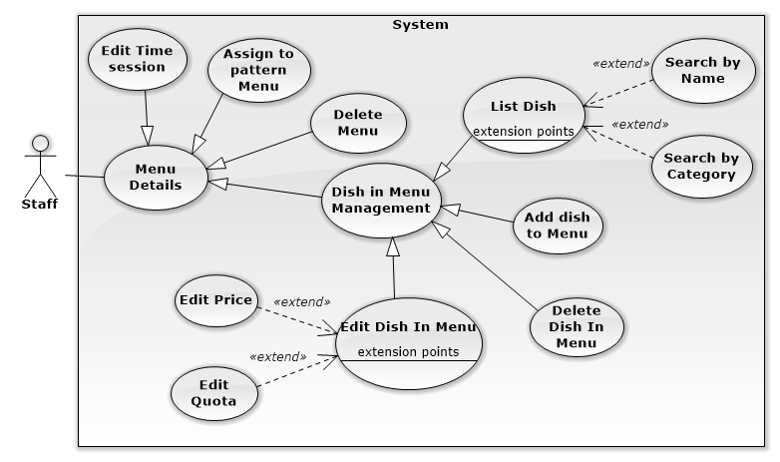

#### 4.2.1.1.3.1 Edit Time Close Session:

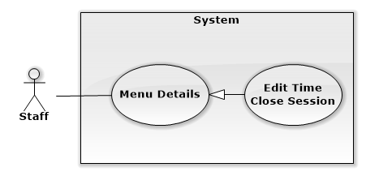

| **USE CASE SPECIFICATION** | | | |
| --- | --- | --- | --- |
| **Use-case No.** | UC003 | **Use-case Version** | 2.0 |
| **Use-case Name** | Edit Time Close Session | | |
| **Author** | Trương Quang Bảo | | |
| **Date** | 18/03/2014 | **Priority** | Low |
| **Actor:**  Staff  **Summary:**  Helps staff edit time close session of Menu.  **Goal:**  The purpose of Edit time close session Use case is allowed staff can edit success time start of menu.  **Triggers:**  Trigger when Staff click menu item at present or future day in calendar and edit close time session.  **Preconditions:**  **-** User must log in with role “Staff  - Has least one menu at present or future day in calendar.  **Post Conditions:**  **Success:**   * Time close session change in Menu Details popup.   **Failure:**   * System show error message in screen.   **Main Success Scenario:**   |  |  | | --- | --- | | Actor Actions | System Response | | 1.Staff click menu at present or future date in calendar.  3. Input time close session info. | 2. Show Menu Details popup model include:   * Left field name “Món Ăn” show all dish not in menu. * Dish item not in Menu include: dish name[text], dish image[image]. * Right field name “Menu” show all dish in menu. * Dish item in Menu include: dish name[text], dish image[image], dish price[label], dish quota[label]. * “Xuất hiện đến: [ClosedTimeSession: datetime picker,datetime]. * [DishCategory: dropdown list, string ].   4. Time close session change in screen. Show success message. |   **Alternative Scenario:**   |  |  | | --- | --- | | Actor Actions | System Response | | N/A | N/A |   **Exceptions:**   |  |  | | --- | --- | | Actor Actions | System Response | | N/A | N/A |   **Relationships:**  - N/A  **Business Rules:**   * N/A | | | |

#### 4.2.1.1.3.2 Assign to pattern Menu:

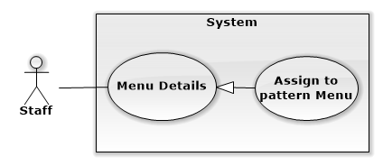

| **USE CASE SPECIFICATION** | | | |
| --- | --- | --- | --- |
| **Use-case No.** | UC004 | **Use-case Version** | 2.0 |
| **Use-case Name** | Assign to pattern Menu | | |
| **Author** | Trương Quang Bảo | | |
| **Date** | 18/03/2014 | **Priority** | Low |
| **Actor:**  Staff  **Summary:**  Helps staff assign Menu to pattern Menu.  **Goal:**  The purpose of this Use case is allowed staff can assign Menu to pattern Menu. After that, staff can use pattern Menu for copy Menu function.  **Triggers:**  Trigger when Staff click menu item in calendar and click button “Xuất”.  **Preconditions:**  -User must log in with role “Staff  - Has least one menu in calendar.  **Post Conditions:**  **Success:**   * Menu selected appear in “Menu Mẫu”.   **Failure:**   * System show error message in screen.   **Main Success Scenario:**   |  |  | | --- | --- | | Actor Actions | System Response | | 1. Staff click menu in calendar.  2. Click button “Mẫu”. | 2. Show Menu Details popup model or Old Menu info popup model.  4. Reload page. This Menu appear in field “Menu Mẫu. |   **Alternative Scenario:**   |  |  | | --- | --- | | Actor Actions | System Response | | N/A | N/A |   **Exceptions:**   |  |  | | --- | --- | | Actor Actions | System Response | | N/A | N/A |   **Relationships:**   * N/A   **Business Rules:**   * N/A | | | |

#### 4.2.1.1.3.3 Delete Menu:

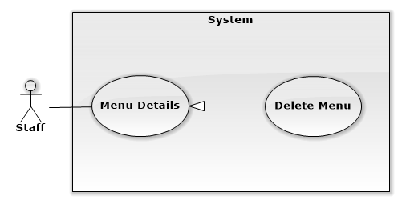

| **USE CASE SPECIFICATION** | | | |
| --- | --- | --- | --- |
| **Use-case No.** | UC005 | **Use-case Version** | 2.0 |
| **Use-case Name** | Delete Menu | | |
| **Author** | Trương Quang Bảo | | |
| **Date** | 18/03/2014 | **Priority** | Normal |
| **Actor:**  Staff  **Summary:**  Helps staff delete Menu.  **Goal:**  The purpose of Delete Menu Use case is allowed staff can delete Menu and all dish in this Menu.  **Triggers:**  Trigger when Staff click menu item at present or future day in calendar and click button “Xóa”  **Preconditions:**  - User must log in with role “Staff  - Has least one menu in calendar.  **Post Conditions:**  **Success:**   * Reload page, Menu disappear in page calendar.   **Failure:**   * System show error message in screen.   **Main Success Scenario:**   |  |  | | --- | --- | | Actor Actions | System Response | | 1. menu item at present or future day in calendar.  3. Click button “Xóa”. | 2. Show Menu Details popup model include:   * Left field name “Món Ăn” show all dish not in menu. * Dish item not in Menu include: dish name[text], dish image[image]. * Right field name “Menu” show all dish in menu. * Dish item in Menu include: dish name[text], dish image[image], dish price[label], dish quota[label]. * “Xuất hiện đến: [ClosedTimeSession: datetime picker,datetime]. * [DishCategory: dropdown list, string ].   4. Reload page. Menu disappear in calendar page. |   **Alternative Scenario:**   |  |  | | --- | --- | | Actor Actions | System Response | | N/A | N/A |   **Exceptions:**   |  |  | | --- | --- | | Actor Actions | System Response | | N/A | N/A |   **Relationships:**   * Dish in Menu Management   **Business Rules:**   * Can’t delete Menu in past. | | | |

#### 4.2.1.1.3.4 Dish in Menu Management:

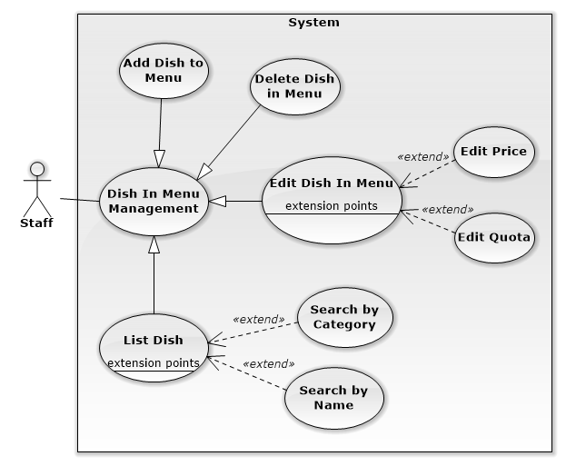

#### 4.2.1.1.3.4.1 List Dish:

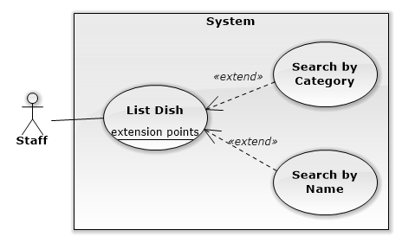

| **USE CASE SPECIFICATION** | | | |
| --- | --- | --- | --- |
| **Use-case No.** | UC006 | **Use-case Version** | 2.0 |
| **Use-case Name** | List Dish | | |
| **Author** | Trương Quang Bảo | | |
| **Date** | 18/03/2014 | **Priority** | High |
| **Actor:**  Staff  **Summary:**  Help staff see list dish in menu and not in menu.  **Goal:**  The purpose of List Dish Use case is show for staff all dish not in Menu and all dish in Menu.  **Triggers:**  Trigger when Staff click menu item in calendar.  **Preconditions:**  - User must log in with role “Staff  - Has least one menu in calendar.  **Post Conditions:**  **Success:**   * Show Menu Details popup.   **Failure:**   * System show error message in screen.   **Main Success Scenario:**   |  |  | | --- | --- | | Actor Actions | System Response | | 1. Staff click menu in calendar.  [Alternative 1][Alternative 2] | 2. Show Menu Details popup model include:   * Left field name “Món Ăn” show all dish not in menu. * Dish item not in Menu include: dish name[text], dish image[image]. * Right field name “Menu” show all dish in menu. * Dish item in Menu include: dish name[text], dish image[image], dish price[label], dish quota[label]. * “Xuất hiện đến: [ClosedTimeSession: datetime picker,datetime]. * [DishCategory: dropdown list, string ]. |   **Alternative Scenario:**   |  |  | | --- | --- | | Actor Actions | System Response | | [Alternative 1]  1. Staff chose category in category filter dropdown list.  [Alternative 2]  1. Staff types in “Tìm kiếm theo tên” textbox. | 2. Show dish not in Menu with suitable category filter conditions.  2. Show dish not in Menu with suitable name filter conditions. |   **Exceptions:**   |  |  | | --- | --- | | Actor Actions | System Response | | N/A | N/A |   **Relationships:**   * Dish in Menu Management   **Business Rules:**   * One Menu has least one Dish. | | | |

#### 4.2.1.1.3.4.2 Add Dish To Menu:

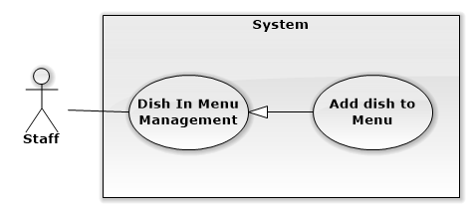

| **USE CASE SPECIFICATION** | | | |
| --- | --- | --- | --- |
| **Use-case No.** | UC007 | **Use-case Version** | 2.0 |
| **Use-case Name** | Add Dish to Menu | | |
| **Author** | Trương Quang Bảo | | |
| **Date** | 18/03/2014 | **Priority** | High |
| **Actor:**  Staff  **Summary:**  Help staff add new Dish to selected Menu.  **Goal:**  The purpose of Add Dish to Menu Use case is allowed Staff can add Dish to selected Menu.  **Triggers:**  Trigger when Staff click menu item at present or future day in calendar. Drag and drop dish into Menu field.  **Preconditions:**  **-** User must log in with role “Staff  - Has least one dish in data.  **Post Conditions:**  **Success:**   * Dish disappear in “Món Ăn” and appear in Menu field   **Failure:**   * System show error message in screen.   **Main Success Scenario:**   |  |  | | --- | --- | | Actor Actions | System Response | | 1. menu item at present or future day in calendar  3. Staff drag dish from “Món Ăn” and drop it into “Menu”. | 2. Show Menu Details popup model include:   * Left field name “Món Ăn” show all dish not in menu. * Dish item not in Menu include: dish name[text], dish image[image]. * Right field name “Menu” show all dish in menu. * Dish item in Menu include: dish name[text], dish image[image], dish price[label], dish quota[label]. * “Xuất hiện đến: [ClosedTimeSession: datetime picker,datetime]. * [DishCategory: dropdown list, string ].   4. Dish disappear in “Món Ăn” and appear in “Menu”. |   **Alternative Scenario:**   |  |  | | --- | --- | | Actor Actions | System Response | | N/A | N/A |   **Exceptions:**   |  |  | | --- | --- | | Actor Actions | System Response | | N/A | N/A |   **Relationships:**   * Dish in Menu Management   **Business Rules:**  - N/A | | | |

#### 4.2.1.1.3.4.3 Delete Dish in Menu:

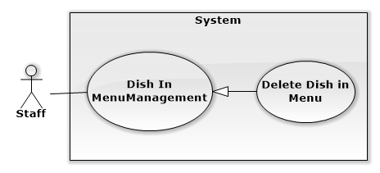

| **USE CASE SPECIFICATION** | | | |
| --- | --- | --- | --- |
| **Use-case No.** | UC008 | **Use-case Version** | 2.0 |
| **Use-case Name** | Delete Dish in Menu | | |
| **Author** | Trương Quang Bảo | | |
| **Date** | 18/03/2014 | **Priority** | Normal |
| **Actor:**  Staff  **Summary:**  Help staff delete Dish in Menu.  **Goal:**  The purpose of Delete Dish in Menu Use case is allowed Staff can remove dish in Menu.  **Triggers:**  Trigger when Staff click menu item at present or future day in calendar. Click red button X beside dish item.  **Preconditions:**  - User must log in with role “Staff.  - Has least two Dish in Menu.  **Post Conditions:**  **Success:**   * Dish disappear in “Menu” and appear in “Món Ăn” field   **Failure:**   * System show error message in screen.   **Main Success Scenario:**   |  |  | | --- | --- | | Actor Actions | System Response | | 1. Staff click menu item at present or future day in calendar  3. Click button  beside dish item “Món Ăn”.  [Exception 1] | 2. Show Menu Details popup model include:   * Left field name “Món Ăn” show all dish not in menu. * Dish item not in Menu include: dish name[text], dish image[image]. * Right field name “Menu” show all dish in menu. * Dish item in Menu include: dish name[text], dish image[image], dish price[label], dish quota[label]. * “Xuất hiện đến: [ClosedTimeSession: datetime picker,datetime]. * [DishCategory: dropdown list, string ].   4. Dish disappear in “Menu” and appear in “Món Ăn”. |   **Alternative Scenario:**   |  |  | | --- | --- | | Actor Actions | System Response | | N/A | N/A |   **Exceptions:**   |  |  | | --- | --- | | Actor Actions | System Response | | [Exception 1]  1. Selected dish to delete is a last dish in Menu. | 2. Show error message “Cần có ít nhất một món ăn trong Menu”. |   **Relationships:**   * Dish in Menu Management.   **Business Rules:**  - One menu has least one dish. | | | |

#### 4.2.1.1.3.4.4 Edit Dish in Menu:

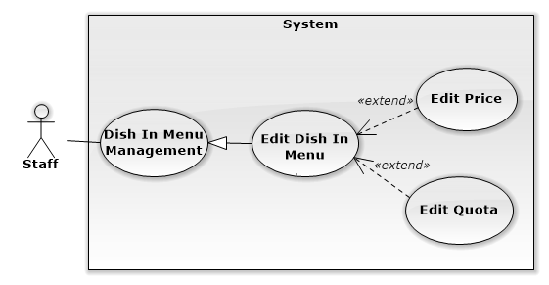

| **USE CASE SPECIFICATION** | | | |
| --- | --- | --- | --- |
| **Use-case No.** | UC009 | **Use-case Version** | 2.0 |
| **Use-case Name** | Edit Dish in Menu | | |
| **Author** | Trương Quang Bảo | | |
| **Date** | 18/03/2014 | **Priority** | Normal |
| **Actor:**  Staff  **Summary:**  Help staff Edit Dish in Menu.  **Goal:**  The purpose of Edit Dish in Menu Use case is allowed Staff can edit price and quota of dish in Menu.  **Triggers:**  Trigger when Staff click menu item at present or future day in calendar. Click red button X beside dish item.  **Preconditions:**  - User must log in with role “Staff  - Has least one dish in Menu.  **Post Conditions:**  **Success:**   * Save new Price and Quota of Dish in database. Display new Price and Quota in screen.   **Failure:**   * System show error message in screen.   **Main Success Scenario:**   |  |  | | --- | --- | | Actor Actions | System Response | | 1. Staff click menu item at present or future day in calendar  3. Click button  in Dish item “Món Ăn”.  [Alternative 1], [Alternative 2] | 2. Show Menu Details popup model include:   * Left field name “Món Ăn” show all dish not in menu. * Dish item not in Menu include: dish name[text], dish image[image]. * Right field name “Menu” show all dish in menu. * Dish item in Menu include: dish name[text], dish image[image], dish price[label], dish quota[label]. * “Xuất hiện đến: [ClosedTimeSession: datetime picker,datetime]. * [DishCategory: dropdown list, string ].   4. Dish disappear in “Menu” and appear in “Món Ăn”. |   **Alternative Scenario:**   |  |  | | --- | --- | | Actor Actions | System Response | | [Alternative 1]  1. Staff click button  beside price of dish in menu field.  3. Staff input price(x) and click button “Ok”.  [Exceptions 1]  [Alternative 2]  1. Staff click button  beside quota of dish in menu field.  3. Staff input quota(x) and click button“Ok”.  [Exceptions 2]. | 2. Show prompt edit price [Textbox, positive integer].  4. System show success message “Giá của món ăn đã được đổi thành x”.  2. Show prompt edit quota [Textbox, positive integer].  4. System show success message “Số lượng của món ăn đã được đổi thành x”. |   **Exceptions:**   |  |  | | --- | --- | | Actor Actions | System Response | | [Exceptions 1]  1. Input price isn’t a number or less than 1.  [Exceptions 2]  1. Input quota isn’t a number or less than 1. | 2. System show error message:” Dữ liệu không đúng, giá của món ăn phải là số nguyên dương!”  2. System show error message:”Dữ liệu không đúng, số lượng của món ăn phải lớn hơn 1!” |   **Relationships:**  - Dish in Menu Management.  **Business Rules:**  - Price can’t less than 1.  - Quota can’t less than 1. | | | |

#### 4.2.1.1.5 MoveAndCopy Menu:

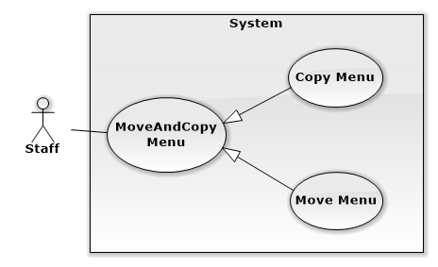

| **USE CASE SPECIFICATION** | | | |
| --- | --- | --- | --- |
| **Use-case No.** | UC010 | **Use-case Version** | 2.0 |
| **Use-case Name** | MoveAndCopyMenu | | |
| **Author** | Trương Quang Bảo | | |
| **Date** | 18/03/2014 | **Priority** | Normal |
| **Actor:**  Staff  **Summary:**  Helps staff move and copy menu in another day.  **Goal:**  The purpose of Edit Dish in Menu Use case is allowed Staff can move or copy from selected Menu to another Menu.  **Triggers:**  Trigger when Staff drag and drop selected menu to another day, click button “sao chép” or “di chuyển”.  **Preconditions:**  **-** User must log in with role “Staff.  - Has least one menu in calendar.  **Post Conditions:**  **Success:**   * Menu appear in calendar in field day was changed.   **Failure:**   * System show error message on screen.   **Main Success Scenario:**   |  |  | | --- | --- | | Actor Actions | System Response | | 1. Staff drag and drop selected menu to another day.  [Alternative 1] [Alternative 2] [Alternative 3]  [Exception1] | 2. Show popup Edit Menu. |   **Alternative Scenario:**   |  |  | | --- | --- | | Actor Actions | System Response | | [Alternative 1]  1. Staff click button “Di Chuyển”  [Alternative 2]  1. Staff click button “Sao Chép”  [Alternative 3]  1. Staff click button “Đóng” | 2. Reload page. Show Menu in calendar in day menu was drop. Menu name change.  Change time selected menu in database.  2. Calendar show old and new copy menu in appropriate day. New copy menu insert in database.  2. Popup close, menu revert to original day. |   **Exceptions:**   |  |  | | --- | --- | | Actor Actions | System Response | | [exception 1]  1. The day menu selected to drop in is existing another menu. | 2. System show error message: ”Menu ngày … đã có sẵn” |   **Relationships:**  - Menu management.  **Business Rules:**   * One day have only one menu. * Can’t move or drop menu to past day. | | | |

#### 4.2.1.2. Suggest Menu:

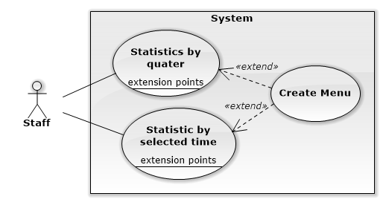

| **USE CASE SPECIFICATION** | | | |
| --- | --- | --- | --- |
| **Use-case No.** | UC011 | **Use-case Version** | 2.0 |
| **Use-case Name** | Suggest Menu | | |
| **Author** | Trương Quang Bảo | | |
| **Date** | 19/03/2014 | **Priority** | Normal |
| **Actor:**  Staff  **Summary:**  Statistics information about number success order by quarter or selected time. Create new menu by suggest dish.  **Goal:**  Show statistics information about number success order by quarter or selected time in chart. Staff success create new menu by suggest dish if they want.  **Triggers:**  Trigger when Staff click button “Thống Kê” in calendar page.  **Preconditions:**  **-** User must log in with role “Staff  - Has least one success order.  **Post Conditions:**  **Success:**   * Statistics info show right. Create success new menu.   **Failure:**   * System show error message on screen.   **Main Success Scenario:**   |  |  | | --- | --- | | Actor Actions | System Response | | 1.Staff click “Thống kê” button.  [alternative 1][ Alternative 2]  3. Staff select dish, input datetime, click “Tạo Menu”.  [Exception 1] [Exception 2] | 2. Show popup “suggest menu” include:   * “Thời gian: [quarter:dropdown list,integer] * “Hiển thị”:[dropdown list, integer] * “Năm”:[year:dropdownlist, integer] * “Từ ngày:[textbox: datetime] * “Đến ngày:[textbox:datetime] * “Chọn ngày:[textbox:datetime] * Tạo Menu: [button:button] |   **Alternative Scenario:**   |  |  | | --- | --- | | Actor Actions | System Response | | [alternative 1]  1. Staff input “Thời gian”, “Hiển thị”,”Năm”. Click button “Kết quả”.  [alternative 2]  1. Staff input “Từ ngày”, “Đến ngày”,”Hiển thị”. Click button “Kết quả” | 2. Show info number order of dish in chart.  Show suggest dish with checkbox for staff create new menu if they want.  2. Show info number order of dish in chart.  Show suggest dish with checkbox for staff create new menu if they want. |   **Exceptions:**   |  |  | | --- | --- | | Actor Actions | System Response | | [Exception 1]  1. Staff not select any dish and click “Tạo Menu”  [Exception 2]  1. Input date is existing | 2. System show error message:”Cần có ít nhất một món ăn trong menu”.  2. System show error message:”Menu cho ngày này đã có, bạn có thể chỉnh sửa”. |   **Relationships:**   * Menu management   **Business Rules:**   * One day have only one menu. | | | |

# 5. System Design Description (SDD)

## 5.1 Class diagram:

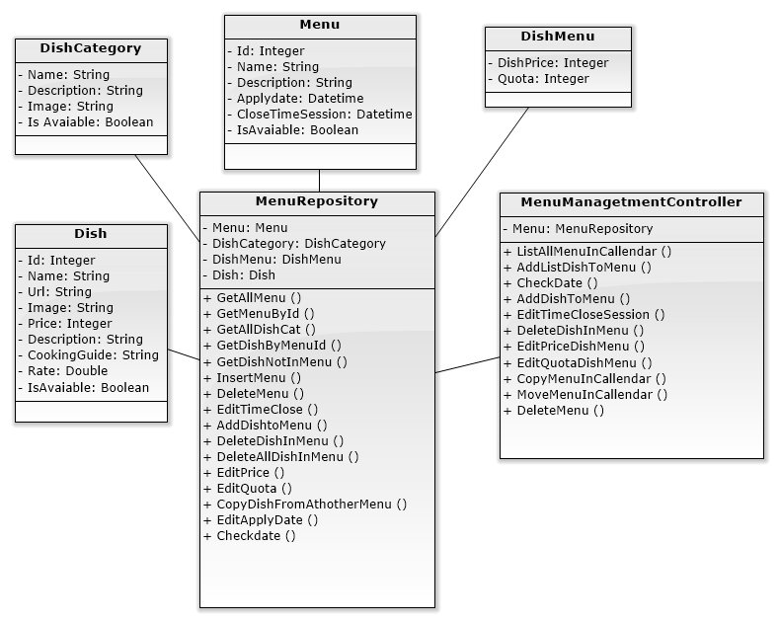

### 5.1.1 Class Diagram Explanation:

#### 5.1.1.1 Menu Repository:

|  |  |
| --- | --- |
| Class name | Menu Repository |
| Description | This class is manage Menu and Dish in Menu |
| **Attribute**:   |  |  |  | | --- | --- | --- | | **Attribute** | **Data Type** | **Description** | | Menu | <Menu> | Menu object in Menu Repository | | DishMenu | <DishMenu> | DishMenu object in Menu Repository | | Dish | <Dish> | Dish object in Menu Repository | | DishCategory | <DishCategory> | DishCategory object in Menu Repository | | |
|  | |
| **Methods**:  *Public list<Menu> GetAllMenu:* Get list all Menu from database.   |  |  |  | | --- | --- | --- | | **Parameter/Return** | **Type** | **Description** | | Return | List<Menu> | Return List of Menu. |   *Public Menu* GetMenuById *(int menuId):* Get Menu by Menu Id.   |  |  |  | | --- | --- | --- | | **Parameter/Return** | **Type** | **Description** | | menuId | Integer | Id of Menu. | | Return | *Menu* | Return a Menu object. |   public list<DishCategory> GetAllDishCat(): Get list all DishCategory   |  |  |  | | --- | --- | --- | | **Parameter/Return** | **Type** | **Description** | | Return | List< DishCategory > | Return list all DishCategory |   public List<Dish> GetDishByMenuId(int menuId): Get list Dish in selected Menu by input menuId   |  |  |  | | --- | --- | --- | | **Parameter/Return** | **Type** | **Description** | | menuId | int | Id of Menu | | Return | List<Dish> | Return list of dish in selected Menu |     public List<Dish> GetDishNotInMenu(int MenuId): Get list Dish not in selected Menu by input menuId   |  |  |  | | --- | --- | --- | | **Parameter/Return** | **Type** | **Description** | | menuId | int | Id of Menu | | Return | List<Dish> | Return list of dish not in selected Menu |   Public int InsertMenu(String name, String Description, String Applydate, String CloseTime): Insert new Menu object to database   |  |  |  | | --- | --- | --- | | **Parameter/Return** | **Type** | **Description** | | name | String | Name of Menu | | description | String | Description of Menu | | applyDate | String | ApplyDate of Menu | | closeTime | String | CloseTimeSession of Menu | | Return | Menu | Return Menu object inserted |     public string DeleteMenu(int menuId): Remove select Menu object in database   |  |  |  | | --- | --- | --- | | **Parameter/Return** | **Type** | **Description** | | menuId | int | Id of Menu | | Return | string | SUCCESS:”success”  ERROR: “error” |     public String EditTimeClose(int menuId, DateTime timeClose): Edit CloseTimeSession attribute of Menu in database.   |  |  |  | | --- | --- | --- | | **Parameter/Return** | **Type** | **Description** | | menuId | int | Id of Menu | | timeClose | int | Close Session time of Menu | | Return | String | SUCCESS:”success”  ERROR: “error” |   public String AddDishtoMenu(int MenuId, int DishId, int Price, int Quota): Insert new DishMenu object in database   |  |  |  | | --- | --- | --- | | **Parameter/Return** | **Type** | **Description** | | menuId | String | Name of Menu | | dishId | int | Id of Dish Staff want to add | | price | int | Price of Dish in Menu | | quota | int | Quota of Dish in Menu | | Return | String | SUCCESS:”success”  ERROR: “error” |       public String DeteleDishInMenu(int dishId, int menuId): Remove DishMenu object in database   |  |  |  | | --- | --- | --- | | **Parameter/Return** | **Type** | **Description** | | dishId | int | Id of Dish | | menuId | int | Id of Menu | | Return | string | SUCCESS:”success”  ERROR: “error” |   public String DeteleAllDishInMenu(int menuId): Remove list DishMenu object contain input menuId.   |  |  |  | | --- | --- | --- | | **Parameter/Return** | **Type** | **Description** | | menuId | int | Id of Menu | | Return | String | SUCCESS:”success”  ERROR: “error” |   public String EditPrice(int price, int dishID, int menuID): Edit Price attribute of DishMenu in database.   |  |  |  | | --- | --- | --- | | **Parameter/Return** | **Type** | **Description** | | price | int | Price of Dish in Menu | | dishID | int | Id of Dish | | menuID | int | Id of Menu | | Return | String | SUCCESS:”success”  ERROR: “error” |   public String EditQuota(int quota, int dishID, int menuID): Edit Quota attribute of DishMenu in database.   |  |  |  | | --- | --- | --- | | **Parameter/Return** | **Type** | **Description** | | quota | int | Quota of Dish in Menu | | dishID | int | Id of Dish | | menuID | int | Id of Menu | | Return | String | SUCCESS:”success”  ERROR: “error” |   public String CopyDishFromAthotherMenu(int menuIdOriginal, int menuIdCopy): Copy list dish form original Menu to copy Menu.   |  |  |  | | --- | --- | --- | | **Parameter/Return** | **Type** | **Description** | | menuIdOriginal | int | Id of Menu Original | | menuIdCopy | int | Id of Menu copy | | Return | String | SUCCESS:”success”  ERROR: “error” |   public String EditApplyDate(int menuId, DateTime date): Edit ApplyDate attribute of Menu to move it to another day in calendar.   |  |  |  | | --- | --- | --- | | **Parameter/Return** | **Type** | **Description** | | menuId | int | Id of Menu | | date | DateTime | New DateTime apply for menu | | Return | String | SUCCESS:”success”  ERROR: “error” |   public boolean Checkdate(DateTime dt): Check menu in this date is avaiable or not?   |  |  |  | | --- | --- | --- | | **Parameter/Return** | **Type** | **Description** | | dt | DateTime | Date time need to check | | Return | boolean | SUCCESS: ”true”  ERROR: “false” | | |

#### 5.1.1.2

|  |  |
| --- | --- |
| Class name | MenuManagementController |
| Description | This class is execute all action of Menu |
| **Attribute**:   |  |  |  | | --- | --- | --- | | **Attribute** | **Data Type** | **Description** | | Menu | MenuRepository | MenuRepository object | | |
|  | |
| **Methods**:  public string ListAllMenuInCallendar(): List all Menu and show them in calendar   |  |  |  | | --- | --- | --- | | **Parameter/Return** | **Type** | **Description** | | Return | List<Menu> | Return List of Menu. |   *Public Menu* GetMenuById *(int menuId):* Get Menu by Menu Id.   |  |  |  | | --- | --- | --- | | **Parameter/Return** | **Type** | **Description** | | menuId | Integer | Id of Menu. | | Return | *Menu* | Return a Menu object. |   public ActionResult MenuCreate(DateTime dt): Open model popup MenuCreate for Staff create new Menu and add dish in Menu.   |  |  |  | | --- | --- | --- | | **Parameter/Return** | **Type** | **Description** | | dt | DateTime | Date time of day in calendar when staff click it. | | Return | *PartialView* | Partail view contain Create Menu model |   public ActionResult MenuDetails(int MenuId): Open model popup Menu Details for Staff view and edit info of Menu in today or future.   |  |  |  | | --- | --- | --- | | **Parameter/Return** | **Type** | **Description** | | MenuId | int | Id of Menu | | Return | *PartialView* | Partail view contain Menu Details model |   public ActionResult MenuInfo(int menuId): Open model popup Menu Info for Staff only view info of Menu in past.   |  |  |  | | --- | --- | --- | | **Parameter/Return** | **Type** | **Description** | | MenuId | int | Id of Menu | | Return | *PartialView* | Partail view contain Menu Info model.(Contain Menu info in past) |   public String CreateMenuAndAddListDish(string info, DateTime dt, DateTime timeClose): Insert list DishMenu to database.   |  |  |  | | --- | --- | --- | | **Parameter/Return** | **Type** | **Description** | | info | string | Info of data input (contain dishID, dish Price, dish quota ) | | dt | DateTime | ApplyDate attribute of Menu | | timeClose | DateTime | TimeCloseSession attribute of Menu | | Return | String | SUCCESS: ”true”  ERROR: “false” |   public string DeleteMenu(int menuId): Remove select Menu object in database   |  |  |  | | --- | --- | --- | | **Parameter/Return** | **Type** | **Description** | | menuId | int | Id of Menu | | Return | string | SUCCESS:”success”  ERROR: “error” |   public String AddDishToMenu(string info, int menuId): Insert DishMenu object to database.   |  |  |  | | --- | --- | --- | | **Parameter/Return** | **Type** | **Description** | | info | string | Info of data input (contain dishID, dish Price, dish quota ) | | dt | DateTime | ApplyDate attribute of Menu | | Return | String | SUCCESS: ”true”  ERROR: “false” |   public string DeleteDishInMenu(int dishId, int menuId): Delete DishMenu object in database.   |  |  |  | | --- | --- | --- | | **Parameter/Return** | **Type** | **Description** | | dishId | int | Info of data input (contain dishID, dish Price, dish quota ) | | menuId | int | ApplyDate attribute of Menu | | Return | String | SUCCESS: ”true”  ERROR: “false” |   public string EditTimeCloseSession(int menuId,DateTime timeClose): Edit Time Close Session attribute of Menu.   |  |  |  | | --- | --- | --- | | **Parameter/Return** | **Type** | **Description** | | timeClose | DateTime | Time Close Session in Menu | | menuId | int | Id of Menu | | Return | String | SUCCESS: ”true”  ERROR: “false” |   public string EditPriceDishMenu(int price, int dishID, int menuId): Edit price attribute of DishMenu.   |  |  |  | | --- | --- | --- | | **Parameter/Return** | **Type** | **Description** | | price | int | Price of Dish in Menu | | dishId | int | Id of Dish | | menuId | int | Id of Menu | | Return | String | SUCCESS: ”true”  ERROR: “false” |   public string EditQuotaDishMenu(int quota, int dishId, int menuId): Edit quota attribute of DishMenu.   |  |  |  | | --- | --- | --- | | **Parameter/Return** | **Type** | **Description** | | quota | DateTime | Quota of Dish in Menu | | dishId | int | Id of Dish | | menuId | int | Id of Menu | | Return | String | SUCCESS: ”true”  ERROR: “false” |   public boolean Checkdate(DateTime dt): Check menu in this date is avaiable or not?   |  |  |  | | --- | --- | --- | | **Parameter/Return** | **Type** | **Description** | | dt | DateTime | Date time need to check | | Return | boolean | SUCCESS: ”true”  ERROR: “false” |   public String CopyMenuInCallendar(int menuId, DateTime dt): Copy selected Menu.   |  |  |  | | --- | --- | --- | | **Parameter/Return** | **Type** | **Description** | | menuId | int | Id of Menu Original | | dt | DateTime | Date Staff want to copy Menu in | | Return | String | SUCCESS: ”true”  ERROR: “false” |   public String MoveMenuInCallendar(int menuId, DateTime dt): Move selected Menu to another days.   |  |  |  | | --- | --- | --- | | **Parameter/Return** | **Type** | **Description** | | menuId | int | Id of selected Menu | | DateTime | DateTime | Date staff want to move Menu in | | Return | String | SUCCESS: ”true”  ERROR: “false” | | |

## 5.2 Sequence Diagram:

### 5.2.1 Create Menu:

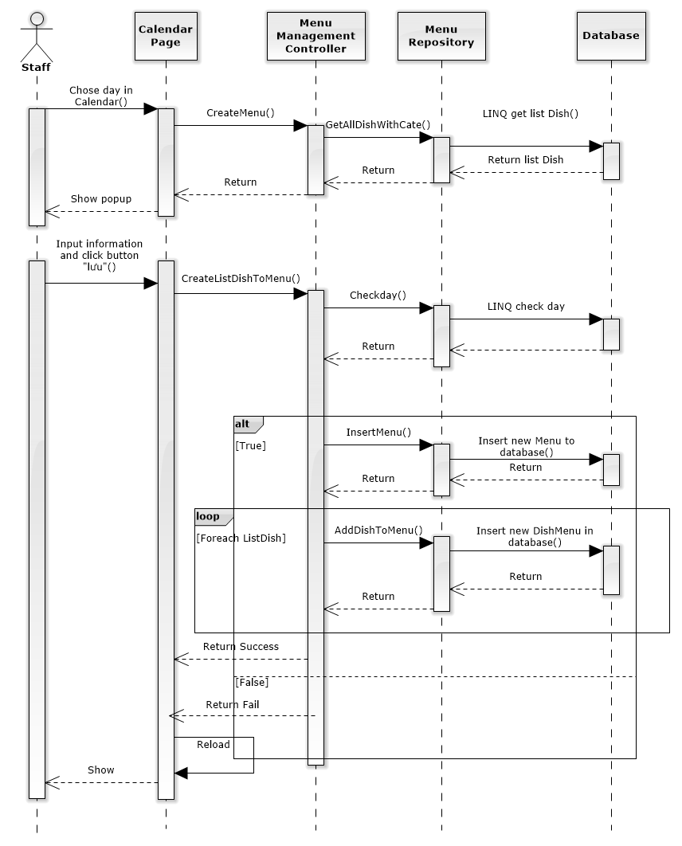

### 5.2.2 Menu Details:

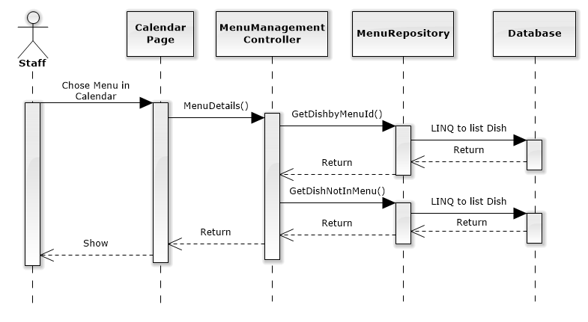

#### 5.2.2.1: Delete Menu:

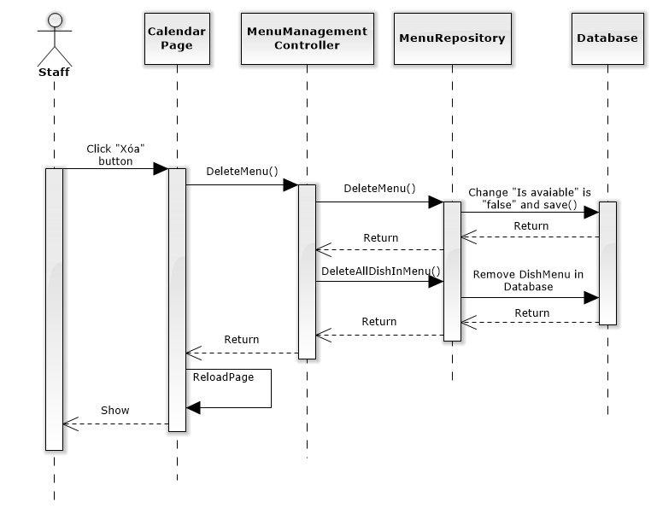

#### 5.2.2.2 Edit Time Close Session:

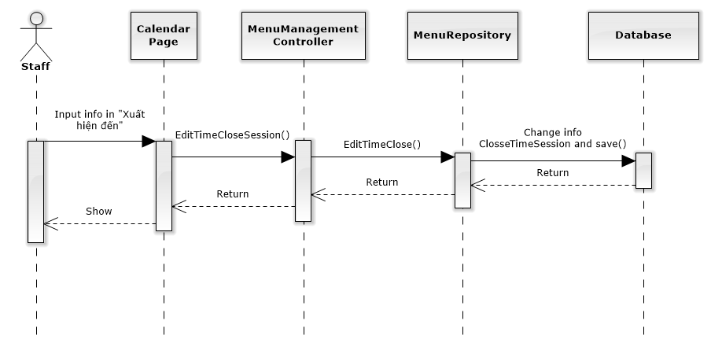

#### 5.2.2.3 Add Dish to Menu: Sequence_adddishtomenu

#### 5.2.2.4 Delete Dish in Menu:

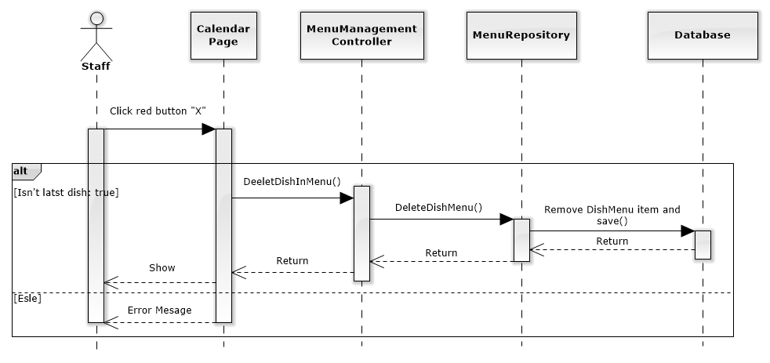

#### 5.2.2.5 Edit Dish Price:

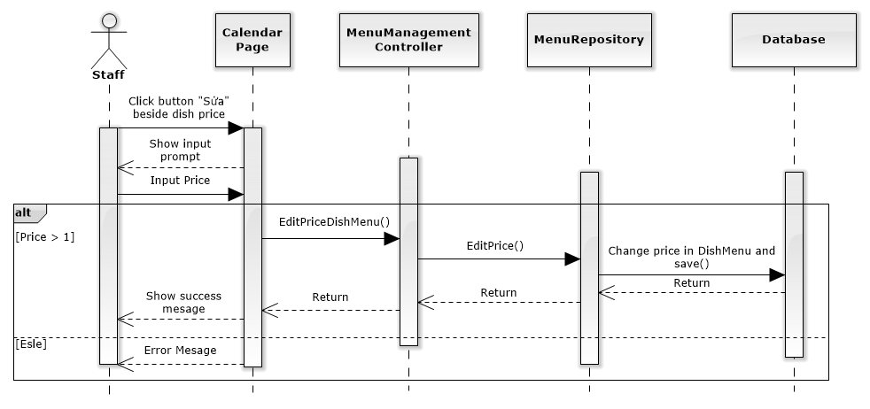

#### 5.2.2.6 Edit Dish Quota:

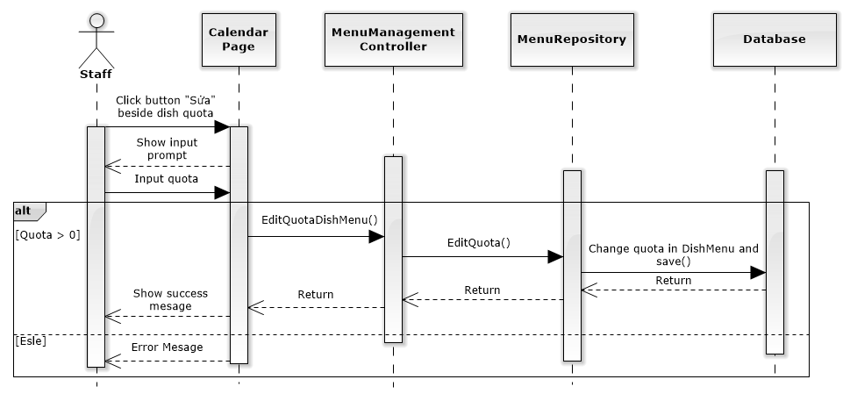

### 5.2.3 MoveAndCopy Menu:

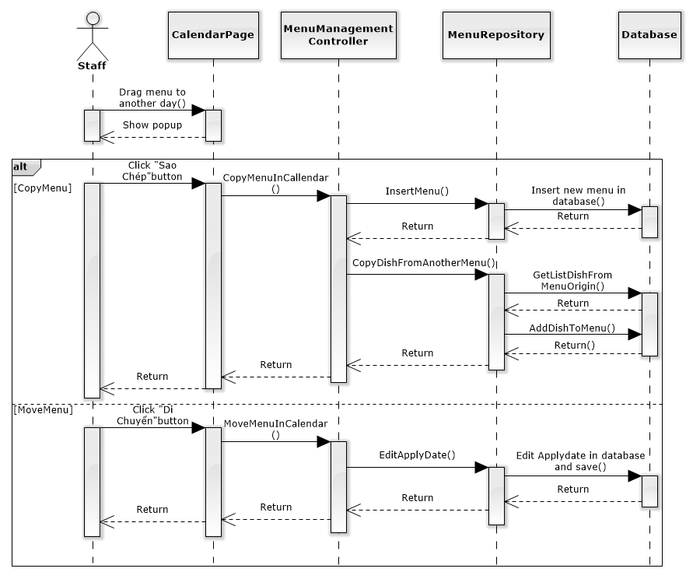

### 5.2.4 Suggest Menu:

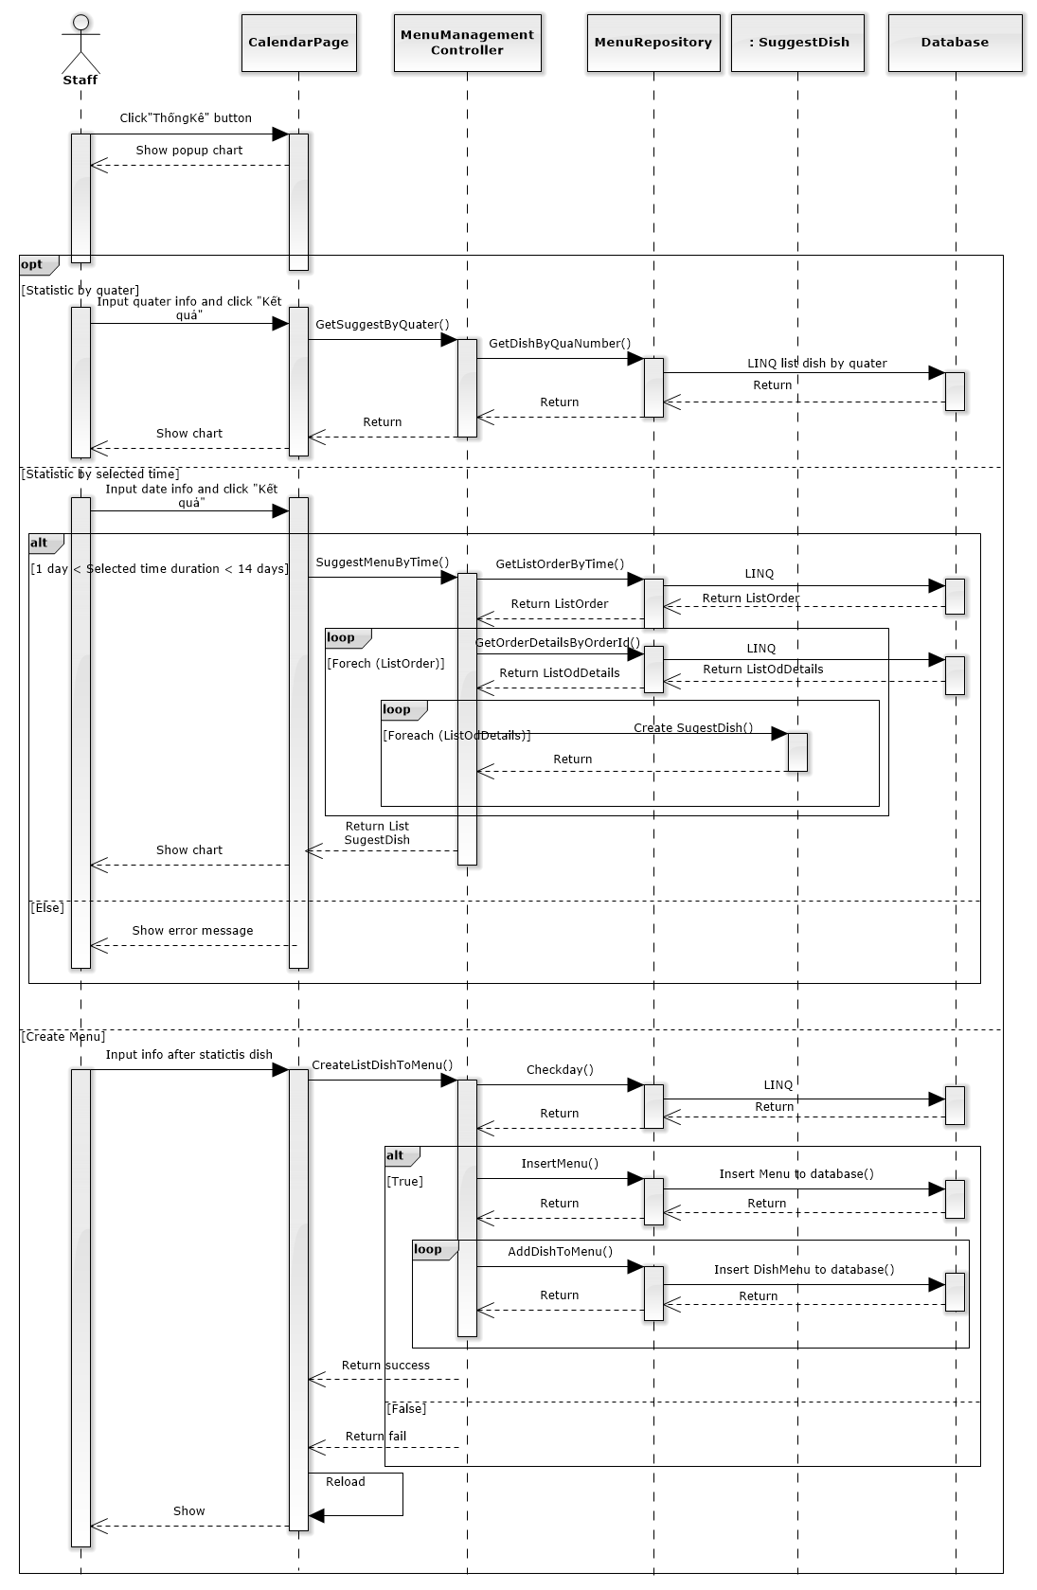

## 5.2. User Interface Design:

### 5.2.1 User Interface Design:

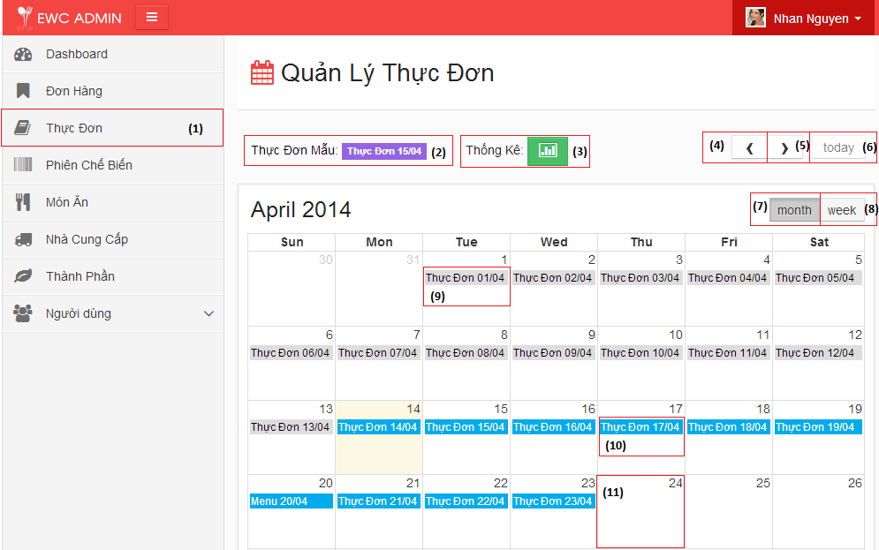

|  |  |  |  |
| --- | --- | --- | --- |
| **No.** | **Name** | **Type** | **Description** |
| **1** | Thực Đơn | Menu | Click “Thực Đơn” in menubar to redirect Menu management page. |
| **2** | Menu mẫu(Drag and drop only) | Fc-event | Drag and drop it to day field in calendar to copy menu. |
| **3** | Thống Kê | Button | Go to suggest menu popup. |
| **4** | Previous button | span | Go to previous month. |
| **5** | Next button | span | Go to next month. |
| **6** | Today | span | Go to the month contain today. |
| **7** | Month | Span | View calendar by month. |
| **8** | Week | Span | View calendar by week. |
| **9** | Menu in past | Fc-event | Menu has grey color mean Menu is past. Staff only view info. |
| **10** | Menu in future | Fc-event | Menu has blue color mean Menu is today or future. Staff can edit it. |
| **11** | Date field | Fc-day | Date in calendar. |

### 5.2.2 Create Menu Design

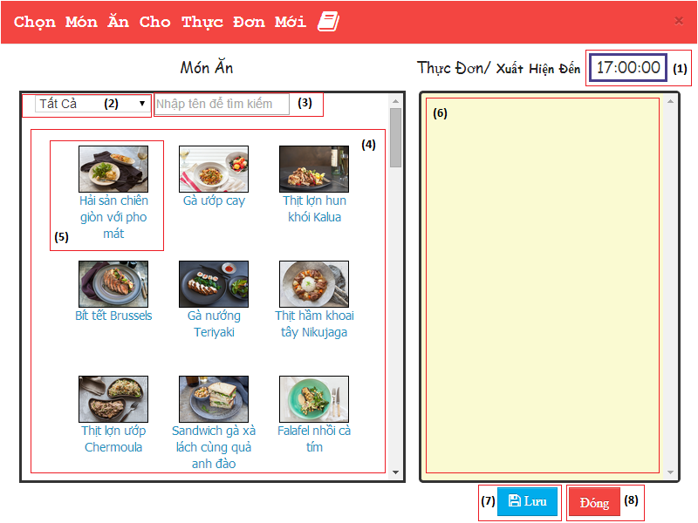

|  |  |  |  |
| --- | --- | --- | --- |
| **No.** | **Name** | **Type** | **Description** |
| **1** | Xuất Hiện đến | Input | Set close time session in menu |
| **2** | SearchByCat | Dropdown list | Search dish by category |
| **3** | SearchByName | Textbox | Search dish by name |
| **4** | Món Ăn | Gridview | List all dish |
| **5** | Dish object | li | Show name and image of dish object not in menu |
| **6** | Menu | Gridview | Field for user drop dish in to |
| **7** | Lưu | Button | Create new Menu. Insert dish in “Menu field” to Menu created |
| **8** | Đóng | Button | Close popup Create menu |

### 5.2.3 Menu Details:

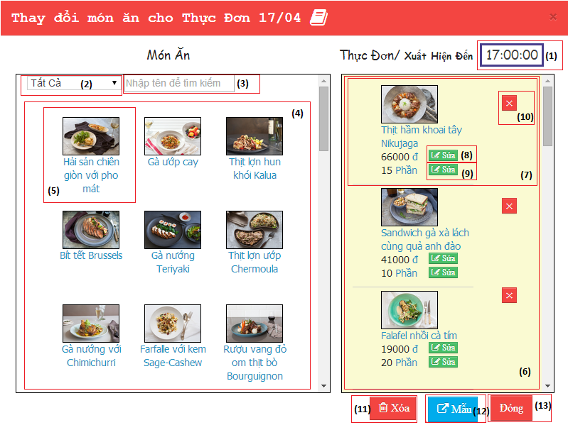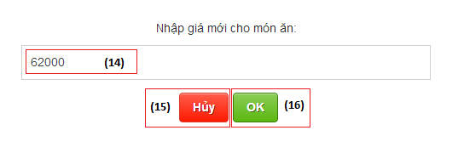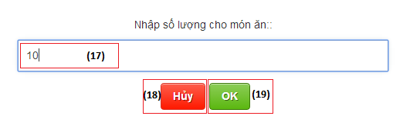

|  |  |  |  |
| --- | --- | --- | --- |
| **No.** | **Name** | **Type** | **Description** |
| **1** | Xuất Hiện Đến | Input | Set close time session in menu |
| **2** | Search by category | Dropdown list | Search dish by category |
| **3** | Search by name | Textbox | Search dish by name |
| **4** | Món Ăn | Gridview | List all dish |
| **5** | Dish object | li | Show name and image of dish object not in menu |
| **6** | Menu | Gridview | Field for user drop dish in to |
| **7** | Dish object (in Menu) | li | Show details info of dish in menu |
| **8** | Remove dish | Button | Remove dish in menu |
| **9** | Sửa | Button | Open edit price prompt (ref 14,15,16) |
| **10** | Sửa | Button | Open edit quota prompt (ref 17,18,19) |
| **11** | Xóa | Button | Delete this menu |
| **12** | Mẫu | Button | Export menu to “menu mẫu” in calendar screen |
| **13** | Đóng | Button | Close popup edit menu |
| **14** | Nhập giá mới | input | Price of dish in menu |
| **15** | Ok | Button | Save change price |
| **16** | Cancel | Button | Close prompt |
| **17** | Nhập số lượng mới | input | Quota of this menu |
| **18** | Ok | Button | Save change quota |
| **19** | Cancel | Button | Close prompt |

### 5.3.4 Menu Info:

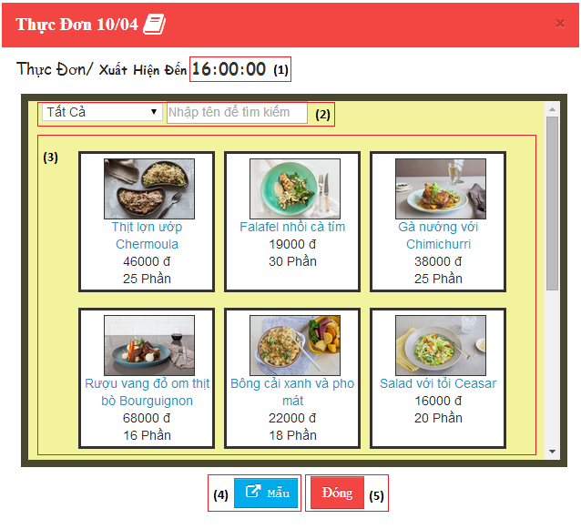

|  |  |  |  |
| --- | --- | --- | --- |
| **No.** | **Name** | **Type** | **Description** |
| **1** | Info of close time session | Label | Show close time session of menu. |
| **2** | Search | Input | Search dish in Menu by category or name. |
| **3** | Menu | Gridview | Show dish in Menu with main info. |
| **4** | Mẫu | Button | Assign this menu to Menu mẫu. Use it to copy Menu. |

### 5.2.5 MoveAndCopy Menu:

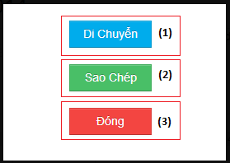

|  |  |  |  |
| --- | --- | --- | --- |
| **No.** | **Name** | **Type** | **Description** |
| **1** | Di Chuyển | Button | Move dragged menu to another day in calendar. |
| **2** | Sao Chép | Button | Copy dragged menu to another day in calendar. |
| **3** | Đóng | Button | Close popup. |

### 5.2.6 Suggest Menu :

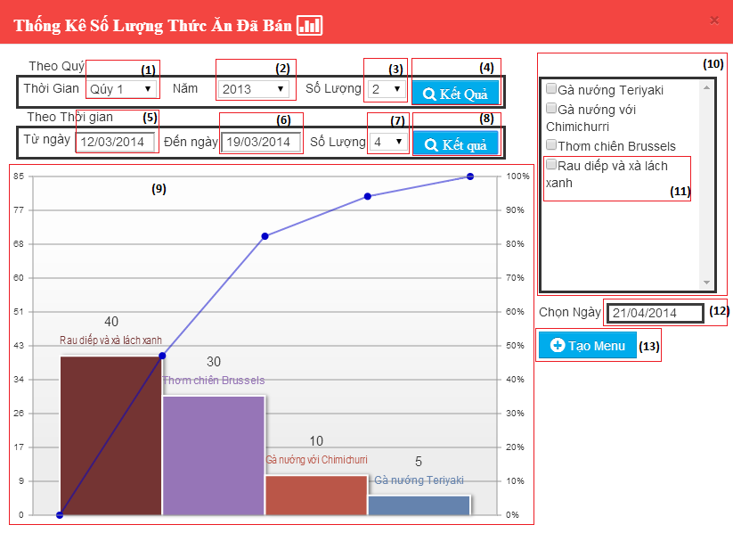

|  |  |  |  |
| --- | --- | --- | --- |
| **No.** | **Name** | **Type** | **Description** |
| **1** | Qúy | Dropdown | Input quarter. |
| **2** | Năm | Dropdown | Input year. |
| **3** | Số Lượng | Dropdown | Input number dish display. |
| **4** | Kết quả | Button | Show result of static dish by quarter in chart below. |
| **5** | Từ ngày | Input | Input start date of range time statistic. |
| **6** | Đến ngày | Input | Input end date of range time statistic. |
| **7** | Số Lượng | Dropdown | Input number dish display. |
| **8** | Kết quả | Button | Show result of static dish by selected time in chart below. |
| **9** | Chart | Chart | Display dish statistic by time or quarter. |
| **10** | List Dish | Div | List dish by statistic chart. |
| **11** | Dish object | Checkbox | Check dish if user want insert it in new menu. |
| **12** | Chọn ngày | Input | Input datetime of menu want to create. |
| **13** | Tạo Menu | Button | Create menu with datetime in “Chọn ngày” and insert dish checked. |

# 6. TestCase:

| **ID** | **Test Case Description** | **Test Case Procedure** | **Expected Output** | **Dependence** | **Result** | **Test Date** |
| --- | --- | --- | --- | --- | --- | --- |
| SD001 | List Menu | 1. Staff click “Menu” in left sidebar.  2. Staff click “previous” button in left side of “today” button.  3. Staff click “next” button in left side of “today” button. | 1. Redirect to Calendar page.  Show menu with right date time.  2. Go to previous month and show menu with right date time.  3. Go to next month and show menu with right date time. |  | pass | 25/03/2014 |
| SD002 | Can’t create Menu if the date have existing Menu | 1. Staff click date field contain menu item in calendar. | 1. Nothing happen. | SD001 | pass | 25/03/2014 |
| SD003 | Create Menu | 1. Staff click blank date field in calendar.  2. Staff drag dish from “Món Ăn” to “Menu”.  3. Staff click button lưu. | 1. Create Menu popup appear.  2. Dish disappear in “Món Ăn” and appear in “Menu”.  3. Reload page, new Menu and DishMenu insert to database. Show menu in calendar. | SD001 | pass | 25/03/2014 |
| SD004 | One Menu has least one dish. | 1. Staff click blank date field in calendar.  2. Staff input nothing and click button “Lưu”. | 2.Show error message: “Cần có ít nhất một món ăn trong Menu”. | SD001 | pass | 25/03/2014 |
| SD005 | Menu Details | 1.Staff click menu item in calendar.  0 | 1. Show MenuDetails popup.  Show dish not in menu in “Món Ăn”  Show dish in menu in “Menu”.  Show time close session. | SD001 | pass | 25/03/2014 |
| SD006 | Search by category | 1. In popup CreateMenu or MenuDetails, staff chose category “Thức ăn trẻ em” | 1. Show dish in category “Thức ăn trẻ em”. | SD003,SD005 | pass | 25/03/2014 |
| SD007 | Search by name | 1. In popup CreateMenu or MenuDetails, staff input “Chicken” in textbox “tìm kiếm theo tên” | 1. Show dish contain string :”Chicken” in name. | SD004,SD005 | pass | 25/03/2014 |
| SD008 | Add dish to menu | 1.Drag dish from”Món Ăn” and drop it to “Menu”. | 1. Dish disappear in “Món Ăn” and appear in “Menu”. New DishMenu item added in database. | SD007 | pass | 25/03/2014 |
| SD009 | Delete dish in menu | 1.Click red button “X” beside dish item in “Menu”. | 1.Dish disappear in “Menu” and appear in “Món Ăn”. Remove DishMenu item in database. | SD007 | pass | 25/03/2014 |
| SD010 | Delete last dish in menu | 1. Delete the all dish in “Menu” until the last dish remain. Delete the last dish. | 1. Show error message “Cần có ít nhất một món ăn trong menu”. | SD007 | pass | 25/03/2014 |
| SD011 | Edit dish Price in menu | 1.Click button “sửa” beside dish price.  2.Input “15000” and click “Ok” | 1.Show prompt edit price.  2.Show message “Giá của món ăn đã được đổi thành “15000” ”. Change price data of DishMenu item in database. | SD007 | pass | 25/03/2014 |
| SD012 | Dish Price must be positive number and greater than one. | 1.Click button “sửa” beside dish price.  2.Input “abc” or “-1” or “0” and click “OK”. | 2. Show error message “Dữ liệu không đúng, chỉ chấp nhận số nguyên”. | SD007 | pass | 25/03/2014 |
| SD013 | Edit dish quota in menu | 1.Click button “sửa” beside dish quota.  2.Input “30” and click “Ok” | 1. Show prompt edit quota.  2. Show message “Số lượng của món ăn đã được đổi thành “30” ”. Change quota data of DishMenu item in database. | SD007 | pass | 25/03/2014 |
| SD014 | Dish Quota must be positive number and greater than one. | 1. Click button “sửa” beside dish price.  2.Input “abc” or “-1” or “0” and click “OK”. | 2. Show error message “Dữ liệu không đúng, chỉ chấp nhận số nguyên”. | SD007 | pass | 25/03/2014 |
| SD015 | Pin Menu | 1.Staff click “menu ngày x” in calendar.  2. Click button “Xuất” | 1. Show MenuDetails popup.  2. Page reload. “Menu ngày x” appear beside text “Menu mẫu”. | SD007 | pass | 25/03/2014 |
| SD016 | Delete Menu | 1. In MenuDetails, click button “Xóa”. | 1.Reload page, change “is available” of Menu in database. Menu item disappear in calendar. | SD007 | pass | 25/03/2014 |
| SD017 | Edit time close session | 1.In MenuDetails, input new time info of “Xuất Hiện Đến”. | 1. Change info of time close session in database. Show new time close session. | SD007 | pass | 25/03/2014 |
| SD018 | MoveAndCopyMenu | 1. Drag selected menu and drop it to empty day field . | 1. Show popup MoveAndCopyMenu. | SD001 | pass | 25/03/2014 |
| SD019 | Can’t move or copy menu to day existing another menu. | 1.Drag selected menu and drop it to day field contain another menu (menu x). | 1. Show error message “Menu ngày “x” đã có sẵn”. Menu item revert to origin place. | SD001 | pass | 25/03/2014 |
| SD020 | Abort MoveAndCopy menu function. | 1. Drag selected menu and drop it to empty day field  2.Click button “Đóng” | 2. Close popup. Menu item revert to origin place. | SD015 | pass | 25/03/2014 |
| SD012 | Copy Menu | 1. Drag selected menu (menu a) and drop it to empty day field (date x).  2.Click button “Sao chép” | 2. Reload page. New menu (menu b) appear in date x field with name “Menu ngày x”, insert info to database. Menu b have same info like menu a. | SD015 | pass | 25/03/2014 |
| SD022 | Move Menu | 1. Drag selected menu (menu a) and drop it to empty day field (date x).  2.Click button “Di chuyển” | 2. Reload page.Menu a appear in date x field with name “Menu ngày x”. ApplyDate of Menu a was edited in database. | SD015 | pass | 25/03/2014 |
| SD023 | Suggest Menu | 1.Staff click button “Thống kê” in calendar. | 1. Show popup “SuggestMenu”. | SD001 | pass | 25/03/2014 |
| SD024 | Statistic top dish have most success order by quarter | 1. Staff input info by quarter “quý x”, “năm y”, số lượng “4” and click button “Thống kê”. | 1. Show chart statistic info of 4 dish has most success order in quý x, năm y.All dish in chart appear in right field for staff create menu. | SD023 | pass | 25/03/2014 |
| SD025 | Statistic top dish have most success order by selected time | 1. Staff input info by selected time: Từ ngày “03/03/2014”, Đến ngày “17/03/2014”, số lượng “6” and click button “Thống kê”. | 1. Show chart statistic info of 6 dish has most success order in duration “03/03/2014-17/03/2014”. All dish in chart appear in right field for staff create menu. | SD023 | pass | 25/03/2014 |
| SD026 | Duration of statistic dish by selected time not greater than 14 days, and less than 1 day. | 1. Staff input info by selected time: Từ ngày “03/03/2014”, Đến ngày “17/03/2014”, số lượng “6” and click button “Thống kê”. | 1. Show error message :”Thời gian chọn không được quá 14 ngày và bé hơn 1 ngày. Nếu muốn xem tổng quát hơn, hãy chọn xem theo quý.” | SD023 | pass | 25/03/201425/03/2014 |
| SD027 | Create menu has least one dish. | 1. Staff input nothing and click button “Tạo Menu”. | 1. Show error message “Cần có ít nhất một món ăn trong Menu”. | SD023 | pass | 25/03/2014 |
| SD028 | Date of menu create menu is existing. | 1. Staff chose dish and input date time is “07/03/2014”. | 1. Show error message “Menu cho ngày này đã có, bạn có thể chỉnh sửa”. | SD023 | pass | 25/03/2014 |
| SD029 | Create menu in suggest menu. | 1. Staff chose dish and input date time is “08/03/2014”. | 1.Insert new Menu and DishMenu in database. Reload page and show “Menu ngày 08/03” in date 08/03/2014 in calendar. | SD023 | pass | 25/03/2014 |

# 7. User Manual

## 7.1 Menu management.

### 7.1.1 Main Page of Menu Management:

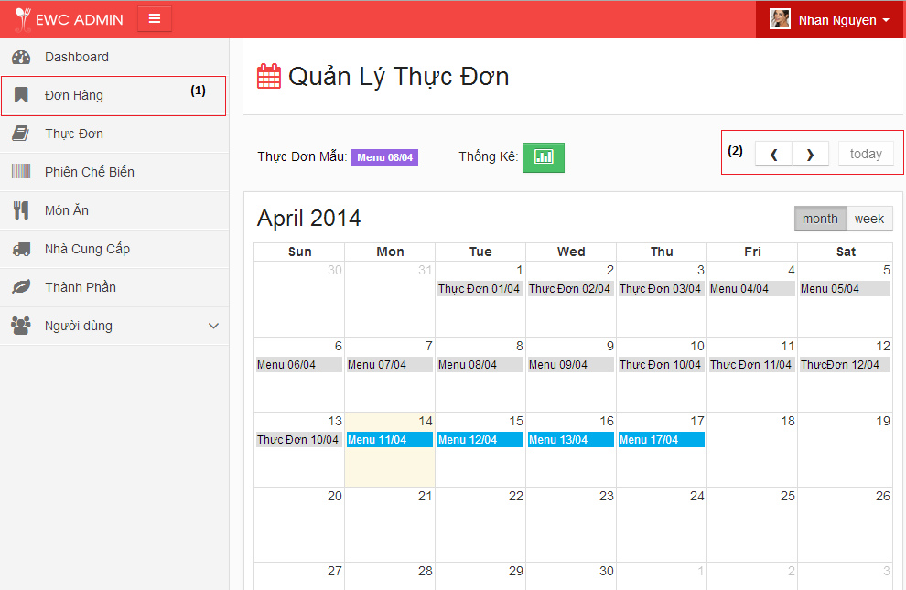

Figure 6.1: Main page of Calendar

| **STEP** | **DESCRIPTION** |
| --- | --- |
| **1** | Click “Menu” in menu bar to go to Calendar page |
| **2** | Click previous or next button to go to previous month or next month. |

#### 6.1.1.1 Create Menu

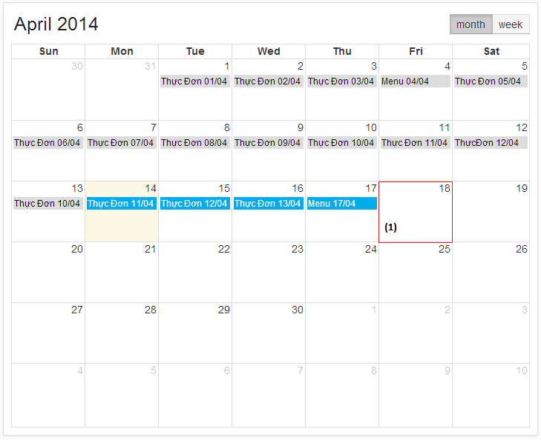

Figure 6.2: Calendar

| **STEP** | **DESCRIPTION** |
| --- | --- |
| **1** | 11/04 is today and it has different with another color. Click this day or next days (days in future) will show popup Create new Menu. |

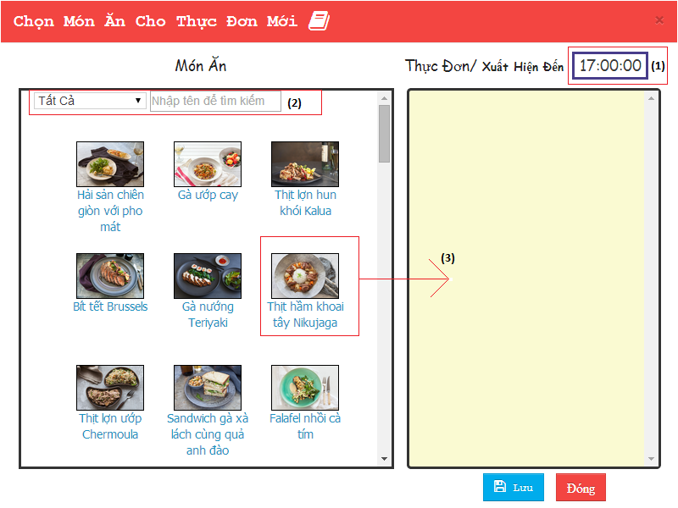

Figure 6.3: Create popup

| **STEP** | **DESCRIPTION** |
| --- | --- |
| **1** | Staff input close time session “Xuất Hiện Đến”. |
| **2** | Input info to search dish. |
| **3** | Drag dish into “Menu”. |

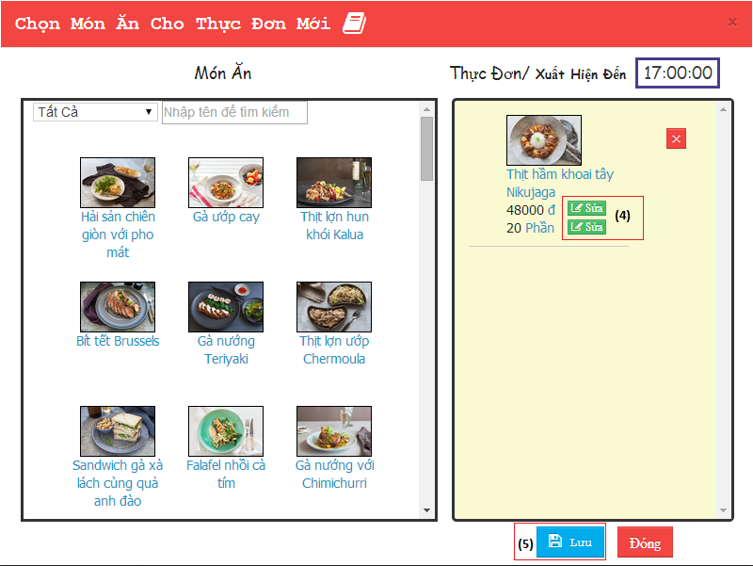

Figure 6.4: Create popup

| **STEP** | **DESCRIPTION** |
| --- | --- |
| **4** | Click button “sửa” to edit price or quota of dish. (Figure 6.7, Figure 6.8). |
| **5** | Click button “Lưu” to create new Menu and add dish to menu with input info. |

#### 6.1.1.2 Menu Details

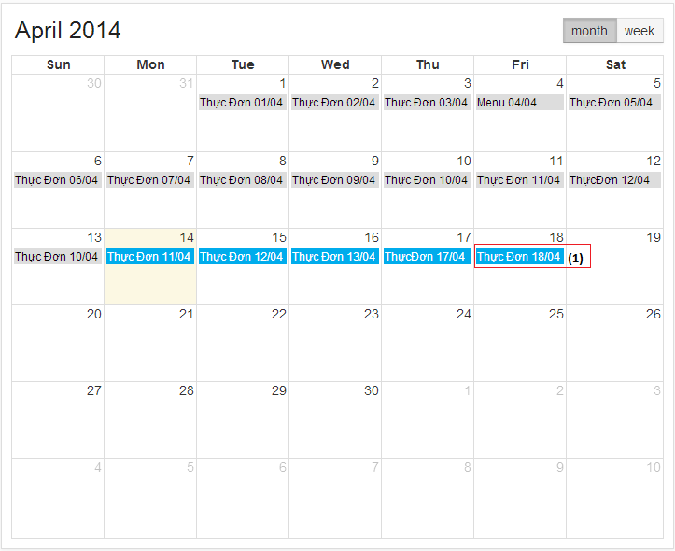

Figure 6.5: Calendar

| **STEP** | **DESCRIPTION** |
| --- | --- |
| **1** | “Menu 18/04” was created appear in calendar. Click it to open popup Menu Details. |

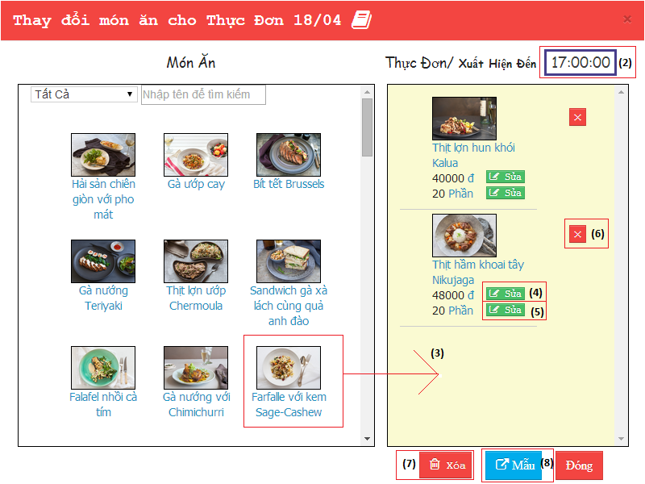

Figure 6.6: MenuDetails popup

| **STEP** | **DESCRIPTION** |
| --- | --- |
| **2** | Input info of “Xuất hiện đến” to change time close session. |
| **3** | Drag and drop dish into Menu to add dish to Menu. |
| **4** | Click button  to open popup edit price (Figure 6.7). |
| **5** | Click button  to open popup edit price (Figure 6.8). |
| **6** | Click button  to delete Dish in Menu. |
| **7** | Click button “Xoá” to delete this Menu. |
| **8** | Click button Xuất to assign menu for “Menu mẫu”(use for copy Menu in Figure 6.11). |

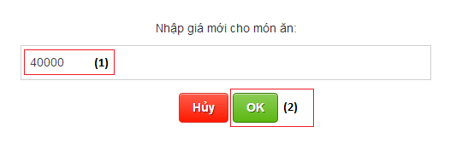

Figure 6.7: Edit Price popup

| **STEP** | **DESCRIPTION** |
| --- | --- |
| **1** | Staff input Dish price want to change. |
| **2** | Click button “Ok”. |

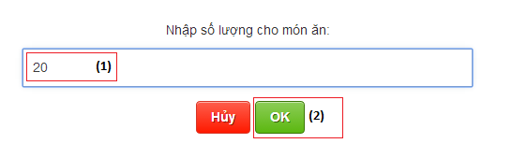

Figure 6.8: Edit Price popup

| **STEP** | **DESCRIPTION** |
| --- | --- |
| **1** | Staff input Dish quota want to change. |
| **2** | Click button “Ok”. |

#### 6.1.1.3 CopyAndMove Menu:

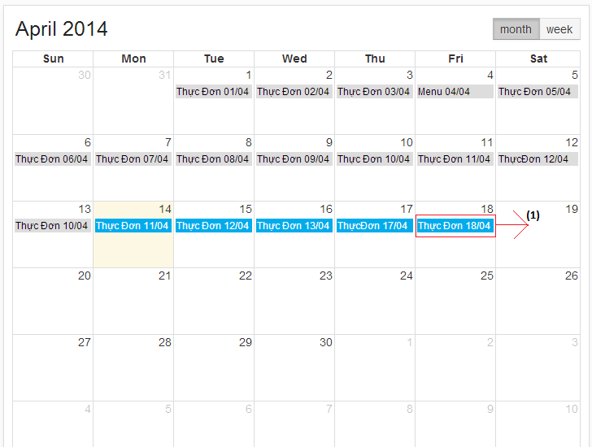

Figure 6.9: Calendar page

| **STEP** | **DESCRIPTION** |
| --- | --- |
| **1** | Staff drag “Menu 18/04” and drop it into 19/04 |

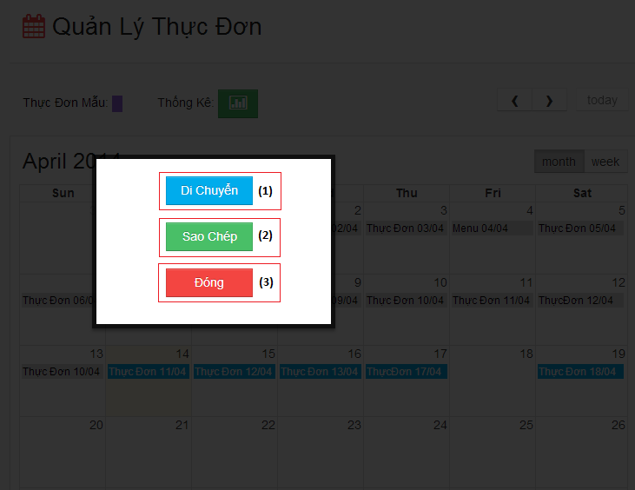

Figure 6.10: Edit Menu popup

| **STEP** | **DESCRIPTION** |
| --- | --- |
| **1** | Staff click button “Di Chuyển” to move Menu 18/04 to 19/04. |
| **2** | Staff click button “Sao chép” to copy Menu 18/04 to 19/04. New copied appear in 05/04 |
| **3** | Staff click button “Đóng” to cancel action and revert menu 18/04 to original place. |

#### 6.1.1.4 SuggestMenu:

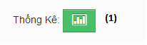

Figure 6.11

| **STEP** | **DESCRIPTION** |
| --- | --- |
| **1** | Staff click green button beside “Thống kê” to open SuggestMenu popup. |

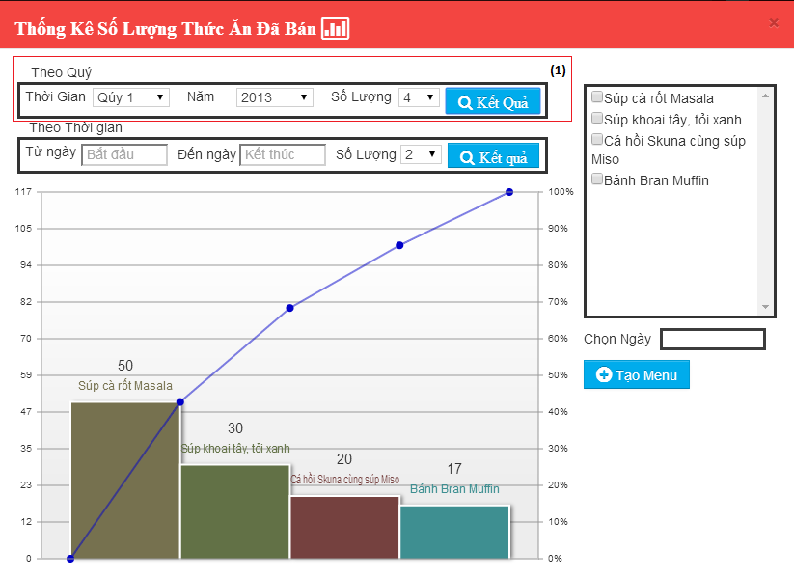

Figure 6.12

| **STEP** | **DESCRIPTION** |
| --- | --- |
| **1** | Staff input quarter, year, display number and click button “Kết Quả”. System will show statistic chart with info. |

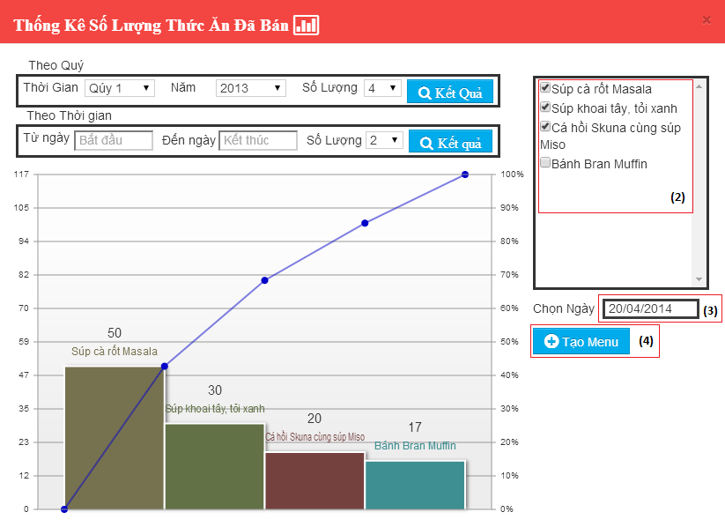

| **STEP** | **DESCRIPTION** |
| --- | --- |
| **2** | Staff check button beside dish want to add to Menu. |
| **3** | Chose date for create Menu |
| **4** | Click button “Tạo Menu” to create menu. |