**1. Install necessary library:**

- ultralytics: ***pip3 install ultralytics***

- scikit-image: ***pip3 install scikit-image***

- pyqt5: ***pip3 install pyqt5***

- opencv-python: ***pip3 install opencv-python***

- pandas: ***pip3 install pandas***

- numpy: ***pip3 install numpy***

- sqlalchemy: ***pip3 install sqlalchemy***

- pyodbc: ***pip3 install pyodbc***

**2. Install VsCode and extensions**

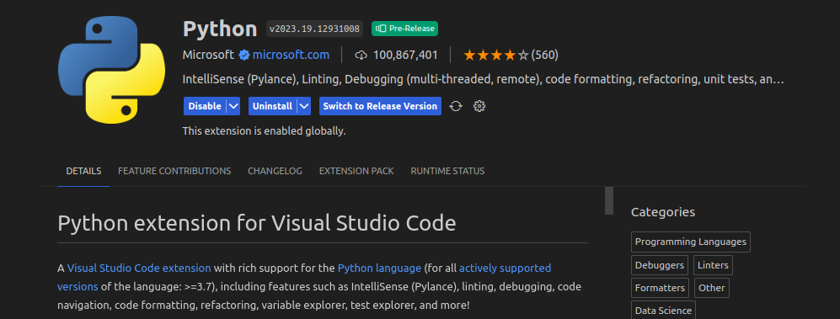

**3. Install SQL Server and SQL command-line tools**

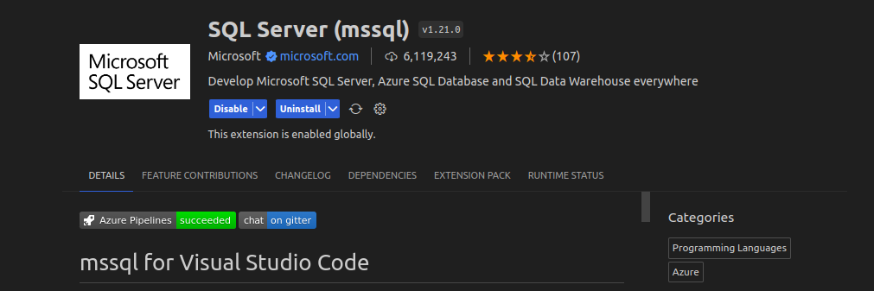

**SQL Server**

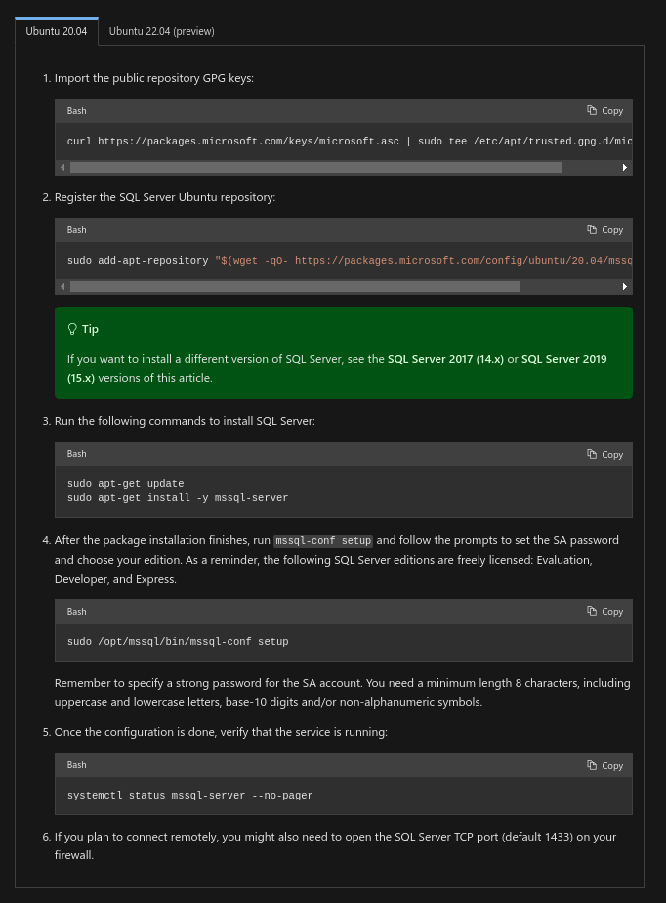

**SQL command-line tools**

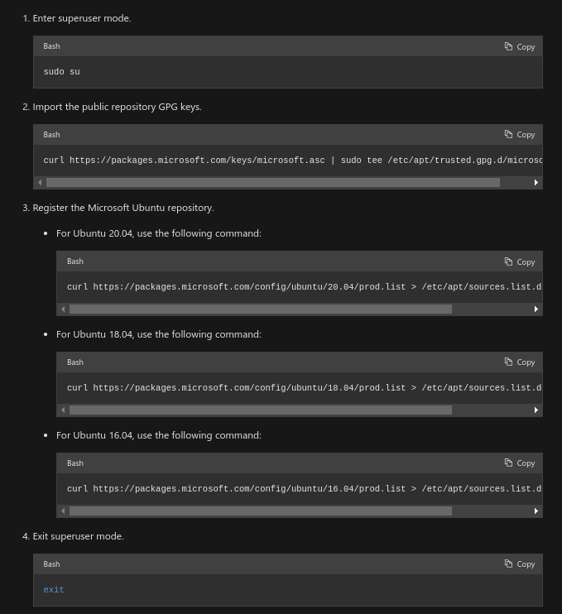

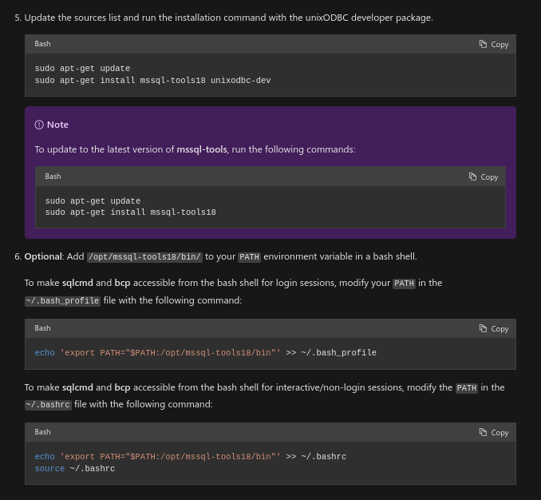

Then run ***sqlcmd -S localhost -U sa -P '<YourPassword>'***

Finally, create a database by SQL Query ***CREATE DATABASE DatabaseName;***

Afer install and create database, we create a connection between Vs Code with SQL Server to write query

- Server name or ADO.NET: localhost

- DatabaseName: DatabaseName

- Authentication Type: SQL Login

- User name: sa

- Password: password

- Save Pass: Yes or No

- Profile name: Display name

**5. Running code**

1. Run file .sql in folder **DatabaseApp** to create Table

2. Run file **mainDatabaseApp.py** to add tables

- Input cut part information

- Input Test2.xlsc path in Dimension Data text field

- Input Hard-pattern image in HardImg text field

Click Add Database to add tables

*Note: You can check table by query SELECT to check*

3. Run **mainApp.py** to check Measurement Application