**Contents**

For the following assignments: 3

Day 1. Lesson 1: Database Basics 3

Assignment 1_Opt1: Student Management 3

1. Exercise 1 3

2. Exercise 2 4

|  |  |
| --- | --- |
|  | **CODE: BSQL_Assignment1_Opt1**  **NAME: NGUYEN NGOC QUANG**  **DURATION: 120 MINUTES** |



# For the following assignments:

# Day 1. Lesson 1: Database Basics

## Assignment 1_Opt1: Student Management

1. **Exercise 1**

**Barem**: a-30%, b-30%

**Objective**: K4SD (Understand basic database knowledge (DBMS, RDBMS, ERD))

**Problem Description**:

A company database needs to store information about **employees** (identified by *ssn, with salary and phone as attributes),* **departments** *(identified by dno,* with *dname and budget as attributes), and* **children of employees** *(with name and age* as attributes).

Employees *work in departments; each department is managed by an* employee; a child must be identified uniquely by *name when the parent (who is an* employee; assume that only one parent works for the company) is known. We are not interested in information about a child once the parent leaves the company.

**Questions to answer**:

1. Draw an ER diagram that captures this information.
2. Convert from ER diagram to relational schema.

**Answer**

a)

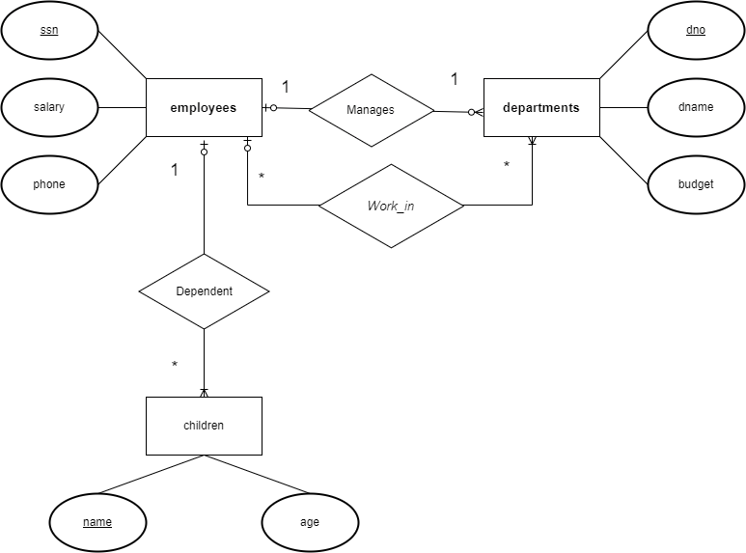

b)

**employees**

|  |  |  |  |
| --- | --- | --- | --- |
| **ssn** | **Salary** | **Phone** | **Dno_id** |

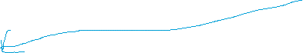

**departments**

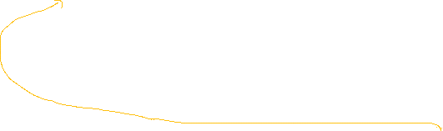

|  |  |  |
| --- | --- | --- |
| **Dno_id** | **Dname** | **budget** |



**child**

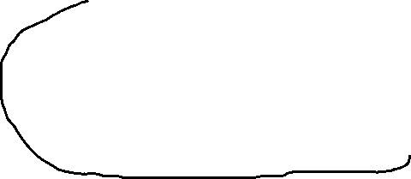

|  |  |  |
| --- | --- | --- |
| **Name** | **Age** | **c_ssn** |

**Work**

|  |  |
| --- | --- |
| **ssn** | **Dno_id** |



CREATE DATABASE d1

GO

USE D1

GO

CREATE TABLE departments(

dno_id CHAR(6) NOT NULL,

dname NVARCHAR(30) NOT NULL,

budget VARCHAR(10),

CONSTRAINT pk_departments PRIMARY KEY(dno_id)

)

GO

--DROP TABLE departments ;

CREATE TABLE employees(

ssn CHAR(6) NOT NULL,

Salary int,

Phone int,

Dno_id CHAR(6) NOT NULL,

CONSTRAINT pk_employees PRIMARY KEY(ssn),

CONSTRAINT fk_departments_employees FOREIGN KEY(dno_id) REFERENCES departments(dno_id),

)

GO

--DROP TABLE employees;

--Go

CREATE TABLE CHILD (

NAME NVARCHAR(100) NOT NULL,

AGE INT,

C_SSN CHAR(6) NOT NULL,

CONSTRAINT PK_CHILD PRIMARY KEY(NAME),

CONSTRAINT fk_employees_child FOREIGN KEY(C_SSN) REFERENCES employees(ssn)

)

go

--DROP TABLE CHILD;

CREATE TABLE Work(

SSN char(6) not null,

dno_id char(6) not null,

CONSTRAINT fk_Work_departments FOREIGN KEY(dno_id) REFERENCES departments(dno_id),

CONSTRAINT fk_work_employees FOREIGN KEY(SSN) REFERENCES employees(ssn)

)

go

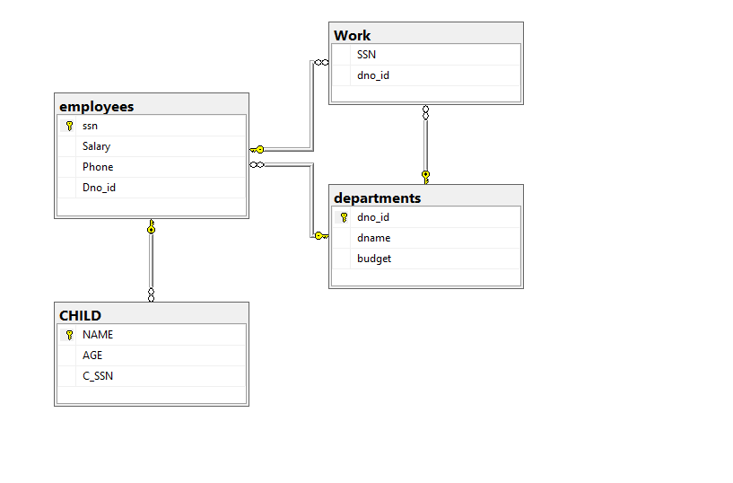

1. **Exercise 2**

**Barem**: 40%

**Objective**: K4SD (Understand basic database knowledge (DBMS, RDBMS, ERD))

**Problem Description**:

Consider the following relations for a database that keeps track of student enrollment in courses and the books adopted for each course (Primary Key is mark post-fix with #):

**STUDENT** (SSN#, Name, Major, Bdate)

**COURSE** (Course#, Cname, Dept)

**ENROLL** (SSN#, Course#, Quarter, Grade)

**BOOK_ADOPTION** (Course#, Quarter, Book_ISBN#)

**TEXT** (Book_ISBN#, Book_Title, Publisher, Author)

**Questions to answer**:

Draw a relational schema diagram specifying the foreign keys for this schema.

**Answer**

The attribute SSN of relation ENROLL that references relation STUDENT,

The attribute Course# in relation ENROLL that references relation COURSE

The attribute Course# in relation BOOK_ADOPTION that references relation COURSE

The attribute Book_ISBN of relation BOOK_ADOPTION that references relation TEXT.

**STUDENT**

|  |  |  |  |
| --- | --- | --- | --- |
| SSN# | Name | Major | Bdate |

**COURSE**



|  |  |  |
| --- | --- | --- |
| Course# | Cname | Dept |

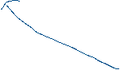

**ENROLL**



|  |  |  |  |
| --- | --- | --- | --- |
| SSN# | Course# | Quarter | Grade |

**BOOK_ADOPTION**

|  |  |  |
| --- | --- | --- |
| Course# | Quarter | Book_ISBN# |



**TEXT**

|  |  |  |  |
| --- | --- | --- | --- |
| Book_ISBN# | Book_Title | Publisher | Author |