|  |  |
| --- | --- |
|  | **CODE: BSQL_Assignment2_Opt1**  **TYPE: n/a**  **LOC: n/a**  **DURATION: 180 MINUTES** |

# For the following assignments:

* Print out respectively the screenshots to show the query results.
* Pack screenshots and SQL scripts or your answers into the zip file named BSQL_Assignment<i>_AccountName.zip (for instance: BSQL_Assignment1_NamNT.zip) then handle to the evaluator via email ([XYZ@fsoft.com.vn](mailto:XYZ@fsoft.com.vn) ) or follow the guidance of the class admin.

# Day 2. Lesson 2: SQL Basic

## Assignment 2_Opt1: Fresher Training Management

**Barem**: a: 40% (4), b: 10%(1), c: 15%(1.5), d: 15%(1.5), e: 20%(2)

**Objective**: H5SD - SQL skills

**Problem Description**:

In the design for the Fresher Training Management, given the Trainee table with below initial attributes fields:

* **TraineeID**: trainee identifier, auto increment field
* **Full_Name**: full name of the trainee
* **Birth_Date**: trainee birth date
* **Gender**: only have one of two value male, female
* **ET_IQ**: entry test point (IQ) of trainee, integer, value range from 0 to 20
* **ET_Gmath**: entry test point (GMath) of trainee, integer, value range from 0 to 20
* **ET_English**: entry test point (English) of trainee, integer, value range from 0 to 50
* **Training_Class**: the class code that trainee is joining
* **Evaluation_Notes**: trainee evaluation notes, free text.

**Questions to answer**:

1. Create the tables (with the most appropriate/economic field/column constraints & types) and add at least 10 records into each created table.
2. Change the table TRAINEE to add one more field named Fsoft_Account which is a not-null & unique field.
3. Create a VIEW which includes all the ET-passed trainees. One trainee is considered as ET-passed when he/she has the entry test points satisfied below criteria:

* ET_IQ + ET_Gmath >=20
* ET_IQ>=8
* ET_Gmath>=8
* ET_English>=18

1. Query all the trainees who is passed the entry test, group them into different birth months.
2. Query the trainee who has the longest name, showing his/her age along with his/her basic information (as defined in the table).

**Estimated Time to complete**:180 mins.

MY ANSWER

CREATE DATABASE D2

GO

/*

*/

USE D2

GO

--A): Create the tables(with the most appropriate/economic field/column constraints & types)

-- and add at least 10 records into each created table.

CREATE TABLE Trainee(

TraineeID int identity(1,1) NOT NULL,

Full_name NVARCHAR(60) NOT NULL,

Birth_date DATE,

Gender varchar(10) not null CHECK(Gender in('male','female')),

ET_IQ INT CHECK(ET_IQ>=0 AND ET_IQ<21 ),

ET_GMATH INT CHECK(ET_GMATH>=0 AND ET_GMATH<21),

ET_ENGLISH INT CHECK (ET_ENGLISH>=0 AND ET_ENGLISH<=50),

TRAINNING_CLASS CHAR(30),

EVALUATION_NOTES NTEXT,

)

GO

INSERT INTO TRAINEE(

Full_name,

Birth_date,

Gender,

ET_IQ,

ET_GMATH,

ET_ENGLISH,

TRAINNING_CLASS,

EVALUATION_NOTES

) VALUES

( N'Nguyễn Ngọc Quang', '1/1/2000', 'male', 18, 18, 30, 'FRESHER_JAVA_12', 'Smart, Talented')

Go

INSERT INTO Trainee

VALUES ('Phoebus Eitan', '9/4/1990','male', 5, 10, 21, 'Fresher-3', 'Hardest, Bad-tempered'),

INSERT INTO Trainee VALUES('Gebhard Crescens', '9/11/1983', 'female', 10, 10, 20, 'Fresher-3', 'Friendly, Cheerful'),

('Wotan Ittai', '2/25/1999', 'male', 12, 14, 40, 'Fresher-2', 'Crazy, Shy, Talkative'),

('Thore Zan', '11/22/1993', 'male', 2, 10, 20, 'Fresher-2', 'Naughty, Boast'),

('Izydor Jenaro', '12/31/1996', 'female', 20, 19, 49, 'Fresher-1', 'Smart, Talented'),

('Arash Euaristos', '1/30/2000', 'male', 16, 15, 40, 'Fresher-2', 'Dependable, Enthusiastic'),

('Damodar Lanzo', '5/3/2009', 'male', 15, 10, 30, 'Fresher-1', 'Sociable, Optimistic'),

('Roderick Anton', '1/30/1996', 'female', 20, 18, 41, 'Fresher-1', 'Serious, Understantding'),

('Werdheri Paschalis', '2/12/1993', 'male', 15, 18, 35, 'Fresher-1', 'Creative, Quite'),

( 'Dumitru An', '1/1/1996', 'male', 19, 15, 44, 'Fresher-2', 'Polite, Hard-working')

GO

DELETE FROM [d2].[dbo].[Trainee] WHERE TRAINEEID=1

go

ALTER TABLE TRAINEE ADD PRIMARY KEY(TRAINEEID)

GO

--B): Change the table TRAINEE to add one more field named Fsoft_Account

--which is a not-null & unique field.

ALTER TABLE Trainee

ADD Fsoft_Account char(40)

GO

UPDATE Trainee SET Fsoft_Account = 'quangnn24@fsoft.com.vn' where TraineeID=2

Go

/*

SELECT SUBSTRING(fullname, 1, CHARINDEX(' ', fullname) - 1) AS Firstname,

SUBSTRING(fullname,

CHARINDEX(' ', fullname) + 1,

LEN(fullname) - CHARINDEX(' ', fullname)) AS Lastname

FROM yourTable

*/

update Trainee set Fsoft_Account=(select SUBSTRING(Full_name,CHARINDEX(' ',Full_name)+1, LEN(Full_name) - CHARINDEX(' ', Full_name)))+'@fsoft.com.vn' where TraineeID >=6

go

---delete * from Trainee

--null

alter table TRAINEE alter column Fsoft_Account char(40) Not null;

Go

--unique

ALTER TABLE TRAINEE ADD UNIQUE(Fsoft_Account)

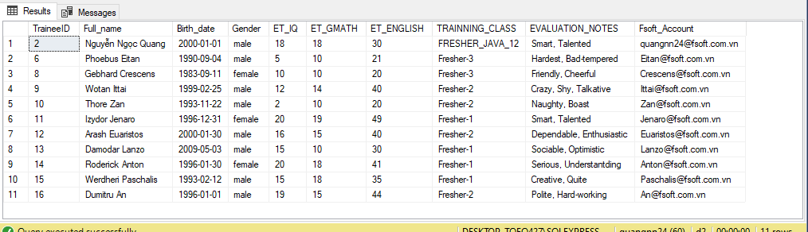

C): Create a VIEW which includes all the ET-passed trainees.

--One trainee is considered as ET-passed when he/she has

-- the entry test points satisfied below criteria:

-- ET_IQ + ET_Gmath >= 20 AND ET_IQ >= 8 AND ET_Gmath >= 8 AND ET_English >= 18

CREATE VIEW ET_Passed_Trainees AS

SELECT TraineeID, Full_Name, Birth_Date, Gender

FROM Trainee

WHERE ET_IQ + ET_Gmath >= 20 AND ET_IQ >= 8 AND ET_Gmath >= 8 AND ET_English >= 18

GO

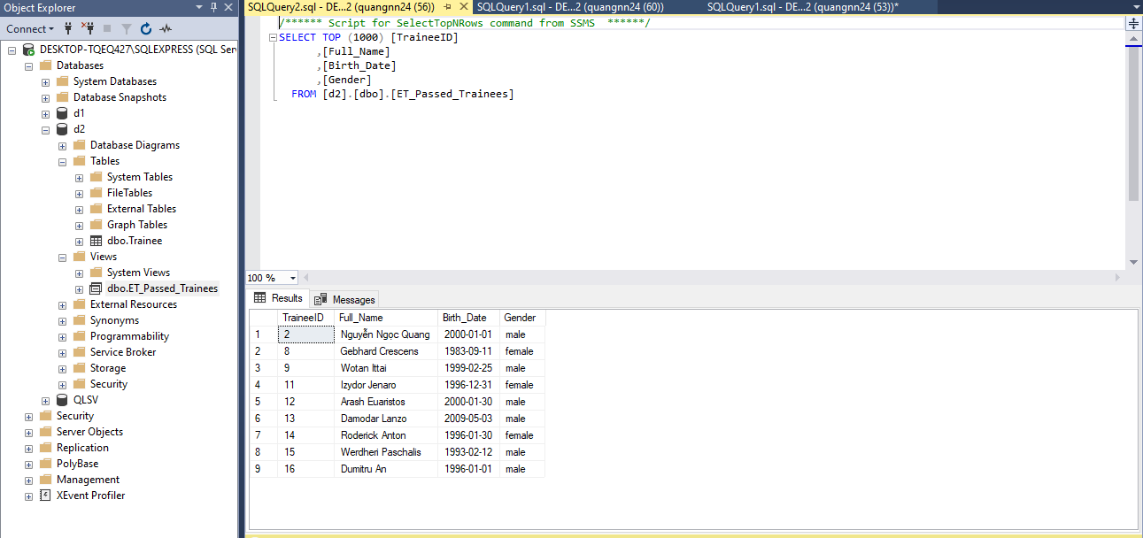

D): Query all the trainees who is passed the entry test,

--group them into different birth months.

SELECT TraineeID,

Full_Name,

Birth_Date

FROM Trainee

WHERE ET_IQ + ET_Gmath >= 20

AND ET_IQ >= 8

AND ET_Gmath >= 8

AND ET_English >= 18

ORDER BY MONTH(Birth_Date)

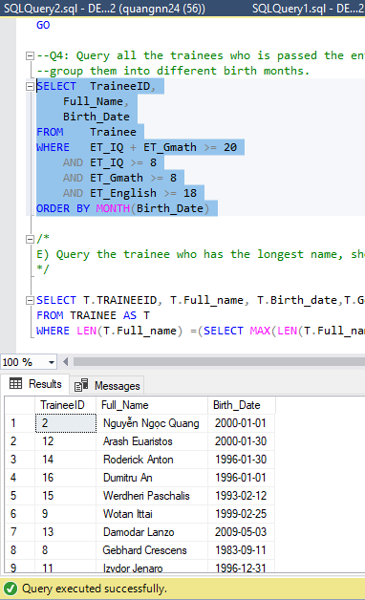

/*

E) Query the trainee who has the longest name, showing his/her age along with his/her basic information (as defined in the table).

*/

SELECT T.TRAINEEID, T.Full_name, T.Birth_date,T.Gender,YEAR(GETDATE())-YEAR(T.Birth_date) AS AGE,T.TRAINNING_CLASS

FROM TRAINEE AS T

WHERE LEN(T.Full_name) =(SELECT MAX(LEN(T.Full_name)) FROM TRAINEE AS T)

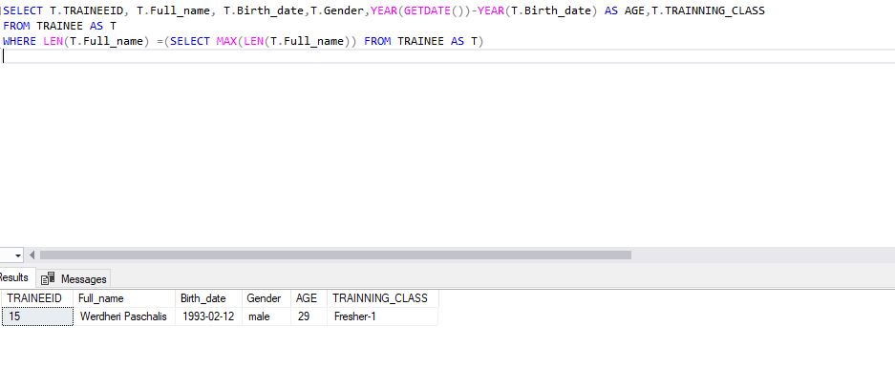

**-- THE END --**