Analyzing Urban Expansion in Hanoi Using Machine Learning and Multi-Temporal Satellite Imagery
Dang Thanh Tung^{1*}(0000-0002-1944-7430), Nguyen Thanh Tung¹, Hoang Thi Thuy², Ta Minh Ngoc¹, Dinh Thi Thanh Huyen¹, Pham Chi Linh¹
¹Hanoi University of Natural Resources and Environment, Ha Noi, Viet Nam
²Hanoi University of Mining and Geology, Ha Noi, Viet Nam
dttung.qldd@hunre.edu.vn
Abstract: The rapid urban expansion and development of Hanoi, the capital of Vietnam, in recent times have presented challenges for managers in monitoring, evaluating, and rationally managing natural resources. This study monitors urban expansion in the centre of Hanoi using GIS and remote sensing techniques based on machine learning algorithms. Satellite images, including Landsat-8 and Sentinel-2, are employed as data for the study. Additionally, the study utilizes the Support Vector Machine (SVM) algorithm to classify land use/land cover and monitor their changes during the period from 2013 to 2023. The results of this study show that the built-up area expanded in different directions during each period. Especially in the last 5-year period, the built-up area expanded rapidly, continuously, and mainly to the East of the centre of Hanoi, while in the previous period, it expanded much to the West. In the past 10 years, the built-up area has increased by approximately 11.56 square kilometres, of which 5.36 and 6.20 square kilometres were increased in the period 2013-2018 and 2018-2023, respectively. The results effectively contribute to urban planning and management, monitoring of environmental protection management, and sustainable development.
Keywords: Urban expansion · Land cover · Machine Learning · Google Earth Engine · Hanoi
1 Introduction
Urbanization causes changes in land use/land cover, and it negatively impacts the environment in many developing countries, primarily by converting agricultural land into various other forms of land use [1]. According to Seto, the global urban area is expected to nearly triple by the year 2030 compared to its area in the year 2000 [2]. The expansion of urban areas affects the environment and results in the loss of biodiversity. Although urbanization is often a local issue, it has global implications [2]. There have been numerous methods to monitor the growth and expansion of urban areas. However, the methods and data used in the aforementioned research have become outdated compared to today’s standards. Nowadays, with the advancement of remote sensing technology, Geographic Information Systems (GIS), and the application of machine learning, these tools have proven to be highly effective in classifying land cover from satellite images and monitoring their changes [3], [4].
Based on classified land covers from satellite image data, the built-up area can be used for cost-effective, reliable, and continuous monitoring of urban sprawl over time [5], [6]. Studies that have utilized remote sensing and GIS technology to monitor the growth and expansion of areas include the research by Jieying Xiao and colleagues, who monitored the urban development of Shizhi Shijiazhuang, Hebei Province, China, from 1934 to 2001 and evaluated changes in land use due to urbanization between 1987 and 2001 [7]. Alternatively, Fan et al. (2009) [8] evaluated the urban expansion of Guangzhou from 1979 to 2003, revealing a remarkable expansion rate of approximately 210.08%, corresponding to an increase in the urban area of 296.54 km². In the Hanoi area, there have been a few related studies, such as research on urban growth utilizing landscape development models [9] and investigations into rural-urban transitions utilizing Landsat imagery [10].

The aforementioned studies, along with similar research, have used Landsat satellite imagery data and land use/land cover classification methods in combination with GIS to monitor urban area expansion. Furthermore, other studies utilize satellite imagery data with index-image methods such as the Colour Difference Index (CDI), which is based on colour variations in different areas of satellite images and can detect environmental changes and urban expansion; The Normalized Difference Built-up Index (NDBI) compares the wavelengths emitted by non-built-up and built-up areas, facilitating the identification of urban expansion; Near Infrared (NIR) combined with the Red band can distinguish between built-up and vegetated areas, allowing for monitoring changes in urban structures; The Normalized Difference Vegetation Index (NDVI) indicates vegetation coverage levels and can detect environmental changes resulting from urban expansion; Additionally, other indicators such as Urban Index (UI), Enhanced Built-up and Bareness Index (EBBI), Index-based Built-up Index (IBI), have been used in various studies to monitor urban changes. In which, the NDBI, or in combination with other indices, has been widely used to monitor urban expansion. These can be mentioned in the study by Yuanmao Zheng et al., which monitors the expansion of the Guangdong-Hong Kong-Macao Greater Bay Area metropolitan area [11]. Alternatively, Li et al. (2018) [12] demonstrated the differentiation of rural areas, urban regions, and expansion in several urban clusters in China from 2012 to 2017 by combining NDBI and nighttime light (NTL) data. However, several studies have also shown that using land cover classification results is more advantageous and achieves higher effectiveness compared to using index-image for identifying and monitoring the expansion of urban areas [13], [14], [15].

Boser et al. (1992) [16] used the SVM algorithm to solve classification problems. This algorithm has since been implemented and applied in various fields, with one of its highly effective applications being the classification of surface cover from satellite image data [17], [18]. Moreover, numerous algorithms have been effectively applied in classifying land cover from satellite images, such as the Minimum Distance Classifier (MDC), Maximum Likelihood Classifier (MLC), K-Nearest Neighbor (KNN), Classification and Regression Tree (CART), Support Vector Machine (SVM), and Random Forest (RF). Particularly, CART, RF, and SVM algorithms have been extensively used in machine learning for near real-time satellite image database exploration on the Google Earth Engine (GEE) platform. Recently, researchers have globally demonstrated the effectiveness of exploiting SVM, CART, or RF algorithms and have evaluated the reliability of each of the aforementioned algorithms in the application of land cover classification from satellite images [19], [20], [21]. Studies on land cover classification, as mentioned above, can be used to monitor the expansion of urban areas. However, the utilization of machine learning algorithms for land cover classification from satellite imagery to monitor and detect urban development and expansion in Hanoi (Vietnam) has not been reported yet. Previous studies have only focused on quantifying expansion in the area, overlooking variations in the direction of urban expansion from the centre [22]. To enhance effectiveness and supplement findings, this study utilizes the SVM machine learning algorithm for the classification of Landsat-8 and Sentinel-2 satellite images to monitor area expansion in Hanoi from 2013 to 2023. Therefore, the study also identifies the extended development direction of the urban area of Hanoi which previous studies have not provided results on.
2 Materials and Methods
2.1 Study area
The study area is the Hanoi urban area, which is located between latitude 20°53’ to 21°23’ North and longitude 105°44’ to 106°02’ East. It covers a natural area of approximately 335,000 hectares and has a population of over 8 million. The study area is divided into 30 administrative units, including districts, counties, and towns, and encompasses 577 communes, wards, and townships [23]. Over the past decade, Hanoi has rapidly expanded and developed, resulting in significant changes in land use and land cover, such as built-up areas, transportation structures and fewer green layers. Particularly, cover layers such as vegetation and water bodies can be significantly reduced.
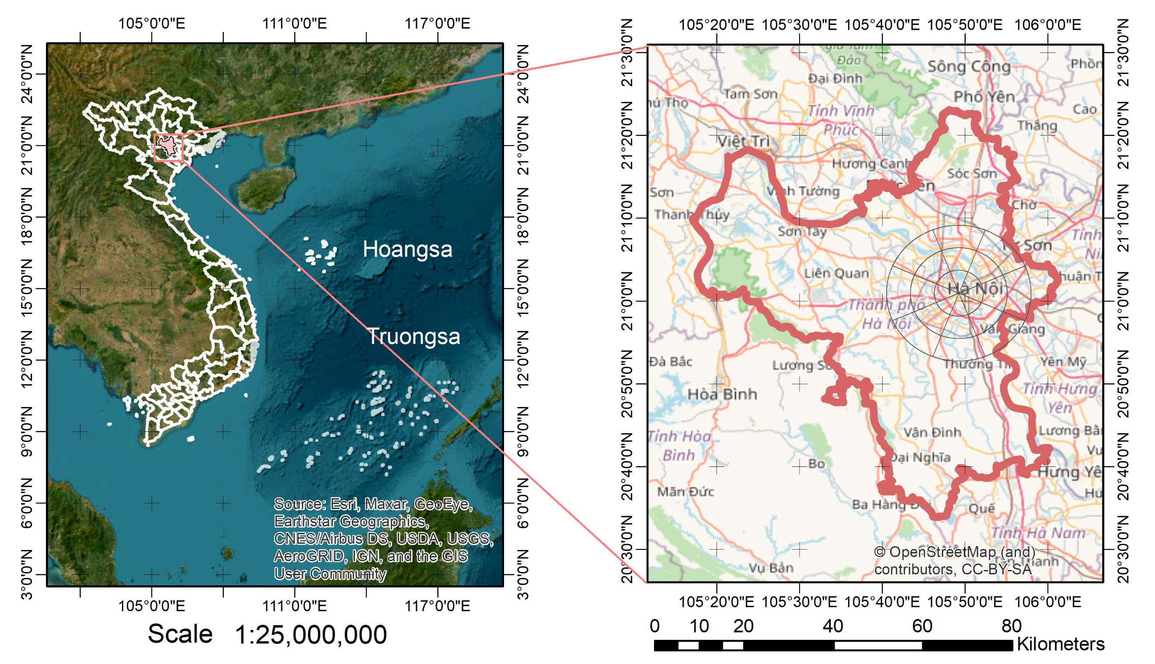
Fig. 1. Location of the study area.
The climate in the study area is situated in the tropical monsoon region, characterized by the summer monsoon (with high humidity, temperature and rainfall) and winter monsoon (with lower humidity, temperature and less rainfall). The difference between these two seasons is known for Hanoi experienced variation in climate, including a large gap of temperatures that reached up to 40°C in the summer and dropped below 5°C (occasionally). Additionally, the study can receive a generous amount of solar radiation during the summer. The annual average radiation is approximately 120 kcal/cm², with an average annual temperature ranging from 21.8°C to 24.9°C and an average humidity ranging from 80% to 82% [24]. The average annual rainfall exceeds 1700mm, distributed over about 114 rainy days per year.

In recent years, the research area has undergone rapid socioeconomic development, accompanied by urban expansion, population growth, and changes in land use/land cover. These developments have had certain impacts on the environment, affecting the health and quality of life of the local population.
2.2 Data
This study utilized Landsat-8 and Sentinel-2 satellite images from 2013 to 2023, accessed online through the GEE platform. Those images were selectively chosen with the lowest cloud cover, typically captured annually between March and June, to ensure high data quality with minimal cloud cover. The period aligns with the transition from foggy and drizzly conditions to clearer skies with minimal rainfall, facilitating the acquisition of high-quality optical remote sensing images.

For data controlling quality, Landsat-8 image data from 2013 to 2018 and Sentinel-2 image data from 2019 to 2023 have been used. All selected satellite images had Top Of Atmosphere (TOA) correction. The study area boundaries have been sourced from the national database of the Ministry of Natural Resources and Environment of Vietnam [25]. Basic information about the satellite image data used in the study is presented in Table 1.
Table 1. Satellite image series in the study area.
No | Year | Image | Cloudy Percentage
1 | 2013 | Landsat-8 | 0.05%
2 | 2014 | Landsat-8 | 0.86%
3 | 2015 | Landsat-8 | 2.68%
4 | 2016 | Landsat-8 | 0.12%
5 | 2017 | Landsat-8 | 1.03%
6 | 2018 | Landsat-8 | 2.5%
7 | 2019 | Sentinel-2 | 1.53%
8 | 2020 | Sentinel-2 | 0.98%
9 | 2021 | Sentinel-2 | 0.73%
10 | 2022 | Sentinel-2 | 1.22%
11 | 2023 | Sentinel-2 | 0.88%

2.3 Method used
Support Vector Machine (SVM) is a supervised machine learning algorithm known for its effectiveness, even when training samples are limited. It performs well in both classification and regression tasks. The SVM algorithm strategically separates support vectors to distinctly classify data points, with the primary objective of identifying two types of independent support vectors with the largest amplitude [26], [27]. Fig. 2 illustrates the SVM algorithm model.

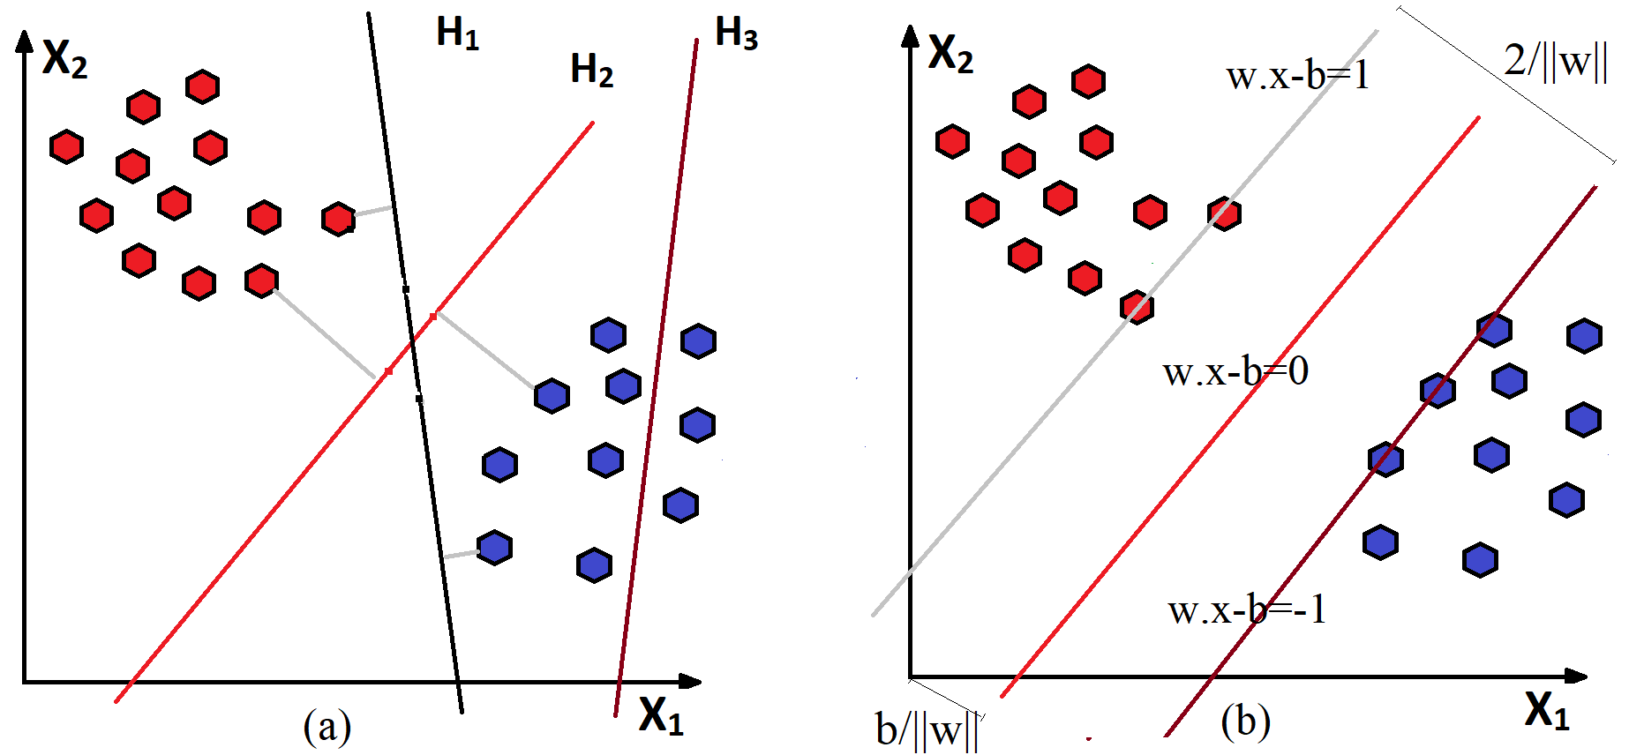
Fig. 2. SVM algorithm illustration. In (a), H3 (brown) does not separate the two data layers. H1 (black) separates the two classes with a small margin, and H2 (red) separates with a maximum margin. In (b), a Hyperplane with a maximum margin for an SVM separates data belonging to two classes. Examples that lie on the Edge are known as support vectors.
Using a dataset of trained samples that belong to predefined classes, the SVM algorithm builds a model to classify objects into these predefined classes. The core aim of this algorithm is to find a feature space (F) and a decision hyperplane (f) within that space that minimizes classification errors. Classification is accomplished through the decision function:
$f\left(x\right)=sign\left(+b\right)$ . | (1)
The function f(x) is obtained by adjusting the weight vector w, which is the vector aimed at maximizing the distance to the hyperplanes (Optimal hyperplane). The given data points lie on parallel hyperplanes and are referred to as Support Vectors. In a space with multiple points, the y_{i} represents the classes containing data points x_{i} and x_{i} represents a multi-dimensional real vector (p dimensions)

Each hyperplane can be expressed as a set of points that satisfy the following:
$w.x-b=0$. | (2)
where, w is a normal vector of the hyperplane; b/||w|| determines the distance from the origin to the hyperplane in the direction of the normal vector w.

In Fig. 2, H_{2,} as the hyperplane is the output and needs to be found. At this point, these hyperplanes are determined by the following functions:
$w.x-b=1$ . | (3)
$w.x-b=-1$ . | (4)
2.4 Land Cover Classification
In this study area, the authors selected six land covers for classification, which include (1) Bare land, (2) Water bodies, (3) Large trees, (4) Shrubs and lawns, (5) Built-up area, and (6) Transportation. These land covers were selected based on their characteristics at the time of image acquisition. Specifically, bare land encompasses open fields, sandy areas, reclaimed land, areas undergoing reclamation, and newly reclaimed vacant land designated for future construction. The water bodies include areas like ponds, lakes, rivers, and canals. The large trees include areas with large shady trees, dense vegetation, and forests. The shrubs and lawns cover grassy areas, fields, and gardens with crops at the time of image acquisition. The built-up area comprises houses, standalone construction projects, and residential or commercial areas, including villages, apartment complexes, and high-rise buildings. The transportation includes various types of major roads and main routes within the study area.

The classification results are based on machine learning training, with training data generated from sample sets, where specific samples are extracted from satellite images for each land cover. Additionally, the author also conducted field surveys to collect characteristic samples for comparison, ensuring the reliability of the sample set used for data training. Fig. 3 illustrates an overview of the research process, and the basic steps in the process are described below. This study uses the JavaScript programming language to perform land cover classification from satellite image data on a cloud computing platform. Image processing and classification steps include the following: Collecting satellite image data based on the GEE cloud computing data platform; Filter and selecting images with the lowest cloud coverage; creating sample sets; data training; Classifying land covers on satellite images according to SVM algorithms; Receiving classification image results; Evaluating the accuracy of the results after classification. After obtaining the results of image classification, proceed with steps to analyze and monitor changes in land covers in the period 2013-2023 in the study area.
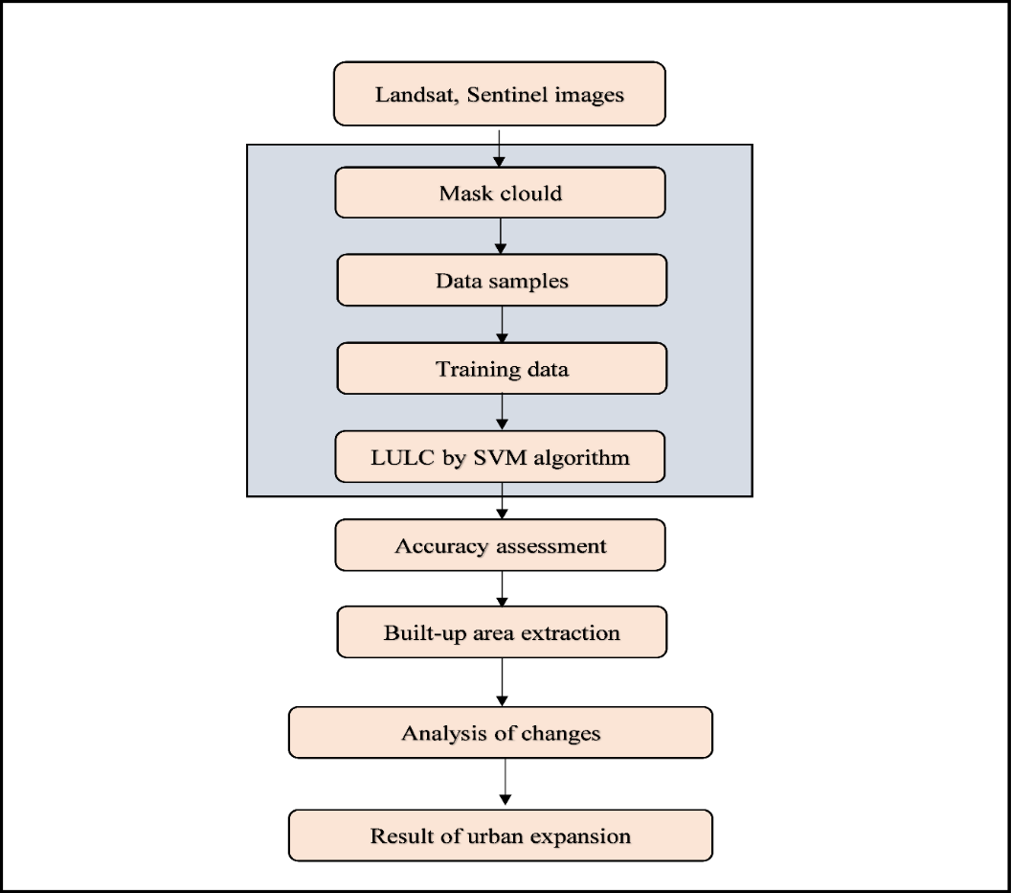
Fig. 3. Workflow for monitoring urban expansion.
2.5 Accuracy assessment
The Confusion Matrix is used to assess the accuracy of land cover classification results in this study. It can characterize the accuracy of overlay classification results and point out classification confusion between different land covers [28], [29]. In particular, basic statistics include assessment of Kappa coefficient, Producer Accuracy (PA), User Accuracy (UA), and Overall Accuracy (OA). The Kappa coefficient has values ranging from 0.4 to 0.6, which are considered to have average results. Values greater than 0.6 to 0.8 are good, and greater than 0.8 to 1.0 are excellent [30], [31]. The accuracy of the classified images is assessed using the error-Matrix function in GEE (Google Earth Engine), where 70% of the sample data is used for image classification, while the remaining 30% of the sample data is reserved for evaluation and testing [32], [33].
2.6 Urban expansion
Built-up area extraction is the first categorized parameter considered for Urban Expansion. Based on the results obtained from classifying six land covers in the study area, the built-up area is also extracted for the analysis and monitoring of urban centre expansion from 2013 to 2023. These built-up area data layers are then spatially overlaid to calculate and provide results for changes in three periods. These periods include urban area changes for two 5-year periods: Period 1 from 2013 to 2018, Period 2 from 2018 to 2023, and Period 3, which encompasses the entire period from 2013 to 2023.

Next, the urban expanding direction should be chosen as the second importance. This study also monitors the expansion of the central urban area of Hanoi within a 15 km radius in the following directions: North (N), North-East (NE), East (E), South-East (SE), South (S), South-West (SW), West (W), and North-west (NW) to analyzing and calculating changes in the built-up area over time. Therefore, to obtain detailed results for each urban expansion area, the study divided the area into four separate zones. Zone 1 has a radius ranging from 0 to 5 km, Zone 2 has a radius ranging from 5 to 10 km, Zone 3 has a radius ranging from 10 to 15 km, and Zone 4 represents the entire area with a radius ranging from 0 to 15 km.
3 Research Methodology
3.1 Image Pre-Processing
The Landsat-8 and Sentinel-2 satellite image data from the period 2013-2023, which were derived from GEE. The satellite acquired images were processed and corrected to surface reflectance values, and included corrections for atmospheric, sun and solar zenith [34]. The pre-processing involves the following steps, such as (1) creation of image data files, (2) cloud filtering, (3) generation of average images for the study areas, (4) preparation of LULC classes, followed by sample training and validation, (5) LULC classification, (6) accuracy assessment and (7) post-processing and analysis. Spectral bands used for classification are bands 2, 3, 4, 5, 6, and 7 for Landsat-8 and bands 2, 3, 4, 8a, 11, 12 for Sentinel-2.
3.2 Classification of LULC Types and Training, Validation of Samples
The LULC classes for the study area were determined based on fieldwork and land use statistics maps in Vietnam [35]. The results include six LULC classes, including (1) Bare land, (2) Water bodies, (3) Large trees, (4) Shrubs and lawns, (5) Built-up area, (6) Transportation (see Table 2)
Table 2. Descriptions of the LULC classes.
No | LULC Classes | Description
1 | Bare land |  | Sandy areas, reclaimed land, uncultivated land, undeveloped land
2 | Water bodies |  | Rivers, ponds, streams, lakes, canal
3 | Large trees |  | Large shady trees, dense vegetation, natural forests
4 | Shrubs, lawns |  | Grassy areas, fields, gardens, clouds, scrub
5 | Built-up area |  | Standalone construction projects, villages, apartment complexes, and high-rise buildings
6 | Transportation |  | Major roads, main routes

The samples used for training are selected from Landsat-8 and Sentinel-2 satellite images based on invariant areas within the six LULC classes and polygons drawn at the centres of these areas. These samples are validated against land use statistics maps from various periods during 2013-2023. In total, 735 samples were used for training the model to LULC classification using the SVM algorithm.
3.3 Image Classification, Accuracy Evaluation
In this study, the SVM algorithm was used for LULC class classification, which is a widely used algorithm that can provide high accuracy. However, it also requires processing time, especially when dealing with a large number of classification samples [36]. Both qualitative and quantitative methods were utilized to assess the accuracy of LULC in this study. For qualitative evaluation, visual inspection and assessment were conducted using Landsat-8 and Sentinel-2 images corresponding to land-use statistic maps during the period of 2013-2023. Various statistical measures were employed for qualitative assessment, such as the Kappa index and Overall accuracy values, as presented in Section 2.5.
3.4 LULC Change Assessment
The LULC classification maps achieved for each year within the 2013-2023 period were then post-processed in ArcGIS. The changes in LULC during the periods of 2013-2018, 2018-2023, and 2013-2023 were computed. Finally, the LULC change maps for these periods were derived.
4 Results and analysis
4.1 LULC Classification and Accuracy
The study has demonstrated significant changes in land cover within the area from 2013 to 2023. Fig. 4 illustrates the land cover products after classification in the research area using the SVM algorithm.
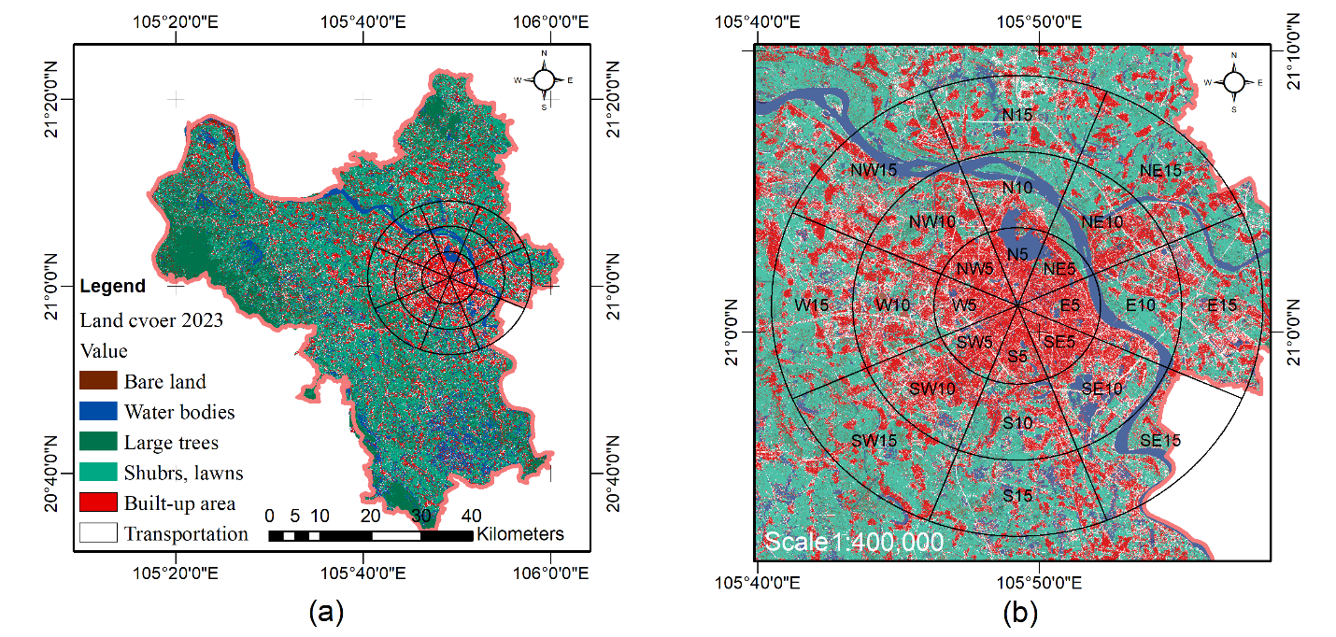
Fig. 4. Land cover in 2023. In (a), land cover in the urban Hanoi. In (b), land is covered in the urban centre.
During the period from 2013 to 2023, the land cover in the Hanoi area underwent various changes, with disparities observed at different times. In the inner-urban areas, the land cover has shown little change, while areas farther from the urban centre have more fluctuations, particularly in newly administratively transformed district areas. The results regarding the expansion of the urban area align with findings from other studies on urban development in Vietnam [37]. Specifically, in the study area the built-up areas and transportation increased in the area together, showing a positive correlation. Conversely, the built-up area exhibits a negative correlation with water bodies during the study period, that as the built-up area increases, water bodies decrease in the area. This decrease in water bodies may be due to the impact of urban development and construction activities and the impact of climate change. These are complex factors that contribute to the rapid decline of water bodies in the study area. After about 10 years of development, the area of water bodies decreased by 8.80%, equivalent to about 29,406 hectares. Therefore, in the case of the water bodies, there is an average annual decrease of around 0.8% relative to the study area. The analysis of changes in the Hanoi area from 2013 to 2023, as depicted in Fig. 5, indicates that the area covered by built-up area has increased by approximately 7%, transportation has expanded by around 3%, bare land has increased by 3%, shrubs, lawns have seen a 2% increase. However, the large trees decreased by 6%, and water bodies had the most significant reduction, decreasing by 9%. These findings provide clear results about the dynamic changes in LULC in Hanoi during the period 2013-2023.
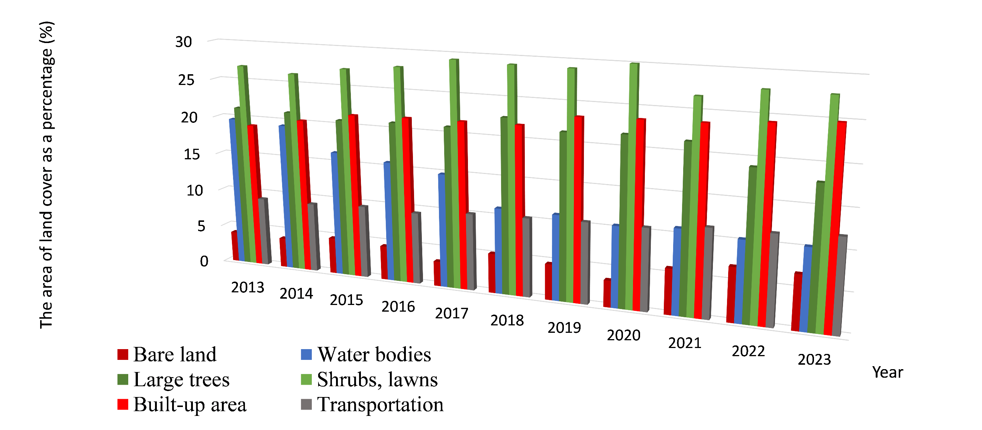
Fig. 5. The land cover changes in the period 2013-2023.
The results show that the accuracy of images after classification is very high, ensuring the reliability of the data used for statistical analysis of land cover changes during the 2013-2023 period in the Hanoi area. Table 3 presents information on the accuracy of image classification in the research area for the years 2013, 2018, and 2023.

Table 3. Classification accuracy.
Land cover | 2013 |  | 2018 |  | 2023
Land cover | PA | UA | PA | UA | PA | UA
Bare land | 0.88 | 0.59 | 0.79 | 0.73 | 0.79 | 0.78
Water bodies | 0.97 | 0.95 | 0.98 | 0.92 | 0.99 | 0.98
Large trees | 0.98 | 0.99 | 0.94 | 0.96 | 0.97 | 0.99
Shrubs, lawns | 0.77 | 0.82 | 0.76 | 0.71 | 0.79 | 0.74
Built-up area | 0.76 | 0.82 | 0.79 | 0.75 | 0.79 | 0.78
Transportation | 0.69 | 0.64 | 0.75 | 0.72 | 0.75 | 0.73
OA | 0.91 |  | 0.93 |  | 0.94
Kappa | 0.89 |  | 0.90 |  | 0.90

The accuracy of image classification is indeed influenced by the quality of the images, especially the quality of the training samples [38], [39]. In this study, the image quality captured over the years has been relatively consistent, with very low cloud cover, and the physical information in the images is clear. Therefore, based on the assessment results, all images after classification from 2013 to 2023 are considered to have high reliability.

4.2 LULC Estimation
The results of the built-up area expansion in Hanoi are illustrated in Fig. 6 and Fig.7. During the period from 2013 to 2018, the built-up area increased by 5.36 square kilometres within a 15-kilometre radius of the urban centre. From 2018 to 2023, there was a further increase of 6.21 square kilometres in the built-up area. In a total of 10 years (2013-2023), the built-up area expanded by 11.57 square kilometres. This result demonstrates the remarkable growth and area expansion of the Hanoi urban during the study period.
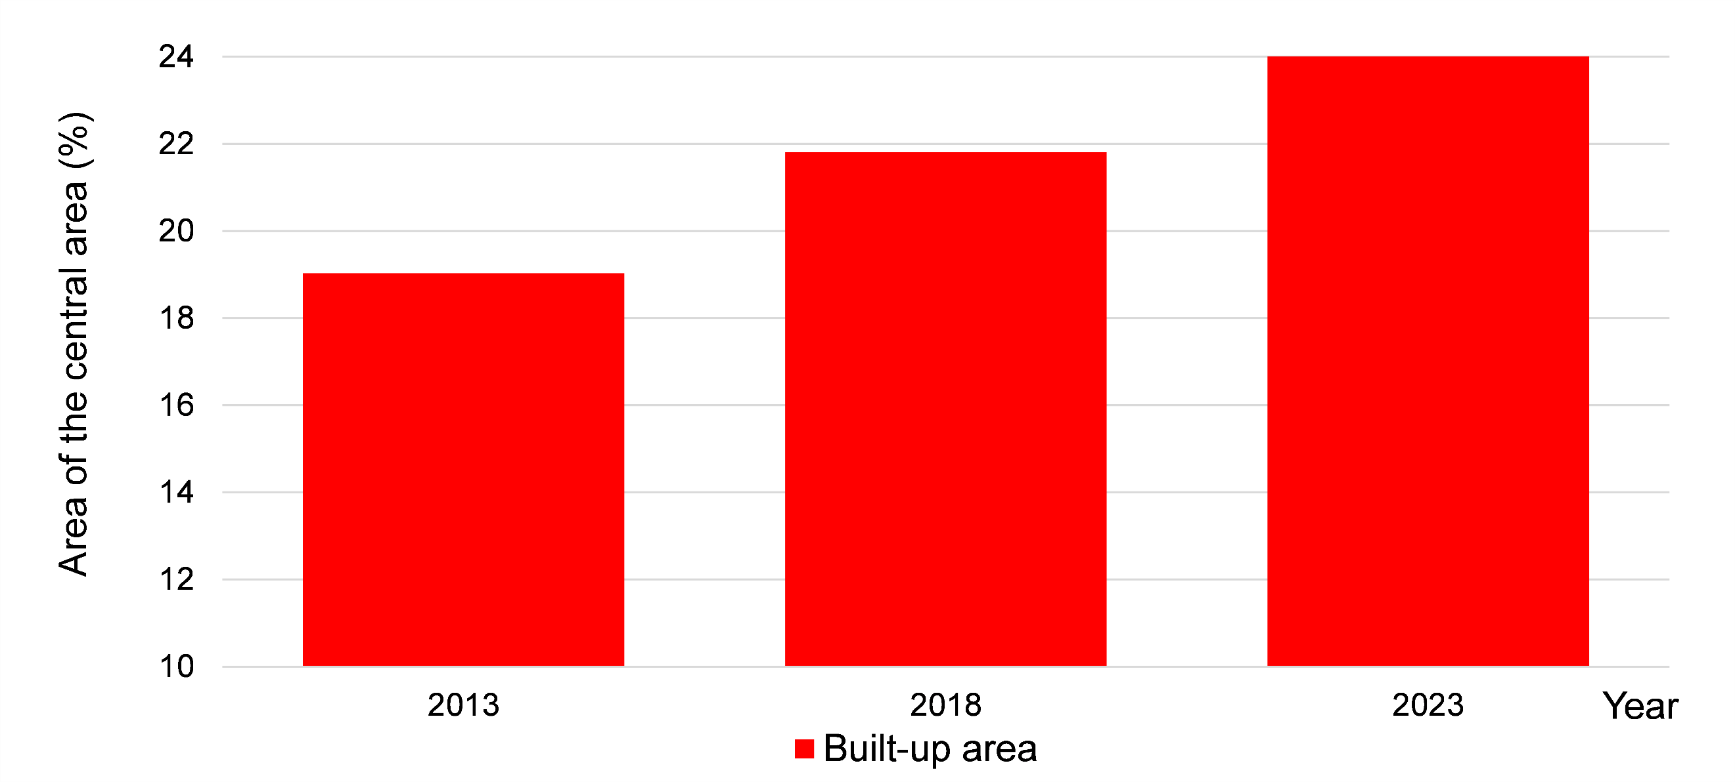
Fig. 6. Built-up area in 2013, 2018, and 2023 in Hanoi Central with a radius of 15 Km.
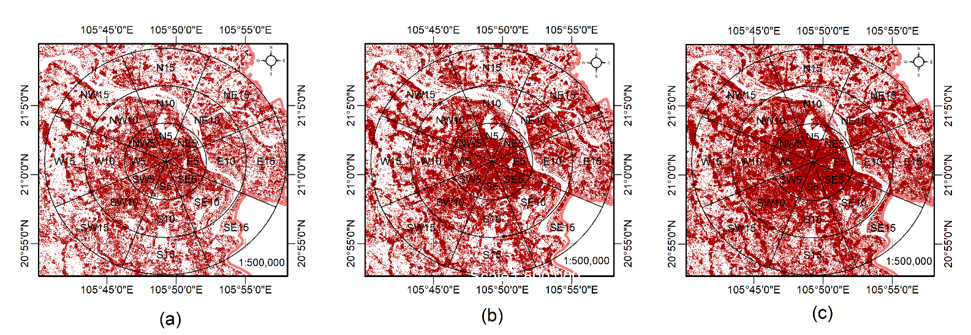
Fig. 7. The Built-up area changes in the Hanoi central area with a radius of 15 Km. In (a), the year 2013. In (b), the year 2018. In (c) the year 2023.
4.3 LULC Evolution Analysis
The research also indicates that each period has seen the expansion of the built-up area in different directions. Especially in the most recent 5-year period (2018-2023), the expansion of the built-up area has been rapid, continuous, and mainly towards the East of the Hanoi urban centre, whereas the built-up area expanded more towards the West in the previous period (2013-2018) (see Fig. 8).
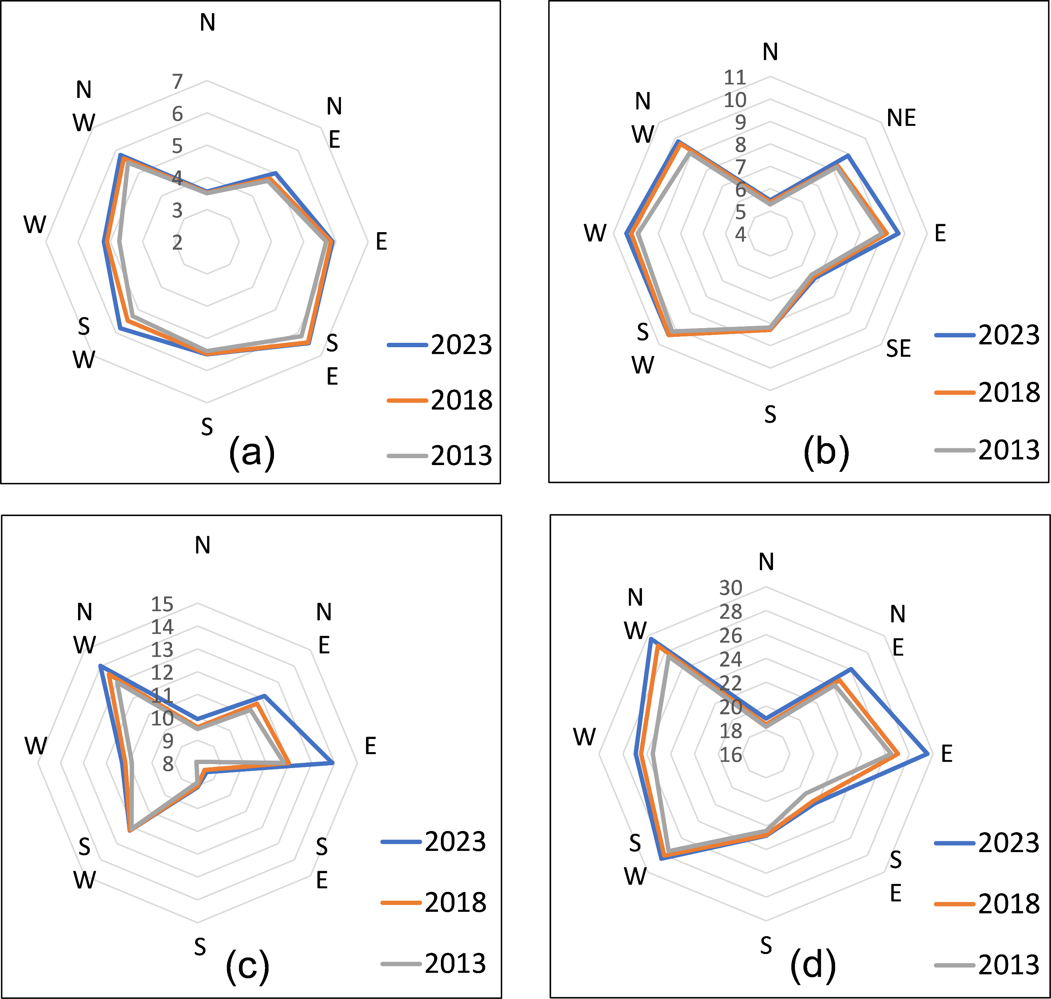
Fig. 8. The built-up area in the Hanoi center is separated into four zones with a radius of 0-5 km, 5-10 km, 10-15 km, and 0-15 km. In (a), the area with a radius of 0 to 5 km. In (b), the area with a radius of 5 to 10 km. In (c), the area with a radius of 10 to 15 km. In (d), the total area with a radius of 0 to 15 km.
In the overall analysis, the expansion of the built-up area within a 15 km radius from the urban centre during the periods 2013-2018 and 2018-2023 is nearly identical, with only a 0.85 square kilometre difference in expansion area between the two periods. This indicates a relatively consistent rate of area expansion during these periods. However, there is a clear difference in the direction of expansion.
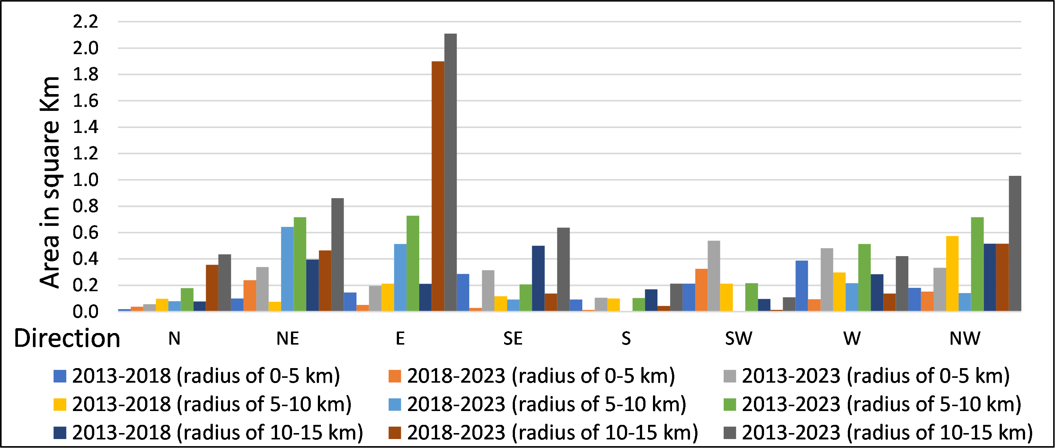
Fig. 9. Urban expansion area in the periods of 2013-2018, 2018-2023, and 2013-2023 with a radius of 5, 10, and 15 km.
Specifically, as illustrated in Fig. 9, the most significant expansion during the 2018-2023 period within a 10-15 kilometres radius occurs towards the East. This direction also represents the most extensive overall expansion from 2013 to 2023, covering an area of 3.03 square kilometres. Additionally, the built-up area during the period from 2013 to 2023 saw substantial expansion in the North-West, North-East, and West directions, covering areas of 2.08, 1.92, and 1.42 square kilometres, respectively. These results demonstrate that urban development and expansion trends in the Hanoi area have exhibited notable differences.
Table 4. Built-up area change (in Km²).
Direction | 2013-2023 | 2018-2023 | 2013-2018
N | 0.67 | 0.47 | 0.20
NE | 1.92 | 1.35 | 0.57
E | 3.03 | 2.46 | 0.57
SE | 1.16 | 0.26 | 0.90
S | 0.42 | 0.06 | 0.36
SW | 0.86 | 0.34 | 0.52
W | 1.42 | 0.45 | 0.97
NW | 2.08 | 0.81 | 1.27
Total | 11.56 | 6.21 | 5.36
The Southern direction has the lowest expansion in terms of area, with an increase of only 0.42 square kilometres, followed by the Northern direction with 0.67 square kilometres. Although, in the overall 10-year period from 2013 to 2023, the Eastern area had the most significant increase in a built-up area, during the initial 5 years of the first period (2013-2018), this area had a minimal expansion, specifically just an increase of 0.57 square kilometre. The substantial increase in a built-up area in this direction occurred primarily during the subsequent 5 years (2018-2023) with an expansion of 2.46 square kilometres. This rapid expansion also took place in areas farther from the city centre, with a radius ranging from 10 to 15 kilometres, while the areas closer to the centre (with a radius of 0-5 kilometres and 5-10 kilometres) did not show exhibit significant expansion in the built-up area during this period. For the North-west direction, the second 5-year period (2018-2023) did not witness a substantial increase in area, whereas the first 5 years (2013-2018) saw a significant expansion of the built-up area, covering an area of 1.27 square kilometres. In the North-west direction, the built-up area primarily increased within the 10-15 kilometres radius, while in the central (0-5 kilometres radius), the expansion was slower.

The study has demonstrated that the growth of the built-up area within a 15-kilometre radius varies depending on the specific area and period. The areas with the most significant growth in built-up areas are in the Eastern, North-west, and South-west directions. The eastern direction, particularly in areas located between 10 and 15 kilometres from the urban centre, has shown the most extensive development in terms of built-up areas. This direction also has been notably expanded during the most recent 5-year period (2018-2023). For the North-west direction, as well as in the South-west direction, the development has been observed within a 5-10 kilometres radius. The results also indicate that the built-up area in this direction experienced rapid growth during the first 5-year period (2013-2018).
5 Discussion
5.1 Accuracy of the LULC Classification
A total of 735 samples were used for classification and testing, with a split of 30% for testing samples and 70% for classified samples in the total dataset. The accuracy results after classification are calculated from the confusion matrix, including basic information such as Overall Accuracy (OA), User’s Accuracy (UA), Producer’s Accuracy (PA), and Kappa, as detailed in Table 2. Some studies have used the number of classification samples per land cover ranging from 10 to 30 times the number of image channels used. For this study, the equivalent number of samples ranges from 80 to 240 samples to ensure the requirements. However, many research results have demonstrated that the number of classification samples does not need to be excessively high. These studies demonstrate that overall accuracy and Kappa coefficients over 90% can be achieved with relatively small sample numbers, typically only 2 to 4 times the number of image bands used for classification, equivalent to 16-32 samples [40], [41]. For this study, the study area is not too large, and there are land covers such as water bodies and large trees with many homogeneous pixel values. The seven bands of satellite images are used for classification, so the average number of samples used for each land cover is approximately 91 samples. Specifically, 221 samples were used in the accuracy assessment, and 554 samples were used in the classification of land covers. This number of samples is equivalent to more than 12 times the number of band images used, resulting in high accuracy.
5.2 LULC Changes
The results of land cover classification in the Hanoi area show varying changes in the area of these land covers over time, consistent with previous studies. For example, Hoang Huy (2016) monitored vegetation cover in suburban areas of Hanoi, finding a decrease in vegetation cover annually in outlying areas while central areas remained relatively stable [42]. Similarly, research by Trinh Hung (2017) also revealed an annual increase in the built-up area in the Hanoi area [37].

With the results of urban expansion, the built-up area in the overall Hanoi area over the 10 years from 2013 to 2023 indicates that the area within a 15 km radius of the Hanoi centre primarily developed towards the East and West directions. For each distinct 5-year period (2013-2018 and 2018-2023), there were fluctuations in different directions, particularly in the core of the Hanoi Central within a 5 km radius that has a small expansion. The built-up area expansion was most evident during the initial 5-year period (2013-2018), while subsequent periods showed less expansion. During the next 5-year period (2018-2023), the study results indicate that the majority of the expansion in the built-up area occurred in areas with a radius ranging from 10-15 km, primarily in the East and West directions from the urban centre. These findings align with the overall development trends of central Hanoi, where land resources in the city centre have become scarce. As a result, the expansion of built-up areas is mainly happening in outlying areas, more than 10 km away from the city centre, in favourable directions.

The changes in LULC could potentially have different impacts on the study area. In the past 10 years, the expansion of urban expansion in Hanoi has had some notable impacts on social changes, and cultural transformations, most notably in the relationships between native villagers and newcomers [43]. Furthermore, the development and urban expansion in the research area have also had a certain influence on environmental changes, affecting the living conditions of the residents in the region, such as phenomena related to urban heat islands, localized flooding, and air pollution [44], [45].
6 Conclusions
The results have demonstrated the suitability of monitoring land cover changes and urban expansion using multi-temporal satellite images such as Landsat-8 and Sentinel-2. The study reveals that from 2013 through 2023, the land cover in Hanoi, Vietnam, has undergone significant changes. The proportions of land covers, such as built-up area, have increased by approximately 7%, transportation has increased by about 3%, while bare land has increased by 3%. Conversely, large trees have decreased by 6%, and water bodies have decreased by 9%.

The study also indicates that due to limited land resources in the central area, built-up area expansion primarily occurred in areas more than 10 kilometres away from the urban centre. Furthermore, the direction of urban expansion for the built-up area during the 2013-2018 period was mainly towards the West, within a radius of 5-10 kilometres, while the 2018-2023 period showed significant expansion towards the East, within a radius of 10-15 kilometres. The corresponding expansion areas for the built-up area within a radius of 5-10 and 10-15 kilometres in the centre of the Hanoi area were 1.27 and 2.46 square kilometres, respectively. The built-up area has mainly expanded to the East and North-west of Hanoi’s centre during the period from 2013 to 2023, covering an additional area of 3.03 and 2.08 square kilometres, respectively.

This is the first study utilizing satellite image series and SVM algorithms to analyze urban expansion trends in the Hanoi urban area over the past 10 years. The study results were evaluated with high reliability, achieving OA and Kappa values of at least 0.91 and 0.89, respectively.

To achieve a more comprehensive and detailed evaluation of urban expansion in Hanoi or similar areas, higher-resolution spatial data and continuous image datasets would be necessary. However, the results of this study can contribute to a better understanding of the current state and trends in built-up area expansion in the Hanoi urban area. This can assist researchers and urban planners in developing adaptation programs to mitigate negative impacts on urban development and environmental management.
Acknowledgements
The authors thank Hanoi University of Natural Resources and Environment for supporting this study, all the authors for their great contributions to the final version, and reviewers and editors for their support.
References
1. Seto K.C., Kaufmann R.K., Woodcock C.E.: Landsat reveals China’s farmland reserves, but they’re vanishing fast. Nature 406(6792), 121-121 (2000)
2. Seto K.C., Güneralp B., Hutyra LR Global forecasts of urban expansion to 2030 and direct impacts on biodiversity and carbon pools. In: Proceedings of the National Academy of Sciences, pp. 16083-16088 (2012)
3. Xie G., Niculescu S.: Mapping and monitoring of land cover/land use (LCLU) changes in the crozon peninsula (Brittany, France) from 2007 to 2018 by machine learning algorithms (support vector machine, random forest, and convolutional neural network) and by post-classification comparison (PCC). Remote Sensing 13(19), 3899 (2021)
4. Feizizadeh B., Omarzadeh D., Kazemi Garajeh M., Lakes T., Blaschke T.: Machine learning data-driven approaches for land use/cover mapping and trend analysis using Google Earth Engine. Journal of Environmental Planning Management 66(3), 665-697 (2023)
5. Mosammam H.M., Nia J.T., Khani H., Teymouri A., Kazemi M.: Monitoring land use change and measuring urban sprawl based on its spatial forms: The case of Qom city. The Egyptian Journal of Remote Sensing and Space Science 20(1), 103-116 (2017)
6. He C., Liu Z., Gou S., Zhang Q., Zhang J., Xu L.: Detecting global urban expansion over the last three decades using a fully convolutional network. Environmental Research Letters 14(3), 034008 (2019)
7. Xiao J., Shen Y., Ge J., Tateishi R., Tang C., Liang Y., Huang Z.: Evaluating urban expansion and land use change in Shijiazhuang, China, by using GIS and remote sensing. Landscape and Urban Planning 75(1), 69-80 (2006)
8. Fan F., Wang Y., Qiu M., Wang Z.: Evaluating the Temporal and Spatial Urban Expansion Patterns of Guangzhou from 1979 to 2003 by Remote Sensing and GIS Methods. International Journal of Geographical Information Science 23(11), 1371-1388 (2009)
9. Nong D.H., Lepczyk C.A., Miura T., Fox J.M.: Quantifying urban growth patterns in Hanoi using landscape expansion modes and time series spatial metrics. PloS one 13(5), e0196940 (2018)
10. Mauro G.: Rural–urban transition of Hanoi (Vietnam): Using Landsat imagery to map its recent peri-urbanization. ISPRS international journal of geo-information 9(11), 669 (2020)
11. Zheng Y., Tang L., Wang H.: An improved approach for monitoring urban built-up areas by combining NPP-VIIRS nighttime light, NDVI, NDWI, and NDBI. Journal of Cleaner Production 328, 129488 (2021)
12. Li K., Chen Y.: A Genetic Algorithm-Based Urban Cluster Automatic Threshold Method by Combining VIIRS DNB, NDVI, and NDBI to Monitor Urbanization. Remote Sensing 10(2), 277 (2018)
13. Hadeel A., Jabbar M., Chen X.: Application of remote sensing and GIS to the study of land use/cover change and urbanization expansion in Basrah province, southern Iraq. Geo-spatial Information Science 12(2), 135-141 (2009)
14. Sekertekin A., Abdikan S., Marangoz A.M.: The acquisition of impervious surface area from LANDSAT 8 satellite sensor data using urban indices: a comparative analysis. Environmental Monitoring and Assessment 190(7), 381 (2018)
15. Jothimani M., Gunalan J., Duraisamy R., Abebe A.: Study the land use/land cover, NDVI, and NdBI dynamics of Addis Ababa city, Ethiopia, by using satellite image processing techniques. AIP Conference Proceedings 2451(1) (2022)
16. Boser B.E., Guyon I.M., Vapnik V.: A training algorithm for optimal margin classifiers. In: Proceedings of the fifth annual workshop on Computational learning theory, pp. 144-152 (1992)
17. Huang C., Davis L., Townshend J.: An assessment of support vector machines for land cover classification. International Journal of remote sensing 23(4), 725-749 (2002)
18. Ma L., Liu Y., Zhang X., Ye Y., Yin G., Johnson B.a.: Deep learning in remote sensing applications: A meta-analysis and review. ISPRS journal of photogrammetry and remote sensing 152, 166-177 (2019)
19. Đo Thi Ngoc A., Nguyen Quang P., Nguyen Hoang S.: Research methods agricutural drought warning in downstream of Ca river 56(3/2017)
20. Long V.H., Giang N.V., Hoanh T.P., Hoa P.V.: Applying Google Earth Egine in river bank erosion monitoring Acase study in lower Mekong river. Natural Sciences and Tecnology 16(6), 38 (2019)
21. Nguyen L.: Land cover change detection in northwestern Vietnam using Landsat images and Google Earth Engine. Journal of water and land development (2020).
22. Tarabalka Y., Fauvel M., Chanussot J., Benediktsson J.a.: SVM-and MRF-based method for accurate classification of hyperspectral images. IEEE Geoscience and Remote Sensing Letters 7(4), 736-740 (2010)
23. Thao D.T.T.: Spatial distribution of High-rise Building in Hanoi City Inner. International Journal Advanced Research Engineering a Technology 12(3), 636-643 (2021)
24. Talukder M.R., Chu C., Rutherford S., Huang C., Phung D.: The effect of high temperatures on risk of hospitalization in northern Vietnam. Environmental Science Pollution Research, 1-8 (2022)
25. Monre.: Technical Regulation on the Structure Model and Content of the National Spatial Data Infrastructure of the Vietnam Scales 1: 10,000 and 1: 25,000; Ministry of Natural Resources and Environment Hanoi: Hanoi, Vietnam (2020)
26. Vapnik V., Samuel Kotz.: Estimation of dependences based on empirical data. Springer-Verlag 40 (1982)
27. Cortes C., Vapnik V.: Support-vector networks. Machine learning 20, 273-297 (1995)
28. Bishop C.M., Nasrabadi N.M.: Pattern recognition and machine learning. Vol. 4, New York: Springer (2006)
29. Hu W.-S., Li H.-C., Pan L., Li W., Tao R., Du Q.: Spatial–spectral feature extraction via deep ConvLSTM neural networks for hyperspectral image classification. IEEE Transactions on Geoscience Remote Sensing 58(6), 4237-4250 (2020)
30. Næsset E.: Use of the weighted Kappa coefficient in classification error assessment of thematic maps. International Journal of Geographical Information Systems 10(5), 591-603 (1996)
31. Foody G.M.: Explaining the unsuitability of the kappa coefficient in the assessment and comparison of the accuracy of thematic maps obtained by image classification. Remote Sensing of Environment 239, 111630 (2020)
32. Shetty S.: Analysis of machine learning classifiers for LULC classification on Google Earth Engine. University of Twente (2019)
33. Srivastava A., Bharadwaj S., Dubey R., Sharma V., Biswas S.: Mapping vegetation and measuring the performance of machine learning algorithm in lulc classification in the large area using sentinel-2 and landsat-8 datasets of dehradun as a test case. The International Archives of the Photogrammetry, Remote Sensing Spatial Information Sciences 43, 529-535 (2022)
34. Claverie M., Ju J., Masek J.G., Dungan J.L., Vermote E.F., Roger J.-C., Skakun S.V., Justice C.: The Harmonized Landsat and Sentinel-2 surface reflectance data set. Remote sensing of environment 219, 145-161 (2018)
35. Hoa N.T.P.: Circular of the Regulation on Economic and Technical Levels of the Landuse Statistics and Landuse Status Mapping, in Ministry of Natural Resources and Environment: Hanoi, Vietnam (2019)
36. Pisner D.A., Schnyer DM.: Support vector machine, in Machine learning. Elsevier. p. 101-121 (2020)
37. Le Hung T., Nga NTT., Tuyên V.D., Phương B.T.: Assessment and prediction of urban land use changes of Hanoi city using remote sensing and GIS techniques. Natural Sciences and Technology 14(3), 176 (2017)
38. Przyborowski M., Tajmajer T., Grad Ł., Janusz A., Biczyk P., Ślęzak D.: Toward machine learning on granulated data–a case of compact autoencoder-based representations of satellite images. In: 2018 IEEE International Conference on Big Data (Big Data), pp. 2657-2662.IEEE (2018)
39. Kamir E., Waldner F., Hochman Z.: Estimating wheat yields in Australia using climate records, satellite image time series and machine learning methods. SPRS Journal of Photogrammetry Remote Sensing 160, 124-135 (2020)
40. Van Niel T.G., Mcvicar T.R., Datt B.: On the relationship between training sample size and data dimensionality: Monte Carlo analysis of broadband multi-temporal classification. Remote sensing of environment 98(4), 468-480 (2005)
41. Li C., Wang J., Wang L., Hu L., Gong P.: Comparison of classification algorithms and training sample sizes in urban land classification with Landsat thematic mapper imagery. Remote sensing 6(2), 964-983 (2014)
42. Huy H.A.: Assessment of Fractional Vegetation Cover Changes in some Urban and Sub-urban Areas of Hanoi Using Multi-spectral and Multi-temporal LANDSAT Images. Journal of Earth and Environmental Sciences (2016)
43. Tran T.H.Y.: Social and Cultural Changes in Rural Villages During the Urbanization Process in Hanoi. National Academy of Politics (2013)
44. Van D.V., Anh M.N.B., Mai T.P.T.: Environment. Study on social environment conflict of urban development projects in Hoan Kiem district, Hanoi city. Science Journal of Natural Resources (46), 36-44 (2023)
45. Loi D.T.: Research on the role of green space in reducing the impact of urban heat island in Hanoi city. Journal of Science Technology 228(02), 280-288 (2023)

