

**SW Architecture and Design**

**Report 4 – Software Design Document**

– HoChiMinh, Spring 2024–

**Table of Contents**

I. Record of Changes 3

II. Software Design Document 4

1. System Design 4

1.1 System Architecture 4

1.2 Package Diagram 4

2. Database Design 4

3. Detailed Design 4

3.1 Class diagram 4

4.Activity Diagram 5

4.1 Order Party 5

4.2 Add room service 6

4.3 Order processing 7

4.4 Register to host 8

4.5 Edit profile 9

# I. Record of Changes

| **Date** | **A* M, D** | **In charge** | **Change Description** |
| --- | --- | --- | --- |
| 22/01 | A | Quang | Create doc |
| 23/01 | M | Vinh | Modify activity |
| 24/01 | M | Quang | Modify activity |
| 25/01 | M | Doanh | Modify activity |
| 26/01 | M | Bach | Modify activity |
| 27/01 | M | Xuan | Modify activity |
|  |  |  |  |
|  |  |  |  |
|  |  |  |  |
|  |  |  |  |
|  |  |  |  |
|  |  |  |  |
|  |  |  |  |

*A - Added M - Modified D - Deleted

# II. Software Design Document

## 1. System Design

### 1.1 System Architecture

### 1.2 Package Diagram

## 2. Database Design

## 3. Detailed Design

### 3.1 Class diagram

## 

## 4.Activity Diagram

### 4.1 Order Party

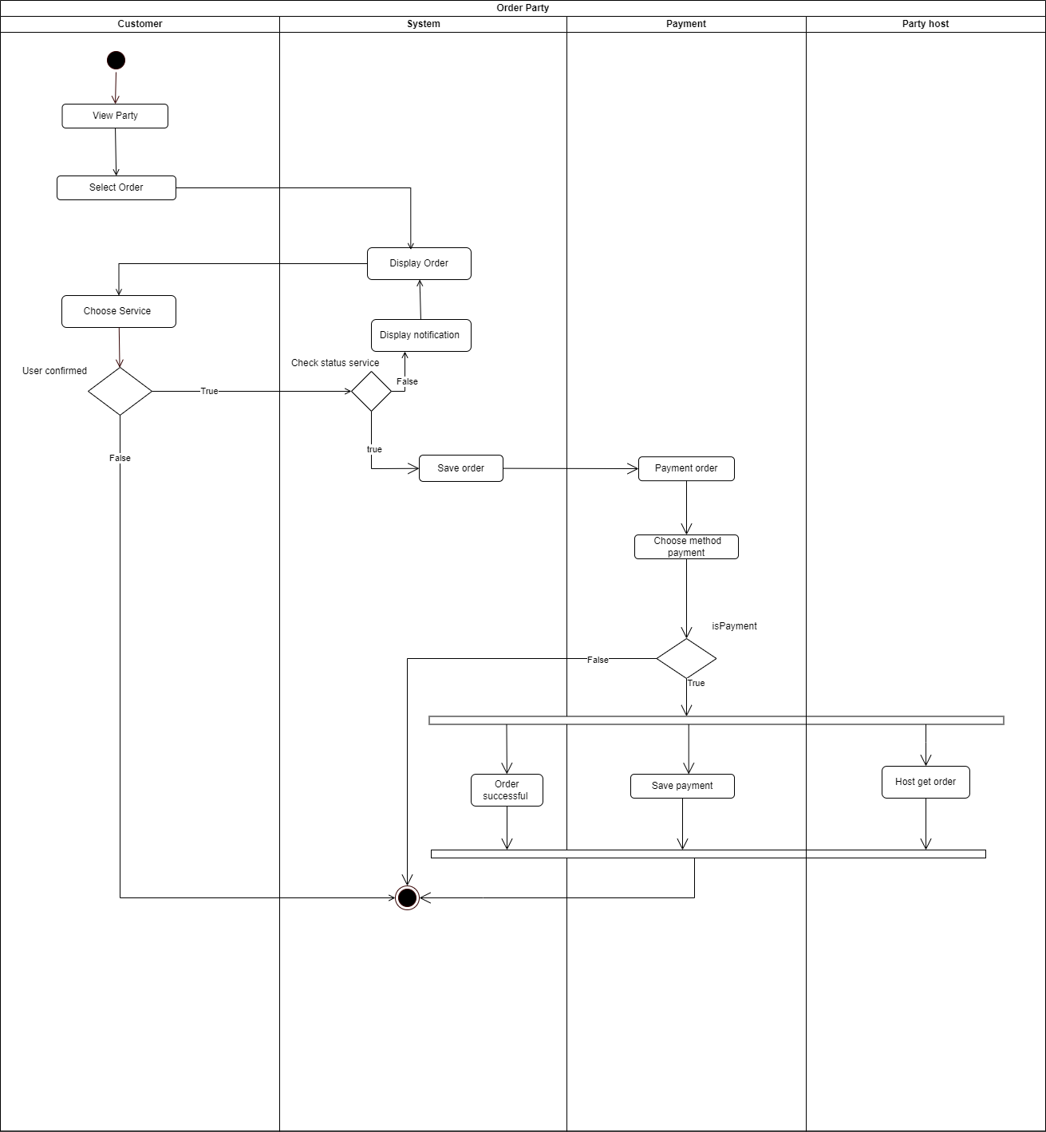

### 4.2 Add room service

### 4.3 Order processing

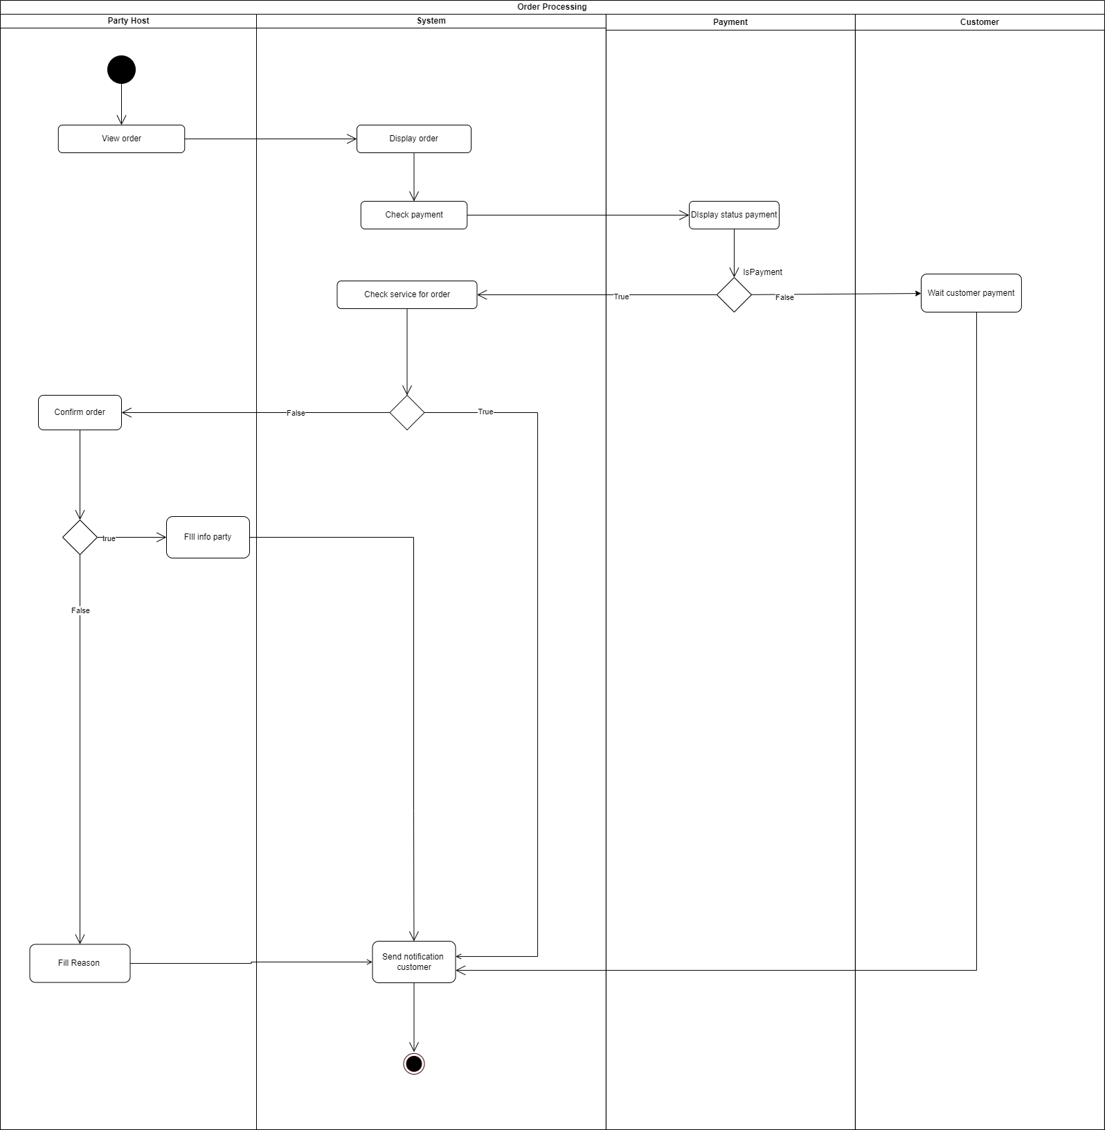

### 4.4 Register to host

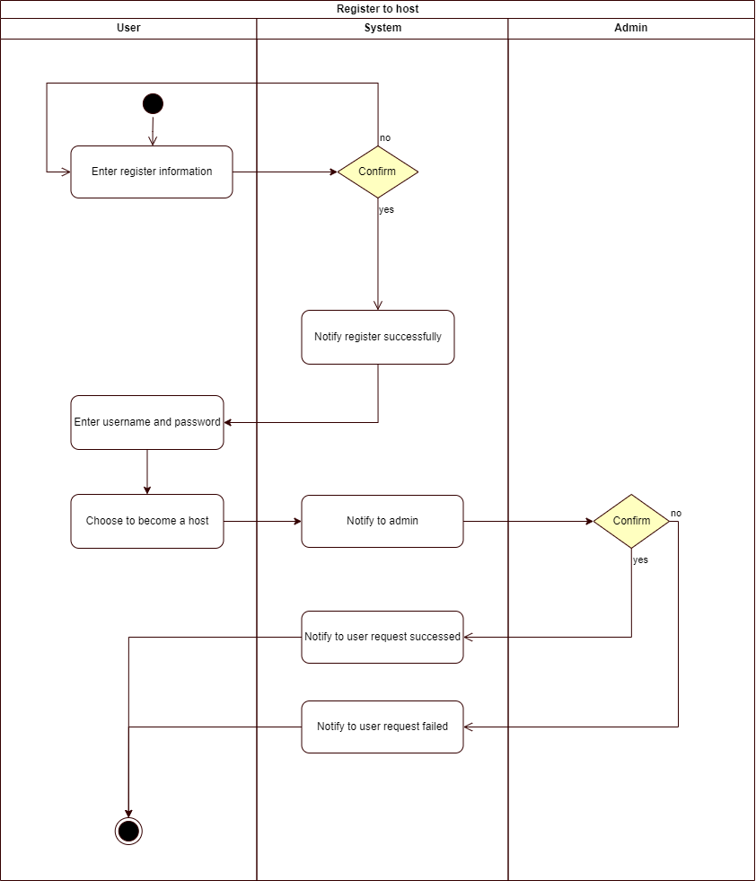

### 4.5 Edit profile

