

**SW Architecture and Design**

**birthday party booking system**

– Ho Chi Minh, Spring 2024 –

**Table of Contents**

I. Record of Changes 3

II. Software Requirement Specification 4

1. Requirement Overview 4

1.1. Purpose 4

1.2 User Requirements 4

1.3 System Functionalities 8

2. Functional Specifications 8

3. UI Requirements 16

4. Non-Functional Requirements 16

4.1 External Interfaces 16

4.2 Quality Attributes 17

5. Requirement Appendix 17

5.1 Business Rules 17

5.2 Common Requirements 18

5.3 Application Messages List 18

5.4 Other Requirements… 18

# I. Record of Changes

| **Date** | **A* M, D** | **In charge** | **Change Description** |
| --- | --- | --- | --- |
| 12/01/24 | M | Quang | create doc |
| 13/01/24 | A | Vinh,Xuân,  Bách,Doanh | Edit Use-Case,Description Use-Case |
| 19/01/24 | M | Quang | Format doc, Edit use case |
| 20/01/24 | M | Vinh,Doanh | Edit Use case Description |
| 21/01/24 | A | Xuân,Bách | Add Use case Description |
|  |  |  |  |
|  |  |  |  |
|  |  |  |  |
|  |  |  |  |
|  |  |  |  |
|  |  |  |  |
|  |  |  |  |
|  |  |  |  |

*A - Added M - Modified D - Deleted

# II. Software Requirement Specification

## 1. Requirement Overview

## 1.1. Purpose

This website is created to match the need of having a birthday party for kids. It allows parents to book and manage their children’s birthday parties. They can choose the day that the party will be held, set up the amount of tables. Parents will be notified if the party is accepted through email confirmation. Also, this website allows the restaurant managers to manage their parties which are were, are and will be celebrated. They can also arrange the amount of staff to set up and serve the party to fit the requirements of their customers. This brings convenience to the staff since they can view the party they will set up, manage them such as update and delete if the customer wishes to cancel the reservation. The staff will be notified the time that a party will be held so that they can arrange their schedule easily.

### 1.2 User Requirements

#### 1.2.1 Actors

| **#** | **Actor** | **Description** |
| --- | --- | --- |
| 1 | Administrator | This user has the role of managing accounts of customers and staff alike, this user can update, delete or add accounts. |
| 2 | Party host | This user can manage the party details. User can approve, update, add and delete party, User can view party order from customers |
| 3 | Customer | A registered user, they can create and manage party listing, provide detail about the party, set pricing and chose payment options |
| 4 | Guest | Guest will have limited access to the website. They can browse through available party options, view the detail of the party and check their desired date |

#### 1.2.2 Use Cases

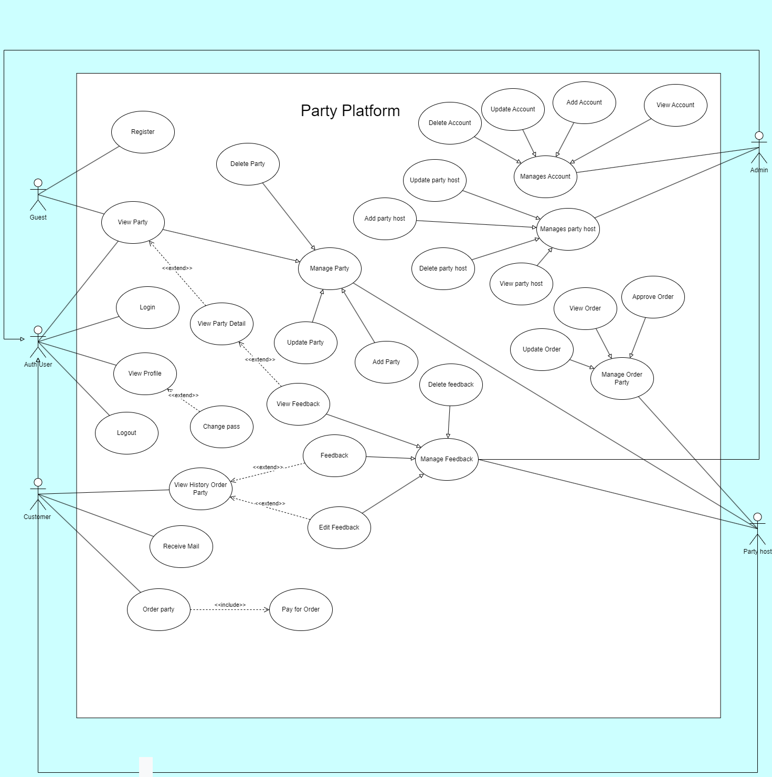

#### 1.2.3 Descriptions

### 

| **ID** | **Use Case** | **Actors** | **Use Case Description** |
| --- | --- | --- | --- |
| UC-01 | View Party | -Guest -Customer -Party host -Admin | Actors can view all the details of the party such as location, date, payment methods, theme…. |
| UC-02 | Add Party host | –Admin | Admin approve a new staff account in the system |
| UC-03 | Login | -Customer -Party host -Admin | By entering username and password, they login to the system. Their screen will be different from others based on their role in the system. |
| UC-04 | Register | -Guest | The Guest registers to the system with username and password and personal information. Username must be different from all the usernames that exist in the system. |
| UC-05 | Logout | -Customer -Party host -Admin | Logout of the system and use it as a guest. |
| UC-06 | View Profile | -Customer -Party host -Admin | Everybody can view their personal profile after login. All the details imputed will be shown. |
| UC-07 | Change Pass | -Customer -Party host -Admin | Changing the current password to another password. New password must be different from the old password. |
| UC-08 | View History Order | -Customer | The Customer can see all the orders they have done. |
| UC-09 | Send Mail | -Customer | Sending all the information that customers wanted to their personal mail address. |
| UC-10 | Create Order Party | -Customer | Customers choose all the details for the party then create an order. The request will be sent to the staff. |
| UC-11 | Pay For Order | -Customer | After creating an order, the customer must pay for it with all the options in the system suitable for the customer. |
| UC-12 | Approve Order | -Party host | The Party host being noticed by the request of the customer. They will approve and create a new party. |
| UC-13 | View Order | -Party host | The Party host view the order information was chosen by the customer. |
| UC-14 | Update Order | -Party host | The Party host update the details in the order. |
| UC-17 | Add Party | -Party host | After approving the order, staff create a new party in the system with all the details that were informed by the customer. |
| UC-18 | Update Party | -Party host | The Party host can update some details in the party. |
| UC-19 | Delete Party | -Party host | After everything is done, the staff delete the party in the system. |
| UC-20 | View Party host | -Admin | Admin can see the staff profile, password, role and activity log. |
| UC-21 | Update Party host | -Admin | Admin can update some details in the staff account as shown. |
| UC-22 | Add Party host | -Admin | Add can approve an account and give it the role of staff for further activities. |
| UC-23 | Delete Party host | -Admin | Admin delete all the information of the staff account in the system. |
| UC-24 | View Account | -Admin | Admin can see the account profile, password, role and their activities. |
| UC-25 | Add Account | -Admin | Admin can add a new account that was recently registered. |
| UC-26 | Update Account | -Admin | Admin can edit and update some details in the account like password, order. |
| UC-27 | Delete Account | -Admin | Admin delete all the information of the account was requested. |
| UC-28 | Feedback | -Customer | Customer can give feedback about party |

### 1.3 System Functionalities

#### 1.3.1 Non-UI Functions

| **#** | **Feature** | **System Function** | **Description** |
| --- | --- | --- | --- |
| 1 | Good response | Notification | Create a good website experience |
| 2 | Authentication | Authentication | Confirm the user's identity |
| 3 | Authorization | Authorization | The process of verifying what you have access to |
| 4 | Security | Security | Secure customer and system information such as password, account, information, .... |
| 5 | Usability | Usability | Make it easy for users to use, use on many different devices |
| 6 | Performance | Operating performance | Performance means the operating performance of the system. |
| 7 | Integrity | Integrity | Talk about the “integrity” of the data. |
| 8 | Compliance | Compliance | The system must ensure compliance with the provisions of law, state regulations, company law ,.. |

## 2. Functional Specifications

### 2.1 UC-01 Order Party

| UC ID and Name: | USE CASE-01 Order Party | | |
| --- | --- | --- | --- |
| Created By: | Quang Vinh | Date Created: | 12/01/2024 |
| Primary Actor: | Customer | Secondary Actors: |  |
| Trigger: | The Customer Press on “Order Party” button after filling all the requirements | | |
| Description: | Customer Orders a party through the website | | |
| Preconditions: | Customer is signed up and logged in | | |
| Postconditions: | Success the order is complete | | |
| Normal Flow: | 1.Customer pressed the “Order Party” button  2.Customer filled “venue information” box  3.Customer filled “available dates” box  4.Customer filled “party themes” box  5.Customer filled “ package options” box  6.Customer filled “payment options” box  7.Customer Click “Confirm” button. | | |
| Alternative Flows: | 4. Customer filled “party themes” box  5.Customer adds optional information to the “Optional” text box next to the “party themes” box  6.Customer filled “ package options” box  7.Customer adds option information to the “Optional” text box next, if they want to provide their own packaging(wrap)  8.Customer filled “payment options” box  9. Customer Click “Confirm” button. | | |
| Exceptions: | The customer hasn't filled out all the required boxes | | |
| Priority: | High | | |
| Frequency of Use: | Often | | |
| Business Rules: |  | | |
| Other Information: | Customer should provide clear information in the ““Optional” text box | | |
| Assumptions: |  | | |

### 2.2 UC-02.Register

| UC ID and Name: | UC-02.Register | | |
| --- | --- | --- | --- |
| Created By: | Quangtv | Date Created: | 13/01/2024 |
| Primary Actor: | Guest | Secondary Actors: |  |
| Trigger: | Customers click on the “Register” button. | | |
| Description: | Guess I want to create an account in order to become a customer. | | |
| Preconditions: | Pre-1: User account must not have been registered | | |
| Postconditions: | POST-1: User account has been registered and given a role of “Customer”  POST-2: Return to Homepage | | |
| Normal Flow: | 1.Click the “**Register**” button.  2.Fill in the information.  3.Click “Submit”  4.System save account information and give account role “**Customer**” then return user to Homepage. | | |
| Alternative Flows: | Show a message box to notify login does not success | | |
| Exceptions: | The customer hasn't filled out all the required boxes | | |
| Priority: | High | | |
| Frequency of Use: | Often | | |
| Business Rules: |  | | |
| Other Information: |  | | |
| Assumptions: |  | | |

### 2.3 UC-03 Login

| UC ID and Name: | UC-03 Login | | |
| --- | --- | --- | --- |
| Created By: | DoanhNDN | Date Created: | 12/01/2024 |
| Primary Actor: | Customer | Secondary Actors: | Party host |
| Trigger: | The Customer click on the “Login” button | | |
| Description: | Customer want to create an account in order to become a customer | | |
| Preconditions: | Pre-1: User account must have been registered  Pre-2: User account has been authorised | | |
| Postconditions: | POST-1: User now access to the website and can use function base on their role | | |
| Normal Flow: | 1.Click the “Login” button  2.Fill in the “Account”, “Password” fields  3.Click “Submit”  4.System validates information successfully. User now can use the function base on their role | | |
| Alternative Flows: | Show a text box to | | |
| Exceptions: | EX-1: 4c.System validates the login failed and displays a messenger box  4c1. User choose “Cancel”  4c2.User choose “Forgot Password” | | |
| Priority: | High | | |
| Frequency of Use: | Often | | |
| Business Rules: |  | | |
| Other Information: | The password should be hidden by default and have a button near it to show it | | |
| Assumptions: |  | | |

### 2.4 UC-04 APPROVE PARTY ORDER

#### 

| UC ID and Name: | UC-04 APPROVE ORDER | | |
| --- | --- | --- | --- |
| Created By: | Quang Vinh | Date Created: | 12/01/2024 |
| Primary Actor: | Party host | Secondary Actors: | None |
| Trigger: | When Party host is logged in and View Order | | |
| Description: | *As a staff, i want manage orders, view and can accept them* | | |
| Preconditions: | User account has been created & logged in | | |
| Postconditions: | The order is accepted  The system tracked accepted order into the Activity Log | | |
| Normal Flow | 1.Party host is logged in  2.Party host click on the “Manage Order” button on the homepage  3.Party host click on the “View Order” button on the Customer’s Order page  4.Party host view and progress the detail of the orders  5.Party host then click “Approve Order” button in the Order’S detail page | | |
| Alternative Flows: | 4.Party host view and progress the detail of the orders  5.Party host then click “Cancel Order” button in the e Order’S detail page | | |
| Exceptions: | 1. The Error Message screen is shown to the user  2. User cancels the logging in *=> UC stops, change to UC-1_View Home Page*  3. User clicks “Forgot Password?” link *=> change to UC-3_Reset Password*  4. User clicks “Register” link *=> change to UC-4_Register User Account* | | |
| Priority: | High | | |
| Frequency of Use: | Often | | |
| Business Rules: |  | | |
| Other Information: | Customer must give appropriate information | | |
| Assumptions: |  | | |

#### 

### 2.5 UC-05 Logout

| UC ID and Name: | UC-05 Logout | | |
| --- | --- | --- | --- |
| Created By: | Quangtv | Date Created: | 12/01/2024 |
| Primary Actor: | Admin, Party host, Customer | Secondary Actors: | None |
| Trigger: | Button logout | | |
| Description: | Users must have an account on the system to be able to logout | | |
| Preconditions: | Website is available, Database is available, Internet, login successful | | |
| Postconditions: | 1.Back to login and signup screen  2.Not already log in user | | |
| Normal Flow | If information is missing, an "Insufficient Information" message is displayed. | | |
| Alternative Flows: | Account authentication timeout | | |
| Exceptions: | When you want to logout it will show the message "are you sure you want to logout and you can log out or stay on the site" | | |
| Priority: | High | | |
| Frequency of Use: | unlimited | | |
| Business Rules: | You must have an account and be logged in to logout | | |
| Other Information: | When you log out you can still see the product but can't buy i | | |
| Assumptions: |  | | |

### 

### 2.6 UC-06 Pay For Order

| UC ID and Name: | UC-06 Pay For Order | | |
| --- | --- | --- | --- |
| Created By: | DoanhNDN | Date Created: | 12/01/2024 |
| Primary Actor: | Customer | Secondary Actors: |  |
| Trigger: | Button Payment | | |
| Description: | *User use it to pay for their orders* | | |
| Preconditions: | Payment is available, login successful | | |
| Postconditions: | 1.Back to the website | | |
| Normal Flow | 1. Click “Payment” button  2. Fill in payment detail  3. Click “Submit” button | | |
| Alternative Flows: | Customer can re-select payment option in the “History Order” page when the order’s status is still pending  1.Click on “View History Order” on “View Profile” page  2.Select the order that need to change “payment”  3.Click the “Payment” button.  4.Fill in payment detail  5 Click “Submit” button | | |
| Exceptions: | Payment isn’t available is not accepted | | |
| Priority: | High | | |
| Frequency of Use: | Often | | |
| Business Rules: |  | | |
| Other Information: |  | | |
| Assumptions: |  | | |

### 2.7 UC-07 Edit profile

| UC ID and Name: | UC-06 Edit profile | | |
| --- | --- | --- | --- |
| Created By: | XuanNC | Date Created: | 12/01/2024 |
| Primary Actor: | Customer | Secondary Actors: | Party Host |
| Trigger: | Edit profile button in profile | | |
| Description: | *Use to change email or password* | | |
| Preconditions: | Login successful | | |
| Postconditions: | 1.Back to the profile page | | |
| Normal Flow | 1. Click “Profile” 2. Click “Edit profile” 3. Fill in the form with new Password/Email 4. Click “Submit” | | |
| Alternative Flows: |  | | |
| Exceptions: | New Password/Email should not be the same as the old Password/Email | | |
| Priority: | High | | |
| Frequency of Use: | Not Often | | |
| Business Rules: |  | | |
| Other Information: |  | | |
| Assumptions: |  | | |

### 2.8 UC-08 ADD ROOM SERVICE

#### 

| UC ID and Name: | UC-08 APPROVE ORDER | | |
| --- | --- | --- | --- |
| Created By: | Quang Vinh | Date Created: | 29/01/2024 |
| Primary Actor: | Party host | Secondary Actors: | None |
| Trigger: | When Party host is logged in and add room service to existed party | | |
| Description: | *As a party host, i want to provide more services* | | |
| Preconditions: | User account has been created & logged in | | |
| Postconditions: | The room service is accepted  The system tracked accepted activity into the Activity Log | | |
| Normal Flow | 1.Party host is logged in  2.Party host click on the “Manage Party” button on the homepage  3.Party host select Party to add Room service  4.Party host Press on "Add Service" button  5.Party host selects Room service to add to party  6.Party host fills in information of the service  7.Party host adds in their description  8.Party host press on “Finish and submit” button | | |
| Alternative Flows: | 6.Party host fills in information of the service  7.Party host does not add in their description  8.Party host press on “Finish and submit” button | | |
| Exceptions: | 1.Party host does not fills in information of the service  2. The process repeat until the party host completely fills in all information | | |
| Priority: | High | | |
| Frequency of Use: | Often | | |
| Business Rules: |  | | |
| Other Information: | Party host must give appropriate information | | |
| Assumptions: |  | | |

#### 

### 2.9 UC-09 Register to host

#### 

| UC ID and Name: | UC-09 Register to host | | |
| --- | --- | --- | --- |
| Created By: | BachTND | Date Created: | 29/01/2024 |
| Primary Actor: | User | Secondary Actors: | None |
| Trigger: | When User clicks become host button | | |
| Description: | *I want to become a party host* | | |
| Preconditions: | User account has been created & logged in | | |
| Postconditions: | Admin accepts user’s request | | |
| Normal Flow | 1. User is logged in  2. User click on the “Become a host” button on the homepage | | |
| Alternative Flows: |  | | |
| Exceptions: | 1. Admin does not accept user’s request | | |
| Priority: | High | | |
| Frequency of Use: | Often | | |
| Business Rules: |  | | |
| Other Information: | User must give appropriate information | | |
| Assumptions: |  | | |

#### 

**Business Rules**

| **ID** | **Business Rule** | **Business Rule Description** |
| --- | --- | --- |
| BR1 | Password Encoding | User’s password must be encoded with MD5 hashing |
| BR2 | Invalid Logging In | User can’t be authenticated to login the system if below cases   * His/her logging-in details are incorrect * His/her account has not been verified * His/her account has been locked or blocked |
| BR3 | Account Locking | If user inputs wrong logging-in details 6 times continuously, his/her account would be locked in 30 minutes |

#### 

## 3. UI Requirements

## 4. Non-Functional Requirements

### 4.1 External Interfaces

**User interface requirements:**

* The system will provide a user-friendly interface for them to select, order party
* The user interface must provide clear instructions.
* The interface will display available order party for kid, including face value, validity period

**Hardware interface requirements:**

* The system must be compatible with many different mobile device
* The system must be compatible with popular payment methods

**Software interface requirements:**

* Responsive design: The interface should be responsive, which means it should be able to adapt to different screen sizes and devices. This is important because users may access the website from various devices such as smartphones, tablets, or desktop computers.
* User-friendly interface: The software interface should be easy to use and navigate for the users. It should be designed in a way that allows users to quickly find the products they are looking for and make purchases without any confusion.
* Security: The interface should have robust security features that protect user data and prevent any unauthorised access or data.

### 4.2 Quality Attributes

#### 4.2.1 Usability

Usability requirements of websites selling order parties for kids can include the ease of use, learnability, efficiency, memorability, error prevention and recovery, and user satisfaction .

#### 4.2.2 Performance

**Response time for a transaction:**

The site has an average response time of less than 10 seconds per transaction. This ensures users receive one quick response when making transactions on the website.

**Processing ability (Throughput):**

The site is capable of handling a minimum of 10 transactions per second. This allows the site to respond to a large number of requests from concurrent users without causing delays or lags.

**Resource Utilisation:**

The site uses system resources efficiently, with CPU, memory and network bandwidth usage not exceeding 70% under high load conditions. This ensures the website makes the most of available resources and at the same time keeps its performance stable