## Timer NE555

* + - * Description:

The 555 monolithic timing circuit is a highly stable controller capable of producing accurate time delays, or oscillation. In the time delay mode of operation, the time is precisely controlled by one external resistor and capacitor. For a stable operation as an oscillator, the free running frequency and the duty cycle are both accurately controlled with two external resistors and one capacitor. The circuit may be triggered and reset on falling waveforms, and the output structure can source or sink up to 200mA.

* + - * Pin Configurations:

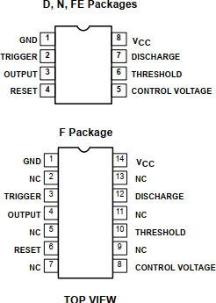

* + - * Application:
* Precision timer circuit
* Square wave generator
* Inverter circuit
* PWM generators and motor control
* PPM (Pulse Position Modulation)
* Linear Ramp Generator

# IC CD4017

* + - * Description:

The CD4017 IC is a 5-stage CMOS Decade counter that counts to 10. It has 10 decoded outputs and a carry out pin that represents numbers 1 to 10. It also has a single clock pin, so for every clock pulse ,the counting increases with one. The IC can be powered from a 3V to 5V supply voltage with a clock speed of 5MHz.

* + - * Configuration:

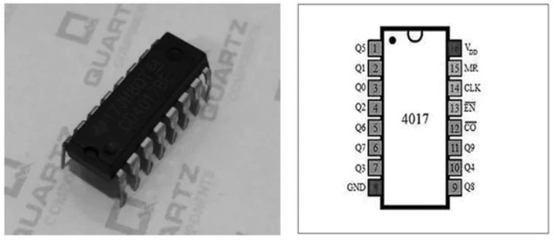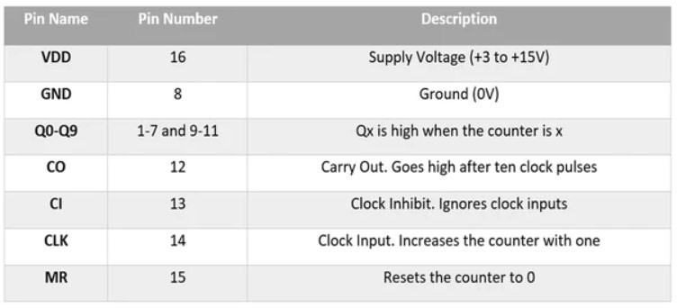

* + - * Application:
* Binary counter
* Decoder
* Frequency divider
* LED chaser
* LED matrix

## Other Electronic Components

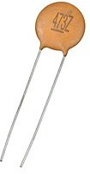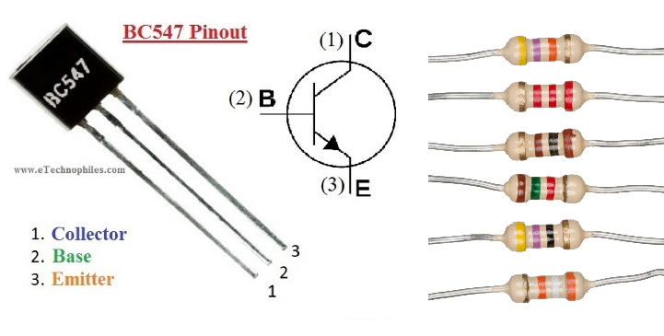

Resistors

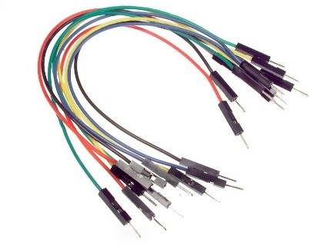



Diode 1N4148

Female to Female wire testboard

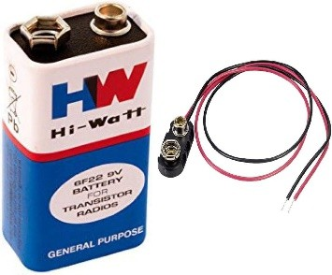

Battery 9V