CSE 577 – Hw5

Below are the steps that were taken to complete the project

# Library_setup

The library_setup.tcl file was sourced to link all the library to the project.

# Read_design

The read_design file was then source to read the synthesized netlist. Once the design was read, the script also setup VDD and VSS for the project.

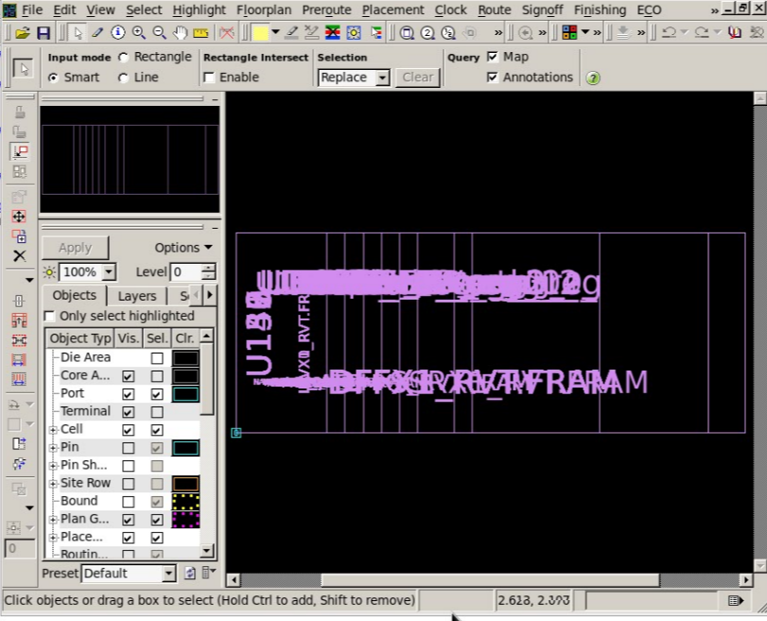

Snapshot of loaded design

# Floorplan1

Each line of this script was ran separately. Below were the finding from each of the line.

* create_floorplan -control_type aspect_ratio -core_utilization 0.63
  + This command creates the size of the core and ensure that the core has a utilization of 1.5
    - Once this command was ran, the cell utilization was set to 66.3565 %. .

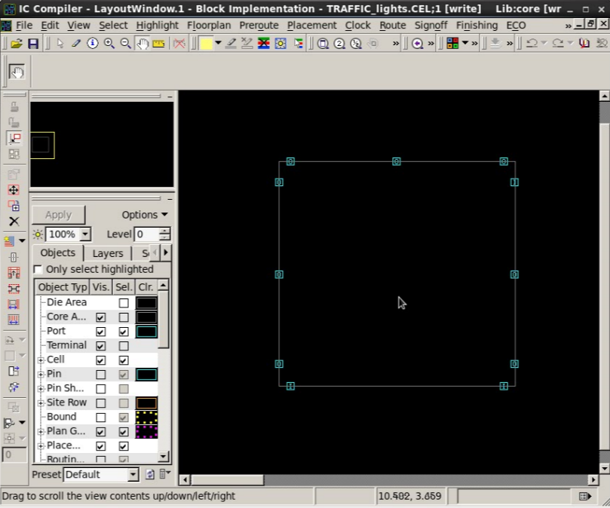

Floor plan with inputs and outputs

* Commands to ensure that properties such as cell density and such are kept
  + set_app_var physopt_hard_keepout_distance 5
  + set_route_zrt_global_options -effort low -timing_driven false -crosstalk_driven false
  + set_app_var placer_max_cell_density_threshold 0.6
  + set_app_var placer_reduce_high_density_regions true
* create_fp_placement -timing_driven
  + This command places all the components onto the core. Their placement is based on their timing, meaning the shortest distance that the wire have to travel.

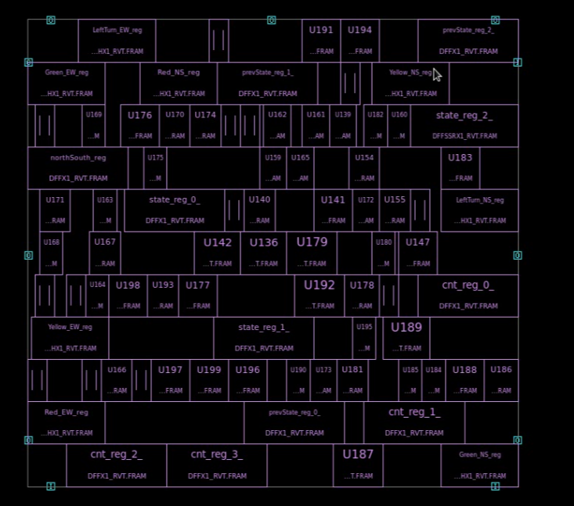

All standard cells are placed inside the core

# Place_route

Each line of this script was ran separately. Below were the finding from each of the line.

* source ../inputs/clock_uncertainity.tcl
  + This command just simply input the uncertainty of our clock
* Psynopt
  + This command performs incremental preroute optimization on the current design.
* Route_zrt_group –nets {clk}
  + This command generates the clock routing for the design

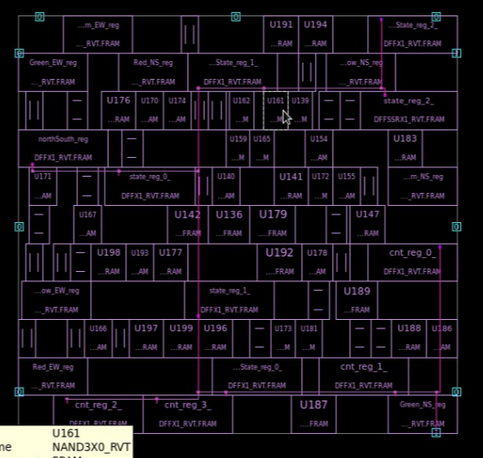

Design with clock tree

* route_opt
  + This command does all the routing and optimization for the design

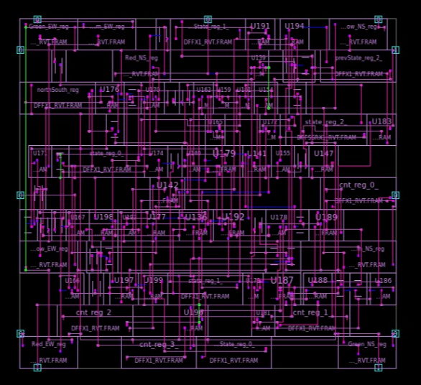

All signals routed

* source generate_report.tcl
  + This script just simply output all the reports to their proper files.

# Conclusion

The optimization done in the ICC stage did indeed improve the design. Below is the chart that compares the reports from the synthesis and the ICC stage. It is evident that the design from the ICC stage is better.

|  |  |  |
| --- | --- | --- |
|  | **Synthesis Stage** | **ICC Stage** |
| **Total Area** | 272.705662 | 270.174529 |
| **Total Power** | 12.5001 | 9.6052 |
| **Slack (MET)** | 0.06 | 1.04 |