MediScan-AI
System Design Documentation
Code Packages · Business Rules · Screens Flow · Entity-Relationship Diagram · Database Schema

1. Code Packages

1.1 Package Diagram
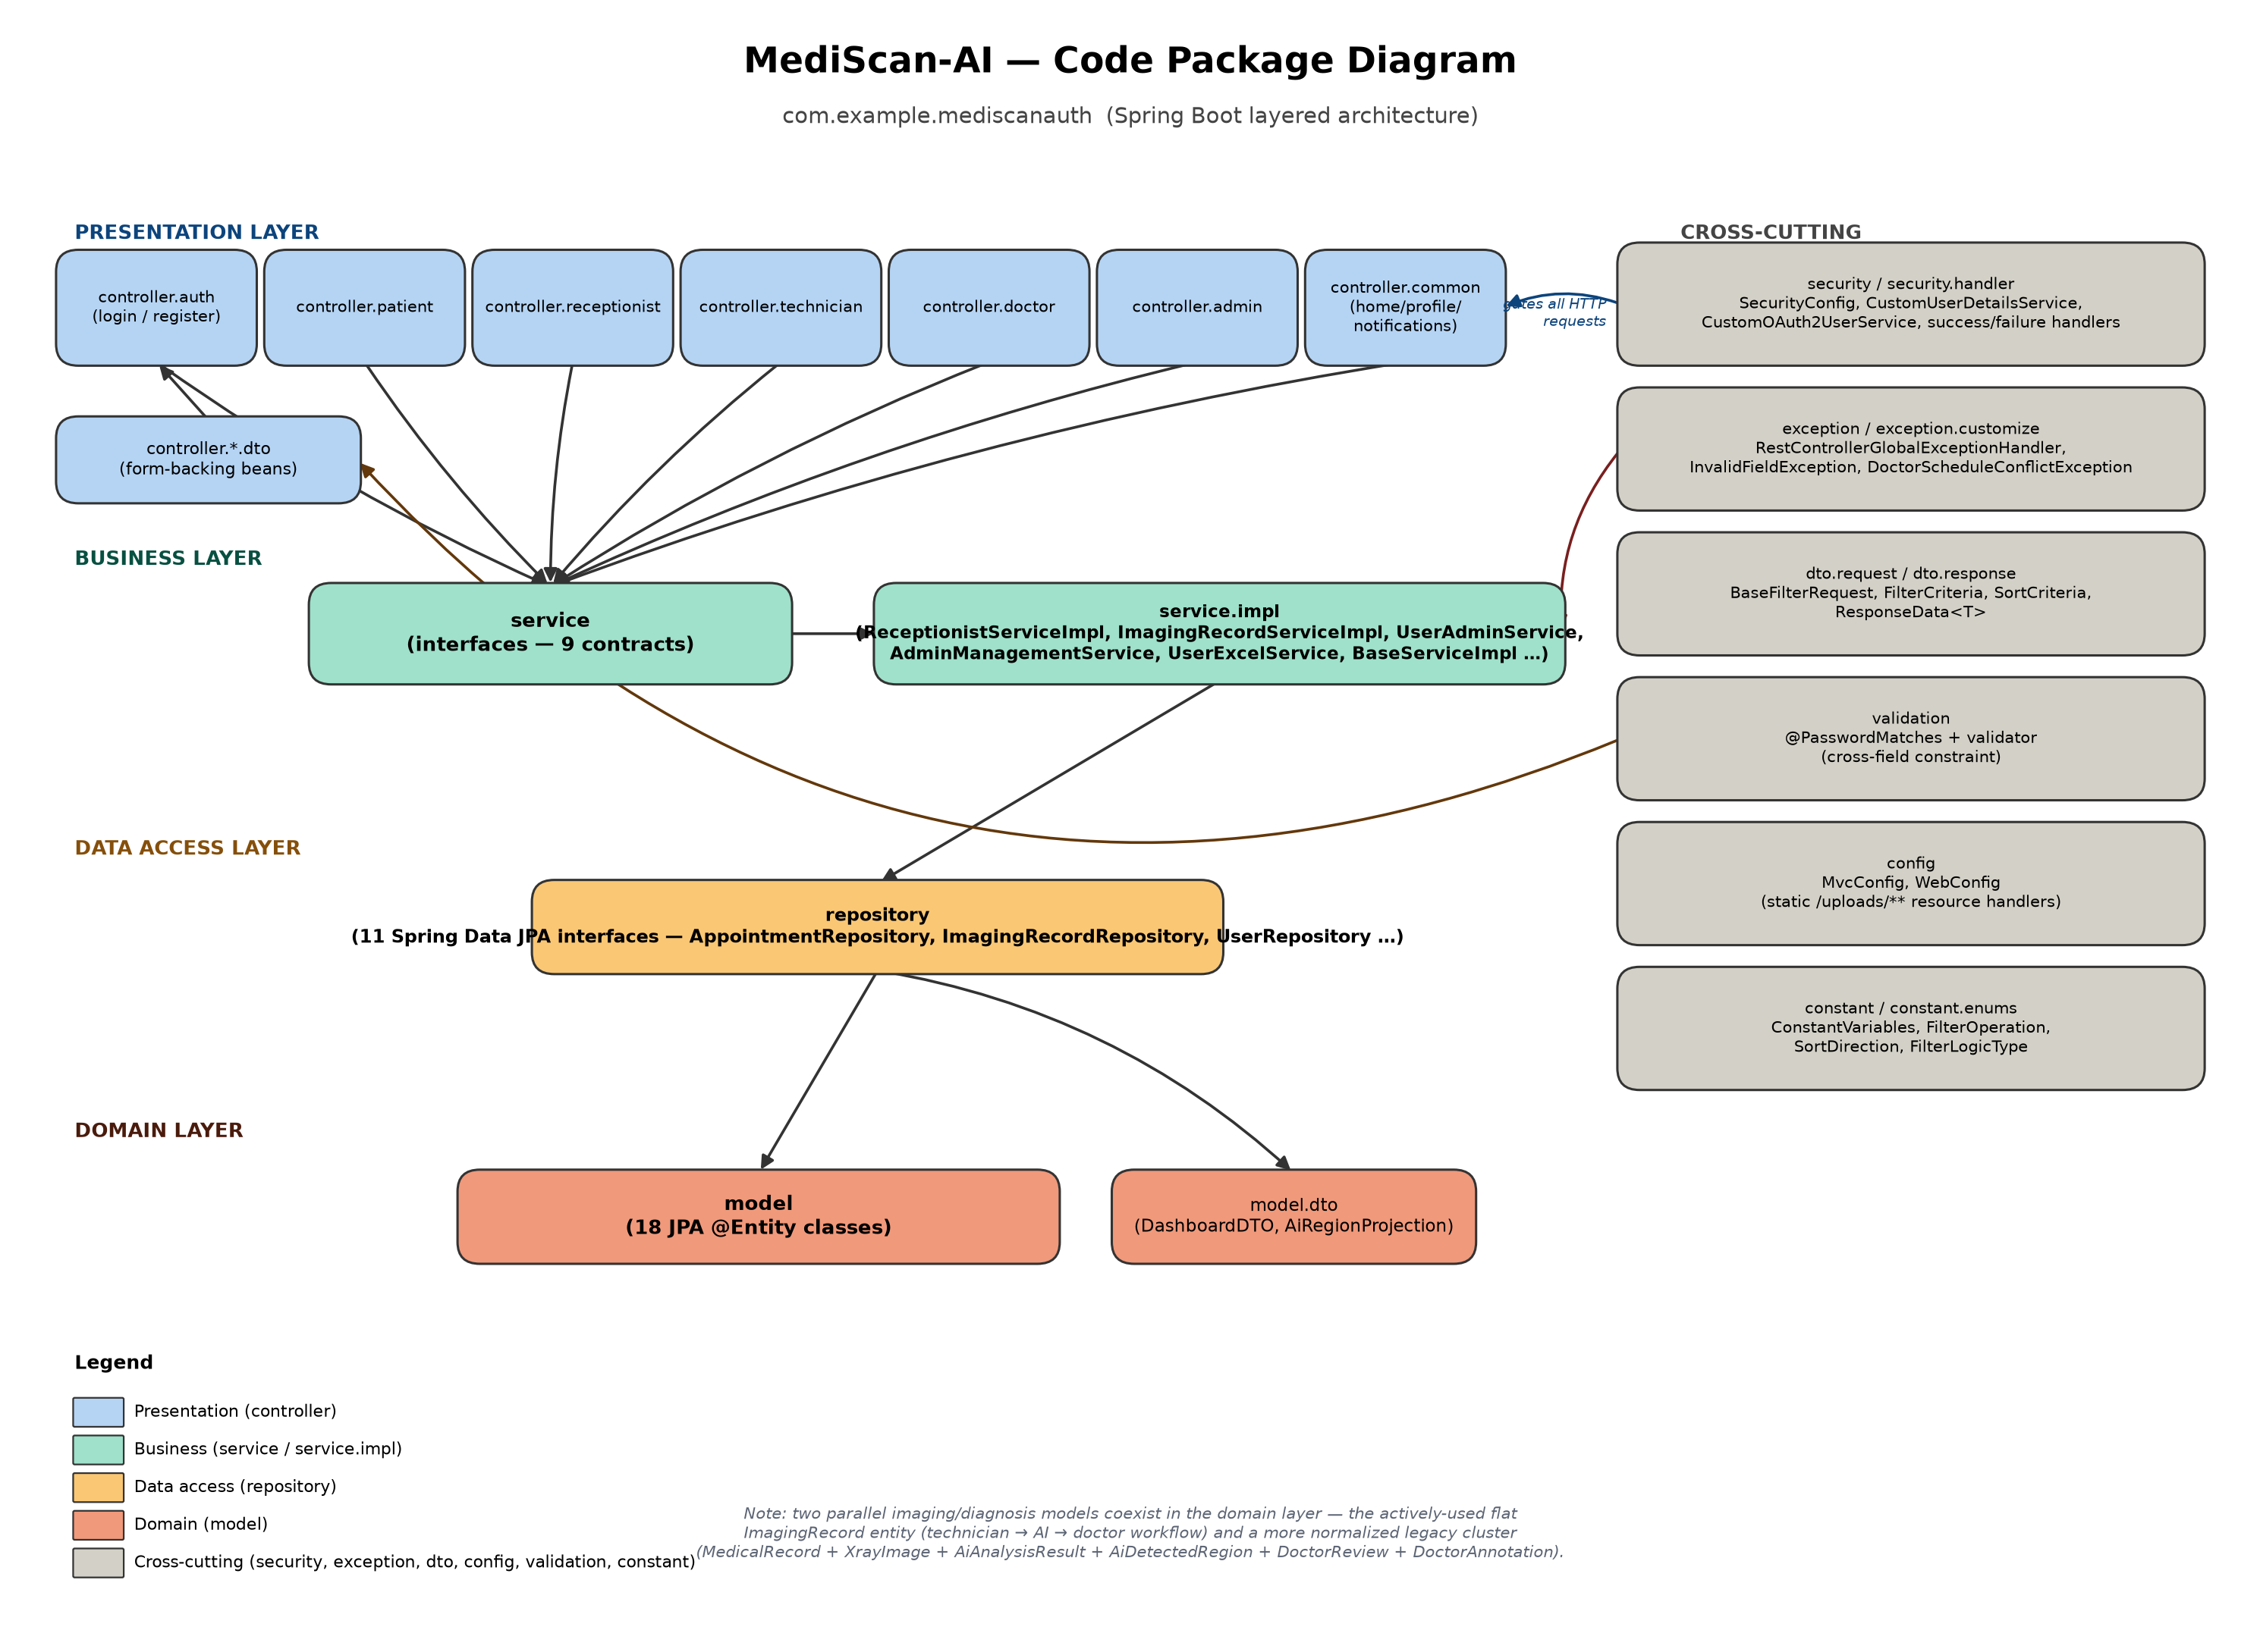
Figure 1.1 — Package dependency diagram: presentation → business → data access → domain layers, with cross-cutting packages on the right.
The codebase (com.example.mediscanauth) follows a standard Spring Boot layered architecture. Two co-existing imaging/diagnosis data models are worth noting: the actively-used, flat ImagingRecord entity drives the technician → AI → doctor workflow across every controller, while a more normalized cluster (MedicalRecord + XrayImage + AiAnalysisResult + AiDetectedRegion + DoctorReview + DoctorAnnotation) is used only by the patient self-check and technician-creation paths.

1.2 Package Descriptions
Package | Description
controller.auth | Login form and patient self-registration endpoints.
controller.patient / .doctor / .receptionist / .technician / .admin | Role-scoped MVC controllers rendering each role's dashboard and workflow screens.
controller.common | Cross-role controllers shared by every logged-in user: post-login router (/home), profile, notifications, and the JSON notification-bell API.
controller.*.dto | Form-backing beans (e.g. RegisterRequest, ProfileUpdateDTO) validated with Jakarta Bean Validation.
service / service.impl | Business-logic contracts and their implementations — the appointment state machine, the technician→AI→doctor imaging workflow, admin management, notifications.
repository | 11 Spring Data JPA interfaces (one per aggregate root) providing queries, atomic conditional updates, and pessimistic locks.
model / model.dto | 18 JPA @Entity classes forming the persistence domain, plus a small set of dashboard/projection DTOs.
security / security.handler | Spring Security configuration, user/OAuth2 authentication, role-based login routing, and one-time password-migration/demo-seed bootstrap runners.
exception / exception.customize | Centralized REST exception-to-response mapping plus custom application exceptions (InvalidFieldException, DoctorScheduleConflictException).
dto.request / dto.response | Generic pagination/filter/sort request DTOs and a standard REST response envelope, used by the generic filterable-list framework.
validation | A custom cross-field Bean Validation constraint (@PasswordMatches) for the registration form.
config | Spring MVC static-resource configuration exposing uploaded X-ray files under /uploads/**.
constant / constant.enums | Process-wide constants and small enum libraries backing the generic filter/sort framework.

2. Business Rules
Rules extracted directly from the service layer (validation constraints, workflow state machines, authorization and scheduling constraints). Each rule is traceable to concrete logic in the codebase.
Rule ID | Rule Definition
Receptionist — Appointment Lifecycle
BR-001 | An appointment can only be confirmed when its status is PENDING or SCHEDULED.
BR-002 | Confirming an appointment with an assigned doctor re-validates doctor availability (row-locked) before the confirmation is applied.
BR-003 | Only an appointment with status CONFIRMED can be checked in.
BR-004 | An appointment cannot be checked in before the calendar day it is scheduled for.
BR-005 | A doctor cannot be (re)assigned to an appointment that is already in a terminal status (COMPLETED, CANCELLED, MISSED).
BR-006 | Reassigning a doctor re-validates schedule availability at the appointment's scheduled time.
BR-007 | Only users holding role DOCTOR who are in ACTIVE status may be assigned to an appointment.
BR-008 | Two appointments for the same doctor within 30 minutes of each other are treated as a scheduling conflict, unless one of them is CANCELLED or MISSED.
BR-009 | A walk-in patient's full name is required and must contain only letters, spaces, and . ' - characters, 2–100 characters long.
BR-010 | A walk-in patient's phone number is required and must match a Vietnamese phone format (0XXXXXXXXX or +84XXXXXXXXX).
BR-011 | A walk-in appointment's symptom description must not exceed 100 characters.
BR-012 | A walk-in/appointment scheduled date cannot be in the past, nor more than 90 days in the future.
BR-013 | A walk-in/appointment scheduled time must fall within clinic operating hours (06:00–21:00) and align to a 30-minute slot boundary.
BR-014 | A walk-in booking reuses an existing patient profile by phone number only if that profile has no linked login account; otherwise a new patient record is created.
BR-015 | A walk-in appointment is created immediately as CONFIRMED, skipping the PENDING state.
BR-016 | An appointment already in a terminal status cannot be cancelled.
BR-017 | A cancellation reason or doctor-assignment note, if provided, must not exceed 500 characters.
BR-018 | Only an appointment in PENDING, SCHEDULED, or CONFIRMED status can be marked MISSED (i.e. only before check-in).
BR-019 | “Call next patient” claims the earliest-scheduled CHECKED_IN appointment atomically, so two receptionists cannot both claim the same patient.
BR-020 | Calling the next patient fails with a clear error if no patient is currently in the CHECKED_IN queue.
BR-021 | Only an appointment in IN_PROGRESS status can be marked COMPLETED.
BR-022 | Every appointment status change is recorded in an audit trail (AppointmentStatusHistory) with the acting user and a note.
Doctor — Imaging Review Workflow
BR-023 | The doctor's active review queue includes only records in PENDING_AI, AI_DONE, AI_ANALYZED, or PENDING_DOCTOR status.
BR-024 | Approving a review sets the record to COMPLETED and stamps a confirmation timestamp.
BR-025 | If a doctor approves without entering a conclusion, the system defaults the conclusion to the AI's prediction text.
BR-026 | Rejecting a review sets the record to DOCTOR_REJECTED rather than completing the case.
BR-027 | A patient may delete only their own imaging record; deleting another patient's record is rejected.
BR-028 | Bulk-clearing non-confirmed records only removes non-COMPLETED statuses — COMPLETED records are never bulk-deleted.
BR-029 | A newly technician-uploaded imaging record starts at PENDING_AI with a placeholder prediction and zero confidence.
BR-030 | Calls to the AI service use a bounded timeout (5s connect / 45s read) so a hung AI service cannot hold a database transaction open indefinitely.
BR-031 | If the AI service call fails or returns an invalid response, the record is marked AI_FAILED with a fallback message directing to manual review.
BR-032 | AI prediction/recommendation text is truncated to a fixed column limit (490 or 900 characters depending on the upload path) before being persisted.
Technician — Capture Workflow
BR-033 | Creating an appointment via the technician workflow always starts it in SCHEDULED status.
BR-034 | Uploading an X-ray auto-creates a patient profile (default gender OTHER, default date of birth 2000-01-01) if none exists yet.
BR-035 | If no body part is supplied for an upload linked to an appointment, the body part is inherited from that appointment.
BR-036 | A newly technician-uploaded medical record and its X-ray image both start in UPLOADED status.
BR-037 | Uploading an image against an existing appointment automatically transitions that appointment to COMPLETED.
Patient — Self-Service
BR-038 | A patient self-upload that fails to reach the AI service is still saved, marked AI_FAILED, rather than blocking the upload.
BR-039 | A successful patient self-upload AI analysis sets the record to AI_ANALYZED, not PENDING_DOCTOR — it is not automatically routed to a doctor.
BR-040 | A fracture detected with ≥80% AI confidence recommends immediate specialist contact; below 80% recommends a clinical exam.
BR-041 | An elevated (non-LOW) AI risk level adds a recommendation to seek further checkup.
BR-042 | A patient self-check upload requires an existing patient profile linked to the current account.
BR-043 | A patient can view only their own medical records.
BR-044 | A medical record can be deleted by its owning patient only while its status is still UPLOADED (before AI has processed it).
BR-045 | Deleting a medical record cascades to delete its linked X-ray image(s).
Admin — Management
BR-046 | Updating a patient profile requires a non-blank full name and a gender of MALE, FEMALE, or OTHER.
BR-047 | Locking a patient requires the patient to have a linked login account; guest-only profiles cannot be locked.
BR-048 | Missing patient profiles are auto-synchronized for any PATIENT-role user that lacks one.
BR-049 | An admin-set appointment status must be one of PENDING, CONFIRMED, COMPLETED, CANCELLED.
BR-050 | A technician or doctor can only be assigned to an appointment if they hold the matching role and are ACTIVE.
BR-051 | A technician cannot be deleted while they still have appointments assigned; the account must be locked instead.
BR-052 | An admin cannot lock their own currently signed-in account, nor remove the ADMIN role from it.
BR-053 | Creating a staff account requires a non-blank name/email and a password of at least 6 characters; the email must not already exist.
BR-054 | Staff accounts created via the admin staff-creation flow may only be assigned role DOCTOR or TECHNICIAN.
BR-055 | A staff account's status can only be set to ACTIVE or LOCKED.
BR-056 | Bulk user import via Excel validates each row independently; rows that fail validation are skipped and reported, without aborting the whole import.
BR-057 | Exported user spreadsheets never include password hashes.
BR-058 | Admin user-listing page size is clamped between 1 and 100 (default 20).
Authentication & Registration
BR-059 | Patient self-registration requires password and confirm-password to match, and a unique, non-blank email.
BR-060 | A newly registered patient account is auto-assigned the PATIENT role, ACTIVE status, and a matching patient profile.
BR-061 | Login is rejected for any account whose status is not ACTIVE.
BR-062 | A granted authority is always normalized to a ROLE_-prefixed value before being handed to Spring Security.
BR-063 | Password change is blocked for Google-authenticated accounts; they cannot set a local password.
BR-064 | Password change requires the current password to match the stored hash, the new password and confirmation to match, and the new password to be at least 6 characters.
BR-065 | A first-time Google sign-in auto-provisions a PATIENT-role, ACTIVE account with a random unusable local password hash.
BR-066 | Google sign-in is rejected for an existing account that is not ACTIVE; on every successful login the profile fields are refreshed from the Google account.
Notifications
BR-067 | Notifications are never created for a null recipient.
BR-068 | A new notification always starts as unread.
BR-069 | Role-broadcast notifications are sent only to users holding the given role(s) who are currently ACTIVE.
BR-070 | A doctor is notified on appointment confirmation, patient check-in, being called into the room, and new case assignment.
BR-071 | A patient is notified on appointment confirmation, cancellation, being called in, and visit completion.
BR-072 | All active receptionists are notified as a group on patient check-in, new walk-in registration, and case completion.

3. Screens

3.1 Screens Flow
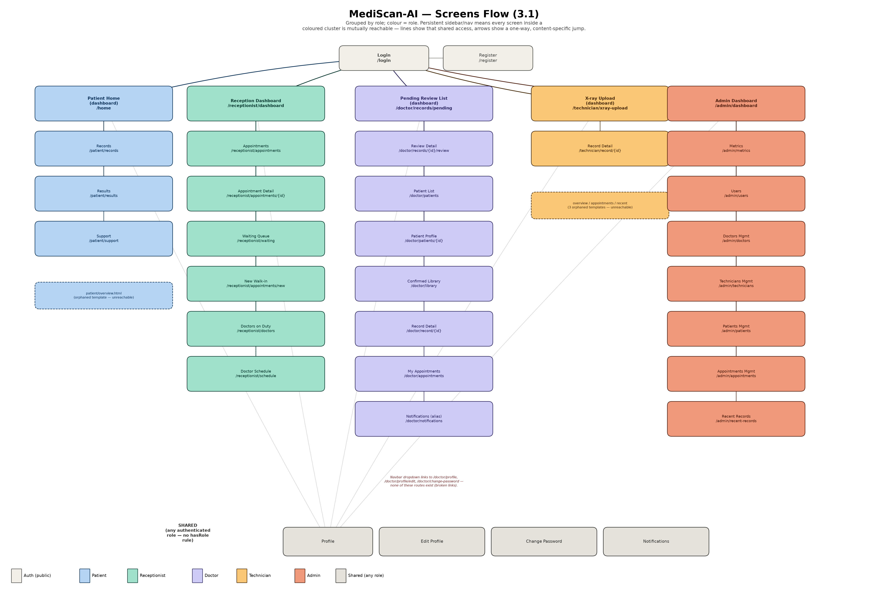
Figure 3.1 — Screens grouped by role. Persistent per-role sidebar navigation means every screen inside a coloured cluster is mutually reachable.
All five roles converge on a single POST /login → /home funnel; HomeController then dispatches by role to that role's dashboard. Two findings from tracing the live navigation graph: four template files on disk are never returned by any controller (orphaned/unreachable — patient/overview.html, technician/overview.html, technician/appointments.html, technician/recent.html), and the doctor role's account-dropdown links to /doctor/profile, /doctor/profile/edit and /doctor/change-password, none of which are mapped routes (broken links — the real shared routes are unprefixed).

3.2 Screen Authorization
Route(s) | Required Authorization
/, /login, /register, static assets | Public — permitAll()
/admin/** | hasRole(“ADMIN”)
/doctor/** | hasRole(“DOCTOR”)
/technician/** | hasRole(“TECHNICIAN”)
/receptionist/** | hasRole(“RECEPTIONIST”)
/patient/** | hasRole(“PATIENT”)
/home, /profile, /profile/edit, /change-password, /notifications, /notifications/click, /api/notifications/recent | Authenticated — any role (no dedicated hasRole rule; falls through to anyRequest().authenticated())

4. Entity-Relationship Diagram (ERD)
Presented in Chen notation (rectangles = entities, ellipses = attributes with primary keys underlined, diamonds = relationships), split into two parts for legibility. Cardinalities are marked at each relationship's connecting line.

4.1 ERD Part 1 — Identity, Scheduling & Cross-Cutting
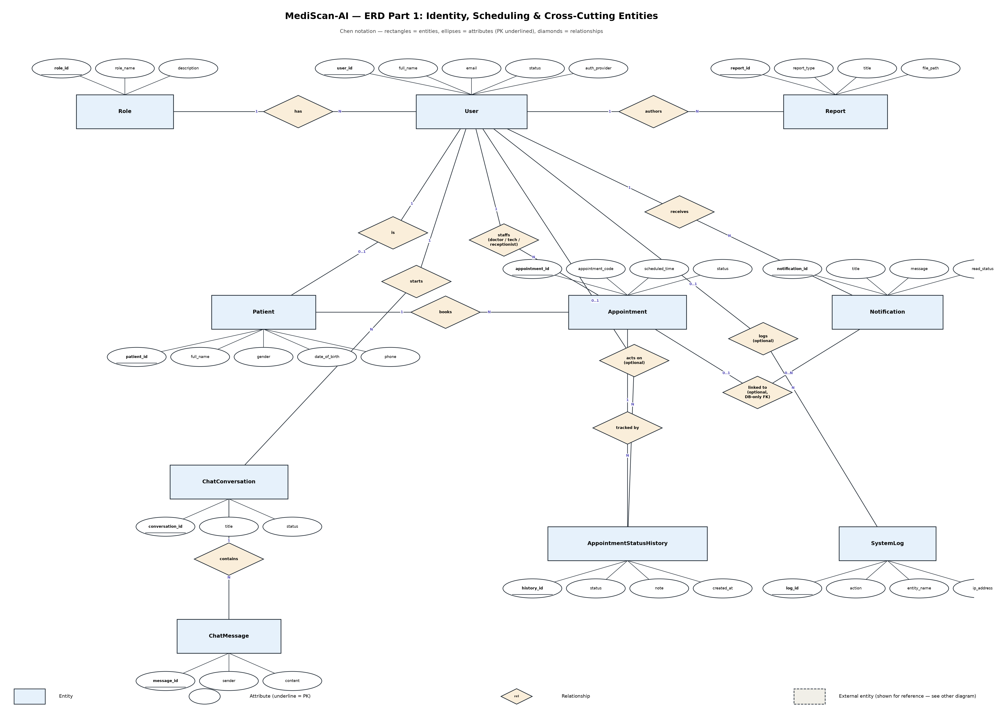
Figure 4.1

4.2 ERD Part 2 — Imaging & AI Diagnosis
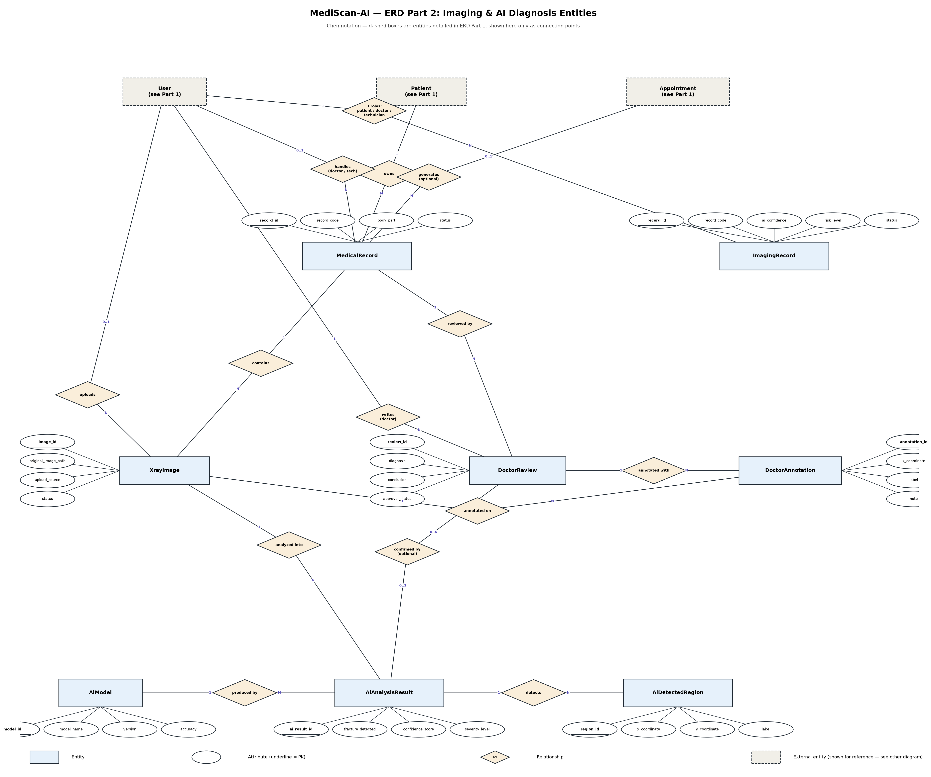
Figure 4.2 — Dashed boxes (User, Patient, Appointment) are detailed in Part 1 and shown here only as connection points.

5. Database Schema
Physical table view of the live MySQL schema (18 tables, 32 foreign keys), split into the same two groupings as the ERD. Bold/underlined = primary key, italic = foreign key. Wide tables are truncated to their most relevant columns with a “+N more…” note; imaging_records in particular carries ~22 additional DICOM-metadata and fracture-statistics columns not shown in full.

5.1 Schema Part 1 — Identity, Scheduling & Cross-Cutting
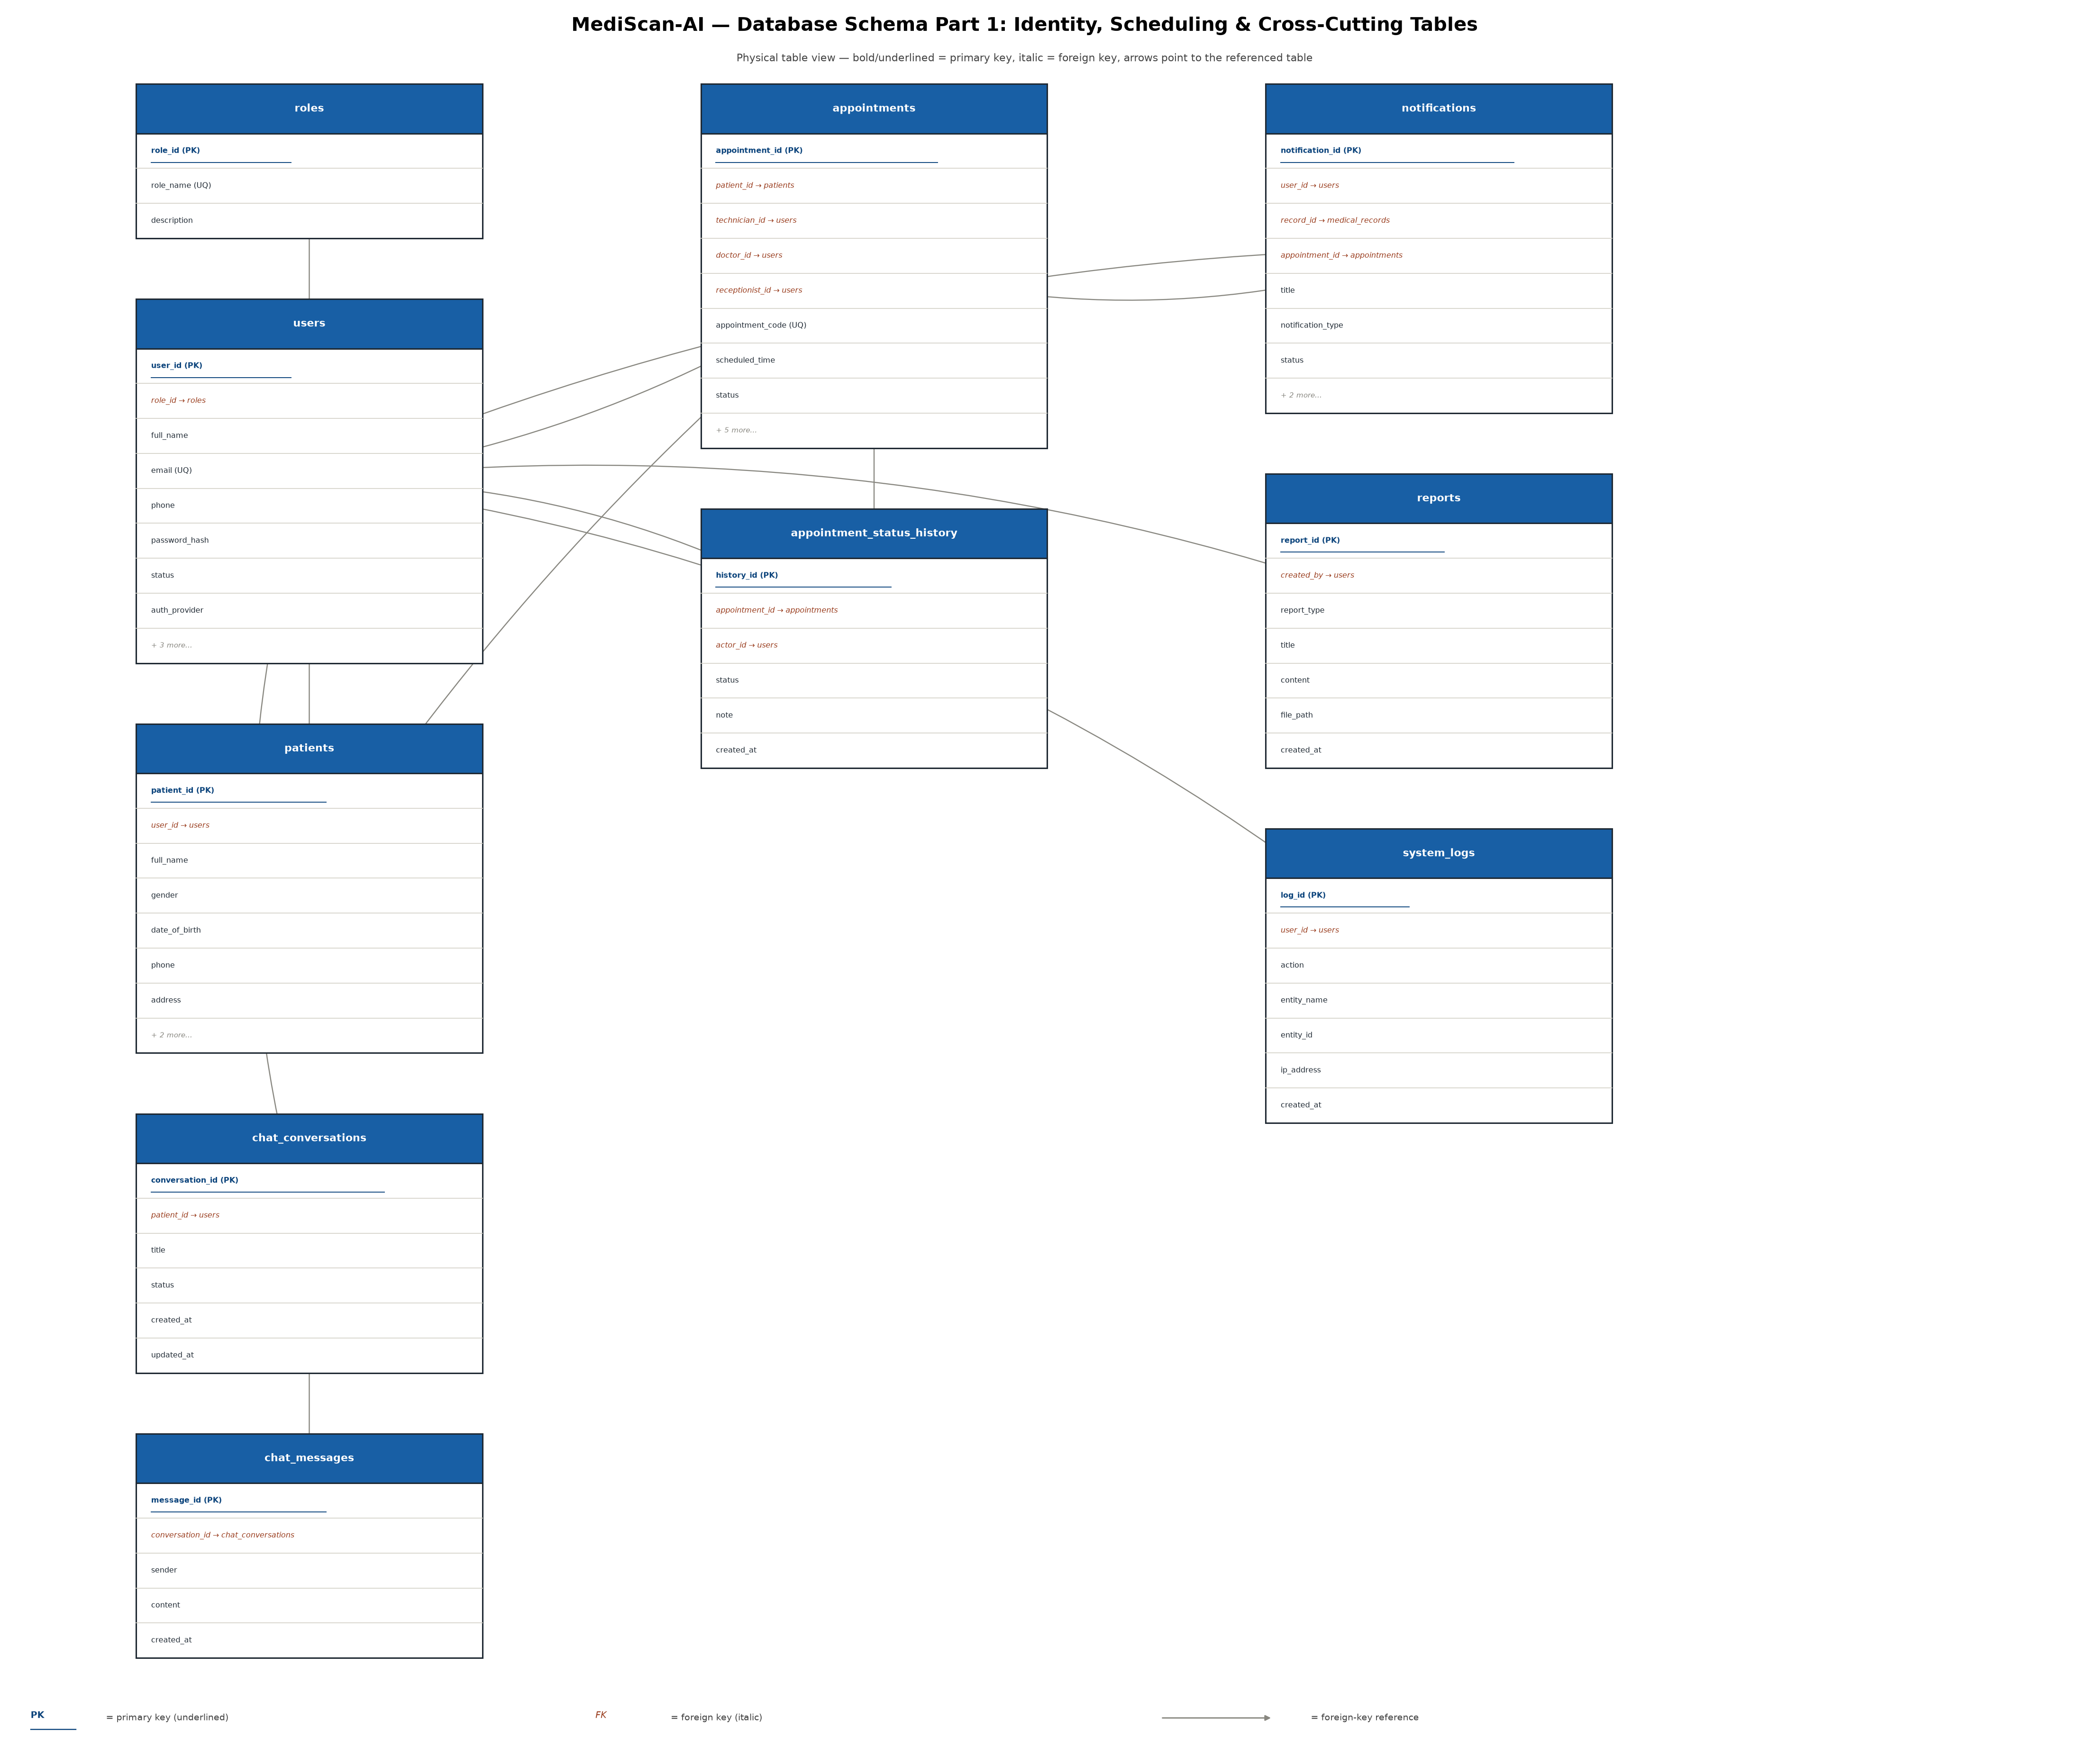
Figure 5.1

5.2 Schema Part 2 — Imaging & AI Diagnosis
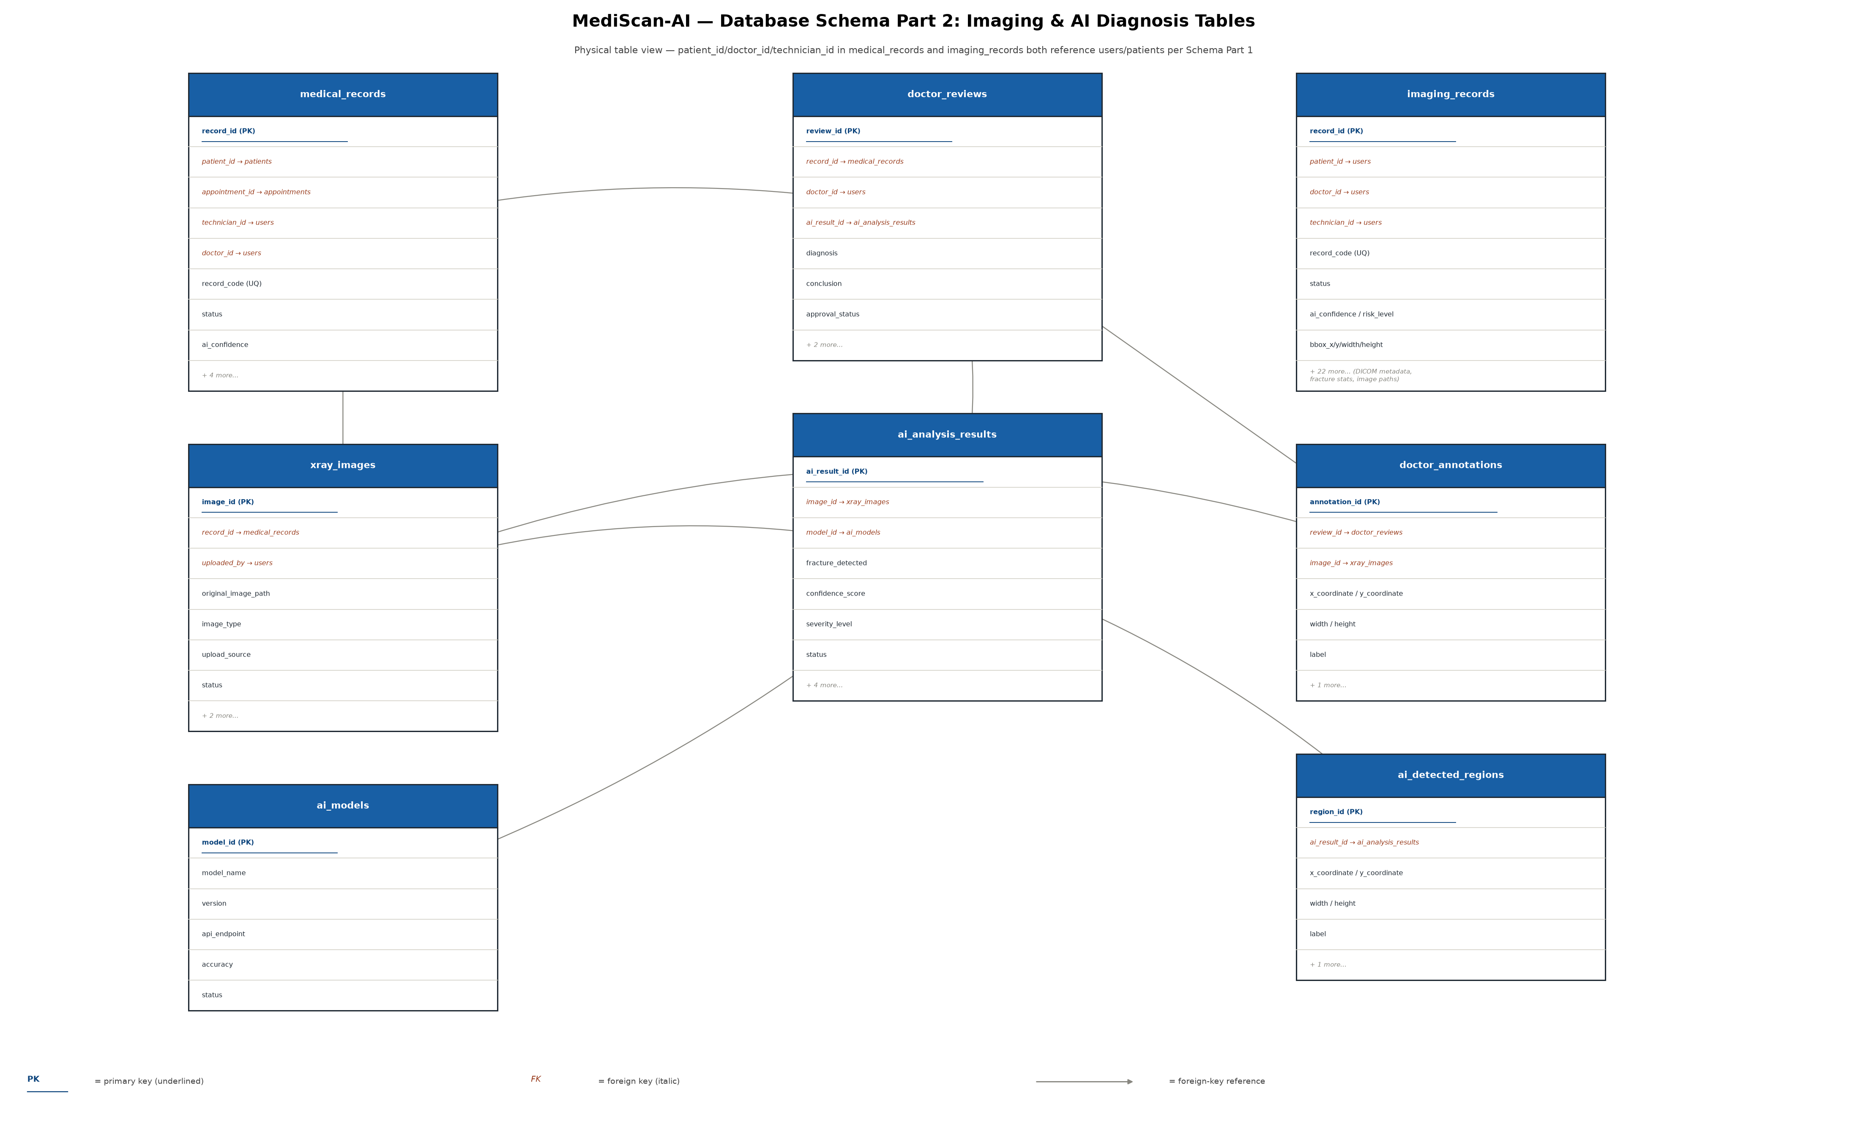
Figure 5.2 — Three foreign keys exist in the live database but are not represented in the JPA entity model: ai_analysis_results.model_id, doctor_reviews.ai_result_id, and notifications.appointment_id.

