1. Given CFG and predictive table :

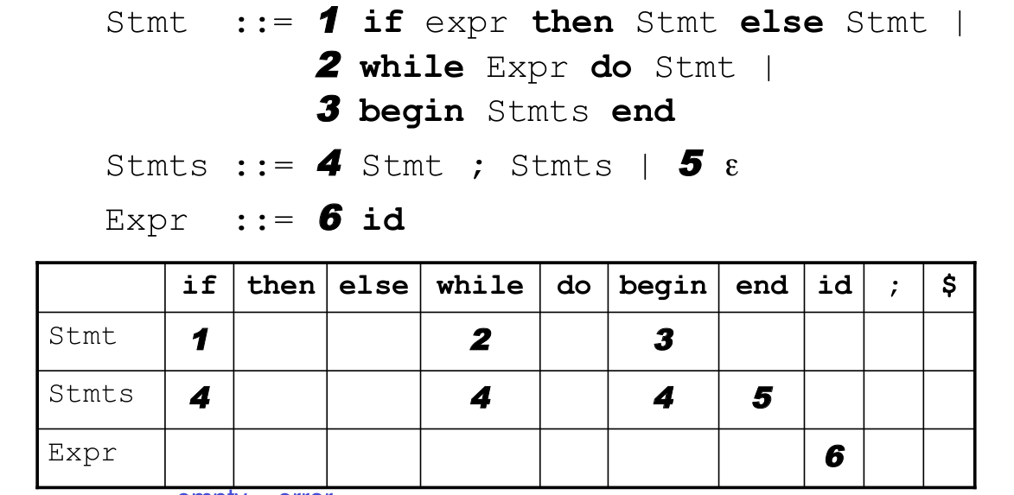

Create Parse tree for the following sentence

*while id do begin begin end;end$*

2. Cho CFG sau

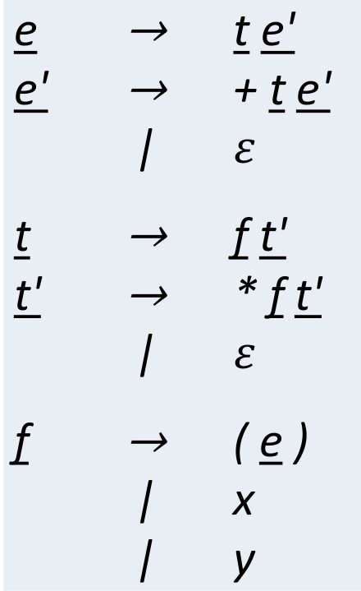

- Create First set

- Create Follow set

- Create Predictive Parsing table

- Create Parse tree for the following sentence

(x+y)\*x