**Hướng dẫn thực hiện LAB 1.1 - Giới thiệu Logism**

**Yêu cầu 1: Đọc lý thuyết và điền bảng chân trị sau đây:**

|  |  |  |
| --- | --- | --- |
| x | y | x XOR y |
| 0 | 0 | 0 |
| 0 | 1 | 1 |
| 1 | 0 | 1 |
| 1 | 1 | 0 |

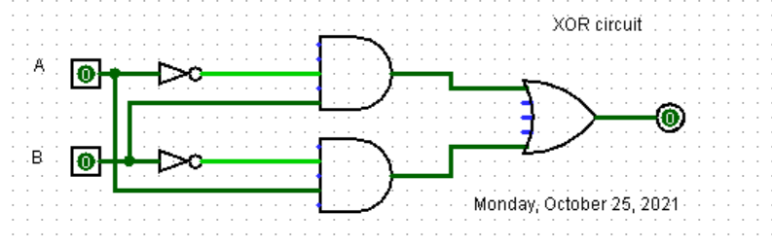

**Hướng dẫn thực hiện LAB 1.2 - Thực hiện mạch tổ hợp**

|  |  |
| --- | --- |
| **Họ tên SV: Nguyễn Tấn Thành** | **MSSV: 52100841** |
| **Ngày thực hiện:25/10/2021** | **Ghi chú: LAB1.2** |

YÊU CẦU 1 VÀ 2

Cho F3 = x⋅y' + x'⋅z (Ch3 p11) Hãy vẽ lại mạch sau đây vào chương trình.

|  |  |  |  |
| --- | --- | --- | --- |
| **x** | **y** | **z** | **F3** |
| 0 | 0 | 0 | 0 |
| 0 | 0 | 1 | 1 |
| 0 | 1 | 0 | 0 |
| 0 | 1 | 1 | 1 |
| 1 | 0 | 0 | 1 |
| 1 | 0 | 1 | 1 |
| 1 | 1 | 0 | 0 |
| 1 | 1 | 1 | 0 |

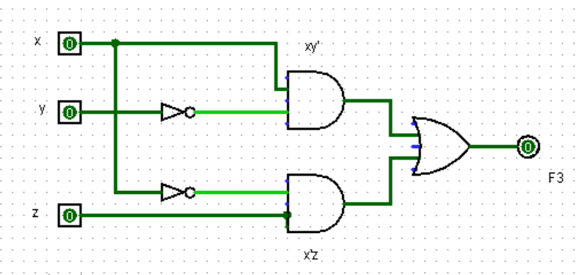

YÊU CẦU 3

1. (a) ABC + AB + ABC’)

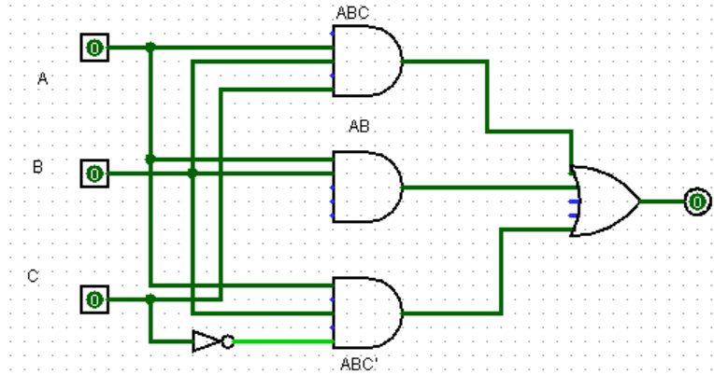

|  |  |  |  |
| --- | --- | --- | --- |
| A | B | C | (a) ABC + AB + ABC’ |
| 0 | 0 | 0 | 0 |
| 0 | 0 | 1 | 0 |
| 0 | 1 | 0 | 0 |
| 0 | 1 | 1 | 0 |
| 1 | 0 | 0 | 0 |
| 1 | 0 | 1 | 0 |
| 1 | 1 | 0 | 1 |
| 1 | 1 | 1 | 1 |

(b) xyz + xz

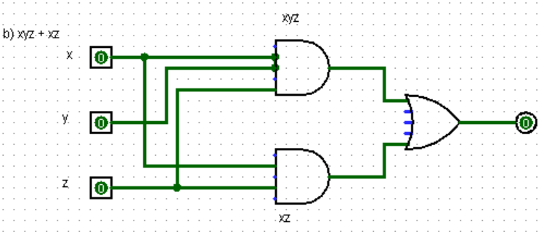

|  |  |  |  |
| --- | --- | --- | --- |
| x | **y** | **z** | (b) xyz + xz |
| 0 | 0 | 0 | 0 |
| 0 | 0 | 1 | 0 |
| 0 | 1 | 0 | 0 |
| 0 | 1 | 1 | 0 |
| 1 | 0 | 0 | 0 |
| 1 | 0 | 1 | 1 |
| 1 | 1 | 0 | 0 |
| 1 | 1 | 1 | 1 |

|  |  |  |
| --- | --- | --- |
| **x** | **y** | (C) |
| 0 | 0 | 0 |
| 0 | 1 | 0 |
| 1 | 0 | 1 |
| 1 | 1 | 1 |
|  |  |  |
|  |  |  |
|  |  |  |
|  |  |  |

(c) (x + y)(x + y’)

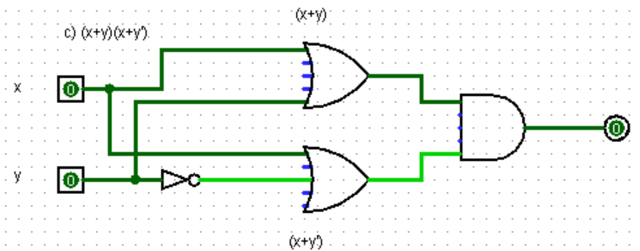

(d) xy + x(wz + wz’)

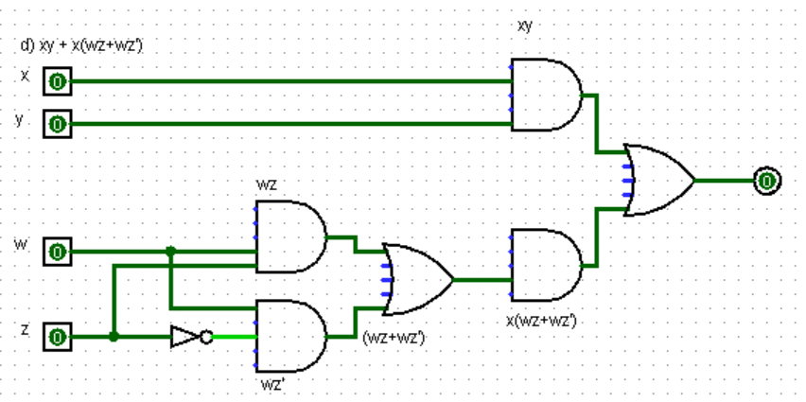

|  |  |  |  |  |
| --- | --- | --- | --- | --- |
| x | **y** | w | z | (d) xy + x(wz + wz’) |
| 0 | 0 | 0 | 0 | 0 |
| 0 | 0 | 0 | 1 | 0 |
| 0 | 0 | 1 | 0 | 1 |
| 0 | 0 | 1 | 1 | 1 |
| 0 | 1 | 0 | 0 | 0 |
| 0 | 1 | 0 | 1 | 0 |
| 0 | 1 | 1 | 0 | 1 |
| 0 | 1 | 1 | 1 | 1 |
| 1 | 0 | 0 | 0 | 0 |
| 1 | 0 | 0 | 1 | 0 |
| 1 | 0 | 1 | 0 | 1 |
| 1 | 0 | 1 | 1 | 1 |
| 1 | 1 | 0 | 0 | 1 |
| 1 | 1 | 0 | 1 | 1 |
| 1 | 1 | 1 | 0 | 1 |
| 1 | 1 | 1 | 1 | 1 |
|  |  |  |  |  |
|  |  |  |  |  |

(e) (BC + AD) (AB + CD)

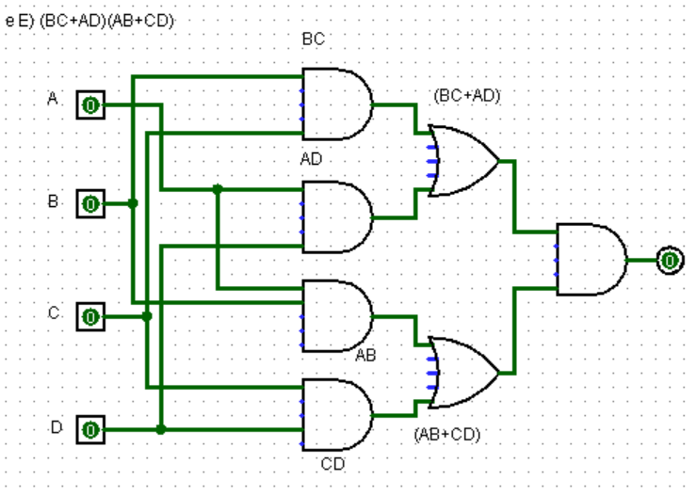

|  |  |  |  |  |
| --- | --- | --- | --- | --- |
| A | B | C | D | (e) (BC + AD) (AB + CD) |
| 0 | 0 | 0 | 0 | 0 |
| 0 | 0 | 0 | 1 | 0 |
| 0 | 0 | 1 | 0 | 0 |
| 0 | 0 | 1 | 1 | 0 |
| 0 | 1 | 0 | 0 | 0 |
| 0 | 1 | 0 | 1 | 0 |
| 0 | 1 | 1 | 0 | 0 |
| 0 | 1 | 1 | 1 | 1 |
| 1 | 0 | 0 | 0 | 0 |
| 1 | 0 | 0 | 1 | 0 |
| 1 | 0 | 1 | 0 | 0 |
| 1 | 0 | 1 | 1 | 1 |
| 1 | 1 | 0 | 0 | 0 |
| 1 | 1 | 0 | 1 | 1 |
| 1 | 1 | 1 | 0 | 1 |
| 1 | 1 | 1 | 1 | 1 |

(f) (a + c) (a + b + c)

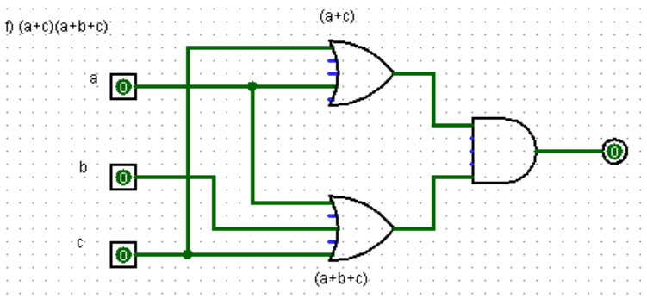

|  |  |  |  |
| --- | --- | --- | --- |
| a | b | c | (f) (a + c) (a + b + c) |
| 0 | 0 | 0 | 0 |
| 0 | 0 | 1 | 1 |
| 0 | 1 | 0 | 0 |
| 0 | 1 | 1 | 1 |
| 1 | 0 | 0 | 1 |
| 1 | 0 | 1 | 1 |
| 1 | 1 | 0 | 1 |
| 1 | 1 | 1 | 1 |