**ASSIGNMENT**

**MÔN: HỆ CƠ SỞ DỮ LIỆU**

Họ và tên:Trần Quang Đãng

MSSV:52100174

**PHẦN 1:**

**1.Đặc tả bài toán quản lí một chợ đầu mối:**

Quản lí một chợ đầu mối.Một chợ đầu mối gồm nhiều quầy hàng khác nhau mỗi quầy hàng bao gồm mã quầy hàng,mã nhân viên,mã loại quầy hàng,mã khu vực.Ở mỗ quầy hàng nhân viên làm việc.Một nhân viên bao gồm các thông tin sau:mã nhân viên,họ tên,chức vụ.lương.Quầy hàng sẽ ở một khu vực nhất định nào đó.Mỗi khu vực sẽ có mã khu vực,tên khu vực,giá thuê của khu vực đó.Ở chợ đầu mối mỗi quầy đều bán một loại quầy hàng nhất định.Loại quầy hàng sẽ có thông tin bao hồm mã loại quầy,tên quầy,diện tích sử dụng và giá thuê.Loại quầy hàng ở chợ đầu mối sẽ bán hai loại là nông sản và thuỷ sản.Ở nông sản chỉ bán các loại rau hoặc củ quả.Ở thuỷ sản cũng chỉ bán các loại thuỷ sản do con người nuôi hoặc đánh bẳt ngoài biển.Để có một quầy hàng ở chợ đầu mối thì người thuê phải có hợp đồng thuê.Mỗi hợp đồng thuê bao gồm mã hợp đồng,mã người thuê,ngày lập,mã quầy hàng,giá trị hợp đồng.Người thuê sẽ có các thông tin là mã người thuê,họ tên,điện thoại,chứng minh nhân dân.Mỗi người thuê khi thuê quầy hàng để buôn bán thì sẽ có một người thân liên quan.Người thân sẽ có mã người thuê liên quan,họ tên,chứng minh nhân dân.Mỗi nhân viên sẽ làm việc ở nhiều quầy hàng khác nhau.Một quầy hàng sẽ có nhiều nhân viên để làm công việc ở quầy hàng ,ở quầy hàng nhân viên chỉ có 2 chức vụ là quản lí và nhân viên.Một khu vực sẽ có nhiều quầy hàng khác nhau.Mỗi quầy hàng sẽ cố định ở một khu vực.Một người có thể có nhiều hợp đồng thuê ,mỗi hợp đòng chỉ để thuê duy nhất một quầy hàng và mỗi quầy hàng chỉ có 1 hợp đồng thuê và hợp đồng thuê cũng chỉ là của một người thuê.Mỗi người thuê quầy hàng cũng sẽ có nhiều người thân khác nhau,mỗi người thân khi có liên quan chỉ có thể liên quan đến một người thuê.

**2.Mô hình ERD**

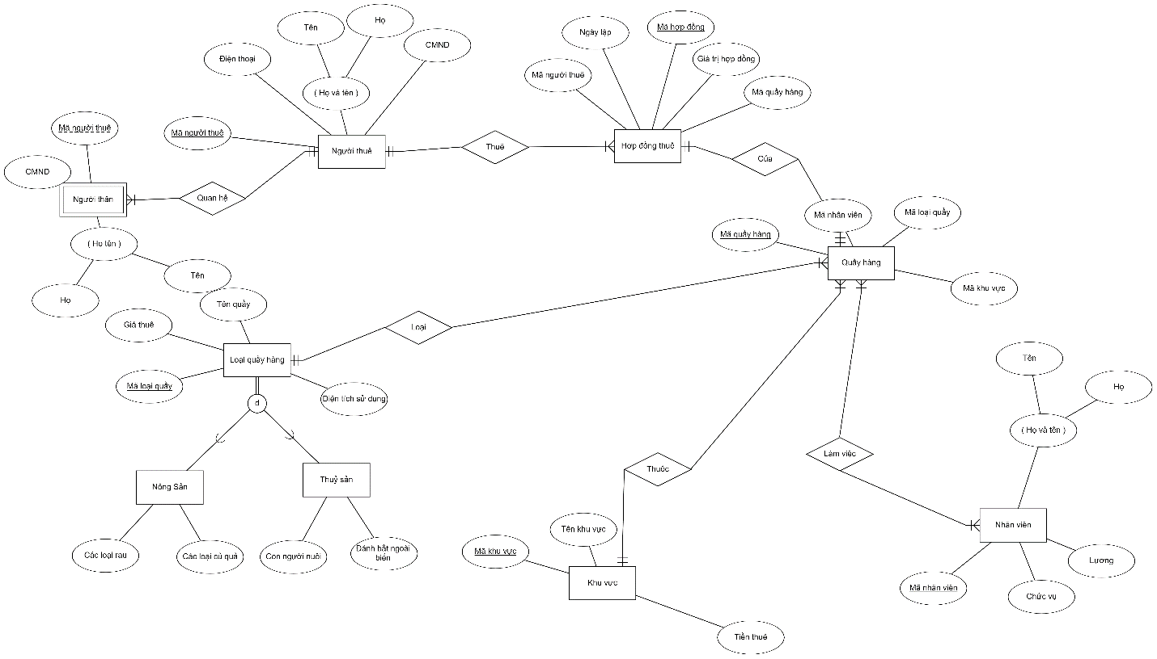

**3.Chuyển mô hình ERD sang mô hình quan hệ**

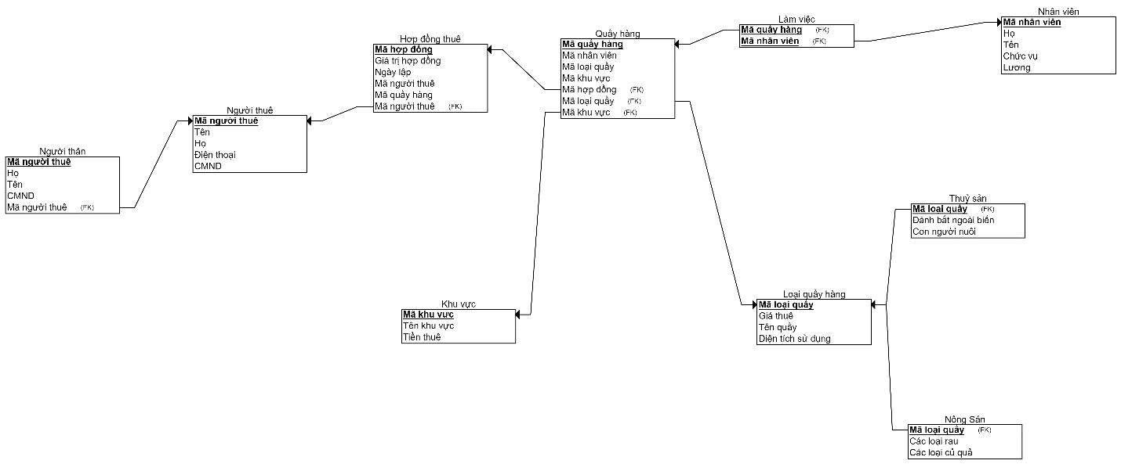

**4.File code.**

USE MASTER

GO

IF EXISTS (SELECT * FROM SYSDATABASES WHERE NAME = 'QLQUAYHANG')

BEGIN

DROP DATABASE QLQUAYHANG

END

GO

CREATE DATABASE QLQUAYHANG

GO

USE QLQUAYHANG

GO

----------------------------------------------------------------

/*

KHUVUC

LOAIQUAYHANG

THUYSAN

NONGSAN

QUAYHANG

NHANVIEN

LAMVIEC

HOPDONGTHUE

NGUOITHUE

NGUOITHAN

*/

------------------------------------------------------------

--FUNCTION INSERT KHUVUC

------------------------------------------------------------

GO

IF EXISTS (SELECT * FROM SYSOBJECTS WHERE NAME = 'ADD_KHUVUC')

BEGIN

DROP FUNCTION ADD_KHUVUC

END

GO

CREATE FUNCTION ADD_KHUVUC(@TENKHUVUC NVARCHAR(50),@TIENTHUE INT)

RETURNS INT

AS

BEGIN

DECLARE @ID_KHUVUC VARCHAR(10)

DECLARE @SQL NVARCHAR(1000)

SET @ID_KHUVUC = 'KV' + RIGHT('000' + CAST((SELECT COUNT(*) FROM KHUVUC) + 1 AS VARCHAR(3)), 3)

SET @SQL = 'INSERT INTO KHUVUC VALUES(' + '''' + @ID_KHUVUC + '''' + ',' + '''' + @TENKHUVUC + '''' + ',' + CONVERT(VARCHAR(10),@TIENTHUE) + ')'

EXECUTE sp_executesql @SQL

RETURN 1

END

------------------------------------------------------------

--FUNCTION INSERT LOAIQUAYHANG

------------------------------------------------------------

GO

IF EXISTS (SELECT * FROM SYSOBJECTS WHERE NAME = 'ADD_LOAIQUAYHANG')

BEGIN

DROP FUNCTION ADD_LOAIQUAYHANG

END

GO

CREATE FUNCTION ADD_LOAIQUAYHANG(@GIATHUE INT,@TENQUAYHANG NVARCHAR(10),@DIENTICH INT)

RETURNS INT

AS

BEGIN

DECLARE @ID_LOAIQUAYHANG VARCHAR(10)

DECLARE @SQL NVARCHAR(1000)

SET @ID_LOAIQUAYHANG = 'LQ' + RIGHT('000' + CAST((SELECT COUNT(*) FROM LOAIQUAYHANG) + 1 AS VARCHAR(3)), 3)

SET @SQL = 'INSERT INTO LOAIQUAYHANG VALUES(' + '''' + @ID_LOAIQUAYHANG + '''' + ',' + CONVERT(VARCHAR(10),@GIATHUE) + ',' + '''' + @TENQUAYHANG + '''' + ',' + CONVERT(VARCHAR(10),@DIENTICH) + ')'

EXECUTE sp_executesql @SQL

RETURN 1

END

GO

------------------------------------------------------------

--FUNCTION INSERT CHITIETQUAYHANG

------------------------------------------------------------

IF EXISTS (SELECT * FROM SYSOBJECTS WHERE NAME = 'ADD_CHITIETQUAYHANG')

BEGIN

DROP FUNCTION ADD_CHITIETQUAYHANG

END

GO

CREATE FUNCTION ADD_CHITIETQUAYHANG(@MALOAIQUAY VARCHAR(10),@LOAIQUAY VARCHAR(10),@TENBANG VARCHAR(10))

RETURNS INT

AS

BEGIN

DECLARE @SQL NVARCHAR(1000)

SET @SQL = 'INSERT INTO '+@TENBANG+' VALUES(' + '''' + @MALOAIQUAY + '''' + ',' + '''' + @LOAIQUAY + '''' + ')'

EXECUTE sp_executesql @SQL

RETURN 1

END

GO

------------------------------------------------------------

--FUNCTION INSERT QUAYHANG

------------------------------------------------------------

IF EXISTS (SELECT * FROM SYSOBJECTS WHERE NAME = 'ADD_QUAYHANG')

BEGIN

DROP FUNCTION ADD_QUAYHANG

END

GO

CREATE FUNCTION ADD_QUAYHANG(@MANHANVIEN NVARCHAR(50),@MALOAIQUAY VARCHAR(10),@MAKHUVUC VARCHAR(10))

RETURNS INT

AS

BEGIN

DECLARE @ID_QUAYHANG VARCHAR(10)

DECLARE @SQL NVARCHAR(1000)

SET @ID_QUAYHANG = 'QH' + RIGHT('000' + CAST((SELECT COUNT(*) FROM QUAYHANG) + 1 AS VARCHAR(3)), 3)

SET @SQL = 'INSERT INTO QUAYHANG VALUES(' + '''' + @ID_QUAYHANG + '''' + ',' + '''' + @MANHANVIEN + '''' + ',' + '''' + @MALOAIQUAY + '''' + ',' + '''' + @MAKHUVUC + '''' + ')'

EXECUTE sp_executesql @SQL

RETURN 1

END

GO

------------------------------------------------------------

--FUNCTION INSERT NHANVIEN

------------------------------------------------------------

IF EXISTS (SELECT * FROM SYSOBJECTS WHERE NAME = 'ADD_NHANVIEN')

BEGIN

DROP FUNCTION ADD_NHANVIEN

END

GO

CREATE FUNCTION ADD_NHANVIEN(@HOTEN VARCHAR(50),@CHUCVU NVARCHAR(50),@LUONG INT)

RETURNS INT

AS

BEGIN

DECLARE @ID_NHANVIEN VARCHAR(10)

DECLARE @SQL NVARCHAR(1000)

SET @ID_NHANVIEN = 'NV' + RIGHT('000' + CAST((SELECT COUNT(*) FROM NHANVIEN) + 1 AS VARCHAR(3)), 3)

SET @SQL = 'INSERT INTO NHANVIEN VALUES(' + '''' + @ID_NHANVIEN + '''' + ',' + '''' + @HOTEN + '''' + ',' + '''' + @CHUCVU + '''' + ',' + CONVERT(VARCHAR(10),@LUONG) + ')'

EXECUTE sp_executesql @SQL

RETURN 1

END

GO

------------------------------------------------------------

--FUNCTION INSERT LAMVIEC

------------------------------------------------------------

IF EXISTS (SELECT * FROM SYSOBJECTS WHERE NAME = 'ADD_LAMVIEC')

BEGIN

DROP FUNCTION ADD_LAMVIEC

END

GO

CREATE FUNCTION ADD_LAMVIEC(@MAQUAYHANG VARCHAR(10),@MANHANVIEN VARCHAR(10))

RETURNS INT

AS

BEGIN

DECLARE @SQL NVARCHAR(1000)

SET @SQL = 'INSERT INTO LAMVIEC VALUES(' + '''' + @MAQUAYHANG + '''' + ',' + '''' + @MANHANVIEN + '''' + ')'

EXECUTE sp_executesql @SQL

RETURN 1

END

GO

------------------------------------------------------------

--FUNCTION INSERT NGUOITHUE

------------------------------------------------------------

IF EXISTS (SELECT * FROM SYSOBJECTS WHERE NAME = 'ADD_NGUOITHUE')

BEGIN

DROP FUNCTION ADD_NGUOITHUE

END

GO

CREATE FUNCTION ADD_NGUOITHUE(@HOTEN VARCHAR(50),@CMND VARCHAR(50),@DIENTHOAI NVARCHAR(50))

RETURNS INT

AS

BEGIN

DECLARE @ID_NGUOITHUE VARCHAR(10)

DECLARE @SQL NVARCHAR(1000)

SET @ID_NGUOITHUE = 'NT' + RIGHT('000' + CAST((SELECT COUNT(*) FROM NGUOITHUE) + 1 AS VARCHAR(3)), 3)

SET @SQL = 'INSERT INTO NGUOITHUE VALUES(' + '''' + @ID_NGUOITHUE + '''' + ',' + '''' + @HOTEN + '''' + ',' + '''' + @CMND + '''' + ',' + '''' + @DIENTHOAI + '''' + ')'

EXECUTE sp_executesql @SQL

RETURN 1

END

GO

------------------------------------------------------------

--FUNCTION INSERT HOPDONGTHUE

------------------------------------------------------------

IF EXISTS (SELECT * FROM SYSOBJECTS WHERE NAME = 'ADD_HOPDONGTHUE')

BEGIN

DROP FUNCTION ADD_HOPDONGTHUE

END

GO

CREATE FUNCTION ADD_HOPDONGTHUE(@NGAYBATDAU VARCHAR(10),@MANGUOITHUE VARCHAR(10),@MAQUAYHANG VARCHAR(10),@GIATRIHOPDONG INT)

RETURNS INT

AS

BEGIN

DECLARE @ID_HOPDONGTHUE VARCHAR(10)

DECLARE @SQL NVARCHAR(1000)

SET @ID_HOPDONGTHUE = 'HD' + RIGHT('000' + CAST((SELECT COUNT(*) FROM HOPDONGTHUE) + 1 AS VARCHAR(3)), 3)

SET @SQL = 'INSERT INTO HOPDONGTHUE VALUES(' + '''' + @ID_HOPDONGTHUE + '''' + ',' + '''' + @NGAYBATDAU + '''' + ',' + '''' + @MANGUOITHUE + '''' + ',' + '''' + @MAQUAYHANG + '''' + ',' + CONVERT(VARCHAR(10),@GIATRIHOPDONG) + ')'

EXECUTE sp_executesql @SQL

RETURN 1

END

GO

------------------------------------------------------------

--FUNCTION INSERT NGUOITHAN

------------------------------------------------------------

IF EXISTS (SELECT * FROM SYSOBJECTS WHERE NAME = 'ADD_NGUOITHAN')

BEGIN

DROP FUNCTION ADD_NGUOITHAN

END

GO

CREATE FUNCTION ADD_NGUOITHAN(@MANGUOITHUE VARCHAR(50),@HOTEN VARCHAR(50),@CMND VARCHAR(50))

RETURNS INT

AS

BEGIN

DECLARE @SQL NVARCHAR(1000)

SET @SQL = 'INSERT INTO NGUOITHAN VALUES(' + '''' + @MANGUOITHUE + '''' + ',' + '''' + @HOTEN + '''' + ',' + '''' + @CMND + '''' + ')'

EXECUTE sp_executesql @SQL

RETURN 1

END

-----------------------------------------

--TABLE KHUVUC

-----------------------------------------

GO

IF EXISTS (SELECT * FROM SYSOBJECTS WHERE NAME = 'KHUVUC')

BEGIN

DROP TABLE KHUVUC

END

GO

CREATE TABLE KHUVUC

(

MAKHUVUC VARCHAR(10) PRIMARY KEY,

TENKHUVUC VARCHAR(10) NOT NULL,

TIENTHUE INT NOT NULL,

)

------------------------------------------------------------

--TABLE LOAIQUAYHANG

------------------------------------------------------------

GO

IF EXISTS (SELECT * FROM SYSOBJECTS WHERE NAME = 'LOAIQUAYHANG')

BEGIN

DROP TABLE LOAIQUAYHANG

END

GO

CREATE TABLE LOAIQUAYHANG

(

MALOAIQUAY VARCHAR(10) PRIMARY KEY,

GIATHUE INT NOT NULL,

TENQUAY VARCHAR(10) NOT NULL,

DIENTICH INT NOT NULL,

)

GO

------------------------------------------------------------

--TABLE THUYSAN

------------------------------------------------------------

IF EXISTS (SELECT * FROM SYSOBJECTS WHERE NAME = 'THUYSAN')

BEGIN

DROP TABLE THUYSAN

END

GO

CREATE TABLE THUYSAN

(

MALOAIQUAY VARCHAR(10) NOT NULL,

LOAIQUAY VARCHAR(10) NOT NULL CHECK(LOAIQUAY IN ('NGOAIBIEN','NUOI')),

FOREIGN KEY (MALOAIQUAY) REFERENCES LOAIQUAYHANG(MALOAIQUAY)

)

GO

------------------------------------------------------------

--TABLE NONGSAN

------------------------------------------------------------

IF EXISTS (SELECT * FROM SYSOBJECTS WHERE NAME = 'NONGSAN')

BEGIN

DROP TABLE NONGSAN

END

GO

CREATE TABLE NONGSAN

(

MALOAIQUAY VARCHAR(10) NOT NULL,

LOAIQUAY VARCHAR(10) NOT NULL CHECK(LOAIQUAY IN ('RAU','CUQUA')),

FOREIGN KEY (MALOAIQUAY) REFERENCES LOAIQUAYHANG(MALOAIQUAY)

)

------------------------------------------------------------

--TABLE QUAYHANG

------------------------------------------------------------

GO

IF EXISTS (SELECT * FROM SYSOBJECTS WHERE NAME = 'QUAYHANG')

BEGIN

DROP TABLE QUAYHANG

END

GO

CREATE TABLE QUAYHANG

(

MAQUAYHANG VARCHAR(10) PRIMARY KEY,

MANHANVIEN VARCHAR(10) NOT NULL,

MALOAIQUAY VARCHAR(10) NOT NULL,

MAKHUVUC VARCHAR(10) NOT NULL,

FOREIGN KEY (MAKHUVUC) REFERENCES KHUVUC(MAKHUVUC),

FOREIGN KEY (MALOAIQUAY) REFERENCES LOAIQUAYHANG(MALOAIQUAY),

)

GO

------------------------------------------------------------

--TABLE NHANVIEN

------------------------------------------------------------

IF EXISTS (SELECT * FROM SYSOBJECTS WHERE NAME = 'NHANVIEN')

BEGIN

DROP TABLE NHANVIEN

END

GO

CREATE TABLE NHANVIEN

(

MANHANVIEN VARCHAR(10) PRIMARY KEY,

HOTEN VARCHAR(50) NOT NULL,

CHUCVU VARCHAR(10) NOT NULL,

LUONG INT NOT NULL,

)

------------------------------------------------------------

--TABLE LAMVIEC

------------------------------------------------------------

GO

IF EXISTS (SELECT * FROM SYSOBJECTS WHERE NAME = 'LAMVIEC')

BEGIN

DROP TABLE LAMVIEC

END

GO

CREATE TABLE LAMVIEC (

MAQUAYHANG VARCHAR(10) NOT NULL,

MANHANVIEN VARCHAR(10) NOT NULL,

FOREIGN KEY (MAQUAYHANG) REFERENCES QUAYHANG(MAQUAYHANG),

FOREIGN KEY (MANHANVIEN) REFERENCES NHANVIEN(MANHANVIEN),

)

GO

------------------------------------------------------------

--TABLE NGUOITHUE

------------------------------------------------------------

IF EXISTS (SELECT * FROM SYSOBJECTS WHERE NAME = 'NGUOITHUE')

BEGIN

DROP TABLE NGUOITHUE

END

GO

CREATE TABLE NGUOITHUE

(

MANGUOITHUE VARCHAR(10) PRIMARY KEY,

HOTEN VARCHAR(50) NOT NULL,

CMND VARCHAR(11) NOT NULL,

DIENTHOAI VARCHAR(10) NOT NULL,

)

GO

------------------------------------------------------------

--TABLE HOPDONGTHUE

------------------------------------------------------------

IF EXISTS (SELECT * FROM SYSOBJECTS WHERE NAME = 'HOPDONGTHUE')

BEGIN

DROP TABLE HOPDONGTHUE

END

GO

CREATE TABLE HOPDONGTHUE

(

MAHOPDONG VARCHAR(10) PRIMARY KEY,

NGAYLAP DATE NOT NULL,

MANGUOITHUE VARCHAR(10) NOT NULL,

MAQUAYHANG VARCHAR(10) NOT NULL,

GIATRIHOPDONG INT NOT NULL,

FOREIGN KEY (MANGUOITHUE) REFERENCES NGUOITHUE(MANGUOITHUE),

FOREIGN KEY (MAQUAYHANG) REFERENCES QUAYHANG(MAQUAYHANG),

)

GO

------------------------------------------------------------

--TABLE NGUOITHAN

------------------------------------------------------------

IF EXISTS (SELECT * FROM SYSOBJECTS WHERE NAME = 'NGUOITHAN')

BEGIN

DROP TABLE NGUOITHAN

END

GO

CREATE TABLE NGUOITHAN

(

MANGUOITHUE VARCHAR(10) NOT NULL,

HOTEN VARCHAR(50) NOT NULL,

CMND VARCHAR(10) NOT NULL,

FOREIGN KEY (MANGUOITHUE) REFERENCES NGUOITHUE(MANGUOITHUE)

)

GO

-------------------------------------------------------------------------------

-- trigger để kiểm tra ràng buộc khoá ngoại, ràng buộc miền giá trị.

-------------------------------------------------------------------------------

-- TRIGGER THUYSAN

-------------------------------------------------------------------------------

GO

IF EXISTS (SELECT * FROM SYSOBJECTS WHERE NAME = 'TRIGGER_THUYSAN')

BEGIN

DROP TRIGGER TRIGGER_THUYSAN

END

GO

CREATE TRIGGER TRIGGER_THUYSAN ON THUYSAN

FOR INSERT, UPDATE, DELETE

AS

DECLARE @LOAIQUAY VARCHAR(10)

DECLARE @MALOAIQUAY VARCHAR(10)

SELECT @LOAIQUAY = LOAIQUAY FROM INSERTED

SELECT MALOAIQUAY = MALOAIQUAY FROM INSERTED

IF @LOAIQUAY NOT IN ('NGOAIBIEN','NUOI')

BEGIN

RAISERROR('LOAIQUAY phai la NGOAIBIEN hoac NUOI',16,1)

ROLLBACK

END

IF @MALOAIQUAY NOT IN (SELECT MALOAIQUAY FROM LOAIQUAYHANG)

BEGIN

RAISERROR('MALOAIQUAY khong ton tai',16,1)

ROLLBACK

END

GO

-------------------------------------------------------------------------------

-- TRIGGER NONGSAN

-------------------------------------------------------------------------------

GO

IF EXISTS (SELECT * FROM SYSOBJECTS WHERE NAME = 'TRIGGER_NONGSAN')

BEGIN

DROP TRIGGER TRIGGER_NONGSAN

END

GO

CREATE TRIGGER TRIGGER_NONGSAN ON NONGSAN

FOR INSERT, UPDATE, DELETE

AS

DECLARE @LOAIQUAY VARCHAR(10)

DECLARE @MALOAIQUAY VARCHAR(10)

SELECT @LOAIQUAY = LOAIQUAY FROM INSERTED

SELECT MALOAIQUAY = MALOAIQUAY FROM INSERTED

IF @LOAIQUAY NOT IN ('RAU','CUQUA')

BEGIN

RAISERROR('LOAIQUAY phai la RAU hoac CUQUA',16,1)

ROLLBACK

END

IF @MALOAIQUAY NOT IN (SELECT MALOAIQUAY FROM LOAIQUAYHANG)

BEGIN

RAISERROR('MALOAIQUAY khong ton tai',16,1)

ROLLBACK

END

GO

-------------------------------------------------------------------------------

-- TRIGGER QUAYHANG

-------------------------------------------------------------------------------

IF EXISTS (SELECT * FROM SYSOBJECTS WHERE NAME = 'TRIGGER_QUAYHANG')

BEGIN

DROP TRIGGER TRIGGER_QUAYHANG

END

GO

CREATE TRIGGER TRIGGER_QUAYHANG ON QUAYHANG

FOR INSERT, UPDATE

AS

DECLARE @MAKHUVUC VARCHAR(10)

DECLARE @MALOAIQUAY VARCHAR(10)

SELECT @MAKHUVUC = MAKHUVUC FROM INSERTED

SELECT @MALOAIQUAY = MALOAIQUAY FROM INSERTED

IF NOT EXISTS (SELECT * FROM KHUVUC WHERE MAKHUVUC = @MAKHUVUC)

BEGIN

RAISERROR('Khong ton tai ma khuvuc', 16, 1)

ROLLBACK

END

IF NOT EXISTS (SELECT * FROM LOAIQUAYHANG WHERE MALOAIQUAY = @MALOAIQUAY)

BEGIN

RAISERROR('Khong ton tai ma loai quay', 16, 1)

ROLLBACK

END

GO

-------------------------------------------------------------------------------

-- TRIGGER NHANVIEN

-------------------------------------------------------------------------------

GO

IF EXISTS (SELECT * FROM SYSOBJECTS WHERE NAME = 'TRIGGER_NHANVIEN')

BEGIN

DROP TRIGGER TRIGGER_NHANVIEN

END

GO

CREATE TRIGGER TRIGGER_NHANVIEN ON NHANVIEN

FOR INSERT, UPDATE

AS

DECLARE @LUONG INT

DECLARE @CHUCVU VARCHAR(10)

SELECT @LUONG = LUONG FROM INSERTED

SELECT @CHUCVU = CHUCVU FROM INSERTED

IF @LUONG < 0

BEGIN

RAISERROR('LUONG phai lon hon 0',16,1)

ROLLBACK

END

IF @CHUCVU NOT IN ('QUAN LY','NHAN VIEN')

BEGIN

RAISERROR('CHUCVU phai la QUANLY hoac NHANVIEN',16,1)

ROLLBACK

END

GO

-------------------------------------------------------------------------------

-- TRIGGER NGUOITHUE

-------------------------------------------------------------------------------

GO

IF EXISTS (SELECT * FROM SYSOBJECTS WHERE NAME = 'TRIGGER_NGUOITHUE')

BEGIN

DROP TRIGGER TRIGGER_NGUOITHUE

END

GO

CREATE TRIGGER TRIGGER_NGUOITHUE ON NGUOITHUE

FOR INSERT, UPDATE

AS

DECLARE @CMND VARCHAR(10)

SELECT @CMND = CMND FROM INSERTED

IF LEN(@CMND) <> 9

BEGIN

RAISERROR('CMND phai co 9 chu so',16,1)

ROLLBACK

END

GO

-------------------------------------------------------------------------------

-- TRIGGER LAMVIEC

-------------------------------------------------------------------------------

GO

IF EXISTS (SELECT * FROM SYSOBJECTS WHERE NAME = 'TRIGGER_LAMVIEC')

BEGIN

DROP TRIGGER TRIGGER_LAMVIEC

END

GO

CREATE TRIGGER TRIGGER_LAMVIEC ON LAMVIEC

FOR INSERT, UPDATE

AS

DECLARE @MAQUAYHANG VARCHAR(10)

DECLARE @MANHANVIEN VARCHAR(10)

SELECT @MAQUAYHANG = MAQUAYHANG FROM INSERTED

SELECT @MANHANVIEN = MANHANVIEN FROM INSERTED

IF NOT EXISTS (SELECT * FROM QUAYHANG WHERE MAQUAYHANG = @MAQUAYHANG)

BEGIN

RAISERROR('Khong ton tai ma quay hang', 16, 1)

ROLLBACK

END

IF NOT EXISTS (SELECT * FROM NHANVIEN WHERE MANHANVIEN = @MANHANVIEN)

BEGIN

RAISERROR('Khong ton tai ma nhan vien', 16, 1)

ROLLBACK

END

GO

-------------------------------------------------------------------------------

-- TRIGGER HOPDONGTHUE

-------------------------------------------------------------------------------

GO

IF EXISTS (SELECT * FROM SYSOBJECTS WHERE NAME = 'TRIGGER_HOPDONGTHUE')

BEGIN

DROP TRIGGER TRIGGER_HOPDONGTHUE

END

GO

CREATE TRIGGER TRIGGER_HOPDONGTHUE ON HOPDONGTHUE

FOR INSERT, UPDATE

AS

DECLARE @GIATRIHOPDONG INT

DECLARE @MANGUOITHUE VARCHAR(10)

DECLARE @MAQUAYHANG VARCHAR(10)

DECLARE @NGAYLAP DATE

SELECT @GIATRIHOPDONG = GIATRIHOPDONG FROM INSERTED

SELECT @MANGUOITHUE = MANGUOITHUE FROM INSERTED

SELECT @MAQUAYHANG = MAQUAYHANG FROM INSERTED

SELECT @NGAYLAP = NGAYLAP FROM INSERTED

IF @GIATRIHOPDONG < 0

BEGIN

RAISERROR('GIATRIHOPDONG phai lon hon 0',16,1)

ROLLBACK

END

IF NOT EXISTS (SELECT * FROM NGUOITHUE WHERE MANGUOITHUE = @MANGUOITHUE)

BEGIN

RAISERROR('Khong ton tai ma nguoi thue', 16, 1)

ROLLBACK

END

IF NOT EXISTS (SELECT * FROM QUAYHANG WHERE MAQUAYHANG = @MAQUAYHANG)

BEGIN

RAISERROR('Khong ton tai ma quay hang', 16, 1)

ROLLBACK

END

IF @NGAYLAP > GETDATE()

BEGIN

RAISERROR('Ngay lap phai nho hon ngay hien tai',16,1)

ROLLBACK

END

GO

-------------------------------------------------------------------------------

-- TRIGGER NGUOITHAN

-------------------------------------------------------------------------------

IF EXISTS (SELECT * FROM SYSOBJECTS WHERE NAME = 'TRIGGER_NGUOITHAN')

BEGIN

DROP TRIGGER TRIGGER_NGUOITHAN

END

GO

CREATE TRIGGER TRIGGER_NGUOITHAN ON NGUOITHAN

FOR INSERT, UPDATE

AS

DECLARE @MANGUOITHUE VARCHAR(10)

DECLARE @CMND VARCHAR(10)

SELECT @MANGUOITHUE = MANGUOITHUE FROM INSERTED

SELECT @CMND = CMND FROM INSERTED

IF NOT EXISTS (SELECT * FROM NGUOITHUE WHERE MANGUOITHUE = @MANGUOITHUE)

BEGIN

RAISERROR('Khong ton tai ma nguoi thue', 16, 1)

ROLLBACK

END

IF LEN(@CMND) <> 9

BEGIN

RAISERROR('CMND phai co 9 chu so',16,1)

ROLLBACK

END

GO

/*

KHUVUC

LOAIQUAYHANG

THUYSAN

NONGSAN

QUAYHANG

NHANVIEN

LAMVIEC

HOPDONGTHUE

NGUOITHUE

NGUOITHAN

*/

-- KHUVUC

EXECUTE DBO.ADD_KHUVUC 'KHU VUC 1',100000

EXECUTE DBO.ADD_KHUVUC 'KHU VUC 2',200000

EXECUTE DBO.ADD_KHUVUC 'KHU VUC 3',300000

EXECUTE DBO.ADD_KHUVUC 'KHU VUC 4',400000

EXECUTE DBO.ADD_KHUVUC 'KHU VUC 5',500000

-- LOAIQUAYHANG

EXECUTE DBO.ADD_LOAIQUAYHANG 100000,'QUAY 1',100

EXECUTE DBO.ADD_LOAIQUAYHANG 200000,'QUAY 2',200

EXECUTE DBO.ADD_LOAIQUAYHANG 300000,'QUAY 3',300

EXECUTE DBO.ADD_LOAIQUAYHANG 400000,'QUAY 4',400

EXECUTE DBO.ADD_LOAIQUAYHANG 500000,'QUAY 5',500

-- THUYSAN

EXECUTE DBO.ADD_CHITIETQUAYHANG 'LQ001','NGOAIBIEN','THUYSAN'

EXECUTE DBO.ADD_CHITIETQUAYHANG 'LQ002','NUOI','THUYSAN'

EXECUTE DBO.ADD_CHITIETQUAYHANG 'LQ003','NGOAIBIEN','THUYSAN'

-- NONGSAN

EXECUTE DBO.ADD_CHITIETQUAYHANG 'LQ004','RAU','NONGSAN'

EXECUTE DBO.ADD_CHITIETQUAYHANG 'LQ005','CUQUA','NONGSAN'

-- QUAYHANG

-- INSERT INTO QUAYHANG VALUES('QH1','NV1','LQ1','KV1')

-- INSERT INTO QUAYHANG VALUES('QH2','NV2','LQ2','KV2')

-- INSERT INTO QUAYHANG VALUES('QH3','NV3','LQ3','KV3')

-- INSERT INTO QUAYHANG VALUES('QH4','NV4','LQ4','KV4')

-- INSERT INTO QUAYHANG VALUES('QH5','NV5','LQ5','KV5')

EXECUTE DBO.ADD_QUAYHANG 'NV001','LQ001','KV001'

EXECUTE DBO.ADD_QUAYHANG 'NV002','LQ002','KV002'

EXECUTE DBO.ADD_QUAYHANG 'NV003','LQ003','KV003'

EXECUTE DBO.ADD_QUAYHANG 'NV004','LQ004','KV004'

EXECUTE DBO.ADD_QUAYHANG 'NV005','LQ005','KV005'

-- NHANVIEN

EXECUTE DBO.ADD_NHANVIEN 'NGUYEN VAN A','NHAN VIEN',1000000

EXECUTE DBO.ADD_NHANVIEN 'HUYNH MINH B','QUAN LY',2000000

EXECUTE DBO.ADD_NHANVIEN 'TRAN NGOC C','NHAN VIEN',3000000

EXECUTE DBO.ADD_NHANVIEN 'LAM TRUONG D','NHAN VIEN',4000000

EXECUTE DBO.ADD_NHANVIEN 'NGUYEN HOANG E','QUAN LY',5000000

-- LAMVIEC

EXECUTE DBO.ADD_LAMVIEC 'QH001','NV001'

EXECUTE DBO.ADD_LAMVIEC 'QH002','NV002'

EXECUTE DBO.ADD_LAMVIEC 'QH003','NV003'

EXECUTE DBO.ADD_LAMVIEC 'QH004','NV004'

EXECUTE DBO.ADD_LAMVIEC 'QH005','NV005'

-- NGUOITHUE

EXECUTE DBO.ADD_NGUOITHUE 'TRAN TRONG CHUNG','342124512','0123456789'

EXECUTE DBO.ADD_NGUOITHUE 'NGUYEN QUANG KHOI','521363214','0213652147'

EXECUTE DBO.ADD_NGUOITHUE 'NGUYEN VAN ANH','923413521','0321652147'

EXECUTE DBO.ADD_NGUOITHUE 'HUYNH MINH DUNG','728271932','0987654321'

EXECUTE DBO.ADD_NGUOITHUE 'NGUYEN VAN HUNG','241231451','0432154123'

-- HOPDONGTHUE

EXECUTE DBO.ADD_HOPDONGTHUE '2018-01-01','NT001','QH001',1000000

EXECUTE DBO.ADD_HOPDONGTHUE '2018-01-02','NT002','QH002',2000000

EXECUTE DBO.ADD_HOPDONGTHUE '2018-01-03','NT003','QH003',3000000

EXECUTE DBO.ADD_HOPDONGTHUE '2018-01-04','NT004','QH004',4000000

EXECUTE DBO.ADD_HOPDONGTHUE '2018-01-05','NT005','QH005',5000000

-- NGUOITHAN

EXECUTE DBO.ADD_NGUOITHAN 'NT001','HUYNH MINH PHUOC','512365214'

EXECUTE DBO.ADD_NGUOITHAN 'NT002','PHAM VAN MAN','213456789'

EXECUTE DBO.ADD_NGUOITHAN 'NT003','VO MINH TAM','992345678'

EXECUTE DBO.ADD_NGUOITHAN 'NT004','LE HUYNH TU','124156789'

EXECUTE DBO.ADD_NGUOITHAN 'NT005','LE ANH TUAN','435678912'

SELECT * FROM KHUVUC

SELECT * FROM LOAIQUAYHANG

SELECT * FROM THUYSAN

SELECT * FROM NONGSAN

SELECT * FROM QUAYHANG

SELECT * FROM NHANVIEN

SELECT * FROM LAMVIEC

SELECT * FROM HOPDONGTHUE

SELECT * FROM NGUOITHUE

SELECT * FROM NGUOITHAN

Kết quả:

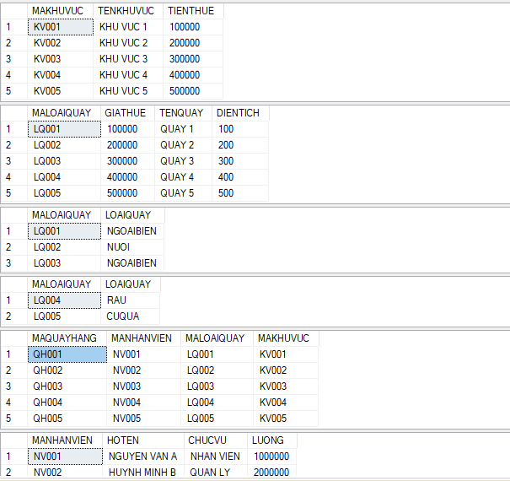

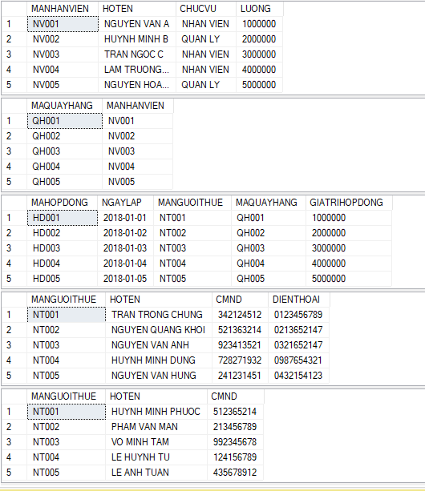

**PHẦN 2:**

**1.Cấu trúc thư mục**

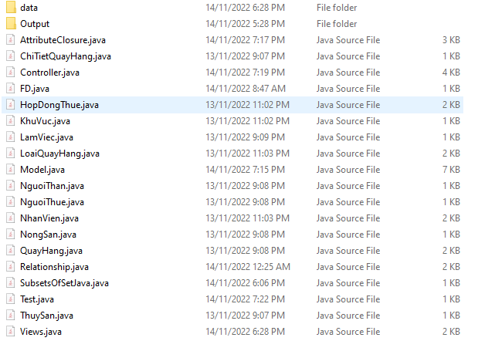

-Thư mục data:để chứ các dữ liệu đầu vào

-Thư mục Output:để chứa các output của từng câu hỏi

-Để chạy chương trình chạy file Test.java

**2.File code:**

**Class** AttributeClosure

import java.util.*;

public class AttributeClosure {

private HashSet<String> U;

private HashSet<FD> F;

public AttributeClosure(HashSet<String> U, HashSet<FD> F) {

this.U = U;

this.F = F;

}

public HashSet<String> getAttributeClosure(HashSet<String> X) {

HashSet<String> closure = new HashSet<String>(X);

int len = 0;

do {

len = closure.size();

for (FD fd : F) {

if (closure.containsAll(fd.getLHS()) && !closure.contains(fd.getRHS())) {

closure.add(fd.getRHS());

}

}

} while (closure.size() > len);

return closure;

}

private HashSet<String> getSetRights() {

HashSet<String> setRights = new HashSet<String>();

for (FD fd : F) {

setRights.add(fd.getRHS());

}

return setRights;

}

private HashSet<String> getSetLefts() {

HashSet<String> setLefts = new HashSet<String>();

for (FD fd : F) {

setLefts.addAll(fd.getLHS());

}

return setLefts;

}

private HashSet<String> subtractHashSet(HashSet<String> set1, HashSet<String> set2) {

HashSet<String> set = new HashSet<String>(set1);

set.removeAll(set2);

return set;

}

private HashSet<String> retainHashSet(HashSet<String> set1, HashSet<String> set2) {

HashSet<String> set = new HashSet<String>(set1);

set.retainAll(set2);

return set;

}

private HashSet<String> getTN() {

return subtractHashSet(U, getSetRights());

}

private HashSet<String> getTG() {

return retainHashSet(getSetLefts(), getSetRights());

}

private HashSet<String> add2HashSet(HashSet<String> set1, HashSet<String> set2) {

HashSet<String> set = new HashSet<String>(set1);

set.addAll(set2);

return set;

}

public ArrayList<HashSet<String>> findAllKeys() {

ArrayList<HashSet<String>> listKeys = new ArrayList<HashSet<String>>();

HashSet<String> TN = getTN();

HashSet<String> TG = getTG();

if (TN.isEmpty()) {

return listKeys;

}

SubsetsOfSetJava<String> subsetsOfSetJava = new SubsetsOfSetJava<String>();

HashSet<HashSet<String>> subsets = subsetsOfSetJava.getSubsets(TG);

for (HashSet<String> subset : subsets) {

if (getAttributeClosure(add2HashSet(subset, TN)).containsAll(U)) {

listKeys.add(add2HashSet(subset, TN));

}

}

// // get HashSet<String> by length min

// int min = Integer.MAX_VALUE;

// for (HashSet<String> key : listKeys) {

// if (key.size() < min) {

// min = key.size();

// }

// }

// ArrayList<HashSet<String>> listKeysMin = new ArrayList<HashSet<String>>();

// for (HashSet<String> key : listKeys) {

// if (key.size() == min) {

// listKeysMin.add(key);

// }

// }

return listKeys;

}

}

Class ChiTietQuayHang

public class ChiTietQuayHang {

private String maLoaiQuay;

private String hinhThucQuayHang;

public ChiTietQuayHang() {

}

public ChiTietQuayHang(String maLoaiQuay, String hinhThucQuayHang) {

this.maLoaiQuay = maLoaiQuay;

this.hinhThucQuayHang = hinhThucQuayHang;

}

public String getMaLoaiQuay() {

return maLoaiQuay;

}

public void setMaLoaiQuay(String maLoaiQuay) {

this.maLoaiQuay = maLoaiQuay;

}

public String getHinhThucQuayHang() {

return hinhThucQuayHang;

}

public void setHinhThucQuayHang(String hinhThucQuayHang) {

this.hinhThucQuayHang = hinhThucQuayHang;

}

public boolean checkLoai(String loai, String[] arr) {

for (String s : arr) {

if (!s.equalsIgnoreCase(loai)) {

return false;

}

}

return true;

}

@Override

public String toString() {

return maLoaiQuay + "_" + hinhThucQuayHang;

}

}

Class Controller

import java.util.*;

import java.io.*;

public class Controller {

private ArrayList<Relationship<Object, Object>> listRelationship;

private Set<String> listClass;

private AttributeClosure attributeClosure;

private Model model;

private Views views;

public Controller() {

this.listRelationship = new ArrayList<Relationship<Object, Object>>();

this.listClass = new HashSet<String>();

this.model = new Model();

this.views = new Views();

}

public ArrayList<Relationship<Object, Object>> getListRelationship() {

return listRelationship;

}

public Set<String> getListClass() {

return listClass;

}

public void handleRelationship(String fileName) {

model.initRelationship(fileName, listRelationship, listClass);

}

public void displayData(String fileName) throws IOException {

HashMap<String, ArrayList<Object>> map = new HashMap<String, ArrayList<Object>>();

model.handleReadData(fileName, map, listClass);

}

public void solveQuestion_1(String pathFileTable, String pathFileRelationships, String pathFileOutput)

throws IOException {

HashMap<String, ArrayList<Object>> map = new HashMap<String, ArrayList<Object>>();

// read data from file

handleRelationship(pathFileRelationships);

model.handleReadData(pathFileTable, map, listClass);

// display data question 1

views.renderAnswerRelationships(pathFileOutput, listRelationship);

for (String key : map.keySet()) {

views.renderAnswerTable(pathFileOutput, key, map.get(key));

}

}

public void configureQuestion_2(String pathFileAtribute)

throws IOException {

HashSet<String> listAtribute = new HashSet<String>();

HashSet<FD> listFD = new HashSet<FD>();

// read data from file

model.readAttributesTable(pathFileAtribute, listAtribute);

model.readFuncDependency(pathFileAtribute, listFD);

attributeClosure = new AttributeClosure(listAtribute, listFD);

}

public HashSet<String> convertString2Set(String str, String regex) {

HashSet<String> set = new HashSet<String>();

String[] arr = str.split(regex);

for (String s : arr) {

set.add(s.toUpperCase());

}

return set;

}

public String convertSet2String(HashSet<String> set, String regex) {

String str = "";

for (String s : set) {

str += s + regex;

}

return str.substring(0, str.length() - regex.length());

}

public void solveQuestion_2(String pathFileOutput, String X) throws IOException {

// closure of X

HashSet<String> setX = convertString2Set(X, "_");

HashSet<String> closures = attributeClosure.getAttributeClosure(setX);

String closure ="("+ X.toUpperCase()+")+" + "->" + convertSet2String(closures, "_");

// find all keys

ArrayList<HashSet<String>> allKeys = attributeClosure.findAllKeys();

ArrayList<String> keys = new ArrayList<String>();

for (HashSet<String> key : allKeys) {

keys.add(convertSet2String(key, "_"));

}

if (X.isEmpty()) {

views.renderAnswerClosure(pathFileOutput, "X is empty");

return;

} else {

// render solveQuestion_2

views.renderAnswerClosure(pathFileOutput, closure);

}

// check empty key

if (allKeys.size() == 0) {

views.renderAnswerAllKeys(pathFileOutput, new ArrayList<String>() {

{

add("No key");

}

});

} else {

// render solveQuestion_2

views.renderAnswerAllKeys(pathFileOutput, keys);

}

}

}

Class FD

import java.util.*;

public class FD {

private HashSet<String> lhs;

private String rhs;

public FD(HashSet<String> l, String r) {

lhs = l;

rhs = r;

}

public boolean equals(Object obj) {

FD fd2 = (FD) obj;

return lhs.equals(fd2.lhs) && rhs.equals(fd2.rhs);

}

public HashSet<String> getLHS() {

return lhs;

}

public String getRHS() {

return rhs;

}

public String toString() {

String s = "";

for (String c : lhs)

s += c+" ";

s += " -> " + rhs;

return s;

}

}

Class HopDongThue

public class HopDongThue {

private String maHopDong;

private String giaTriHopDong;

private String ngayBatDau;

private String maNguoiThue;

private String maQuayHang;

public HopDongThue() {

}

public HopDongThue(String maHopDong, String giaTriHopDong, String ngayBatDau, String maNguoiThue, String maQuayHang) {

this.maHopDong = maHopDong;

this.giaTriHopDong = giaTriHopDong;

this.ngayBatDau = ngayBatDau;

this.maNguoiThue = maNguoiThue;

this.maQuayHang = maQuayHang;

}

public String getMaHopDong() {

return maHopDong;

}

public void setMaHopDong(String maHopDong) {

this.maHopDong = maHopDong;

}

public String getGiaTriHopDong() {

return giaTriHopDong;

}

public void setGiaTriHopDong(String giaTriHopDong) {

this.giaTriHopDong = giaTriHopDong;

}

public String getNgayBatDau() {

return ngayBatDau;

}

public void setNgayBatDau(String ngayBatDau) {

this.ngayBatDau = ngayBatDau;

}

public String getMaNguoiThue() {

return maNguoiThue;

}

public void setMaNguoiThue(String maNguoiThue) {

this.maNguoiThue = maNguoiThue;

}

public String getMaQuayHang() {

return maQuayHang;

}

public void setMaQuayHang(String maQuayHang) {

this.maQuayHang = maQuayHang;

}

@Override

public String toString() {

return maHopDong + "_" + giaTriHopDong + "_" + ngayBatDau + "_" + maNguoiThue + "_" + maQuayHang;

}

}

Class KhuVuc

public class KhuVuc {

private String maKhuVuc;

private String tenKhuVuc;

private String tienThue;

public KhuVuc() {

}

public KhuVuc(String maKhuVuc, String tenKhuVuc, String tienThue) {

this.maKhuVuc = maKhuVuc;

this.tenKhuVuc = tenKhuVuc;

this.tienThue = tienThue;

}

public String getMaKhuVuc() {

return maKhuVuc;

}

public void setMaKhuVuc(String maKhuVuc) {

this.maKhuVuc = maKhuVuc;

}

public String getTenKhuVuc() {

return tenKhuVuc;

}

public void setTenKhuVuc(String tenKhuVuc) {

this.tenKhuVuc = tenKhuVuc;

}

public String getTienThue() {

return tienThue;

}

public void setTienThue(String tienThue) {

this.tienThue = tienThue;

}

@Override

public String toString() {

return maKhuVuc + "_" + tenKhuVuc + "_" + tienThue;

}

}

Class LamViec

public class LamViec {

private String maQuayHang;

private String maNhanVien;

public LamViec() {

}

public LamViec(String maQuayHang, String maNhanVien) {

this.maQuayHang = maQuayHang;

this.maNhanVien = maNhanVien;

}

public String getMaQuayHang() {

return maQuayHang;

}

public void setMaQuayHang(String maQuayHang) {

this.maQuayHang = maQuayHang;

}

public String getMaNhanVien() {

return maNhanVien;

}

public void setMaNhanVien(String maNhanVien) {

this.maNhanVien = maNhanVien;

}

@Override

public String toString() {

return maQuayHang + "_" + maNhanVien;

}

}

Class LoaiQuayHang

public class LoaiQuayHang {

private String maLoaiQuay;

private String giaThe;

private String tenQuay;

private String dienTich;

public LoaiQuayHang() {

}

public LoaiQuayHang(String maLoaiQuay, String giaThe, String tenQuay, String dienTich) {

this.maLoaiQuay = maLoaiQuay;

this.giaThe = giaThe;

this.tenQuay = tenQuay;

this.dienTich = dienTich;

}

public String getMaLoaiQuay() {

return maLoaiQuay;

}

public void setMaLoaiQuay(String maLoaiQuay) {

this.maLoaiQuay = maLoaiQuay;

}

public String getGiaThe() {

return giaThe;

}

public void setGiaThe(String giaThe) {

this.giaThe = giaThe;

}

public String getTenQuay() {

return tenQuay;

}

public void setTenQuay(String tenQuay) {

this.tenQuay = tenQuay;

}

public String getDienTich() {

return dienTich;

}

public void setDienTich(String dienTich) {

this.dienTich = dienTich;

}

@Override

public String toString() {

return maLoaiQuay + "_" + giaThe + "_" + tenQuay + "_" + dienTich;

}

}

Class Model

import java.util.*;

import java.io.*;

public class Model {

public Model() {

}

private Object createObjectByStringName(String clasName) {

switch (clasName) {

case "THUYSAN":

return new ThuySan();

case "QUAYHANG":

return new QuayHang();

case "NONGSAN":

return new NongSan();

case "NHANVIEN":

return new NhanVien();

case "NGUOITHUE":

return new NguoiThue();

case "NGUOITHAN":

return new NguoiThan();

case "LOAIQUAYHANG":

return new LoaiQuayHang();

case "LAMVIEC":

return new LamViec();

case "KHUVUC":

return new KhuVuc();

case "HOPDONGTHUE":

return new HopDongThue();

default:

return null;

}

}

private ThuySan thuySan(String maLoaiQuay, String loai) {

return new ThuySan(maLoaiQuay, loai);

}

private QuayHang quayHang(String maQuayHang, String maNhanVien, String maLoaiQuay, String maKhuVuc) {

return new QuayHang(maQuayHang, maNhanVien, maLoaiQuay, maKhuVuc);

}

private NongSan nongSan(String maLoaiQuay, String loai) {

return new NongSan(maLoaiQuay, loai);

}

private NhanVien nhanVien(String maNhanVien, String hoTen, String chucVu, String luong) {

return new NhanVien(maNhanVien, hoTen, chucVu, luong);

}

private NguoiThue nguoiThue(String maNguoiThue, String hoTen, String SDT, String CMND) {

return new NguoiThue(maNguoiThue, hoTen, SDT, CMND);

}

private NguoiThan nguoiThan(String maNguoiThue, String hoTen, String CMND) {

return new NguoiThan(maNguoiThue, hoTen, CMND);

}

private LoaiQuayHang loaiQuayHang(String maLoaiQuay, String giaThe, String tenQuay, String dienTich) {

return new LoaiQuayHang(maLoaiQuay, giaThe, tenQuay, dienTich);

}

private LamViec lamViec(String maQuayHang, String maNhanVien) {

return new LamViec(maQuayHang, maNhanVien);

}

private KhuVuc khuVuc(String maKhuVuc, String tenKhuVuc, String tienThue) {

return new KhuVuc(maKhuVuc, tenKhuVuc, tienThue);

}

private HopDongThue hopDongThue(String maHopDong,

String giaTriHopDong, String ngayBatDau, String maNguoiThue,

String maQuayHang) {

return new HopDongThue(maHopDong, giaTriHopDong, ngayBatDau, maNguoiThue, maQuayHang);

}

private Object createClass(String className, String[] args) {

switch (className) {

case "THUYSAN":

return thuySan(args[0], args[1]);

case "QUAYHANG":

return quayHang(args[0], args[1], args[2], args[3]);

case "NONGSAN":

return nongSan(args[0], args[1]);

case "NHANVIEN":

return nhanVien(args[0], args[1], args[2], args[3]);

case "NGUOITHUE":

return nguoiThue(args[0], args[1], args[2], args[3]);

case "NGUOITHAN":

return nguoiThan(args[0], args[1], args[2]);

case "LOAIQUAYHANG":

return loaiQuayHang(args[0], args[1], args[2], args[3]);

case "LAMVIEC":

return lamViec(args[0], args[1]);

case "KHUVUC":

return khuVuc(args[0], args[1], args[2]);

case "HOPDONGTHUE":

return hopDongThue(args[0], args[1], args[2], args[3], args[4]);

default:

return null;

}

}

public void readRelationship(String fileName, ArrayList<Relationship<Object, Object>> listRelationship,

Set<String> listClass) throws IOException {

File file = new File(fileName);

Scanner scanner = new Scanner(file);

while (scanner.hasNextLine()) {

String line = scanner.nextLine();

String[] tokens = line.split(",");

Object objA = createObjectByStringName(tokens[0].toUpperCase());

Object objB = createObjectByStringName(tokens[1].toUpperCase());

String typeObjectA = tokens[2];

String typeObjectB = tokens[3];

Relationship<Object, Object> relationship = new Relationship<>(objA, objB,

typeObjectA, typeObjectB);

listRelationship.add(relationship);

listClass.add(tokens[0]);

listClass.add(tokens[1]);

}

scanner.close();

}

public void initRelationship(String fileName, ArrayList<Relationship<Object, Object>> listRelationship,

Set<String> listClass) {

try {

readRelationship(fileName, listRelationship, listClass);

} catch (IOException e) {

e.printStackTrace();

}

}

public HashMap<String, ArrayList<Object>> handleReadData(String fileName, HashMap<String, ArrayList<Object>> map,

Set<String> listClass)

throws IOException {

File file = new File(fileName);

Scanner scanner = new Scanner(file);

while (scanner.hasNextLine()) {

String line = scanner.nextLine();

String[] tokens = line.split(",");

String className = tokens[0].toUpperCase();

Object obj = createClass(className, Arrays.copyOfRange(tokens, 1, tokens.length));

ArrayList<Object> list = map.get(className);

if (list == null) {

list = new ArrayList<Object>();

}

list.add(obj);

map.put(className, list);

}

scanner.close();

return map;

}

public void readAttributesTable(String pathFileAtribute, HashSet<String> listAtribute) throws IOException {

File file = new File(pathFileAtribute);

Scanner scanner = new Scanner(file);

while (scanner.hasNextLine()) {

String line = scanner.nextLine();

String[] tokens = line.split("->");

if (tokens.length == 1) {

int indexArrow = tokens[0].indexOf("(");

String className = tokens[0].substring(0, indexArrow).toUpperCase();

listAtribute.add(className);

}

}

scanner.close();

}

public void readFuncDependency(String pathFileFuncDependency, HashSet<FD> listFD) throws IOException {

File file = new File(pathFileFuncDependency);

Scanner scanner = new Scanner(file);

while (scanner.hasNextLine()) {

String line = scanner.nextLine();

String[] tokens = line.split("->");

if (tokens.length == 2) {

HashSet<String> lhs = new HashSet<String>();

String[] lhsTokens = tokens[0].split("_");

for (String lhsToken : lhsTokens) {

lhs.add(lhsToken.toUpperCase());

}

String[] rhs = tokens[1].split("_");

for (String s : rhs) {

listFD.add(new FD(lhs, s.toUpperCase()));

}

}

}

scanner.close();

}

}

Class NguoiThan

public class NguoiThan {

private String maNguoiThue;

private String hoTen;

private String CMND;

public NguoiThan() {

}

public NguoiThan(String maNguoiThue, String hoTen, String CMND) {

this.maNguoiThue = maNguoiThue;

this.hoTen = hoTen;

this.CMND = CMND;

}

public String getMaNguoiThue() {

return maNguoiThue;

}

public void setMaNguoiThue(String maNguoiThue) {

this.maNguoiThue = maNguoiThue;

}

public String getHoTen() {

return hoTen;

}

public void setHoTen(String hoTen) {

this.hoTen = hoTen;

}

public String getCMND() {

return CMND;

}

public void setCMND(String CMND) {

this.CMND = CMND;

}

@Override

public String toString() {

return maNguoiThue+"_"+hoTen+"_"+CMND;

}

}

Class NguoiThue

public class NguoiThue {

private String maNguoiThue;

private String hoTen;

private String SDT;

private String CMND;

public NguoiThue() {

}

public NguoiThue(String maNguoiThue, String hoTen, String SDT, String CMND) {

this.maNguoiThue = maNguoiThue;

this.hoTen = hoTen;

this.SDT = SDT;

this.CMND = CMND;

}

public String getMaNguoiThue() {

return maNguoiThue;

}

public void setMaNguoiThue(String maNguoiThue) {

this.maNguoiThue = maNguoiThue;

}

public String getHoTen() {

return hoTen;

}

public void setHoTen(String hoTen) {

this.hoTen = hoTen;

}

public String getSDT() {

return SDT;

}

public void setSDT(String SDT) {

this.SDT = SDT;

}

public String getCMND() {

return CMND;

}

public void setCMND(String CMND) {

this.CMND = CMND;

}

@Override

public String toString() {

return maNguoiThue+"_"+hoTen+"_"+SDT+"_"+CMND;

}

}

Class NhanVien

public class NhanVien {

private String maNhanVien;

private String hoTen;

private String chucVu;

private String luong;

public NhanVien() {

}

public NhanVien(String maNhanVien, String hoTen, String chucVu, String luong) {

this.maNhanVien = maNhanVien;

this.hoTen = hoTen;

this.chucVu = chucVu;

this.luong = luong;

}

public String getMaNhanVien() {

return maNhanVien;

}

public void setMaNhanVien(String maNhanVien) {

this.maNhanVien = maNhanVien;

}

public String getHoTen() {

return hoTen;

}

public void setHoTen(String hoTen) {

this.hoTen = hoTen;

}

public String getChucVu() {

return chucVu;

}

public void setChucVu(String chucVu) {

this.chucVu = chucVu;

}

public String getLuong() {

return luong;

}

public void setLuong(String luong) {

this.luong = luong;

}

@Override

public String toString() {

return maNhanVien + "_" + hoTen + "_" + chucVu + "_" + luong;

}

}

Class NongSan

public class NongSan extends ChiTietQuayHang {

public NongSan() {

super();

}

public NongSan(String maLoaiQuay, String loai) {

super(maLoaiQuay, loai);

if (!this.checkLoai(loai, new String[] { "Rau", "CuQua" })) {

this.setHinhThucQuayHang("CuQua");

}

}

@Override

public String toString() {

return "Nong San: "+super.toString();

}

}

Class QuayHang

public class QuayHang {

private String maQuayHang;

private String maNhanVien;

private String maLoaiQuay;

private String maKhuVuc;

public QuayHang() {

}

public QuayHang(String maQuayHang, String maNhanVien, String maLoaiQuay, String maKhuVuc) {

this.maQuayHang = maQuayHang;

this.maNhanVien = maNhanVien;

this.maLoaiQuay = maLoaiQuay;

this.maKhuVuc = maKhuVuc;

}

public String getMaQuayHang() {

return maQuayHang;

}

public void setMaQuayHang(String maQuayHang) {

this.maQuayHang = maQuayHang;

}

public String getMaNhanVien() {

return maNhanVien;

}

public void setMaNhanVien(String maNhanVien) {

this.maNhanVien = maNhanVien;

}

public String getMaLoaiQuay() {

return maLoaiQuay;

}

public void setMaLoaiQuay(String maLoaiQuay) {

this.maLoaiQuay = maLoaiQuay;

}

public String getMaKhuVuc() {

return maKhuVuc;

}

public void setMaKhuVuc(String maKhuVuc) {

this.maKhuVuc = maKhuVuc;

}

@Override

public String toString() {

return maQuayHang + "_" + maNhanVien + "_" + maLoaiQuay + "_" + maKhuVuc;

}

}

Class Relationship

public class Relationship<A, B> {

private A ObjectA;

private B ObjectB;

private String typeObjectA;

private String typeObjectB;

public Relationship() {

}

public Relationship(A ObjectA, B ObjectB, String typeObjectA, String typeObjectB) {

this.ObjectA = ObjectA;

this.ObjectB = ObjectB;

this.typeObjectA = typeObjectA;

this.typeObjectB = typeObjectB;

}

public A getObjectA() {

return ObjectA;

}

public void setObjectA(A ObjectA) {

this.ObjectA = ObjectA;

}

public B getObjectB() {

return ObjectB;

}

public void setObjectB(B ObjectB) {

this.ObjectB = ObjectB;

}

public String getTypeObjectA() {

return typeObjectA;

}

public void setTypeObjectA(String typeObjectA) {

this.typeObjectA = typeObjectA;

}

public String getTypeObjectB() {

return typeObjectB;

}

public void setTypeObjectB(String typeObjectB) {

this.typeObjectB = typeObjectB;

}

@Override

public String toString() {

return ObjectA.getClass().getSimpleName() + ": " + typeObjectA + " <-> " + typeObjectB + " :" + ObjectB.getClass()

.getSimpleName();

}

}

Class SubsetsOfSetJava

import java.util.*;

public class SubsetsOfSetJava<T> {

public SubsetsOfSetJava() {

}

public HashSet<HashSet<T>> getSubsets(HashSet<T> set) {

HashSet<HashSet<T>> subsets = new HashSet<HashSet<T>>();

if (set.isEmpty()) {

subsets.add(new HashSet<T>());

return subsets;

}

List<T> list = new ArrayList<T>(set);

T head = list.get(0);

HashSet<T> rest = new HashSet<T>(list.subList(1, list.size()));

for (HashSet<T> set1 : getSubsets(rest)) {

HashSet<T> newSet = new HashSet<T>();

newSet.add(head);

newSet.addAll(set1);

subsets.add(newSet);

subsets.add(set1);

}

return subsets;

}

}

Class ThuySan

public class ThuySan extends ChiTietQuayHang {

public ThuySan() {

super();

}

public ThuySan(String maLoaiQuay, String loai) {

super(maLoaiQuay, loai);

if (!this.checkLoai(loai, new String[] { "NgoaiBien", "Nuoi" })) {

this.setHinhThucQuayHang("NgoaiBien");

}

}

@Override

public String toString() {

return "Thuy San: "+super.toString();

}

}

Class Views

import java.util.*;

import java.io.*;

public class Views {

public Views() {

}

public void renderAnswerRelationships(String fileName, ArrayList<Relationship<Object, Object>> listRelationship)

throws IOException {

FileWriter fileWriter = new FileWriter(fileName);

fileWriter.write("Cac quan he giua cac doi tuong trong tap tin Input1.txt la:");

fileWriter.write("\n");

for (Relationship<Object, Object> relationship : listRelationship) {

fileWriter.write(relationship.toString());

fileWriter.write("\n");

}

fileWriter.close();

}

public void renderAnswerTable(String fileName, String nameTable, ArrayList<Object> listObject) throws IOException {

FileWriter fileWriter = new FileWriter(fileName, true);

fileWriter.write("Du lieu bang " + nameTable + " la:");

fileWriter.write("\n");

for (Object object : listObject) {

fileWriter.write(object.toString());

fileWriter.write("\n");

}

fileWriter.close();

}

public void renderAnswerClosure(String pathFileOutput, String closure) throws IOException {

FileWriter fileWriter = new FileWriter(pathFileOutput);

fileWriter.write("Bao dong cua tap dau vao la:");

fileWriter.write("\n");

fileWriter.write(closure);

fileWriter.write("\n");

fileWriter.close();

}

public void renderAnswerAllKeys(String pathFileOutput, ArrayList<String> keys) throws IOException {

FileWriter fileWriter = new FileWriter(pathFileOutput, true);

fileWriter.write("Cac khoa cua tap dau vao la:");

fileWriter.write("\n");

for (String key : keys) {

fileWriter.write(key);

fileWriter.write("\n");

}

fileWriter.close();

}

}

Class Test

public class Test {

public static void main(String[] args) throws Exception {

Controller controller = new Controller();

// answer question 1

controller.solveQuestion_1("data/data.csv", "data/Input1.txt", "Output/Output1.txt");

// question 2

// config data question 2

controller.configureQuestion_2("data/Input3.txt");

//answer question 2

controller.solveQuestion_2("Output/Output3.txt","a_b");

}

}

**3.Kết quả thực thi chương trình**

**3.1 Câu 1**

**Input:**

File Input1.txt

NguoiThan,NguoiThue,1,n

HopDongThue,NguoiThue,n,1

QuayHang,HopDongThue,1,1

LoaiQuayHang,QuayHang,n,1

LoaiQuayHang,NongSan,1,n

LoaiQuayHang,ThuySan,1,n

QuayHang,KhuVuc,n,1

QuayHang,NhanVien,n,n

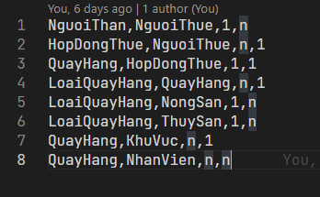

File dữ liệu kèm theo data.csv

HOPDONGTHUE,HD001,2018-01-01,NT001,QH001,1000000

HOPDONGTHUE,HD002,2018-01-02,NT002,QH002,2000000

HOPDONGTHUE,HD003,2018-01-03,NT003,QH003,3000000

HOPDONGTHUE,HD004,2018-01-04,NT004,QH004,4000000

HOPDONGTHUE,HD005,2018-01-05,NT005,QH005,5000000

KHUVUC,KV001,KHU VUC 1,100000

KHUVUC,KV002,KHU VUC 2,200000

KHUVUC,KV003,KHU VUC 3,300000

KHUVUC,KV004,KHU VUC 4,400000

KHUVUC,KV005,KHU VUC 5,500000

LAMVIEC,QH001,NV001

LAMVIEC,QH002,NV002

LAMVIEC,QH003,NV003

LAMVIEC,QH004,NV004

LAMVIEC,QH005,NV005

LOAIQUAYHANG,LQ001,100000,QUAY 1,100

LOAIQUAYHANG,LQ002,200000,QUAY 2,200

LOAIQUAYHANG,LQ003,300000,QUAY 3,300

LOAIQUAYHANG,LQ004,400000,QUAY 4,400

LOAIQUAYHANG,LQ005,500000,QUAY 5,500

NGUOITHAN,NT001,HUYNH MINH PHUOC,512365214

NGUOITHAN,NT002,PHAM VAN MAN,213456789

NGUOITHAN,NT003,VO MINH TAM,992345678

NGUOITHAN,NT004,LE HUYNH TU,124156789

NGUOITHAN,NT005,LE ANH TUAN,435678912

NGUOITHUE,NT001,TRAN TRONG CHUNG,342124512,0123456789

NGUOITHUE,NT002,NGUYEN QUANG KHOI,521363214,0213652147

NGUOITHUE,NT003,NGUYEN VAN ANH,923413521,0321652147

NGUOITHUE,NT004,HUYNH MINH DUNG,728271932,0987654321

NGUOITHUE,NT005,NGUYEN VAN HUNG,241231451,0432154123

NHANVIEN,NV001,NGUYEN VAN A,NHAN VIEN,1000000

NHANVIEN,NV002,HUYNH MINH B,QUAN LY,2000000

NHANVIEN,NV003,TRAN NGOC C,NHAN VIEN,3000000

NHANVIEN,NV004,LAM TRUONG D,NHAN VIEN,4000000

NHANVIEN,NV005,NGUYEN HOANG E,QUAN LY,5000000

NONGSAN,LQ004,RAU

NONGSAN,LQ005,CUQUA

QUAYHANG,QH001,NV001,LQ001,KV001

QUAYHANG,QH002,NV002,LQ002,KV002

QUAYHANG,QH003,NV003,LQ003,KV003

QUAYHANG,QH004,NV004,LQ004,KV004

QUAYHANG,QH005,NV005,LQ005,KV005

THUYSAN,LQ001,NGOAIBIEN

THUYSAN,LQ002,NUOI

THUYSAN,LQ003,NGOAIBIEN

**Output:**

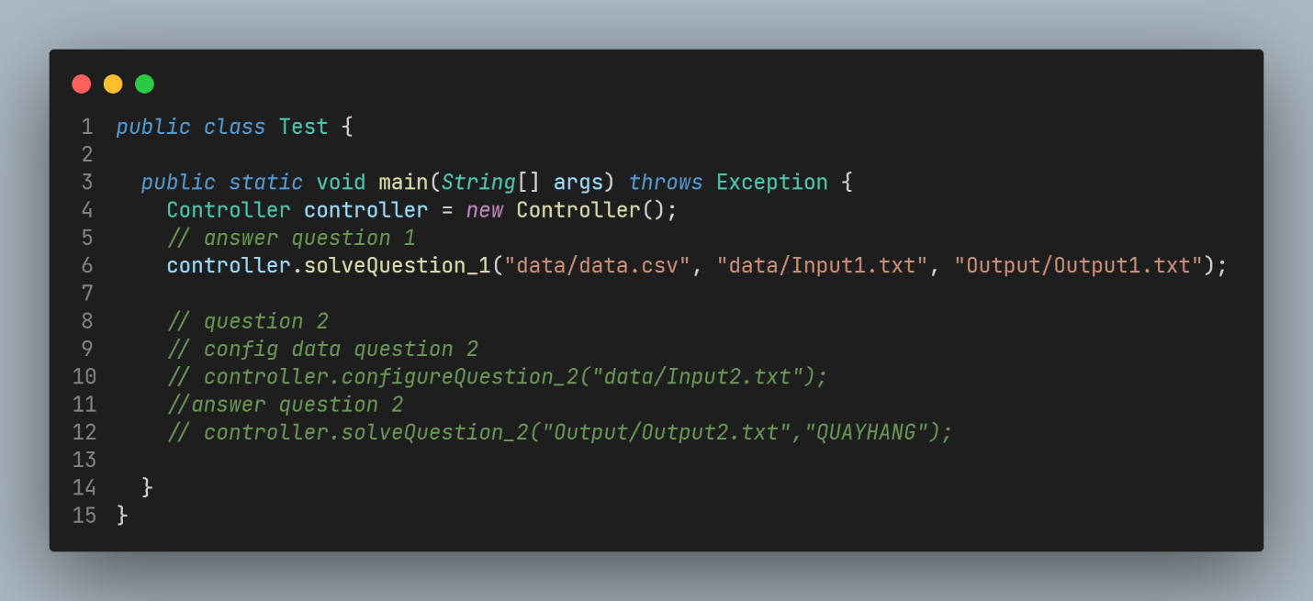

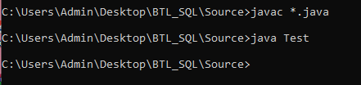

**Kết quả**:File Output1.txt

Cac quan he giua cac doi tuong trong tap tin Input1.txt la:

NguoiThan: 1 <-> n :NguoiThue

HopDongThue: n <-> 1 :NguoiThue

QuayHang: 1 <-> 1 :HopDongThue

LoaiQuayHang: n <-> 1 :QuayHang

LoaiQuayHang: 1 <-> n :NongSan

LoaiQuayHang: 1 <-> n :ThuySan

QuayHang: n <-> 1 :KhuVuc

QuayHang: n <-> n :NhanVien

Du lieu bang LAMVIEC la:

QH001_NV001

QH002_NV002

QH003_NV003

QH004_NV004

QH005_NV005

Du lieu bang NGUOITHUE la:

NT001_TRAN TRONG CHUNG_342124512_0123456789

NT002_NGUYEN QUANG KHOI_521363214_0213652147

NT003_NGUYEN VAN ANH_923413521_0321652147

NT004_HUYNH MINH DUNG_728271932_0987654321

NT005_NGUYEN VAN HUNG_241231451_0432154123

Du lieu bang LOAIQUAYHANG la:

LQ001_100000_QUAY 1_100

LQ002_200000_QUAY 2_200

LQ003_300000_QUAY 3_300

LQ004_400000_QUAY 4_400

LQ005_500000_QUAY 5_500

Du lieu bang HOPDONGTHUE la:

HD001_2018-01-01_NT001_QH001_1000000

HD002_2018-01-02_NT002_QH002_2000000

HD003_2018-01-03_NT003_QH003_3000000

HD004_2018-01-04_NT004_QH004_4000000

HD005_2018-01-05_NT005_QH005_5000000

Du lieu bang KHUVUC la:

KV001_KHU VUC 1_100000

KV002_KHU VUC 2_200000

KV003_KHU VUC 3_300000

KV004_KHU VUC 4_400000

KV005_KHU VUC 5_500000

Du lieu bang NONGSAN la:

Nong San: LQ004_CuQua

Nong San: LQ005_CuQua

Du lieu bang THUYSAN la:

Thuy San: LQ001_NgoaiBien

Thuy San: LQ002_NgoaiBien

Thuy San: LQ003_NgoaiBien

Du lieu bang NHANVIEN la:

NV001_NGUYEN VAN A_NHAN VIEN_1000000

NV002_HUYNH MINH B_QUAN LY_2000000

NV003_TRAN NGOC C_NHAN VIEN_3000000

NV004_LAM TRUONG D_NHAN VIEN_4000000

NV005_NGUYEN HOANG E_QUAN LY_5000000

Du lieu bang QUAYHANG la:

QH001_NV001_LQ001_KV001

QH002_NV002_LQ002_KV002

QH003_NV003_LQ003_KV003

QH004_NV004_LQ004_KV004

QH005_NV005_LQ005_KV005

Du lieu bang NGUOITHAN la:

NT001_HUYNH MINH PHUOC_512365214

NT002_PHAM VAN MAN_213456789

NT003_VO MINH TAM_992345678

NT004_LE HUYNH TU_124156789

NT005_LE ANH TUAN_435678912

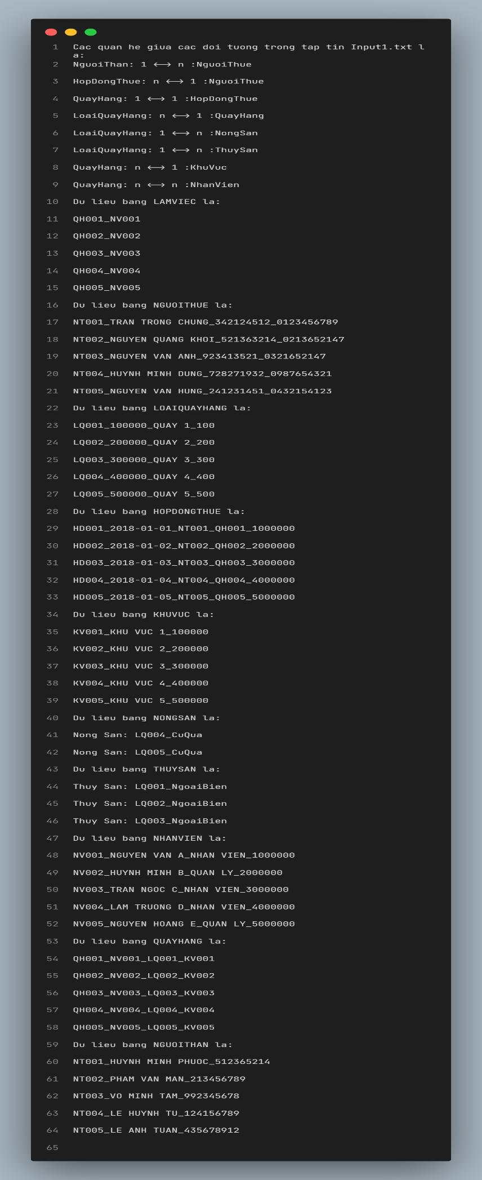

**3.2 Câu 2**

**Input 1:**File Input2.txt

KHUVUC(MAKHUVUC,TENKHUVUC,TIENTHUE)

LOAIQUAYHANG(MALOAIQUAY,GIATHUE,TENQUAY,DIENTICH)

THUYSAN(MALOAIQUAY,LOAIQUAY)

NONGSAN(MALOAIQUAY,LOAIQUAY)

QUAYHANG(MAQUAYHANG,MANHANVIEN,MALOAIQUAY,MAKHUVUC)

NHANVIEN(MANHANVIEN,HOTEN,CHUCVU,LUONG)

LAMVIEC(MAQUAYHANG,MANHANVIEN)

HOPDONGTHUE(MANGUOITHUE,HOTEN,CMND,DIENTHOAI)

NGUOITHUE(MAHOPDONG,NGAYLAP,MANGUOITHUE,MAQUAYHANG,GIATRIHOPDONG)

NGUOITHAN(MANGUOITHUE,HOTEN,CMND)

NGUOITHUE->NGUOITHAN

HOPDONGTHUE->NGUOITHUE_QUAYHANG

QUAYHANG->LOAIQUAYHANG_KHUVUC

LAMVIEC->QUAYHANG_NHANVIEN

THUYSAN->LOAIQUAYHANG

NONGSAN->LOAIQUAYHANG

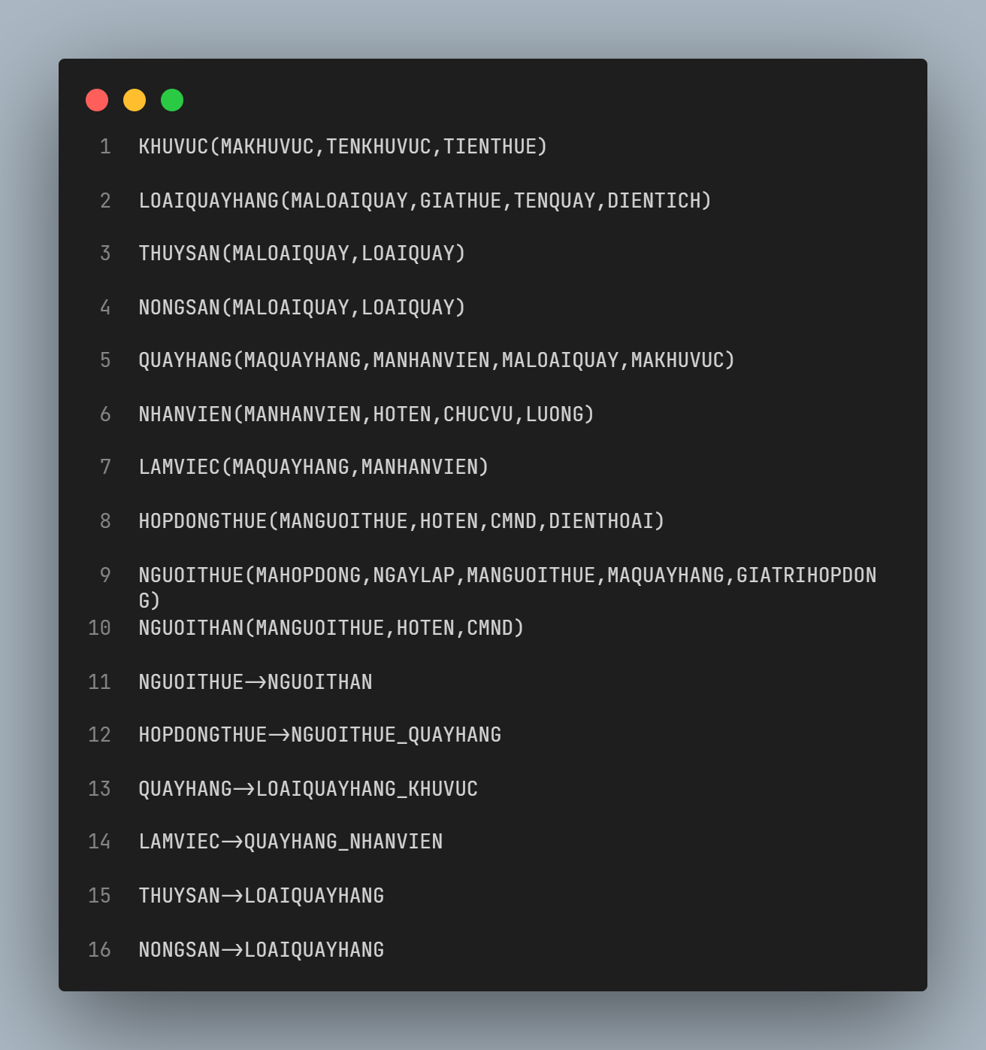

**Output 1:**

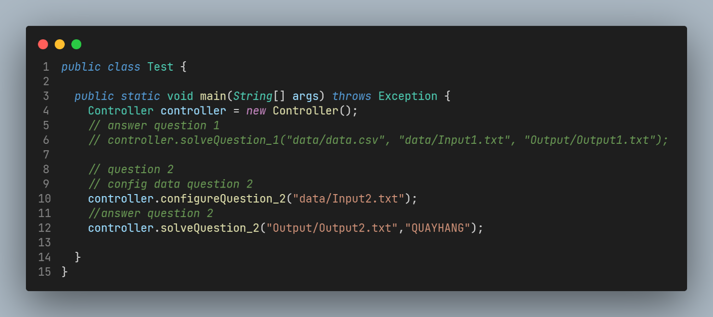



**Kết quả**:File Output2.txt

Bao dong cua tap dau vao la:

(QUAYHANG)+->LOAIQUAYHANG_KHUVUC_QUAYHANG

Cac khoa cua tap dau vao la:

LAMVIEC_HOPDONGTHUE_THUYSAN_NONGSAN

LAMVIEC_NGUOITHUE_HOPDONGTHUE_THUYSAN_NONGSAN

LAMVIEC_NGUOITHUE_HOPDONGTHUE_THUYSAN_NONGSAN_QUAYHANG

LAMVIEC_HOPDONGTHUE_THUYSAN_NONGSAN_QUAYHANG

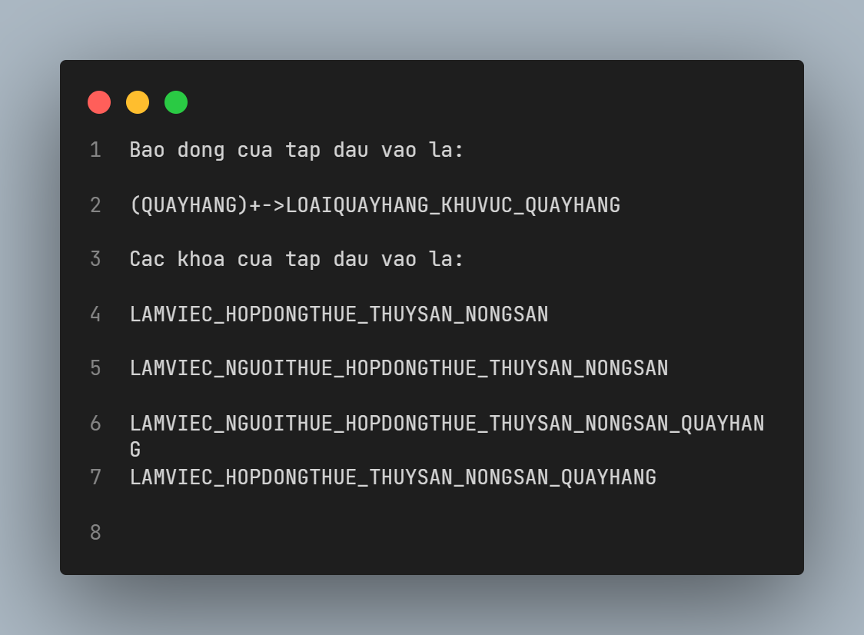

**Input 2**:File Input3.txt

a()

b()

c()

d()

e()

g()

h()

e->c

h->e

a->d

a_e->h

d_g->b

d_g->c

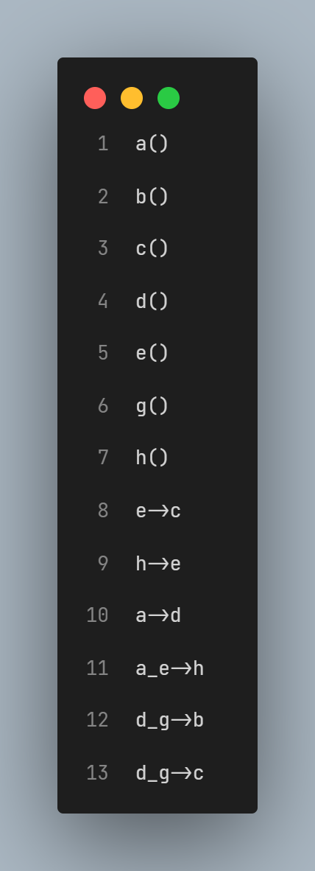

**Output 2:**

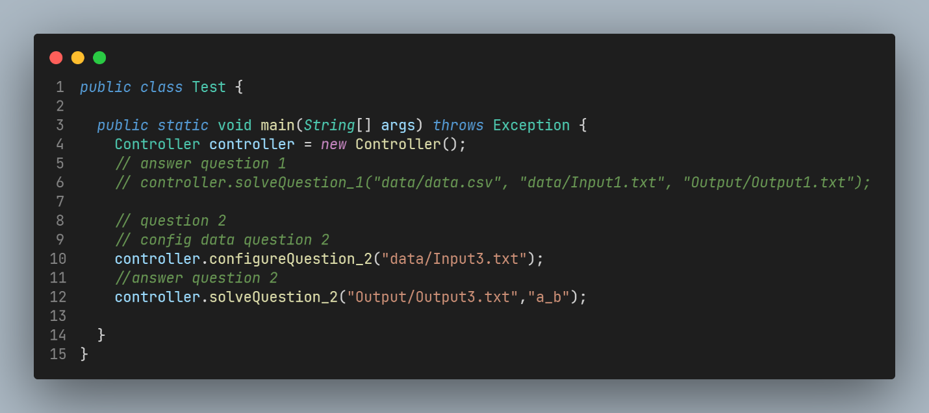



**Kết quả**:File Output3.txt

Bao dong cua tap dau vao la:

(A_B)+->A_B_D

Cac khoa cua tap dau vao la:

A_D_E_G_H

A_E_G

A_G_H

A_D_E_G

A_D_G_H

A_E_G_H

