Nhóm 39:

Đỗ Đức Quang

Đặng Văn Sướng

Đỗ Hoàng Phúc

Nguyễn Như Phúc

Lê Văn Nguyên

Báo cáo kế hoạch kiểm thử

Mục lục

1. Giới thiệu 2

1.1. Mục đích kiểm thử 2

1.2. Giới thiệu về ứng dụng kiểm thử 2

1.3. Phạm vi kiểm thử 2

2. Lập kế hoạch kiểm thử 3

2.1. Kế hoạch kiểm thử 3

2.2. Phân công công việc 3

2.3. Môi trường kiểm thử 3

3. Tiến hành kiểm thử 3

3.1. Kiểm thử giao diện người dùng 4

3.2. Kiểm thử chức năng 5

4. Kết quả sau kiểm thử 5

# Giới thiệu

## Mục đích kiểm thử

Tài liệu này nhằm mô tả quá trình tiến hành kiểm thử trên web: <http://demo.sachmem.com/>

Mục tiêu kiểm thử nhằm:

* Phát hiện các lỗi về chức năng và giao diện trên đối tượng.
* Đưa ra đánh giá, gửi phản hồi về lập trình viên phát triển.

Kết quả quá trình kiểm thử dựa trên 2 phương thức: kiểm thử giao diện người dùng và kiểm thử chức năng trên đối tượng kiểm thử.

## 1.2. Giới thiệu về ứng dụng kiểm thử

Website Sách mềm là ứng dụng được xây dựng trên nền tảng web. Website cung cấp các bài học dựa theo các cuốn sách giáo khoa Tiếng Anh, bắt đầu từ lớp 3. Đây là công cụ học tập thú vị, hữu ích cho mọi đối tượng người học.

Mỗi cuốn sách theo lớp được chia thành nhiều Unit, mỗi Unit lại gồm nhiều Lesson, và nhiều bài học, cung cấp đầy đủ các kỹ năng Nghe – Nói – Đọc – Viết cho người học. Người học thực hiện theo hướng dẫn để hoàn thành các bài học và có thể xem kết quả sau khi hoàn thành mỗi bài học đó. Với các hình ảnh, âm thanh minh họa, các bài học trở nên thú vị, đem lại cho người học cảm giác mới mẻ và hấp dẫn hơn so với các học và đọc sách thông thường.

Đây là phần mềm hỗ trợ giảng dạy và học tập theo sách giao khoa của Nhà Xuất bản Giáo dục.

Các đơn vị phối hợp phát triển:

* Nhà Xuất bản Giáo dục Việt Nam
* Đại học Quốc gia Hà Nội
* Công ty CP Công nghệ Sao Khuê

## 1.3. Phạm vi kiểm thử

Phạm vi kiểm thử trên các bài học trong cuốn Sách bài tập Tiếng Anh 3.

# 2. Lập kế hoạch kiểm thử

## 2.1. Kế hoạch kiểm thử

Lập kế hoạch kiểm thử: Xác định mục tiêu, lập tiến trình kiểm thử. Sử dụng phương pháp kiểm thử hộp đen.

Xây dựng checklist kiểm thử giao diện: Xây dựng checklist kiểm thử giao diện.

Phân công công việc: Mỗi thành viên kiểm thử giao diện kết hợp kiểm thử chức năng trên từng Unit, Lesson được giao, ghi lại đánh giá.

Tổng hợp, viết báo cáo:

## 2.2. Phân công công việc

|  |  |
| --- | --- |
| Lập kế hoạch | Đỗ Đức Quang |
| Xây dựng checklist | Cả nhóm |
| Kiểm thử Unit 1 - 4 | Đỗ Đức Quang |
| Kiểm thử Unit 5 - 8 | Đặng Văn Sướng |
| Kiểm thử Unit 9 - 12 | Nguyễn Như Phúc |
| Kiểm thử Unit 13 - 16 | Đỗ Hoàng Phúc |
| Kiểm thử Unit 17 - 20 | Lê Văn Nguyên |

## 2.3. Môi trường kiểm thử

- Môi trường hệ điều hành window 8.1, windows 10

- Trình duyệt web sử dụng: Chrome, Firefox

- Tài khoản sử dụng: doducquang1994@gmail.com

# 3. Tiến hành kiểm thử

## 3.1. Kiểm thử giao diện người dùng

Checklist kiểm tra về giao diện xoay quanh tính dễ dùng, chức năng được cung cấp, danh sách mang tính chất tương đối:

* Kiểm tra màu nền chung của toàn bộ màn hình có đúng theo yêu cầu hay hợp lý không?
* Kiểm tra màu chữ, font, font size của tất cả các textbox có đúng theo yêu cầu không, có hợp lý, đồng nhất không?
* Kiểm tra background (màu nền) của tất cả các textbox có đúng theo yêu cầu không, có hợp lý không?
* Kiểm tra màu chữ, font, font size của tất cả các label, text box có đúng theo yêu cầu không, có hợp lý và thống nhất không?
* Kiểm tra background (màu nền) của tất cả các label có đúng theo yêu cầu không, có hợp lý không?
* Kiểm tra tất cả các thành phần trên màn hình có được canh đều hay không? (Label, textbox, checkbox, list…)
* Kiểm tra mặc định tất cả các ký tự chữ đều canh trái. Ngọai trừ trường hợp có yêu cầu cụ thể
* Kiểm tra mặc định tất cả các số đều canh phải. Ngọai trừ trường hợp có yêu cầu cụ thể.
* Kiểm tra tất cả các msg thông báo trên màn hình có được viết đúng chính tả hay không?
* Kiểm tra tất cả các giá trị input chữ hoa hay chữ thường có được hiển thị đúng hay không?
* Kiểm tra tất cả các textbox có yêu cầu set border hay không?
* Kiểm tra độ phân giải của màn hình có được set theo đúng chuẩn yêu cầu hay không? VD độ phân giải tối thiểu là 800x600
* Mục đích: sử dụng checklist được xây dựng, tìm ra các lỗi xuất hiện trên giao diện tương tác với người dùng (như vỡ hình, sai font, căn lề… )

## 3.2. Kiểm thử chức năng

Dựa trên đầu vào là đáp án, hoặc input trên từng Lesson, dự đoán đầu ra chương trình sẽ đưa ra so sánh với thực tế khi test trên chương trình.

Kiểm thử chức năng sử dụng kỹ thuật kiểm thử hộp đen, người kiểm thử sử dụng các chức năng của ứng dụng thông qua giao diện người dùng và phân tích các kết quả hoặc đầu ra.

* Mục đích: So sánh kết quả thực tế và kết quả mong đợi.

# 4. Kết quả sau kiểm thử

Nhóm đã kiểm thử trên 211 Lesson, trong 20 Unit của quyển Sách bài tập Tiếng Anh 3.

Sau khi tổng hợp kết quả báo cáo của từng thành viên, sau đây là các lỗi cơ bản phát hiện ra:

* Giới hạn độ dài của vị trí điền từ (1)
* Bố cục hình ảnh, vị trí từ, chữ (2)
* Thiếu thông tin phụ lục, thiếu thông tin đề bài (3)
* Lỗi check kết quả (4)
* Lỗi font chữ (5)
* lỗi chuẩn hóa chữ hoa, chữ thường (6)
* lỗi khác (7)

Các hình ảnh tiêu biểu về lỗi:

(các lỗi cơ bản đã được tạo issue và mô tả chi tiết hơn online trên <https://github.com/truonganhhoang/kiemthu2015/> )

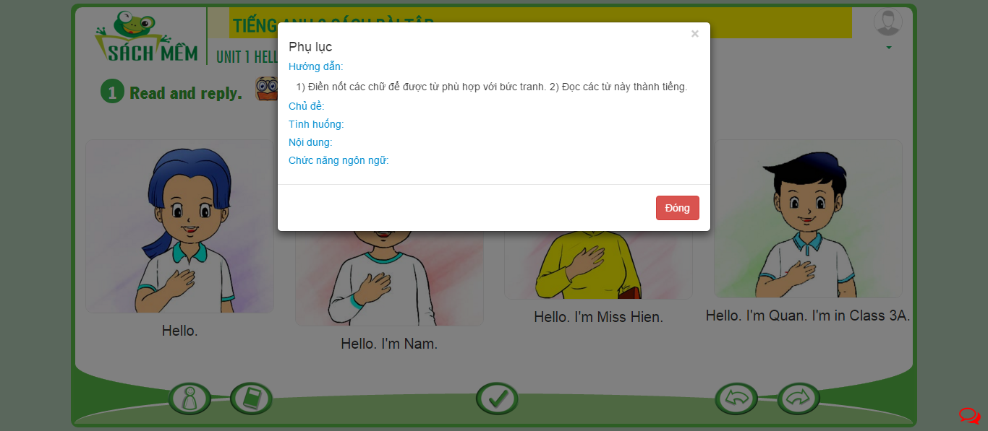

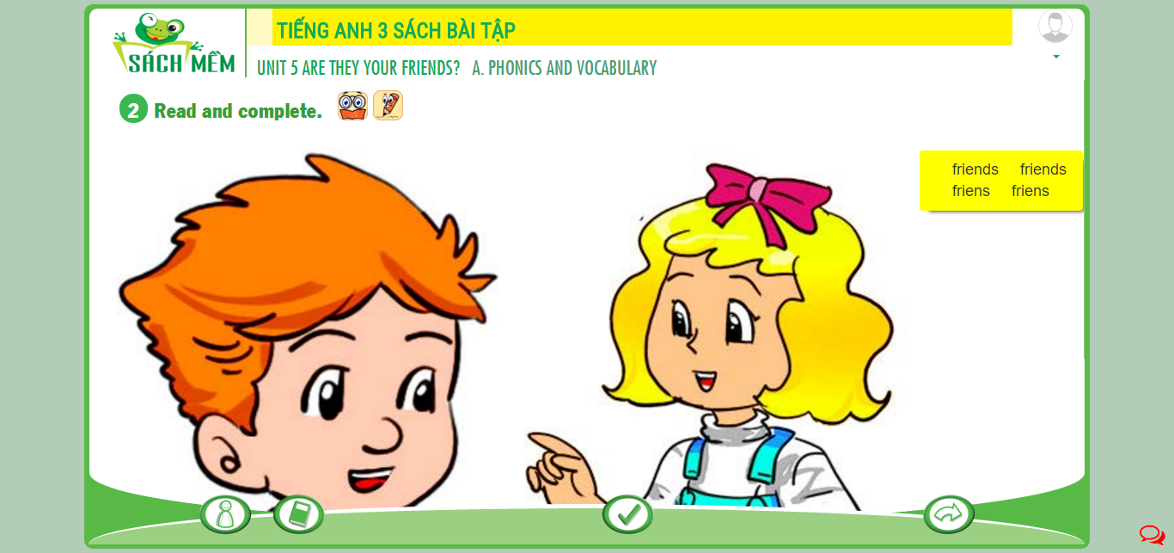

Lỗi sai nội dung

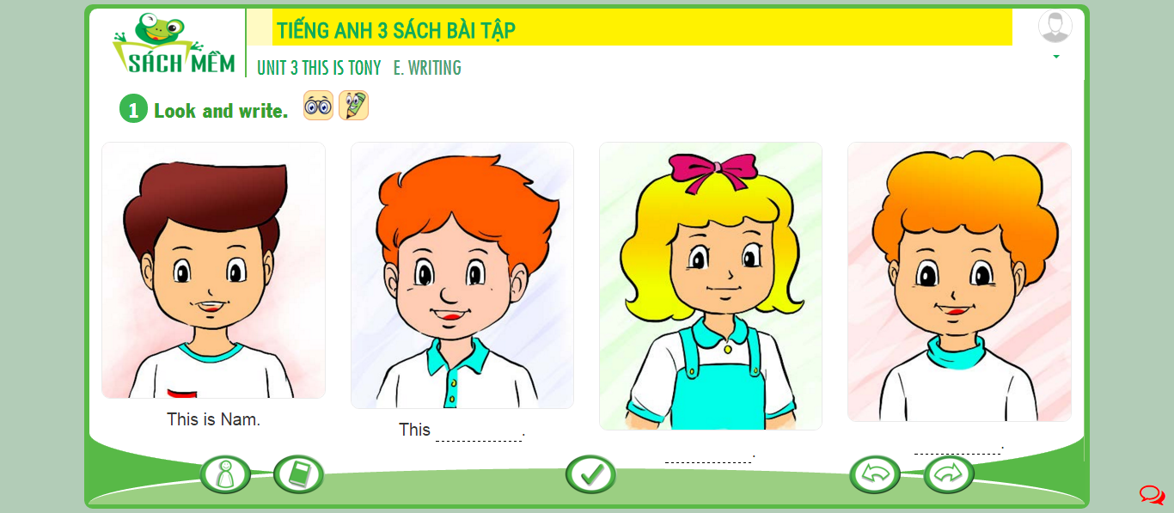

Không có thông tin để đưa kết quả

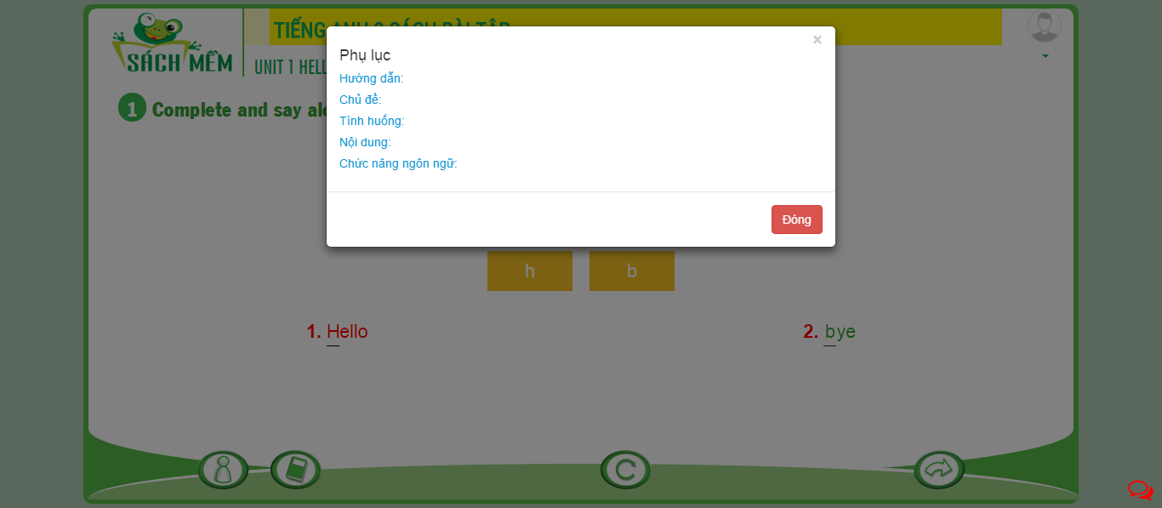

Thông tin hỗ trợ từng bài chưa đầy đủ

Bảng đánh giá kết quả sau kiểm thử trên từng lesson

Thang đánh giá điểm:

0 – không có lỗi

1- lỗi ở mức có thể chấp nhận

2- vi phạm các lỗi đầu vào trở lại

3- vi phạm các lỗi kết quả trở lại

4- vi phạm các lỗi chức năng, module hệ thống trở lại

5- module không hoạt động, hoặc gặp quá nhiều lỗi đan xen

|  |  |  |  |  |
| --- | --- | --- | --- | --- |
| **Unit** | **Lesson** | **Activity** | **Link** | **Kết quả kiểm thử (giá trị từ 0 đến 5)** |
| Unit 1 Hello | A. PHONICS AND VOCABULARY | 1 Complete and say aloud. | <http://demo.sachmem.com/admin/books/5/exercises/629> | 2 |
| Unit 1 Hello | A. PHONICS AND VOCABULARY | 3 Look, read and match. | <http://demo.sachmem.com/admin/books/5/exercises/1252> | 3 |
| Unit 1 Hello | B. SENTENCE PATTERNS | 1 Read and match. | <http://demo.sachmem.com/admin/books/5/exercises/1275> | 4 |
| Unit 1 Hello | B. SENTENCE PATTERNS | 2 Match the sentences. | <http://demo.sachmem.com/admin/books/5/exercises/710> | 0 |
| Unit 1 Hello | B. SENTENCE PATTERNS | 3 Put the words in order. Then read aloud. | <http://demo.sachmem.com/admin/books/5/exercises/711> | 1 |
| Unit 1 Hello | C. SPEAKING | 1 Read and reply. | <http://demo.sachmem.com/admin/books/5/exercises/1898> | 5 |
| Unit 1 Hello | D. READING | 1 Read and match. | <http://demo.sachmem.com/admin/books/5/exercises/1254> | 1 |
| Unit 1 Hello | D. READING | 2 Read and complete. | <http://demo.sachmem.com/admin/books/5/exercises/1081> | 1 |
| Unit 1 Hello | E. WRITING | 1 Look and write. | <http://demo.sachmem.com/admin/books/5/exercises/916> | 4 |
| Unit 1 Hello | E. WRITING | 2 Write about you. | <http://demo.sachmem.com/admin/books/5/exercises/872> | 1 |
| Unit 2 What's your name? | A. PHONICS AND VOCABULARY | 1 Complete and say aloud. | <http://demo.sachmem.com/admin/books/5/exercises/790> | 2 |
| Unit 2 What's your name? | A. PHONICS AND VOCABULARY | 3 Read and complete. | <http://demo.sachmem.com/admin/books/5/exercises/1094> | 2 |
| Unit 2 What's your name? | B. SENTENCE PATTERNS | 1 Read and match. | <http://demo.sachmem.com/admin/books/5/exercises/820> | 0 |
| Unit 2 What's your name? | B. SENTENCE PATTERNS | 2 Match the sentences. | <http://demo.sachmem.com/admin/books/5/exercises/745> | 0 |
| Unit 2 What's your name? | B. SENTENCE PATTERNS | 3 Put the words in order. Then read aloud. | <http://demo.sachmem.com/admin/books/5/exercises/712> | 0 |
| Unit 2 What's your name? | C. SPEAKING | 1 Read and reply. | <http://demo.sachmem.com/admin/books/5/exercises/1899> | 1 |
| Unit 2 What's your name? | D. READING | 1 Look, read and match. | <http://demo.sachmem.com/admin/books/5/exercises/1255> | 1 |
| Unit 2 What's your name? | D. READING | 2 Read and complete. | <http://demo.sachmem.com/admin/books/5/exercises/1091> | 1 |
| Unit 2 What's your name? | E. WRITING | 1 Look and write. | <http://demo.sachmem.com/admin/books/5/exercises/917> | 3 |
| Unit 2 What's your name? | E. WRITING | 3 Write about you. | <http://demo.sachmem.com/admin/books/5/exercises/873> | 1 |
| Unit 3 This is Tony | A. PHONICS AND VOCABULARY | 1 Complete and say aloud. | <http://demo.sachmem.com/admin/books/5/exercises/792> | 2 |
| Unit 3 This is Tony | A. PHONICS AND VOCABULARY | 3 Look and write. | <http://demo.sachmem.com/admin/books/5/exercises/948> | 0 |
| Unit 3 This is Tony | B. SENTENCE PATTERNS | 1 Read and match. | <http://demo.sachmem.com/admin/books/5/exercises/823> | 2 |
| Unit 3 This is Tony | B. SENTENCE PATTERNS | 2 Look and write. | <http://demo.sachmem.com/admin/books/5/exercises/919> | 0 |
| Unit 3 This is Tony | B. SENTENCE PATTERNS | 3 Put the words in order. Then read aloud. | <http://demo.sachmem.com/admin/books/5/exercises/713> | 1 |
| Unit 3 This is Tony | C. SPEAKING | 1 Read and reply. | <http://demo.sachmem.com/admin/books/5/exercises/1900> | 1 |
| Unit 3 This is Tony | D. READING | 1 Look, read and match. | <http://demo.sachmem.com/admin/books/5/exercises/1256> | 0 |
| Unit 3 This is Tony | D. READING | 2 Read and complete. | <http://demo.sachmem.com/admin/books/5/exercises/1092> | 1 |
| Unit 3 This is Tony | E. WRITING | 1 Look and write. | <http://demo.sachmem.com/admin/books/5/exercises/918> | 3 |
| Unit 3 This is Tony | E. WRITING | 2 Look and write. | <http://demo.sachmem.com/admin/books/5/exercises/920> | 3 |
| Unit 3 This is Tony | E. WRITING | 3 Write about your friend. | <http://demo.sachmem.com/admin/books/5/exercises/1278> | 3 |
| Unit 4 How old are you? | A. PHONICS AND VOCABULARY | 1 Complete and say aloud. | <http://demo.sachmem.com/admin/books/5/exercises/794> | 1 |
| Unit 4 How old are you? | A. PHONICS AND VOCABULARY | 2 Match. | <http://demo.sachmem.com/admin/books/5/exercises/1276> | 5 |
| Unit 4 How old are you? | B. SENTENCE PATTERNS | 1 Read and match. | <http://demo.sachmem.com/admin/books/5/exercises/826> | 0 |
| Unit 4 How old are you? | B. SENTENCE PATTERNS | 2 Match the sentences. | <http://demo.sachmem.com/admin/books/5/exercises/749> | 0 |
| Unit 4 How old are you? | B. SENTENCE PATTERNS | 3 Put the words in order. Then read aloud. | <http://demo.sachmem.com/admin/books/5/exercises/714> | 0 |
| Unit 4 How old are you? | C. SPEAKING | 1 Read and reply. | <http://demo.sachmem.com/admin/books/5/exercises/1901> | 2 |
| Unit 4 How old are you? | D. READING | 2 Read and complete. | <http://demo.sachmem.com/admin/books/5/exercises/1093> | 1 |
| Unit 4 How old are you? | E. WRITING | 1 Look and write. | <http://demo.sachmem.com/admin/books/5/exercises/922> | 3 |
| Unit 4 How old are you? | E. WRITING | 2 Look and write the answers. | <http://demo.sachmem.com/admin/books/5/exercises/923> | 2 |
| Unit 4 How old are you? | E. WRITING | 3 Write about you. | <http://demo.sachmem.com/admin/books/5/exercises/1279> | 1 |
| Unit 5 Are they your friends? | A. PHONICS AND VOCABULARY | 2 Read and complete. | <http://demo.sachmem.com/admin/books/5/exercises/1096> | 4 |
| Unit 5 Are they your friends? | A. PHONICS AND VOCABULARY | 3 Look, read and complete. | <http://demo.sachmem.com/admin/books/5/exercises/1095> | 4 |
| Unit 5 Are they your friends? | B. SENTENCE PATTERNS | 1 Read and match. | <http://demo.sachmem.com/admin/books/5/exercises/828> | 0 |
| Unit 5 Are they your friends? | B. SENTENCE PATTERNS | 2 Match the sentences. | <http://demo.sachmem.com/admin/books/5/exercises/751> | 0 |
| Unit 5 Are they your friends? | B. SENTENCE PATTERNS | 3 Put the words in order. Then read aloud. | <http://demo.sachmem.com/admin/books/5/exercises/715> | 5 |
| Unit 5 Are they your friends? | C. SPEAKING | 1 Read and reply. | <http://demo.sachmem.com/admin/books/5/exercises/1902> | 5 |
| Unit 5 Are they your friends? | D. READING | 1 Read and complete. | <http://demo.sachmem.com/admin/books/5/exercises/1102> | 0 |
| Unit 5 Are they your friends? | D. READING | 2 Read and tick. | <http://demo.sachmem.com/admin/books/5/exercises/1277> | 0 |
| Unit 5 Are they your friends? | E. WRITING | 1 Look and write. | <http://demo.sachmem.com/admin/books/5/exercises/924> | 1 |
| Unit 5 Are they your friends? | E. WRITING | 3 Write about your friend. | <http://demo.sachmem.com/admin/books/5/exercises/1568> | 1 |
| Unit 6 Stand up! | A. PHONICS AND VOCABULARY | 1 Complete and say aloud. | <http://demo.sachmem.com/admin/books/5/exercises/795> | 0 |
| Unit 6 Stand up! | B. SENTENCE PATTERNS | 1 Read and match. | <http://demo.sachmem.com/admin/books/5/exercises/830> | 0 |
| Unit 6 Stand up! | B. SENTENCE PATTERNS | 2 Match the sentences. | <http://demo.sachmem.com/admin/books/5/exercises/752> | 0 |
| Unit 6 Stand up! | C. SPEAKING | 1 Read and reply. | <http://demo.sachmem.com/admin/books/5/exercises/1903> | 4 |
| Unit 6 Stand up! | D. READING | 1 Read and complete. | <http://demo.sachmem.com/admin/books/5/exercises/1097> | 4 |
| Unit 6 Stand up! | D. READING | 2 Read and answer as the teacher. | <http://demo.sachmem.com/admin/books/5/exercises/950> | 0 |
| Unit 6 Stand up! | E. WRITING | 2 Look and write the questions. | <http://demo.sachmem.com/admin/books/5/exercises/926> | 1 |
| Unit 6 Stand up! | E. WRITING | 3 Write three questions to ask for permission. | <http://demo.sachmem.com/admin/books/5/exercises/1570> | 1 |
| Unit 7 That's my school | A. PHONICS AND VOCABULARY | 1 Complete and say aloud. | <http://demo.sachmem.com/admin/books/5/exercises/799> | 4 |
| Unit 7 That's my school | A. PHONICS AND VOCABULARY | 3 Look and write. | <http://demo.sachmem.com/admin/books/5/exercises/933> | 1 |
| Unit 7 That's my school | B. SENTENCE PATTERNS | 1 Read and match. | <http://demo.sachmem.com/admin/books/5/exercises/834> | 0 |
| Unit 7 That's my school | B. SENTENCE PATTERNS | 2 Match the sentences. | <http://demo.sachmem.com/admin/books/5/exercises/753> | 0 |
| Unit 7 That's my school | B. SENTENCE PATTERNS | 3 Put the words in order. Then read aloud. | <http://demo.sachmem.com/admin/books/5/exercises/717> | 0 |
| Unit 7 That's my school | C. SPEAKING | 1 Read and reply. | <http://demo.sachmem.com/admin/books/5/exercises/1904> | 5 |
| Unit 7 That's my school | D. READING | 1 Read and complete. | <http://demo.sachmem.com/admin/books/5/exercises/1098> | 4 |
| Unit 7 That's my school | D. READING | 2 Read and circle the correct answers. | <http://demo.sachmem.com/admin/books/5/exercises/1083> | 0 |
| Unit 7 That's my school | E. WRITING | 1 Look, read and write. | <http://demo.sachmem.com/admin/books/5/exercises/927> | 1 |
| Unit 7 That's my school | E. WRITING | 2 Look and write the answers. | <http://demo.sachmem.com/admin/books/5/exercises/952> | 5 |
| Unit 7 That's my school | E. WRITING | 3 Write about your school. | <http://demo.sachmem.com/admin/books/5/exercises/1571> | 1 |
| Unit 8 This is my pen | A. PHONICS AND VOCABULARY | 1 Complete and say aloud. | <http://demo.sachmem.com/admin/books/5/exercises/800> | 0 |
| Unit 8 This is my pen | A. PHONICS AND VOCABULARY | 3 Look and write. | <http://demo.sachmem.com/admin/books/5/exercises/932> | 1 |
| Unit 8 This is my pen | B. SENTENCE PATTERNS | 1 Read and match. | <http://demo.sachmem.com/admin/books/5/exercises/832> | 0 |
| Unit 8 This is my pen | B. SENTENCE PATTERNS | 2 Match the sentences. | <http://demo.sachmem.com/admin/books/5/exercises/757> | 0 |
| Unit 8 This is my pen | B. SENTENCE PATTERNS | 3 Put the words in order. Then read aloud. | <http://demo.sachmem.com/admin/books/5/exercises/718> | 0 |
| Unit 8 This is my pen | C. SPEAKING | 1 Read and ask the questions. | <http://demo.sachmem.com/admin/books/5/exercises/1905> | 4 |
| Unit 8 This is my pen | D. READING | 1 Read and complete. | <http://demo.sachmem.com/admin/books/5/exercises/1101> | 0 |
| Unit 8 This is my pen | D. READING | 2 Read and tick. | <http://demo.sachmem.com/admin/books/5/exercises/1316> | 0 |
| Unit 8 This is my pen | E. WRITING | 1 Look and write. | <http://demo.sachmem.com/admin/books/5/exercises/928> | 1 |
| Unit 8 This is my pen | E. WRITING | 2 Look and write the answers. | <http://demo.sachmem.com/admin/books/5/exercises/955> | 1 |
| Unit 8 This is my pen | E. WRITING | 3 Write about your school things. | <http://demo.sachmem.com/admin/books/5/exercises/1572> | 1 |
| Unit 9 What colour is it? | A. PHONICS AND VOCABULARY | 1 Complete and say aloud. | <http://demo.sachmem.com/admin/books/5/exercises/802> | 6 |
| Unit 9 What colour is it? | A. PHONICS AND VOCABULARY | 3 Look and write. | <http://demo.sachmem.com/admin/books/5/exercises/931> | 6 |
| Unit 9 What colour is it? | B. SENTENCE PATTERNS | 1 Read and match. | <http://demo.sachmem.com/admin/books/5/exercises/836> | 6 |
| Unit 9 What colour is it? | B. SENTENCE PATTERNS | 2 Read and complete. | <http://demo.sachmem.com/admin/books/5/exercises/1103> | 6 |
| Unit 9 What colour is it? | B. SENTENCE PATTERNS | 3 Put the words in order. Then read aloud. | <http://demo.sachmem.com/admin/books/5/exercises/723> | 6 |
| Unit 9 What colour is it? | C. SPEAKING | 1 Read and reply. | <http://demo.sachmem.com/admin/books/5/exercises/1907> | 6 |
| Unit 9 What colour is it? | D. READING | 1 Read and complete. | <http://demo.sachmem.com/admin/books/5/exercises/1104> | 6 |
| Unit 9 What colour is it? | D. READING | 2 Read and write. | <http://demo.sachmem.com/admin/books/5/exercises/1577> | 6 |
| Unit 9 What colour is it? | E. WRITING | 1 Look and write. | <http://demo.sachmem.com/admin/books/5/exercises/929> | 6 |
| Unit 9 What colour is it? | E. WRITING | 2 Write the answers. | <http://demo.sachmem.com/admin/books/5/exercises/956> | 6 |
| Unit 9 What colour is it? | E. WRITING | 3 Write about your school things. | <http://demo.sachmem.com/admin/books/5/exercises/1578> | 6 |
| Unit 10 What do you do at break time? | A. PHONICS AND VOCABULARY | 1 Complete and say aloud. | <http://demo.sachmem.com/admin/books/5/exercises/803> | 6 |
| Unit 10 What do you do at break time? | A. PHONICS AND VOCABULARY | 3 Look and write. | <http://demo.sachmem.com/admin/books/5/exercises/957> | 6 |
| Unit 10 What do you do at break time? | B. SENTENCE PATTERNS | 1 Read and match. | <http://demo.sachmem.com/admin/books/5/exercises/838> | 6 |
| Unit 10 What do you do at break time? | B. SENTENCE PATTERNS | 2 Match the sentences. | <http://demo.sachmem.com/admin/books/5/exercises/758> | 6 |
| Unit 10 What do you do at break time? | B. SENTENCE PATTERNS | 3 Put the words in order. Then read aloud. | <http://demo.sachmem.com/admin/books/5/exercises/724> | 6 |
| Unit 10 What do you do at break time? | C. SPEAKING | 1 Read and reply. | <http://demo.sachmem.com/admin/books/5/exercises/1908> | 6 |
| Unit 10 What do you do at break time? | D. READING | 1 Read and complete. | <http://demo.sachmem.com/admin/books/5/exercises/1099> | 6 |
| Unit 10 What do you do at break time? | D. READING | 2 Read and write. | <http://demo.sachmem.com/admin/books/5/exercises/1582> | 6 |
| Unit 10 What do you do at break time? | E. WRITING | 1 Look and write. | <http://demo.sachmem.com/admin/books/5/exercises/930> | 6 |
| Unit 10 What do you do at break time? | E. WRITING | 2 Write about you. | <http://demo.sachmem.com/admin/books/5/exercises/1583> | 6 |
| Unit 11 This is my family | A. PHONICS AND VOCABULARY | 1 Complete and say aloud. | <http://demo.sachmem.com/admin/books/5/exercises/804> | 6 |
| Unit 11 This is my family | A. PHONICS AND VOCABULARY | 3 Look and write. | <http://demo.sachmem.com/admin/books/5/exercises/934> | 6 |
| Unit 11 This is my family | B. SENTENCE PATTERNS | 1 Read and match. | <http://demo.sachmem.com/admin/books/5/exercises/842> | 6 |
| Unit 11 This is my family | B. SENTENCE PATTERNS | 2 Match the sentences. | <http://demo.sachmem.com/admin/books/5/exercises/768> | 6 |
| Unit 11 This is my family | B. SENTENCE PATTERNS | 3 Put the words in order. Then read aloud. | <http://demo.sachmem.com/admin/books/5/exercises/727> | 6 |
| Unit 11 This is my family | C. SPEAKING | 1 Read and ask the questions. | <http://demo.sachmem.com/admin/books/5/exercises/1909> | 6 |
| Unit 11 This is my family | D. READING | 1 Read and complete. | <http://demo.sachmem.com/admin/books/5/exercises/1105> | 6 |
| Unit 11 This is my family | D. READING | 2 Read and circle the correct answers. | <http://demo.sachmem.com/admin/books/5/exercises/1137> | 6 |
| Unit 11 This is my family | E. WRITING | 1 Look and write. | <http://demo.sachmem.com/admin/books/5/exercises/935> | 6 |
| Unit 11 This is my family | E. WRITING | 2 Write the questions. | <http://demo.sachmem.com/admin/books/5/exercises/1585> | 6 |
| Unit 11 This is my family | E. WRITING | 3 Write about your family. | <http://demo.sachmem.com/admin/books/5/exercises/1587> | 6 |
| Unit 12 This is my house | A. PHONICS AND VOCABULARY | 1 Complete and say aloud. | <http://demo.sachmem.com/admin/books/5/exercises/805> | 6 |
| Unit 12 This is my house | A. PHONICS AND VOCABULARY | 3 Look and write. | <http://demo.sachmem.com/admin/books/5/exercises/936> | 6 |
| Unit 12 This is my house | B. SENTENCE PATTERNS | 1 Read and match. | <http://demo.sachmem.com/admin/books/5/exercises/844> | 6 |
| Unit 12 This is my house | B. SENTENCE PATTERNS | 2 Match the sentences. | <http://demo.sachmem.com/admin/books/5/exercises/770> | 6 |
| Unit 12 This is my house | B. SENTENCE PATTERNS | 3 Put the words in order. Then read aloud. | <http://demo.sachmem.com/admin/books/5/exercises/728> | 6 |
| Unit 12 This is my house | C. SPEAKING | 1 Read and ask the questions. | <http://demo.sachmem.com/admin/books/5/exercises/1910> | 6 |
| Unit 12 This is my house | D. READING | 1 Read and complete. | <http://demo.sachmem.com/admin/books/5/exercises/1106> | 6 |
| Unit 12 This is my house | D. READING | 2 Read and tick. | <http://demo.sachmem.com/admin/books/5/exercises/1317> | 6 |
| Unit 12 This is my house | E. WRITING | 1 Look and write. | <http://demo.sachmem.com/admin/books/5/exercises/937> | 6 |
| Unit 12 This is my house | E. WRITING | 2 Write the answers. | <http://demo.sachmem.com/admin/books/5/exercises/958> | 6 |
| Unit 12 This is my house | E. WRITING | 3 Write about your house. | <http://demo.sachmem.com/admin/books/5/exercises/1593> | 6 |
| Unit 13 Where's my book? | A. PHONICS AND VOCABULARY | 1 Complete and say aloud. | <http://demo.sachmem.com/admin/books/5/exercises/806> | 6 |
| Unit 13 Where's my book? | A. PHONICS AND VOCABULARY | 2 Look, read and match. | <http://demo.sachmem.com/admin/books/5/exercises/1260> | 6 |
| Unit 13 Where's my book? | B. SENTENCE PATTERNS | 1 Read and match. | <http://demo.sachmem.com/admin/books/5/exercises/848> | 6 |
| Unit 13 Where's my book? | B. SENTENCE PATTERNS | 2 Match the sentences. | <http://demo.sachmem.com/admin/books/5/exercises/773> | 6 |
| Unit 13 Where's my book? | B. SENTENCE PATTERNS | 3 Put the words in order. Then read aloud. | <http://demo.sachmem.com/admin/books/5/exercises/729> | 6 |
| Unit 13 Where's my book? | C. SPEAKING | 1 Look, read and reply. | <http://demo.sachmem.com/admin/books/5/exercises/1911> | 6 |
| Unit 13 Where's my book? | D. READING | 1 Look, read and match. | <http://demo.sachmem.com/admin/books/5/exercises/1261> | 6 |
| Unit 13 Where's my book? | D. READING | 2 Look, read and write. | <http://demo.sachmem.com/admin/books/5/exercises/1605> | 6 |
| Unit 13 Where's my book? | E. WRITING | 1 Look and write. | <http://demo.sachmem.com/admin/books/5/exercises/959> | 6 |
| Unit 13 Where's my book? | E. WRITING | 2 Look and write the answers. | <http://demo.sachmem.com/admin/books/5/exercises/1606> | 6 |
| Unit 13 Where's my book? | E. WRITING | 3 Write about your things. | <http://demo.sachmem.com/admin/books/5/exercises/1607> | 6 |
| Unit 14 Are there any posters in the room? | A. PHONICS AND VOCABULARY | 1 Complete and say aloud. | <http://demo.sachmem.com/admin/books/5/exercises/807> | 6 |
| Unit 14 Are there any posters in the room? | A. PHONICS AND VOCABULARY | 2 Look, read and complete. | <http://demo.sachmem.com/admin/books/5/exercises/938> | 6 |
| Unit 14 Are there any posters in the room? | B. SENTENCE PATTERNS | 1 Read and match. | <http://demo.sachmem.com/admin/books/5/exercises/850> | 6 |
| Unit 14 Are there any posters in the room? | B. SENTENCE PATTERNS | 2 Match the sentences. | <http://demo.sachmem.com/admin/books/5/exercises/776> | 6 |
| Unit 14 Are there any posters in the room? | B. SENTENCE PATTERNS | 3 Put the words in order. Then read aloud. | <http://demo.sachmem.com/admin/books/5/exercises/731> | 6 |
| Unit 14 Are there any posters in the room? | C. SPEAKING | 1 Look, read and reply. | <http://demo.sachmem.com/admin/books/5/exercises/1912> | 6 |
| Unit 14 Are there any posters in the room? | D. READING | 1 Look, read and write. | <http://demo.sachmem.com/admin/books/5/exercises/1270> | 6 |
| Unit 14 Are there any posters in the room? | D. READING | 2 Read and tick. | <http://demo.sachmem.com/admin/books/5/exercises/1318> | 6 |
| Unit 14 Are there any posters in the room? | E. WRITING | 2 Look and write the answers. | <http://demo.sachmem.com/admin/books/5/exercises/1614> | 6 |
| Unit 14 Are there any posters in the room? | E. WRITING | 3 Write about things in your house. | <http://demo.sachmem.com/admin/books/5/exercises/1621> | 6 |
| Unit 15 Do you have any toys? | A. PHONICS AND VOCABULARY | 1 Complete and say aloud. | <http://demo.sachmem.com/admin/books/5/exercises/808> | 6 |
| Unit 15 Do you have any toys? | A. PHONICS AND VOCABULARY | 2 Look and write. | <http://demo.sachmem.com/admin/books/5/exercises/939> | 6 |
| Unit 15 Do you have any toys? | B. SENTENCE PATTERNS | 1 Read and match. | <http://demo.sachmem.com/admin/books/5/exercises/853> | 6 |
| Unit 15 Do you have any toys? | B. SENTENCE PATTERNS | 2 Match the sentences. | <http://demo.sachmem.com/admin/books/5/exercises/778> | 6 |
| Unit 15 Do you have any toys? | B. SENTENCE PATTERNS | 3 Put the words in order. Then read aloud. | <http://demo.sachmem.com/admin/books/5/exercises/734> | 6 |
| Unit 15 Do you have any toys? | C. SPEAKING | 1 Read and reply. | <http://demo.sachmem.com/admin/books/5/exercises/1913> | 6 |
| Unit 15 Do you have any toys? | D. READING | 2 Read and write the answers. | <http://demo.sachmem.com/admin/books/5/exercises/1626> | 6 |
| Unit 15 Do you have any toys? | E. WRITING | 1 Look and write. | <http://demo.sachmem.com/admin/books/5/exercises/1627> | 6 |
| Unit 15 Do you have any toys? | E. WRITING | 1 Look and write. | <http://demo.sachmem.com/admin/books/5/exercises/1628> | 6 |
| Unit 15 Do you have any toys? | E. WRITING | 1 Look and write. | <http://demo.sachmem.com/admin/books/5/exercises/1665> | 6 |
| Unit 15 Do you have any toys? | E. WRITING | 1 Look and write. | <http://demo.sachmem.com/admin/books/5/exercises/1666> | 6 |
| Unit 15 Do you have any toys? | E. WRITING | 2 Write about your toys. | <http://demo.sachmem.com/admin/books/5/exercises/1630> | 6 |
| Unit 16 Do you have any pets? | A. PHONICS AND VOCABULARY | 1 Complete and say aloud. | <http://demo.sachmem.com/admin/books/5/exercises/809> | 6 |
| Unit 16 Do you have any pets? | A. PHONICS AND VOCABULARY | 3 Look and write. | <http://demo.sachmem.com/admin/books/5/exercises/940> | 6 |
| Unit 16 Do you have any pets? | B. SENTENCE PATTERNS | 1 Read and match. | <http://demo.sachmem.com/admin/books/5/exercises/856> | 6 |
| Unit 16 Do you have any pets? | B. SENTENCE PATTERNS | 2 Look and write. | <http://demo.sachmem.com/admin/books/5/exercises/960> | 6 |
| Unit 16 Do you have any pets? | B. SENTENCE PATTERNS | 3 Put the words in order. | <http://demo.sachmem.com/admin/books/5/exercises/1661> | 6 |
| Unit 16 Do you have any pets? | C. SPEAKING | 1 Read and ask the questions. | <http://demo.sachmem.com/admin/books/5/exercises/1914> | 6 |
| Unit 16 Do you have any pets? | D. READING | 1 Read and tick. | <http://demo.sachmem.com/admin/books/5/exercises/1319> | 6 |
| Unit 16 Do you have any pets? | D. READING | 2 Read the text and write. | <http://demo.sachmem.com/admin/books/5/exercises/1662> | 6 |
| Unit 16 Do you have any pets? | E. WRITING | 2 Write about your pets. | <http://demo.sachmem.com/admin/books/5/exercises/1663> | 6 |
| Unit 16 Do you have any pets? | E. WRITING | 3 Draw your pet and colour it. | <http://demo.sachmem.com/admin/books/5/exercises/1664> | 6 |
| Unit 17 What toys do you like? | A. PHONICS AND VOCABULARY | 1 Complete and say aloud. | <http://demo.sachmem.com/admin/books/5/exercises/810> | 0 |
| Unit 17 What toys do you like? | A. PHONICS AND VOCABULARY | 2 Write the word under each picture. | <http://demo.sachmem.com/admin/books/5/exercises/941> | 0 |
| Unit 17 What toys do you like? | A. PHONICS AND VOCABULARY | 3 Look and write. | <http://demo.sachmem.com/admin/books/5/exercises/961> | 0 |
| Unit 17 What toys do you like? | B. SENTENCE PATTERNS | 1 Match the sentences. | <http://demo.sachmem.com/admin/books/5/exercises/782> | 0 |
| Unit 17 What toys do you like? | B. SENTENCE PATTERNS | 2 Read and complete. | <http://demo.sachmem.com/admin/books/5/exercises/1107> | 4 |
| Unit 17 What toys do you like? | B. SENTENCE PATTERNS | 3 Put the words in order. Then read aloud. | <http://demo.sachmem.com/admin/books/5/exercises/737> | 0 |
| Unit 17 What toys do you like? | C. SPEAKING | 1 Read and ask the questions. | <http://demo.sachmem.com/admin/books/5/exercises/1916> | 3 |
| Unit 17 What toys do you like? | D. READING | 1 Read and complete. | <http://demo.sachmem.com/admin/books/5/exercises/1108> | 0 |
| Unit 17 What toys do you like? | D. READING | 2 Read and tick. | <http://demo.sachmem.com/admin/books/5/exercises/1320> | 0 |
| Unit 17 What toys do you like? | E. WRITING | 1 Look and write. | <http://demo.sachmem.com/admin/books/5/exercises/942> | 0 |
| Unit 17 What toys do you like? | E. WRITING | 2 Read and write the questions. | <http://demo.sachmem.com/admin/books/5/exercises/1667> | 0 |
| Unit 17 What toys do you like? | E. WRITING | 3 Write about your pets and toys. | <http://demo.sachmem.com/admin/books/5/exercises/1668> | 0 |
| Unit 18 What are you doing? | A. PHONICS AND VOCABULARY | 1 Complete and say aloud. | <http://demo.sachmem.com/admin/books/5/exercises/811> | 0 |
| Unit 18 What are you doing? | A. PHONICS AND VOCABULARY | 3 Fill the gaps with the words from the puzzle. | <http://demo.sachmem.com/admin/books/5/exercises/1669> | 0 |
| Unit 18 What are you doing? | B. SENTENCE PATTERNS | 1 Read and match. | <http://demo.sachmem.com/admin/books/5/exercises/858> | 0 |
| Unit 18 What are you doing? | B. SENTENCE PATTERNS | 2 Match the sentences. | <http://demo.sachmem.com/admin/books/5/exercises/784> | 0 |
| Unit 18 What are you doing? | B. SENTENCE PATTERNS | 3 Put the words in order. Then read aloud. | <http://demo.sachmem.com/admin/books/5/exercises/739> | 0 |
| Unit 18 What are you doing? | C. SPEAKING | 1 Read and reply. | <http://demo.sachmem.com/admin/books/5/exercises/1917> | 0 |
| Unit 18 What are you doing? | D. READING | 1 Read and complete. | <http://demo.sachmem.com/admin/books/5/exercises/1109> | 0 |
| Unit 18 What are you doing? | E. WRITING | 1 Look and write. | <http://demo.sachmem.com/admin/books/5/exercises/943> | 0 |
| Unit 18 What are you doing? | E. WRITING | 2 Write the questions. | <http://demo.sachmem.com/admin/books/5/exercises/1670> | 0 |
| Unit 18 What are you doing? | E. WRITING | 3 Write about you and your parents. | <http://demo.sachmem.com/admin/books/5/exercises/1671> | 0 |
| Unit 19 They're in the park | A. PHONICS AND VOCABULARY | 1 Complete and say aloud. | <http://demo.sachmem.com/admin/books/5/exercises/812> | 0 |
| Unit 19 They're in the park | A. PHONICS AND VOCABULARY | 3 Look and write. | <http://demo.sachmem.com/admin/books/5/exercises/944> | 0 |
| Unit 19 They're in the park | B. SENTENCE PATTERNS | 1 Read and match. | <http://demo.sachmem.com/admin/books/5/exercises/860> | 0 |
| Unit 19 They're in the park | B. SENTENCE PATTERNS | 2 Match the sentences. | <http://demo.sachmem.com/admin/books/5/exercises/785> | 0 |
| Unit 19 They're in the park | B. SENTENCE PATTERNS | 3 Put the words in order. Then read aloud. | <http://demo.sachmem.com/admin/books/5/exercises/741> | 0 |
| Unit 19 They're in the park | C. SPEAKING | 1 Read and ask the questions. | <http://demo.sachmem.com/admin/books/5/exercises/1918> | 0 |
| Unit 19 They're in the park | D. READING | 1 Read and complete. | <http://demo.sachmem.com/admin/books/5/exercises/1110> | 0 |
| Unit 19 They're in the park | D. READING | 2 Read and tick. | <http://demo.sachmem.com/admin/books/5/exercises/1321> | 0 |
| Unit 19 They're in the park | E. WRITING | 1 Look and write. | <http://demo.sachmem.com/admin/books/5/exercises/945> | 0 |
| Unit 19 They're in the park | E. WRITING | 2 Write the questions. | <http://demo.sachmem.com/admin/books/5/exercises/1672> | 0 |
| Unit 19 They're in the park | E. WRITING | 3 Write about your town / village. | <http://demo.sachmem.com/admin/books/5/exercises/1673> | 0 |
| Unit 20 Where's Sa Pa? | A. PHONICS AND VOCABULARY | 1 Complete and say aloud. | <http://demo.sachmem.com/admin/books/5/exercises/813> | 0 |
| Unit 20 Where's Sa Pa? | A. PHONICS AND VOCABULARY | 3 Look and write. | <http://demo.sachmem.com/admin/books/5/exercises/946> | 0 |
| Unit 20 Where's Sa Pa? | B. SENTENCE PATTERNS | 1 Match the sentences. | <http://demo.sachmem.com/admin/books/5/exercises/787> | 0 |
| Unit 20 Where's Sa Pa? | B. SENTENCE PATTERNS | 2 Read and complete. | <http://demo.sachmem.com/admin/books/5/exercises/1111> | 4 |
| Unit 20 Where's Sa Pa? | B. SENTENCE PATTERNS | 3 Put the words in order. Then read aloud. | <http://demo.sachmem.com/admin/books/5/exercises/743> | 0 |
| Unit 20 Where's Sa Pa? | C. SPEAKING | 1 Read and reply. | <http://demo.sachmem.com/admin/books/5/exercises/1919> | 0 |
| Unit 20 Where's Sa Pa? | D. READING | 1 Read and complete. | <http://demo.sachmem.com/admin/books/5/exercises/1112> | 0 |
| Unit 20 Where's Sa Pa? | D. READING | 2 Answer the questions. | <http://demo.sachmem.com/admin/books/5/exercises/1674> | 0 |
| Unit 20 Where's Sa Pa? | E. WRITING | 1 Look and write. | <http://demo.sachmem.com/admin/books/5/exercises/947> | 0 |
| Unit 20 Where's Sa Pa? | E. WRITING | 2 Read and write. | <http://demo.sachmem.com/admin/books/5/exercises/1676> | 0 |
| Unit 20 Where's Sa Pa? | E. WRITING | 3 Write about your hometown / village. | <http://demo.sachmem.com/admin/books/5/exercises/1677> | 0 |