LÊ QUANG GIẢNG  HR EXECUTIVE / HR DATA ANALYST  Ho Chi Minh City, Vietnam • 0356252300 • lequanggiang.hrm@gmail.com  GitHub: quanggiang169 • LinkedIn: Lê Quang Giảng • DOB: 16/09/2002 | 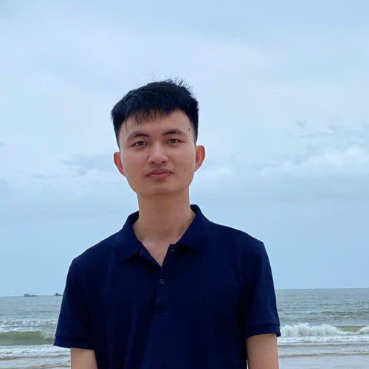

HR Executive with hands-on experience in recruitment, workforce forecasting, and HR process automation for warehouse/frontline operations. Builds Python- and Apps Script-based tools (Telegram bots, dashboards, forecasting models) to turn HR data into operational decisions. Google Data Analytics certified; comfortable with SQL, Power BI, and cross-functional collaboration.
WORK EXPERIENCE
HRBP Executive | Giao Hàng Nhanh (GHN) — HCM20 Warehouse Jun 2026 – Present
- Own end-to-end frontline recruitment (sourcing, screening, onboarding) at the Tân Kim warehouse and coordinate a 5-person recruitment team, keeping warehouse operations supplied with people.
- Own attrition reporting for the HRBP group and took the lead in building a Telegram automation (Python, GitHub Actions, Google Apps Script), replacing weekly manual reports with real-time dashboards on attrition, resignation trends, onboarding and probation, so managers see turnover risk sooner.
- Own recruitment tracking, automated it on Google Sheets, and led the design of an HR management website where HR and warehouse supervisors track and coordinate work in one place, replacing error-prone manual tracking and reducing information gaps between HR and operations.
- Took ownership of warehouse workforce planning and built a forecasting model on 11 tables (StarRocks/Doris, Trino/Presto) that predicts staffing needs from shipment volume, giving managers a data basis for hiring decisions and labor cost control.
- Evaluated cost-reduction options for warehouse operations and reviewed the new salary policy, then advised management on its impact on compensation structure and labor cost.
Independent HR Data Analytics Projects | Self-Directed Jan 2025 – May 2026
- Set my own learning plan in HR analytics, business statistics and problem-solving, and applied it to real HR questions, moving from reporting numbers to recommending decisions.
- Owned HR analytics projects end to end on GitHub (Excel, Power BI, SQL, Python), from framing the question to recommendation, turning workforce data into decision-ready dashboards and insights.
- Took the lead in designing dashboards for recruitment, training and workforce metrics, reducing reporting effort and giving operational and talent decisions one shared view.
Learning & Development Intern | Bình Minh Plastic (BMP) Aug 2024 – Dec 2024
- Responsible for ISO 9001-compliant training records (100% accuracy) and an HSE training-needs assessment against Vietnam OSH regulations, helping the company stay compliant.
- Coordinated 32 training sessions (12 external, 20 internal), owning scheduling, logistics and cross-department communication so sessions ran as planned.
- Owned training reporting: built Excel and Power BI dashboards tracking 104 training sessions and analyzing 2,000+ feedback entries, giving HR a clear basis to monitor and improve training.
- Guided 3 HR teammates in Excel and Power BI, so team reports followed one standard.
HR & Admin Intern | AZ Architects (AZA) Apr 2024 – Jul 2024
- Owned end-to-end recruitment for multiple roles, screening 400+ CVs and coordinating candidate assessments under tight deadlines to meet hiring needs.
- Led requirement-setting with hiring managers and reshaped the screening workflow, improving recruitment efficiency.
- Owned the company's first e-learning onboarding program for 10 employees and interns, reaching 90% satisfaction and giving new joiners a consistent start.
- Organized and led a 34-participant team-building event, rated 4.1/5 and strengthening team engagement.
VOLUNTARY EXPERIENCE
Head of HR Department | Young Promising Managers (YPM) Apr 2022 – Jun 2023
- Built the initial organizational structure for a 20-member club, defining roles and coordination processes so work was clearly shared.
- Owned HR end to end (recruitment, engagement, training, evaluation) for academic competitions and student events, making sure each event had the people and skills it needed.
- Led the "Wake Up" engagement project, lifting active participation from 40% to 90% (18/20 members).
- Led a 20-member cross-functional team and delivered soft-skill training (leadership, problem-solving, time management), raising the team's overall capability.
EDUCATION
Bachelor of Arts in Human Resources Management | UEF — GPA 3.53/4.0 Sep 2020 – Aug 2024
- Certificate of Outstanding Contribution to Faculty of Business Administration activities (2021–2023).
- Certificate of Participation in University-level Scientific Research (2024).
Google Data Analytics Professional Certificate — Coursera, Oct 2024
Build a Company Learning and Development Program — LinkedIn Learning, Jul 2022
SKILLS
HR & Data: Recruitment & CV Screening • Workforce Forecasting • HR Reporting & Analytics • Onboarding & Records Management • Compensation Review
Technical: Python • SQL • Power BI • Google Apps Script • GitHub Actions • Excel • Tableau • R
Working Style: Stakeholder Management • Structured Problem-Solving • Process Automation • Data Storytelling • Proactive Learning

