The way TripMystic works is that we have a search bar on each page and we use the same search bar to navigate to different pages.

Soo on the landing Page we have the search bar as below
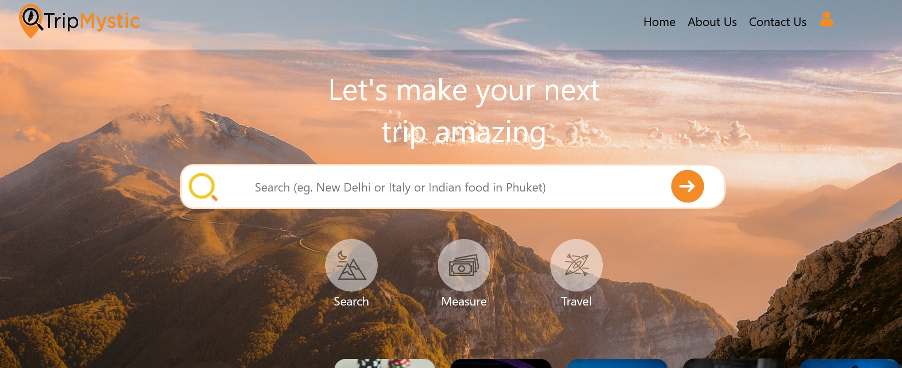

In this search bar if you search for any country, for eg Vietnam, then you will be directed to the Country Page as Below
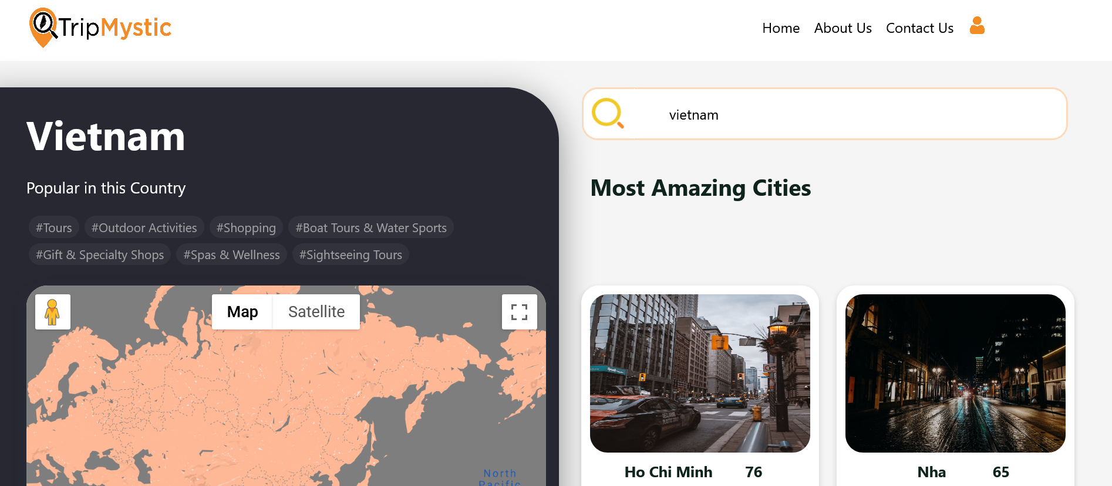

But on the search bar on the landing page, If you search for any city, for eg Hanoi, then you will be directed to the City Page as below
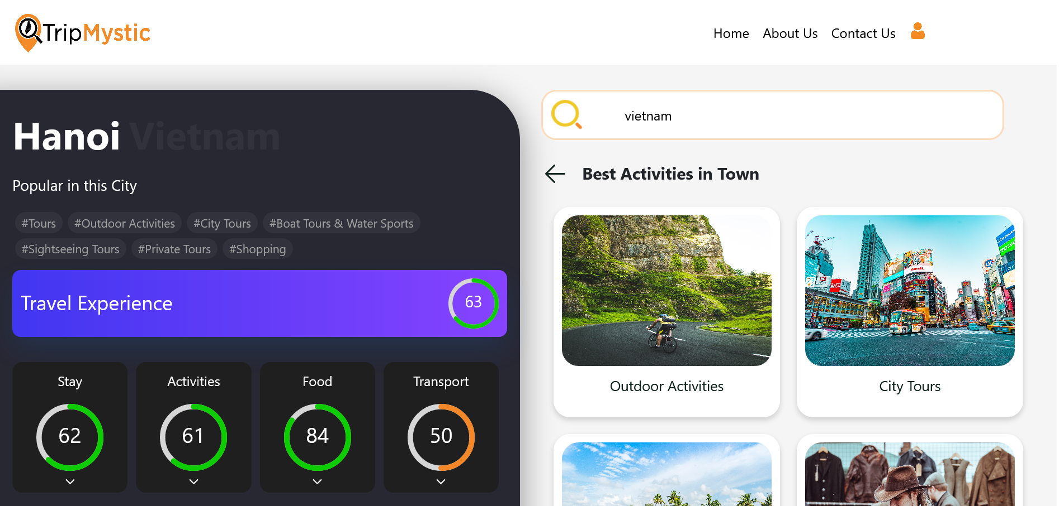

And on the landing page search bar if you search for a more detailed thing, for eg Nightlife in Hanoi, then you will be redirected to the Map Page as below

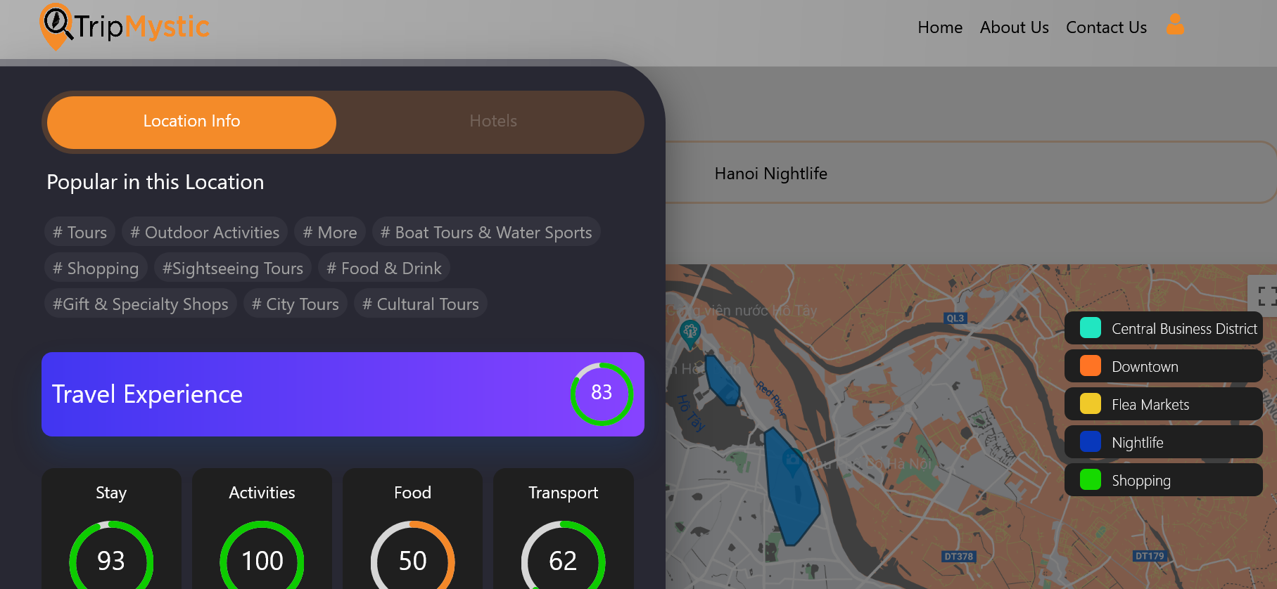

But all these navigations is from one single API.

Features

Autofill suggestions for search Bar
We need to integrate autofill feature for our search bars across the website(we have search bar on every page). We have an API that returns suggestions as we type on the search bar. You will have to show these suggestions in a drop down on the search bar.
API endpoint: https://autofill-cn3husryaa-uc.a.run.app
Request :
{
"text" : "new del"
}

Response:
[
"New Delhi 4Wd",
"New Delhi Castles",
"New Delhi Forests",
"New Delhi Gardens",
"New Delhi Museums",
"New Delhi Safaris",
"New Delhi Lookouts",
"New Delhi Shopping",
"New Delhi Theaters",
"New Delhi Eco Tours"
]

Picture Gallery
We need to show a set of pictures on the black slide panel that appears on the city page and the map page. On clicking these pictures, they should show on the whole page. This is like any other picture gallery like on various sites. Attached in the chat is a sample video named “PictureGallery” from Expedia.com
So just like the video we can have some pictures in preview on small tiles like the in the video and then on clicking the pictures expand and there is a next and previous option and a close option just like in the video. Please make sure this component is compatible for the mobile screen as well just like you made last time.

City Page
On the city page on the side panel below the weather chart we need to include this gallery.
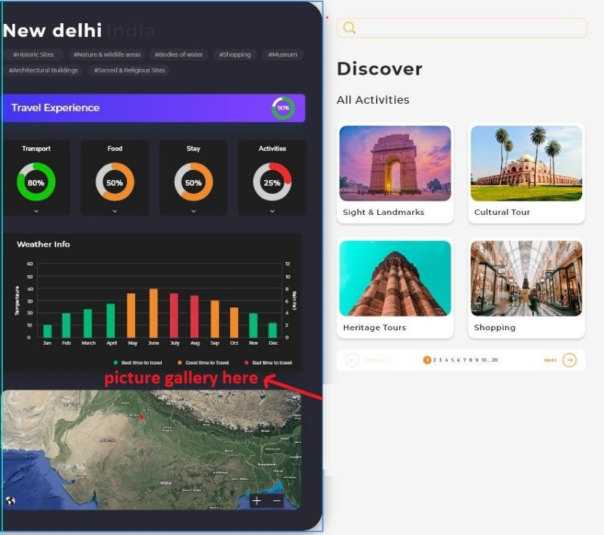

API endpoint (this API is already integrated in the page) : https://search-dev-temp-cn3husryaa-uc.a.run.app

Request:
{
"text" : "new delhi"
}
Response: in the response you will get key “PicList” with a list of links to pictures that you need to show.
"PicList": [
"https://storage.googleapis.com/world_images/Top100Cities/India_NewDelhi_HistoricalBuildings_50_86599_image.jpg",
"https://storage.googleapis.com/world_images/Top100Cities/India_NewDelhi_Relegious_75_86599_image.jpg",
"https://storage.googleapis.com/world_images/Top100Cities/India_NewDelhi_Historical_37_86599_image.jpg",
"https://storage.googleapis.com/world_images/Top100Cities/India_NewDelhi_Historical_28_89546_image.jpg",
"https://storage.googleapis.com/world_images/Top100Cities/India_NewDelhi_Relegious_83_86602_image.jpg"
]

Map Page

On the map page we need this picture gallery on bottom of the black sliding panel.
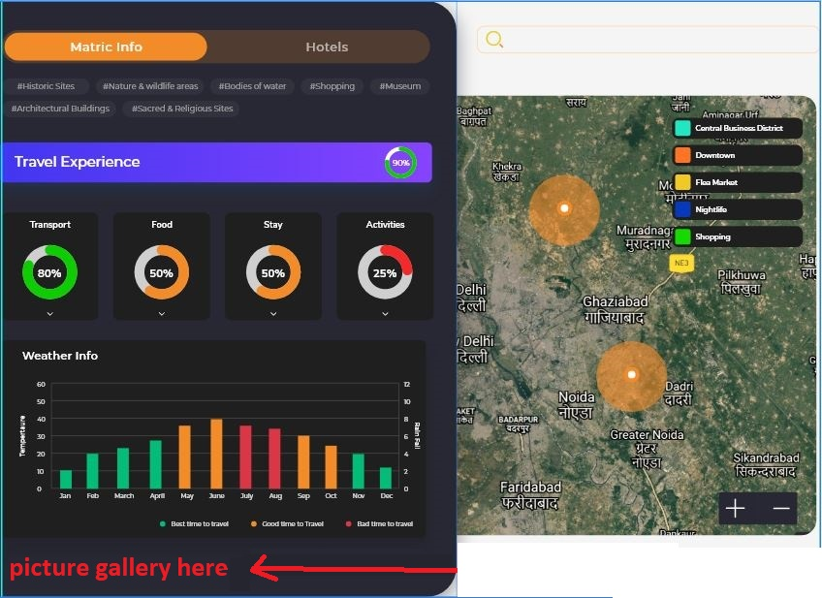

API end Point(this API is already integrated in the page) : https://search-dev-temp-cn3husryaa-uc.a.run.app

Request:
{
"text" : "surfing in bali"
}

Response: in the response you will get key “PicList” with a list of lists containing links to pictures that you need to show. The ith list is corresponding to the ith polygon.
"PicList":
[
[
"https://storage.googleapis.com/world_images/Top100Cities/Indonesia_Bali_Nature_138_42218_image.jpg",
"https://storage.googleapis.com/world_images/Top100Cities/Indonesia_Bali_Nature_135_42226_image.jpg",
"https://storage.googleapis.com/world_images/Top100Cities/Indonesia_Bali_Beach_40_42221_image.jpg",
https://storage.googleapis.com/world_images/Top100Cities/Indonesia_Bali_Beach_35_42222_image.jpg
],
[
"https://storage.googleapis.com/rand-data/Untitled.png"
],
[
"https://storage.googleapis.com/rand-data/Untitled.png"
]
]

Minor Cosmetic changes

- Need to decrease the size of the weather chart on the map page and the city page by almost half. Right now, it occupies a lot of space even though its not a very important feature. Reduce the size of this block to half of it on both the pages.
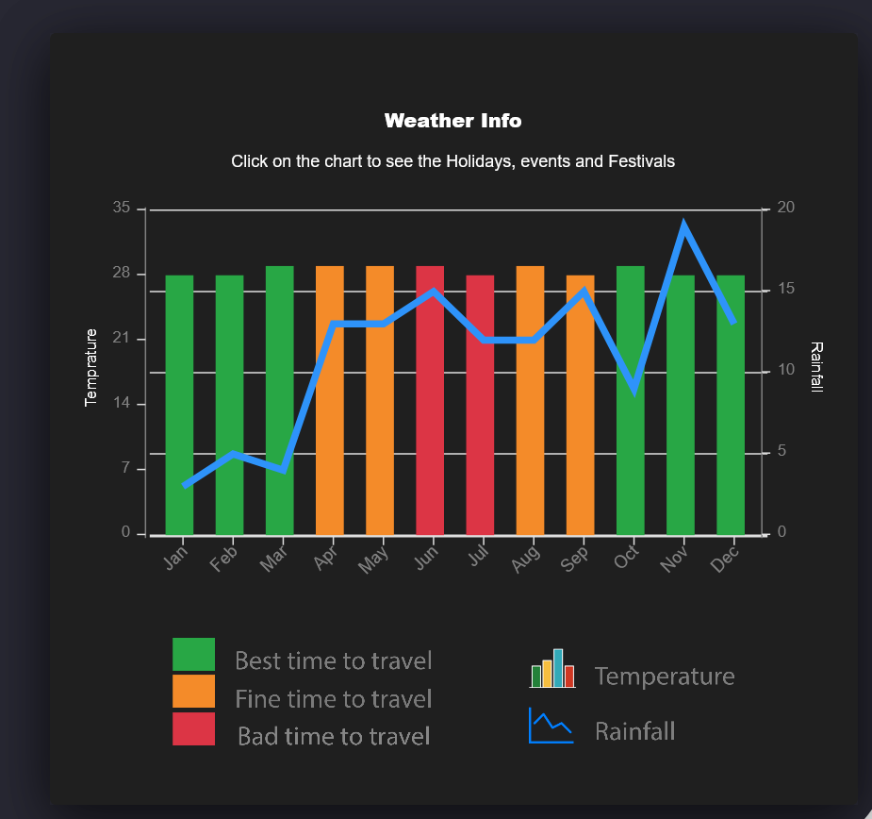
- Need to change the look and feel of the chart. Need to make it look more like the screen shot below which is from our mobile App.
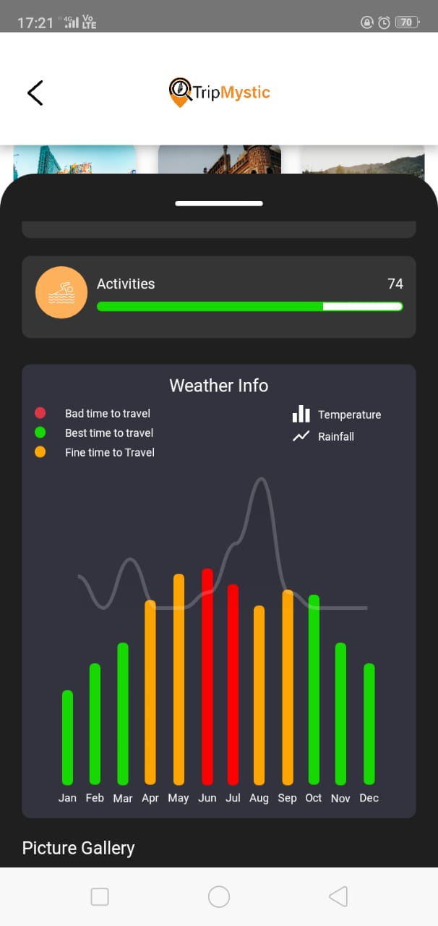

- Need to change the mobile app coming soon section as we have the mobile app live now.
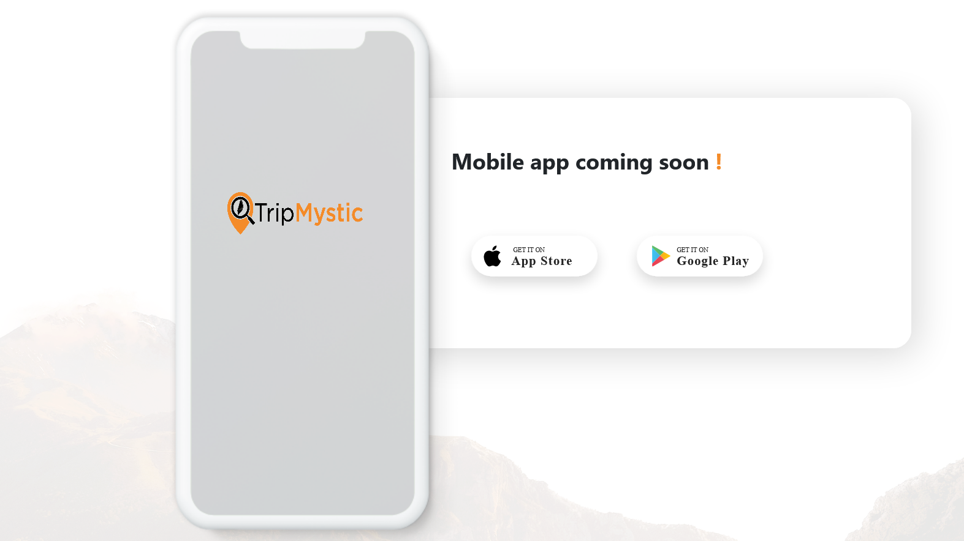
Change text from “Mobile App Coming Soon” to “Download our Mobile App”
Switch the positions of the Google play store icon icon and apple app store icon. Bring Google Play store icon before the Apple Store icon
On clicking the Google Play icon redirect to this link : https://play.google.com/store/apps/details?id=com.tripmystic.app
On clicking the Apple store icon show hover message “IOS App Coming soon”.
Change the phone image with the image attached in chat called “AppSection” and round the corners of the image and give shadow effect like the current phone image.

- On the Activities page which appears when you click on the “View all” icon on the landing page in the Curated activities section. The numbers are a bit distorted.
