PE_PRN212_FA24_TrialTest
FALL 2024
Subject: PRN212
Duration: 90 minutes

INSTRUCTIONS
Please read the instructions carefully before doing the questions.
- You are NOT allowed to use any other materials. You are NOT allowed to use any device to share data with others.
- You must use IDE as Visual Studio 2019 or later, MSSQL Server 2016 or later database for your development tools.
IMPORTANT – Before you start doing your solution, MUST do the following steps:
- To do your program, you must use Windows Presentation Foundation (WPF), apply 3-Layer architecture. Note that you are not allowed to connect direct to database from WPF Windows/Pages, every database connection must be used with Repository and Data Access Objects. The database connection string must get from appsettings.json file. In the case your program connects directly to database from WPF Windows/Pages or you hardcode connection string, you will get 0 point.
- If there are syntax errors or compilation errors in your PE program, you will not pass the PE requirements, the point will be 0.
- Create Solution in Visual Studio 2019/2022 named PE_PRN212_FA24_TrialTest_StudentName. Inside the Solution, Project WPF named: GermanyEuro2024_StudentName.
- Create your MS SQL database named GermanyEuro2024DB by running code in script GermanyEuro2024DB.sql.
- Set the default user interface for your project as Login window/page.
- Your work will be considered invalid (0 point) if your code inserts stuff that is unrelated to the test.

Create an application using Windows Presentation Foundation (WPF) with .NET5/.NET6/.NET7/.NET8, C#, and Entity Framework Core. A MS SQL Server database will be created to persist the data and it will be used for reading and managing data.
The below Figure is a part of GermanyEuro2024DB database.

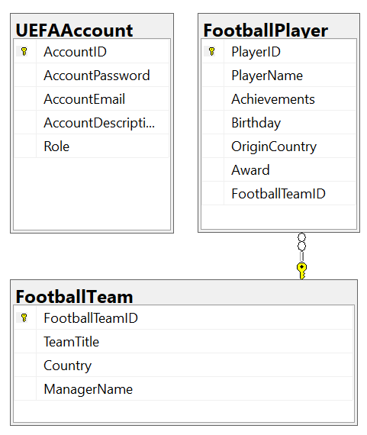
Note that: Role: Administrator = 1; Staff = 2; Manager = 3; Member = 4. A football team will have many players, a player will belong to only one football team.

Task 1. Design graphic user interface.
- (0.5 point) Design Login Window includes UI controls for login function.
Object Type | Properties
Window | Title=Login Window PE118801  Height= 400  Width= 700  FontFamily= Tahoma  FontSize= 13  Background= #FFF2F184  WindowStartupLocation: CenterScreen
Label | Font: Arial Narrow, 12pt  ForeColor: 0,0,255
TextBox | TextAlign: Right

- (1.0 point) Design Football Player Management window/page, this window/page includes UI controls for CRUD actions with football player information. Note: The FootballTeamID/TeamTitle will come from the FootballTeam table. Design a window which allows you to view the list of records, create a new item, update the existing item, and delete a specific item.

Object Type | Properties
Window | Title= PE118801- Main PE Management Window  Height= 500  Width= 800  FontFamily= Tahoma  FontSize= 13  Background= #FFF2F184  WindowStartupLocation= CenterScreen
Label | Font=Tahoma, 13pt  ForeColor= 0, 0, 255  TextAlign=Left
TextBox | TextAlign=Right  ForeColor = Blue

Task 2. Implement CRUD actions with GUI.
- (1.0 point) Authentication function
If user with a Manager and Staff role logs in successfully (using email address/password for login process), save this information to a temporary parameter. All CRUD actions are required authentication. In the case login unsuccessfully, display “You have no permission to access this function!”.
- All CRUD actions are required with Manager role,
- Staff role is required for only Read action.

- (1.5 points) Check if login successfully with Manager and Staff role, list all items in FootballPlayer table (each record includes information of football players and TeamTitle).

- (1.0 point) Check if login successfully with Manager role, search football player information by Achivements or PlayerName (using relative search).

- (1.0 point) Check if login successfully with Manager role, delete the selected item with the confirmation then update the list of items.

- (2.5 points) Check if login successfully with Manager role, add new item with the requirements:
- The FootballTeamID/ TeamTittle will come from the FootballTeam table (you can use ComboBox UI control in this case)
- All fields are required.
- Birthday <= 01/01/2004
- Value for PlayerName (the title of the Team) is in the range of 3 – 100 characters. Each word of the PlayerName must begin with the capital letter or digits (1 – 9). PlayerName is not allowed with special characters.

- (1.5 points) Check if login successfully with Manager role, update an existing item.
- You can use your different window/page or use the data grid view for this update function (update by FootballTeamID).
- With update function, the same validation requirements with Add function.

