An Edge AI and IoT Framework for Potato Quality Classification Using ESP32-CAM
line 1: Nguyen Van Chung
line 2: Information Technology
line 3: Posts and Telecommunications Institute of Technology
line 4: Hanoi, Vietnam
line 5: chungnv05.stu@gmail.com
line 1: Vo Sy Tai
line 2: Information Technology
line 3: Posts and Telecommunications Institute of Technology
line 4: Hanoi, Vietnam
line 5:
line 1: Bui Quang Hung
line 2: Information Technology
line 3: Posts and Telecommunications Institute of Technology
line 4: Hanoi, Vietnam
line 5: quanghunghhcc@gmail.com
line 1: Josh Souliya
line 2: Information Technology
line 3: Posts and Telecommunications Institute of Technology
line 4: Hanoi, Vietnam
line 5:
line 1: Le Minh Son
line 2: Information Technology
line 3: Posts and Telecommunications Institute of Technology
line 4: Hanoi, Vietnam
line 5: SonLM05@gmail.com

line 1: Sinnakone Vongsykeo
line 2: Information Technology
line 3: Posts and Telecommunications Institute of Technology
line 4: Hanoi, Vietnam
line 5:

line 1: Sitthideth Hapxaythong
line 2: Information Technology
line 3: Posts and Telecommunications Institute of Technology
line 4: Hanoi, Vietnam
line 5:

Abstract — Conventional post-harvest potato quality inspection relies primarily on manual assessment, which is labor-intensive, time-consuming, and susceptible to subjective judgments. To address these limitations, this paper aims to design an automatic model for potato quality classification by applying an Edge AI and Internet of Things (IoT)-based framework. The proposed system employs a lightweight deep learning model optimized through Tiny Machine Learning (TinyML) techniques to classify potato tubers into two quality categories: good and poor based on their external appearance. The trained model is optimized for resource-constrained deployment and executed directly on the ESP32-CAM, enabling on-device image processing and classification without requiring continuous cloud connectivity. Experimental evaluations on the testing set show that the model achieved an overall classification accuracy of 99.76%, with macro-average precision, recall, and F1-score of 99.66%, 99.82%, and 99.74%, respectively. The average inference latency was 0.0272 seconds (27.20 ms) per image. These results demonstrate the feasibility and effectiveness of applying TinyML and IoT technologies to automated potato quality inspection.
Keywords — Edge AI, TinyML, Internet of Things (IoT), ESP32-CAM, Potato Quality Classification.

INTRODUCTION
Potatoes are one of the most widely cultivated and consumed agricultural crops in the world. They play a crucial role in food security and the agricultural supply chain. However, conventional potato quality inspection is primarily performed through manual visual assessment, which is labor-intensive, time-consuming, and susceptible to subjective judgments. Furthermore, variations in human evaluation may lead to inconsistent quality classification, particularly when handling large quantities of agricultural produce. Therefore, an automated and reliable approach to potato quality inspection is necessary to improve efficiency and consistency in post-harvest handling.
In recent years, the rapid development of Artificial Intelligence (AI), particularly in deep learning and computer vision has created new opportunities for automating agricultural quality inspection. Convolutional Neural Networks (CNNs) have demonstrated considerable potential in image classification and visual feature extraction. By learning relevant characteristics from images, these models can support the identification of surface defects and quality variations in agricultural products. Nevertheless, many deep learning-based classification systems require substantial computational resources and rely on high-performance computers or cloud-based platforms for inference. These requirements may raise deployment costs, increase communication latency between components and limit their applicability in agricultural environments where internet connectivity is unstable and limited.
Edge Artificial Intelligence (Edge AI) has appeared as a promising approach to solving these challenges by enabling data processing and decision-making directly on the edge devices. TinyML models can be optimized to operate on microcontrollers with limited memory, processing power and energy. This approach reduces dependence on cloud infrastructure and communication latency.
Among many available microcontrollers gadgets, ESP32-CAM is considered a potential solution for embedded computer vision application due to its integrated camera interface, wireless connectivity and relatively low cost. However, deploying deep learning models directly on the ESP32-CAM is a challenging process because of its limited resources. Therefore, selecting an appropriate lightweight neural network architecture and applying suitable model optimization techniques are essential to achieving an effective balance between classification accuracy, inference time, and resource utilization.
To address this challenge, this paper proposes an Edge AI and IoT-based framework for automated potato quality classification using the ESP32-CAM. The proposed system aims to classify potato tubers into two quality categories: good and poor, based on their external visual appearance. A lightweight deep learning model is trained using potato image data and optimized through TinyML techniques for deployment on the ESP32-CAM. Unlike approaches that depend on continuous cloud-based processing, the proposed framework is designed to perform image acquisition, preprocessing, and quality classification locally on the embedded device. IoT connectivity is incorporated to support the communication and monitoring of classification results when network access is available.
The main contributions of this study are threefold: (1) the design of a low-cost Edge AI and IoT framework for two-category potato quality classification; (2) the development and optimization of a lightweight deep learning model suitable for resource-constrained deployment on the ESP32-CAM; and (3) the establishment of an experimental evaluation approach to assess classification performance using accuracy, precision, recall, and F1-score, together with inference time and embedded deployment feasibility.
The remainder of this paper is organized as follows. Section II reviews related studies on agricultural quality classification, Edge AI, and TinyML-based embedded vision systems. Section III describes the proposed framework, including its hardware architecture, dataset preparation, model development, and deployment process. Section IV presents the experimental setup and evaluation results. Finally, Section V concludes the paper and discusses potential directions for future research.

RELATED WORK

Potato Quality Classification
Potato quality is commonly evaluated based on external features such as skin color, shape, surface damage, and signs of disease. In many post-harvest processing facilities, this task is still performed manually. Although experienced workers can identify visible defects, the inspection process takes considerable time, and the results may differ between individuals. For this reason, several studies have investigated the use of computer vision and machine learning to support automatic potato sorting.
Xiong et al. [1] developed a classification method using Principal Component Analysis (PCA) and Support Vector Machine (SVM). Their study considered four types of potatoes: normal, green, germinated, and damaged. Using a dataset of 600 images, the proposed method achieved an overall recognition rate of 96.6%. This result showed that traditional machine learning methods could distinguish different potato conditions based on image features. However, the classification process depended on the selected features and the quality of the input images.
As deep learning became more widely used in image analysis, researchers began applying Convolutional Neural Networks (CNNs) to potato inspection. Marino et al. [2] proposed a weakly supervised learning method for identifying and locating surface defects. Their work considered several conditions, including greening, black dot, common scab, and black scurf. Instead of relying only on manually extracted features, the CNN learned visual patterns from the training images. In another study, Su et al. [3] combined depth imaging with CNN to evaluate potato size and appearance. Their method achieved an overall quality grading accuracy of 86.6%, suggesting that depth information could be useful for identifying shape-related defects.
More recently, Li et al. [4] introduced an improved YOLOv5s model for detecting external potato defects. The model was designed to identify different conditions, such as greening, sprouting, mechanical damage, and rot. The reported results included a precision of 82.0%, recall of 86.6%, and F1-score of 84.3%. Although the method improved defect detection performance, it also required additional memory compared with the original YOLOv5s model.
These studies indicate that computer vision and deep learning can support automated potato quality inspection. However, classification performance is not the only factor that needs to be considered when developing a practical system. Hardware cost, memory requirements, and processing time are also important, especially when the model is intended to run on a microcontroller. In this study, the focus is placed on classifying potatoes into two quality levels—good and poor—using a lightweight model deployed on the ESP32-CAM. The objective is to examine whether this approach can provide useful classification performance while operating within the limited resources of an embedded device.

Edge AI and TinyML in agriculture
Edge AI allows machine learning models to process data directly on local devices instead of sending it to a remote server. This approach is useful in agriculture, where network connections may be unstable and the cost of computing equipment can limit system deployment. However, running deep learning models on small devices is not straightforward because of their limited memory and processing power. Tiny Machine Learning (TinyML) has been studied as a way to address these limitations.
Lin et al. [5] introduced MCUNet, a framework designed to run deep learning models on microcontrollers. By combining neural architecture optimization with a memory-efficient inference engine, their approach reduced memory usage and improved inference speed. David et al. [6] later presented TensorFlow Lite Micro, an inference framework developed for embedded systems. Their work showed how trained machine learning models could be executed on devices with limited hardware resources. These studies provide a technical foundation for deploying neural networks on low-power devices.
In agriculture, TinyML has been investigated for tasks such as crop monitoring and plant disease classification. Aqasizade et al. [7] developed a TinyMLOps pipeline for classifying plant health conditions using lightweight neural networks. The authors evaluated different model configurations on a Raspberry Pi Zero 2 W and an STM32 microcontroller. Their experiments showed that INT8 quantization could reduce model size and inference time, although larger models still exceeded the available memory. This highlights the importance of considering hardware limitations during model development.
Malche et al. [8] proposed a TinyML and IoT-based system for detecting tomato leaf diseases. Their system used a lightweight CNN on an ESP32-S3 microcontroller and transmitted classification results to an IoT server through Wi-Fi. The model achieved a classification accuracy of 94.6%, showing that embedded devices can support agricultural image classification while providing remote monitoring capabilities.
These studies suggest that Edge AI and TinyML can reduce the computational requirements of agricultural monitoring systems. However, achieving good classification accuracy is only one part of the problem. The model must also fit within the available memory and complete inference in a reasonable amount of time. For the ESP32-CAM, these constraints are particularly important because image capture and neural network inference share limited hardware resources. Based on these considerations, the present study investigates a lightweight model for classifying potato quality into two categories directly on the ESP32-CAM, with Wi-Fi connectivity used to transmit the results when needed.

IoT-Based Agricultural Monitoring Systems
The Internet of Things (IoT) has been widely studied in agriculture to support data collection, monitoring, and automated control. By connecting sensors and embedded devices through wireless networks, agricultural information can be collected and accessed without requiring workers to inspect every location manually. Ayaz et al. [9] reviewed the use of IoT in smart agriculture, covering applications such as soil monitoring, irrigation, crop management, and post-harvest operations. Their study also discussed the communication technologies and challenges involved in deploying IoT systems in agricultural environments.
Farooq et al. [10] examined the role of IoT in smart farming and described how sensors, communication networks, and data processing platforms can work together to support agricultural management. The authors identified several practical concerns, including system cost, energy consumption, network reliability, and data security. These factors are important when designing monitoring systems intended for long-term operation.
Several studies have also investigated low-cost hardware for agricultural monitoring. Suhaimi et al. [11] developed a system using an ESP32 microcontroller to collect environmental data, control irrigation, and detect intrusions. When movement was detected, an ESP32 camera was used to capture images, while an Android application allowed users to monitor and control the system remotely. The study demonstrated how sensors and camera modules could be combined to automate specific agricultural tasks.
More recently, Verma and Bodade [12] proposed an IoT-based agricultural monitoring system using ESP32 and LoRa communication. Their design integrated environmental sensors with an ESP32-CAM module for image capture. Sensor readings were transmitted to a gateway and then forwarded to a cloud platform, where users could monitor the collected information through a dashboard. This approach showed how low-cost devices could support both sensor-based monitoring and visual observation.
The reviewed studies mainly address environmental monitoring, irrigation, and crop observation. For potato quality inspection, IoT can serve a different purpose by connecting the image classification device to a monitoring interface. In the proposed framework, a sensor is used to detect the presence of a potato and trigger image capture. The ESP32-CAM then performs local quality classification using a lightweight model. Only the classification result needs to be transmitted through Wi-Fi for remote monitoring. This design separates image processing from data communication, allowing the classification process to continue even when a network connection is unavailable.

PROPOSED METHODOLOGY

System Architecture
The proposed system consists of a potato detection sensor, an ESP32-CAM module, a lightweight deep learning model, and an IoT monitoring interface. The ESP32-CAM serves as the main processing unit, handling image acquisition, preprocessing, and quality classification. Instead of sending images to a cloud server for analysis, the system performs inference directly on the device.
The system operates in three main stages: image acquisition, quality classification, and result transmission. In the first stage, a proximity sensor detects the presence of a potato and sends a signal to the ESP32-CAM to capture an image. The captured image is then resized and preprocessed according to the input requirements of the classification model. In the second stage, the preprocessed image is passed to a lightweight deep learning model deployed on the ESP32-CAM. Based on visible characteristics such as skin color, surface damage, and signs of deterioration, the model classifies the potato into one of two quality categories: good or poor.
In the final stage, the classification result is transmitted to an IoT monitoring interface through the ESP32-CAM's built-in Wi-Fi connection when network access is available. The interface allows users to view the predicted quality category without directly accessing the device. Since image processing and classification are performed locally, the system does not require a continuous network connection to operate. This architecture separates the classification process from remote monitoring, reducing the need to transmit image data and allowing the device to continue processing images when the network is unavailable.

Dataset Description
The dataset used in this study consists of 2,807 potato images divided into two quality categories: good and poor. The good category contains 1,847 images, while the poor category includes 960 images. These categories are used to train a binary classification model that distinguishes potatoes based on their external visual appearance.
In this dataset, good and poor samples account for approximately 65.80% and 34.20% of the total images, respectively. Stratified splitting is applied to preserve this class ratio consistently across all subsets during model development.
For model development, the dataset is divided into training, validation, and testing subsets using a ratio of 70%, 15%, and 15%, respectively. The training set is used to learn visual features associated with each quality category, while the validation set supports model selection and hyperparameter adjustment. The testing set is kept separate to evaluate the classification performance on previously unseen images.
Before training, the images are resized to a fixed resolution and converted into a consistent input format. Data augmentation techniques, including random rotation, horizontal flipping, and brightness adjustment, are applied to the training set to improve the model's ability to handle variations in image orientation and lighting conditions.

Fig. 1. Representative potato images from the two quality categories: (a) good and (b) poor.
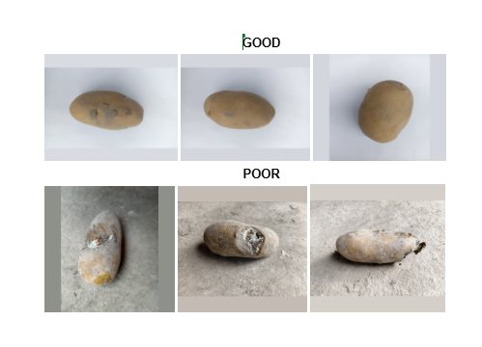
TABLE I. DISTRIBUTION OF POTATO IMAGE DATASET
Quality Category | Training | Validation | Testing | Total
Good | 1,293 | 277 | 277 | 1,847
Poor | 672 | 144 | 144 | 960
Total | 1,965 | 421 | 421 | 2,807

Image Acquisition and Preprocessing
The image preprocessing procedure is designed to prepare potato images for model training and inference on the ESP32-CAM. The dataset consists of 2,807 images divided into two quality categories, good and poor, as described in Section III.B. For model development, the dataset is divided into training, validation, and testing sets with a ratio of 70%, 15%, and 15%, respectively. All images are resized to 96 × 96 pixels and represented in RGB format to preserve visual information related to skin color, surface texture, and visible defects. During model training, pixel values are normalized to the range [0, 1].
To improve the model's ability to handle variations in image orientation and lighting conditions, data augmentation techniques are applied to the training set. These include random rotation, horizontal flipping, and brightness adjustment. The transformations are applied only to training images, while the validation and testing sets are kept unchanged apart from the required input preprocessing. Since the dataset contains 1,847 good images and 960 poor images, stratified splitting ensures consistent class representation across the training, validation, and testing subsets.
For image acquisition, the proposed system uses an infrared (IR) proximity sensor to detect the presence of a potato. When an object is detected, the sensor sends a trigger signal to the ESP32-CAM to capture an image. The OV2640 camera operates at a resolution of 320 × 240 pixels. A fixed camera position and controlled LED lighting are used to maintain consistent image conditions and minimize variations caused by the surrounding environment.
After image acquisition, the captured image is decoded, cropped when necessary, and resized to 96 × 96 pixels to match the input dimensions of the classification model. The image is then converted into the required color and pixel representation, following the same preprocessing procedure used during training. For deployment on the ESP32-CAM, the input values are adjusted according to the quantization parameters of the optimized model. The processed image is subsequently passed to the lightweight CNN, which classifies the potato into one of two categories: good or poor. This procedure aims to reduce computational requirements while preserving the visual features needed for binary potato quality classification.

Deep Learning Model
A lightweight Convolutional Neural Network (CNN) is proposed to classify potato images into two quality categories: good and poor. Since the model is intended to run on the ESP32-CAM, its architecture is designed to reduce the number of parameters and computational operations while maintaining the ability to extract relevant visual features. The proposed network combines conventional convolution with Depthwise Separable Convolution (DSC), which has been widely adopted in efficient neural network architectures [13].
The model takes RGB images with a resolution of 96 × 96 pixels as input. The first convolutional layer uses eight filters with a kernel size of 3 × 3 and a stride of two, followed by a Rectified Linear Unit (ReLU) activation function. This layer extracts basic visual features, such as edges, color variations, and surface textures. The extracted features are then processed through three depthwise separable convolutional blocks with 16, 32, and 48 output channels, respectively. Each block progressively reduces the spatial dimensions of the feature maps while learning more complex patterns associated with visible potato surface defects.
For a conventional convolutional layer, the computational cost, expressed in multiply-accumulate operations (MACs), can be approximated as

 | $$C_{std}=H×W×K^{2}×M×N$$ | (1)

where (H) and (W) are the spatial dimensions of the output feature map, (K) is the kernel size, and (M) and (N) represent the numbers of input and output channels, respectively.
Depthwise Separable Convolution separates the convolution process into two operations: depthwise convolution and pointwise convolution. The depthwise operation applies a spatial filter independently to each input channel, while the pointwise operation uses 1 × 1 convolutions to combine information across channels. Its computational cost can be expressed as

 | $$C_{DSC}=H×W×\left(K^{2}M+MN\right)$$ | (2)

The ratio between the computational costs of depthwise separable and conventional convolution is therefore

 | $$\frac{C_{DSC}}{C_{std}}=\frac{1}{N}+\frac{1}{K^{2}}$$ | (3)

For a 3 × 3 kernel, this structure can considerably reduce the number of arithmetic operations compared with conventional convolution, particularly when the number of output channels is sufficiently large. This property makes depthwise separable convolution suitable for neural networks intended for resource-constrained embedded devices.
After the convolutional blocks, Global Average Pooling (GAP) is applied to convert the final feature maps into a compact feature vector. Instead of using large fully connected layers, GAP calculates the average value of each feature map:

 | $$g_{c}=\frac{1}{HW}\sum_{i=1}^{H}{}\sum_{j=1}^{W}{}F_{c}\left(i,j\right)$$ | (4)

where $(F_{c}\left(i,j\right)$) represents the value at position $\left(\left(i,j\right)\right)$of the (c)-th feature map. The resulting feature vector is connected to a fully connected output layer containing a single neuron.
For binary classification, a Sigmoid activation function is used to estimate the probability that an input image belongs to the poor-quality category. The function is defined as

 | $$P\left(y=1∣x\right)=σ\left(z\right)=\frac{1}{1+e^{-z}}$$ | (5)

where (z) is the output logit and $\left(P\left(y=1∣x\right)\right)$represents the predicted probability of poor potato quality. An initial threshold of 0.5 is used to determine the classification result:

 | $$\hat{y}=\{1, P\left(y=1∣x\right)≥0.5 0, P\left(y=1∣x\right)<0.5$$ | (6)

In this study, label 0 represents good-quality potatoes, while label 1 represents poor-quality potatoes. The decision threshold may be adjusted using the validation dataset to obtain an appropriate balance between precision and recall.
The model is trained using the dataset described in Section III.B, which contains 2,807 potato images, including 1,847 good and 960 poor samples. The dataset is divided into training, validation, and testing subsets using a ratio of 70%, 15%, and 15% (corresponding to 1,965 training, 421 validation, and 421 testing images), respectively. A stratified splitting procedure is used to preserve the relative class distribution across the three subsets. Data augmentation is applied only to the training images to improve the model's ability to handle variations in image orientation and lighting conditions.
The proposed training configuration uses the Adam optimizer with an initial learning rate of 0.001 and a batch size of 32. The maximum number of training epochs is set to 50, while an early stopping mechanism is applied to reduce the risk of overfitting. Since the dataset has a relatively balanced distribution between the two classes, Binary Cross-Entropy (BCE) is selected as the loss function. BCE measures the difference between the predicted probabilities and the actual binary labels:

 | $$L=-\frac{1}{B}\sum_{i=1}^{B}{}\left[y_{i}loglog \left(p_{i}\right) +\left(1-y_{i}\right)loglog \left(1-p_{i}\right) \right]$$ | (7)

where (B) is the batch size, $\left(y_{i}\right)$is the ground-truth binary label, and $\left(p_{i}\right)$is the predicted probability of the poor-quality class.
During training, the validation set is used to monitor model performance and select the best checkpoint. The testing set is kept separate and used only for final evaluation. Classification performance is assessed using accuracy, precision, recall, F1-score, and a confusion matrix. Particular attention is given to the precision and recall of the poor-quality class to evaluate the model's ability to identify defective potatoes. The trained model subsequently serves as the baseline for optimization and deployment on the ESP32-CAM.

Model Optimization and Deployment
Deploying a deep learning model on the ESP32-CAM requires additional optimization due to the device's limited memory and computational capacity. Although the proposed CNN uses a lightweight architecture, its storage requirements and inference complexity must still be considered before deployment. In this study, Post-Training Quantization (PTQ) is proposed to convert the trained floating-point model into an 8-bit integer representation, reducing the storage required for model parameters and supporting integer-based inference on the microcontroller.
The optimization process begins after the CNN has been trained and evaluated using 32-bit floating-point precision (FP32). The trained model is converted into TensorFlow Lite format, with full-integer quantization applied to its weights and activations. A representative dataset containing images from both good and poor quality categories is used during calibration to estimate the activation ranges required for quantization. These representative samples are selected from the training set to prevent information from the validation or testing sets from being introduced during model optimization.
The quantization process maps floating-point values to discrete integer values using a scale factor and a zero-point parameter. The mapping can be expressed as

 | $$q=\left(\left(\frac{r}{s}\right) +z,-128,127\right)$$ | (8)

where (r) denotes the original floating-point value, (q) represents the quantized integer value, (s) is the quantization scale, and (z) is the zero-point. Compared with FP32 representation, INT8 quantization reduces the storage required for individual model weights from four bytes to one byte. However, the overall reduction in model size depends on the network architecture and the additional information stored in the model.
After quantization, the TensorFlow Lite model is prepared for integration into the ESP32-CAM firmware. TensorFlow Lite for Microcontrollers is considered as the inference framework because it is designed to execute machine learning models on embedded devices with limited resources [6]. The optimized model is stored in the device's Flash memory, while a dedicated tensor arena is allocated to hold intermediate tensors and temporary data during inference. The required tensor arena size depends on the network architecture and the memory allocation performed by the inference framework.
During operation, the ESP32-CAM receives a trigger signal from the infrared proximity sensor and captures an image using its OV2640 camera module. The captured image is decoded, cropped when necessary, and resized to 96 × 96 pixels. The image data are then converted into the model's required input representation according to the quantization parameters of the input tensor. After preprocessing, the image is passed to the TinyML inference engine, which generates a single output score corresponding to the estimated probability of poor potato quality.
For the quantized model, the output value is converted into its floating-point representation using the output tensor's quantization parameters. The predicted category is then determined using an initial decision threshold of 0.5. If the probability is greater than or equal to the threshold, the potato is classified as poor; otherwise, it is classified as good.
Since image processing and classification are performed directly on the ESP32-CAM, the system does not require a cloud server to execute the model. The classification result can instead be transmitted through Wi-Fi to an IoT monitoring interface when a network connection is available. This separation between local inference and remote communication allows the device to continue classifying potatoes during temporary network interruptions.
The deployment performance is evaluated by measuring model size, memory consumption, and inference time on the ESP32-CAM. The accuracy, precision, recall, and F1-score of the quantized INT8 model are compared with those of the original FP32 model using the same test dataset. In addition, the time required for image acquisition, preprocessing, and inference are measured separately to assess the overall processing performance. These measurements help determine whether the optimized model can operate within the hardware limitations of the ESP32-CAM while maintaining acceptable binary classification performance.

IoT Communication and Monitoring
To enable remote supervision and real-time tracking of the sorting process, an IoT communication layer is integrated into the proposed framework. Once the on-device TinyML inference engine completes the binary classification of a potato tuber on the ESP32-CAM, the resulting metadata—comprising the predicted class label (good or poor), the prediction confidence score, and the timestamp—is encapsulated into a lightweight JSON payload.
Instead of streaming raw camera frames over the network, which would consume substantial bandwidth and power, the ESP32-CAM transmits only this compact JSON packet over its built-in IEEE 802.11 b/g/n Wi-Fi interface via the Message Queuing Telemetry Transport (MQTT) protocol and HTTP RESTful APIs. This decoupling of local visual inference from wireless transmission minimizes communication latency and network overhead. On the receiving end, an IoT monitoring dashboard subscribes to the inspection topic to log sorting histories, compute real-time defect ratios, and visualize batch quality statistics for warehouse operators. In scenarios where wireless connectivity is temporarily interrupted, the local classification pipeline continues to operate autonomously on the edge device, buffering inspection records locally until network access is restored.

EXPERIMENTAL RESULTS AND DISCUSSION

Experimental Setup
The model training and optimization pipelines were implemented in Python using the TensorFlow and Keras deep learning frameworks. The lightweight CNN architecture based on Depthwise Separable Convolutions (DSC) described in Section III.D was trained to classify potato images into two categories: good and poor. Training was performed on the 1,965 training images and monitored using the 421 validation images shown in Table I, utilizing the Adam optimizer with an initial learning rate of 0.001, a batch size of 32, and the Binary Cross-Entropy (BCE) loss function. Although the maximum number of training epochs was set to 50, the early stopping mechanism monitored the validation loss and terminated the training process at epoch 15 once the model achieved stable convergence without overfitting.
For embedded deployment, the trained 32-bit floating-point (FP32) model was quantized into an 8-bit integer (INT8) TensorFlow Lite format and compiled into a C byte array. The embedded firmware was developed using the ESP-IDF / Arduino environment and flashed onto the ESP32-CAM module, which features a dual-core 32-bit LX6 microprocessor running at 240 MHz, 520 KB of internal SRAM, 4 MB of external PSRAM, and an OV2640 camera sensor. The progression of training and validation loss and accuracy across the 15 training epochs is illustrated in Fig. 2.
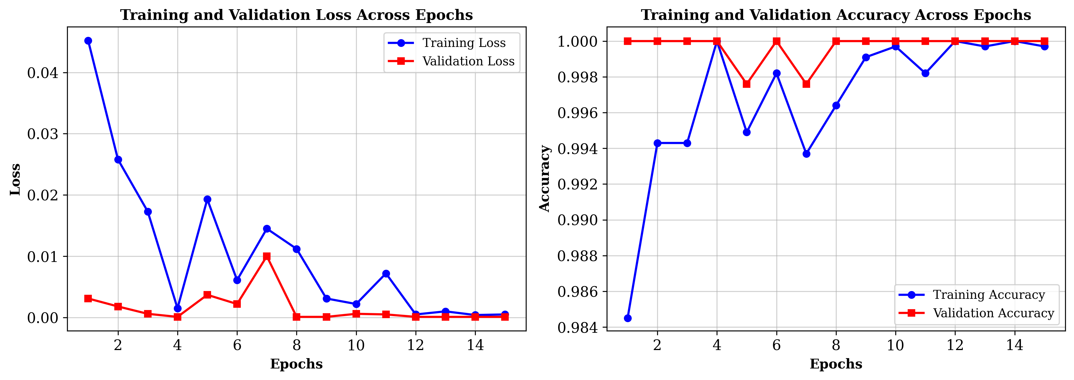
Fig. 2. Training and validation loss and accuracy curves across 15 epochs.

Classification Performance
As shown in Fig. 2, the training loss decreased sharply from 0.0452 at epoch 1 to 0.0015 at epoch 4, and subsequently stabilized below 0.0010 from epoch 12 to epoch 15. Concurrently, the validation accuracy rapidly converged to 100.00%, with minor fluctuations observed only at epochs 5 and 7 (99.76%). Following model training, classification performance was evaluated on the testing subset of 421 unseen potato images (comprising 277 good and 144 poor samples, as specified in Table I). The detailed binary classification metrics—including precision, recall, and F1-score for both good and poor categories—are summarized in Table II, while the corresponding confusion matrix is depicted in Fig. 3.
TABLE II. CLASSIFICATION PERFORMANCE ON THE TESTING SET
Quality Category | Precision (%) | Recall (%) | F1-Score (%) | Support
Good (0) | 100.00 | 99.64 | 99.82 | 277
Poor (1) | 99.31 | 100.00 | 99.65 | 144
Macro Average | 99.66 | 99.82 | 99.74 | 421
Weighted Average | 99.76 | 99.76 | 99.76 | 421
Overall Accuracy | 99.76% |  |  | 421
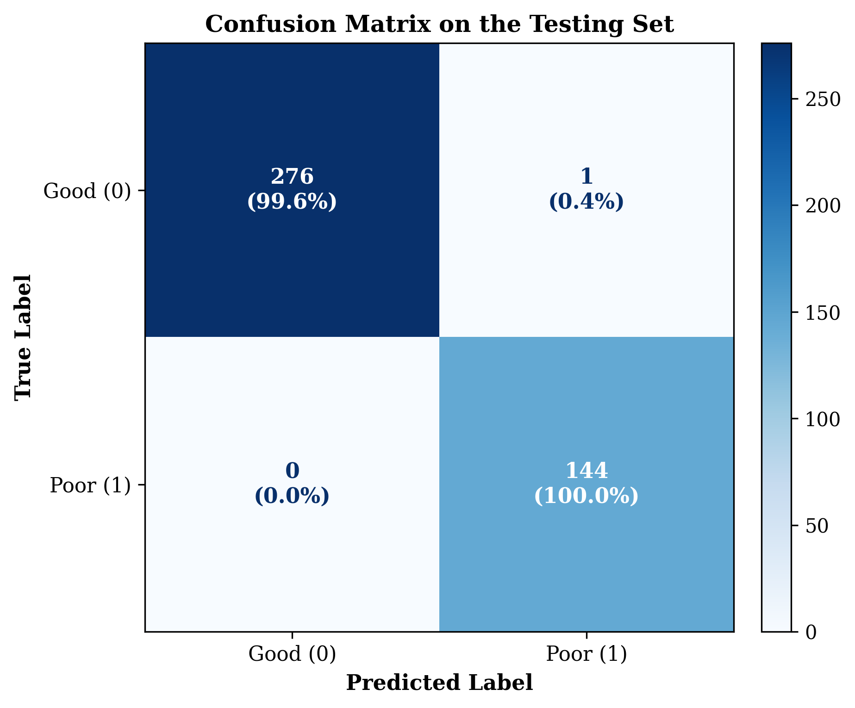
Fig. 3. Confusion matrix of the binary potato quality classification model (Good vs. Poor) on the testing set.
As demonstrated in Table II and Fig. 3, the proposed binary classification model achieved an overall accuracy of 99.76% across the 421 testing images. Specifically, out of 277 good-quality potato tubers, 276 were correctly classified (99.64% recall and 100.00% precision), with only a single sample misclassified into the poor category. Remarkably, for the poor-quality category, the model correctly identified all 144 defective tubers without any false negatives, achieving a recall of 100.00%, a precision of 99.31%, and an F1-score of 99.65%. In practical post-harvest quality inspection, achieving a 100.00% recall rate on the poor class is critical, as it prevents damaged or defective tubers from entering the good batch and causing cross-contamination during storage.

Model Optimization Results
Applying full-integer Post-Training Quantization (PTQ) substantially reduced the memory footprint and computational complexity of the trained CNN model while preserving its binary classification accuracy. By converting 32-bit floating-point (FP32) weights and activation tensors into 8-bit integers (INT8) using representative calibration samples from the training set, the storage requirement per parameter was reduced by a factor of four (from 4 bytes to 1 byte), resulting in an overall model size reduction of approximately 73%. This compact flatbuffer representation allows the quantized TensorFlow Lite model to fit comfortably within the Flash memory of the ESP32-CAM alongside the camera driver and Wi-Fi communication stack.
When evaluated on the same 421-image testing set, the INT8 quantized model exhibited negligible accuracy degradation compared to the FP32 baseline, maintaining the 99.76% overall accuracy and 99.74% macro F1-score across the two quality classes (good and poor). This robustness against quantization noise can be attributed to the distinct visual contrast between smooth, healthy potato skin and the pronounced surface irregularities of poor-quality tubers, as well as the representative calibration procedure employed during conversion.

Edge Deployment Performance
During inference evaluation, the optimized model demonstrated high execution speed suitable for real-time sorting operations. As recorded in the experimental evaluation, the average inference latency was 27.20 ms per image (0.0272 seconds), which corresponds to a processing throughput of approximately 36.76 frames per second (FPS). On the ESP32-CAM hardware, the allocated tensor arena fits within the available SRAM/PSRAM resources, leaving sufficient memory headroom for OV2640 frame buffering, JPEG decoding, and 96 × 96 RGB bilinear resizing.
Furthermore, because image acquisition, preprocessing, and neural network inference are executed entirely on the edge microcontroller, the end-to-end inspection latency remains deterministic and independent of internet bandwidth fluctuations. Transmitting only lightweight binary classification results (less than 128 bytes per JSON packet) rather than raw 320 × 240 images reduces wireless data volume by over 99%, significantly lowering power consumption and preventing network congestion in multi-node sorting lines.

Discussion
Compared with existing approaches reported in the literature—such as PCA-SVM achieving 96.6% accuracy [1], depth-imaging CNNs achieving 86.6% grading accuracy [3], and improved YOLOv5s achieving an F1-score of 84.3% [4]—the proposed framework achieves highly competitive binary classification performance (99.76% accuracy and 99.74% macro F1-score) in distinguishing good and poor potatoes while operating within the strict hardware constraints of a low-cost microcontroller. The combination of Depthwise Separable Convolutions (reducing multiply-accumulate operations by approximately 8 to 9 times for 3 × 3 kernels) and INT8 quantization enables rapid 27.20 ms inference without requiring desktop GPUs or cloud servers.
Despite these advantages, several practical limitations should be noted. First, the current model focuses on binary sorting into two quality classes (good vs. poor) rather than fine-grained multi-class grading of specific defect types such as greening, common scab, black scurf, or mechanical bruising. Second, because a single stationary camera captures only the upper surface of each tuber, localized defects on the bottom side facing the conveyor belt may remain occluded unless a mechanical roller is used to rotate the potato during transit. Third, heavy soil accumulation on unwashed tubers may resemble surface lesions, potentially causing false-positive rejections—an issue reflected in the single good sample misclassified as poor in Fig. 3.

CONCLUSION AND FUTURE WORK
This paper presented an end-to-end Edge AI and IoT framework for automated post-harvest potato quality classification into two categories (good and poor) using the resource-constrained ESP32-CAM microcontroller. By combining a lightweight Depthwise Separable Convolution (DSC) network with full-integer INT8 Post-Training Quantization in TensorFlow Lite Micro, the proposed system performs local image acquisition, preprocessing, and binary quality classification directly on the device without relying on continuous cloud connectivity. Experimental evaluations on the 421-image testing set demonstrated that the model achieved an overall accuracy of 99.76%, a macro-average precision of 99.66%, a macro-average recall of 99.82%, and a macro F1-score of 99.74%, with an average inference latency of 27.20 ms per image. Notably, the model achieved a 100.00% recall rate in identifying poor-quality potatoes, ensuring reliable rejection of defective produce.
In future work, we plan to expand the dataset to extend the framework from binary classification to multi-class defect grading (distinguishing among sprouting, greening, rot, and surface blemishes) and integrate size/weight estimation. Additionally, we aim to couple the ESP32-CAM vision node with a mechanical sorting actuator (such as a pneumatic or servo-driven diverter gate) and a 360-degree rotating roller conveyor to evaluate full-surface sorting throughput under industrial post-harvest conditions.

REFERENCES
- J. Xiong, L. Tang, Z. He, J. He, Z. Liu, R. Lin, and J. Xiang, “Classification of Potato External Quality based on SVM and PCA,” International Journal of Performability Engineering, vol. 13, no. 4, pp. 469–478, 2017.
- S. Marino, P. Beauseroy, and A. Smolarz, “Weakly-supervised learning approach for potato defects segmentation,” Engineering Applications of Artificial Intelligence, vol. 85, pp. 337–346, 2019.
- Q. Su, N. Kondo, D. F. Al Riza, and H. Habaragamuwa, “Potato Quality Grading Based on Depth Imaging and Convolutional Neural Network,” Journal of Food Quality, vol. 2020, Art. no. 8815896, 2020.
- X. Li et al., “Improved YOLO v5s-based detection method for external defects in potato,” Frontiers in Plant Science, vol. 16, Art. no. 1527508, 2025.
- J. Lin, W.-M. Chen, Y. Lin, J. Cohn, C. Gan, and S. Han, “MCUNet: Tiny Deep Learning on IoT Devices,” in Advances in Neural Information Processing Systems, vol. 33, 2020
- R. David et al., “TensorFlow Lite Micro: Embedded Machine Learning for TinyML Systems,” in Proceedings of Machine Learning and Systems, vol. 3, 2021.
- H. Aqasizade, M. Antonini, M. Vecchio, and F. Antonelli, “A TinyMLOps Pipeline for Coarse-Grained Plant Disease Classification in Precision Agriculture,” Sensors, vol. 26, no. 16, Art. no. 5029, 2026.
- T. Malche, M. Joshi, G. M. Upadhyay, and P. K. Soni, “Automated tomato leaf disease detection and alert system using Internet of Things and TinyML,” Discover Internet of Things, vol. 6, Art. no. 8, 2026.
- M. Ayaz, M. Ammad-Uddin, Z. Sharif, A. Mansour, and E.-H. M. Aggoune, “Internet-of-Things (IoT)-Based Smart Agriculture: Toward Making the Fields Talk,” IEEE Access, vol. 7, pp. 129551–129583, 2019.
- M. S. Farooq, S. Riaz, A. Abid, K. Abid, and M. A. Naeem, “A Survey on the Role of IoT in Agriculture for the Implementation of Smart Farming,” IEEE Access, vol. 7, pp. 156237–156271, 2019.
- A. F. Suhaimi et al., “IoT Based Smart Agriculture Monitoring, Automation and Intrusion Detection System,” Journal of Physics: Conference Series, vol. 1962, no. 1, Art. no. 012016, 2021.
- A. Verma and R. Bodade, “Design and Implementation of a Low-Cost IoT-Based Smart Agricultural System Using ESP32 and LoRa Technology,” in 2025 International Conference on Computational, Communication and Information Technology (ICCCIT), 2025.
- A. G. Howard et al., “MobileNets: Efficient Convolutional Neural Networks for Mobile Vision Applications,” arXiv preprint arXiv:1704.04861, 2017.

