Online Post Office Management

- Problem definition:

TARS Delivery System is a postal organization with different branches at different cities delivering the mails through various options like courier, speed post, Normal post, VPP etc… and money orders. They used to charge for the delivery of the mails based on the type of the service preferred, weight of the mail and as well based on the distance.
Currently they are using a stand-alone application that holds the details of the mails like the delivery number, date of posting, the weight, type of delivery chosen, Destination address, the address of the person who has posted it, contact details, etc… As soon as the packet or the letter is received, the date of receipt at the destination place office and the date of delivery to the destination address are captured. Some of them (companies, etc…) send multiple envelopes, or couriers, etc….
Now they want an online application to be incorporated in the system so that the customer can also check from his end when the packet or the letter is delivered, as most of the packets or letters that are posted are mainly for the business purpose like tenders, application forms, etc….. Also the department people instead of maintaining separate applications each at a location they can use the same application (online) that performs all the tasks of the application that they are using.
The application which they are using right now, also calculates the charges for the delivery based on the weight, distance, and the type of the service chosen by the customer. The application that they are currently using also holds the information of the charges, Pin code details, and the contact details include based on the location. The Organization head alone has the right to change the charges for the delivery.
Even these concepts are needed to be incorporated in the online application.
- Problem Analyze:

They want an online application through which the offices at different cities can be connected through a single application and they want to avoid using multiple applications, one each at a city office. Also they want that the application should perform all the tasks of the application that they are using, like calculating the charges. Also it should hold the information of the details of the charges, pin codes, contact details of the offices based on the location.
The Organization head alone decides the charges for the services and he can alone change them. Also the organization head can alone create the account for the employees to ensure for the security. After the employee login id and the password are created, they are provided to the employee so that he can login with that site. As well the Employee is given the right to change his/her password of that account. As well there should be a separate login for the Organization head, and that of the employees who are using it for entering the details of the deliverables, to ensure that the employees can only enter the details of the deliverable, or update his a/c or change his/her password. Also he can check the details like the charges for the service, pin code and as well the contact details. Also the employees should also be able to search for the records like the delivery mail details, and also they have the authority to change the details or add some more details of the deliverable mail.
The customers should be able to utilize the services of the website like to check the status of the delivery based on the delivery number given to him/her, at the time of dropping the mail, also he should be asked for the contact number as mentioned while posting, for the verification purpose that the same person who has dropped it for the delivery is checking for the details (i.e., for the security purpose). Also he can check for the charges of the different kinds of the services they provide, pin codes of the locations, and the contact details based on the location.
To the maintaining the records through a lump sum of paper work and it is tedious job to fetch the details whenever required, as it is time consuming process, also to calculate the charges levied for the delivery as it depends on the weight and some of the calculations depends on the type of the delivery the customer is willing to opt for. Also it should maintain the separate records for the type of the delivery with the complete details which will be divided into the different sub modules like the state, pin code, charges, weight, date of delivery, etc… including the details like from whom the deliverable is recovered, i.e., from the other branch office or from the customer. Sometimes misplacement of the deliverable takes place due to which there is a possibility of getting delayed in delivery. And no proper management for maintaining the records of the deliverables
From the past few months they are facing a problem with the current scenario like misplacing the mails, etc… So they have approached you to provide a system application to track down the information about the mails they have received from the customers, their branches, etc… so as to meet customer satisfaction and to cope up in the competitive electronic world and as well to make it easy to track down the details of the service like the time of discharging, charges, address, etc… and the taxes levied if applicable
They want to incorporate a system, which can hold the information of each and every deliverable state wise, city wise, pin code wise, and as per the category of the delivery service opted like VPP, Speed post, Courier, parcels, and Money order, so that the delivery can take place with no delay in the postal service and reducing the misplacement of the deliverables. Also they want the system alone to calculate the charges levied on the postal service depending on the type of the service and weight of the deliverable.
- Customer Requirement Specification:
After reading Problem Analyze, we can see that there are three Objects who use this application. And step by step, we have functions of application for System depends on their requirement.
- Head of the Organization :
- The Admin (Head of the Organization) should be able to create the employee profiles like the login id and the password for the employees and as well he alone has the right to declare and modify the charges.
- The Admin can create or modify all of service which corporation supply.
- The Admin have to access to see revenue report by day, or by month, by year.
- The admin has the right to access all the pages of the website
- The Employee profile change can be altered only after the admin agrees for it.
- Employee :
  - Delivery Employee :
- The employee will only be able to access the details of the deliverable where he can enter, update the details and as well the details of service charges, contact address based on the location, and the pin codes of the locations.
- He can change the password or even he can update his details. He can also see the details of the charges, contact information based on the location, and the pin codes of the location. But he cannot access the details of the other employees as he is not authorized for it.
  - Website Administrator :
- Admin of website can update, create or modify news, and have responsibility about Content of Website such as: news, services…etc.
- Active or lock the account who break the rules of website.
- Customer:
- Guess can register to become the customer.
- After check mail to complete register progress, guess become the customer and they can use all service of post office such as: set magazine daily, send the letter and parcels post service.
- Customer can edit, update their profile but profile in database will be updated when admin accept update profile.
- Customer can send feedback to admin to resolve problem with application or employee.

- Active Diagram:
- Customer Function :
  - Letter and parcels post service Function :
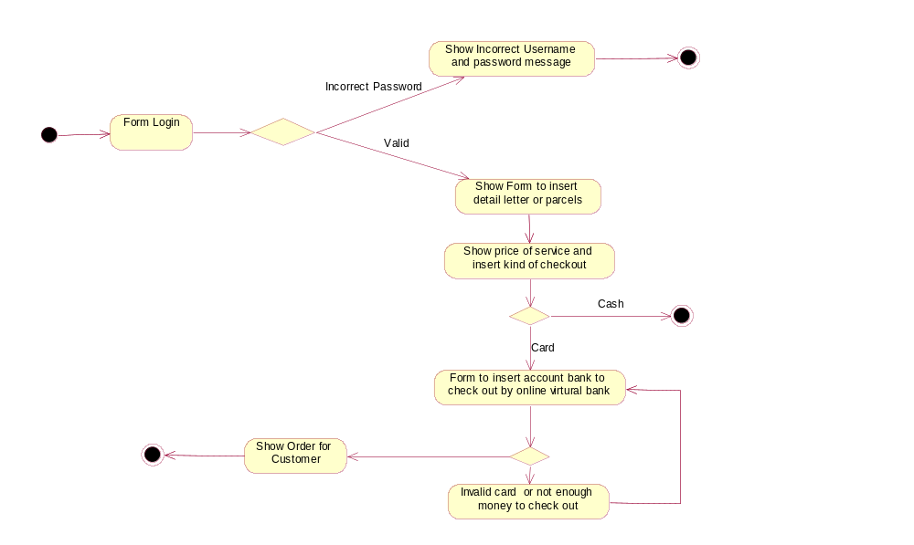
  - Set Magazine daily function:
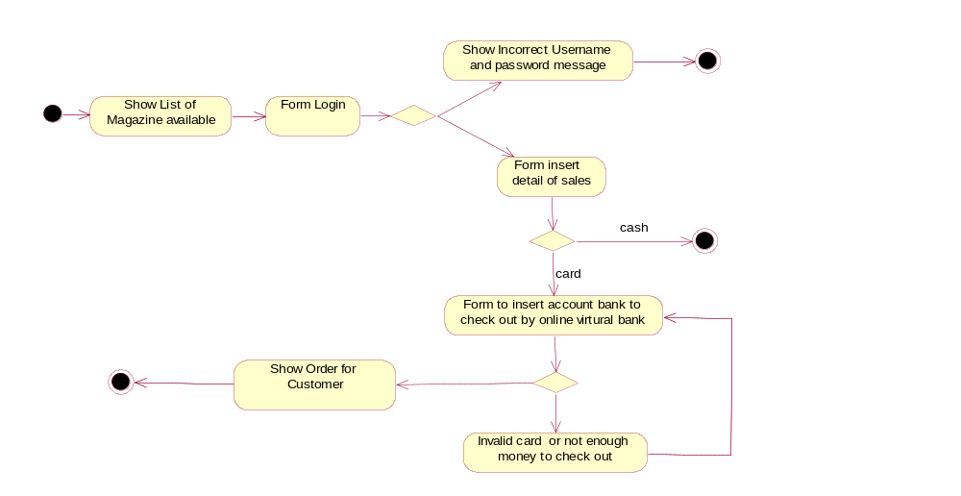

  - Register Function :
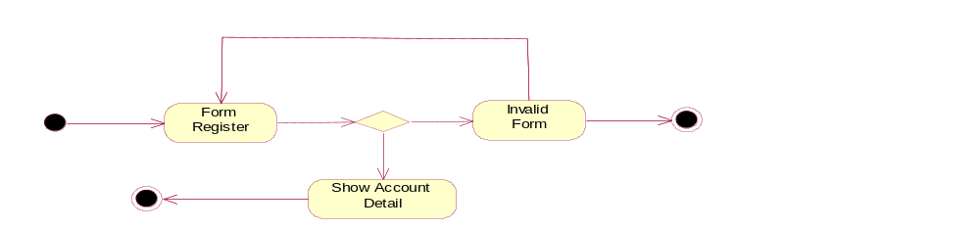
  - Feedback Function :
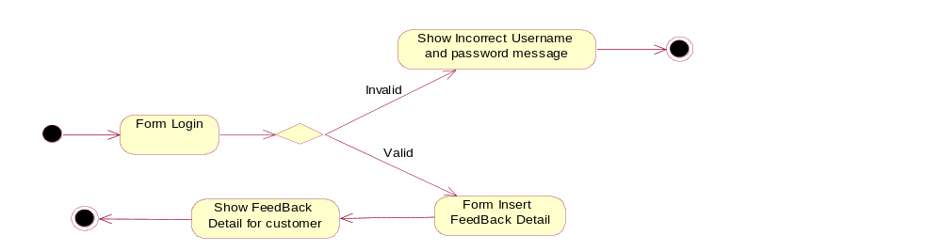
- Admin Function :
  - create new, update, stop service:
    - Create new service:
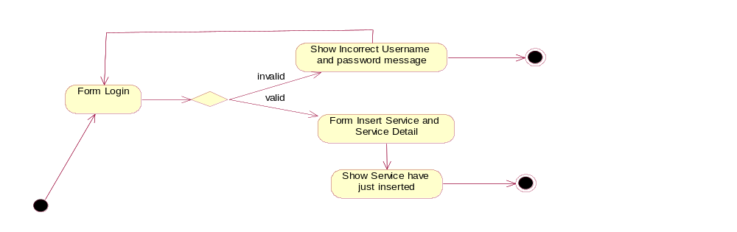
    - Update and stop Service:
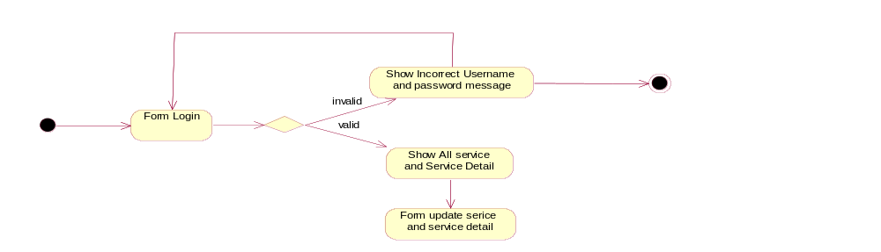

  - create new, update parcel post :
    - Create new parcel post :
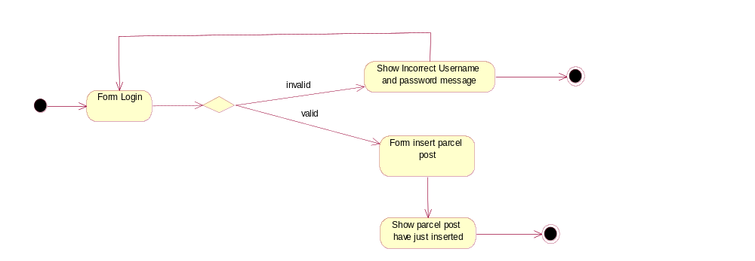
    - Update parcel post :
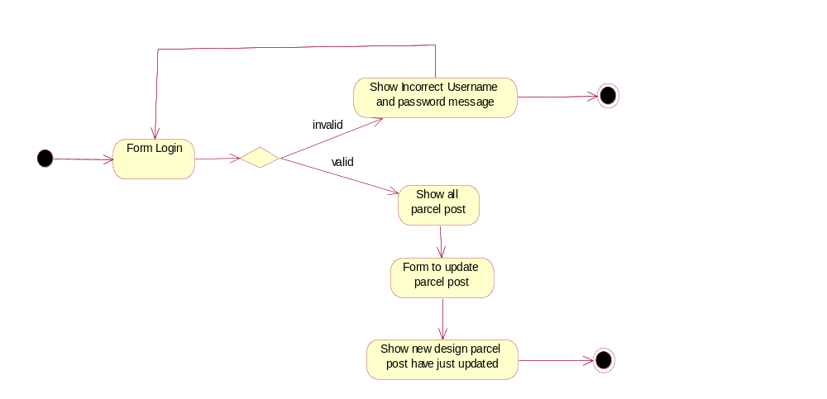
  - create new, update magazine daily :
    - create new magazine daily :
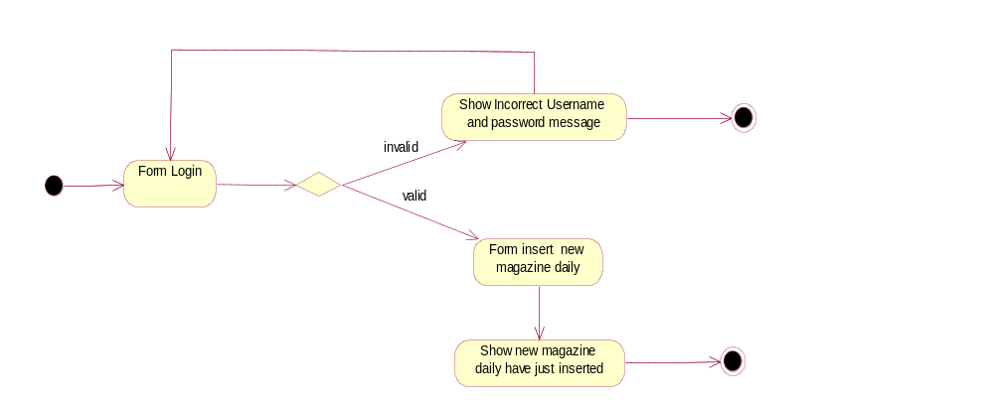
    - update magazine daily :
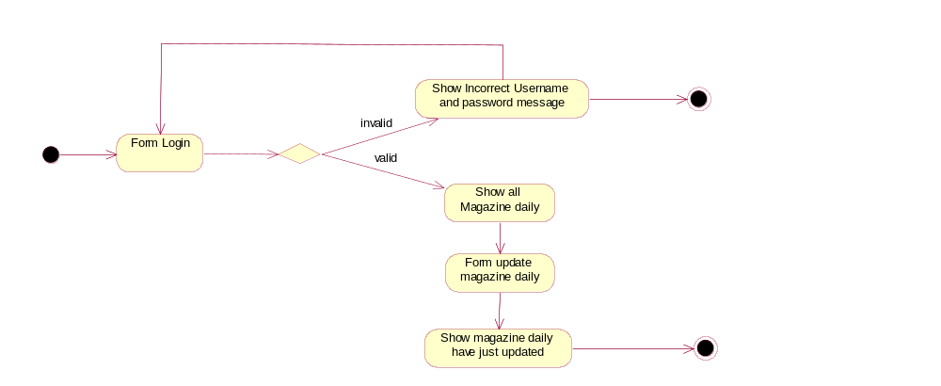
  - create new, update Employee :
    - create new Employee :
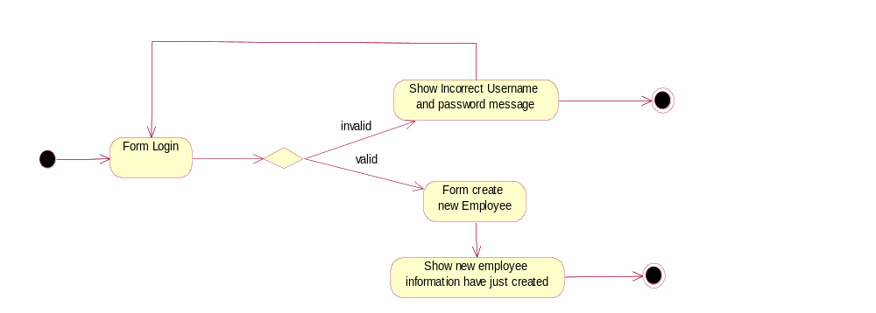
    - update Employee :
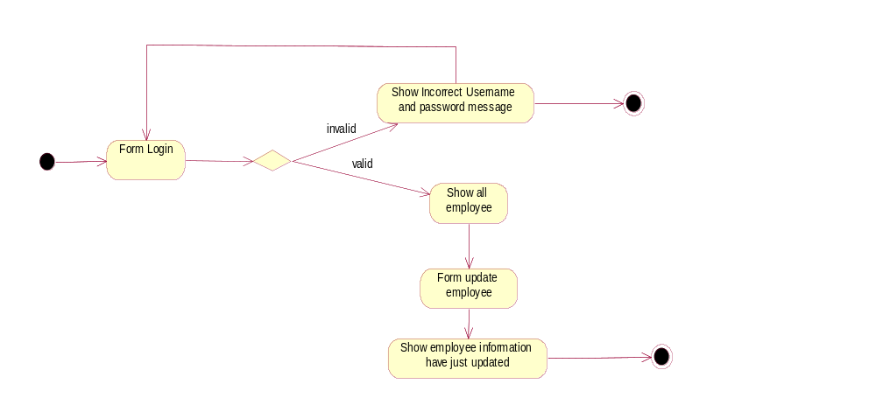
  - create new, update branch :
    - create new branch :
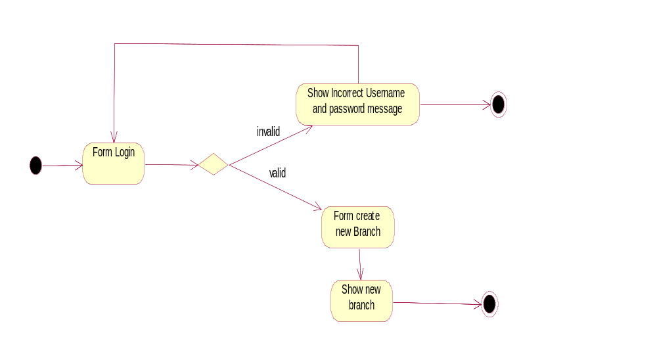
    - update branch :
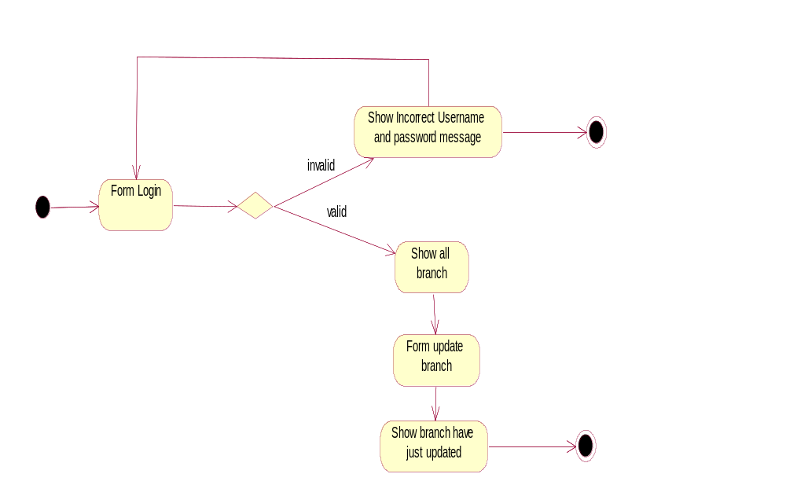

- Use Case :
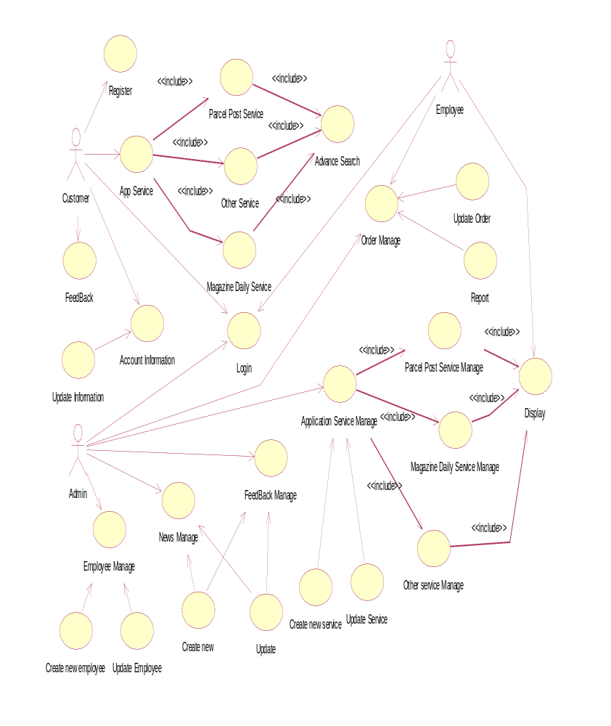
- Class Diagram:
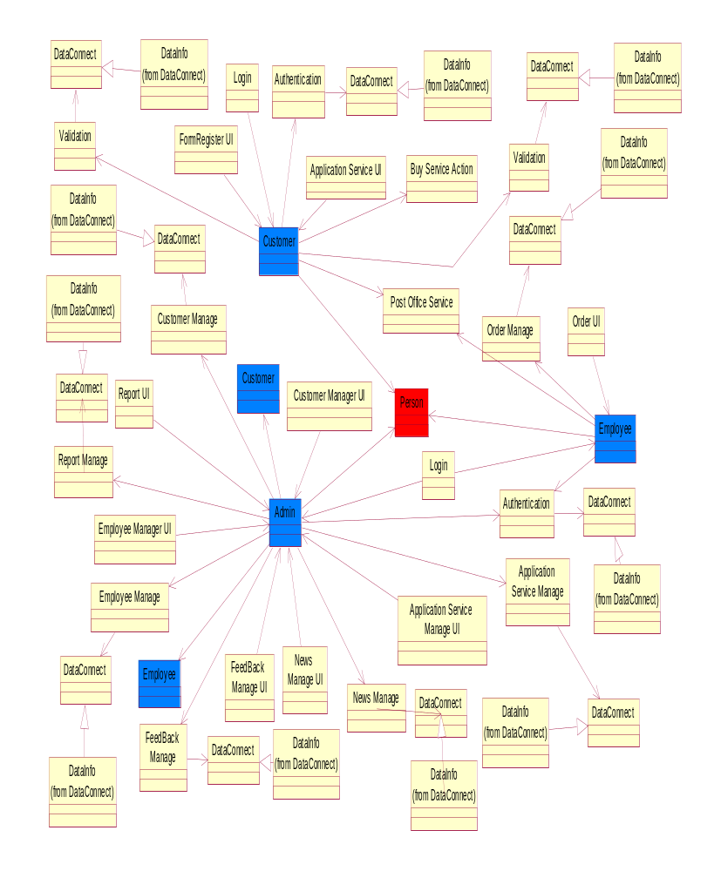
- Database Design:
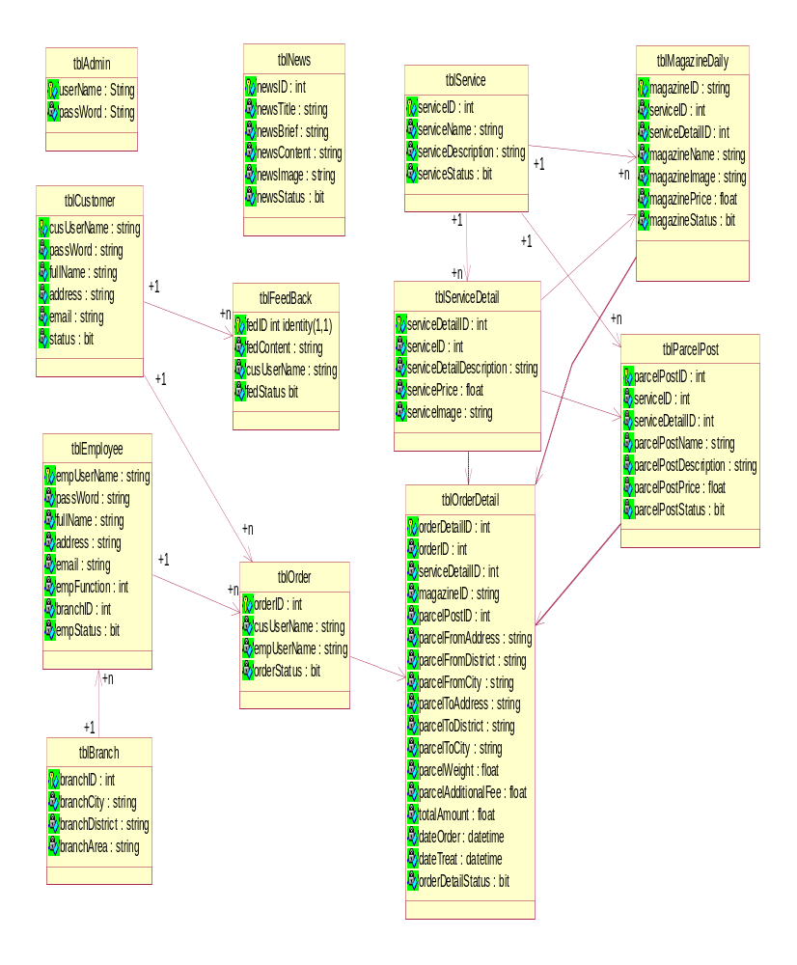
- Sequence Diagram:
- Visitor Function :
1.1 Register Function:
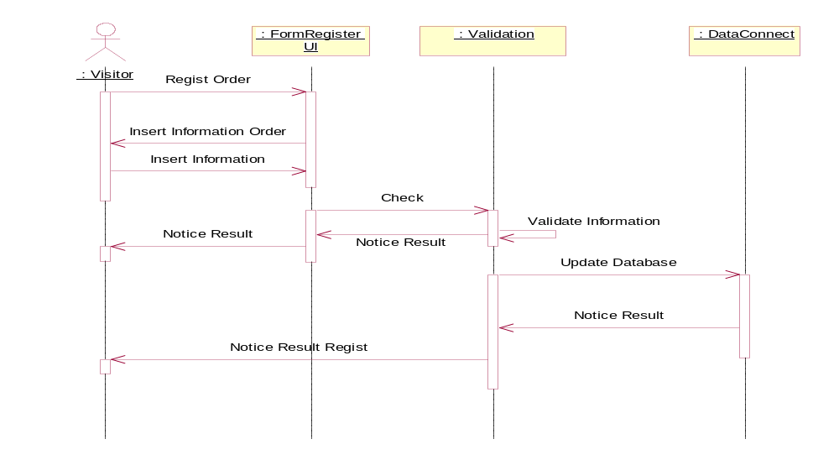
- Customer Function:
  - Login Function:
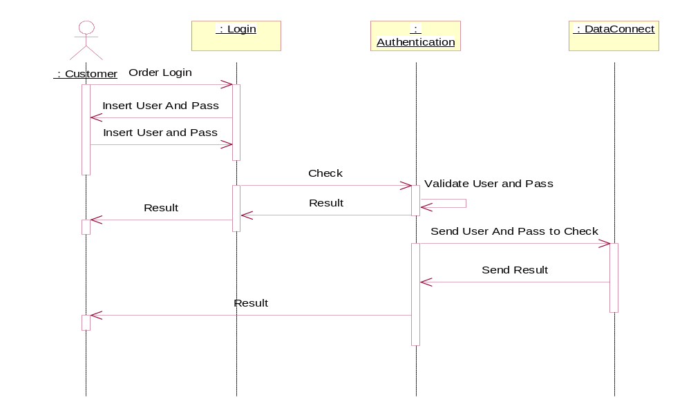
  - Buy Post Office Services Function :
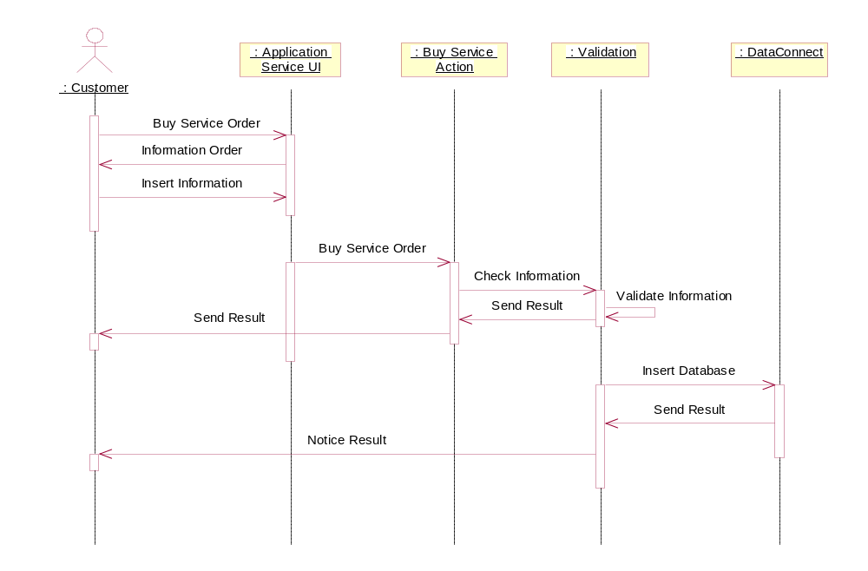
  - Send Feedbacks Function:
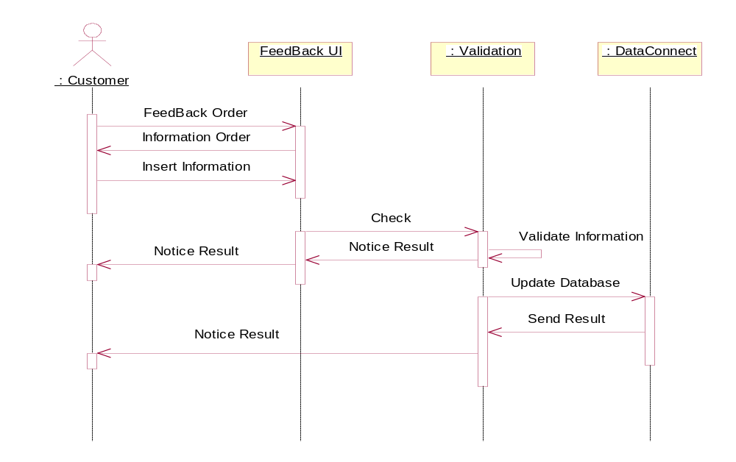
- Employee Function :
  - Order Manage :
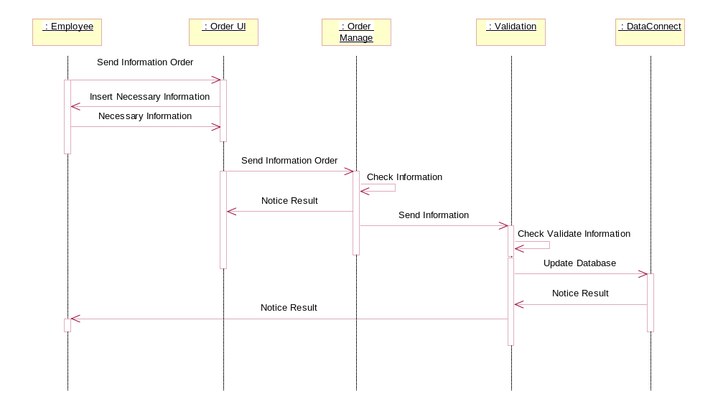
- Admin Function :
  - Application Manage Function :
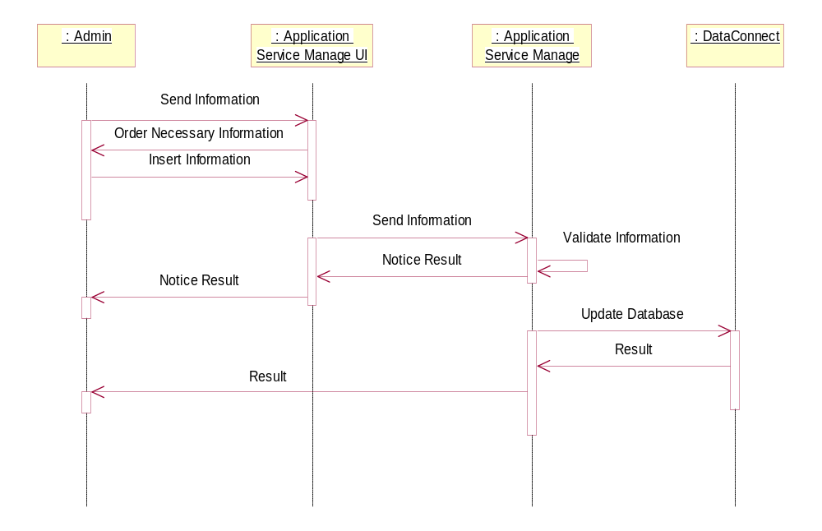
  - Feedbacks Manage:
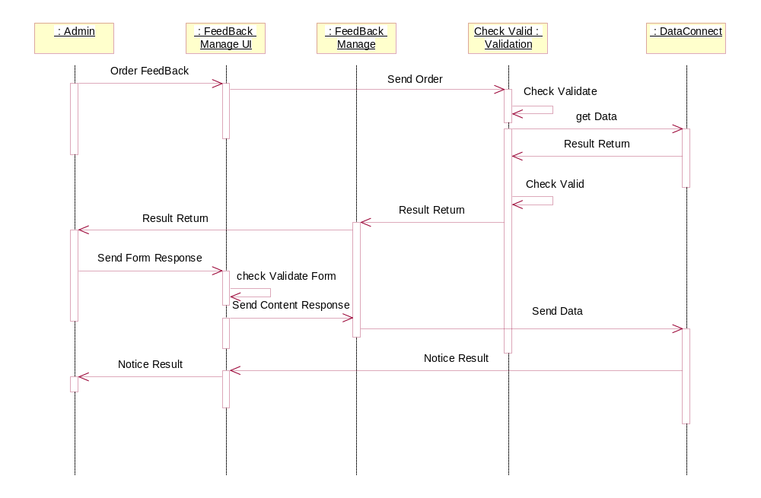
  - Employee Manage :
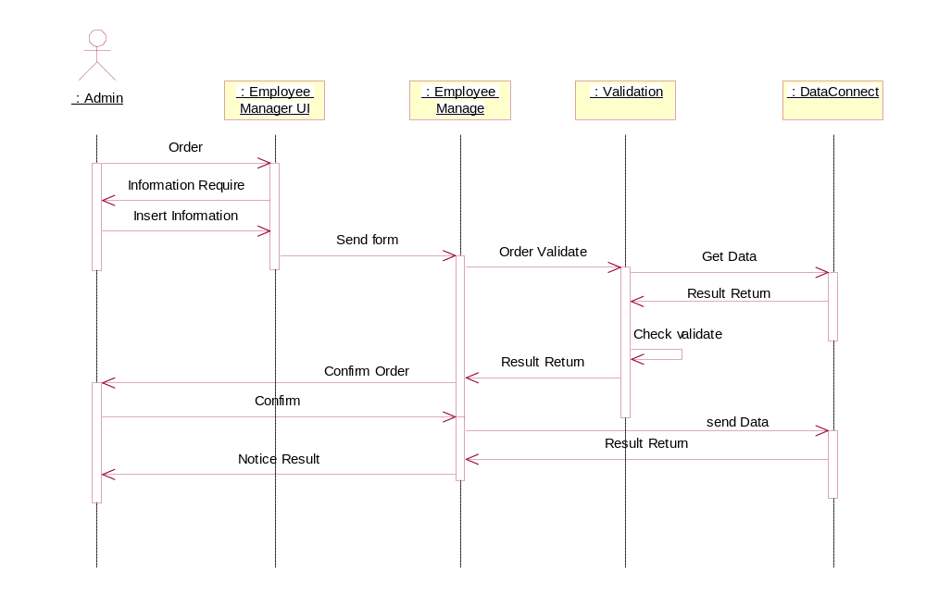
  - Report Manage :
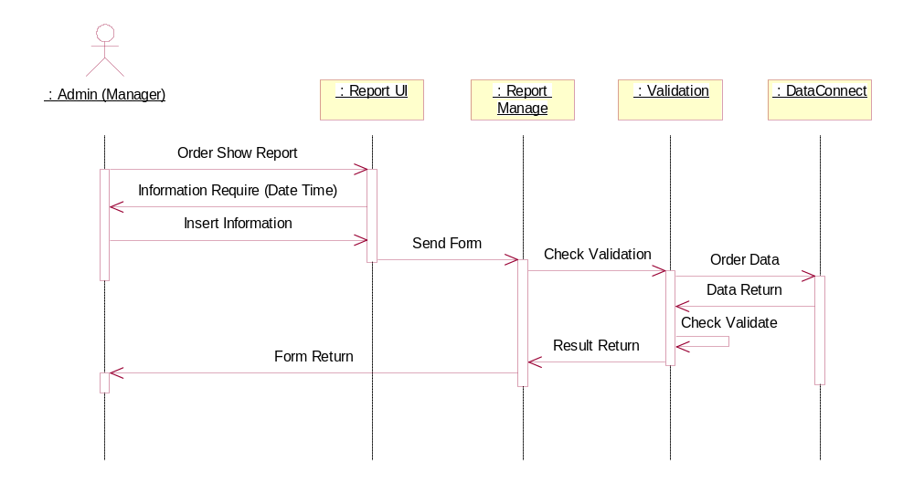
  - Customer Manage :
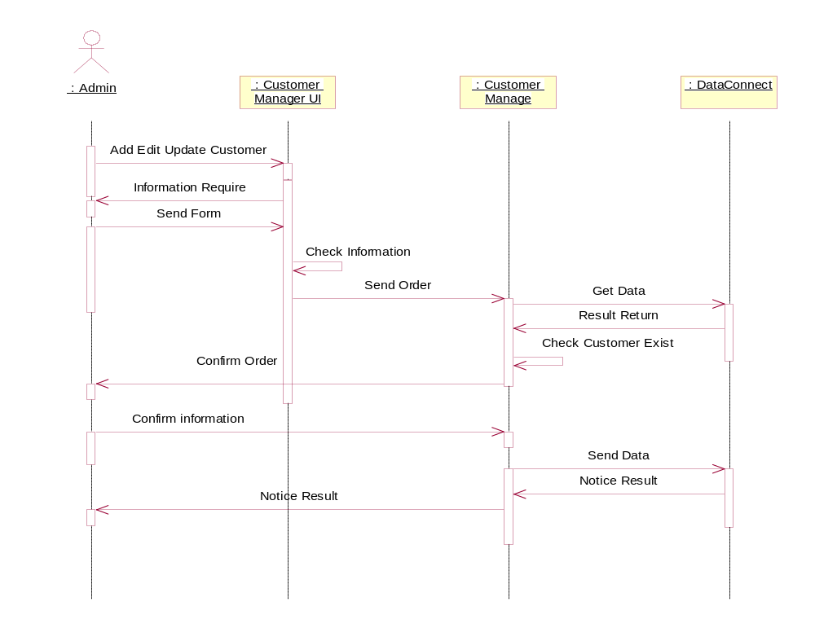

- GUI standards :
- Interface Design:
- Task Sheet:

