2015597_DoanQuangHuy_CTK44-PM

LAB 1

# Bài 1:

Cau 1: Write a Python program to print the following string in a specific format (see the output).

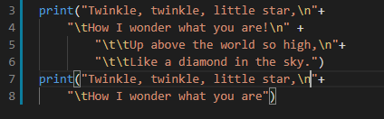

Cau 2: Write a Python program to get the Python version you are using

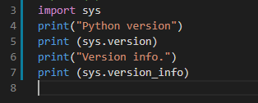

Cau 3: Write a Python program to display the current date and time.

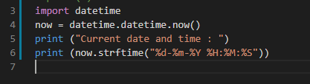

Cau 4: Write a Python program which accepts the radius of a circle from the user and compute the area.

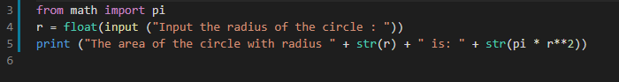

Cau 5: Write a Python program which accepts the user's first and last name and print them in reverse order with a space between them.

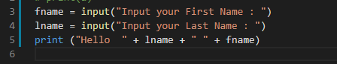

CAU 6: Write a Python program which accepts a sequence of comma-separated numbers from user and generate a list and a tuple with those numbers.

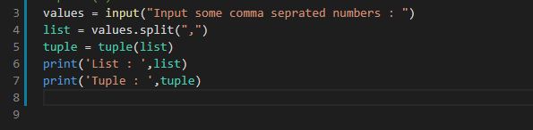

CAU 7: Write a Python program to accept a filename from the user and print the extension of that.

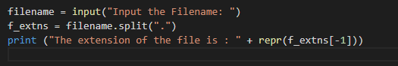

Cau 8: Write a Python program to display the first and last colors from the following list.

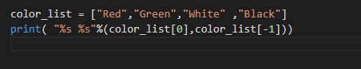

Cau 9: Write a Python program to display the examination schedule. (extract the date from exam_st_date).

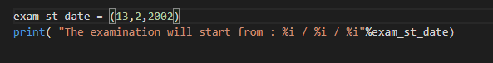

Cau 10: Write a Python program that accepts an integer (n) and computes the value of n+nn+nnn.

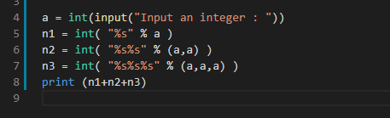

Cau 11: Write a Python program to print the documents (syntax, description etc.) of Python built-in function(s).

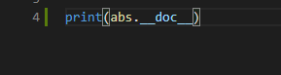

CAU 12: Write a Python program to print the calendar of a given month and year.  
Note : Use 'calendar' module.

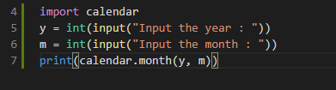

CAU 13:  Write a Python program to print the following 'here document'.

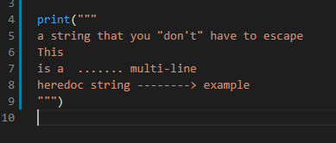

Cau 14: Write a Python program to calculate number of days between two dates.

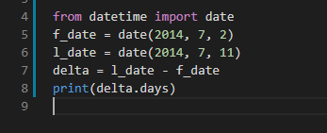

Cau 15:  Write a Python program to get the volume of a sphere with radius 6.

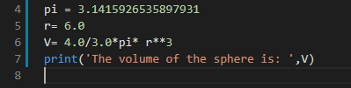

Cau 16: Write a Python program to get the difference between a given number and 17, if the number is greater than 17 return double the absolute difference.

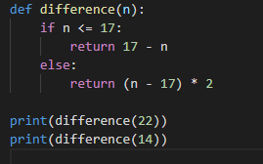

Cau 17: Write a Python program to test whether a number is within 100 of 1000 or 2000.

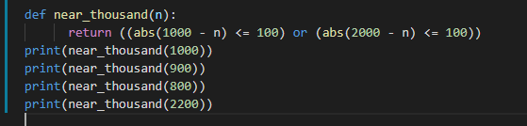

Cau 18: Write a Python program to calculate the sum of three given numbers, if the values are equal then return three times of their sum.

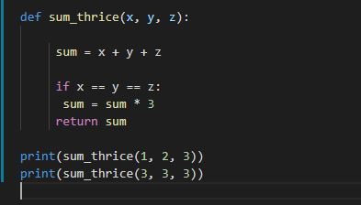

Cau 19: Write a Python program to get a new string from a given string where "Is" has been added to the front. If the given string already begins with "Is" then return the string unchanged.

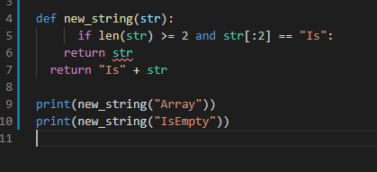

Cau 20: Write a Python program to get a string which is n (non-negative integer) copies of a given string.

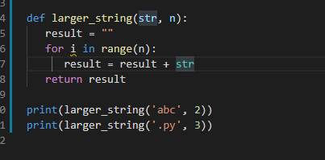

Cau 21: Write a Python program to find whether a given number (accept from the user) is even or odd, print out an appropriate message to the user.

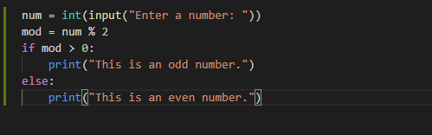

Cau 22: Write a Python program to count the number 4 in a given list.

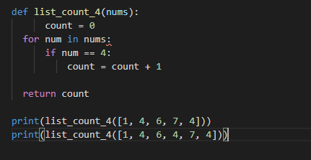

Cau 23: Write a Python program to get the n (non-negative integer) copies of the first 2 characters of a given string. Return the n copies of the whole string if the length is less than 2.

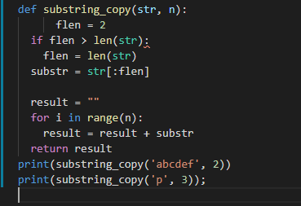

Cau 24: Write a Python program to test whether a passed letter is a vowel or not.

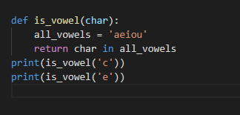

Cau 25: Write a Python program to check whether a specified value is contained in a group of values.

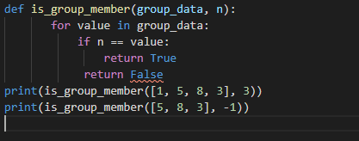

# Bài 2:

Câu 1:

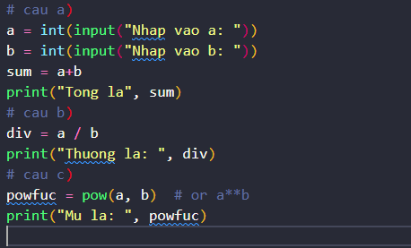

Câu 2:

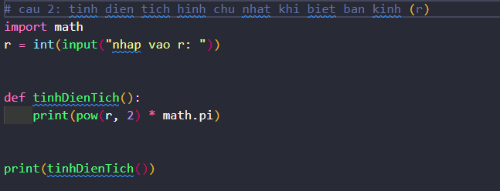

Câu 3:

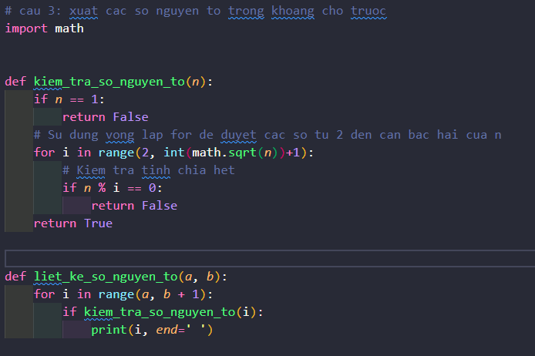

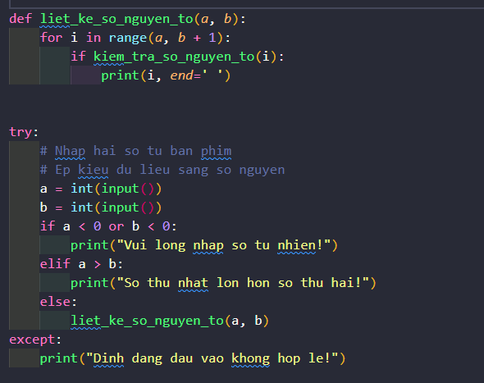

Câu 4:

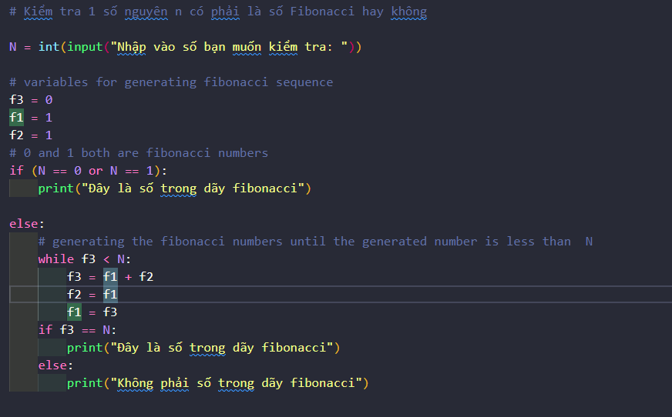

Câu 5:

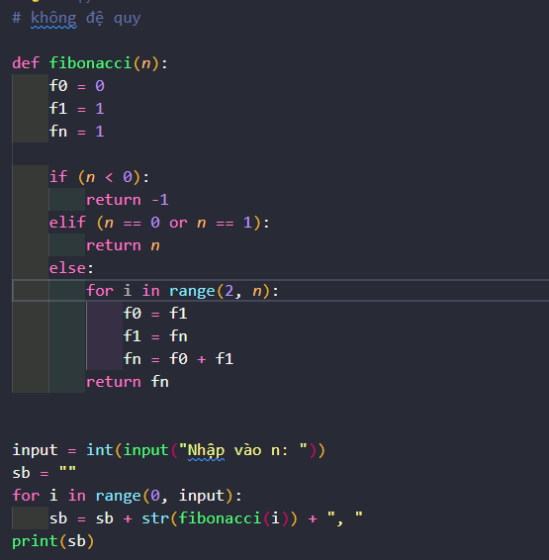

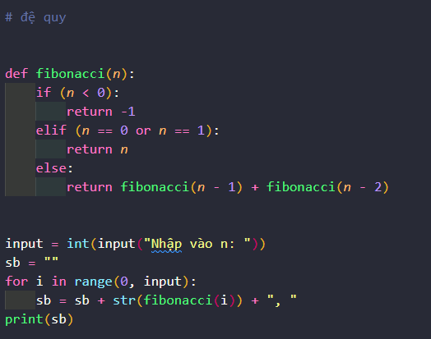

Câu 6:

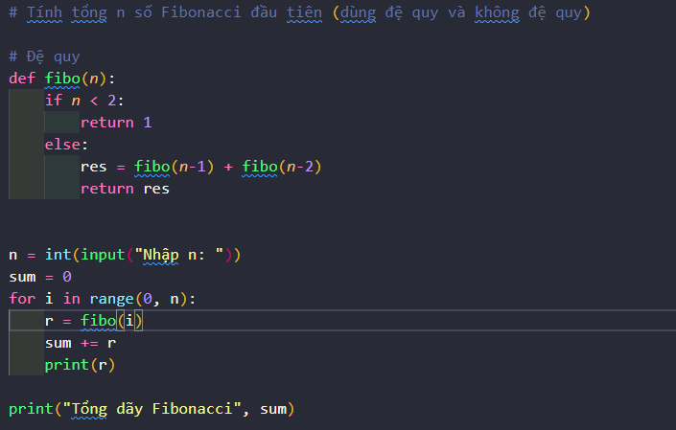

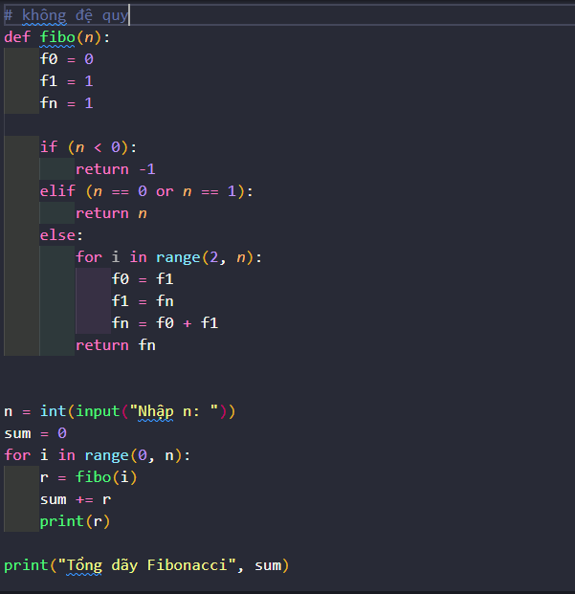

Câu 7:

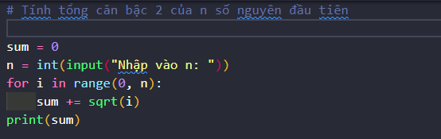

Câu 8:

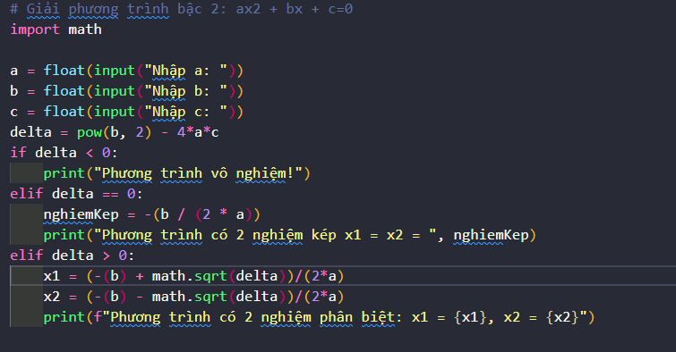

Câu 9:

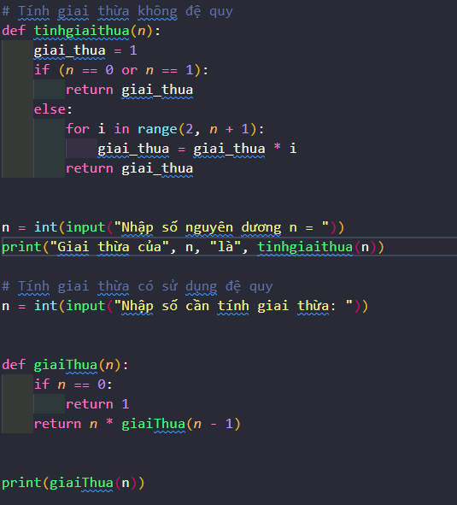

Câu 10:

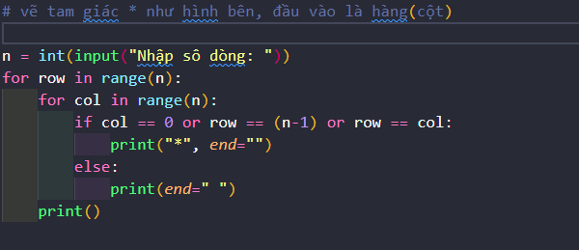

Câu 11:

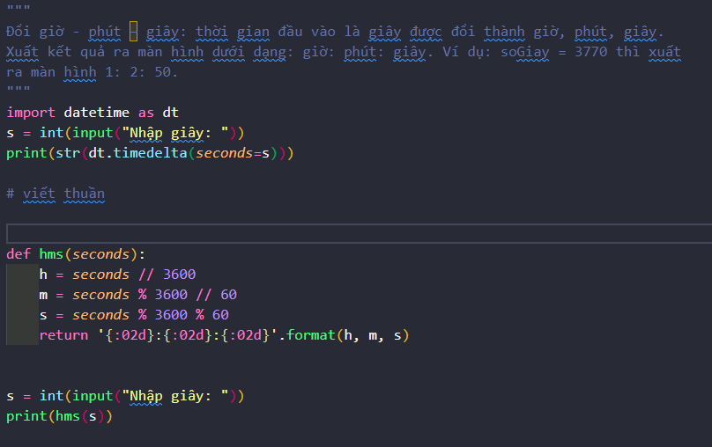

Câu 12: