HO CHI MINH UNIVERSITY OF TECHNOLOGY AND EDUCATION

FACULTY OF HIGH QUALITY TRAINING



**PROJECT 1 REPORT**

**ONLINE SHOPPING STORE**

**Instructor: PhD. Nguyễn Thiên Bảo**

Team Members:

Lê Minh Quang 17110063

**TP. HCM – 7/2020**

# Thanks

The success of a student more or less always accompanies a lecturer. We would like to express our sincere thanks to Mr. Nguyen Duc Khoan, who directly supported the group, give us suggestions, comments and suggestions as well as provide tips to help us make the project. Thanks for your instructions which help our team understand the problems to do, the presentation as well as the implementation of the project so we have completed the project with a lot of experience that we learn. Again, our team would like to thank the lecturer.

Projects are made within 8 weeks, just enough to complete it. However, due to many new knowledge as well as the time we do through each week is not optimal, the project will have many errors, that is inevitable. We are looking forward to receiving all the comments of our teachers to help us improve our knowledge. Sincerely thanks.

# Preface

The purpose and objective of this training and particularly the content is really time-being and with this training we have gained some confidence regarding to introduce the application. We also believe that way we gained some sorts of IT knowledge and if we practice more and having some experience in the field then we will be able to survive smartly in today’s competitive environment.

The effort to write the report is a partial fulfillment to complete the course. In the report I try my best to represent all the content which we learnt in a great deal in the program in a systematic and presentable order. I divided each of the topics as an individual chapter to reflect the entire topic more prominently and clearly. In the reference I have used citation method in the entire report. Finally, I am very hopeful that the structure and topic of the report will be a useful print material to all the reader especially to the user.

**CONTENT**

Thanks 3

Preface 4

1. List of images 6

2. List of tables 6

3. Contents 7

3.1. Project Description 7

3.1.1. Objective 7

3.1.2. ERD & Database Diagram 7

3.1.3. Usage Situations 8

3.1.4. Expected user interface 9

3.1.5. Usecase 10

3.2. Project Design 12

3.2.1. Tables 12

3.2.2. Class Diagram 13

3.3. Screenshot 14

References 18

# List of images

Image 1: Database Diagram 7

Image 2: ERD Diagram 8

Image 3: Expected user interface 9

Image 4: Usecase Diagram 10

Image 5: Class Diagram 14

Image 6: Homepage 15

Image 7: Login page 15

Image 8: Order page 16

Image 9: Product manager 16

Image 10: Product detail 17

Image 11: Cart detail 17

# List of tables

Table 1: Work Assignment 10

Table 2: Work progress 11

Table 3: Admin 12

Table 4: Customer 12

Table 5: Product 12

Table 6: Order 13

Table 7: OrderDetail 13

Table 8: Category 13

# Contents

## Project Description

### Objective

Create a website for a pizza shop, a popular fast food today. The website allows customers to log in and order the pizzas and accompanying dishes, in addition the admin can login to manage product.

The user interface is easy to use and customer friendly so customers can search and choose the dishes they like the most easily.

**Admin account:**

- Username: admin

- Password: admin

### ERD & Database Diagram

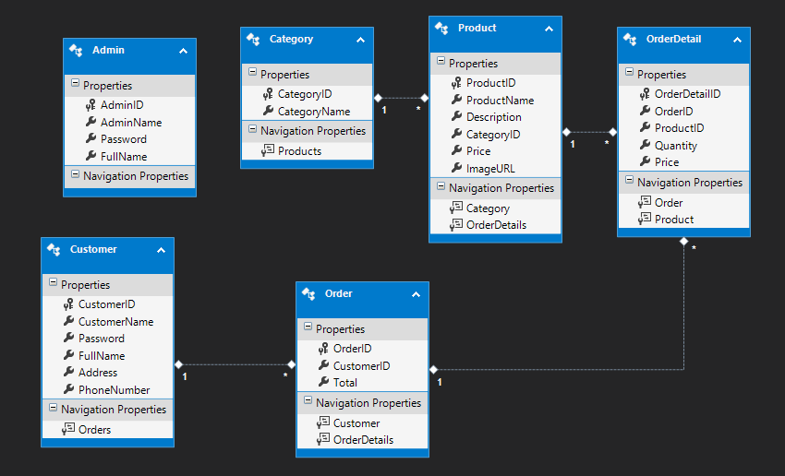

Image 1: Database Diagram

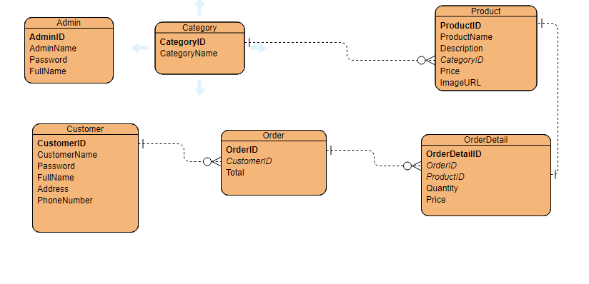

Image 2: ERD Diagram

### Usage Situations

Website used to manage the online pizzashop.

#### Purposes

The website has the following purposes:

* Allows user to order products from pizza shop.
* Allows admin manage products, orders, bills.

#### Features

The web application provides user many features:

* Add, edit, delete products, category, bills.
* Register, login system.
* Authorization for admin and customer.
* Ordering and checkout system.

### Expected user interface

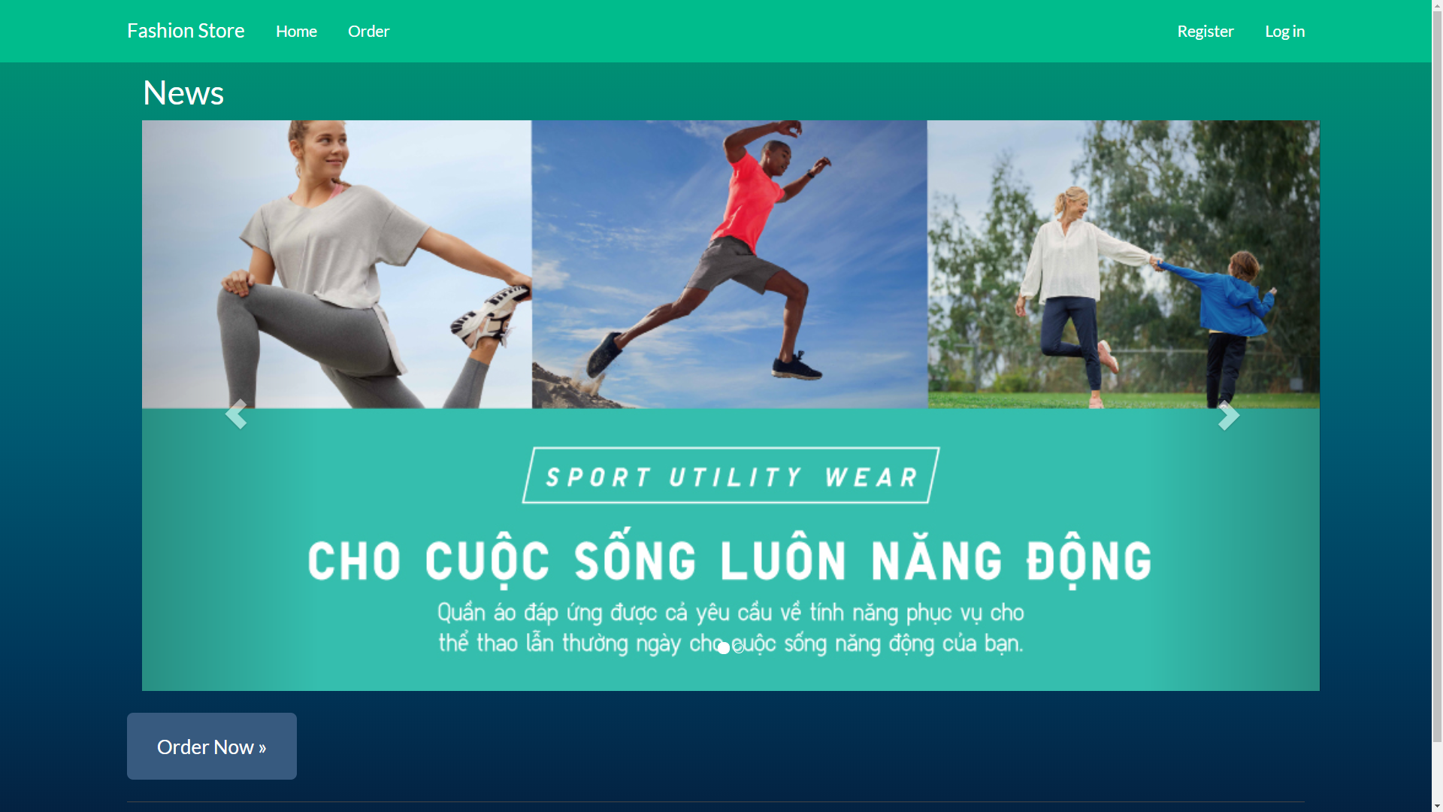

Image 3: Expected user interface

### Usecase

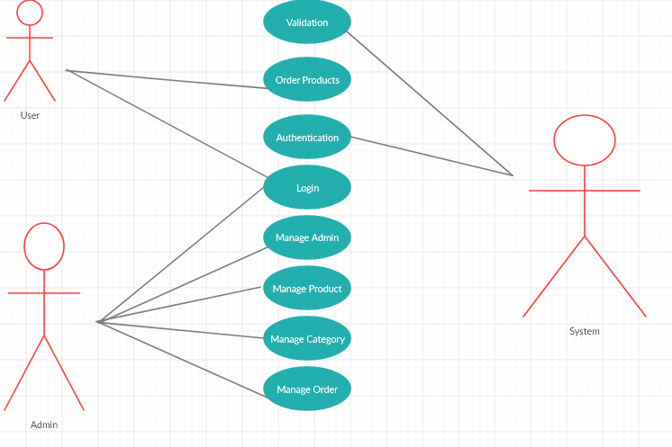

Image 4: Usecase Diagram

## Project Design

### Tables

##### Table 3: Admin

|  |  |  |
| --- | --- | --- |
| **Column Name** | **Data Type** | **Allow Null** |
| *AdminID* | *Int* | *NO* |
| *AdminName* | *Varchar(50)* | *NO* |
| *Password* | *Varchar(50)* | *NO* |
| *FullName* | *Nvarchar(50)* | *NO* |

##### Table 4: Customer

|  |  |  |
| --- | --- | --- |
| **Column Name** | **Data Type** | **Allow Null** |
| *CustomerID* | *Int* | *NO* |
| *CustomerName* | *Varchar(50)* | *NO* |
| *Password* | *Varchar(50)* | *NO* |
| *FullName* | *Nvarchar(50)* | *NO* |
| *Address* | *Nvarchar(80)* | *NO* |
| *PhoneNumber* | *Varchar(12)* | *NO* |

##### Table 5: Product

|  |  |  |
| --- | --- | --- |
| **Column Name** | **Data Type** | **Allow Null** |
| *ProductID* | *Int* | *NO* |
| *ProductName* | *Nvarchar(100)* | *NO* |
| *Description* | *Nvarchar(800)* | *YES* |
| *CategoryID* | *Int* | *NO* |
| *Price* | *Int* | *NO* |
| *ImageURL* | *Nvarchar(300)* | *YES* |

##### Table 6: Order

|  |  |  |
| --- | --- | --- |
| **Column Name** | **Data Type** | **Allow Null** |
| *OrderID* | *Int* | *NO* |
| *CustomerID* | *Int* | *NO* |
| *Total* | *Int* | *NO* |

##### Table 7: OrderDetail

|  |  |  |
| --- | --- | --- |
| **Column Name** | **Data Type** | **Allow Null** |
| *OrderDetailID* | *Int* | *NO* |
| *OrderID* | *Int* | *NO* |
| *ProductID* | *Int* | *NO* |
| *Quantity* | *Int* | *NO* |
| *Price* | *Int* | *NO* |

##### Table 8: Category

|  |  |  |
| --- | --- | --- |
| **Column Name** | **Data Type** | **Allow Null** |
| *CategoryID* | *Int* | *NO* |
| *CategoryName* | *Nvarchar(100)* | *NO* |

### Class Diagram

Image 5: Class Diagram

## Screenshot

## 

Image 6: Homepage

## 

Image 7: Login page

## 

Image 8: Order page

## 

Image 9: Product manager

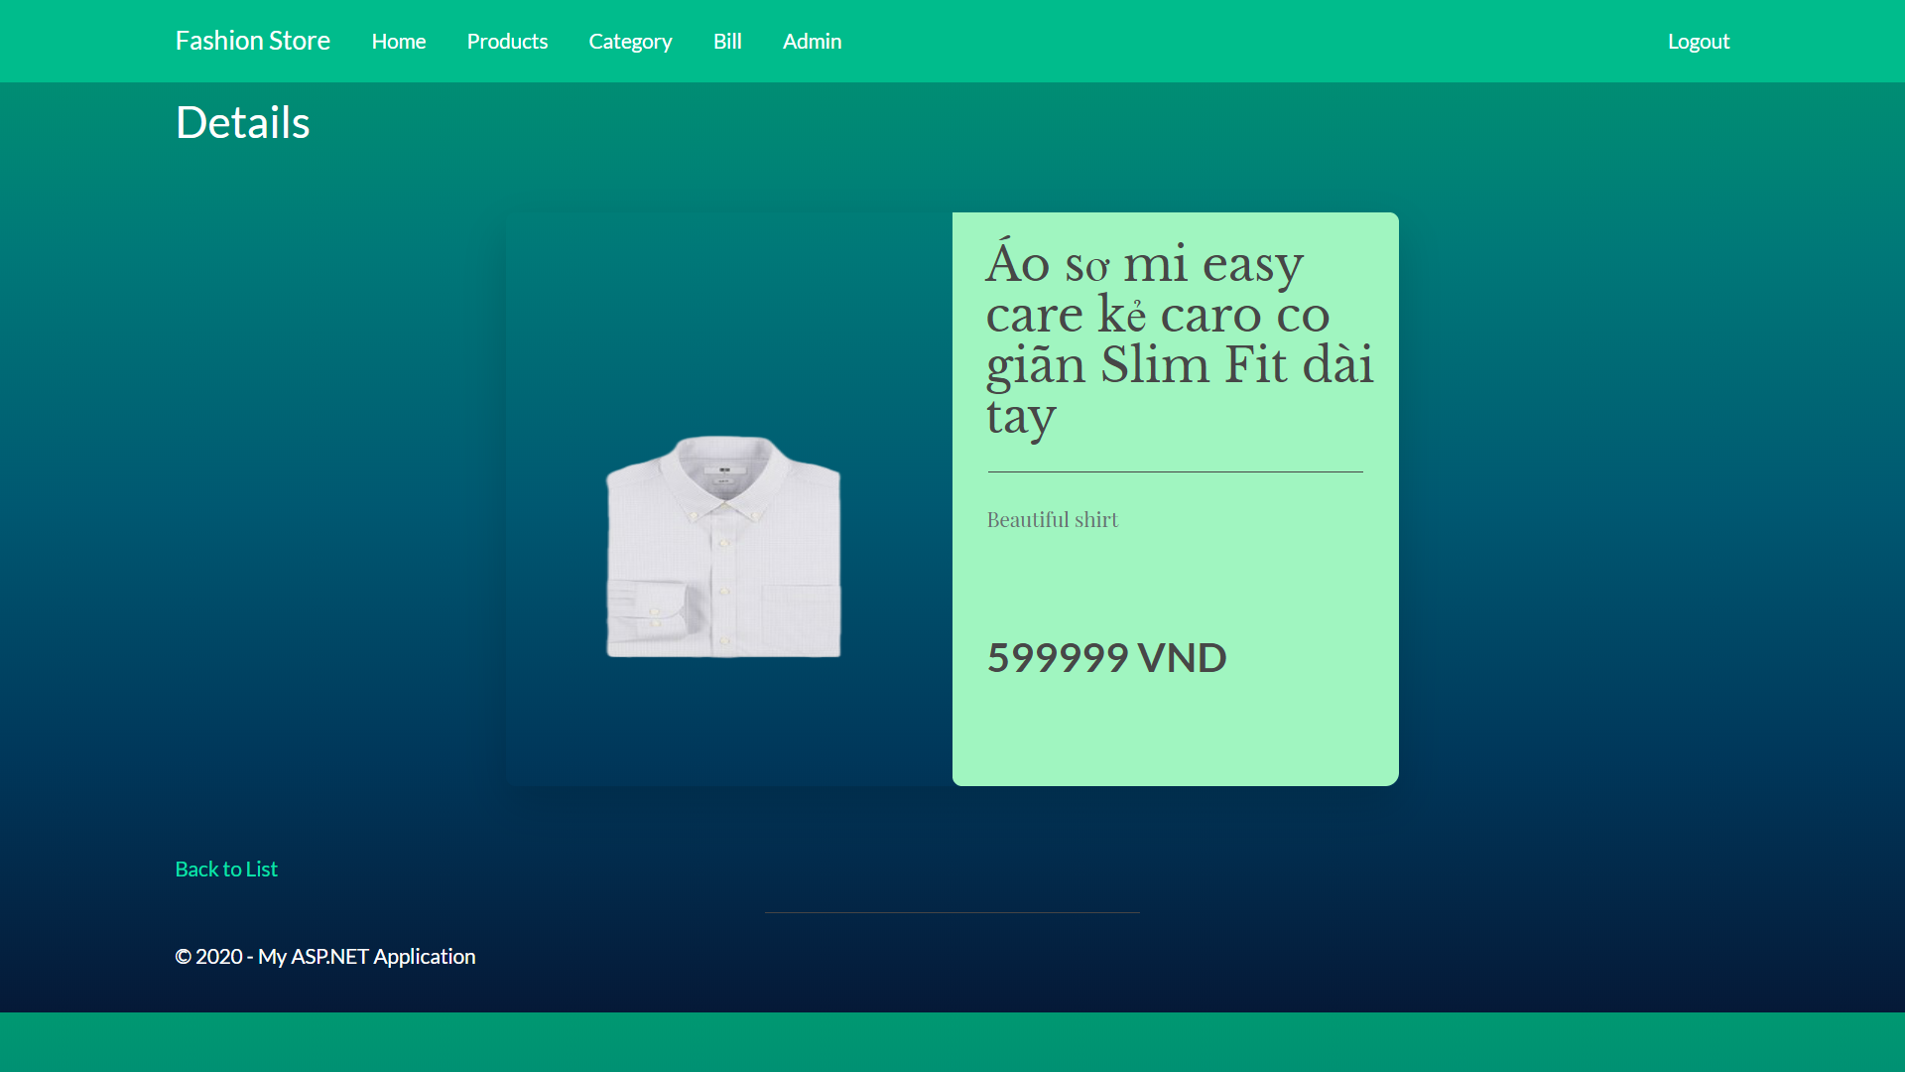

Image 10: Product detail

## 

Image 11: Cart detail

# References:

<https://dotnet.microsoft.com/apps/aspnet/mvc>

<https://stackoverflow.com/>

<https://docs.microsoft.com/en-us/aspnet/mvc/overview/older-versions/mvc-music-store/mvc-music-store-part-8>

<https://www.tutorialspoint.com/asp.net_mvc/index.htm>

# 

**LECTURER COMMENT**

Lecturer

(Name, signature)

_____________________________