

**Fitness and Lifestyle Documentation**

**(Template báo cáo cho các nhóm)**

|  |  |
| --- | --- |
| **Avengers<Tên nhóm>** | |
| **Group Member** | Đào Quang Linh(Leader)  Đào Đình Luyện  Lê Xuân Bắc  … |
| **Center** | ACE-HANOI-2-FPT |

- Hanoi, 8/20222 -

**Table of Contents**

1. Problem Definition 3

i. Introduction 3

ii. Implementation Environment 3

User Stories 4

1.2 User type 1 (Example: Admin) 4

i. Story 1 4

ii. Story 2 4

iii. Story 3 4

iv. … 4

1.3 User type 2 (Example: Staff) 4

i. Story 1 4

ii. Story 2 4

iii. … 4

1.4 User type 3 (Example: Customer) 4

i. Story 1 4

ii. Story 2 4

iii. Story 3 4

iv. … 4

[2. Flowchart 6](https://docs.google.com/document/d/1BqdS-eteOSuVxmBdmryPj17peh2B6gm0/edit#heading=h.1t3h5sf)

2.1 Search Products 6

2.2 Purchase Products

2.3…

3. Database(Chỉ category 2,3) 5

3.1 DB Relationship Diagram 5

3.2 Table 1 (Example: Account) 5

3.3 Table 2 (Example: Category) 6

3.4 Table 3 (Example: Product) 6

3. UI\UX 7

3.1 GUI 1 (Example: Login Form) 7

3.2 GUI 2 (Example: Address Book Form) 7

3.3 GUI 3 8

3.4 … 8

3.5 … 9

3.6 … 9

3.7 ... 9

3.8 ... 9

3.9 ... 9

3.10 ... 9

3.11 ... 9

4. Summary 10

# Problem Definition

### Introduction

Strength is one of the most important factors in today's world and should be our top priority. With the increase of diseases and the large number of urban populations, it becomes difficult to book an appointment or medical examination. There may be a person who wants to check their blood pressure, Weight, etc., and for this purpose, they ask to continue to visit the clinic. Sometimes, a whole day after making an appointment, a person may forget this or may go to the doctor's hospital/clinic and the doctor is unavailable. What individuals look for is an easy means to help them track and monitor their health. They will be able to set up reminders for doctor appointments, create a daily medication schedule, and track their weight, blood pressure and sugar levels, and more.

* Proposed solution

There needs to be a web app called PersonalHealthAssistant to help people manage their health

better health.

The app will allow users to register and then, view appointments, receive reminders

about their appointment, keep regular records of their health such as Blood Pressure (BP), Glucose,

etc medication dosing schedule and more.

* Scale

This application will be used by individuals who want to monitor health

their. They can set up reminders for doctor appointments, create calendars

Daily medication dosing schedule, monitoring weight, blood pressure and levels of blood sugar, etc.

### Implementation Environment

- Front End: HTML5, CSS3, Bootstrap / Angular, JavaScript, jQuery, XML

- Client & Server: Java 8 or higher, Java EE 7 or higher with Apache NetBeans IDE or Eclipse 2021 OR with Visual Studio IDE or higher, [ASP.NET](https://l.facebook.com/l.php?u=https%3A%2F%2FASP.NET%2F%3Ffbclid%3DIwAR0P03m-4MiJfHTMvxU5Xmn0zKRa8LOZZAArIz4JZFKw2j1ToJXCdG-4sAo&h=AT1i1GLyZ2FQu6o23jeDEpE6WcmbWr8ZTJLmLeipjJcKFUi1_GCYc4uav2369irOJHCg2rQlXrDqdyKy2h-UrCA_-ecq7i_TqPpfkz3utZfLEOEmpeuCH7vihDM0T2yqiU8Y&__tn__=q&c%5B0%5D=AT2i3ZJaQlBfCR-7Q08HF1dqkwgWApOTwykyyoyaRthwlm4rBpiHW16lWoFuzBfUY7Scw3QdKxJu_ZcmTSEgv6iA6yYFWsOMSrfS4vYhJkiy_xbYZ0VIbNo-K8IiJZ9LP7W2RAPWpHiHBIJMkyIDbJw2) MVC and Core

# User Stories

## User type 1 ( Admin )

### Story 1

With more than 10 years of experience in the field of medical technology equipment and services, going to many different hospital routes across the country, witnessing queues, waiting for medical examination. Along with that, the journey to find doctors, hospitals to treat relatives, friends, acquaintances... has prompted the founding team to see that something needs to be done to contribute to making it easier for people to go to the doctor. easier, more convenient and more efficient.

“Besides, we also often see many patients who have gone to many places, met many doctors but the disease is not cured, it takes time for treatment, it costs money, leading to depression, frustration, give up. One of the important reasons is due to the wrong person, right disease (right doctor, right medicine, right method) with the patient's problem.

Home Care Service - Is a great medical examination/treatment service in today's society, especially during the difficult time of the global epidemic - Covid-19. Besides being absolutely safe for the patient, it also saves the patient a great deal of time when there is no need to wait.

### Story 2

Regarding the cause of the above situation, according to experts in medical administration, it is because patients have no sense of community, have not registered for medical examination before and most of them do not receive medical examination on time. of specialists, you can go to the doctor every day. In advanced countries and even countries in the region, except for emergencies, patients who come for medical examination must register with a doctor or hospital in advance. Check up on the appointment of the specialist and always determine that if you go to the doctor today, it is considered not to do anything else. The appointment of medical examination will help the hospital to have a specific work plan, carefully prepared patient records in advance, especially in the case of follow-up visits. Confusion and haste will no longer occur and the doctor will have a comfortable mood when examining, then the quality of medical examination and treatment will also be greatly increased

According to health administrators, all of the above problems are due to habits, lasting for many years, our behavior when going to the doctor has been neglected, allowing bad habits to develop. with justification, insurmountable difficulties...

During the subsidy period, hospital fees were a very minor issue for both patients, hospitals and doctors. When a patient sees an illness, he or she comes for treatment, the doctor sees the need for an operation, and the hospital does not have to worry about losing revenue. Everything was taken care of by the State, doctors only focused on their expertise, but due to subsidies, some conditions and means of treatment were also limited.

Gone are the days of subsidies. Currently, in order to have funding for the operation of the hospital, each patient who is hospitalized for treatment needs to have a source of funding from the patient himself, his family, the State, and health insurance. and other forms of insurance, from charity and social funding... And hospital fees are now a big concern of patients. There have been many cases where patients did not agree to stay in the hospital and especially did not agree to surgery for the sole reason of not having money to pay hospital fees.

## User type 2 ( Staff )

### Story 1

At exactly 7:15 a.m., after briefing all the staff of the outpatient ward, we

returned to the outpatient clinic. As soon as the door opened, about a dozen patients were called in at once. Everyone's face was filled with anxiety and haste. More than a dozen medical examination sheets were put on the table at the same time and no one was willing to give up, everyone wanted an early examination. Le Thi T., 25 years old, a worker of an export garment factory suffering from a fibroid tumor in her left breast, firmly suggested that we get an early examination so that we could visit some friends who had just come out of the countryside. Sitting next to her is the old lady Tran Ngoc B., 65 years old, suffering from renal colic.

The patient herself and we suggest that Ms. B. be examined first because of the emergency. However, even though we said everything, patient T. still insisted on being examined first because he was too busy. Finally, with the doctor's right, we examined Mrs. B. in advance and transferred to the emergency room in time. Patient T. still has questions and claims to the authority. Other patients, even though they were already sitting in the clinic, were demanding an early examination. We also can't understand, if the examination is delayed for 4-5 minutes and leaves it to other patients such as the elderly, emergency patients, pregnant women... will it affect them or not ?

### Story 2

### …

## User type 3 (Example: Customer)

### Story 1

Called 6 times to many places for emergency help, I can't help but watch my father die

From the health hotline of Go Vap district, Mr. M.H. continued to be instructed to call the Health Station of Ward 16 (Go Vap District) at the phone number of Dr. Giang. However, when contacted, Dr. Giang said that the ward medical office only gave emergency treatment for COVID-19 cases, not stroke.

Mr. M.H. Called the Go Vap district health center, he was asked to wait and give the phone number of Dr. Thuong, head of the medical station in Ward 16, Go Vap. After nearly 5 minutes of waiting but no one came to the emergency room, Mr. M.H. continue to call 911 Emergency Center and will be informed that they will be accepted.

After nearly 20 minutes, 115 Emergency Center called back to ask about the situation and then instructed his family to find a way to take Mr. H. to the hospital, but could not access the emergency.

"They told me to feel and see if my father's heart was still beating, but at that time my father stopped breathing. They told me to find a way to bring myself to 175 Military Hospital for emergency, but there is no other way," said Mr. M.H. tell.

At 7:30 a.m., his family took Mr. H. to Military Hospital 175. However, the doctor determined that Mr. H had had a cardiac arrest before entering the hospital.

According to Mr. H's family, at 7:45 a.m., a team of 4 people from the ward health station came down, but at this time Mr. H. was taken to the hospital.

### Story 2

As an adult, they often suffer from diseases such as bone and joint pain, cardiovascular disease, and blood pressure. These diseases are characterized by the fact that they cannot be completely cured, but can only be controlled and restrained from the development of the disease. . Therefore, having a person who regularly monitors and takes care of the health of the elderly is essential, finding home health care services for the elderly is the most appropriate solution at this time.

### Story 3

### Like the elderly, young children often suffer from various diseases due to the influence of their underdeveloped physical body, poor stamina and resistance. Instead of going to the pediatric hospital, which is always overloaded, waiting and waiting to see and diagnose the baby, and having to spend a lot of effort to take care of the baby, the home examination service immediately eliminates the hassles. that nuisance.

## …

## …

## ...

## ...

# Flowchart

## User

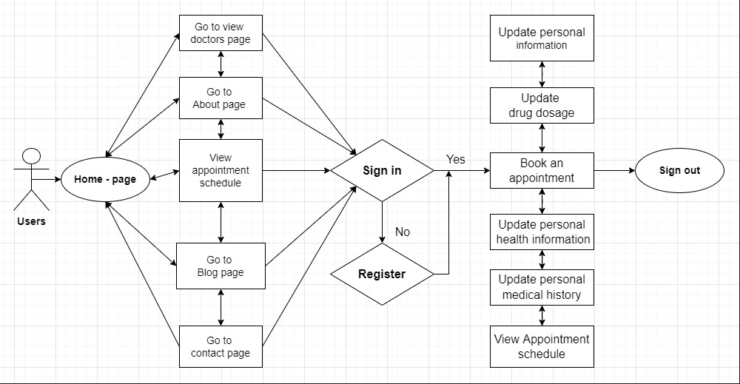

**Users:**

Users who visit our homepage will be able to see detailed information software PersonalhealthAssistant. When you find it necessary for your own health, you must register an account to be able to log in to the system. Once you have an account, you can book appointments, check your personal information, the amount of medication you take and check your own medication history.

## Admin

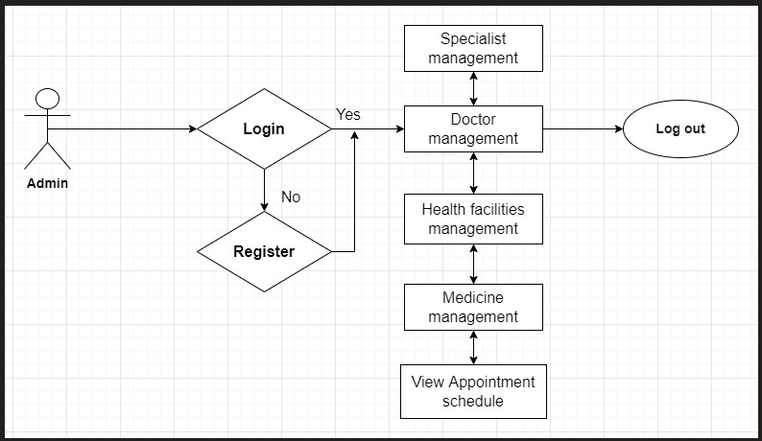

**Admin**:

Our will manage the rights of users and the doctors we manage. We have specialists in different fields in top facilities. From the booking information of each customer, we will control and comply with your requirements, and our system also ensures to remind you of your appointment by email.

# Database

## DB Relationship Diagram

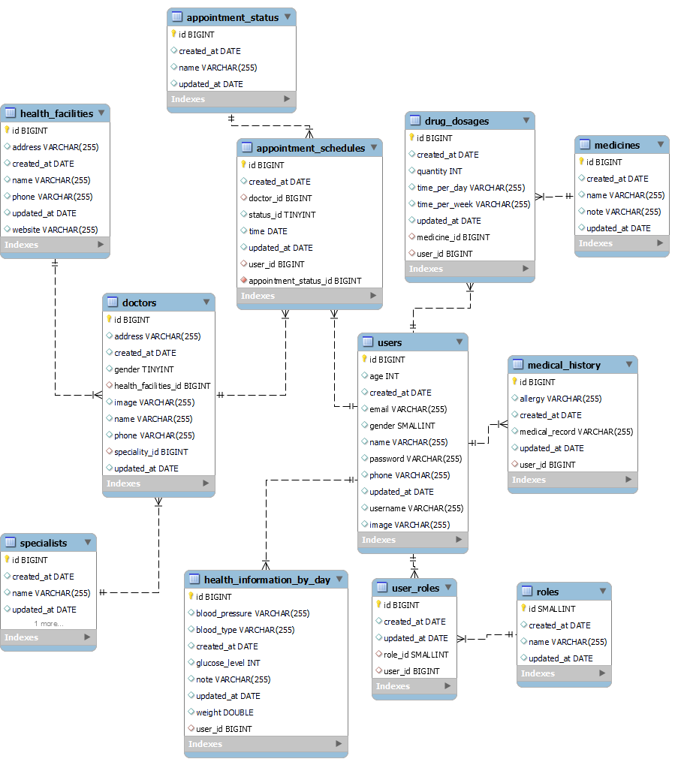

## Table 1 (Health_facilities)

|  |  |  |  |
| --- | --- | --- | --- |
| **Column Name** | **Data Type** | **Constraint** | **Description** |
| id | bigint | primary key | Indentity of the health facility |
| name | varchar(255) | not null | Name of the health facility |
| phone | varchar(255) | not null | Phone contact number |
| address | varchar(255) | not null | Address of health facility |
| website | varchar(255) | not null | Website of health facility |
| created_at | date | auto genenrate | The date created in the app system of that facility |
| update_at | date | auto update | The date that data of the health facility got updated |

## Table 2 (Specialists)

|  |  |  |  |
| --- | --- | --- | --- |
| id | bigint | primary key | Indentity of a Medical specialty in the system |
| name | varchar(255) | not null | Name of the medical specialists or doctor specialties |
| image | varchar(255) |  | Image that represents health specialties |
| created_at | date | auto generate | The date that the specialty is created in the app system |
| update_at | date | auto generate | The date that the specialty is updated in the app system |

## Table 3 (Doctors)

|  |  |  |  |
| --- | --- | --- | --- |
| id | bigint | primary key | Indentity of a doctor in the system |
| name | varchar(255) |  | Name of the doctor |
| gender | tinyint |  | Gender of the doctor |
| phone | varchar(255) |  | Phone number to contact with doctor |
| address | varchar(255) |  | Address of the doctor |
| image | varchar(255) |  | Image of the doctor (profile picture) |
| health_facilities_id | bigint | foreign key (Health_facilities) | Define where the health facility that doctor is working |
| speciality_id | bigint | foreign key (Specialties) | Define medical specialty of that doctor |
| created_at |  | auto generate | The day the doctor profile created in the app |
| updated_at |  | auto generate | The day the doctor profile updated in the app |

## Table 4 (Users)

|  |  |  |  |
| --- | --- | --- | --- |
| id | bigint | primary key | Indentity of a doctor in the system |
| name | varchar(255) | not null | Full name of the user |
| age | int |  | Age of the user |
| email | varchar(255) | not null, unique | Register email of the user |
| phone | varchar(255) | not null, unique | Phone number of the user |
| gender | tinyint | not null | Gender of the user |
| image | varchar(255) |  | Image of the user |
| username | varchar(255) | not null, unique | User name for login |
| password | varchar(255) | not null | Password for login |
| created_at | date | auto generate | Auto generate created date |
| updated_at | date | auto generate | Auto update the day profile got updated |

## Table 5 (Roles)

|  |  |  |  |
| --- | --- | --- | --- |
| id | bigint | primary key | Indentity of a Roles in the system |
| name | varchar(255) | not null | Title of the roles |
| created_at | date | auto generate | Auto generate created date |
| updated_at | date | auto generate | Auto update the day Role got updated |

## Table 6 (User_Roles)

|  |  |  |  |
| --- | --- | --- | --- |
| id | bigint | primary key | Indentity of a User_Roles in the system |
| role_id | smallint | foreign key  (Roles) | Id of the role in the Roles table |
| user_id | bigint | foreign key  (Users) | Id of the user in the Users table |
| created_at | date | auto generate | Auto generate created date |
| updated_at | date | auto generate | Auto update the day User_Role got updated |

## Table 7 (Health_information_by_day)

|  |  |  |  |
| --- | --- | --- | --- |
| id | bigint | primary key | Indentity of a Health information by day in the system |
| blood_pressure | varchar(255) |  | Describe daily blood pressure of the user |
| blood_type | varchar(255) |  | Describe blood type of the user |
| glucose_level | int |  | Describe glucose level of the user daily |
| weight | double |  | Describe weigh of the user daily |
| note | varchar(255) |  | Note by the user for their daily health |
| user_id | bigint | foreign key(Users) | Id of the user in the Users table |
| created_at | date | auto generate | Auto generate created date |
| updated_at | date | auto generate | Auto update the day Role got updated |

## Table 8 (Medical History)

|  |  |  |  |
| --- | --- | --- | --- |
| id | bigint | primary key | Indentity of a Medical History in the system |
| medical_record | varchar(255) |  | Note all the medical status and important disases infomation here |
| allergy | varchar(255) |  | Note if user has any allergic to anything |
| user_id | bigint | foreign key(Users) | Id of the user in the Users table |
| created_at | date | auto generate | Auto generate created date |
| updated_at | date | auto generate | Auto update the day Role got updated |

## Table 9 (Medicine)

|  |  |  |  |
| --- | --- | --- | --- |
| id | bigint | primary key | Indentity of a Medicine in the system |
| name | varchar(255) | not null | Drug name or Medicine name |
| note | varchar(255) |  | Document with the aim of guiding decisions and criteria Degarding diagnosis, management, and treatment in specific areas of healthcare |
| created_at | date | auto generate | Auto generate created date |
| updated_at | date | auto generate | Auto update the day Role got updated |

## Table 10 (Drug_dosages)

|  |  |  |  |
| --- | --- | --- | --- |
| id | bigint | primary key | Indentity of a Drug and Dosage in the system |
| quantity | int | not null | Quantity of drug the user has to take each time |
| time_per_week | int | not null | Number of times the user has to user the drug for a week |
| time_per_day | int | not null | Number of times the user has to user the drug for a day |
| medicine_id | bigint | foreign key(Medicine) | Medicine id that link to Medicine table |
| user_id | bigint | foreign key(User) | User id that link to Users table |
| created_at | date | auto generate | Auto generate created date |
| updated_at | date | auto generate | Auto update when table updated |

## Table 11 (Appointment status)

|  |  |  |  |
| --- | --- | --- | --- |
| id | bigint | primary key | Indentity of a appointment status |
| name | varchar(255) | not null | Describe all appointment status of a appointment |
| created_at | date | auto generate | Auto generate created date |
| updated_at | date | auto generate | Auto update the day appointment status got updated |

## Table 12 (Appoitment Schedules)

|  |  |  |  |
| --- | --- | --- | --- |
| id | bigint | primary key | Indentity of an appointment in the system |
| doctor_id | bigint | foreign key (Doctors) | Link to the identity of the doctors table |
| status_id | tinyint | foreign key (Appointment status) | Link to the id of the appointment status table |
| user_id | bigint | foreign key (Users) | Link to the id of Users table |
| time | date | not null | Time request for the appointment between doctors and users |
| created_at | date | auto generate | The day the doctor profile created in the app |
| updated_at | date | auto generate | Auto update the day appointment status got updated |

# UI\UX

## GUI 1 (Home Page)

Example 1:

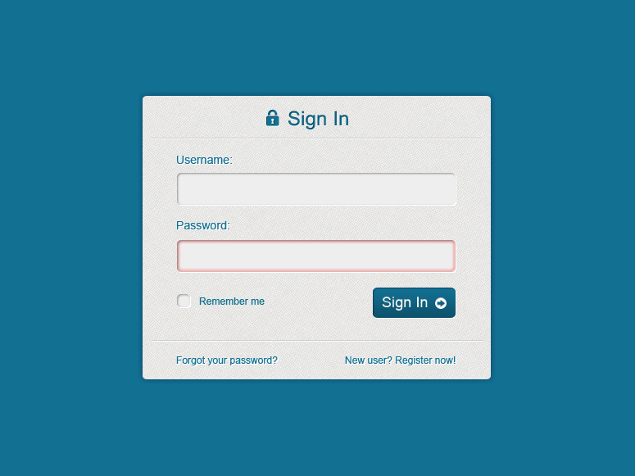

Example 2 (Login Form):

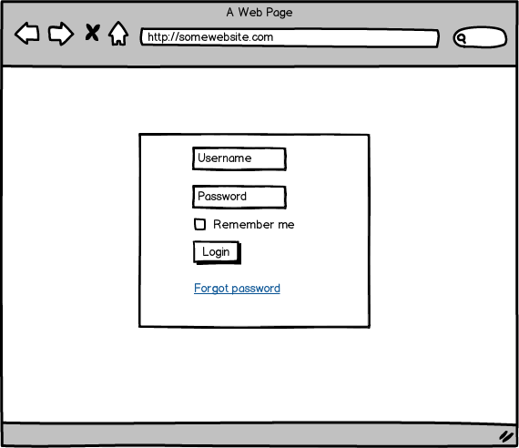

## GUI 2 (Booking Care Form)

Example 1:

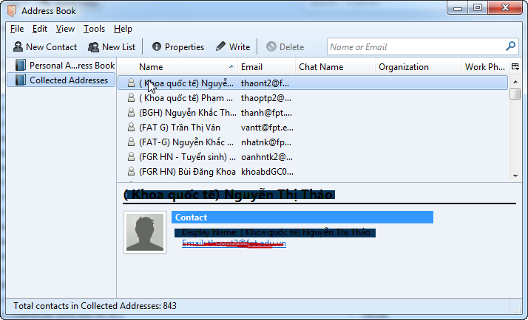

Example 2 (Mock UI):

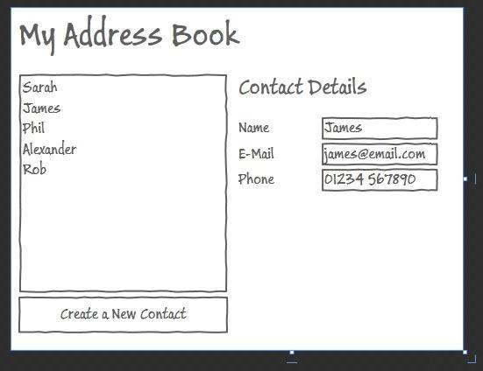

## GUI 3 (About Us)

## GUI 4 (Doctors)

## GUI 5 (Contact)

## GUI 6 (Login/Logout Form)

## GUI 7(Search Information)

## GUI 8 ((Profile User)

## GUI 9 (Add data)

## GUI 10 (Update data)

## GUI 11 (Delete data)

# Summary

* Because the global epidemic situation is still stressful, to keep ourselves healthy, we had the idea and designed the Personal Health Assistant app to help people self-monitor their health.
* The application we designed for the purpose of improving people's health, has many different functions, but especially helps you to make an appointment with top doctors and automatically remind you to schedule an appointment by email.
* We use technologies to design this application such as HTML5, CSS3, Bootstrap, JavaScript, jQuery, VueJS, Springboot and have quite satisfactory results.
* From this TechWiz session, we have learned more about the strengths and weaknesses of working together as a team. Have a great experience participating in the competition. Those are also useful experiences in the future when working for us.
* Thank you to the organizers and teachers for helping us have such an interesting TechWiz contest.