Санкт-Петербургский Национальный Исследовательский Университет

Информационных Технологий, Механики и Оптики

ФКТиУ, кафедра Вычислительной техники

Лабораторная работа №2

по дисциплине

«Программирование»

Вариант - 18065

Выполнил: Чан Куанг Лок

Группа: P3100

Санкт-Петербург

2018 г.

На основе базового класса Pokemon написать свои классы для заданных видов покемонов. Каждый вид покемона должен иметь один или два типа и стандартные базовые характеристики:

* очки здоровья (HP)
* атака (attack)
* защита (defense)
* специальная атака (special attack)
* специальная защита (special defense)
* скорость (speed)

Классы покемонов должны наследоваться в соответствии с цепочкой эволюции покемонов. На основе базовых классов PhysicalMove, SpecialMove и StatusMove реализовать свои классы для заданных видов атак.

Атака должна иметь стандартные тип, силу (power) и точность (accuracy). Должны быть реализованы стандартные эффекты атаки. Назначить каждому виду покемонов атаки в соответствии с вариантом. Уровень покемона выбирается минимально необходимым для всех реализованных атак.

Используя класс симуляции боя Battle, создать 2 команды покемонов (каждый покемон должен иметь имя) и запустить бой.

Базовые классы и симулятор сражения находятся в [jar-архиве](https://se.ifmo.ru/documents/10180/660917/Pokemon.jar/ce164749-d074-40ed-bc13-15e09d62600a). Документация в формате javadoc - в [zip-архиве](https://se.ifmo.ru/documents/10180/660917/doc.zip/244252e6-e4dd-4b52-8de1-b497d4402c7a).

Информацию о покемонах, цепочках эволюции и атаках можно найти на сайтах [http://poke-universe.ru](http://poke-universe.ru/), [http://pokemondb.net](http://pokemondb.net/),<http://veekun.com/dex/pokemon>

Вариант

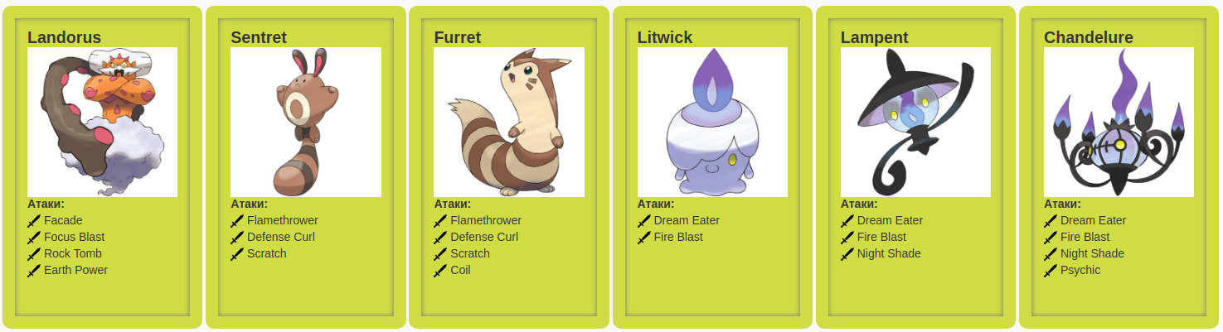

**UML Диаграмма**

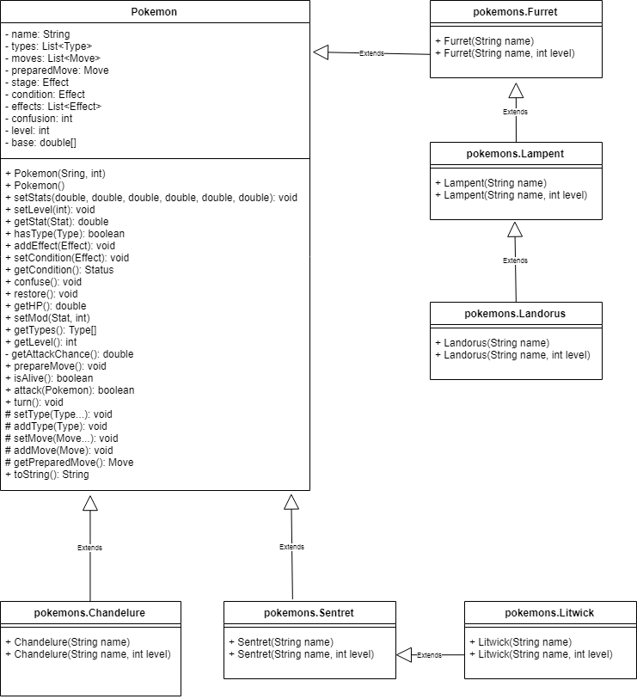

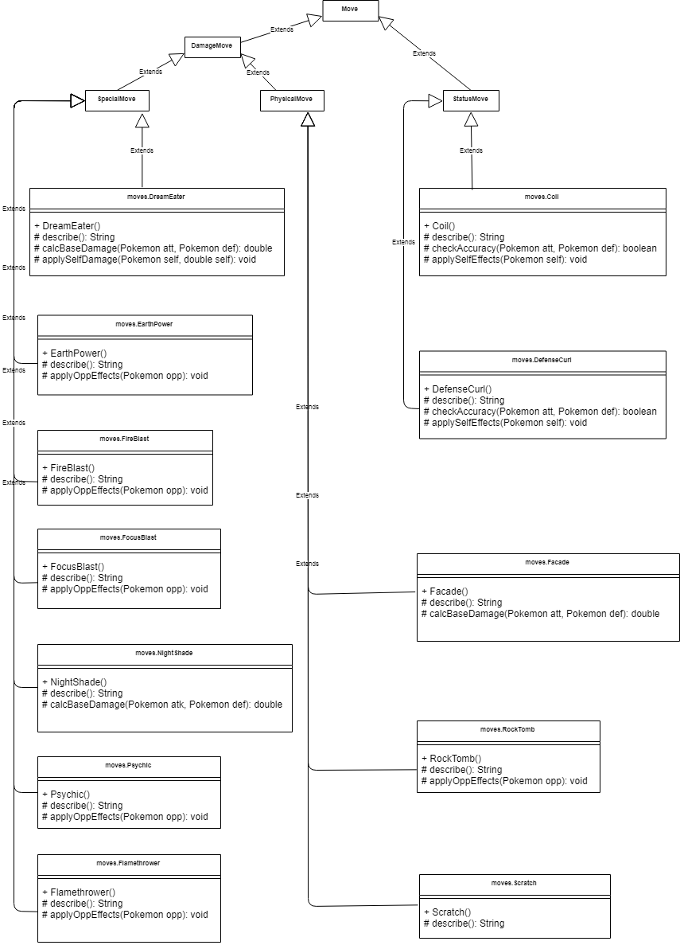

**Исходный код программы**

**// ru/ifmo/se/s267880/lab2/moves/Coil.java**

package ru.ifmo.se.s267880.lab2.moves;

import ru.ifmo.se.pokemon.Pokemon;

import ru.ifmo.se.pokemon.StatusMove;

import ru.ifmo.se.pokemon.Stat;

import ru.ifmo.se.pokemon.Type;

**public** **class** Coil **extends** StatusMove {

**public** Coil() {

super(Type.POISON, 0, 1);

}

@Override

**protected** String describe() {

// yep, strong one

return "Coil: Raises the user's Attack, Defense, and accuracy by one stage each";

}

@Override

**protected** **boolean** checkAccuracy(Pokemon att, Pokemon def) {

return **true**;

}

@Override

**protected** **void** applySelfEffects(Pokemon self) {

self.setMod(Stat.ATTACK, 1);

self.setMod(Stat.DEFENSE, 1);

self.setMod(Stat.ACCURACY, 1);

}

}

**// ru/ifmo/se/s267880/lab2/moves/DefenseCurl.java**

package ru.ifmo.se.s267880.lab2.moves;

import ru.ifmo.se.pokemon.Pokemon;

import ru.ifmo.se.pokemon.StatusMove;

import ru.ifmo.se.pokemon.Stat;

import ru.ifmo.se.pokemon.Type;

**public** **class** DefenseCurl **extends** StatusMove {

**public** DefenseCurl() {

super(Type.NORMAL, 0, 1);

}

@Override

**protected** String describe() {

return "DefenseCurl: Raises user's Defense by one stage";

}

@Override

**protected** **boolean** checkAccuracy(Pokemon att, Pokemon def) {

return **true**;

}

@Override

**protected** **void** applySelfEffects(Pokemon self) {

self.setMod(Stat.DEFENSE, 1);

}

}

**// ru/ifmo/se/s267880/lab2/moves/DreamEater.java**

package ru.ifmo.se.s267880.lab2.moves;

import ru.ifmo.se.pokemon.Pokemon;

import ru.ifmo.se.pokemon.SpecialMove;

import ru.ifmo.se.pokemon.Status;

import ru.ifmo.se.pokemon.Stat;

import ru.ifmo.se.pokemon.Type;

**public** **class** DreamEater **extends** SpecialMove {

**public** DreamEater() {

super(Type.PSYCHIC, 100, 1);

}

@Override

**protected** String describe() {

return "Dream Eater: Dream Eater only works if the target is asleep. Dream Eater inflicts damage and 50% of the damage dealt (rounded up) is restored to the user as HP";

}

@Override

**protected** **double** calcBaseDamage(Pokemon att, Pokemon def) {

**if** (def.getCondition() == Status.SLEEP) {

return super.calcBaseDamage(att, def);

}

return 0;

}

@Override

**protected** **void** applySelfDamage(Pokemon self, **double** dam) {

self.setMod(Stat.HP, (**int**)Math.ceil(dam / 2));

}

}

**// ru/ifmo/se/s267880/lab2/moves/EarthPower.java**

package ru.ifmo.se.s267880.lab2.moves;

import ru.ifmo.se.pokemon.Pokemon;

import ru.ifmo.se.pokemon.SpecialMove;

import ru.ifmo.se.pokemon.Stat;

import ru.ifmo.se.pokemon.Type;

**public** **class** EarthPower **extends** SpecialMove {

**public** EarthPower() {

super(Type.GROUND, 90, 1);

}

@Override

**protected** String describe() {

return "Earth Power: Has a 10% chance to lower the target's Special Defense by one stage";

}

@Override

**protected** **void** applyOppEffects(Pokemon opp) {

**if** (Math.random() < 0.1) opp.setMod(Stat.SPECIAL_DEFENSE, -1);

}

}

**// ru/ifmo/se/s267880/lab2/moves/Facade.java**

package ru.ifmo.se.s267880.lab2.moves;

import ru.ifmo.se.pokemon.PhysicalMove;

import ru.ifmo.se.pokemon.Pokemon;

import ru.ifmo.se.pokemon.Status;

import ru.ifmo.se.pokemon.Type;

**public** **class** Facade **extends** PhysicalMove {

**public** Facade() {

super(Type.NORMAL, 70, 1);

}

@Override

**protected** String describe() {

return "Facade: Power doubles if user is burned, paralyzed, or poisoned";

}

@Override

**protected** **double** calcBaseDamage(Pokemon att, Pokemon def) {

**double** dam = super.calcBaseDamage(att, def);

Status defSt = def.getCondition();

**if** (defSt == Status.BURN || defSt == Status.PARALYZE || defSt == Status.POISON) {

dam *= 2;

}

return dam;

}

}

**// ru/ifmo/se/s267880/lab2/moves/FireBlast.java**

package ru.ifmo.se.s267880.lab2.moves;

import ru.ifmo.se.pokemon.Effect;

import ru.ifmo.se.pokemon.Pokemon;

import ru.ifmo.se.pokemon.SpecialMove;

import ru.ifmo.se.pokemon.Type;

**public** **class** FireBlast **extends** SpecialMove {

**public** FireBlast() {

super(Type.FIRE, 110, 0.85);

}

@Override

**protected** String describe() {

return "Fire Blast: Has a 10% chance to burn the target";

}

@Override

**protected** **void** applyOppEffects(Pokemon opp) {

**if** (Math.random() < 0.1) Effect.burn(opp);

}

}

**// ru/ifmo/se/s267880/lab2/moves/Flamethrower.java**

package ru.ifmo.se.s267880.lab2.moves;

import ru.ifmo.se.pokemon.Effect;

import ru.ifmo.se.pokemon.SpecialMove;

import ru.ifmo.se.pokemon.Type;

import ru.ifmo.se.pokemon.Pokemon;

**public** **class** Flamethrower **extends** SpecialMove {

**public** Flamethrower() {

super(Type.FIRE, 90, 1);

}

@Override

**protected** String describe() {

return "Flamethrower: Has a 10% chance to burn the target";

}

@Override

**protected** **void** applyOppEffects(Pokemon opp) {

**if** (Math.random() < 0.1) Effect.burn(opp);

}

}

**// ru/ifmo/se/s267880/lab2/moves/FocusBlast.java**

package ru.ifmo.se.s267880.lab2.moves;

import ru.ifmo.se.pokemon.Effect;

import ru.ifmo.se.pokemon.Pokemon;

import ru.ifmo.se.pokemon.SpecialMove;

import ru.ifmo.se.pokemon.Stat;

import ru.ifmo.se.pokemon.Type;

**public** **class** FocusBlast **extends** SpecialMove {

**public** FocusBlast() {

super(Type.FIGHTING, 120, 70);

}

@Override

**protected** String describe() {

return "Focus Blast: Has a 10% chance to lower the target's Special Defense by one stage";

}

@Override

**protected** **void** applyOppEffects(Pokemon opp) {

**if** (Math.random() < 0.1) opp.setMod(Stat.SPECIAL_DEFENSE, -1);

}

}

**// ru/ifmo/se/s267880/lab2/moves/NightShade.java**

package ru.ifmo.se.s267880.lab2.moves;

import ru.ifmo.se.pokemon.SpecialMove;

import ru.ifmo.se.pokemon.Type;

import ru.ifmo.se.pokemon.Pokemon;

**public** **class** NightShade **extends** SpecialMove {

**public** NightShade() {

super(Type.GHOST, -1, 1);

}

@Override

**protected** String describe() {

return "Night Shade: Inflicts damage equal to the user's level";

}

@Override

**protected** **double** calcBaseDamage(Pokemon atk, Pokemon def) {

return atk.getLevel();

}

}

**// ru/ifmo/se/s267880/lab2/moves/Psychic.java**

package ru.ifmo.se.s267880.lab2.moves;

import ru.ifmo.se.pokemon.SpecialMove;

import ru.ifmo.se.pokemon.Type;

import ru.ifmo.se.pokemon.Stat;

import ru.ifmo.se.pokemon.Pokemon;

**public** **class** Psychic **extends** SpecialMove {

**public** Psychic() {

super(Type.PSYCHIC, 90, 1);

}

@Override

**protected** String describe() {

return "Psychic: Has a 10% chance to lower the target's Special Defense by one stage";

}

@Override

**protected** **void** applyOppEffects(Pokemon opp) {

**if** (Math.random() < 0.1) opp.setMod(Stat.SPECIAL_DEFENSE, -1);

}

}

**// ru/ifmo/se/s267880/lab2/moves/RockTomb.java**

package ru.ifmo.se.s267880.lab2.moves;

import ru.ifmo.se.pokemon.PhysicalMove;

import ru.ifmo.se.pokemon.Pokemon;

import ru.ifmo.se.pokemon.Stat;

import ru.ifmo.se.pokemon.Type;

**public** **class** RockTomb **extends** PhysicalMove {

**public** RockTomb() {

super(Type.ROCK, 60, 0.95);

}

@Override

**protected** String describe() {

return "Rock Tomb: Has a 100% chance to lower the target's Speed by one stage";

}

@Override

**protected** **void** applyOppEffects(Pokemon opp) {

opp.setMod(Stat.SPEED, -1);

}

}

**// ru/ifmo/se/s267880/lab2/moves/Scratch.java**

package ru.ifmo.se.s267880.lab2.moves;

import ru.ifmo.se.pokemon.PhysicalMove;

import ru.ifmo.se.pokemon.Type;

**public** **class** Scratch **extends** PhysicalMove {

**public** Scratch() {

super(Type.NORMAL, 40, 1);

}

@Override

**protected** String describe() {

return "Scratch: Inflicts regular damage with no additional effect";

}

}

**// ru/ifmo/se/s267880/lab2/pokemons/Chandelure.java**

package ru.ifmo.se.s267880.lab2.pokemons;

import ru.ifmo.se.s267880.lab2.pokemons.Lampent;

import ru.ifmo.se.s267880.lab2.moves.Psychic;

**public** **class** Chandelure **extends** Lampent {

**public** Chandelure(String name) {

this(name, 13);

}

**public** Chandelure(String name, **int** level) {

super(name, level);

setStats(60, 55, 90, 145, 90, 80);

// move learnt by using machine

addMove(new Psychic());

}

}

**// ru/ifmo/se/s267880/lab2/pokemons/Furret.java**

package ru.ifmo.se.s267880.lab2.pokemons;

import ru.ifmo.se.pokemon.Pokemon;

import ru.ifmo.se.s267880.lab2.pokemons.Sentret;

import ru.ifmo.se.s267880.lab2.moves.Coil;

**public** **class** Furret **extends** Sentret {

**public** Furret(String name) {

this(name, 4);

}

**public** Furret(String name, **int** level) {

super(name, level);

setStats(85, 76, 64, 45, 55, 90);

// no level required

addMove(new Coil());

}

}

**// ru/ifmo/se/s267880/lab2/pokemons/Lampent.java**

package ru.ifmo.se.s267880.lab2.pokemons;

import ru.ifmo.se.s267880.lab2.pokemons.Litwick;

import ru.ifmo.se.s267880.lab2.moves.NightShade;

**public** **class** Lampent **extends** Litwick {

**public** Lampent(String name) {

this(name, 13);

}

**public** Lampent(String name, **int** level) {

super(name, level);

setStats(60, 40, 60, 95, 60, 55);

**if** (level >= 13) addMove(new NightShade());

}

}

**// ru/ifmo/se/s267880/lab2/pokemons/Landorus.java**

package ru.ifmo.se.s267880.lab2.pokemons;

import ru.ifmo.se.pokemon.Pokemon;

import ru.ifmo.se.s267880.lab2.moves.Facade;

import ru.ifmo.se.s267880.lab2.moves.FocusBlast;

import ru.ifmo.se.s267880.lab2.moves.RockTomb;

import ru.ifmo.se.s267880.lab2.moves.EarthPower;

**public** **class** Landorus **extends** Pokemon {

**public** Landorus(String name) {

this(name, 43); // required level

}

**public** Landorus(String name, **int** level) {

super(name, level);

setStats(89, 125, 90, 115, 80, 101);

// Moves learnt by machine

addMove(new Facade());

addMove(new FocusBlast());

// this move and be learnt using machine or pokemon is at the level 0

addMove(new RockTomb());

**if** (level >= 43) {

// actually this move can be taught by an NPC anytime :v

addMove(new EarthPower());

}

}

}

**// ru/ifmo/se/s267880/lab2/pokemons/Litwick.java**

package ru.ifmo.se.s267880.lab2.pokemons;

import ru.ifmo.se.pokemon.Pokemon;

import ru.ifmo.se.s267880.lab2.moves.DreamEater;

import ru.ifmo.se.s267880.lab2.moves.FireBlast;

**public** **class** Litwick **extends** Pokemon {

**public** Litwick(String name) {

this(name, 1); // required level

}

**public** Litwick(String name, **int** level) {

super(name, level);

setStats(50, 30, 55, 65, 55, 20);

// moves learnt by using machines

addMove(new DreamEater());

addMove(new FireBlast());

}

}

**// ru/ifmo/se/s267880/lab2/pokemons/Sentret.java**

package ru.ifmo.se.s267880.lab2.pokemons;

import ru.ifmo.se.pokemon.Pokemon;

import ru.ifmo.se.s267880.lab2.moves.Flamethrower;

import ru.ifmo.se.s267880.lab2.moves.DefenseCurl;

import ru.ifmo.se.s267880.lab2.moves.Scratch;

**public** **class** Sentret **extends** Pokemon {

**public** Sentret(String name) {

this(name, 4);

}

**public** Sentret(String name, **int** level) {

super(name, level);

setStats(35, 46, 34, 35, 45, 20);

// moves learnt by using machine

addMove(new Flamethrower());

// no level require

addMove(new Scratch());

**if** (level >= 4) addMove(new DefenseCurl());

}

}

**// ru/ifmo/se/s267880/lab2/IWannaBeTheVeryBest.java**

package ru.ifmo.se.s267880.lab2;

import ru.ifmo.se.pokemon.Battle;

import ru.ifmo.se.s267880.lab2.pokemons.*;

**public** **class** IWannaBeTheVeryBest {

**public** **static** **void** main(String[] args) {

String names[] = {

"Pankratiy Andrei",

"Maryana Uliana",

"Dorofei Anisim",

"Sveta Igor",

"Diana Gavriil",

"Yuliy Vitaliya",

};

Battle bt = new Battle();

bt.addAlly(new Sentret(names[2]));

bt.addAlly(new Lampent(names[0]));

bt.addAlly(new Landorus(names[5]));

bt.addFoe(new Furret(names[3]));

bt.addFoe(new Litwick(names[4]));

bt.addFoe(new Chandelure(names[1]));

bt.go();

}

}

**Результат работы программы.**

Sentret Dorofei Anisim from the team Greren enters the battle!

Furret Sveta Igor from the team Purple enters the battle!

Furret Sveta Igor Scratch: Inflicts regular damage with no additional effect.

Sentret Dorofei Anisim loses 6 hit points.

Sentret Dorofei Anisim Flamethrower: Has a 10% chance to burn the target.

Furret Sveta Igor loses 6 hit points.

Furret Sveta Igor Coil: Raises the user's Attack, Defense, and accuracy by one stage each.

Furret Sveta Igor increases attack.

Furret Sveta Igor increases defense.

Furret Sveta Igor increases accuracy.

Sentret Dorofei Anisim Scratch: Inflicts regular damage with no additional effect.

Furret Sveta Igor loses 5 hit points.

Furret Sveta Igor Flamethrower: Has a 10% chance to burn the target.

Sentret Dorofei Anisim loses 6 hit points.

Sentret Dorofei Anisim DefenseCurl: Raises user's Defense by one stage.

Sentret Dorofei Anisim increases defense.

Furret Sveta Igor Coil: Raises the user's Attack, Defense, and accuracy by one stage each.

Furret Sveta Igor increases attack.

Furret Sveta Igor increases defense.

Furret Sveta Igor increases accuracy.

Sentret Dorofei Anisim Flamethrower: Has a 10% chance to burn the target.

Furret Sveta Igor loses 7 hit points.

Furret Sveta Igor Scratch: Inflicts regular damage with no additional effect.

Sentret Dorofei Anisim loses 4 hit points.

Sentret Dorofei Anisim Flamethrower: Has a 10% chance to burn the target.

Furret Sveta Igor loses 4 hit points.

Furret Sveta Igor faints.

Litwick Diana Gavriil from the team Purple enters the battle!

Sentret Dorofei Anisim DefenseCurl: Raises user's Defense by one stage.

Sentret Dorofei Anisim increases defense.

Litwick Diana Gavriil struggles.

Sentret Dorofei Anisim loses 3 hit points.

Litwick Diana Gavriil loses 1 hit points.

Sentret Dorofei Anisim faints.

Lampent Pankratiy Andrei from the team Greren enters the battle!

Lampent Pankratiy Andrei struggles.

Litwick Diana Gavriil loses 12 hit points.

Lampent Pankratiy Andrei loses 3 hit points.

Litwick Diana Gavriil faints.

Chandelure Maryana Uliana from the team Purple enters the battle!

Chandelure Maryana Uliana Psychic: Has a 10% chance to lower the target's Special Defense by one stage.

Lampent Pankratiy Andrei loses 15 hit points.

Lampent Pankratiy Andrei struggles.

Chandelure Maryana Uliana loses 6 hit points.

Lampent Pankratiy Andrei loses 2 hit points.

Chandelure Maryana Uliana Dream Eater: Dream Eater only works if the target is asleep. Dream Eater inflicts damage and 50% of the damage dealt (rounded up) is restored to the user as HP.

Lampent Pankratiy Andrei loses 3 hit points.

Chandelure Maryana Uliana loses 2 hit points.

Lampent Pankratiy Andrei struggles.

Chandelure Maryana Uliana loses 5 hit points.

Lampent Pankratiy Andrei loses 1 hit points.

Chandelure Maryana Uliana Night Shade: Inflicts damage equal to the user's level.

Critical hit!

Lampent Pankratiy Andrei loses 86 hit points.

Lampent Pankratiy Andrei faints.

Landorus Yuliy Vitaliya from the team Greren enters the battle!

Landorus Yuliy Vitaliya Rock Tomb: Has a 100% chance to lower the target's Speed by one stage.

Critical hit!

Chandelure Maryana Uliana loses 106 hit points.

Chandelure Maryana Uliana decreases speed.

Chandelure Maryana Uliana faints.

Team Purple loses its last Pokemon.

The team Greren wins the battle!

**Выводы:** в процессе выполнения лабораторной работы были получены

навыки использования объектно-ориентированного подхода

программирования.