COFFEE "C" FUTURES | TRADING PLAN
Sell the December/March spread on the 2022 playbook
Short KCZ26 / long KCH27, closed before first notice day on 19 November 2026
Prepared 5 October 2026 · market data to 2 October 2026 settlement · DRAFT – for Finance review before distribution

1. The plan in one page
The idea is simple. Today December coffee costs 8.25 US cents/lb more than March coffee. We expect that premium to shrink before December delivery starts, as it did in 2022, the year that looks most like today. So we sell December and buy March as one spread trade, and we make money if the gap gets smaller.
Item | Plan
Trade | Sell 1 KCZ26 (Dec 2026) and buy 1 KCH27 (Mar 2027) for each spread. Same number of lots on each side.
Entry | Spread between 8.00¢ and 8.50¢ (now 8.25¢). Do not chase above 8.50¢.
Stop (price) | Exit if the spread settles above 10.50¢. Loss ≈ 2.25¢ = $844 per spread, plus about $85 costs.
Stop (supply) | Exit if certified stocks fall below 240,000 bags, or fall for 10 reports in a row while fewer than 5,000 bags wait for grading.
Target 1 | 2.50¢ – take profit on half. Gain 5.75¢ = $2,156 per spread.
Target 2 | 0.00¢ – take profit on the rest. Gain 8.25¢ = $3,094 per spread.
Time rules | If the spread is still above 7.00¢ on 6 Nov (start of index roll), close half. Close everything by 18 Nov, the day before first notice.
Size | Small. Size so that hitting the stop costs no more than 1% of your trading capital.

Why we think it works – and how sure we are
For: in 2022 the spread stood at 8.40¢ on 3 October – almost exactly today's level – and fell to −2.90¢ by first notice day (−11.30¢). Then, as now, warehouse stocks were very low and a wave of Brazilian semi-washed coffee was queuing for ICE grading.
Against: in 2023 and 2025 the same spread rose by 9.00¢ and 13.80¢ into first notice day, when no new supply was arriving. A rules-based test of bear spreads across all coffee contract months lost money (17 trades, 29% winners).
Our view: this is a judgment trade with one strong historical match, not a proven system. The edge depends on supply continuing to arrive, so the plan exits fast if the stock reports stop confirming it.

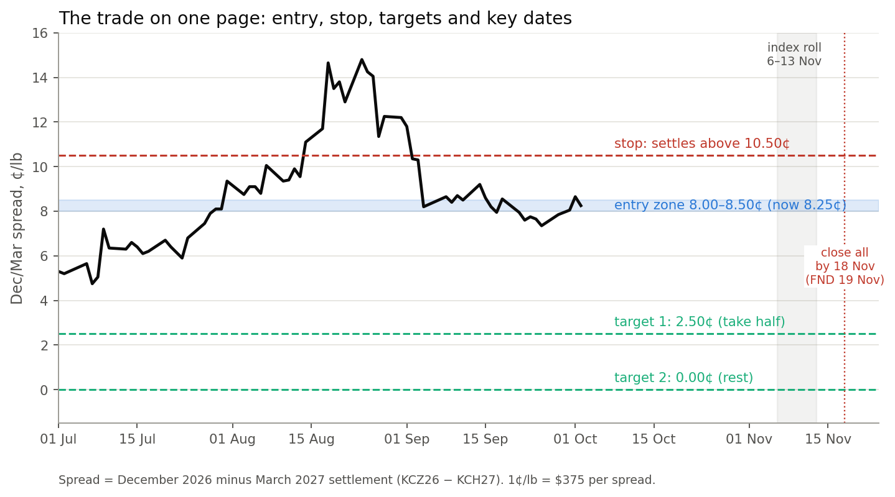
Figure 1 – The trade on one page. Black line: December 2026 minus March 2027 settlement. The spread is inside the entry zone today.

2. The December/March spread in plain words
The spread is the price of December coffee minus the price of March coffee. Each contract is 37,500 lb, so a 1¢/lb move in the spread is worth $375 per spread.
- Above zero (backwardation): buyers pay more for coffee now than later. This happens when coffee that can be delivered against the exchange is scarce.
- Below zero (contango): later coffee costs more, mostly because of storage and financing. This is the normal state when supply is comfortable.
- Into first notice day: holders of December who cannot take delivery must sell or roll. If sellers have plenty of certified coffee to deliver, the December premium tends to collapse. If they don't, it can explode.
That is why the most important input to this trade is not the coffee price itself but the ICE certified warehouse stock report: how much exchange-grade coffee is ready to deliver, and how much is waiting to be graded.

3. The 2022 analogy
We lined up every year since 2019 by the number of trading days left before December first notice day. On that clock, 2026 today sits almost exactly where 2022 was – and 2022 is the one year in which the spread collapsed from a high level.
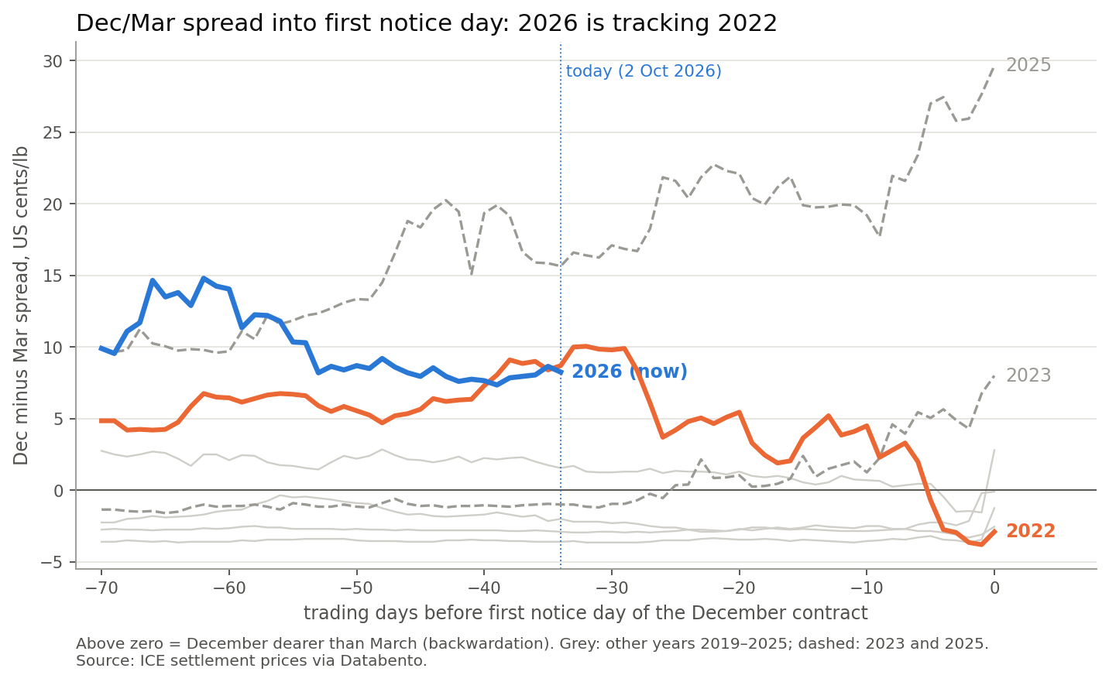
Figure 2 – Dec/Mar spread in the last 70 trading days before first notice day. Orange: 2022. Blue: 2026 so far. Dashed: 2023 and 2025, when the spread rose instead.

What happened in 2022, step by step
Date (2022) | Dec/Mar spread | What it meant
3–4 Oct | 8.40¢ – 8.70¢ | Same distance from first notice day as today (34–35 trading days). Our entry rule would have triggered.
6 Oct | 10.05¢ (high) | Worst point. Just 0.45¢ below our 10.50¢ stop – the stop is tight, and that is deliberate.
26 Oct | 2.45¢ | Target 1 (2.50¢) reached.
4 Nov | 4.10¢ | Reuters that day: ICE stocks at a 23-year low near 380,000 bags, but more than 160,000 bags waiting for grading and at least 100,000 more on the way – mostly Brazilian semi-washed coffee. The spread bounced, then fell again.
14 Nov | −0.70¢ | Target 2 (0.00¢) reached.
18 Nov | −3.80¢ | Lowest point, the last trading day before first notice.
21 Nov (FND) | −2.90¢ | Spread ended 11.30¢ lower than on 3 Oct.

The lesson of 2022: the spread did not need warehouse stocks to be high. It needed the market to see that deliverable supply was on its way. Low stocks plus a visible grading queue was enough to break the December premium.

2022 and 2026 side by side
 | 2022 | 2026 (today)
Dec/Mar spread, 34 trading days before FND | 8.40¢ – 8.70¢ | 8.25¢
Highest level since August | 10.05¢ (6 Oct) | 14.80¢ (24 Aug)
Certified stocks | ~380,000 bags, 23-year low | 260,239 bags – lower still
Coffee waiting for grading | >160,000 bags, +100,000 on the way | Peak 64,955 (11 Sep); 12,646 now
Where the new supply came from | Brazilian semi-washed | Brazil: 98.5% of the queue at its peak; 100% at Antwerp
Outcome into FND | Fell 11.30¢ to −2.90¢ | ?

Where 2026 is different – read this before trading
1. Much of the supply wave has already landed. In 2022 the queue was large and growing into November. In 2026 the queue peaked in mid-September and is now small (12,646 bags, about 5% of stocks). The spread already fell from 14.80¢ to about 8¢ on this news.
2. Stocks are even lower than in 2022. At 260,000 bags, there is less room for error. If stocks start falling again, the 2023 or 2025 pattern – a rising spread – becomes the risk.
3. One match is not proof. 2022 is the only year since 2019 that fits this setup, so the analogy guides the plan but cannot guarantee it. That is why the plan has a supply stop, not only a price stop.

4. What the 2026 warehouse reports show
We read all 42 daily ICE Coffee "C" certified stock reports from 5 August to 2 October 2026. The story has four phases.
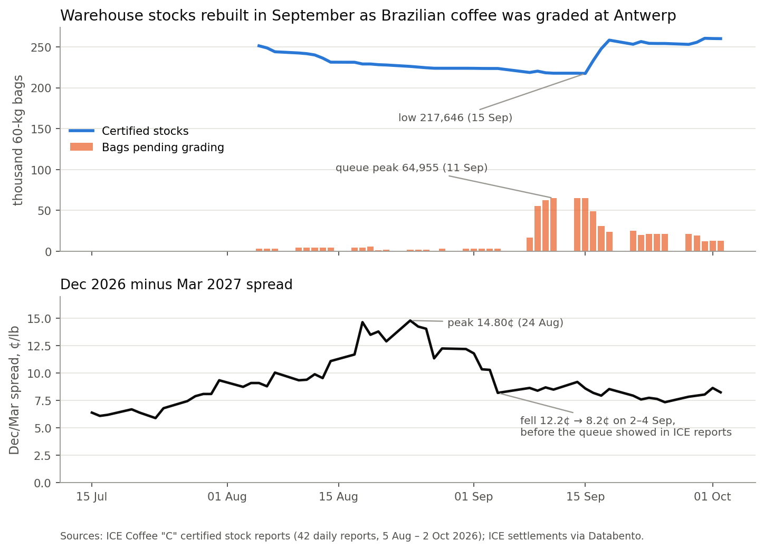
Figure 3 – Top: certified stocks (blue) and bags waiting for grading (orange). Bottom: the Dec/Mar spread over the same weeks.
Phase | Dates | Certified stocks | Waiting for grading | What happened
1. Drawdown | 5 Aug – 4 Sep | 251,417 → 223,712 | about 3,000 | Stocks fell about 11%. Almost nothing was queuing. The spread climbed to 14.80¢.
2. Queue builds | 8 – 15 Sep | low 217,646 (15 Sep) | peak 64,955 (11 Sep) | Brazilian coffee arrived at Antwerp for grading.
3. Fast grading | 16 – 18 Sep | → 258,415 | → 23,685 | 41,270 bags passed in three sessions.
4. Plateau | 21 Sep – 2 Oct | 260,239 (2 Oct) | 12,646 (2 Oct) | A second grading wave, then stable.

Grading results, 5 Aug – 2 Oct 2026 | Bags
Passed grading | 64,083
Failed grading | 31,369
Pass rate | 67.1%
Share of passed bags from Brazil | 97%
Share of passed bags graded at Antwerp | 96%
"Transition" bags (discount applies from 2027) as share of stocks, 2 Oct | 77.6%

Two things the data does NOT show
- The report did not lead the spread. The spread fell from 12.2¢ to 8.2¢ on 2–4 September, before the queue appeared in the reports on 8 September, and it barely moved while 41,000 bags passed grading. The market learns about shipments faster than the report shows them. Use the report to confirm the thesis, not to time entries.
- More stocks did not push the spread lower by themselves. Since 4 September the spread has stayed between 7.35¢ and 9.20¢. In 2022, most of the fall came in the final weeks, through index rolling and first notice day. We expect the same timing now.

5. Every year since 2019
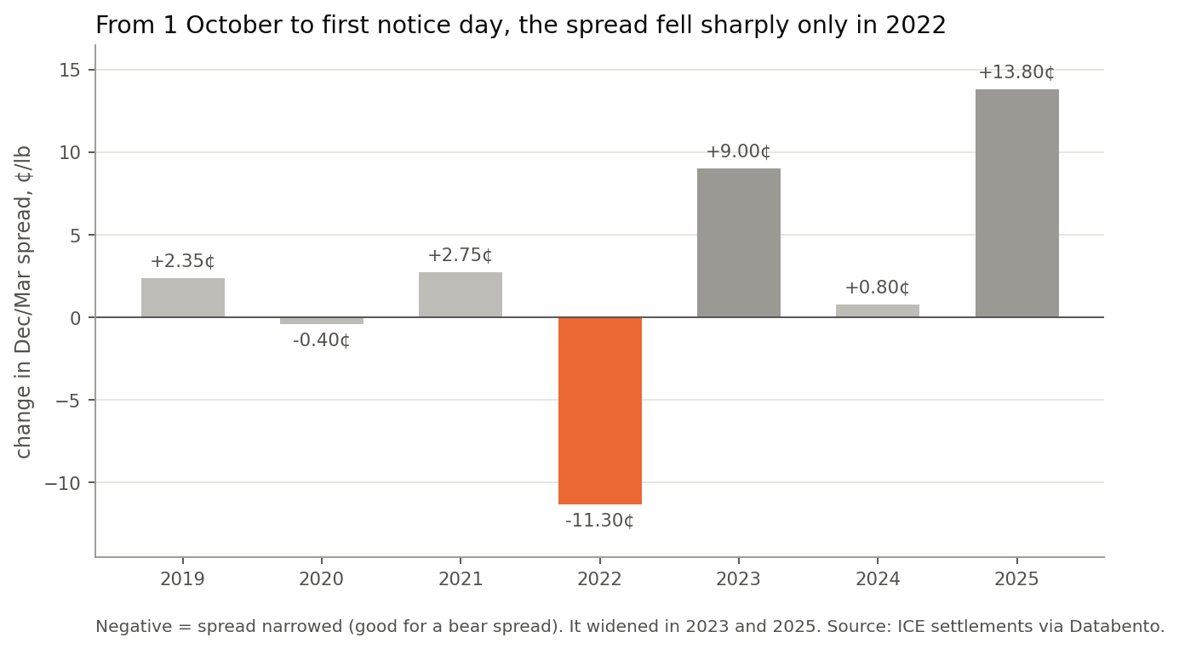
Figure 4 – Change in the Dec/Mar spread from 1 October to December first notice day.
Year | Spread on 1 Oct | Spread at FND | Change | Would this plan have traded?
2019 | −3.60¢ | −1.25¢ | +2.35¢ | No – no backwardation
2020 | −2.15¢ | −2.55¢ | −0.40¢ | No – no backwardation
2021 | −2.85¢ | −0.10¢ | +2.75¢ | No – no backwardation
2022 | +8.40¢ | −2.90¢ | −11.30¢ | Yes – both targets hit (26 Oct, 14 Nov)
2023 | −1.00¢ | +8.00¢ | +9.00¢ | No – no backwardation
2024 | +2.00¢ | +2.80¢ | +0.80¢ | No – spread too small
2025 | +15.85¢ | +29.65¢ | +13.80¢ | No – far above entry zone, stocks falling
2026 | +8.65¢ | – | – | Yes – in the entry zone (8.25¢ on 2 Oct)

Read the table this way: the December premium does not usually collapse on its own. It collapsed in the one year when new deliverable supply was clearly coming. In the years when it was not (2023, 2025) the premium grew, and fast. This plan bets that 2026 is a 2022 year, and it watches the stock report every day to check.

6. How to trade it

Levels and money, per spread
Level | Spread | Move from 8.25¢ | Profit / loss per spread
Entry (now) | 8.25¢ | – | –
Stop – exit all | 10.50¢ | +2.25¢ against us | −$844
Target 1 – exit half | 2.50¢ | 5.75¢ in our favour | +$2,156
Target 2 – exit rest | 0.00¢ | 8.25¢ in our favour | +$3,094
Both targets hit (average) | – | 7.00¢ in our favour | +$2,625
Round-trip costs (est.) | – | 1 tick + $2.50 per leg per side | about −$85

Reward against risk is about 3 to 1 if both targets are hit ($2,625 against $844). Exchange margin for a calendar spread is normally much lower than for an outright position; confirm the current requirement with your broker before trading.

Rules, in order
- Enter only between 8.00¢ and 8.50¢, as a spread order (both legs together). Scale in over two or three days if you like.
- Check the ICE stock report every day. It is published around 13:15–13:25 New York time. Exit on the supply stop (Section 7).
- Exit everything if the spread settles above 10.50¢. No exceptions, no widening.
- Take half at 2.50¢ and the rest at 0.00¢.
- Time check on 6 November: if the spread is still above 7.00¢ when the index roll starts, close half – by the same week in 2022 the spread was already down to about 4¢.
- Close all by 18 November. Do not hold a short December position into first notice day on 19 November.

Key dates
Date | Event | Why it matters
Every trading day | ICE certified stock report | Confirms or breaks the supply thesis
Every Friday | CFTC Commitments of Traders | Shows whether speculators are still long December
6 – 13 Nov (approx.) | Large commodity indices roll December into March | Index funds sell December and buy March – pushes the spread down
18 Nov | Last day to hold this trade | Exit before notice period
19 Nov | First notice day, KCZ26 | Delivery period starts
18 Dec | Last trading day, KCZ26 | –

7. What would prove us wrong
Warning sign | Why it matters | Action
Spread settles above 10.50¢ | Market is pricing a squeeze, as in 2025 | Exit all
Certified stocks below 240,000 bags | Supply is draining again – back toward the September low | Exit all
Stocks fall 10 reports in a row while fewer than 5,000 bags wait for grading | This is what August 2026 looked like before the spread hit 14.80¢ | Exit all
Large new grading queue (more than 30,000 bags) | More supply on the way – the 2022 pattern | Hold; supports the trade
Spread above 7.00¢ on 6 Nov | The expected move is late | Close half
Brazil port, weather or logistics shock | Can stop shipments to Europe quickly | Review the same day

Three ways this could go
Scenario | What we would see | Spread by 18 Nov | Per spread
Like 2022 (our base case) | Stocks hold above 250,000; some new grading; index roll in November | 0¢ to 2.5¢ | +$2,156 to +$3,094
Nothing happens | Stocks flat, no new queue; spread drifts | 6¢ to 8¢ | Small gain or loss; half closed on 6 Nov
Like 2023 / 2025 | Stocks fall again, roasters take coffee out, no new supply | Above 10.50¢ | −$844 (stop)

8. Evidence and limits
We want this plan to stand up to questions, so here is everything we tested – including what did not work.
Test | Result | What it tells us
This plan's rules on Dec/Mar, 2019–2025 | 1 trade (2022): both targets hit | The setup is rare. One example, not a statistic.
Simpler rule: sell Dec/Mar on 1 Oct whenever backwardation is at least 4¢, 2019–2025 | 2 trades: 2022 +$2,395; 2025 −$2,293 (stopped out) | Without checking supply, the 2025 trade failed while stocks were falling.
Bear spreads on every contract roll (H/K, K/N, N/U, U/Z, Z/H), 2022–2026 | 17 trades, 29% winners, net −$5,672 | Selling backwardation blindly loses money. The supply condition is essential.
Systematic carry, trend and positioning signals, KC and RC, 2019–2026 | No signal beat buy-and-hold after costs | There is no simple rule that wins on its own here.

How we kept the numbers honest: prices are official ICE settlements; every value is used only after it was published (the stock report from about 13:20 New York time; the spread from that day's settlement); costs of one tick per side plus $2.50 per contract are included; and every figure in this plan was rechecked against the source data.

Corrections to earlier drafts
Earlier internal notes contained some figures that did not match the source data. These are the corrected values used here:
Item | Earlier note | Corrected
2022 spread at first notice day | −3.80¢ (change −12.20¢) | −2.90¢ (change −11.30¢). −3.80¢ was the low on 18 Nov
2023 spread at first notice day | +6.75¢ | +8.00¢ (change +9.00¢)
2025 spread at first notice day | +29.85¢ | +29.65¢ (change +13.80¢)
2022 stock situation | "Stocks were replenished" | Stocks were at a 23-year low; the grading queue was the signal
Origin of the 2026 queue | "669,397 pending lot entries" | That double-counts days. Correct: 98.5% Brazilian, 100% at Antwerp on the peak day
"Queue is a 3–7 day leading indicator" | Stated as a rule | Seen once; the spread moved before the queue appeared
Spread margin | "$500–$800" | Removed – check the current ICE requirement with your broker

9. Other risks
- Squeeze risk. Stocks are historically very low. A sudden drop or large withdrawal by roasters can push the spread up fast, as in 2025.
- Transition bags. 77.6% of certified stocks are "transition" bags that take a discount from 2027. This could make holders keener to deliver against December – which would help the trade – but the effect is not proven. Read the ICE notice.
- Index roll timing. The usual November roll window is an estimate based on published index schedules; exact days can differ.
- Liquidity and gaps. Spreads can jump on news. A stop on settlement can be filled worse than 10.50¢.
- Small sample. Seven years of history (2019–2025), one matching year. Size accordingly.

Important
This document is research for discussion. It is not investment advice or an offer to trade. Futures and spreads involve substantial risk of loss. Past patterns, including 2022, may not repeat. Each reader is responsible for their own trading decisions and position size.
Status: draft – it must be reviewed by Finance before it is distributed outside the research team.

Appendix – data sources
Data | Source | Period
Coffee "C" settlement prices, all contract months | ICE Futures U.S., via Databento (end-of-day statistics) | Jan 2019 – 2 Oct 2026
Certified stocks, grading, pending bags | ICE Coffee "C" Certified Warehouse Stock Report (daily .xls) | 5 Aug – 2 Oct 2026 (42 reports)
2022 stock situation | Reuters, "Arabica coffee heads to ICE warehouses, putting pressure on prices", 4 Nov 2022 | –
Contract dates | ICE Coffee "C" rules: FND = 7 business days before the first business day of the delivery month | –

