The graph below gives information about the percentage of people living in Australia who were born in Asia, the UK, and other regions.

Sumarize the information by selecting and reporting the main features, and make comparisons where relevant.

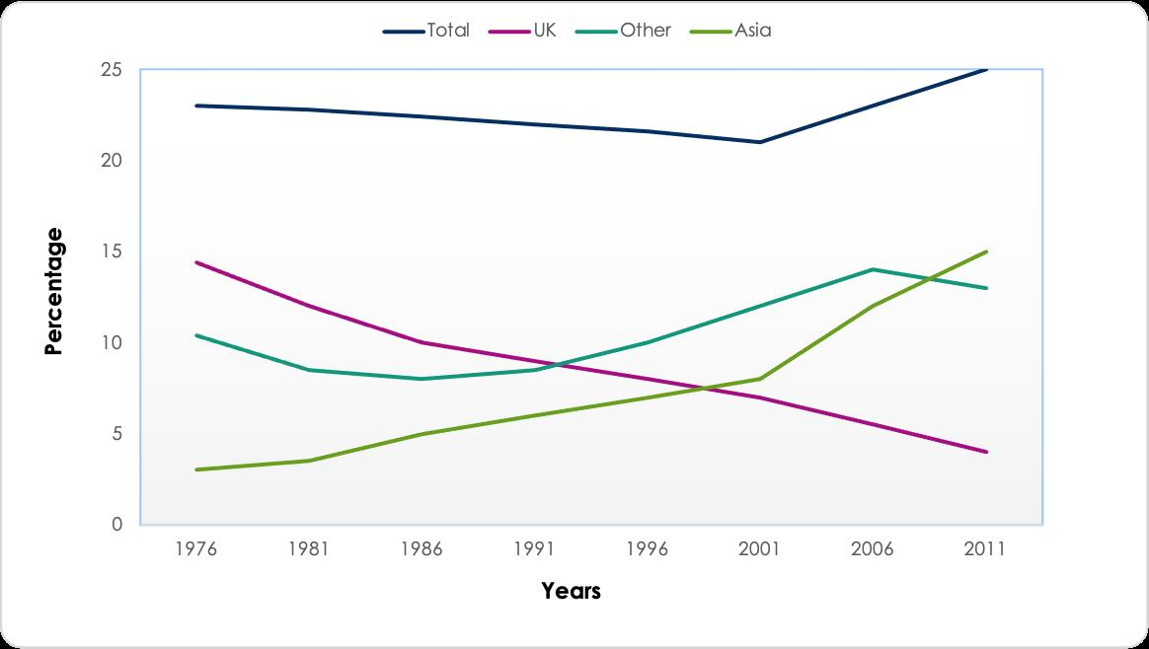

The given graph illustrates the percentage of Australian people whose original countries were in Asia, the UK or other regions from 1976 to 2011.

Overall, the number of foreigners who decided to immigrate to Australia experienced a surge over the researched period. On top that, the percentage of UK demographics dropped over the years whilst the opposite trend could be seen with Asians and people from other countries.

In 1976, the UK is responsible for the highest proportion of immigrants with around 14%. In the second place, we had other countries at approximately 11% whereas Asia only accounted for a mere 2.5%. Over the course of 35 years, fewer and fewer UK citizen chose to settle in Australia, leading to a gradual decline in this proportion to 4% in 2011. Asia, conversely, seemed to thrive as their demographics increased steadily and peaked at 15% by the end of the period.

Meanwhile, the figure of other countries fluctuated multiple times including a drop of 5% by 1986 then start to rise again an reached a peak of 14% in 2006 and plummeted to 13% at the end. There was a slight climb in the percentage of Australia immigrants from 23% to 25%, including a trough of 21% in 2001.