

**COMPUTER SCIENCE ENGINEERING**

***PROJECT TITLE***

A project/thesis in the Department of Computer Science Engineering presented in partial fulfillment of the requirements for the Degree of

Bachelor of Computer Science Engineering

**PREPARED BY**

**Student 1**

***Bui Lam Quang Ngoc***

***15020019***

**Student 2**

***Duong Duc Hung***

***15020018***

**ADVISOR**

***Tran The Vu***

***Dang Thi Phuong Thao***

**Da Nang, 2019**

DECLARATION

We, Hung and Ngoc declare that this thesis/project titled, **Thesis/Project Title** and the work presented in it are my own. we confirm that:

* This work was done wholly or mainly while in candidature for a BSc degree at VNUK Institute for Research and Executive Education.
* Where any part of this thesis has previously been submitted for a degree or any other qualification at VNUK Institute for Research and Executive Education or any other institution, this has been clearly stated.
* Where we have consulted the published work of others, this is always clearly attributed.
* Where we have quoted from the work of others, the source is always given. With the exception of such quotations, this thesis is entirely our own work.
* We have acknowledged all main sources of help.
* Where the thesis is based on work done by ourselves jointly with others, we have made clear exactly what was done by others and what we have contributed ourselves.

*[Bui Lam Quang Ngoc, 15020019 and Computer Science and Engineering 15]*

*[Duong Duc Hung, 15020018 and Computer Science and Engineering 15]*

CERTIFICATE

I do hereby declare that the research works embodied in this thesis/project entitled “**Thesis or Project Title**” is the outcome of an original work carried out by Duong Duc Hung and Bui Lam Quang Ngoc under my supervision.

I further certify that the dissertation meets the requirements and the standard for the degree of [MSc/ BSc] in Computer Science and Engineering.

________________________________________

*Name and designation of Supervisor*

ACKNOWLEDGEMENT

*The success and final outcome of this project required a lot of guidance and assistance from many people and we are extremely privileged to have got this all along the completion of my project. All that we have done is only due to such supervision and assistance and we would not forget to thank them.*

*We respect and thank Mr. Tran The Vu, for providing me an opportunity to do the project work in VN-UK Institute for Research and Executive Education and giving us all support and guidance which made us complete the project duly. We are extremely thankful to him for providing such a nice support and guidance, although he had busy schedule managing the corporate affairs.*

*We owe our deep gratitude to our project guide Mrs. Dang Thi Phuong Thao, who took keen interest on our project work and guided us all along, till the completion of our project work by providing all the necessary information for developing a good system.*

Da Nang, 2019 *Bui Lam Quang Ngoc*

*Duong Duc Hung*

ABSTRACT

*This website is designed to attend to all your needs – from buying computing goods properly, selling products in Da Nang, Viet Nam. Here you found the better items of technology in there. Portal help us to maintain the database of various items and clients information. It not only help us to maintain the customer’s information but here we also setup and develop a recommended system to help users having a good experiences when they are interacting with our website.*

*The site may be focused on selling computing goods, uploading new information which relate to stat-of-the-art technologies. In addition to that clients or users could rate or vote the level of their satisfaction with several items on our website. We will be putting an effort to provide the right choice to people when they are searching and looking for new technological products and beware them from the false advertising.*

*We also develop the system that recommend users which items is the most suitable with them. All of this functions based on how many clicks of category-related products they did, and the rate of their voting with any kind of products. This system is a big challenge with us during the process of developing and researching the way to build it.*

**TABLE OF CONTENTS**

DECLARATION 2

CERTIFICATE 3

ACKNOWLEDGEMENT 4

ABSTRACT 5

LIST OF FIGURES 8

LIST OF TABLES 8

SYMBOLS 9

ABBREVIATIONS 10

REQUIREMENTS ANALYSIS DOCUMENT 11

1. INTRODUCTION 11

1.1 Purpose of the system 11

1.2 Scope of the system 11

1.3 Objectives and success criteria of the project 12

1.4 Definitions, acronyms, and abbreviations 13

1.5 References 13

1.6 Overview 13

2. CURRENT SYSTEM 14

3. PROPOSED SYSTEM 14

3.1. Overview 14

3.2. Functional Requirements 14

3.3. Nonfunctional Requirements 15

3.4. System Models 16

3.4.1. Scenarios 16

3.4.2. Use Case Model 16

3.4.3. Object Model 18

3.4.4. Dynamic Model 18

3.4.5. User Interface—Navigational Paths and Screen Mock-Ups 18

4. GLOSSARY 19

5. PROJECT BUDGET AND TIME PLAN 19

5.1. Gantt chart 19

5.2. Project Budget 20

5.3. Project Phase Distribution 21

5.4. Other Tables 21

6. PROJECT SPECIFIC CONTENT 21

6.1. Accessibility 21

6.2. User Manual 21

6.3. Test Plan 21

6.4. Maintenance Plan 22

6.5. Setup and Installation 22

CONCLUSION AND DISCUSSION 23

REFERENCES 24

APPENDIXES 25

BIOGRAPHY 26

26

LIST OF FIGURES

Figure 3.1 Use case model shopping online 16

Figure 3.2 View items use case. 17

Figure 3.3 Checkout, authentication and payment use cases. 18

LIST OF TABLES

Table 5.1 Project budget table 16

Table 5.2 Project phase distribution 16

SYMBOLS

β Sample Test Phase

ABBREVIATIONS

VSC Visual Studio Code

HTML Hypertext Markup Language

CSS Cascading Style Sheets

REQUIREMENTS ANALYSIS DOCUMENT

# INTRODUCTION

*The first section of the RAD is an Introduction. Its purpose is to provide a brief overview of the function of the system and the reasons for its development, its scope, and references to the development context (e.g., reference to the problem statement written by the client, references to existing systems, feasibility studies). The introduction also includes the objectives and success criteria of the project.*

|  |
| --- |
| Purpose of the system |
| The purpose of project is to allow users to seek out and purchase technological products. The website is built by two parts: front-end and back-end. HTML & CSS are used to develop front-end and design the interface of our website. Meanwhile, python is a language that has been used to build and improve Back-end and recommended system.  Our website also focuses on primary experiences and business model. Furthermore, it help clients become more efficient and reduce operational expense, bring them better serve our customers and address their needs about technological items.  There are many important elements that go into building a successful e-commerce website such as removing friction during the purchasing process, making the checkout smooth and easy, making the website fast and attractive, up selling users on related products, incentivizing buyers, reducing cart abandonment, nurturing past buyers to buy again, remarketing to past visitors who haven’t yet purchased, using the proper payment options. |

|  |
| --- |
| Scope of the system |
| The website has features that enable any one person to purchase items online, whether they live in anywhere in Viet Nam. It also lets people be more familiar with their experiences similar to other prominent website such as lazada, tiki.  It reduce client’s monthly expenses because of saving travelling fees. In addition to that users can find and buy virtually anything they may need. Web-based stores are open 24/7; this means you can make purchases when you have the desire and spare time. |

|  |
| --- |
| Objectives and success criteria of the project |
| **Our website objectives are:**  High reachability - The main objective and at the same time need is traction on our web store. Of course if users are selling products online what we require are customers. If users are getting good reachability then our business will definitely grow. Therefore one of the objective is high reachability.  [High Conversions](http://sunarctechnologies.com/boost-up-your-e-commerce-sales-with-some-easy-dos/) - if people are coming on our web store and purchasing something then it will calculate as conversions and from the number of people who are buying stuff from our web store we can calculate the conversion rate.  [Customer satisfaction](http://sunarctechnologies.com/7-easy-ways-to-handle-customer-service-for-e-commerce/) - Customer is the main part of any E-commerce business so it is very important to make our customer happy and satisfied. By providing quality and desirable products, on time delivery, 24*7 customer support, and timely sale & best deal offers users can make my customer happy. It is one of the main objectives of our website.  **Success criteria:**  A good website should have a simple design and should be easy to understand and use. Regular updates are necessary for e-commerce sites to reflect the changing avail-ability of products, changes to information, addition of new products and deletion of obsolete products. Technical availability of the website is also very important. Provision of appropriate and correct product information is very important in deciding the quality of an e-commerce website.  The design of website to enable users to experience easily.  Recommended system processing effectively.  Listing, viewing, purchasing and delivering products chosen intuitively. |

|  |
| --- |
| Definitions, acronyms, and abbreviations |
| Home Page: A main page which lists all of top products and information of website.  AboutUs Page: A page which shows the information of group.  Product Page: A page which displays all available products.  SignUp Page: A page which serves registration procedure to users.  SignIn Page: A page which required users to log in registered account.  Recommend system: A system which recommends items based on what items that users have watched.  COD: Cost On Delivery |

|  |
| --- |
| References |
| <https://en.wikipedia.org/wiki/Online_shopping>  <https://www.quoteroller.com/proposal-templates/ecommerce-proposal-template/>  <https://www.quora.com/What-are-the-needs-and-objectives-of-E-Commerce/> |

|  |
| --- |
| Overview |
|  |

# CURRENT SYSTEM

*The second section, Current system, describes the current state of affairs. If the new system will replace an existing system, this section describes the functionality and the problems of the current system. Otherwise, this section describes how the tasks supported by the new system are accomplished now.*

# PROPOSED SYSTEM

*The third section documents the requirements elicitation and the analysis model of the new system.*

|  |
| --- |
| Overview |
| This section provides a functional overview of the system. This will again be properly be divided into two parts: functional requirements and nonfunctional requirements. |

|  |
| --- |
| Functional Requirements |
| Internet browser is required such as: Google Chrome, Mozila Firefox, etc.  Personal details of user needed to be filled in form to help delivery process occurring smoothly.  Keeping records of admission of customers.  Keeping record of the products.  Keeping the daily sell.  Storing feedback of customers.  Keeping details products whether it is delivered or not.  Storing the items selected by users in the temporary storage. |

|  |
| --- |
| Nonfunctional Requirements |
| Following Non-Functional requirements will be there in the insurance on internet:  **i).** 24 x 7 availability  **ii).** Better component design to get better performance at peak time.  **3.3.1 Usability**   * Website must be used and manipulated by mouse. * Readability of Text. * Convenience of a product Catalog. * Description and Photo of a product. * Similar Products. * Contact information of Terms and Service. * System must notice to users who have purchased or selected temporary items recently.   **3.3.2 Reliability**   * Providing sufficient contact details, not only an e-mail address. * Components of the project code will be tested alongside the implementation phase to ensure that they are functional.   **3.3.3 Performance**   * Manipulation must be smooth without graphical lagging. * Validation of the information of users or keeping track of delivery process will be noticeable.   **3.3.4 Supportability**   * The website should be able to run on any browsers.   **3.3.5 Implementation**   * All project graphical user interfaces will be created using a HTML and CSS. * Recommend System is implemented Python. |

|  |
| --- |
| System Models |
| *Describes the scenarios, use cases, object model, and dynamic models for the system. This section contains the complete functional specification, including mock-ups illustrating the user interface of the system and navigational paths representing the sequence of screens. The subsections Object model and Dynamic model are written during the Analysis activity.* Scenarios A scenario is an outline of events - planned or unplanned, possible or probable - depending on the circumstances. Use Case Model   Figure 3.1 Use case model shopping online  .    Figure 3.2 View items use case.    Figure 3.3 Checkout, authentication and payment use cases. Object ModelDynamic ModelUser Interface—Navigational Paths and Screen Mock-Ups |

# GLOSSARY

*A glossary of important terms, to ensure consistency in the specification and to ensure that we use the client’s terms. A precursor to the****Data Dictionary.***

# PROJECT BUDGET AND TIME PLAN

*A project plan is one of the most important ingredients for a successful project. It is used to document and communicate expectations, to control schedule and delivery, and to calculate and manage risks. In general, it acts as a roadmap for everyone involved in the project.*

## Gantt chart

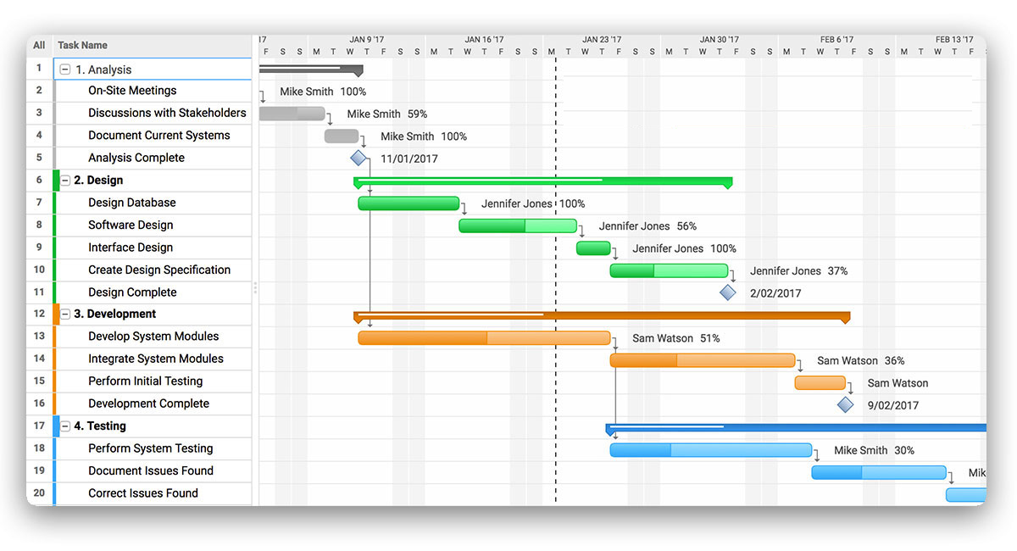

Figure 5.1 Gantt chart sample 1

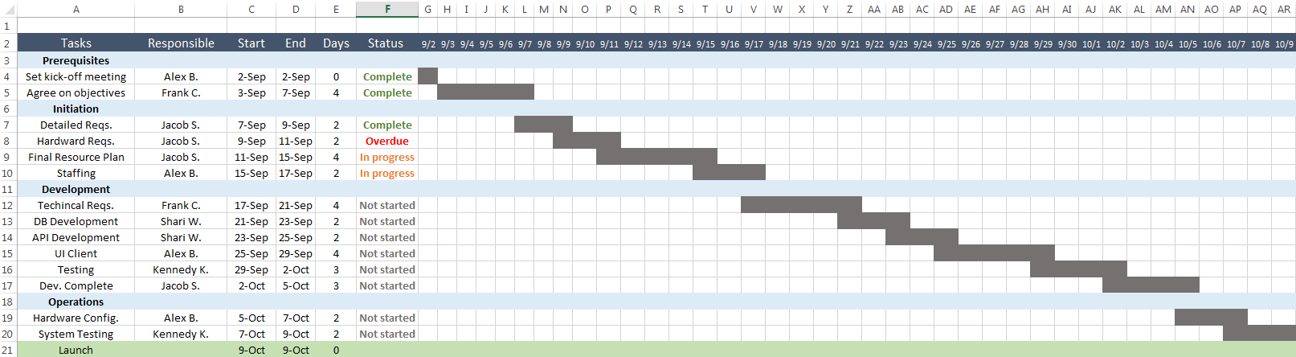

Figure 5.2 Gantt chart sample 2 made with excel

## Project Budget

*Initially, the Project Budget allows the project manager to determine how much the project is likely to cost. Throughout the course of the project, it lets the project manager check whether or not the project is sticking to its budget.*

*In this section, calculate the total budget in details. Budget includes salaries, fees, price of hardware, fixed investment costs, license price, and so on.*

Table 5.1 Project budget table

|  |  |  |  |  |
| --- | --- | --- | --- | --- |
|  | **Estimated** | | | **Actual** |
| **Expenses** | **Period**  **(One time or Recurrent)** | **Cost per Period (USD)** | **Total Cost (USD)** | **Total Cost**  **(USD)** |
| Human resource | 30 Man day | 50 | 1.500 | 1400 |
| License for Visual Studio | 1 Time | free | 0 | 0 |
| Arduino and related stuff | 2 Sets | 300 | 600 | 900 |
| Travel | 5 Times | 200 | 1.000 | 600 |
| Accommodation | - | - | - | - |
| Conference Registration Fee | 2 Times | 300 | 600 | 300 |
| …. |  |  |  |  |
|  |  |  |  |  |
| TOTAL BUDGET | | | 3.700 | 3.200 |

According to the plan, estimated project budget was over estimated as 3.700 USD. But some expenses have been cheaper than estimated. So the actual cost is 3.200 USD.

## Project Phase Distribution

In this section

Table 5.2 Project phase distribution

|  |  |  |  |
| --- | --- | --- | --- |
| **Planning & Analysis** | **Design** | **Implementation** | **Testing** |
| %40 | %15 | % 35 | %10 |

## Other Tables

You can extend this section as 5.3 Log tables, 5.4 Advisor meeting tables, or other tables or diagrams as you wish.

# PROJECT SPECIFIC CONTENT

In this chapter, you can write anything about your project. User manual, screenshot, essential part of your project, whatever you want...

|  |
| --- |
| Accessibility |
| Images  * Images have descriptive alternative text * Decorative and spacer images have null alternative text.   **Plain English**   * Some pages may still contain complex and technical language, but we will, where possible, simplify complex language unless unable to do so due to legal reasons.   **Consistent navigation**   * The website has been designed to provide a variety of navigation routes to access information. Key navigation options can be accessed from every page on the site.   **Forms**   * Form fields contain the appropriate text labels, field sets, legends and captions * Forms have accessible error handling which are marked with an asterisk for mandatory fields.  Link to website help from all pages  * We provide a link from the footer of the website through to our help pages.   **Correctly structured pages**   * We aim to provide correctly structured and well-titled headings. |

|  |
| --- |
| User Manual |
|  |

|  |
| --- |
| Test Plan |
|  |

|  |
| --- |
| Maintenance Plan |
|  |

|  |
| --- |
| Setup and Installation |
|  |

CONCLUSION AND DISCUSSION

*The purpose and objective of online shopping website is achieved*. *Online shopping is the process whereby consumers directly buy goods or services from a seller in real-time, without an intermediary service, over the Internet. It is a form of electronic commerce. An online shop, e-shop, e-store, internet shop, web-shop, web-store, online store, or virtual store evokes the physical analogy of buying products or services at a bricks-and-mortar retailer or in a shopping centre. The process is called Business-to-Consumer (B2C) online shopping. When a business buys from another business it is called Business-to-Business (B2B) online shopping.*

*A good shopping cart design must be accompanied with user-friendly shopping cart application logic. It should be convenient for the customer to view the contents of their cart and to be able to remove or add items to their cart. The shopping cart application described in this project provides a number of features that are designed to make the customer more comfortable. This project helps in understanding the creation of an interactive web page and the technologies used to implement it. The design of the project which includes Data Model and Process Model illustrates how the database is built with different tables, how the data is accessed and processed from the tables. The building of the project has given me a precise knowledge about how Python is used to develop a recommend system and how it connects to the database to access the data and how the data and web pages are modified to provide the user with a shopping cart application.*

REFERENCES

*Includes all references: articles, media facts, books, reports, regulations, internet articles, papers that you referenced from the text.*

*Some examples are given below.*

(Kumari, 2016)(Wikipedia, 2016)

*[2] R. Levenshteyn, and I. Fikouras, “Mobile services interworking for IMS and XML Web Services,” IEEE Communications Magazine, pp. 80–87, Sep. 2006.*

*[3] D. Lozano, L.A. Galindo, and L. Garcia, “WIMS 2.0: Converging IMS and Web 2.0. Designing REST APIs for the exposure of session-based IMS capabilities,” in Proc. of The Second International Conference on Next Generation Mobile Applications, Services, and Technologies, 2008, pp. 18–24.*

APPENDIXES

*Type or paste your appendices here. Appendices are a place to organize and include all of the “extra” material that is important to your research work but that is too detailed for the main text.  Examples can include: specific analytical methods, computer code, spreadsheets of data, details of statistical analyses, etc. But, these materials do not speak for themselves. There should be a reference to these materials from the main chapters (complete details included in Appendix A) and there should be some text at the beginning of each appendix to briefly explain what the information is and means that is included in that appendix.*

BIOGRAPHY



Student name 1



Student name 2