Insert your name, centre number and candidate number into the header above.
Save this evidence document as evidence_ followed by your centre number_ candidate number. For example: evidence_ zz999_9999
Screenshots or program listings must be copied into appropriate cells in the following tables.
Examiners must be able to read the contents including any screenshots without the use of a magnifying glass. Answers that are not readable or missing will not be awarded any marks.
Save this evidence document at regular intervals, for example, every 10 minutes.
Question 1
Part 1(a)
class node:
def __init__(self, data, nextNode):
self.data = data
self.nextNode = nextNode

Part 1(b)
linkedList = [node(1, 1), node(5, 4), node(6, 7), node(7, -1), node(2, 2), node(0, 6), node(0, 8), node(56, 3), node(0, 9), node(0, -1)]

startPointer = 0
emptyList = 5

Part 1(c)(i)
def outputNodes(nodeArray : list[node], startPointer):
currentPointer = startPointer

while currentPointer != -1:
print(str(nodeArray[currentPointer].data))
pointer = nodeArray[currentPointer].nextNode

Part 1(c)(ii)
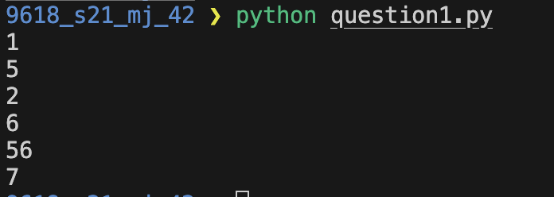

Part 1(d)(i)
def addNode(linkedList : list[node], currentPointer, emptyList):
dataToAdd = int(input("Enter number to add: "))

if emptyList < 0 or emptyList > 9:
return False
else:
newNode = node(dataToAdd, -1)
linkedList[emptyList] = newNode

previousPointer = 0
while currentPointer != -1:
previousPointer = currentPointer
currentPointer = linkedList[currentPointer].nextNode

linkedList[previousPointer].nextNode = emptyList
emptyList = linkedList[emptyList].nextNode

return True

Part 1(d)(ii)
outputNodes(linkedList, startPointer)

result = addNode(linkedList, startPointer, emptyList)

if result == True:
print("Item successfully added")
else:
print("Failed to add item")

outputNodes(linkedList, startPointer)

Part 1(d)(iii)
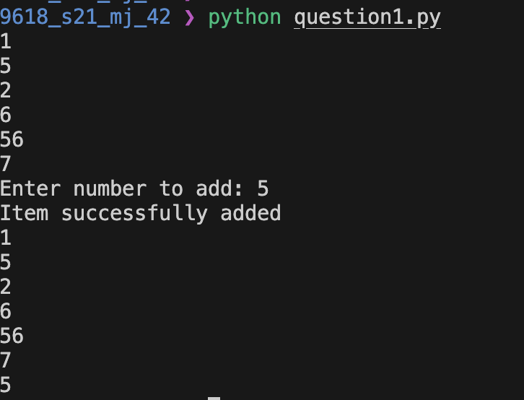

Question 2
Part 2(a)
arrayData = [10, 5, 6, 7, 1, 12, 13, 15, 21, 8] # Array [0: 10] of INTEGER

Part 2(b)(i)
def linearSearch(target: int):
global arrayData

for i in range(10):
if arrayData[i] == target:
return True

return False

Part 2(b)(ii)
searchValue = int(input("Input target value: "))

found = linearSearch(searchValue)

if found == True:
print("Value found in list")
else:
print("Value not found in list")

Part 2(b)(iii)
{Copy and paste the screenshots for question 2(b)(iii) here}

Part 2(c)
{Copy and paste program code listing for question 2(c) here}

Question 3
Part 3(a)
{Copy and paste program code listing for question 3(a) here}

Part 3(b)
{Copy and paste program code listing for question 3(b) here}

Part 3(c)(i)
{Copy and paste program code listing for question 3(c)(i) here}

Part 3(c)(ii)
{Copy and paste program code listing for question 3(c)(ii) here}

Part 3(c)(iii)
{Copy and paste program code listing for question 3(c)(iii) here}

Part 3(c)(iv)
{Copy and paste program code listing for question 3(c)(iv) here}

Part 3(c)(v)
{Copy and paste screenshots of the two tests for question 3(c)(v) here}

