Screenshots or program listings must be copied into appropriate cells in the following table.
Save this evidence document as evidence_ followed by your centre number_ candidate number, for example, evidence_ zz999_9999 and insert your name, candidate number and centre number into the header above.
Examiners must be able to read the contents including any screenshots without the use of a magnifying glass. Answers that are not readable or are missing will not be awarded any marks.
Save this evidence document at regular intervals, for example every 10 minutes.
Question 1
Part 1(a)(i)
def IterativeVowels(Value):
Total = 0
LengthString = len(Value)

for x in range(0, LengthString):
FirstCharacter = Value[0:1]

if FirstCharacter == 'a' or FirstCharacter == 'e' or FirstCharacter == 'i' or FirstCharacter == 'o' or FirstCharacter == 'u':
Total = Total + 1

Value = Value[1: len(Value)]

return Total

Part 1(a)(ii)
print(IterativeVowels("house"))

Part 1(a)(iii)
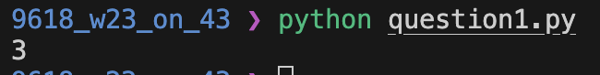

Part 1(b)(i)
def RecursiveVowels(Value):
if len(Value) == 0:
return 0
elif Value[0] == 'a' or Value[0] == 'e' or Value[0] == 'i' or Value[0] == 'o' or Value[0] == 'u':
return 1 + RecursiveVowels(Value[1: len(Value)])
else:
return RecursiveVowels(Value[1: len(Value)])

Part 1(b)(ii)
print(RecursiveVowels("imagine"))

Part 1(b)(iii)
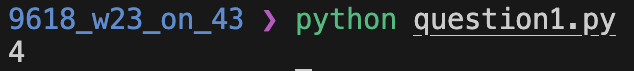

Question 2
Part 2(a)(i)
Queue = ['' for i in range(50)] # Array of STRING, 50 spaces
HeadPointer = -1
TailPointer = 0

Part 2(a)(ii)
def Enqueue(value: str):
global Queue, HeadPointer, TailPointer

if HeadPointer == -1:
Queue[TailPointer] = value
HeadPointer = 0
TailPointer = TailPointer + 1
print("Added element")
else:
if TailPointer > 49:
print("Queue is full")
else:
Queue[TailPointer] = value
TailPointer = TailPointer + 1
print("Added Element")

Part 2(a)(iii)
def Dequeue():
global Queue, HeadPointer, TailPointer

if HeadPointer == -1 or TailPointer == 0 or HeadPointer == TailPointer:
return 'Empty'
else:
nextItem = Queue[HeadPointer]
HeadPointer = HeadPointer + 1
return nextItem

Part 2(b)
def ReadData():

try:
file = open("QueueData.txt", 'r')

NextLine = file.readline().strip()

while NextLine != "" :
Enqueue(NextLine)
NextLine = file.readline().strip()

file.close()
except IOError:
print("File not found")

print(Queue, HeadPointer, TailPointer)

Part 2(c)(i)
class RecordData:
def __init__(self):
self.ID = "" # Record ID: STRING
self.Total = 0 # Total times ID appears: INTEGER

Part 2(c)(ii)
def TotalData():
global Records, NumberRecords

DataAccessed = Dequeue()
Flag = False

if NumberRecords == 0:
Records[NumberRecords].ID = DataAccessed
Records[NumberRecords].Total = 1
Flag = True
NumberRecords = NumberRecords + 1
else:
for x in range(NumberRecords):
if Records[x].ID == DataAccessed:
Records[x].Total = Records[x].Total + 1
Flag = True

if Flag == False:
Records[NumberRecords].ID = DataAccessed
Records[NumberRecords].Total = 1
NumberRecords = NumberRecords + 1

Part 2(c)(iii)
def TotalData():
global Records, NumberRecords

DataAccessed = Dequeue()
Flag = False

if NumberRecords == 0:
Records[NumberRecords].ID = DataAccessed
Records[NumberRecords].Total = 1
Flag = True
NumberRecords = NumberRecords + 1
else:
for x in range(NumberRecords):
if Records[x].ID == DataAccessed:
Records[x].Total = Records[x].Total + 1
Flag = True

if Flag == False:
Records[NumberRecords].ID = DataAccessed
Records[NumberRecords].Total = 1
NumberRecords = NumberRecords + 1

Part 2(d)
def OutputRecords():
global Records, NumberRecords

for i in range(NumberRecords):
print("ID " + str(Records[i].ID) + " Total " + str(Records[i].Total))

Part 2(e)(i)
ReadData()

for i in range(HeadPointer, TailPointer):
TotalData()

OutputRecords()

Part 2(e)(ii)
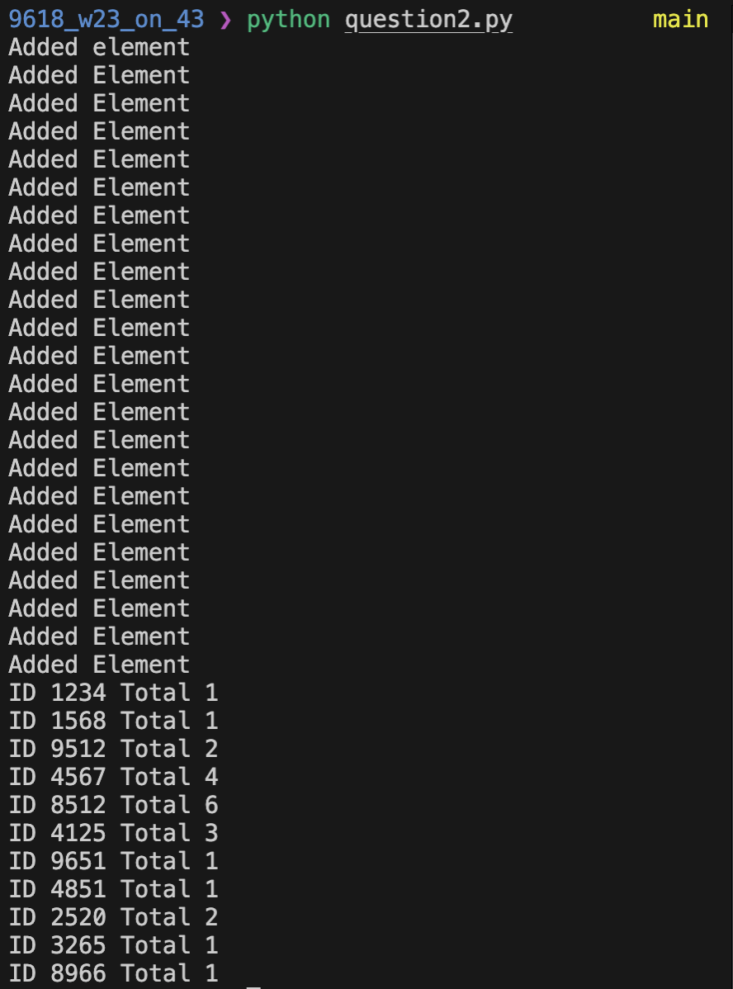

Question 3
Part 3(a)(i)
class Character:
def __init__(self, pName, pXPos, pYPos):
self.Name = pName # Chracter Name: STRING
self.XPosition = pXPos # Chracter X-Position: INTEGER
self.YPosition = pYPos # Chracter Y-Position: INTEGER

Part 3(a)(ii)
def GetXPosition(self):
return self.XPosition

def GetYPosition(self):
return self.YPosition

Part 3(a)(iii)
def SetXPosition(self, pXPos):
if self.XPosition + pXPos > 10000:
self.XPosition = 10000
elif self.XPosition + pXPos < 0:
self.XPosition = 0
else:
self.XPosition = self.XPosition + pXPos

def SetYPosition(self, pYPos):
if self.YPosition + pYPos > 10000:
self.YPosition = 10000
elif self.YPosition + pYPos < 0:
self.YPosition = 0
else:
self.YPosition = self.YPosition + pYPos

Part 3(a)(iv)
def Move(self, direction):
if direction == 'up':
self.SetYPosition(10)
elif direction == 'down':
self.SetYPosition(-10)
elif direction == 'left':
self.SetXPosition(-10)
elif direction == 'right':
self.SetXPosition(10)

Part 3(b)
Jack = Character("Jack", 50, 50)

Part 3(c)(i)
class BikeCharacter(Character):
def __init__(self, pName, pXPos, pYPos):
super().__init__(pName, pXPos, pYPos)

Part 3(c)(ii)
def Move(self, direction):
if direction == 'up':
self.SetYPosition(20)
elif direction == 'down':
self.SetYPosition(-20)
elif direction == 'left':
self.SetXPosition(-20)
elif direction == 'right':
self.SetXPosition(20)

Part 3(d)
Karla = BikeCharacter("Karla", 100, 50)

Part 3(e)(i)
TargetCharacter = str(input("Target Character: "))

while TargetCharacter != "jack" and TargetCharacter != "karla":
print("Invalid Character")
TargetCharacter = str(input("Target Character: "))

TargetDirection = str(input("Target Dircection: "))

while TargetDirection != 'up' and TargetDirection != 'down' and TargetDirection != 'left' and TargetDirection != 'right':
print("Invalid Direction")
TargetDirection = str(input("Target Dircection: "))

if TargetCharacter == 'jack':
Jack.Move(TargetDirection)
print("Jack's new poisition is X = " + str(Jack.GetXPosition()) + " Y = " + str(Jack.GetYPosition()))
elif TargetCharacter == "karla":
Karla.Move(TargetDirection)
print("Karla's new poisition is X = " + str(Jack.GetXPosition()) + " Y = " + str(Jack.GetYPosition()))

Part 3(e)(ii)
