Insert your centre number, name and candidate number into the header above.
Save this evidence document as evidence_ followed by your centre number_ candidate number. For example: evidence_ zz999_9999
Screenshots or program listings must be copied into appropriate cells in the following table.
Examiners must be able to read the contents including any screenshots without the use of a magnifying glass. Answers that are not readable or missing will not be awarded any marks.
Save this evidence document at regular intervals, for example every 10 minutes.
Question 1
Part 1(a)
StackData = [] # 1D Array of 10 integer elements
StackPointer = 0

Part 1(b)
def PrintStack():
global StackData, StackPointer

print("Stack values: ", end="")
for i in range(StackPointer): # Loop over the Stack
print(StackData[i], end=" ") # Print value

print("\nPointer Value:", StackPointer) # Print pointer value

Part 1(c)
def PushToStack(value):
global StackData, StackPointer
if StackPointer == 10: # Check if stack is full
return False
else:
StackData[StackPointer] = value # Push the value to the stack
StackPointer += 1 # Move the pointer to the next free space
return True

Part 1(d)(i)
for i in range(11): # run 11 times
InputValue = int(input("Enter the number to push to stack: "))

PushResponse = PushToStack(InputValue)

if PushResponse == True: # Check if value is pushed to stack
print("Successfully pushed value", InputValue, "to Stack") # Output sucessful message
else:
print("Stack is full, cannot push value", InputValue, "to stack") # Output failed message

PrintStack()

Part 1(d)(ii)
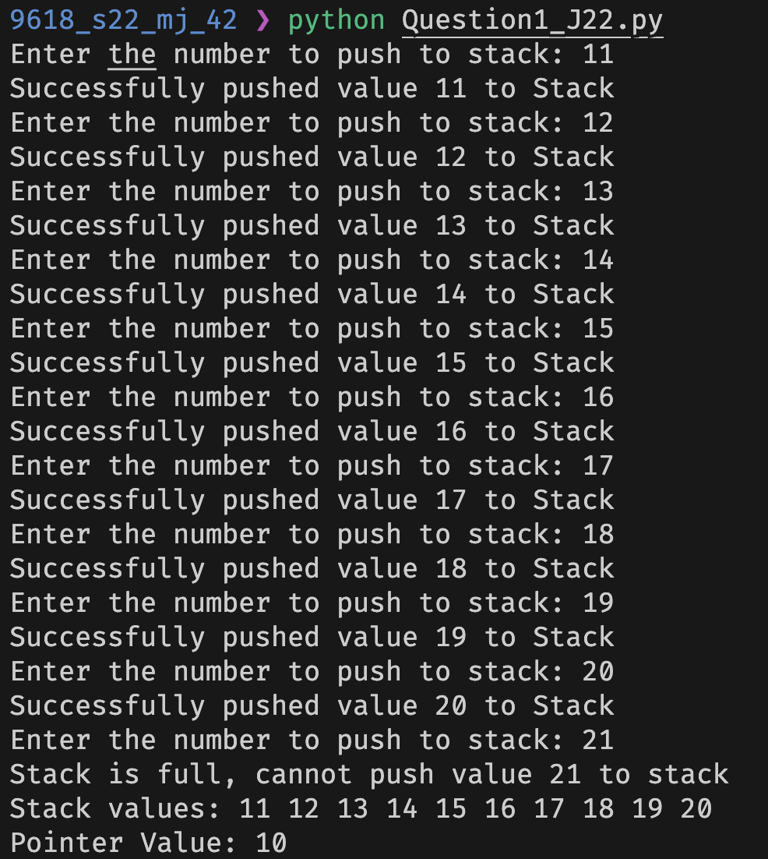

Part 1(e)(i)
def Pop():
global StackData, StackPointer

if StackPointer == 0: # Check if stack is empty
return -1

TopValue = StackData[StackPointer-1] # Get the top value
StackData.pop() # Remove the value from list
StackPointer = StackPointer - 1 # Move the pointer to the previous free space
return TopValue

Part 1(e)(ii)
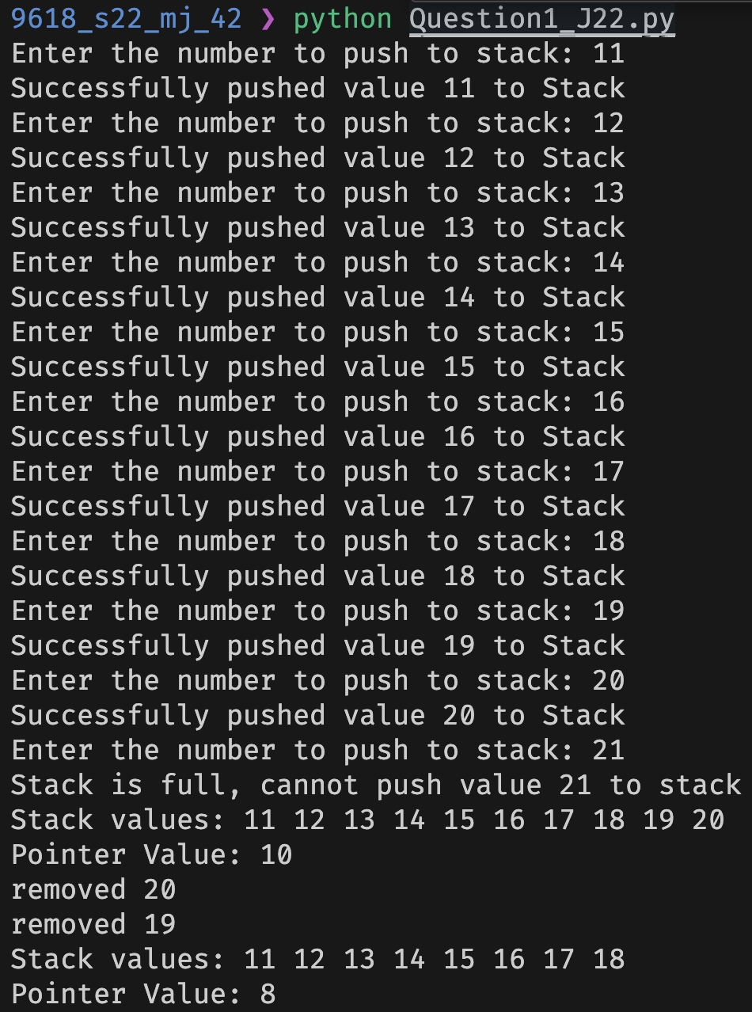

Question 2
Part 2(a)
import random

ArrayData = [] # 2D Array of 10 by 10 integer elements

for i in range(10):
InsideArray = [] # Blank array for 10 integer elements
for j in range(10):
RandomNumber = random.randint(1,100) # Generate a random number between 1 and 100
InsideArray.append(RandomNumber) # Add to the subarray

ArrayData.append(InsideArray) # Append to main array

Part 2(b)(i)
ArrayLength = 10

# Increase all index search by 1 as index starts at 0 and ends at (n-1)
for X in range(ArrayLength):
for Y in range(ArrayLength-1):
for Z in range(ArrayLength-Y-1):
if ArrayData[X][Z] > ArrayData[X][Z+1]:
TempValue = ArrayData[X][Z]
ArrayData[X][Z] = ArrayData[X][Z+1]
ArrayData[X][Z+1] = TempValue

Part 2(b)(ii)
def printArrayData():
global ArrayData
for i in range(10): # Loop over first dimension
for j in range(10): # Loop over second dimension
print(ArrayData[i][j], end="\t") # Output value [row][column]
print("\n") # Create new line (new row)

Part 2(b)(iii)
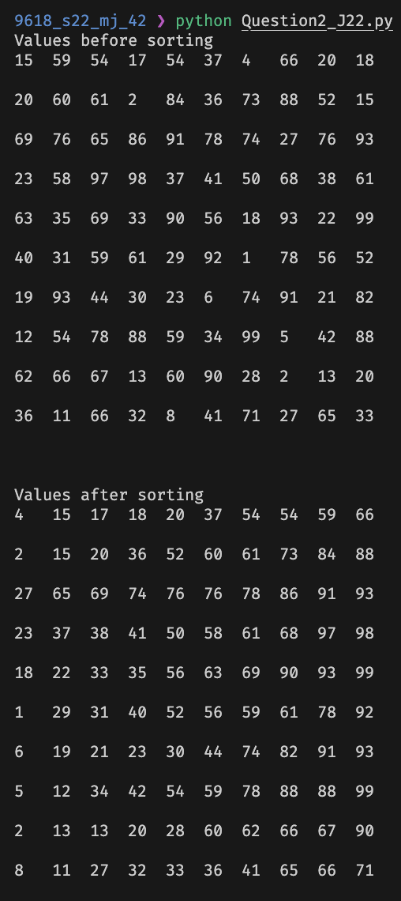

Part 2(c)(i)
def BinarySearch(SearchArray, Lower, Upper, SearchValue) -> int:
global ArrayData
if Upper > Lower:
Mid = (Lower + (Upper -1)) // 2
if SearchArray[0][Mid] == SearchValue:
return Mid
else:
if SearchArray[0][Mid] > SearchValue:
return BinarySearch(SearchArray, 0, Mid - 1, SearchValue)
else:
return BinarySearch(SearchArray, Mid+1, Upper, SearchValue)

return -1

Part 2(c)(ii)
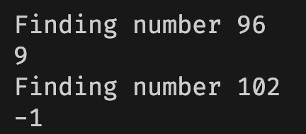

Question 3
Part 3(a)
class Card:
# private __number: INTEGER number of the card
# private __colour: STRING colour of the card
def __init__(self, number, colour):
self.__number = number # Create a private attribute to store number
self.__colour = colour # Create a private attribute to store colour

Part 3(b)
def GetNumber(self):
return self.__number

def GetColour(self):
return self.__colour

Part 3(c)
CardArray = [] # Array of 30 elements with datatype Card

CardValuesFile = open('CardValues.txt', 'r') # Open CardValues.txt
CardValuesFileData = CardValuesFile.read().split("\n") # Read the data line by line
NumberOfLines = 60
CardValuesFile.close() # Close the file

for line in range(0, NumberOfLines, 2): # Loop through 2 lines at a time
CardNumber = int(CardValuesFileData[line]) # Get card number
CardColour = CardValuesFileData[line+1] # Get card colour

CardArray.append(Card(CardNumber, CardColour)) # Add the Card to the array

Part 3(d)
def ChooseCard():
global ChosenCards
CardAvailible = False

while CardAvailible == False:
CardChoice = int(input("Select the card index you want: "))
if CardChoice >= 1 and CardChoice <= 30: # Check if valid index
if CardChoice not in ChosenCards: # Check if card is already chosen
CardAvailible = True # Set valid varible to True
ChosenCards.append(CardChoice) # Add choice to chosen cards
else:
print("Card already chosen, please choose again") # Display message asking user to choose again
else:
print("Not valid index, please choose from 1 to 30 (inclusive)") # Display message asking user to choose again

return CardChoice # return index of chosen card

Part 3(e)(i)
Player1 = [] # Array for player 1 chosen cards of type Card

for i in range(4):
Player1CardChoice = ChooseCard() # Ask player to choose card
Player1.append(CardArray[Player1CardChoice-1]) # Add the chosen card to Player1's array minus 1 because index starts at 0

print("Player 1 chosen cards:")
for i in range(4): # Loop over Player1 chosen cards
P1Card = Player1[i]
P1CardNumber = P1Card.GetNumber() # Get card number
P1CardColour = P1Card.GetColour() # Get card colour
print("Card:", P1CardNumber, "-", P1CardColour) # Output card number and colour

Part 3(e)(ii)
TEST 1:
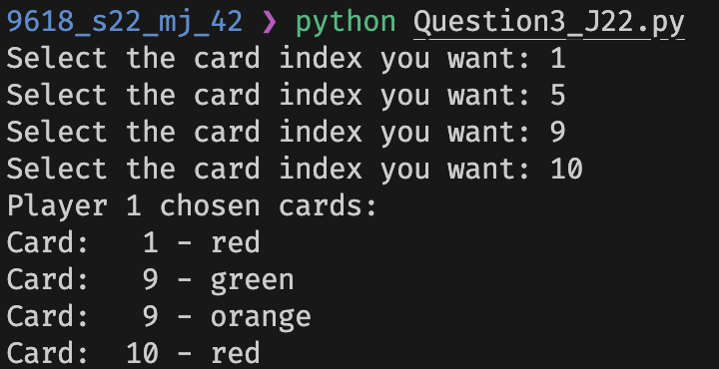

TEST 2:
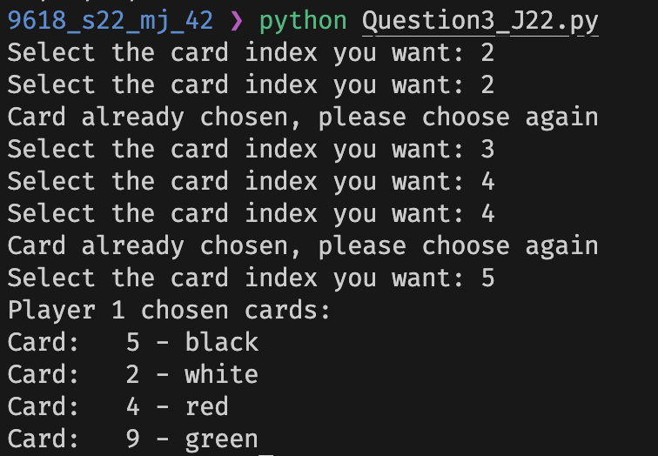

Time taken: 2:01:50

